**Ghebre’s Restaurant**

**Introduction**

We look forward to working with you to build your website!

Our team will provide you an easy to use website that will be easily maintained. We will work with you over the project development lifecycle to ensure your goals are met. We will also provide recommendations on design features to make your website state of the art and on par with current standards.

This proposal is our starting point to ensure we meet your needs. As the project moves forward, this document will be updated to reflect changes in design and functionality.

**Current Website:** https://www.facebook.com/GhebreRestaurant/

### **Theme Choice**

**Base theme:** Dyad - <https://wordpress.org/themes/dyad/>

Dyad is by Automattic. It is very clean, amazing and well thought of. The beautiful aspects of Dyad are: it is well balanced and super clean, makes beautiful use of typography and white spaces. Dyad displays words and images in perfect balance: a post’s featured image and text excerpt get equal billing on the main blog page, while single posts and pages size and position images dynamically, depending on the screen size. The homepage shows a series of Featured Content with a large Featured Image.

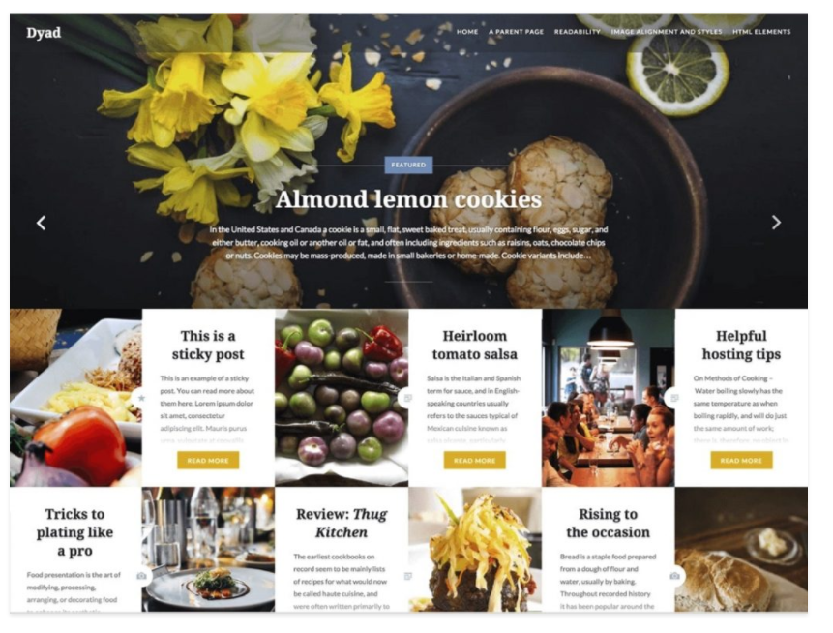

### 

### **Logo**

We are reviewing the logo below to learn how to incorporate a similar look and feel of your website with the proposed color scheme indicated later in this document.



### **Theme Design Notes**

**Design Notes 7/15/2017**

**Contact Person**: Mike Davidovich

davidovm@csp.edu

919-280-7943

**Technical Person:** Ahmed Dalmar

dalmara@csp.edu

612-229-3959

**Team Members:** Karyn Boyd

boydp1@csp.edu

512-848-0309

www.karynboyd.com

Rhodia Xiong

[xiongr2@csp.edu](mailto:xiongr2@csp.edu)

612-889-5088

**Your Goals**

* Build awareness for the business
  + You will be able to use your domain name on marketing materials, media, and other communication channels
* Provide access to menus, events, and some way to contact management
  + Forms, links, and other navigation items on the website will allow users to find this information
* Drive business to location
  + A Contact Page will assist users in finding the restaurant and knowing your hours
* Showcase East African food including Ethiopian and Eritrean food through pictures and descriptions of food
  + We are proposing a WordPress theme built for restaurants that will give you the option to showcase many photos of your food; all photos will be linked to a main gallery with a description of the food.

**Your Customers**

We have established multiple customer profiles, but generally, we seem to be targeting customers who have roots from east Africa or are interested in trying authentic, global cuisine.

**Website Navigation**

Our business analyst provided us with a list of your preferred navigation menu layout. We propose to the following layout to optimize your user experience and meet your goals:

* Home
* Menu
* Contact Us (location and hours, address with Google Maps pin, contact form)
* Upcoming Events (calendar)
* Gallery
* About Us
  + History
  + Mission
  + Features

### **Color Scheme**

Below is a color palette that we think would be a great color scheme for the website. We stuck with the orange and the blue color that was provided from the restaurant’s sign and we added in a few colors that we think would complement the blue and orange.

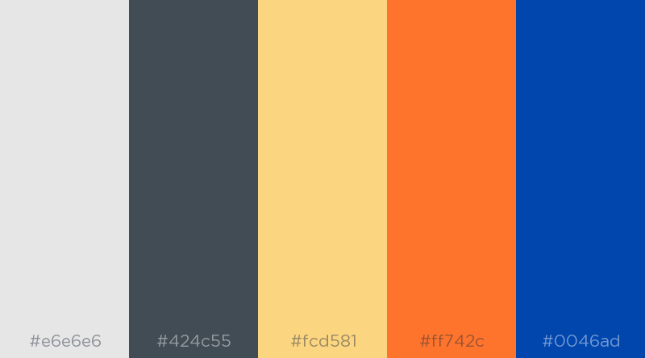

**#e6e6e6** (gray) will be used for the background color.

**#424c55** (dark gray) will be the font color for the body.

**#fcd581** (faded yellow) will be a faint, transparent background color for the navigation panel at the top.

**#ff742c** (orange) and **#0046ad** (blue) will be colors to use for headings and buttons.

### **Fonts**

The font for the headline is Noto Serif or Georgia.

The font for the body copy is Lato or Helvetica Neue.

The following is a screen capture of the Live Preview of the [Dyad](https://dyaddemo.wordpress.com/) WordPress theme we have selected.

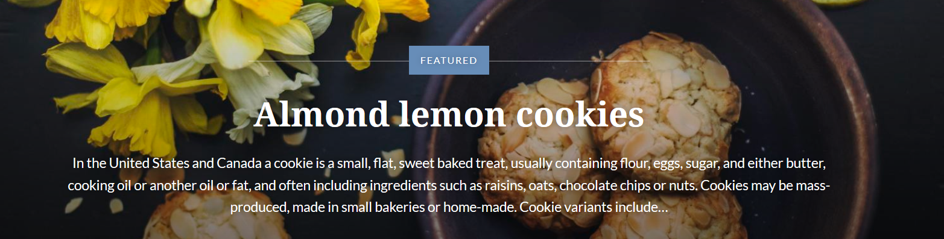

### **Technical Notes**

**General Notes**

* The development environment will be hosted on Pantheon - to be maintained by Ahmed
* We are researching various plug-ins to reach the goals of the client:
  + Calendar: <https://wordpress.org/plugins/the-events-calendar/>
  + Social media: <https://wordpress.org/plugins/custom-facebook-feed/>

**Hosting a Web Site**

Hosting your own website is an essential part of running a business today. We hope to make it easy for you to maintain and update your website after we work closely with you to build it out. Some things to know:

* Your website will be powered by WordPress, a powerful content management system designed originally for blogs; many websites use this technology today to create easy to maintain restaurants
* WordPress contains many add-ons or plug-ins to make your website more and more robust, our team will propose options to you as we work through the project

The team will assist the client in domain name service (DNS) registry for the client at project completion. After project hand off, the client will be able to maintain and update the website using the WordPress administrator panel

Proposed domain names:

* [www.ghebres.com](http://www.ghebres.com)
* [www.ghebresrestaurant.com](http://www.ghebresrestaurant.com)