Hypertrophy

Daunte Jules

Technical Project Proposal

Technical Project Title: Hypertrophy

Project Overview: The app will allow users to set workout plans, track calories, log
workouts and allow trainers to set their own workout plans for people to follow.

Project Rationale: This project aims to provide workout plans, exercise tracking,
nutrition tracking and reminders to any person that is interested in working out in one
place, for free, anytime, anywhere. People want to workout, track their calories, track
their progress over time and also get information about exercise ideas and proper form.

Project Audience:
End Users: Fitness Enthusiasts, Athletes, Body Builders and Personal Trainers

Project Format: Mobile Application

Project Scope:
- Research existing fitness tracking apps, user needs, and best
practices in fitness app design.
- Design a seamless and intuitive UI/UX that enables an easy user
experience for key app functionalities.
- Develop core features of the app including workout plans, exercise
tracking, etc.
- Develop a system where trainers can upload workout plans and
schedules and “students” (users) can follow their plans instead of
creating their own, users can also share data with trainers once
authorized.
- Develop Systems to track calories, protein, sleep and water intake.
- Implement secure and scalable backend infrastructure to manage
user accounts and user data(workouts, nutrition logs).
- Develop Functioning Admin Panel
- Utilize Standard Monitoring Services
- Implement Notifications and Reminders for users to workout
- Implement Intuitive Progress Monitoring
Project Personnel: Daunte Jules
Evaluation:
Mobile App
- Intuitive and Seamless UI/UX Design
- Steady Performance and Responsiveness
- Fast Load Times
- App has all core features
- Offline Functionality
- Integration with API
API Backend
- Excellent API Design
- Data Security
- Efficient Database Integration
- Proper Caching
- Error Handling and Logging
- Scalability and Performance
Dashboard (Admin Panel)
- Administrative Features
- Established Security Measures
- Integration with API and Monitoring Service
- Intuitive UI/UX
Monitoring Service
- Real-time Monitoring of all Services
- Adequate Notification and Alerts
- Performance Metrics
- Log Audits
Overall
- Performative App in terms of response time and resource utilization
- Systems are secure with enough data encryption and vulnerability
scanning/penetration testing
- Systems receive minimal downtime
- All Systems are scalable to handle user load
- Code is maintainable and reusable
Project Related Skills:
- Programming Skills (Rust, Kotlin)
- UI/UX Design Skills
- Project Management Skills
- Problem Solving Skills
- Time Management Skills
- Critical Thinking Skills
- Analytical Thinking Skills
- Attention to detail
Resource Needs:
- Cloud Hosting Servers for the API Backend, Dashboard and
Monitoring Service
- Machine for Development and Testing
- CI/CD Tools for Automation
- Security Tools for Pentesting/Vulnerability Scanning
- Testing Tools for Application Testing
- Database for User Storage (PostgreSQL)
- Mobile Devices to test App functionality
- Version Control (Git) to track Changes
- Visual Studio Code (Insiders) for Development
- Docker for containerization and easy deployment
- Knowledge in SSH and Remote Development
Learning Goals:
- Learn how to effectively troubleshoot and debug complex issues
during development, especially when integrating multiple features.
- Develop problem-solving skills when encountering challenges in
development.
- Learn back-end programming skills with the use of Rust and
Rocket, using a REST API.
- Learn mobile app technologies developing effective mobile
applications with Kotlin.
- Learn to develop intuitive UI/UX designs to ensure smooth
operations.
- Develop effective project management and time management skills.
- Learn how to accurately test an app with CI/CD to limit bugs and
security risks.

Project Teams:
Daunte Jules

Approved By:
Kem Emmanuel

Date:
29/01/2025

Abstract

Acknowledgements

Table of Contents

Chapter 1 – Introduction
Overview
Hypertrophy is a fully featured mobile application that will allow fitness enthusiasts, personal trainers, gym goers and home workout enthusiasts alike, to track their workouts and exercises, create workout plans with scheduled reminders, log different types of daily nutrition intake. What makes Hypertrophy different from all other fitness mobile applications is the ability for inexperienced users to follow workout plans created by experienced trainers. At Hypertrophy we have chosen modern technologies to ensure of our mission, using Rust for the backend, React Native for mobile development and React + NextJS for Web Development, PostgreSQL and Redis for data handling, and Docker for deployment along with other services such as Uptime-Kuma, Prometheus and Grafana for monitoring. Hypertrophy aims to be completely user friendly and free, allowing users far and wide to use the application and benefit from it.

Background
Recently, I was looking for a mobile fitness app to track my at home workouts, and found it extremely difficult to find one that had all the features to suit my needs or be free, this was completely frustrating, as this should not be the case, hence, the idea for Hypertrophy was born. As fitness apps have grown in popularity over the recent years due to digital technology becoming pivotal in everyday human life, traditional methods of tracking workout progress such as manual pen and paper or excel spreadsheets have become near obsolete, being extremely inefficient. Modern fitness apps have since therefore risen to fill that gap but, Existing implementations always offer some core features, but more often than not features are fragmented, requiring that a user download more than one app to track their fitness journey, reducing customizability and maintainability. Hypertrophy aims to completely address these challenges by providing users with all the features they need when it comes to exercise tracking.

Problem Statement

The current landscape of fitness mobile applications is very wide, with many applications that provide similar functionalities. Existing fitness applications often provide core features but with fragmented features, requiring users to switch between multiple platforms for workout tracking. Another one of them being unfavourable design behind basic application functionalities which deters the user from wanting to use the app, as well as straying away inexperienced users from attempting to begin tracking their workouts seriously due to the complexity of the applications setup. Also, personal trainers also face challenges in managing their clients' workout plans efficiently, as traditional methods like spreadsheets and messaging apps are not optimized for structured fitness tracking and real-time progress monitoring. Additionally, some apps lock essential features behind paywalls, making it difficult for users to access comprehensive fitness management tools without subscriptions.

Objective

The main objective of this project is to develop Hypertrophy, a cross-platform mobile fitness application that provides users both experienced and inexperienced comfortable and user friendly workout tracking, nutrition logging, and trainer-client interactions. The app aims to have all these features packaged together to be the one stop shop for all fitness enthusiasts alike.

Some key objectives of this project include:
- Develop an application that offers an offline first approach towards fitness tracking, exercise viewing and nutrition logging, to provide convenient and ergonomic ways for users to track their fitness journey from the beginning.

- Provide a clean, user interface and experience for advanced and beginners, as well as keep the entire application free, without limitations, allowing freedom to all features.

- Provide a system where trainers can upload workout plans, and users can follow them while sharing progress data.

- Develop an Admin Panel to enable administrative control over application data, real-time monitoring, and performance tracking of the application.

- Implement a stable backend using Rust and PostgreSQL to manage user data efficiently while ensuring security and scalability.

Project Scope
- Research – Conduct research on existing fitness application implementations and how they can be improved for smoother user experiences.

- UI/UX Design – Design and Develop an intuitive, visually appealing and user-friendly interface for the application.

- Mobile App Development:
1. Implement core features such as workout tracking and nutrition logging
2. Develop a trainer-client system for users to interact with trained professionals
3. Implement notifications and reminders for users to workout
4. Enable offline access for essential app features

- Backend Development:
1. Build a secure and stable API using Rust and Rocket Web Server
2. Design efficient database structures using PostgreSQL
3. Use performant caching with Redis

- Admin Panel – Create an Admin Panel for creating, reading, updating and deleting user data.

- Monitoring – Integrate monitoring services for real time tracking of performance and app usage.

Delimitations
Partial Internet Connection Requirement – Although core features will be accessible offline, certain services, such as the trainer interactions, and data synchronization to ensure data redundancy, will be inaccessible without an internet connection.

Nutrition Tracking – The app will provide only the basic kinds of nutrition tracking and will not be implementing any specific macronutrient tracking in the initial version.

Trainer Client Interactions – Although clients (users) will be able to follow trainers and therefore follow their workout plans, messaging or videoing features will not be implemented in the initial version.

Smart Watch Integration – The app will not provide direct compatibility towards smart watch devices, which will come in later versions

Platform App Integration – The app will not be available on platforms like the Web or Desktop, due to the native architecture.

Chapter 2 – Literature Review
Introduction

In this chapter you will find research on mobile architecture, server architecture, client architecture, database and caching servers, as well as monitoring services, which are all the core components that make up Hypertrophy. The goal of this chapter is to examine existing technologies and frameworks in the development of a modern fitness mobile application.

Background

In an ideal situation, Hypertrophy would allow all fitness enthusiasts alike to be able to track their workouts, make workout plans, and log their nutrition and connect with personal trainers, with the following impact:

- Comprehensive Features – By integrating all features correctly users will have a centralized system to manage their fitness journey.
- Opportunities For Personal Trainers – Personal Trainers would now get a platform to share their own workout plans for other users to use.
- Healthier Lifestyles - The app encourages users to adopt and maintain healthier routines by being able to track their nutrition and the frequency of their physical activity.

The positives of this project include:

- Accessibility: Free to use, mobile-first, and offline functionality, making it accessible to a wide range of users.
- Motivation: Features like progress tracking, reminders help users stay committed to their fitness goals that they set for themselves.
- Technological Innovation: Demonstrates the application of modern technologies such as Rust, React Native, Docker, PostgreSQL and Redis.

There are no current systems like Hypertrophy in place.

There are a few applications that solve similar problems:



Name: Future

Description: Future is a fitness app specialized in personal trainers, where users can choose personal trainers who will guide them through certain programs as well as requesting feedback.

Key Features:

- Personal Trainer just for you
- Training Plans
- Guides, Tips and Videos
Advantages:

- One on One interactions with Personal Trainers
- Heavily customizable to your needs

Disadvantages:

- Lacks features for general workout tracking
- Extremely pricy, starting at $199.99/month



Name: Peloton App

Description: This is an application which provides access to a multitude of yoga, meditation, outdoor running, and gym workouts, as well as 3 cardio equipment classes per month behind an subscription.

Key Features:

- Wide variety of classes, including strength, Pilates, yoga, cycling, etc.
- Works well on multiple platforms including smartphones, smartwatches and TV’s

Advantages:

- No equipment necessary to start as classes cater to multiple different types of workouts
- Personalized features like music playlists
- High quality instructors to enhance the workout experience

Disadvantages:

- Limited interactivity that are locked behind paywalls
- Some classes and equipment reference equipment specifically sold by Pelton, which is less relevant for novice users
- IOS App has more features than the Android counterpart.

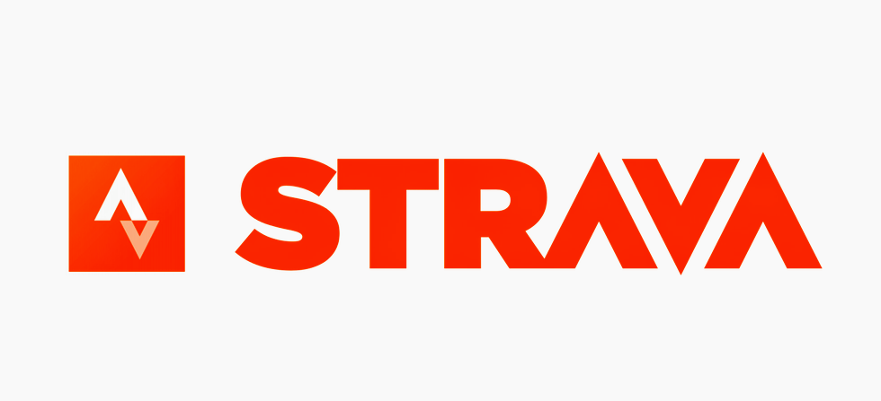

Name: Strava

Description: Strava is a fitness tracking app with community-based features allowing for connectivity around the world.

Features:

- Track running and cycling with GPS
- Challenges to motivate users
- Friends and Followers
- Shareable Achievements

Advantages:

- Beacon safety feature which shares real time location with users.
- Integrated with most smart watch devices
- Community engagement (Leaderboards, Challenges)

Disadvantages:

- Paid subscription costs
- Unhealthy competitive pressure
- Privacy concerns with real time location data



Name: Sweat

Description: Sweat fitness app is a comprehensive fitness tracking platform specifically designed for women, offering a wide variety of programs, nutritional guidance and community support.

Features:

- Diverse workout plans including HIIT cardio, yoga, Pilates as well as programs for post pregnancy
- Nutritional Support with dietary plans
- Progress Tracking
Advantages:

- Global Community Engagement with women around the world
- Accessible everywhere
- User-Friendly Interface

Disadvantages:

- Relies on GIF’s and Images instead of full video workouts.
- Paid subscription cost to access the apps features
- Gender specific focus for women

In analysing these applications, Hypertrophy aims to integrate the most valuable features found across not only the fitness apps listed above, but other existing ones as well, such as workout planning, community engagement and nutritional logging while eliminating the disadvantages that come with some of the existing implementations like heavy priced paywalls and cluttered user interfaces. This is so that Hypertrophy can deliver a user experience that is accessible, effective and free of troubles that often discourage users from using fitness apps.

Types of Development Technologies

Dynamic VS Static Applications

Static Applications:

Static Applications are applications where the content and layout are fixed and do not change when user interactions or external data is involved, Therefore, the content is the same for every user. They are often built with HTML, CSS and little to no JavaScript.

Advantages:

- Extremely Fast Load Times
- Easier to maintain
- More Secure

Disadvantages:

- Limited functionality
- No interactivity with users (personalization)

Examples:

- Portfolios
- Documentation Websites

Dynamic Applications:

Dynamic applications are applications where user content is generated by user settings, preferences, interactions and data. They use client-server communication (e.g. REST APIs) and are built with technologies like JavaScript (React), mobile frameworks (React Native, Kotlin), or server-side frameworks (Node.js, Django, Rocket).

Advantages:

- Real-time content updates
- Complex interactive features
- Personalized user experiences

Disadvantages:

- Performance may decrease
- Complex to build and maintain
- Higher security risks
Examples:

- E-Commerce Apps
- Social Media Platforms
- Fitness Tracking Apps

Web / Mobile Development Technologies

Front-end Programming is the development of user interfaces, what the end user will interact with directly. Back-end Programming on the other hand involves the business logic and server-side functionality of the application, which includes data storage, authentication and process communications.

Front End Web Technologies

HTML:



HTML (Hyper Text Markup Language) “is a markup language for the web that defines the structure of web pages.” (Chris, 2021). It defines the layout that web pages will follow as well as the content using headings, paragraphs, links and images.

Advantages:

- Widely supported across all browsers
- Simple to understand and implement
- Lightweight and Quick
- Integrates well with CSS and JavaScript

Disadvantages:

- Limited to only static content
- Interactive elements are not possible on its own

CSS:



CSS (Cascading Style Sheets) “a stylesheet language used to describe the presentation of a document written in HTML or XML” (Mozilla, 2025). CSS allows developers to apply consistent styling rules across multiple web pages and components. It supports selectors, media queries, animations, and grid/flexbox layouts, making it essential for building modern, responsive, and visually appealing web interfaces.

Advantages:

- Allows for responsive design depending on device
- Allows consistent styling across multiple pages with classes and ID’s
- Separation of content from design

Disadvantages:

- Cross compatibility browser issues
- Complex in large projects
- Debugging can become difficult

JavaScript:



JavaScript is “a scripting or programming language that allows you to implement complex features on web pages” (Mozilla, 2025). JavaScript is executed directly in the client’s browser but can be used on the server as well with tools like Node.js. It was originally developed by Netscape as a way to feature dynamic and interactive elements on websites.
Advantages:

- Compatible with all browsers
- Easy to use
- Can be used on both front-end and back-end
- Vast ecosystem of libraries (React, Vue, Angular)

Disadvantages:

- Security Risks
- Performance can be impacted
- Code maintainability becomes difficult if not managed efficiently
- Errors cause entire websites to crash

Front End Mobile Technologies

Kotlin:



Kotlin, a programming language made by JetBrains, is “a modern but already mature programming language designed to make developers happier. It's concise, safe, interoperable with Java and other languages, and provides many ways to reuse code between multiple platforms for productive programming.” (JetBrains, 2025). Kotlin can be used to create android applications, games and server-side applications.

Advantages:

- Interoperable with Java
- Expressive Syntax
- Official language for Android Devices
- Null Safety
- Great Tooling Support

Disadvantages:

- Compilation Speed is Slower
- Distinct from Java
- Not as large support and community as Java

Example Applications:

- Netflix
- Trello
- Pinterest

Java:

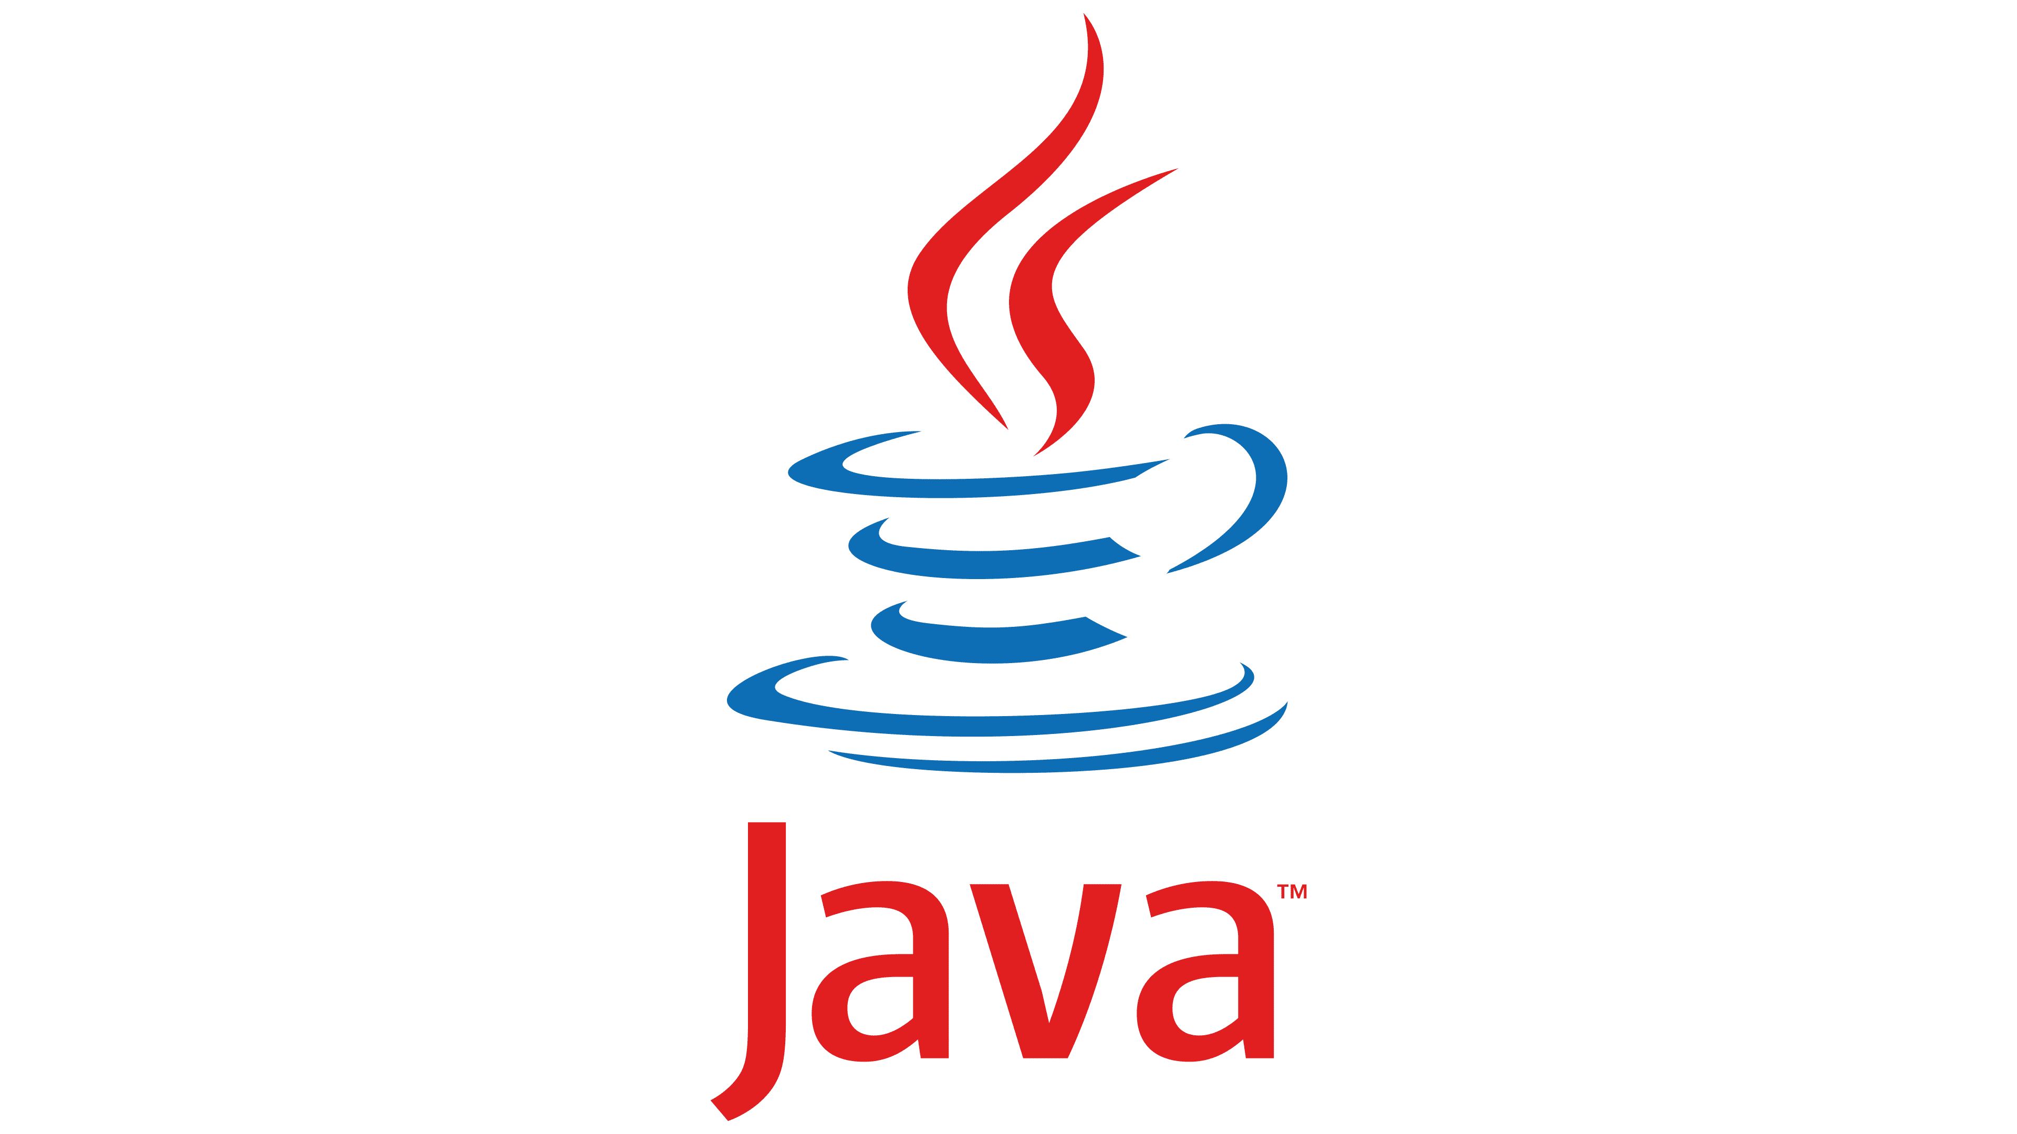

Java is a “general-purpose, concurrent, strongly typed, class-based object-oriented language.” (Oracle, n.d.). It is owned by Oracle and is run on more than 3 billion devices. It can be used to build mobile and desktop applications, web servers and games, etc.

Advantages:

- Works on multiple platforms due to the JVM (Java Virtual Machine)
- Easy to learn and simple to use
- Large community support
- One of the most popular programming languages in the world
- High performance

Disadvantages:

- Prone to null pointer exception errors
- More verbose than other programming languages
- Slower to write in large scaled projects

Example Applications:

- Spotify
- Signal
- Minecraft

Swift:



Swift is a “powerful and intuitive programming language for all Apple platforms.” (Apple, n.d.). Swift is used for developing IOS, macOS, watchOS and tvOS applications. It is fast, safe, modern with type safety included.

Advantages:

- High performant
- Active community
- Supported by Apple
- Program Safety in Memory Management

Disadvantages:

- IOS only
- Smaller community than other mobile languages
- Limited backwards compatibility with older IOS versions
- Poor interoperability with third-party tools

Example Applications:

- Airbnb
- Lyft
- WhatsApp
- Slack

Flutter:

Flutter, “is an open source framework for building beautiful, natively compiled, multi-platform applications from a single codebase.” (Flutter, n.d.). It compiles to native ARM code and uses a custom rendering engine.

Advantages:

- Cross-Platform Development
- Lower maintenance costs
- Prebuilt components
- Growing ecosystem

Disadvantages:

- Large app size
- Steep learning curve
- Limited third-party libraries

Example Applications:

- Alibaba
- Google Classroom
- E-Bay

React Native:

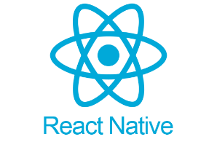

React Native is “a popular JavaScript-based mobile app framework that allows you to build natively-rendered mobile apps for iOS and Android” (Netguru, n.d.). It is actively developed by Meta (Facebook). React Native allows building cross-platform mobile applications in the same codebase.

Advantages:

- Large ecosystem and community
- Hot reload speeds up development
- Code reusability

Disadvantages:

- Performance may not compare to native applications
- Debugging is tricky due to the JavaScript Bridge

Example Applications:

- Discord
- Instagram
- Facebook
- Amazon
- Discord
- PlayStation App

Back End Technologies

Python:



Python, as stated by its creators, “is an interpreted, object-oriented, high-level programming language with dynamic semantics. Its high-level built in data structures, combined with dynamic typing and dynamic binding, make it very attractive for Rapid Application Development, as well as for use as a scripting or glue language to connect existing components together.” (Python Software Foundation, n.d.)

Advantages:

- Easy to learn
- Great community and libraries
- Cross-Platform
- Rapid Prototyping

Disadvantages:

- Slower performance
- Prone to runtime errors
- Memory Intensive

Example Backends:

- Reddit
- Spotify
- Dropbox

PHP:



PHP is “A popular general-purpose scripting language that is especially suited to web development.” (PHP, 2025). It is commonly used with MySQL and frameworks like Laravel and Symfony.
Advantages:

- Huge ecosystem of developers
- Easy to integrate with HTML
- Easy to learn and use

Disadvantages:

- Poor built-in security
- Code can become difficult to maintain in huge codebases
- Lack of debugging tools

Example Backends:

- WordPress
- Wikipedia
- Tumblr

Rust:



Rust is “a low-level statically-typed multi-paradigm programming language focusing on safety and performance.” (Gavriluk, 2024). It is a memory safe programming language and is used in backend development with frameworks like Rocket, Actix Web and Axum.
Advantages:

- Extremely Fast and Performant
- Memory Efficient
- Growing Ecosystem
- Thread safety and concurrency
- Strong compile time checks

Disadvantages:

- Steep learning curve
- Long Compile Times
- Fewer Libraries compared to other languages

Example Backends:

- Dropbox Internal Rust Services
- Cloudflare Edge
- Discord Components

Node.js:

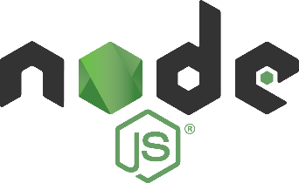

Node JS is “asynchronous event-driven JavaScript runtime, Node.js is designed to build scalable network applications.” (Node J.S., n.d.). It allows for JavaScript to be run on the server-side and is used to build real time web applications.

Advantages:

- Non Blocking I/O
- Huge third-party library ecosystem

Disadvantages:

- Single Threaded making it non-ideal for CPU heavy tasks.
- Heavily callback based
- Huge memory consumption

Example Backends:

- NASA
- Notion
- LinkedIn

Golang:



Golang (Go) is “is an open source programming language that makes it simple to build secure, scalable systems.” (Golang, 2025). It is great for building API’s and microservices due to its simplicity and concurrency.
Advantages:

- Fast compilation times
- Built in concurrency
- Automatic Garbage Collection

Disadvantages:

- Limited generics support
- Less third-party libraries than other back-end languages

Example Backends:

- Capital One
- Kubernetes
- SendGrid

Databases

There are a few types of Databases, these include Relational Databases, NoSQL Databases, Time-Series Databases and Object-Oriented Databases.

Relational Databases:

Relational Databases store data in tables with row and columns, using predefined schemas. They use the Structured Query Language (SQL) for querying and data manipulation.

Advantages:

- Data Accuracy
- Data Integrity
- Supports complex relationships and queries
- Large community support

Disadvantages:

- Hard to scale horizontally
- Less flexible for data that changes rapidly
- Rigid Database Schemas

Examples:

- PostgreSQL
- MySQL
- Microsoft SQL Server

NoSQL Databases:

NoSQL Databases are Databases that store data in another format other than relational tables, such as JSON Document Databases and Graph Databases.

Advantages:

- Flexible due to schema-less foundation
- Easy to scale horizontally
- Better for storing nested data

Disadvantages:

- Difficulty upholding consistency
- Complex relationships are less effective

Examples:

- MongoDB
- Firebase Firestore

Key Value Store Databases:

These are Databases that store their data in key/value pairs, making them extremely efficient.

Advantages:

- Extremely fast performance
- Simple to implement
- Excellent for caching
- Highly scalable

Disadvantages:

- No relationships or complex operations
- No standard query language
- Data inconsistency

Examples:

- Redis
- Amazon DynamoDB

Object-Oriented Databases:

Object-Oriented Databases store data in the form of objects like object-oriented programming (OOP) does, where data and its behavior (methods) are encapsulated together.

Advantages:

- Integration with OOP Languages
- Complex Queries
- Supports other OOP Principles (Inheritance, Polymorphism)

Disadvantages:

- Limited Adoption in the real world
- Small community
- Performance not efficient

Examples:

- ObjectStore
- ObjectDB
- Wakanda

Additional Features

Docker

Docker is a platform that enables developers to package applications into containers, lightweight and portable cross-platform environments.

Benefits:

- Speeds up development and testing
- Simplifies CI/CD (Continuous Deployment)
- Ensures consistent deployments

Uptime-Kuma

Uptime Kuma is a self-hosted monitoring tool for tracking the uptime and status of services, websites, and APIs in real time.

Benefits:

- Easy to setup and manage
- No Cost as Self Hosted
- Clean UI/UX

React Email

React Email is a framework for building responsive HTML emails using React components.

Benefits:

- Allows developers to build emails using familiar syntax
- Improves maintainability and reusability of emails
- Benefits with cross email client compatibility

Postgres Backup Web

Pgbackweb is a reliable user interface to manage PostgreSQL backups.

Benefits:

- Automatic PostgreSQL Backups
- Health Checks
- Good Security Practices
Prometheus

Prometheus is an open-source metrics collection and alerting tool used for monitoring system performance and resource usage.

Benefits:

- Provides real-time metrics for your backend and services
- Integrates seamlessly with Docker
- Essential for monitoring system performance

Grafana

Grafana is an open-source data visualization and dashboarding tool commonly used to analyze metrics collected by tools like Prometheus.

Benefits:

- Transforms raw data into insightful dashboards
- Alerts and Real-Time Updates
- Highly customizable

Chapter 3 – Design
[Introduction to chapter]
[List features of your application]
[List the Technologies you’ve chosen ]
[State development methodolgy used and how it was implmented];
[Diagrams with Descriptions]
[Usecase]
[SwimLane]
[Entity Relationship Diagram]
[Data Flow]
[Wireframes]
[Site maps]

Chapter 4 – Integration
[Introduction]
[Describe how the techonologies chosen are integrated]
[Describe user interface]
[State queries integrated in application] {e.g. in other to sort or filter things]
[Describe the implementation (build) of three(3) features integrated in your application]
[Speak to security principles which were adhered to]
[Problems you faced and how you addressed those problems (this component is necessary if your solution deffered from your scope)]

Chapter 5 – Conclusion
[Restate Problem Statement]
[State how you have solved said problem]
[Limitations of your solution]
[Recommendations]
[Future work]

References

Apple. (n.d.) “Swift”. https://developer.apple.com/swift/

Chris, K. (2021, August 24). What is HTML – Definition and Meaning of Hypertext Markup Language. https://www.freecodecamp.org/news/what-is-html-definition-and-meaning/

Flutter (n.d.). Flutter – Build apps for any screen. https://flutter.dev/

Gavriluk, V. (2024, May 03). What is Rust and Why You Should Use It?. https://arounda.agency/blog/what-is-rust-and-why-you-should-use-it.

Golang (2025). “Golang Programming Language”. https://go.dev/

JetBrains. (2025, April 16). “Getting Started with Kotlin”. https://kotlinlang.org/docs/getting-started.html#install-kotlin

Mozilla. (2025). CSS: Cascading Style Sheets. https://developer.mozilla.org/en-US/docs/Web/CSS

Mozilla. (2025). What is JavaScript?. https://developer.mozilla.org/en-US/docs/Learn_web_development/Core/Scripting/What_is_JavaScript

Netguru. (n.d.). What is React Native? Complex Guide for 2024. https://www.netguru.com/glossary/react-native

Node J.S. (n.d.) “About Node.js”. https://nodejs.org/en/about

Oracle. (n.d.). “Java™ Programming Language”. https://docs.oracle.com/javase/8/docs/technotes/guides/language/index.html

PHP. (2025). “PHP”. https://www.php.net/

Python Software Foundation. (n.d.) “What is Python? Executive Summary”. https://www.python.org/doc/essays/blurb/

Appendix

