SOFTWARE REQUIREMENT SPECIFICATION

ATM CONSOLE BASED APPLICATION

**TRAINED BY NageSWARRAO, HCL TSS FC – TRAINER**

**1.Introduction:**

1.1) Purpose.

1.2) Document Conventions.

1.3) Project Scope.

1.4) Use cases.

1.5) References.

**2. Overall Description:**

2.1) Application Features.

2.2) User Classes and Characteristics.

**3. System Features:**

3.1) Functional Requirements.

**4. Acknowledgement**

**1.Introduction:**

The ATM Project in Java is developed using Java Programming Language. A ATM Machine Java Program is used for an electronic banking outlet that allows customers to complete basic transactions without the aid of a branch representative. In this ATM Program in Java, it allows consumers to perform quick self-service transactions such as deposits, cash withdrawals and checking balance.

* 1. **Purpose -**  A ATM Machine Java Program is used for an electronic banking outlet that allows customers to complete basic transactions without the aid of a branch representative.
  2. **Document Conventions –** Scanner class andATM class is created which contains withdraw (), deposit () and printbalance () functions.
  3. **Project Scope -** The scope of the project is to design an ATM system that will help in completely automatic banking this software is going to be designed for withdrawal and deposit of money and register the transaction in the database where the customer’s information is stored.
  4. **Use cases -**

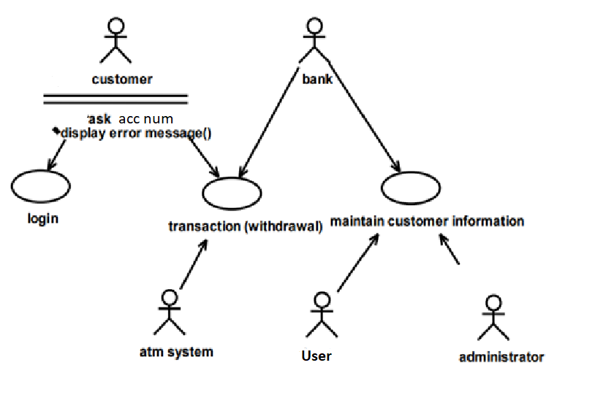

* 1. **References:**

1. [**www.geeksforgeeks.org**](http://www.geeksforgeeks.org/)
2. [**www.w3schools.com**](http://www.w3schools.com/)
3. [**www.develper.mozilla.org**](http://www.develper.mozilla.org/)
4. [**www.geeksforgeeks.org/**](http://www.geeksforgeeks.org/)
5. [**www.youtube.com**](http://www.youtube.com/)
6. [**https://stackoverflow.com**](https://stackoverflow.com/)
7. [**www.wikipedia.org**](http://www.wikipedia.org/)
8. [**https://www.aspneto.com/**](https://www.aspneto.com/)
9. [**www.google.co.in**](http://www.google.co.in/)

**2. Overall Description:**

**2.1) Application Features.**

The features of this console based application is similar to ATM software installed in ATM center. It should first validate the pin in the ATM card. Then the type of transaction is enquired and the information from the customer is

validated. If it is a withdrawal the amount is asked. After the money is

delivered the transaction.

**.**

**2.2) User Classes and Characteristics.** 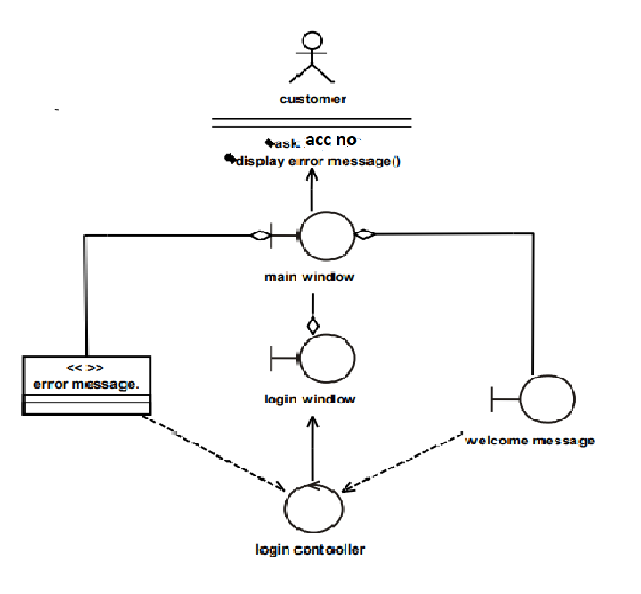

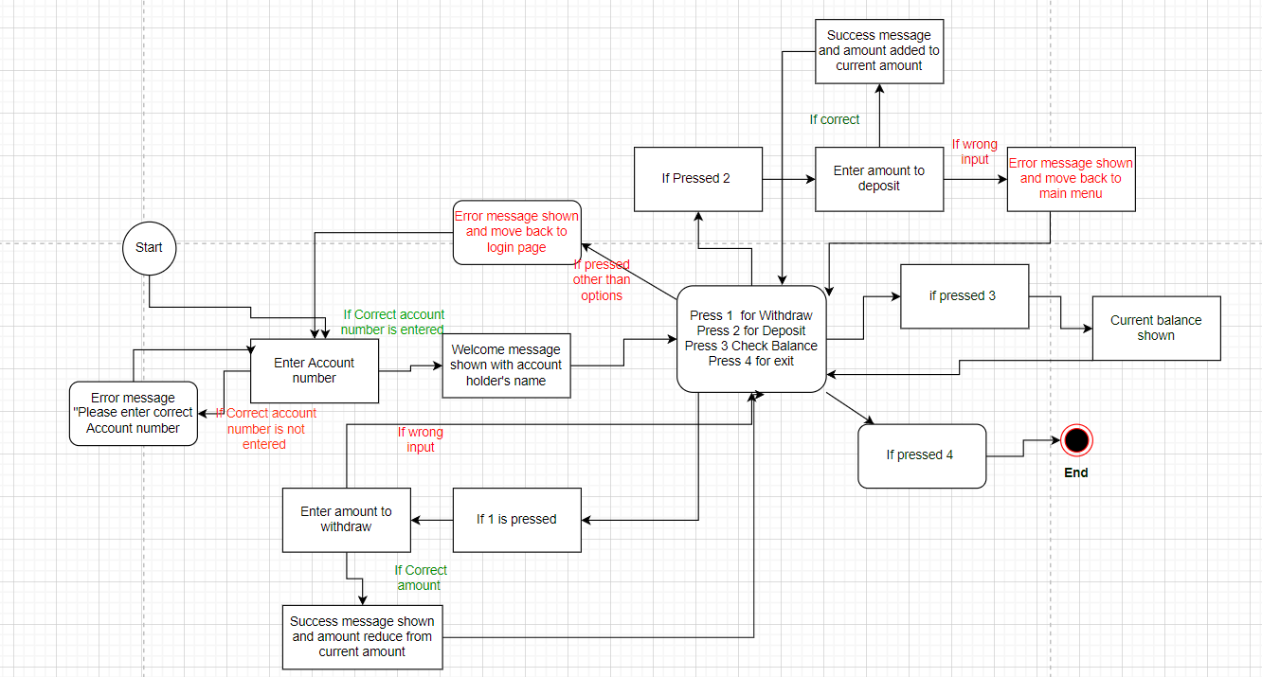**2.3) State Transition Diagram:**

**3. System Features:**

**3.1) Functional Requirements** - This section provides software requirements to a level of detail sufficient to enable designers to design the system and testers to test the system.

**User Interfaces:**

* 1. Account Holder
  2. Account Number

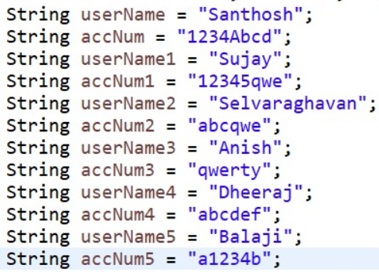

3.Welcome message –

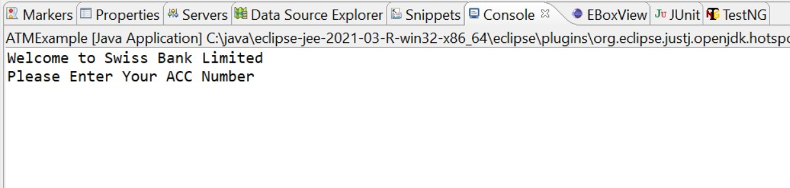



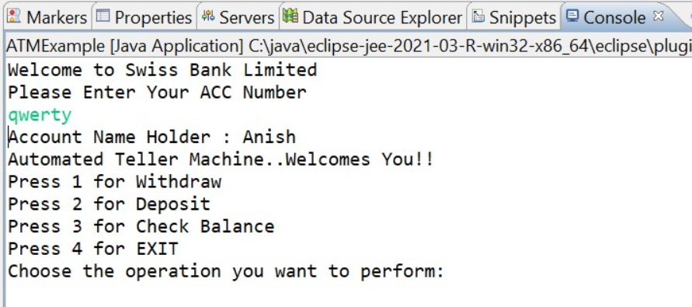4.Interface of ATM –

5.Withdrawing the amount -

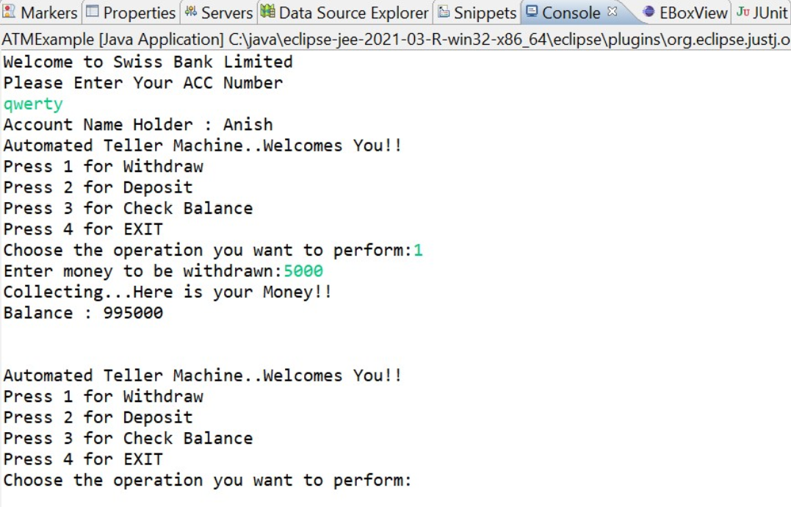

6.Depositing the amount:

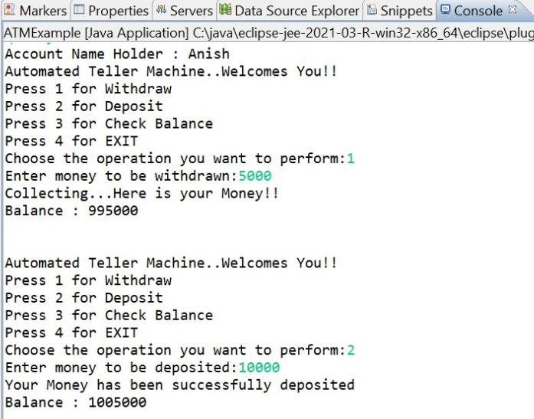

7.Checking the balance amount:

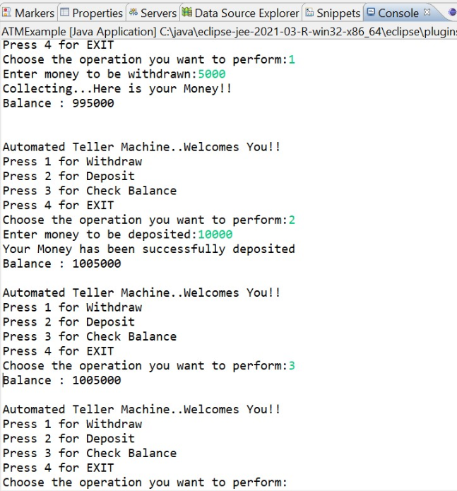

8.Exit: 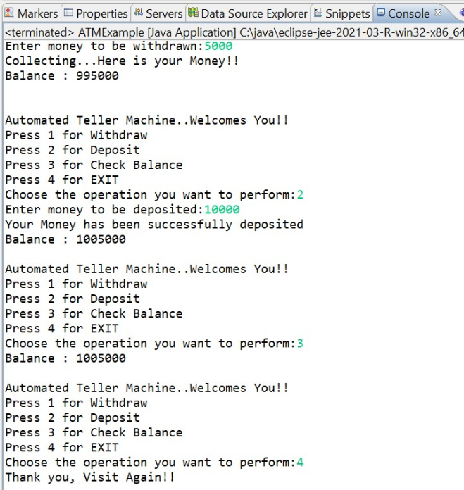

**Requirements:**

**R_01 –** Account number

Valid: 1234Abcd, 12345qwe , abcqwe ,qwerty , abcdef , a1234b

Invalid: Integer, 0, Negative Values.

**R_02 –** Withdraw

Valid: (1-1000000)

Invalid: Negative values, Zero, String, Float

**R_03 –** Deposit

Valid: (1 – Infinity)

Invalid: Negative values, Zero, String, Float

**4.ACKNOWLEDGEMENT:**

First and foremost, praises and thanks to the God, the Almighty, for his showers of blessings throughout our project work to complete the project successfully.

We would like to express my deep and sincere gratitude to my technical trainer, Nageswarrao, HCL TSS FC – TRAINER, for giving us the opportunity to do the project and providing invaluable guidance throughout this project. His dynamism, vision, sincerity and motivation have deeply inspired us. He has taught us the methodology to carry out the project and to present the project works as clearly as possible. It was a great privilege and honor to work and study under his guidance. We are extremely grateful for what she has offered us. We would also like to thank his for his friendship and empathy.

We are extremely grateful to our parents for their love, prayers, caring and sacrifices for educating and preparing us for our future. Our Special thanks goes to our friends and colleagues who supported us throughout our project.

PROJECT DONE BY:

1. ANISH KB

2. SANTHOSH S

3. SUJAY K

4. DHEERAJ V

5. BALAJI S

6. SELVARAGHAVAN S