Amazon

* We can sign-in by taking user’s credentials

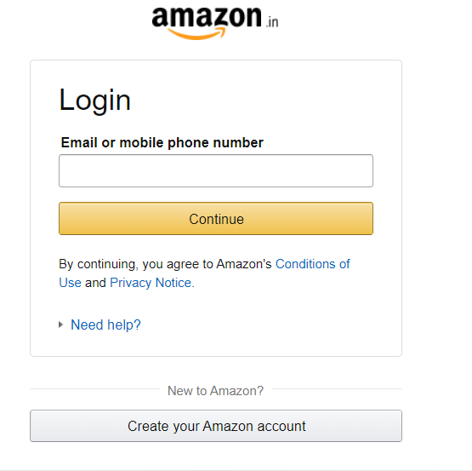

* We can search for item which we will take input from user

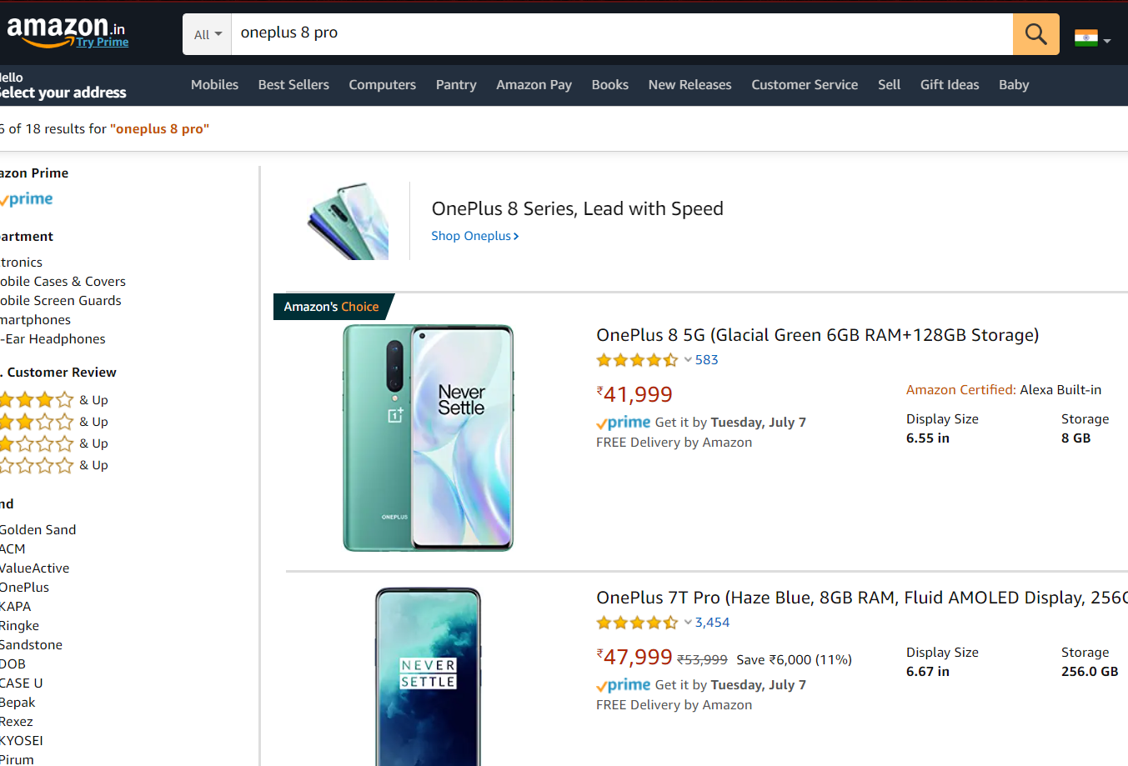

* We can sort them by given features

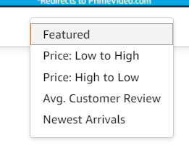

* We can open first product which is satisfied by user’s input

