**Flipkart**

Flipkart is an [Indian](https://en.wikipedia.org/wiki/India) [e-commerce](https://en.wikipedia.org/wiki/E-commerce) [company](https://en.wikipedia.org/wiki/Company) based in [Bangalore](https://en.wikipedia.org/wiki/Bangalore), [Karnataka](https://en.wikipedia.org/wiki/Karnataka), [India](https://en.wikipedia.org/wiki/India). It was founded by [Sachin Bansal](https://en.wikipedia.org/wiki/Sachin_Bansal) and [Binny Bansal](https://en.wikipedia.org/wiki/Binny_Bansal) in 2007. The company focuses on online sales of book, electronics, fashion, home essentials, groceries and lifestyle products.

Functions you can perform on Flipkart:-

1. **Create account**

Open flipkart.com

Select create account

Enter all details (name, email id, address), password

Press create account

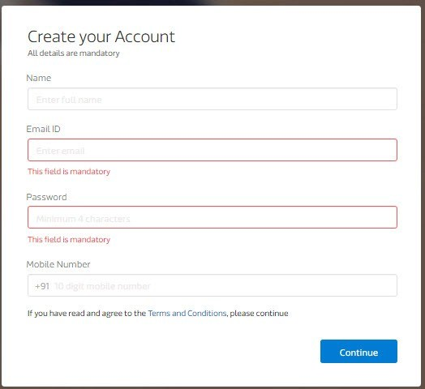

1. **Login**

Open flipkart.com

Select login

Enter details required and password

Press login

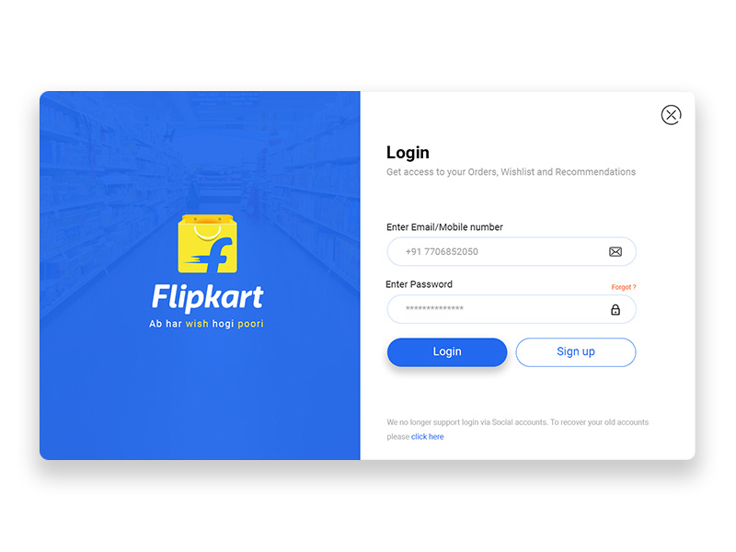

1. **Order items**

Open flipkart.com

Search the product

Select the item

Select buy product

Give the address you want the product to be delivered

Select the paymet option you want to make payment. (Cash, debit card, credit card, UPI, etc)

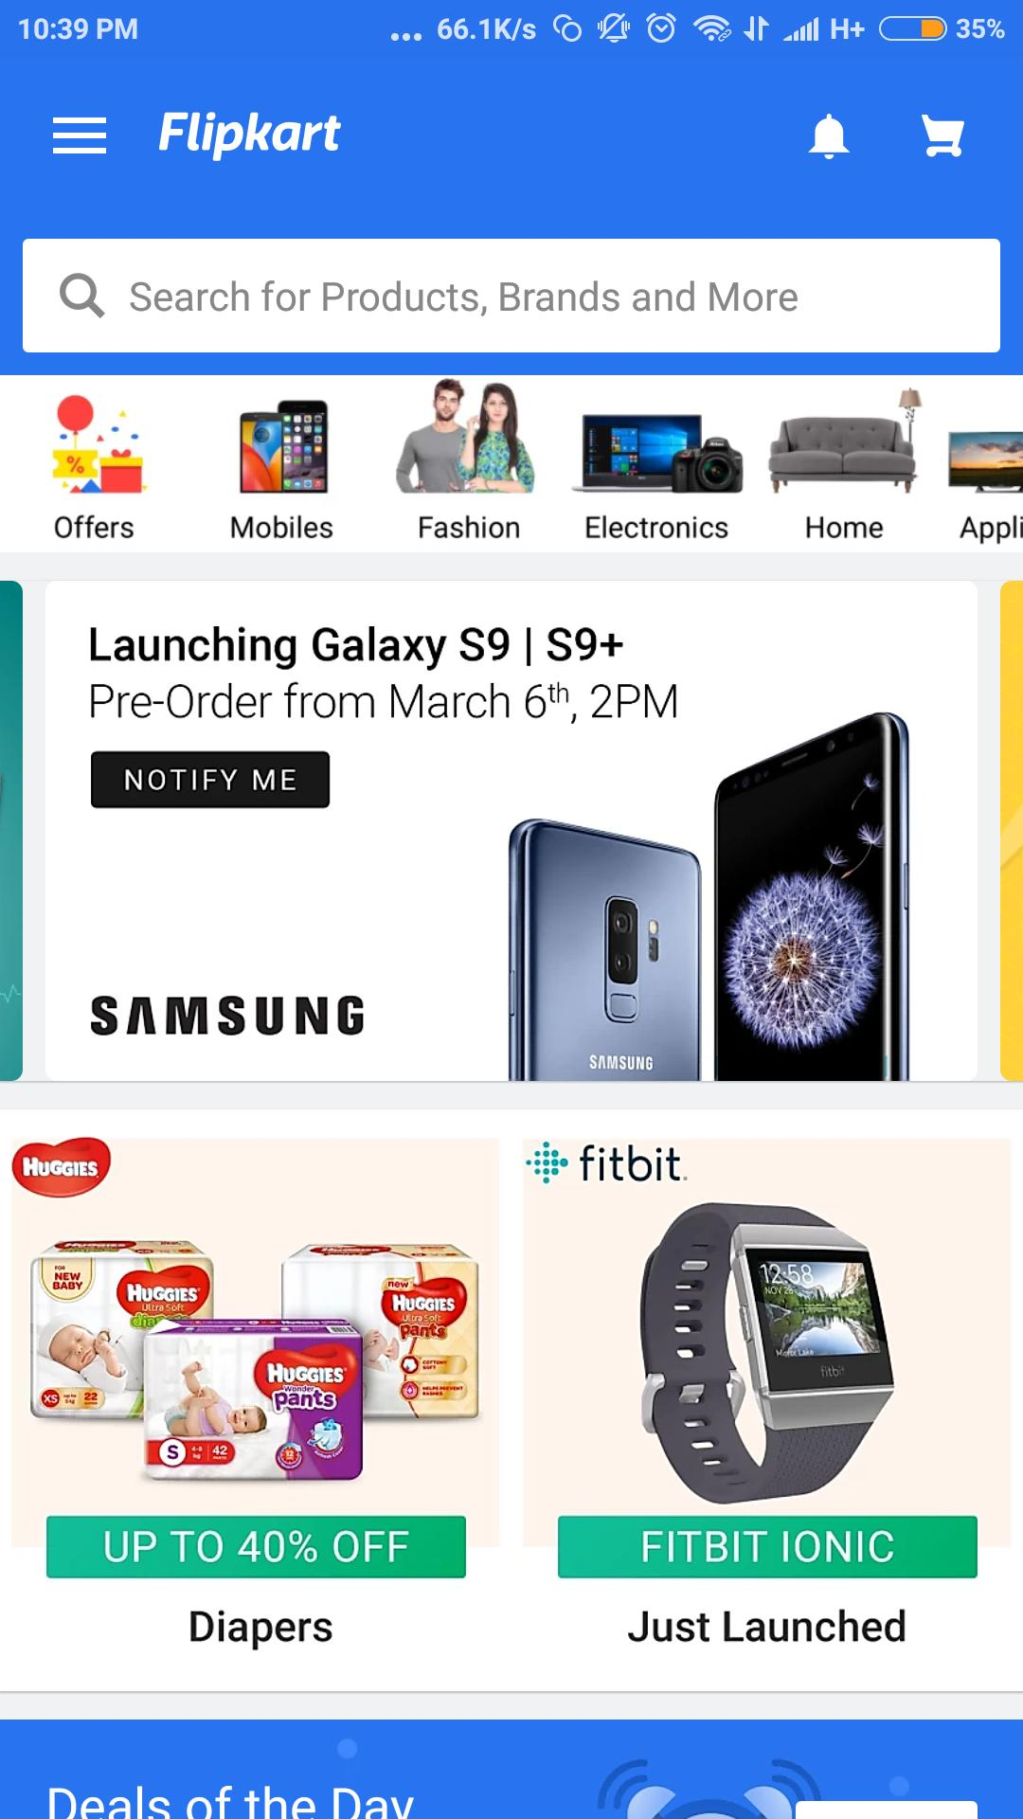

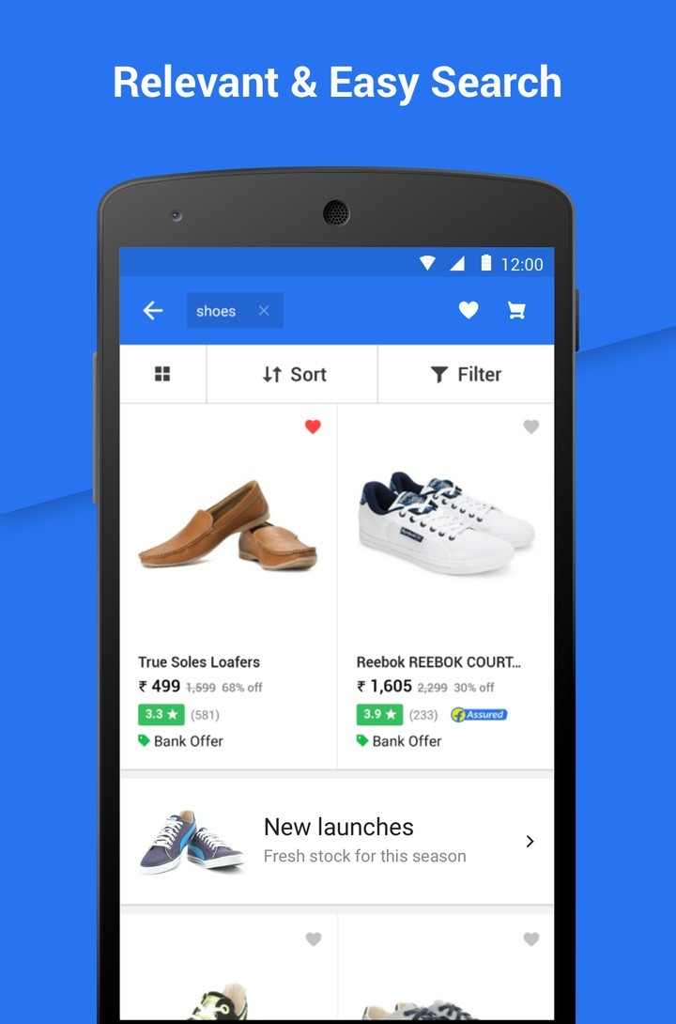

1. **Settings**

Click on the profile icon button

You can change different details and settings

Pressing the three lines button option present on the top left corner of Flipkart, you can easily find the categories of items (electronics, TV and appliances, fashion, home and furniture, books and more)

There you can also find your orders, coupons, items in your cart, your wishlist option.

You can also change account settings (My account option), etc.

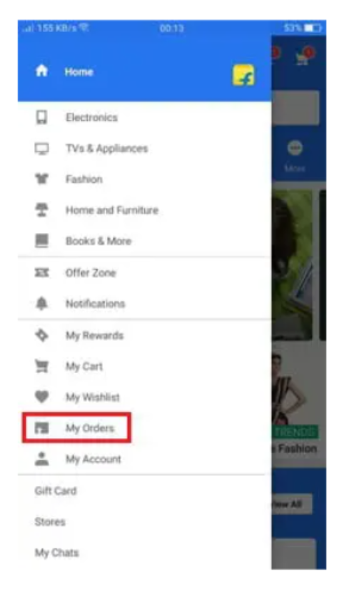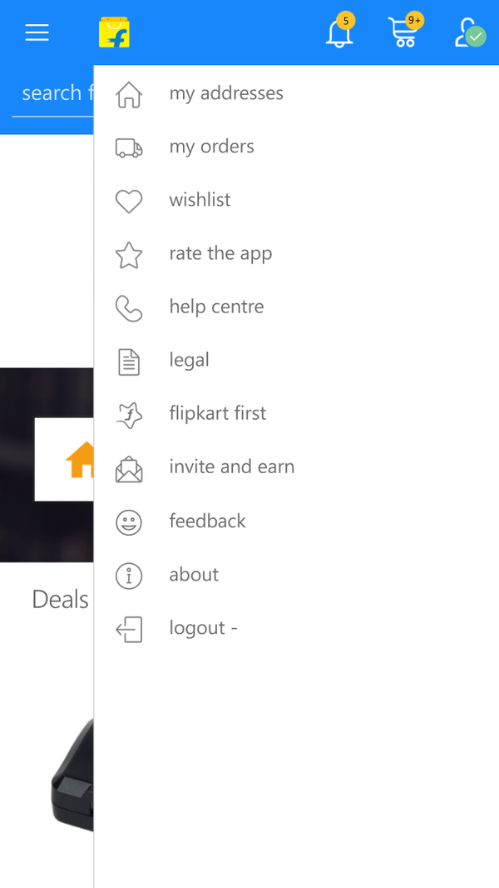

1. **Return items**

Customers can also return the items

But the policy of returning has criteria to return (validity of return duration is mentioned in the item details)

Return can lead to refunds, replacements or return cancellation

After the delivery of the item, you can go to the Orders tab in the Flipkart mobile app or desktop site to find the Return option. Opt for this and follow the next steps of the process. The Flipkart product returns team will take over from here. Depending on the category of product ordered, you may opt for a Replacement or Refund.

