IRCTC

* We can open irctc.com website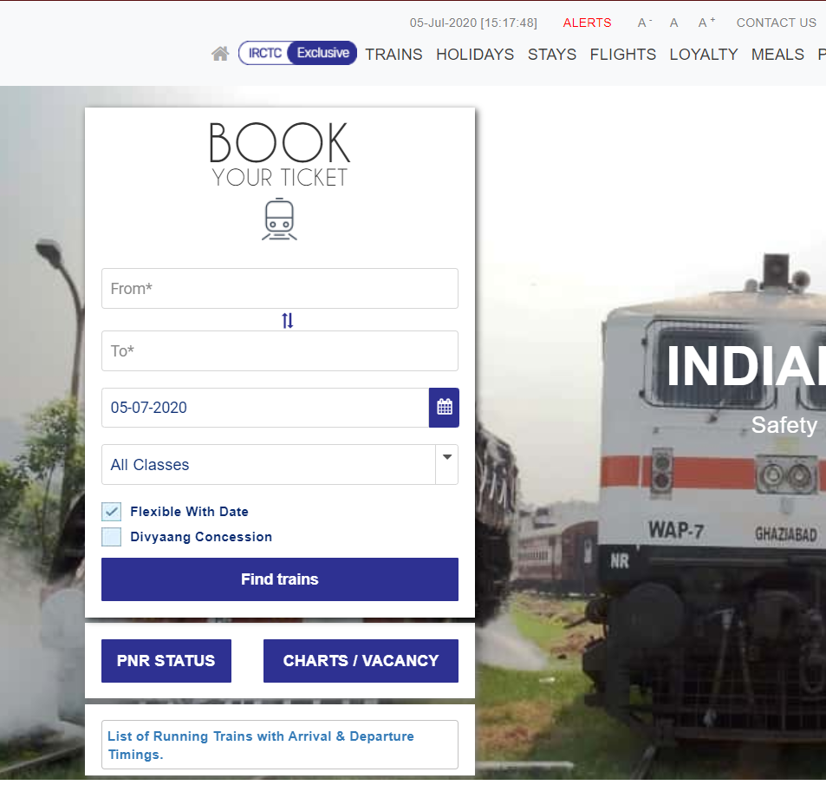
* We can enter origin and destination location by taking input from user

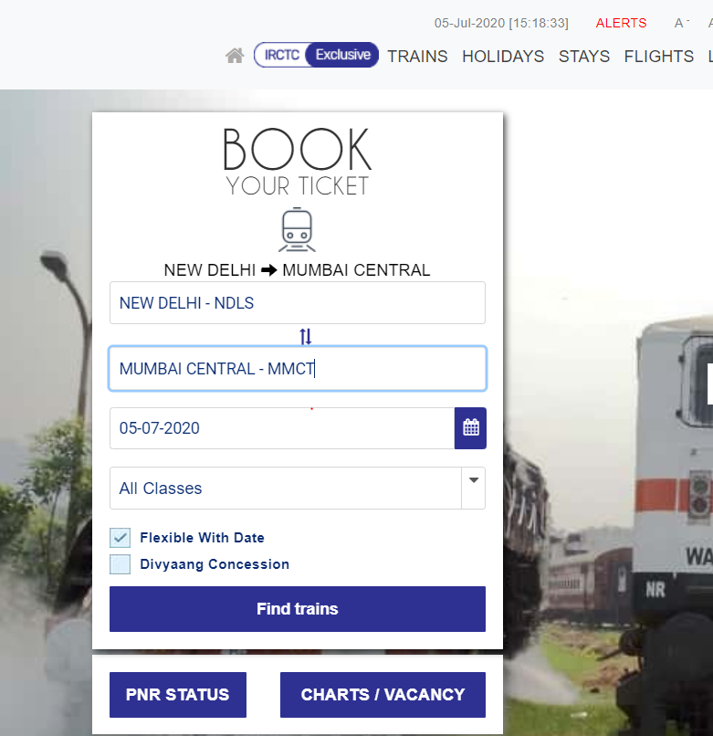

* Also user can enter Date of Travelling and can find trains on that date. Then user can decide which train is suitable for him/her.

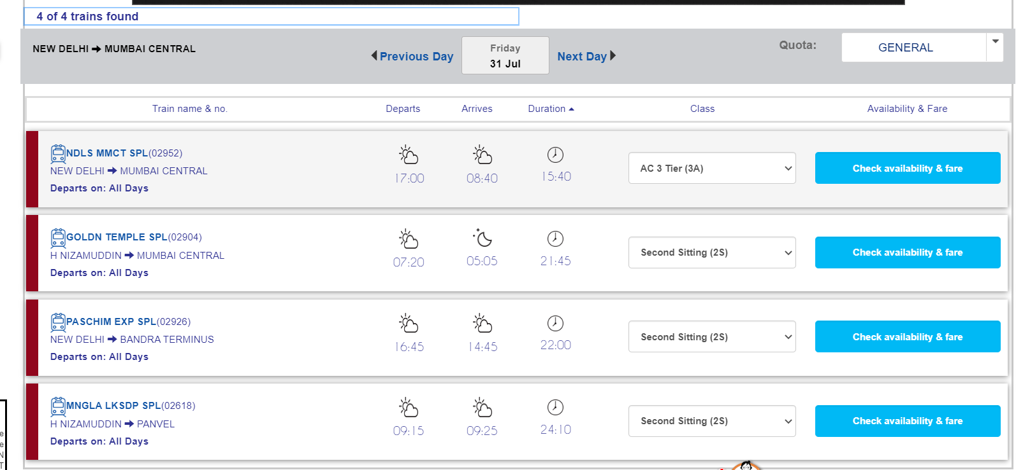

IRCTC

We can sign-in app using user’s credentials

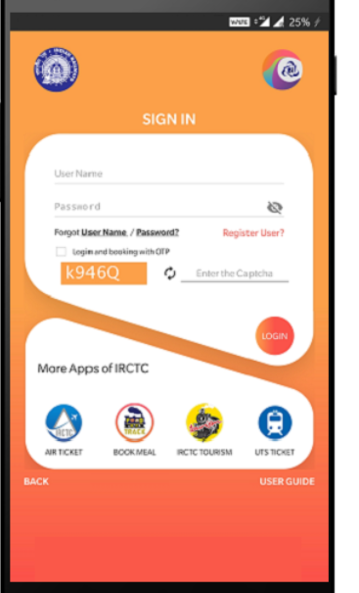

We can plan a journey, view bookings, check pnr,cancel ticket or file tdr using irctc app

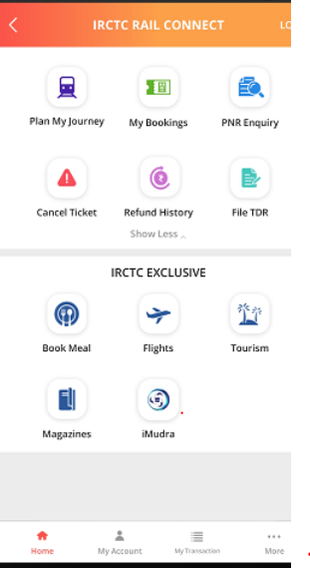

We can book trains on a specified date and location

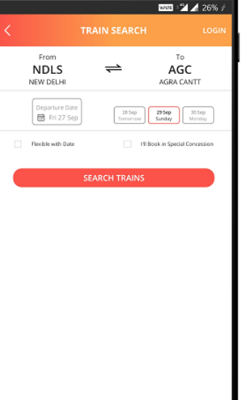

We can check availability of seats in trains of user’s choice

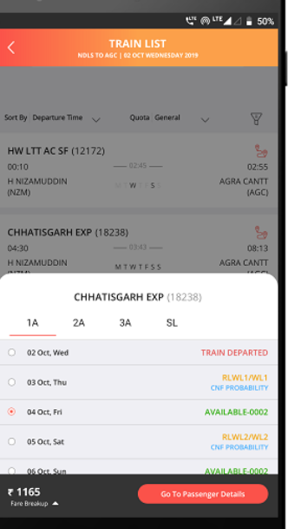

We can then fill passenger’s details and then book the train

