**Instagram**

Instagram is a photo sharing application, where users can upload pictures and videos. They can follow other users and gain followers in return. Users can even send direct messages.

Functions we can perform on Instagram:-

1. **Create account**

Open Instagram

Select sign up with email or phone number

Enter the details required such as name, email address/phone number, password and select an available username.

Verify email address if provided

Ready to use

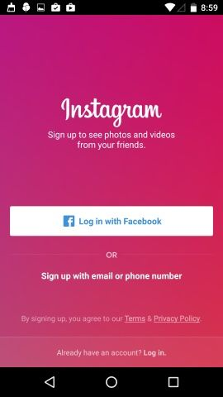

1. **Log in**

Open Instagram

Select login

Enter username/email address and password

Press log in

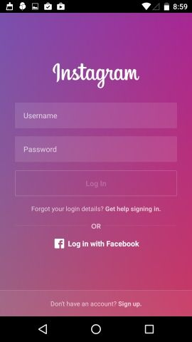

1. **Search people**

Open Instagram

Press the search button present at the bottom

Enter the name you want to search

Press search icon on keyboard

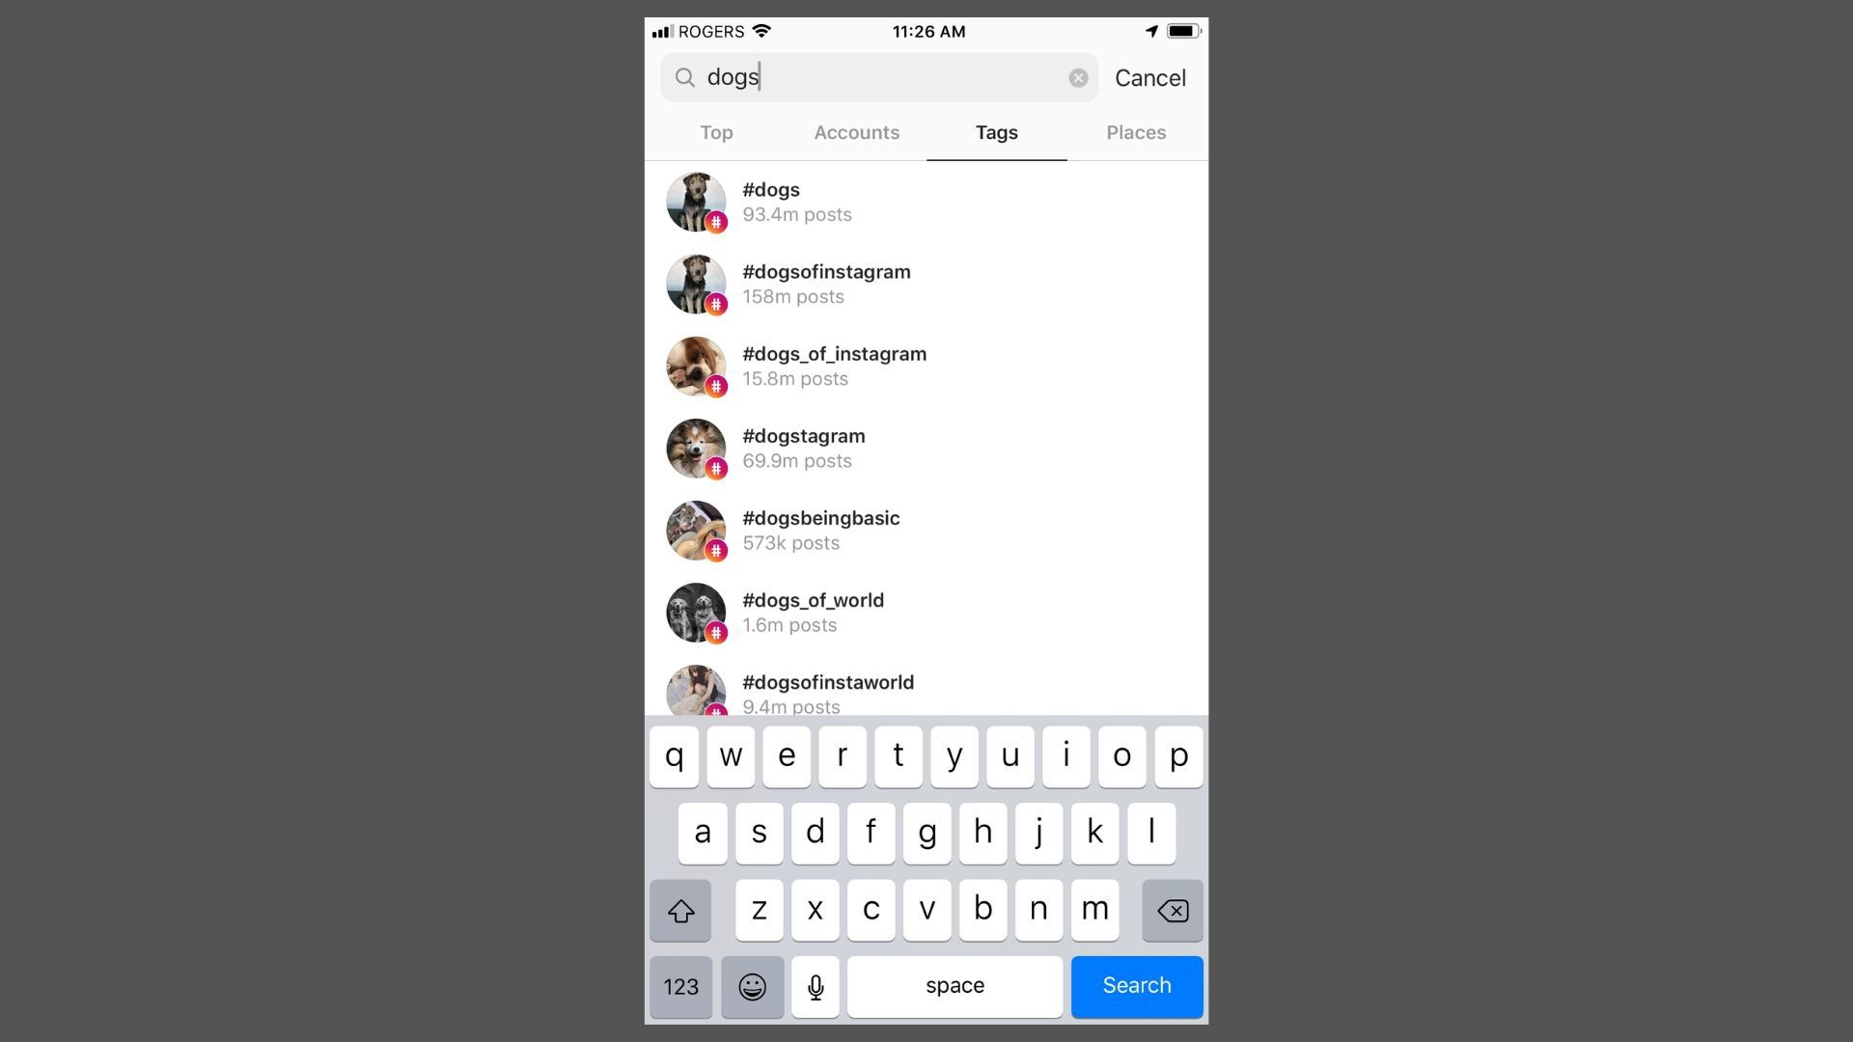

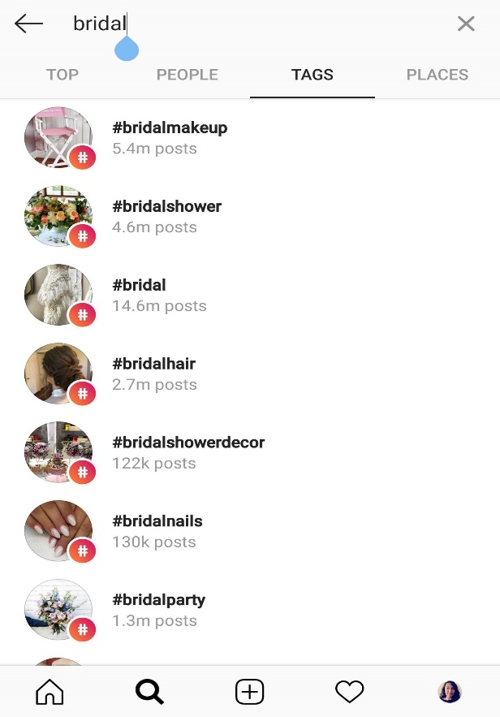

1. **Send direct message (dm)**

Open Instagram

Select the recipient to send dm

Type the message

Send it

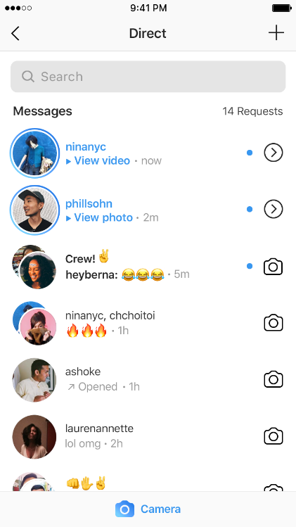

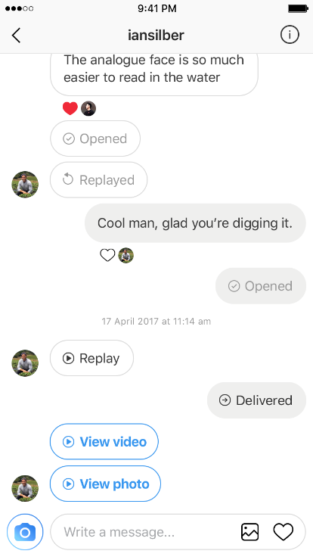

1. **Post Picture/Video**

Open Instagram

Select picture/video to post

Add caption

Post it

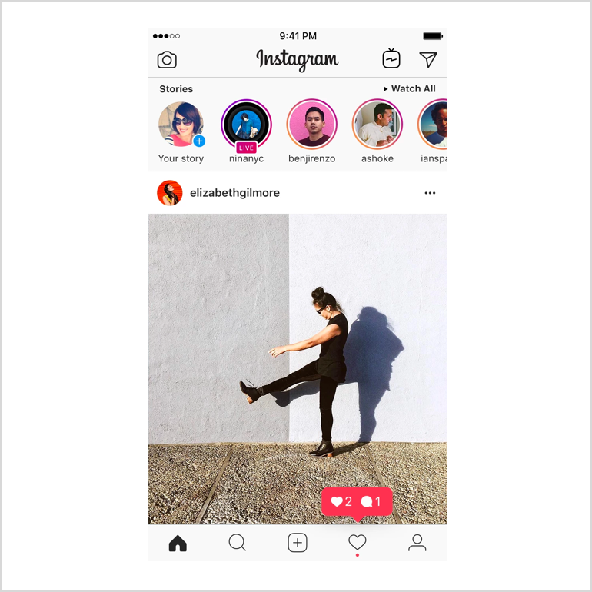

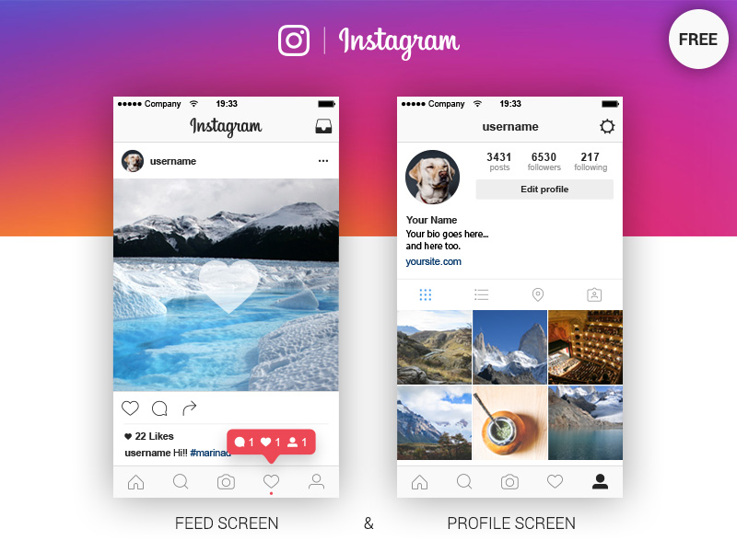

1. **Settings**

In the profile section, if you click the 3 lines button you can change various settings

For example account privacy, blocked accounts, activity status, story and comment controls, linked accounts, account data, etc.

