LINE

Line is a freeware app for instant communications on electronic devices such as smartphones, tablet computers, and personal computers. Line users exchange texts, images, video and audio, and conduct free VoIP conversations and video conferences.

* We can message in a group or a person

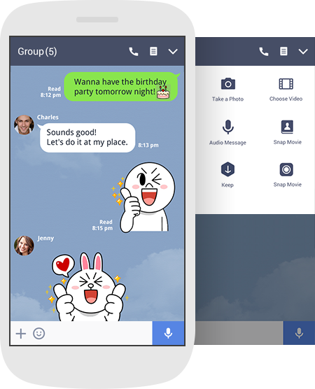

* We can do video or voice call



* We can send them photos, videos and voice message in a chat

