LinkedIn

* First we will create two variables to store user’s email and password
* Then we will open linkedin.com on a browser
* Then we will click sign-in button and sign-in by clicking login button

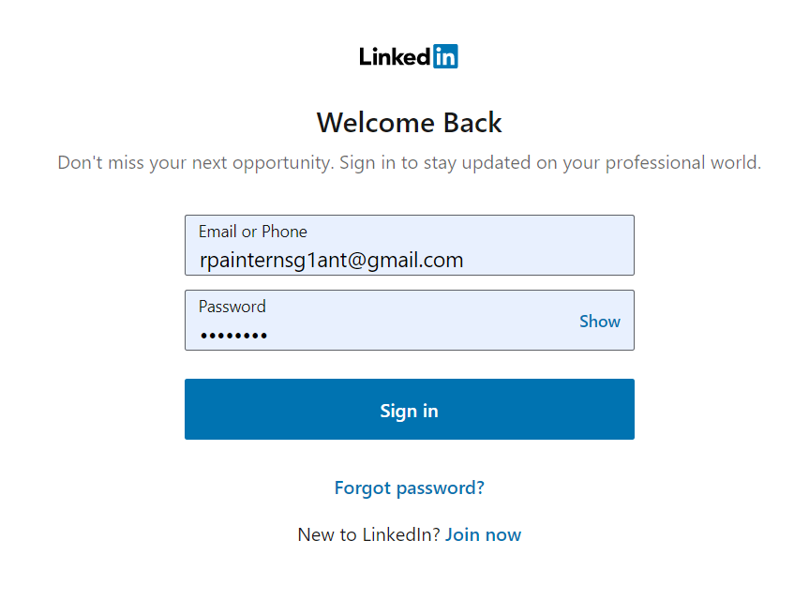

* We can find the people/company and we can open them and follow them on linkedin by taking input from user

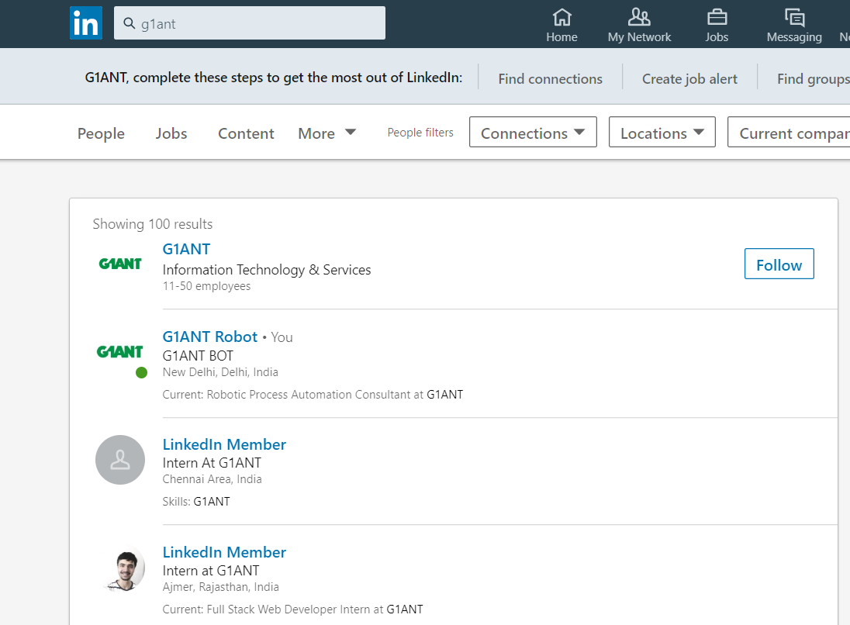

* We can write a post in linkedin by taking a string input from user and share it in the network

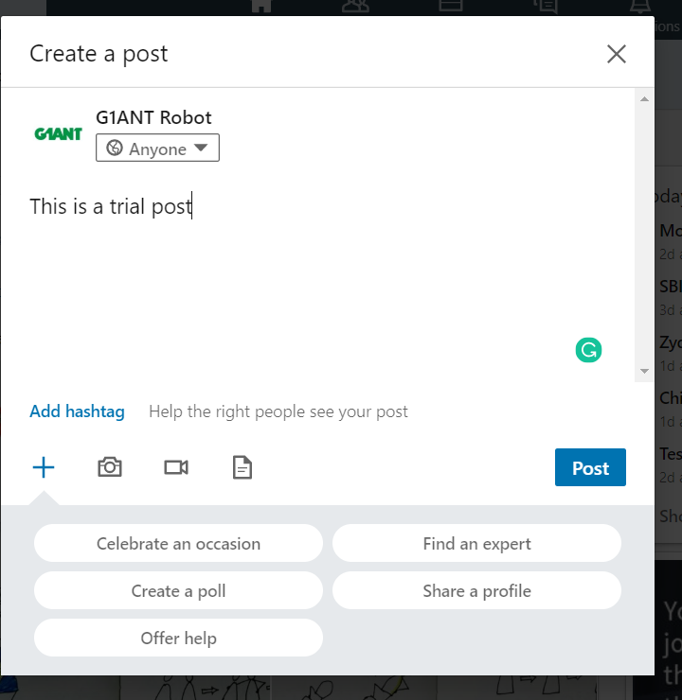

* We can take choice from user to like or comment on the latest post in its feed.



* We can display no of connections user have in a dialog box
* We can display no of people who have viewed their profile
* We can share the latest post of feed if the user allows

LinkedIn

* We can find new people and connect with them



We can open user’s profile



We can scroll in user’s newsfeed



We can find jobs on Linkedin app

