**Medium**

Medium a website interface is designed solely for information acquisition of a wide variety of topics. Starting from the rudimentary to the most sophisticated topics; all sorts of content are available in this website.

Firstly, an account can be created by signing up with a google account, after which different Genre can be accessed.

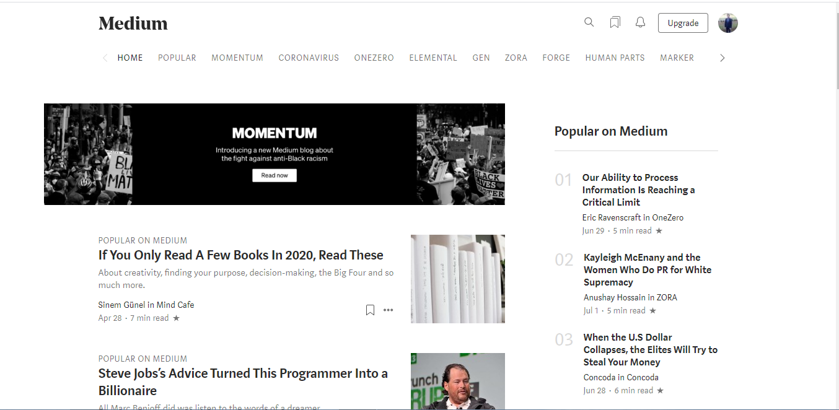

**Features:**

* The different boxes indicate different topics that can be read. A click and these topics can be viewed.
* Certain articles can be obtained by upgrading the package. This can be done using the upgrade option.
* Using a medium content, blogs can also be exported which can then be posted once deemed good for publishing.

The page also allows you to play with your minds. The option to write on different topics can be made possible in the write option. Once posted, the editorials scan the content which is then sent across and posted in the medium digest for viewers to see across the world.

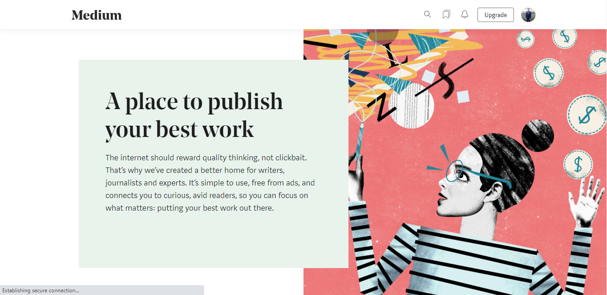

Features:

* Once the medium partner program is joined, writers can post their contents online and let others view it.
* This writing can be edited by experts in the editorial column.
* Once an adequate number of readership is obtained, there would be a revenue for your writing piece.