**Ola**

**Ola Cabs** (stylised as **OLΛ**) is an [Indian](https://en.wikipedia.org/wiki/India) [ridesharing company](https://en.wikipedia.org/wiki/Ridesharing_company) (TNC) offering services that include [peer-to-peer ridesharing](https://en.wikipedia.org/wiki/Peer-to-peer_ridesharing) and ride service hailing.

Functions we can perform on Ola:-

1. **Create account**

Open Ola

Press create account

Enter email id, password

Verify email id

Ready to book

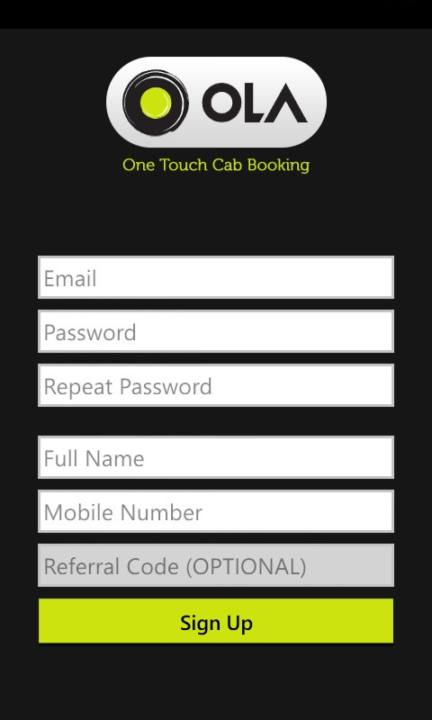

1. **Book ride**

Open Ola

Enter pick point and drop point

Choose convenient ride

Select payment option

Book the ride

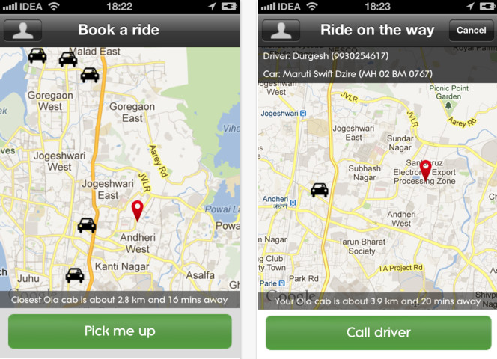

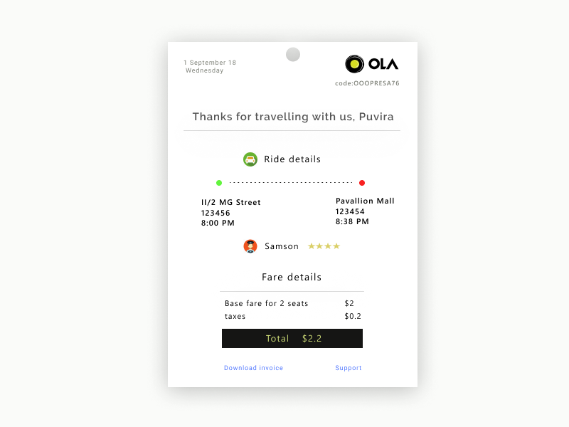

1. **Settings**

A profile icon present at the left top corner

If you click on my profile, you can change or update settings related to your account, privacy and security

There you can find your previous rides, ola pass, share pass, ola money and other options.

