Quora

* We can sign in quora.com by taking credentials from user
* We can put up a question by taking question as input from user

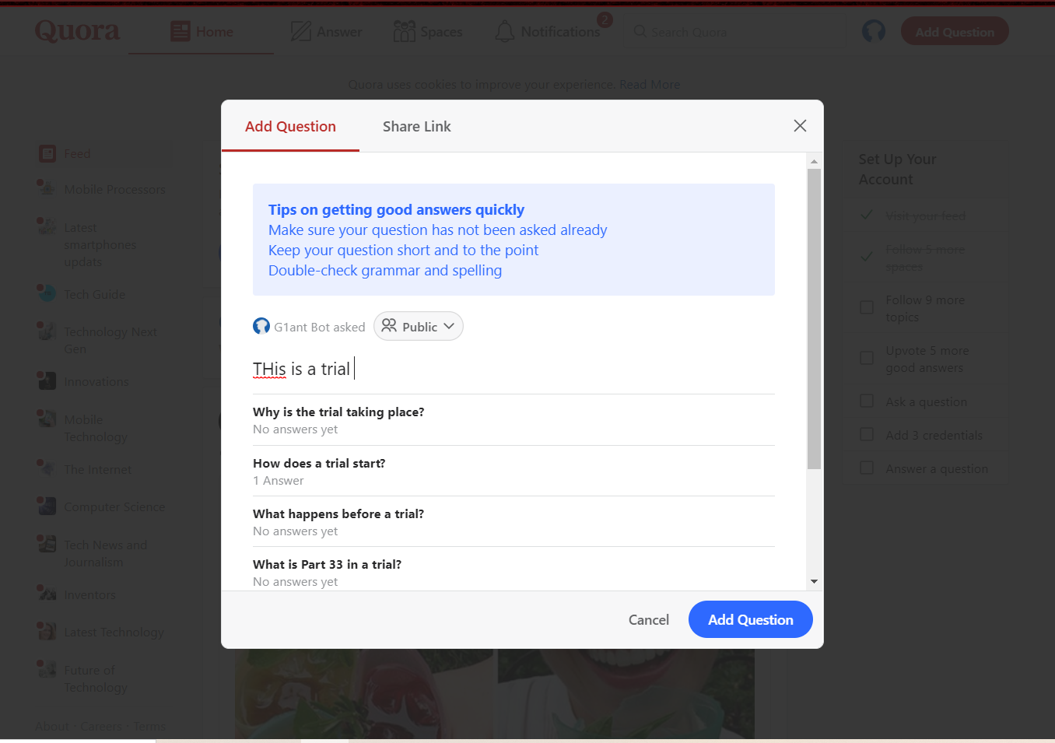

* We can search for question or any space in search bar



* We can see all spaces we are following

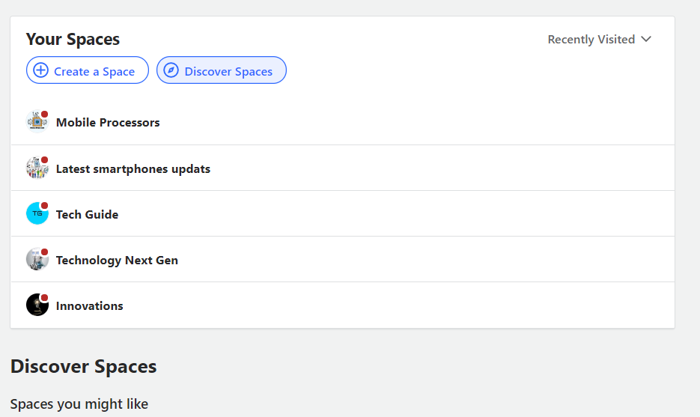

* We can see all notifications of the user

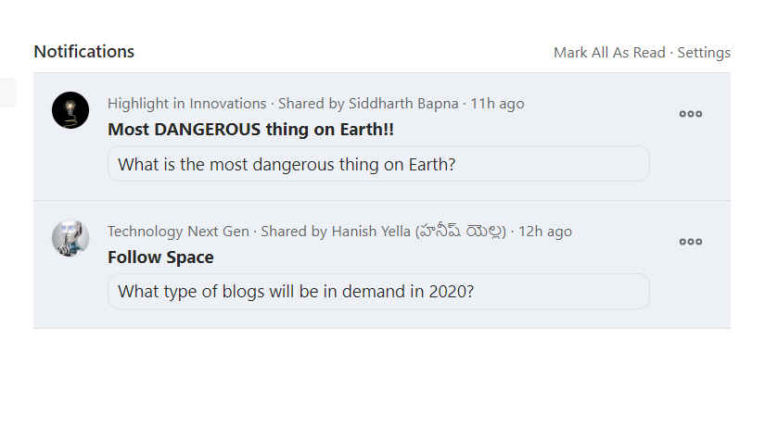

Quora

We can scroll in Feed section of app where questions of user’s interest are present

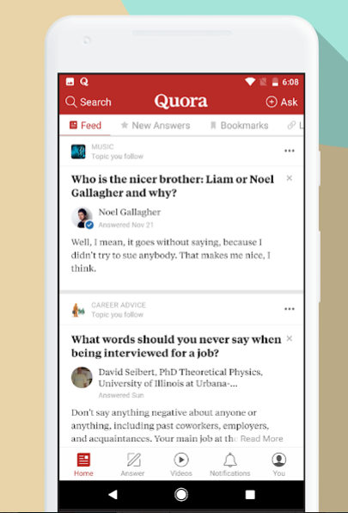

We can ask questions easily on the app

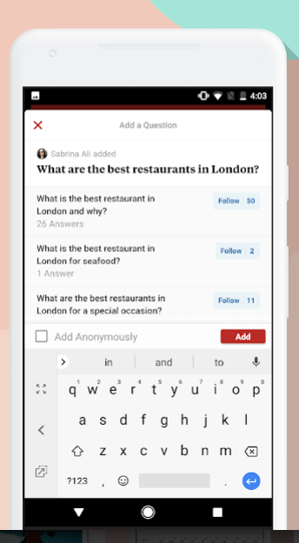

We can join spaces/community of user’s interest



We can answer the questions

