**RAPIDO**

Rapido is an Indian online bike taxi aggregator based out of [Bangalore](https://en.wikipedia.org/wiki/Bangalore), India. The company was founded in 2015 in Bengaluru. It operates in 100 cities across the country. The Rapido app allows the user to book a ride, after which a rider arrives at the location. The fare includes a base fare of ₹15 in addition to ₹3 for every kilometre of the ride.

Functions we can perform using Rapido:-

1. **Create account**

Download the Rapido app

Open it

Choose a language to get started

Enter your mobile number

Verify it

Enter password

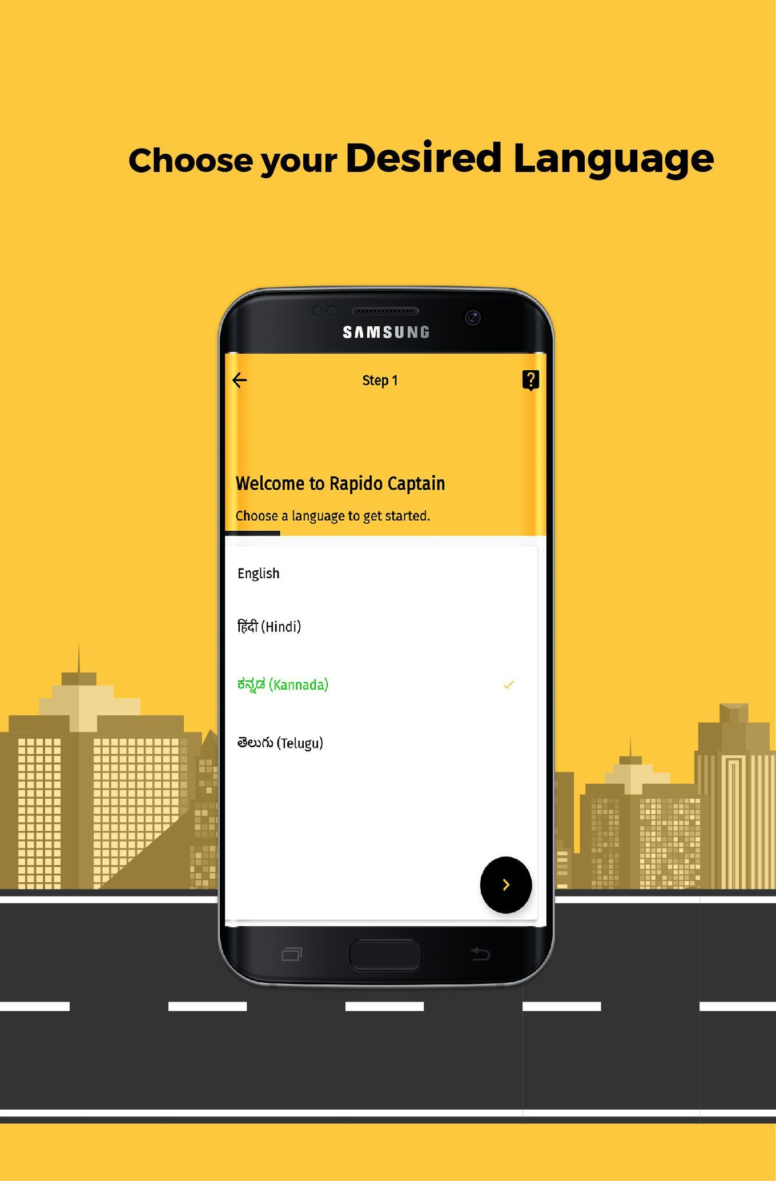

1. **Log in**

Open Rapido

Enter mobile number and password

Log in

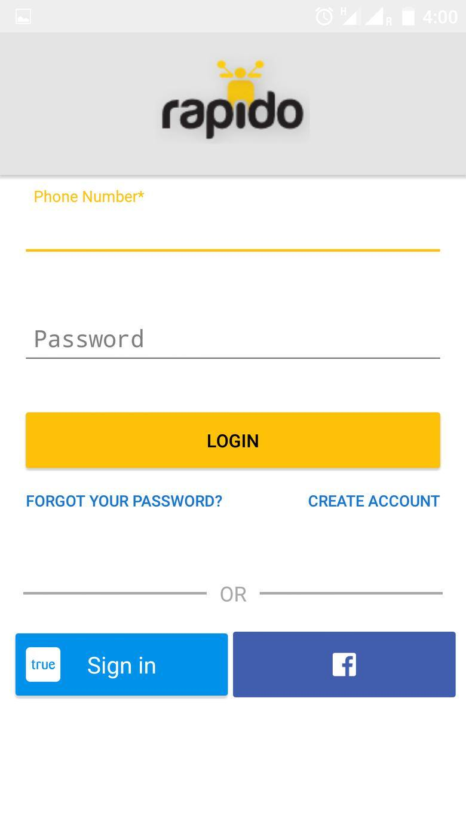

1. **Book ride**

Open Rapido

Enter your location and destination

Choose suitable payment option

Confirm ride

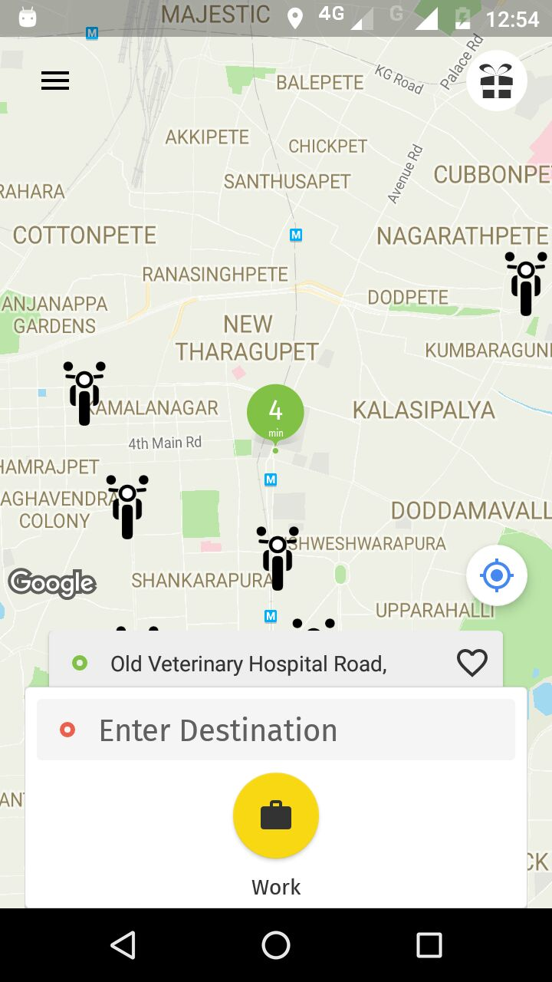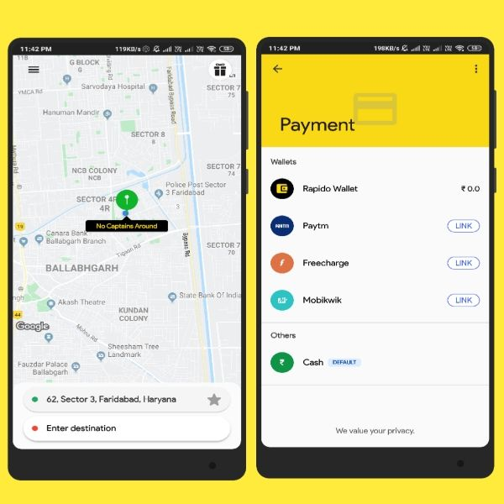

After confirming the ride, you will be assigned a driver

You can view his name, location, vehicle number, profile picture and ratings

You can also know how long he will take to reach

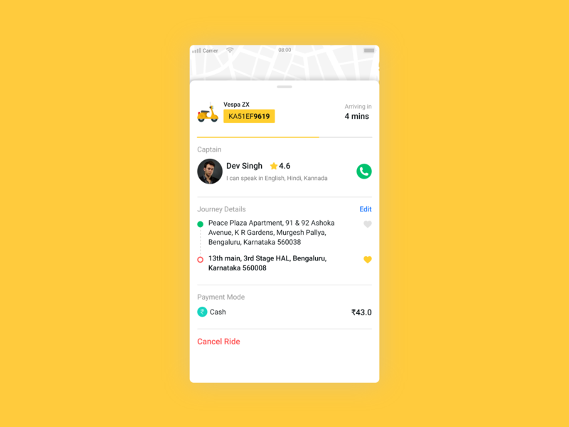

1. **Settings**

Under settings option (setting icon), you can change and update different settings such as profile, preferences, app language.

You can log out of the account

