SWIGGY

* We can enter the location and find restaurant in it

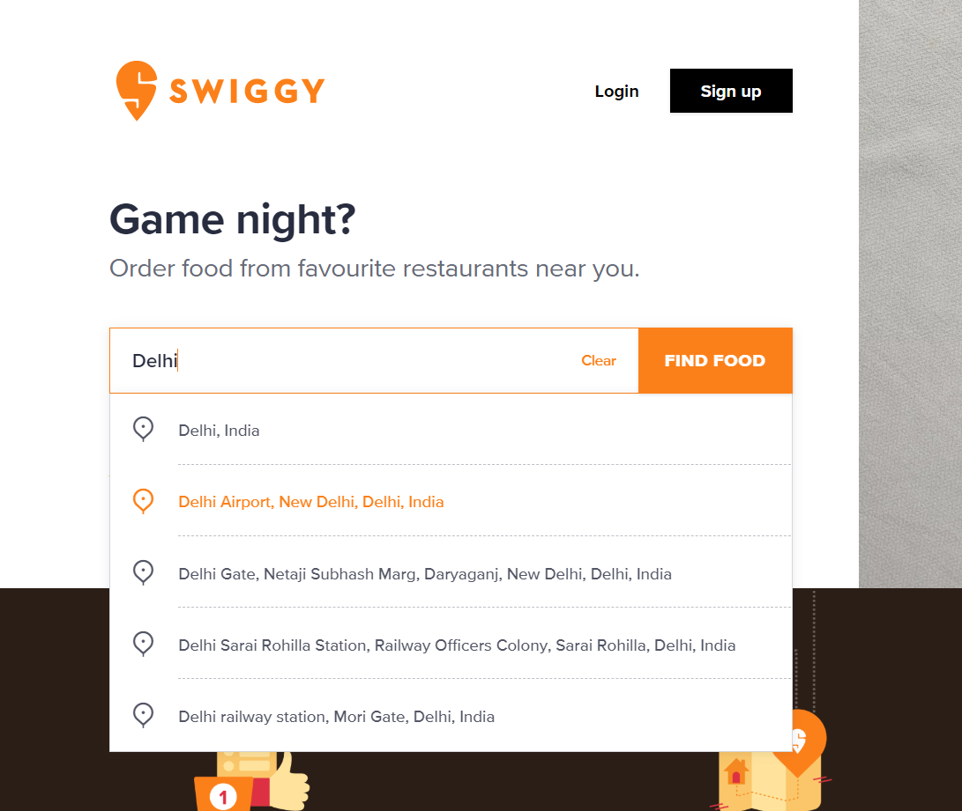

* We can take option from user that it wants pure veg

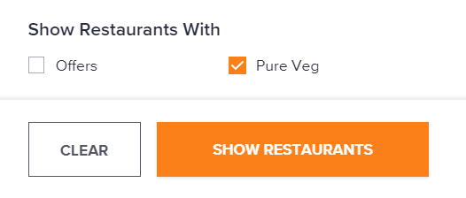

* We can sort the list of restaurants according to Relevance, Cost of Two, Delivery Time, Rating

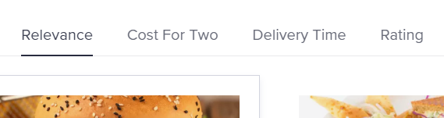

* We can then open the first restaurant after taking user’s preference

