**Snapchat**

One of the principal features of Snapchat is that pictures and messages are usually only available for a short time before they become inaccessible to their recipients.

Functions we can perform on Snapchat:-

1. **Create account**

Open Snapchat

Press sign up

Enter details like name, username, email address, phone number, birth date and password

Press sign up and accept

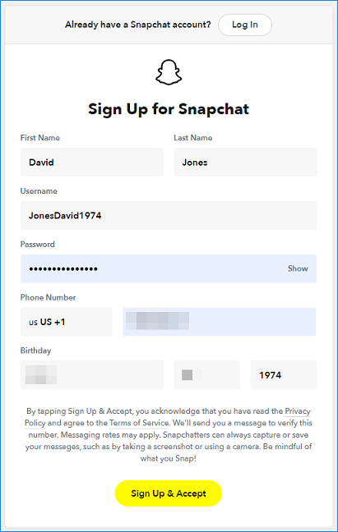

1. **Login**

Open Snapchat

Enter username and password

Press log in

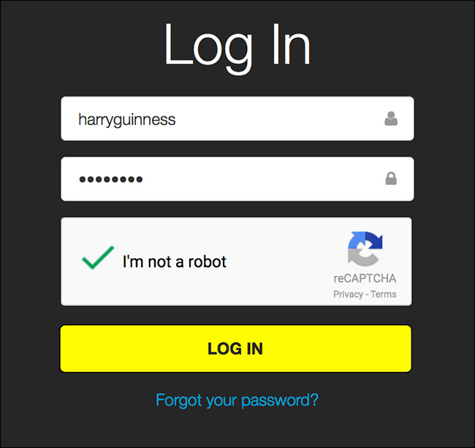

1. **Message**

Open Snapchat

Select recipient to send message

Type message

Send it

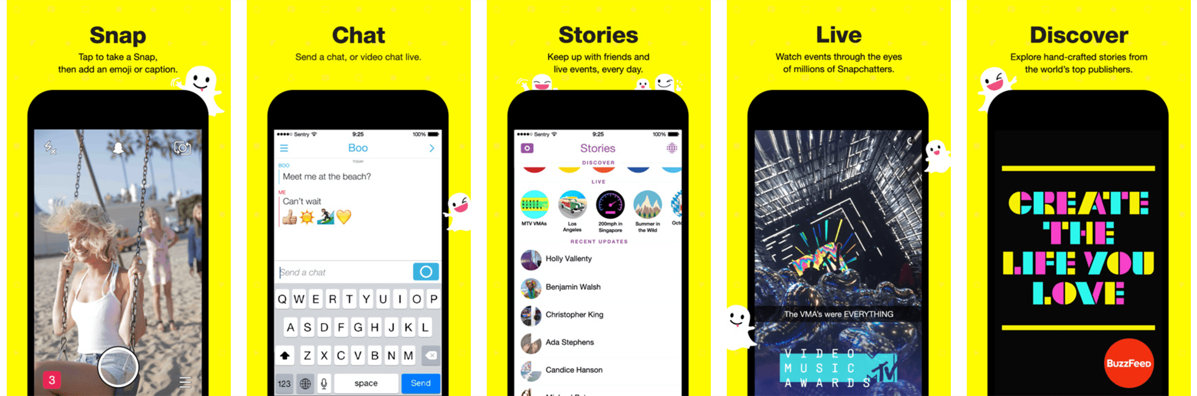

1. **Send snaps**

Open Snapchat

Click picture/video

Press Send

Select who you want to send



1. **Add Story**

Open Snapchat

Click picture/video

Press Send

Select who you want to send

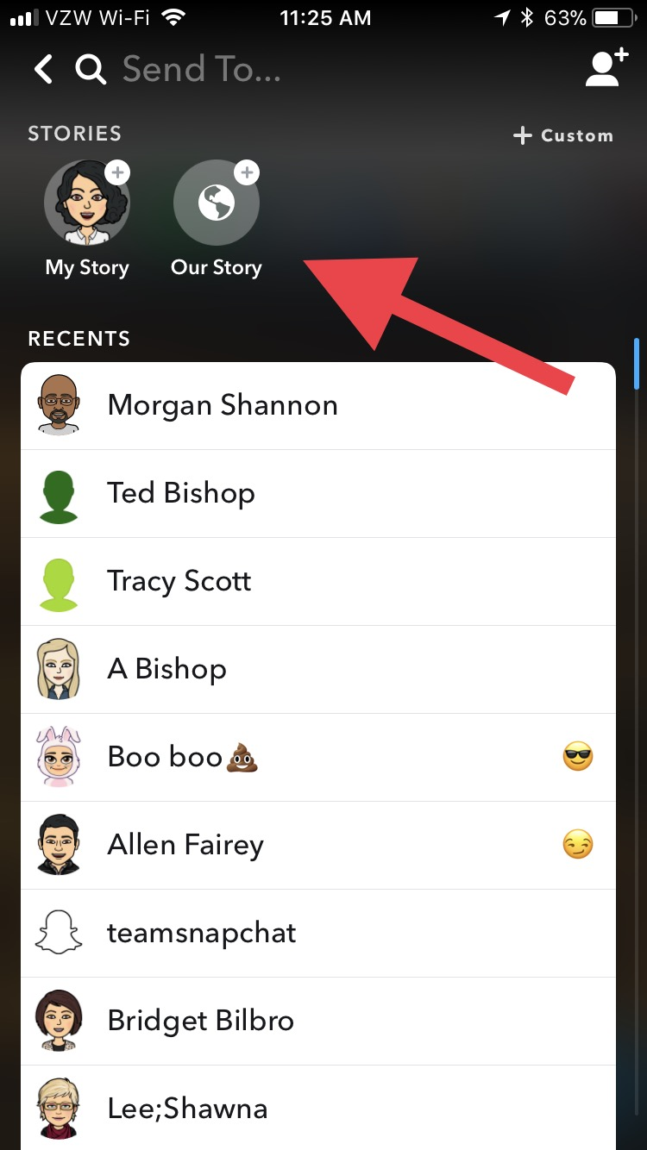

1. **Settings**

Open Snapchat

Click on the settings button

You can change different settings

