**Twitter**

Twitter is a service for people to communicate and stay connected through the exchange of quick, frequent messages. It's an online social networking and micro blogging service that enables users to send and read short 140 character text messages, called "tweets".

Functions we can perform on twitter:-

1. **Create account**

Open Twitter

Press sign up

Enter email address/phone number and password

Verify email address

Ready to tweet

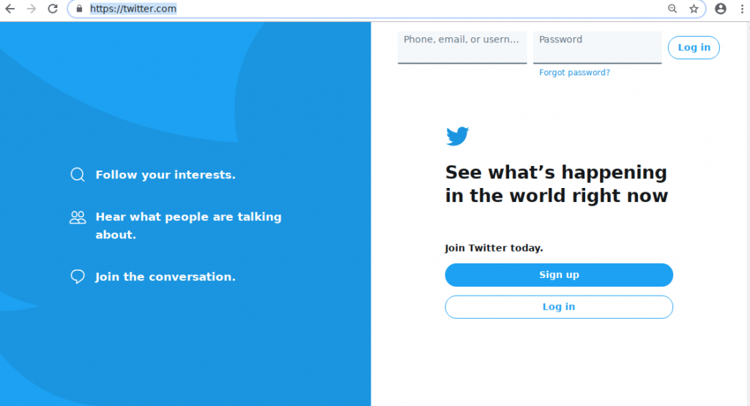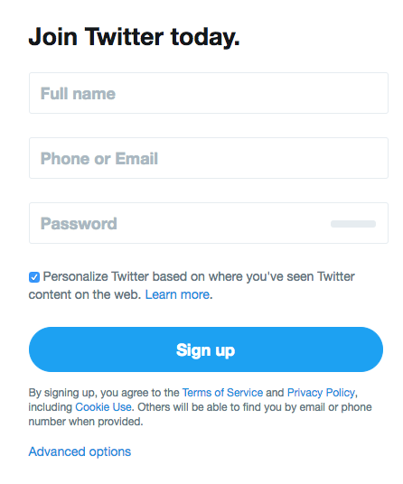

1. **Log in**

Open Twitter

Press login

Enter email address and password

Press log in



1. **Tweet**

Open Twitter

Type a message to tweet

Enter send

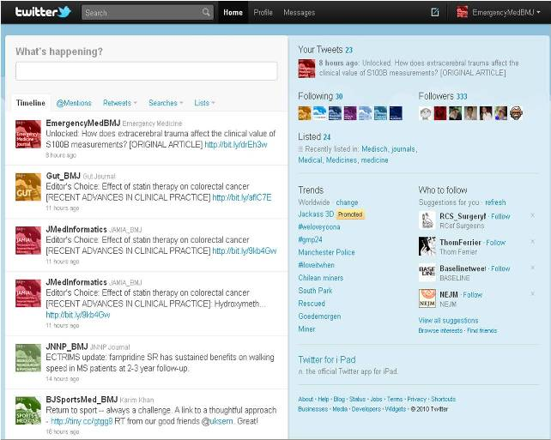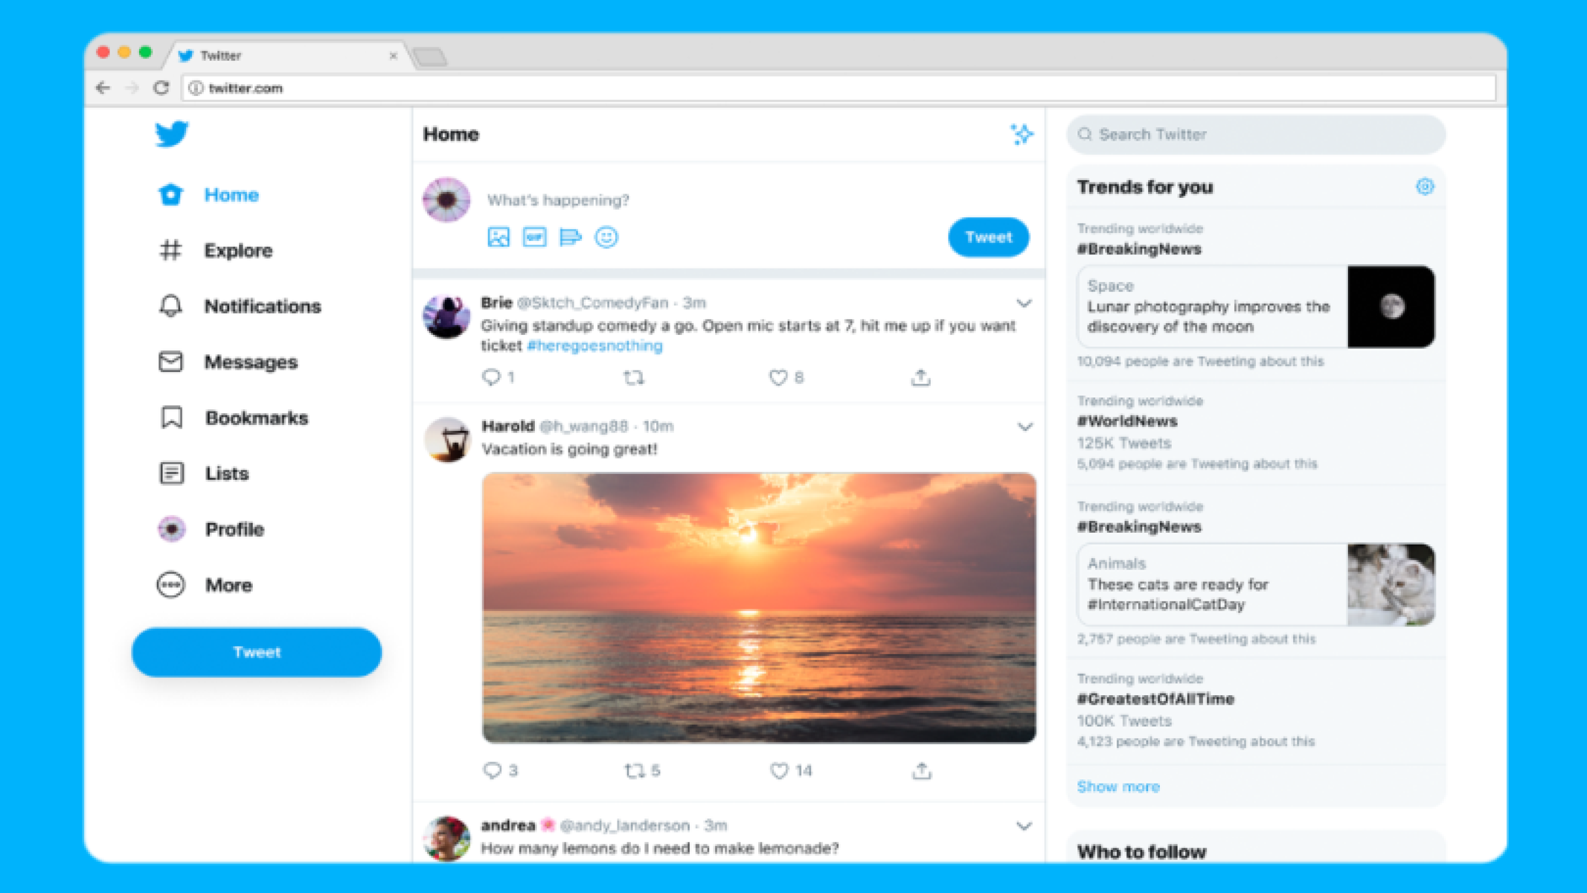

1. **Retweet**

Press retweet option present below the tweet you want to retweet

Enter message

Enter send

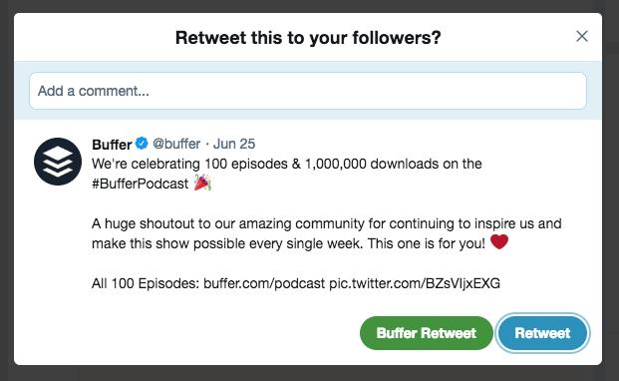

1. **Settings**

Pressing the three line button present at the top left corner of twitter, you can change different types of settings such as profile, privacy, security.

You can change or update the mobile, email address, password

You can manage the blocked accounts, mute accounts, accessibility, etc.

