**Uber**

* Uber is a company which allows car rides.
* Passengers use the Uber app to order a ride, where they are quoted the fare.
* Uber uses a [dynamic pricing](https://en.wikipedia.org/wiki/Dynamic_pricing) model; prices for the same route vary according to [supply and demand](https://en.wikipedia.org/wiki/Supply_and_demand) for rides at the time that the ride is requested.
* Earlier, Uber also had food delivery services, but now it’s acquired by Zomato.

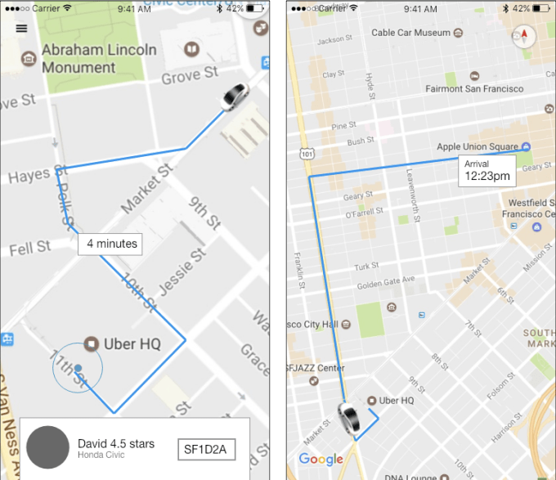

Functions we can perform on Uber:-

1. **Create account**

Open uber

Press create account

Enter email id, password

Verify email id

Ready to book

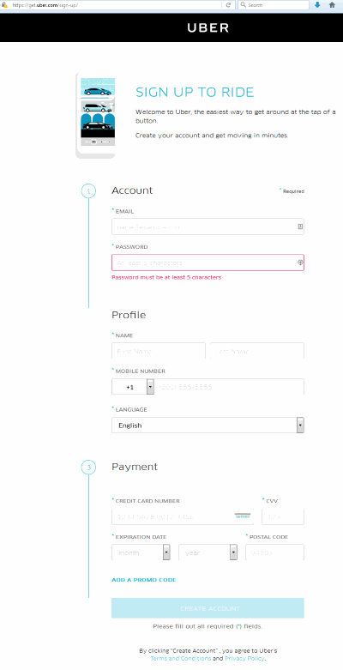

1. **Book ride**

Open uber

Enter pick point and drop point

Choose convenient ride

Select payment option

Book the ride

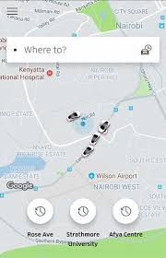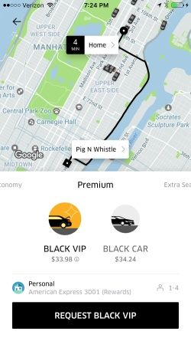

1. **Settings**

The 3 lines button present at the left top corner will direct you to change settings

You can change the settings you want (account settings, address, privacy and security settings, etc)

You can also check your previous trips (Your trips option), send your friends free rides (free rides option, send a gift option) and get help about uber (help option) if required.

