**WhatsApp**

WhatsApp is a great messaging platform. Through WhatsApp we can send images, audios, videos, documents, contact. It uses internet connection for sending stuff. Users can even voice call or video call. WhatsApp allows its users to share location in real time. It has a feature which allows users to add a status update.

Functions we can perform using whatsapp are:-

1. **Message**

Open WhatApp

Go to the profile you want to send message

Type the message

Send it by pressing enter

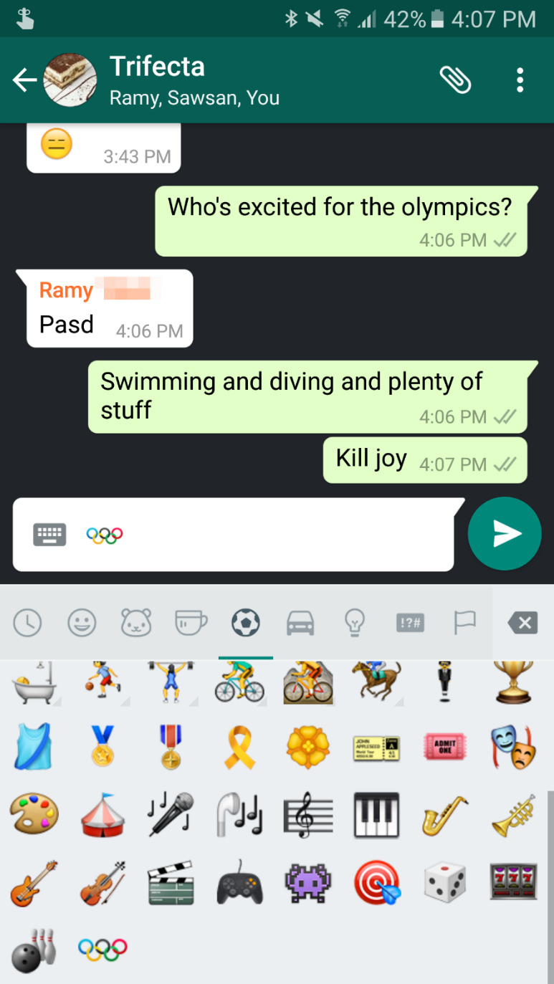

1. **Send Attachments**

Open WhatApp

Go to the profile/group you want to send attachment

Add attachment (Image, Video, Audio, Document, Contact)

Send it

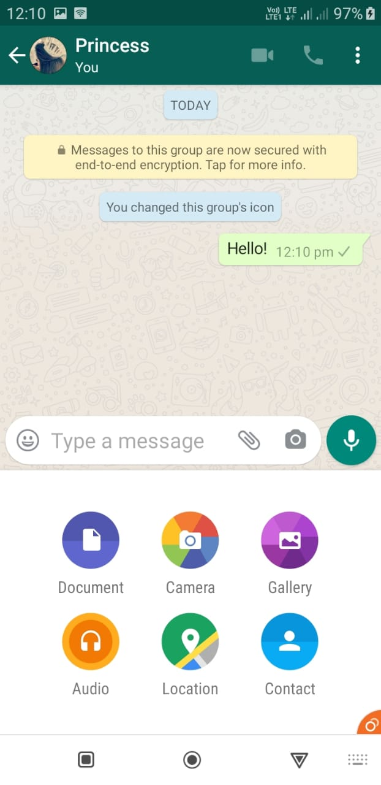

1. **Voice/Video Call**

Open Whatsapp

Press the call symbol (for voice call) or the video symbol (for video call).

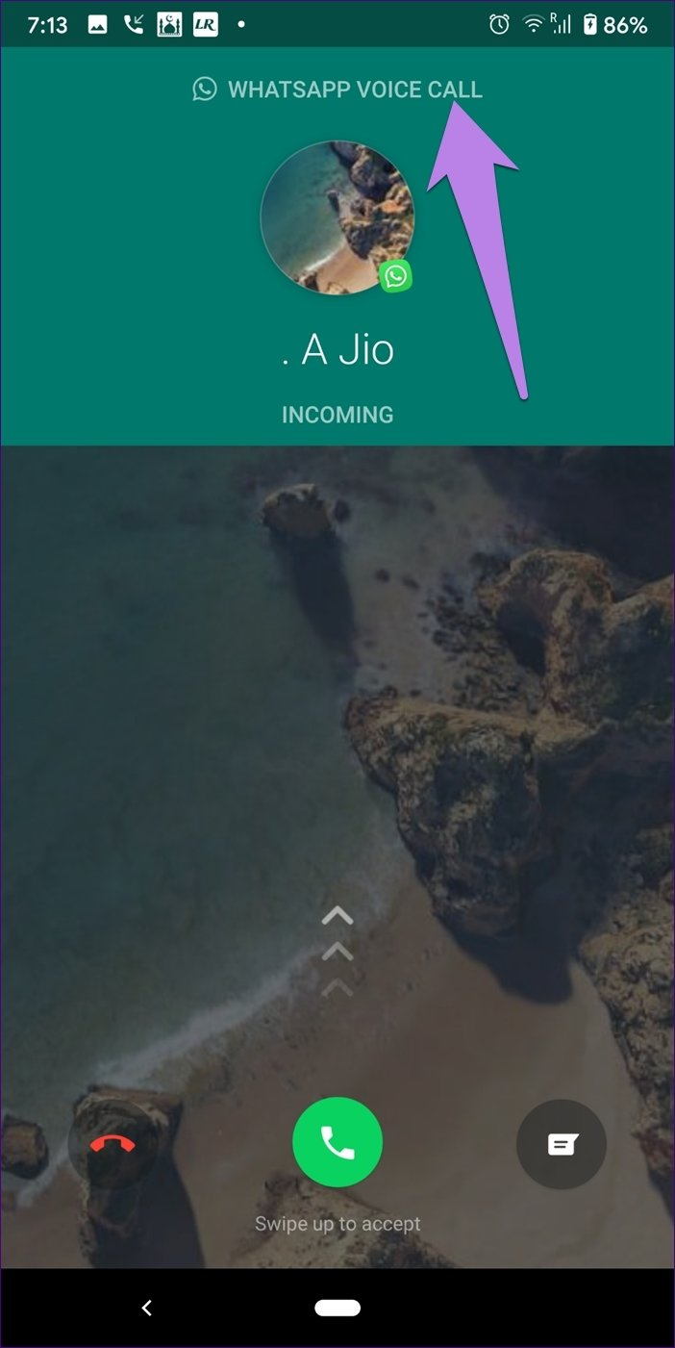



1. **Add status**

Open Whatsapp

Click on tap to add status

Select photo/video to add

Press send/enter.

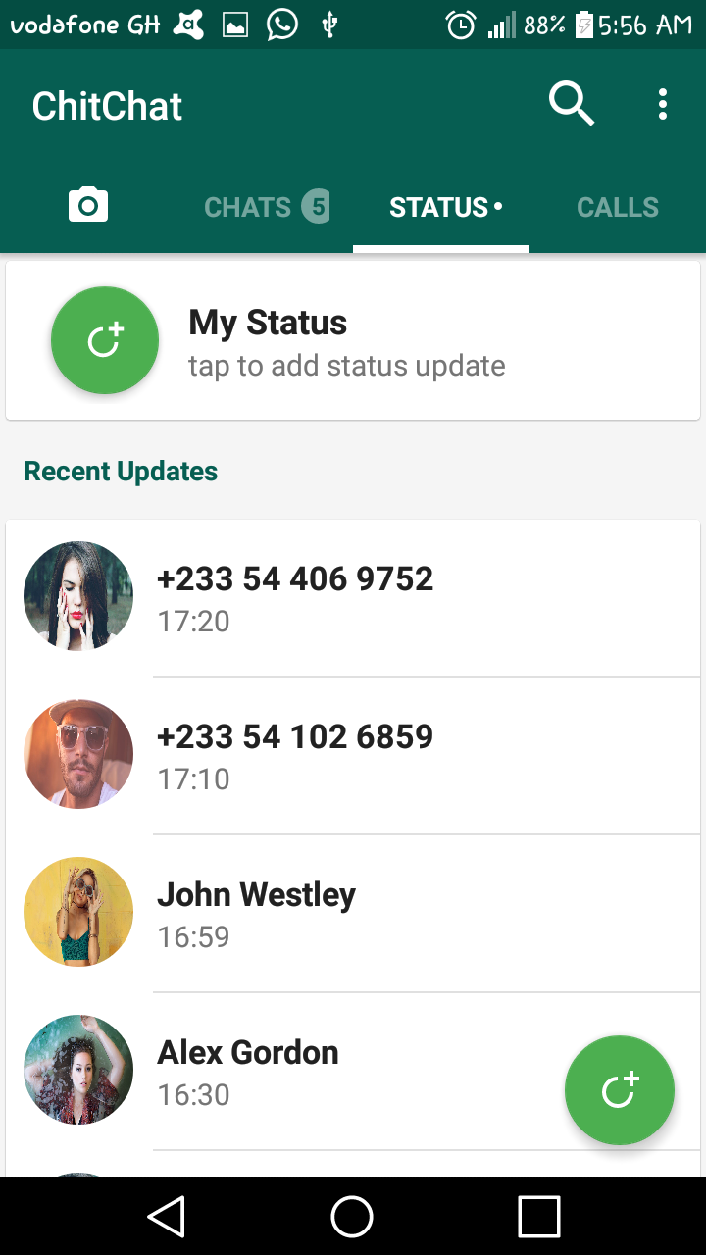

1. **Settings**

Press the three dots button to change any setting

You can make a new group of members you want

You can make a new broadcast of people you want

Using whatsapp web you can use whatsapp on your desktop

You star the important messages for future use

And in actual settings you can change the account, chat, notifications data and storage usage settings.

