Youtube

* We can sign in the user in youtube.com by taking input from user for its login and password

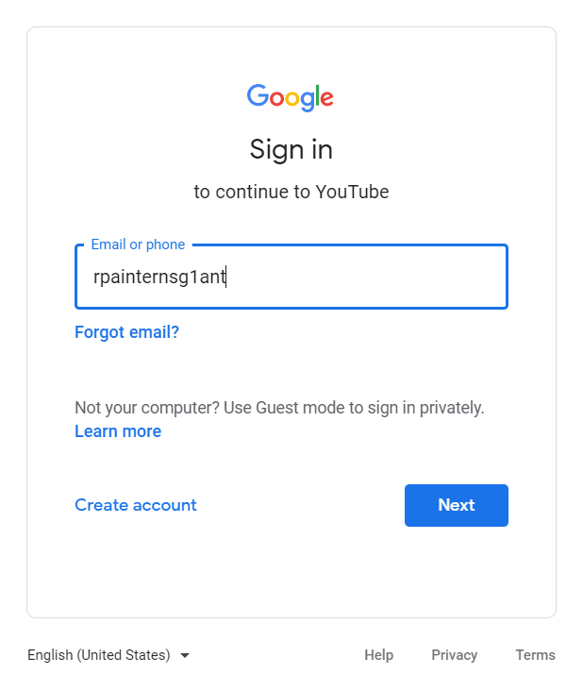

* We can take name of video as input and search it in search bar and then play the result on top of search result

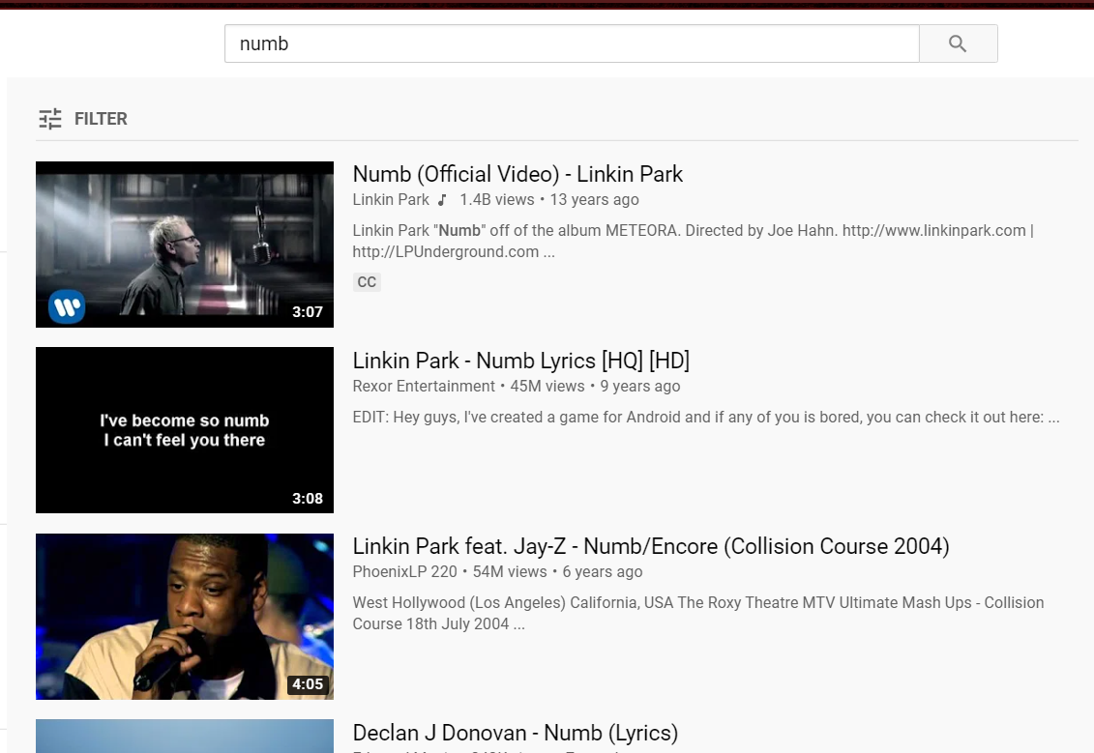

* We can like the playing video if user allows

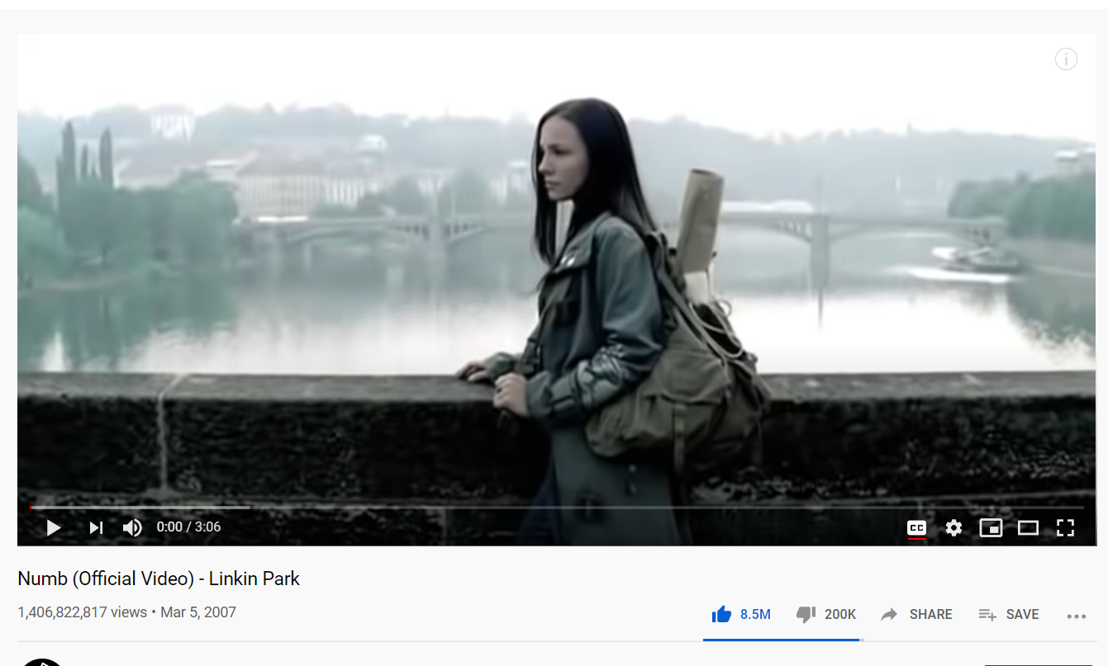

* We can subscribe the channel which user will give input

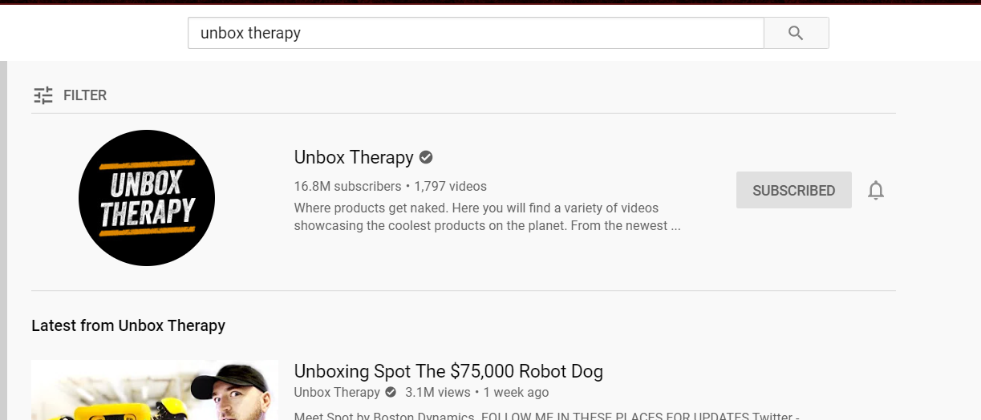

* We can comment in the playing video by taking user’s allowance and input for comment from user

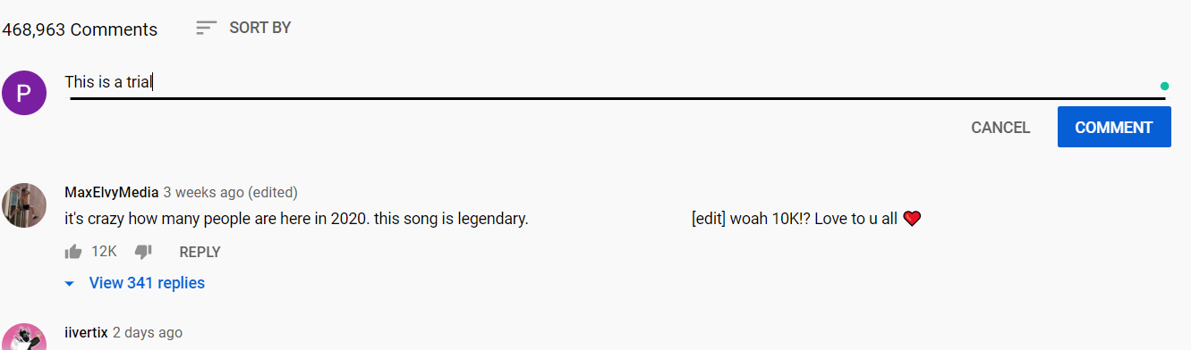

* We can create a channel and upload a video in it
* We can play the latest video of the user’s subscribed channel

Youtube

We can comment or like a video

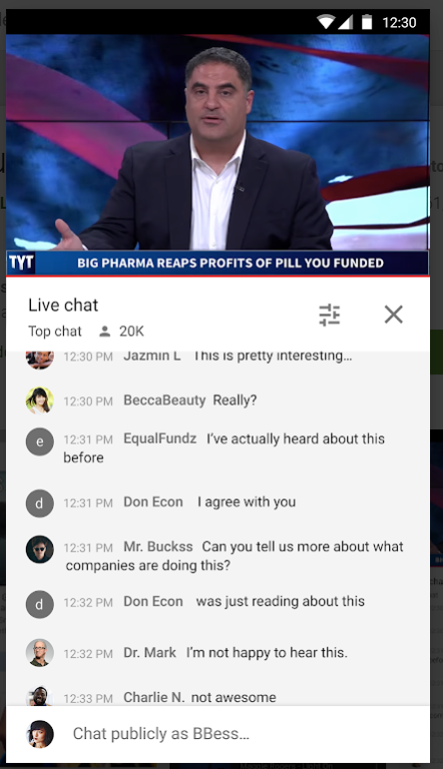

We can subscribe a channel



We can play or create a playlist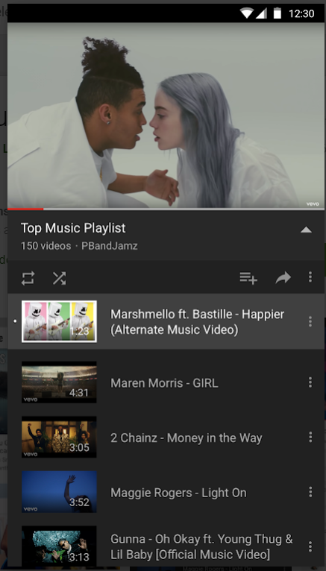

We can play recommended videos on our homepage or open your subscriptions or can view your liked or downloaded videos in Library

