**ZOOM**

An online video conferencing application, zoom allows users to interact with people around the world with its simplified usage. This has also been specialized in terms of conducting classes, sharing documents, for webinars and other multipurpose applications.

Some of the features include:

* Specialized waiting rooms in times of crowd.
* Specific zones for talking with multiple people at the same time.
* Mute and unmute participants, with accessing the participants present at the same time.
* Disabling video camera facility and locking the meetings.
* Facilitating data sharing with the purpose of screen sharing where documents can be displayed among people.

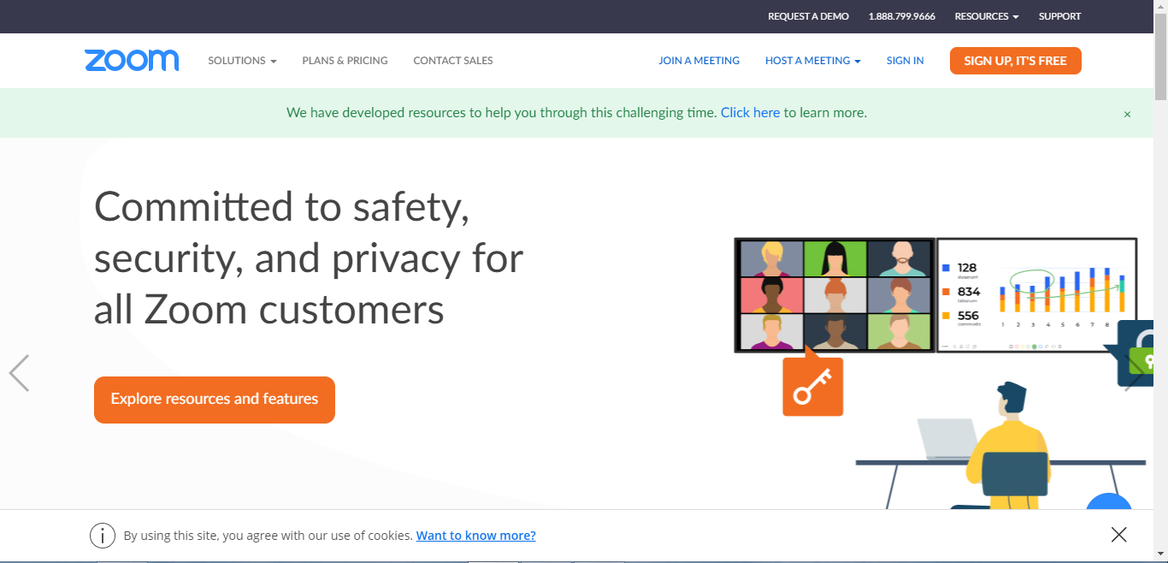

* A unique chatting room can be created by scheduling a meeting.
* 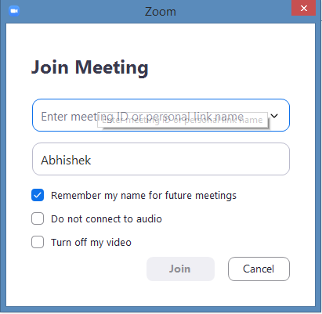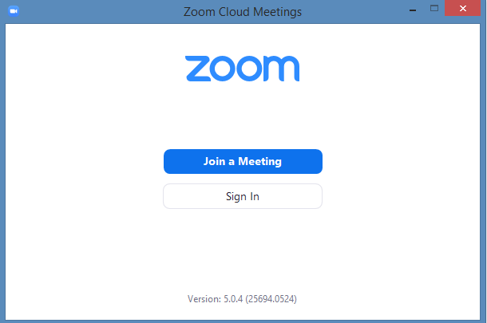This can enable the user enter the specified room for conferencing.
* The facility of waiting rooms can be enabled when the user is inside the meeting room with different people.