COMP1004 Lab: MySQL Setup

# 1. Connecting to the University of Nottingham Virtual Desktop

**Please note if you are working from within a Computer Science lab you can skip to the next section.**

## Setup MFA

Please follow the instructions on this page for downloading and configuring MFA (Multi Factor Authentication:

<https://www.nottingham.ac.uk/dts/accounts-and-access/it-account-and-password/multi-factor-authentication.aspx>

## 1.2 Setup “Remote Desktop”

Please follow the instructions on this page for downloading and configuring the “Remote Desktop” software for your OS:

<https://www.nottingham.ac.uk/it-services/computers/virtual.aspx>

In the instructions when you reach the point where you are instructed to double click or tap your relevant desktop, do this for “Computer Science Desktop”.

# 2. Connecting to the School of Computer Science Linux Servers

Once you have logged on to the “Computer Science Desktop” follow the below steps:

* Click on the “Type here to search” field at the bottom left. A menu will appear that contains the icon “**(UoN) PuTTY**”. If the icon is not visible, type “putty” in the field and the icon will appear. Click on the icon: “**(UoN) PuTTY**”
* In the “Host name (or IP address) field type the name of your linux machine (it could be any of the below. If you have been instructed to use a particular machine, use it):
  + avon.cs.nott.ac.uk
  + bann.cs.nott.ac.uk
  + clyde.cs.nott.ac.uk
  + mersey.cs.nott.ac.uk
  + roach.cs.nott.ac.uk
* A PuTTY security alert will appear if you have not previously connected to this hosts. Click “Yes” to accept.
* At the login prompt enter your university user name and password to login.

You should now be successfully connected to your linux server.

# 3. Connecting to the School MySQL database server and creating a database

Now that you have successfully logged on to a CS linux server you can proceed to the next steps.

## 3.1 Introduction

MySQL is installed on mysql.cs.nott.ac.uk and can also be accessed from **Avon**, **Bann**, **Clyde**, **Mersey**, **Roach** and **Severn** also as well as any local machine that has suitable client software installed.

## 3.2 Configuration for MySQL

On the Linux servers mentioned above, the MySQL server will be contacted by default when you use the mysql command line utility.

## 3.3 Creating a MySQL Account and database

You may create up to 10 mysql databases. Each database will be prefixed with your username and if you have not used MySQL before, you will need an account setting up, you can do this yourself by logging into a unix server that is set up for MySQL (Avon, Bann, Clyde, Mersey, Roach or Severn) and typing:

setup_mysql

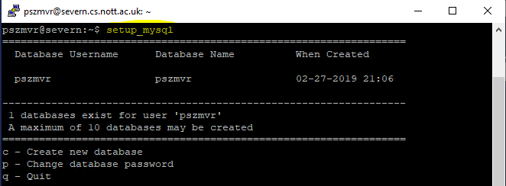

Select option **c** to create a new database.

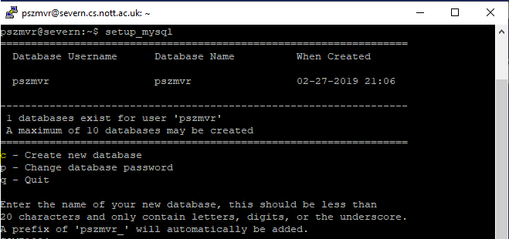

If you have not created one previously you will see a prompt asking if you wish to create a default database, this will have the same database name and username and your login username. Optionally you may choose to create a database with a custom name, this will however then be prefixed automatically with **username_**.

Enter the name of your new database:

COMP1004

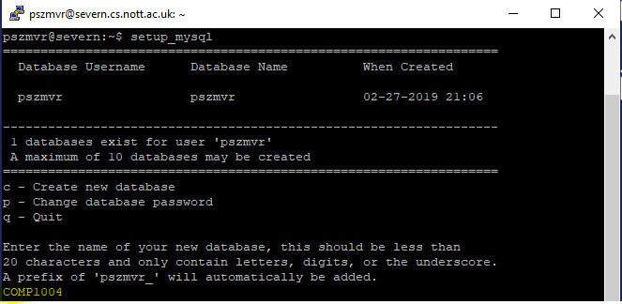

Your new database will be created and the details will be displayed.

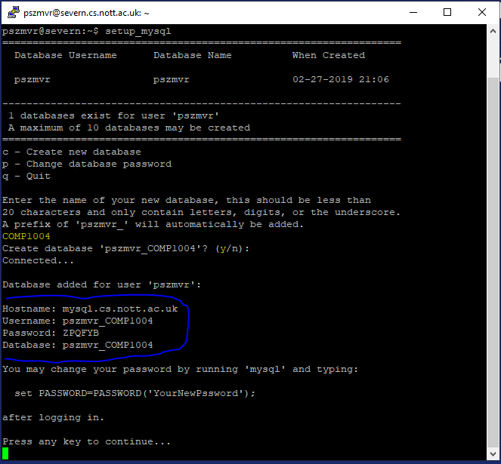

## 3.4 Using MySQL

You can access the MySQL command line by typing:

mysql -u [USERNAME] -p [DATABASE NAME]

To specify a particular account to log into, where USERNAME is the MySQL username (which in most cases is the same as your Unix username) and DATABASE NAME is the name of the database (which is also usually the same as your Unix username). The -p option ensures you are prompted for a password.

Below is an example command line. Please do not attempt to use the details from the below screenshot. Make sure you use your own username.

mysql –u pszmvr_COMP1004 –D pszmvr_COMP1004 –p

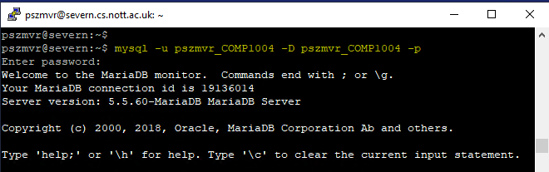

## 3.5 Changing your MySQL Password

Your MySQL password can be changed by logging into Avon, Bann, Clyde, Mersey, Roach or Severn and running the setup_mysql command.

# 4. Support

If you have any issues can you can contact the module teaching asssistants.

If there are any persistent issues, please contact the School IT support.