
Understanding dB & dBm in Telecommunications
Why Not Just Use Watts? — A Complete Beginner-to-Professional Guide
Standalone Tutorial | www.nodalwireacademy.com

1. Introduction — Why Not Just Use Watts?
In telecom networks, signals travel through fibre cables, air, amplifiers, splitters, and connectors. Every component either adds power or takes it away. Engineers must track these changes with precision to confirm a signal arrives strong enough at the destination.

The natural first instinct is to measure everything in watts. But watts fail quickly in real systems for one simple reason: the power range is enormous.

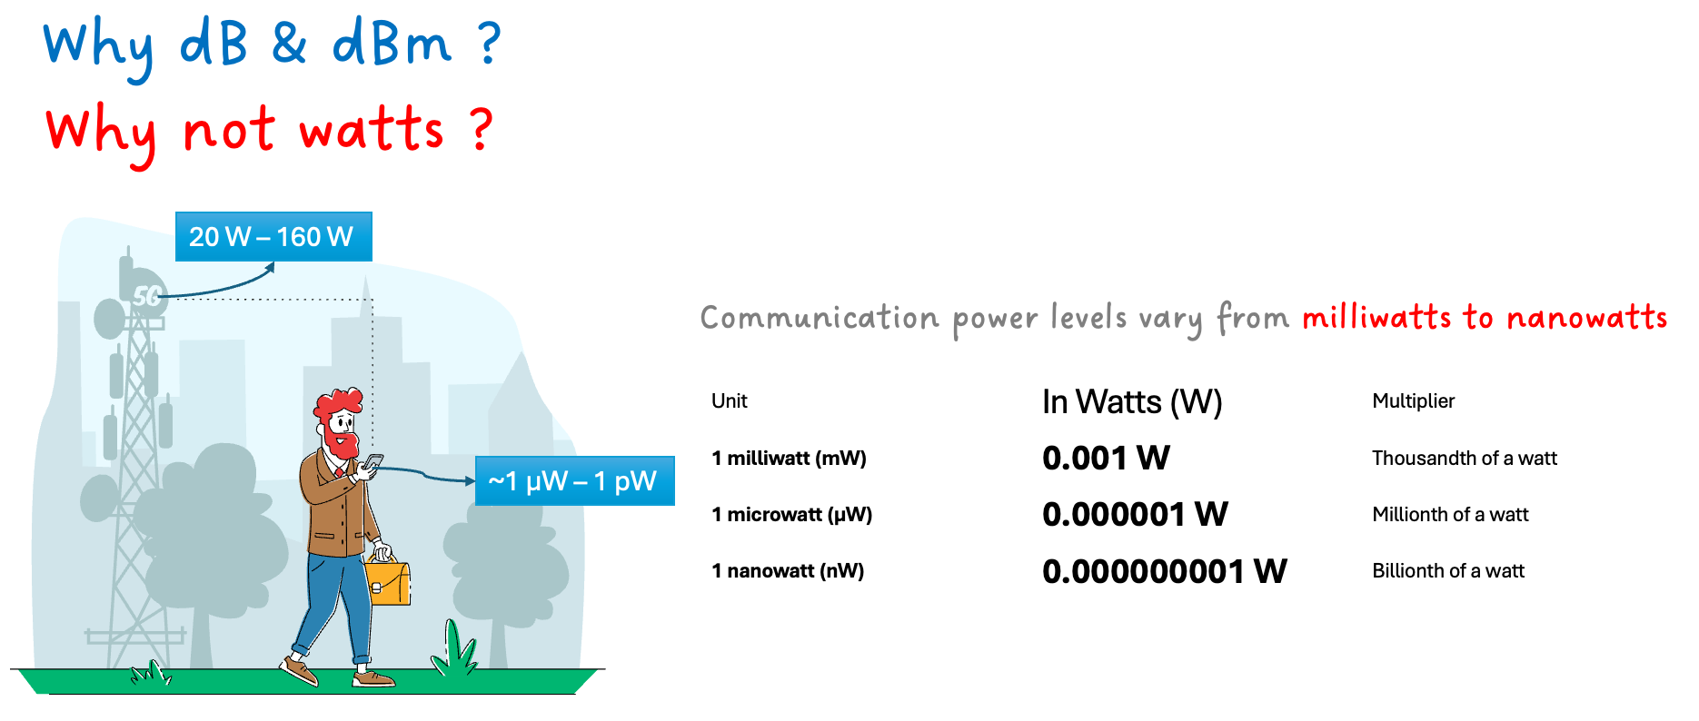
Figure 1 — Telecom power levels span from milliwatts to nanowatts
A 5G macro base station transmits at around 40 watts (+46 dBm). By the time that signal reaches a mobile phone several kilometres away — after passing through air, buildings, and the phone’s antenna — the received power may be as low as 0.000000000001 W (10⁻¹² W). That is a ratio of 40,000,000,000,000 to 1. Writing and calculating with such numbers every day is impractical.

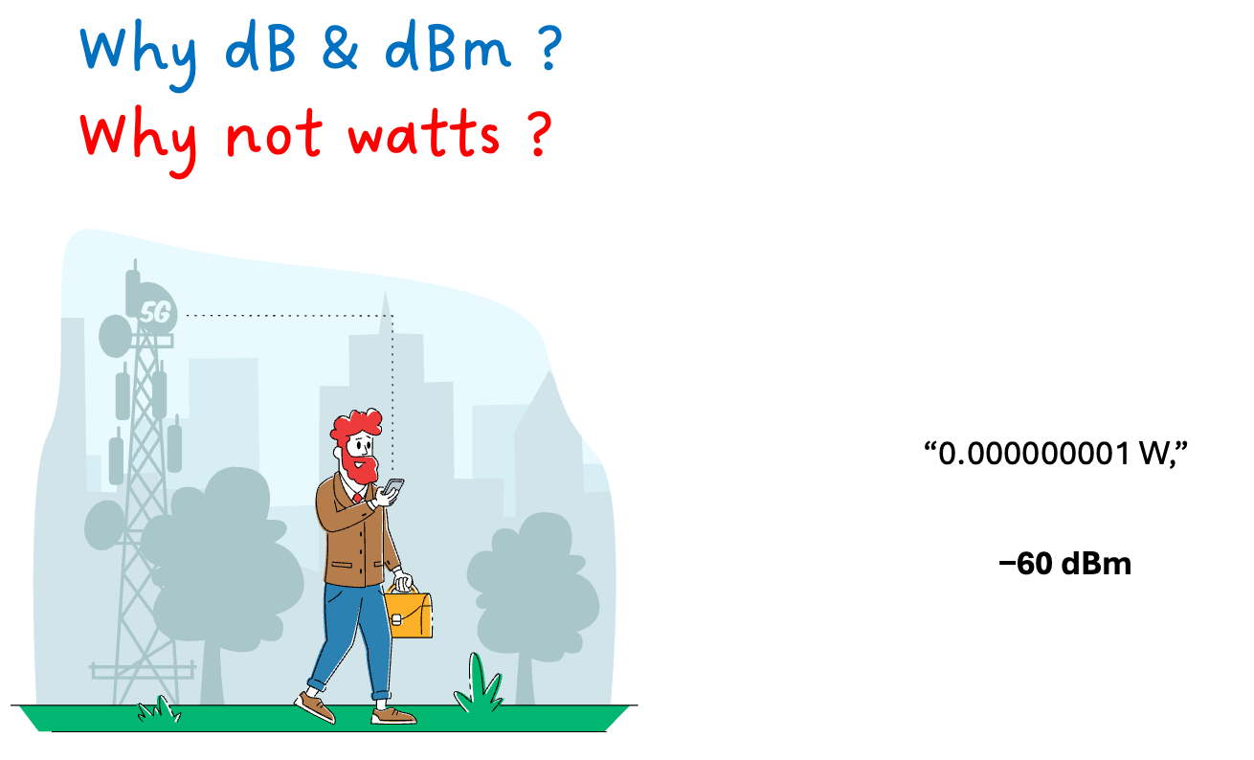
Figure 2 — 0.000000001 W becomes simply −60 dBm
This is why the telecom industry uses dB and dBm. These units compress any range of power into small, manageable numbers that can be added and subtracted instead of multiplied and divided. The entire 40 W to 10⁻¹² W journey is just +46 dBm to −120 dBm — a difference of 166 dB that any engineer can calculate in their head.

2. What is dB (Decibel)?

2.1 The Mountain Analogy
Picture two mountains side by side. Mountain A is clearly taller than Mountain B. That statement tells you the relative difference in height — but nothing about the actual height of either mountain. You cannot say whether Mountain A is 500 m tall or 5,000 m tall.

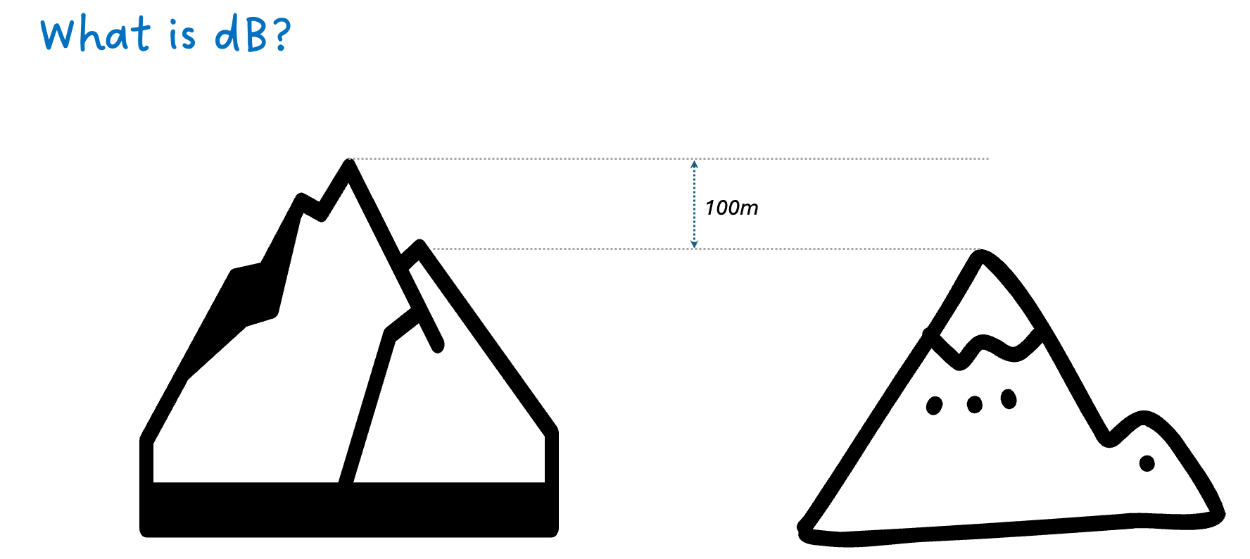
Figure 3 — dB is like the height difference between two mountains
This is precisely what dB measures. It is always a comparison between two power levels — never an absolute measurement on its own. In a fibre link, Pin enters the cable and Pout exits. The dB value tells you how much power was lost — the difference, just like the difference in height between the two mountains.

2.2 The dB Formula
The decibel is a logarithmic ratio:

dB = 10 × log₁₀ ( P_out / P_in )

📐 Formula Breakdown
P_out = Power leaving the component (output)
P_in = Power entering the component (input)
log₁₀ = Base-10 logarithm
10 × = Converts bels to decibels (1 bel = 10 dB)
Negative result = loss (P_out < P_in)
Positive result = gain (P_out > P_in)
Zero result = no change (P_out = P_in exactly)

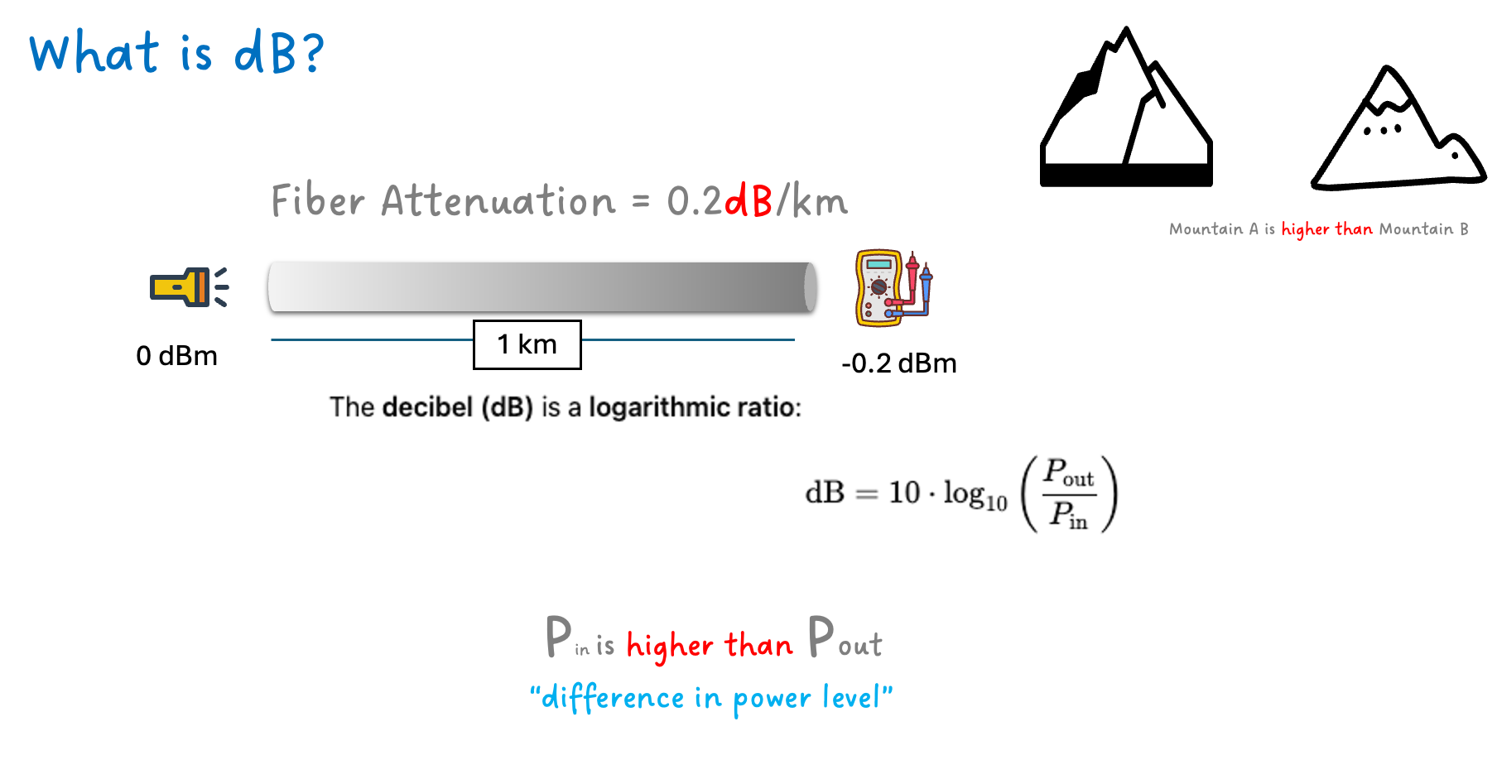
Figure 4 — Fibre attenuation of 0.2 dB/km shown with the formula

2.3 Why Logarithms? Multiplication Becomes Addition
The single most important property of the dB scale is this: multiplying power values in the real world becomes adding dB values. This is not a convenience trick — it transforms complex system calculations into simple arithmetic.

💡 The Core Insight
In linear (watts) arithmetic, two components each causing 50% loss:
0.5 × 0.5 = 0.25 (25% of power remains)
In dB arithmetic, the identical calculation:
−3 dB + (−3 dB) = −6 dB
A real fibre link might have 20+ components. Adding 20 dB numbers takes seconds. Multiplying 20 fractions takes a calculator and introduces errors.

2.4 Key dB Reference Values — No Memorisation Required
You do not need to memorise this table. You only need to remember two anchor points and apply them repeatedly:

🏛️ The Building Floors Analogy
+3 dB = go up 3 floors = power doubles
+10 dB = go up 10 floors = power ×10
−3 dB = go down 3 floors = power halves
−10 dB = go down 10 floors = power ÷10
All other values are combinations of these two rules.

dB Value | Power Ratio | Plain English | How to derive it
0 dB | ×1.0 | No change | log(1) = 0, always
+3 dB | ×2.0 | Power doubles | log(2) = 0.301, ×10 = 3
+6 dB | ×4.0 | Power quadruples | +3 dB twice: 2 × 2 = 4
+9 dB | ×8.0 | Power ×8 | +3 dB three times: 2³ = 8
+10 dB | ×10.0 | Power ×10 | log(10) = 1, ×10 = 10
+13 dB | ×20.0 | Power ×20 | +10 dB + 3 dB: 10 × 2 = 20
+20 dB | ×100.0 | Power ×100 | +10 dB twice: 10 × 10 = 100
−3 dB | ×0.5 | Power halves | Mirror of +3 dB
−10 dB | ×0.1 | Power drops to 1/10 | Mirror of +10 dB
−20 dB | ×0.01 | Power drops to 1/100 | +−10 dB twice

⚠️ Common Misconception — Corrected
Incorrect: "dB values scale linearly with power."
Correct: dB is logarithmic. +3 dB doubles power (not triples). +6 dB quadruples it. +10 dB multiplies by 10. The dB number is NOT a direct multiplier. Every +3 dB is another doubling on top of the last.

3. What is dBm (Decibel-Milliwatt)?

3.1 The Sea Level Analogy
Return to the mountain analogy. Knowing Mountain A is taller than Mountain B still does not tell you how tall either mountain actually is. To express an absolute height, you need a universally agreed reference point — a fixed zero. Geographers chose sea level.

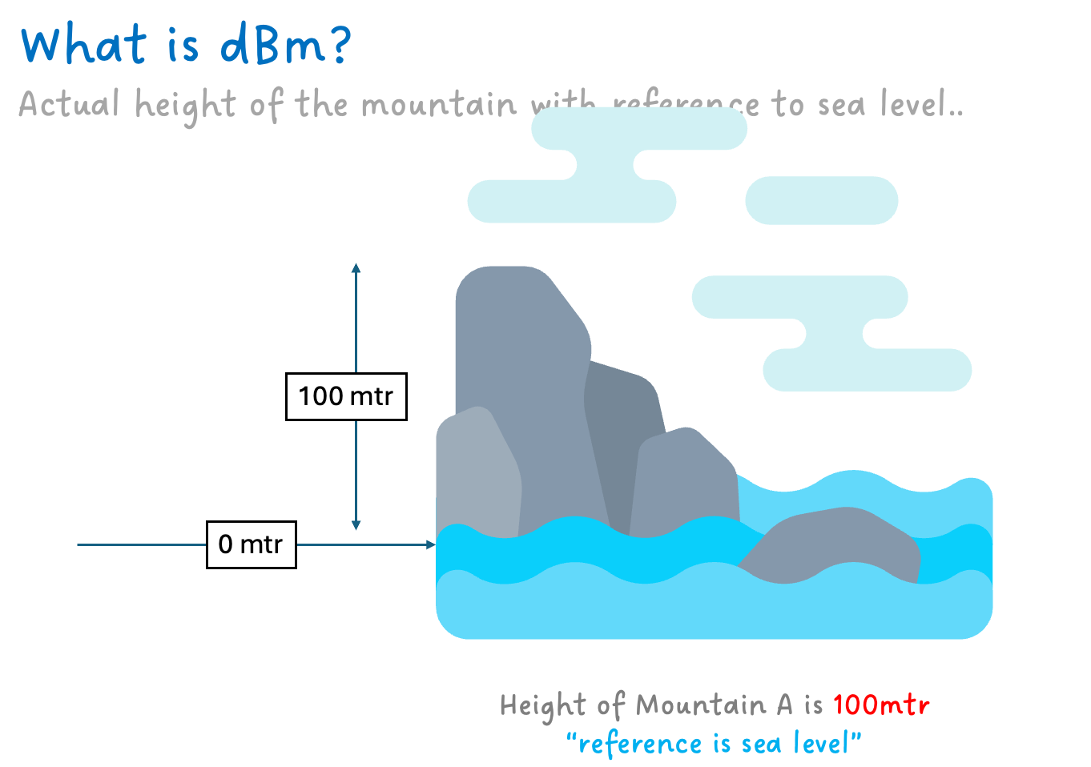
Figure 5 — dBm uses 1 mW as sea level: the fixed reference point
dBm applies the same principle to signal power. It fixes a reference at exactly 1 milliwatt (1 mW), which is defined as 0 dBm. Every signal power is then measured relative to this anchor. A signal above 1 mW is positive dBm. A signal below 1 mW is negative dBm.

3.2 Why Specifically 1 mW? The Historical Reason
Engineers in the 1930s at Bell Labs needed a standard reference to compare telephone equipment across manufacturers. They needed a value that was:

- Small enough — telecom signals are weak; watts are too large a unit
- Large enough — measurable with instruments of that era
- Central — real signal levels sat both above and below it
- Round — easy to calculate with

1 milliwatt satisfied all four requirements. It sits almost exactly in the centre of the practical power range used in real systems, which means most values you encounter daily are modest positive or negative numbers — no extreme values in either direction.

🌊 Sea Level Analogy Revisited
Geographers did not choose Everest as zero altitude, and they did not choose the ocean floor either. They chose sea level because most human activity happens close to it. Telecom engineers made the exact same choice with 1 mW — it sits in the middle of the practical range so numbers stay small and manageable in both directions.

3.3 The dBm Formula
dBm = 10 × log₁₀ ( P / 1 mW )

📐 Formula Breakdown
P = The actual signal power you are measuring (in milliwatts)
1 mW = The fixed reference — this is what makes it dBm, not dB
Positive result = power is above 1 mW
Negative result = power is below 1 mW
0 dBm = power is exactly 1 mW

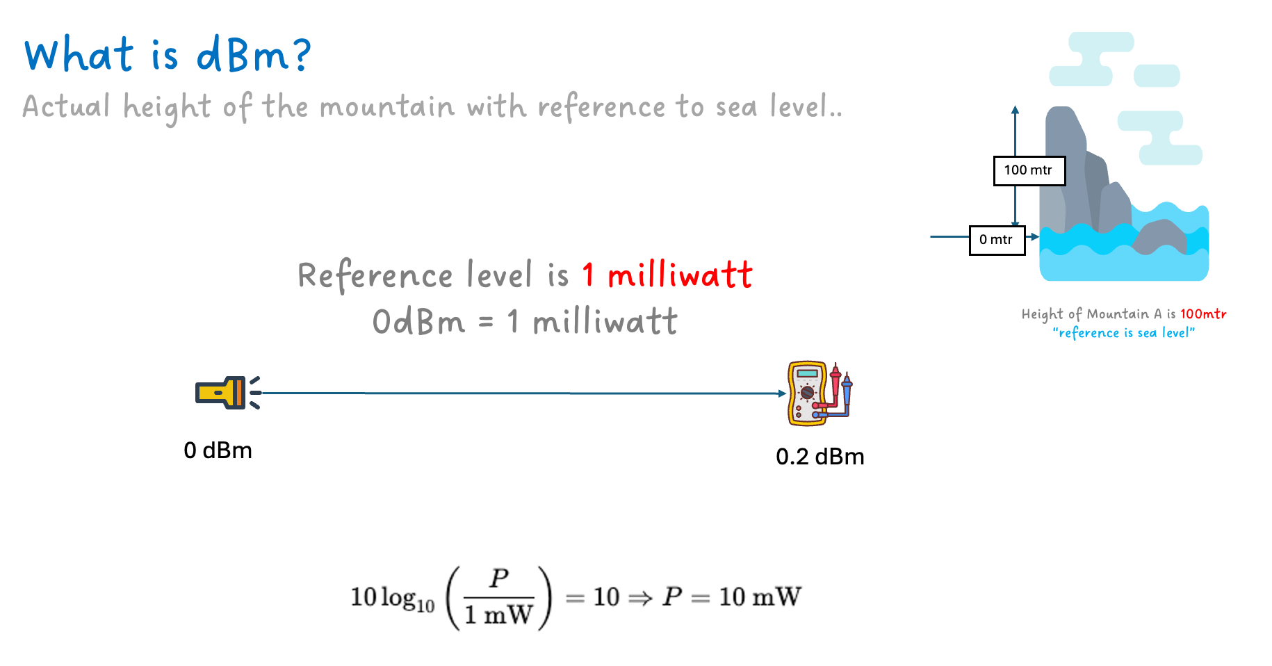
Figure 6 — 0 dBm = 1 mW; the formula applied to a fibre link

3.4 Corrected dBm Reference Table
A common source of confusion is the mapping between watts and dBm. The key conversion step is: first convert W to mW (multiply by 1000), then apply the formula. Each additional factor of 1000 in the watts value shifts the dBm result by 30.

Power in Watts | Power in mW | Calculation | dBm Value | Where you see this
1 W | 1000 mW | 10×log(1000/1) | +30 dBm | High-power RF transmitter
0.1 W (100 mW) | 100 mW | 10×log(100/1) | +20 dBm | Optical booster amp output
0.002 W (2 mW) | 2 mW | 10×log(2/1) | +3 dBm | SFP laser transmit power
0.001 W (1 mW) | 1 mW | 10×log(1/1) | 0 dBm | Reference level; test point
0.0005 W | 0.5 mW | 10×log(0.5/1) | −3 dBm | After 1×2 splitter
0.0000001 W | 0.0001 mW | 10×log(0.0001/1) | −40 dBm | Weak optical signal
0.000000001 W | 0.000001 mW | 10×log(10⁻⁶/1) | −60 dBm | 1 nanowatt — very weak signal
0.000000000001 W | 0.000000001 mW | 10×log(10⁻⁹/1) | −90 dBm | Mobile phone receive level

💡 Quick Mental Rule: Zeros to dBm
Starting from 0 dBm = 0.001 W (1 mW), every 3 extra zeros added to the decimal shifts dBm by −30:
0.001 W = 0 dBm
0.000001 W = −30 dBm (3 more zeros)
0.000000001 W = −60 dBm (6 more zeros)
0.000000000001 W = −90 dBm (9 more zeros)
−90 dBm = 10⁻¹² W = 1 picowatt — NOT 10⁻⁹ W. Count your zeros carefully!

3.5 How dB and dBm Work Together
This combination is what enables all real system engineering. dBm is your absolute anchor; dB values describe every step along the path.

📌 The Golden Rule
dBm + dB = dBm — absolute + relative = new absolute
dBm − dBm = dB — difference between two levels = relative ratio
dB + dB = dB — two relative values = total relative change

4. Where Are dB and dBm Used?

Figure 7 — Five core use cases for dB in telecommunications

4.1 Loss — Signal Attenuation
Component | Typical Loss (dB) | Notes
SMF fibre (G.652, 1550 nm) | 0.2–0.4 dB/km | Long-haul standard
SMF fibre (G.652, 1310 nm) | 0.3–0.4 dB/km | Used in PON systems
Multimode fibre (MMF) | 0.5–3.5 dB/km | Short distances only (<2 km)
FC/UPC connector | 0.1–0.3 dB | Per mated pair
FC/APC connector | 0.1–0.2 dB | Better return loss than UPC
Fusion splice | 0.02–0.1 dB | Preferred; very low loss
Mechanical splice | 0.2–0.5 dB | Field restoration use
1×2 passive splitter | 3.5 dB | Theoretical min = 3 dB
1×4 passive splitter | 7 dB | Common in GPON
1×8 passive splitter | 10 dB | Large PON distribution
1×16 passive splitter | 13 dB | Very large PON deployments
WDM coupler / MUX | 0.5–1.5 dB | Insertion loss of mux

4.2 Gain — Signal Amplification
Amplifier Type | Typical Gain | Application
EDFA (Erbium-Doped Fibre Amplifier) | +15 to +25 dB | Long-haul DWDM; C-band
Raman Amplifier | +10 to +15 dB | Distributed; pairs with EDFA
SOA (Semiconductor Optical Amp) | up to +30 dB | Metro; gating switch
RF Power Amplifier | +20 to +40 dB | Wireless BTS, MW backhaul
LNA (Low Noise Amplifier) | +15 to +25 dB | First-stage Rx; preserves SNR

4.3 Signal Quality Metrics
Metric | Full Name | What It Measures | Typical Value
SNR | Signal-to-Noise Ratio | Signal power vs. noise floor | >20 dB (RF)
OSNR | Optical Signal-to-Noise Ratio | Signal vs. ASE noise in DWDM | >20 dB coherent
ORL | Optical Return Loss | Reflected power vs. launched power | −30 to −60 dB

5. Optical Power Budget — Complete Worked Example
A power budget is the most important practical application of dB and dBm. It answers one critical engineering question: will the signal reach the receiver with enough power to work reliably?

📐 Power Budget Formula
Received Power (dBm) = Tx Power (dBm) − Total Path Loss (dB)
Pass condition: Received Power ≥ Receiver Sensitivity
Fail condition: Received Power < Receiver Sensitivity

5.1 Scenario: 10 km GPON Feeder Link
Component | Quantity | Unit Loss (dB) | Total Loss (dB)
OLT SFP transmit power | — | — | +3.00 dBm (start)
SMF fibre (G.652, 1310 nm) | 10 km | 0.35 dB/km | 3.50 dB
FC/APC connectors | 4 (2 pairs) | 0.25 dB each | 1.00 dB
Fusion splices | 3 | 0.05 dB each | 0.15 dB
1×4 passive splitter | 1 | 7.00 dB | 7.00 dB
Repair/ageing margin | — | — | 3.00 dB

Step-by-Step Calculation
🧮 Calculation
Tx Power = +3.00 dBm
Less: Fibre (10 × 0.35) = −3.50 dB
Less: Connectors (4 × 0.25) = −1.00 dB
Less: Splices (3 × 0.05) = −0.15 dB
Less: Splitter loss = −7.00 dB
Less: Repair/ageing margin = −3.00 dB
─────────────────────────────────────────────
Received Power at ONT = −11.65 dBm
GPON Class B+ ONT sensitivity: −27 dBm minimum
Result: −11.65 dBm >> −27 dBm → Link passes with 15.35 dB margin. ✓

💡 What the Margin Means
15.35 dB of margin means the link can absorb approximately 15 more dB of degradation before the receiver fails. This covers connector ageing, bending losses, temperature changes, and future splitter upgrades over the cable’s 20–25 year lifetime. Operators target a minimum of 3–6 dB margin; above 10 dB is considered very healthy.

6. Where to Use dBm — Absolute Power Measurements
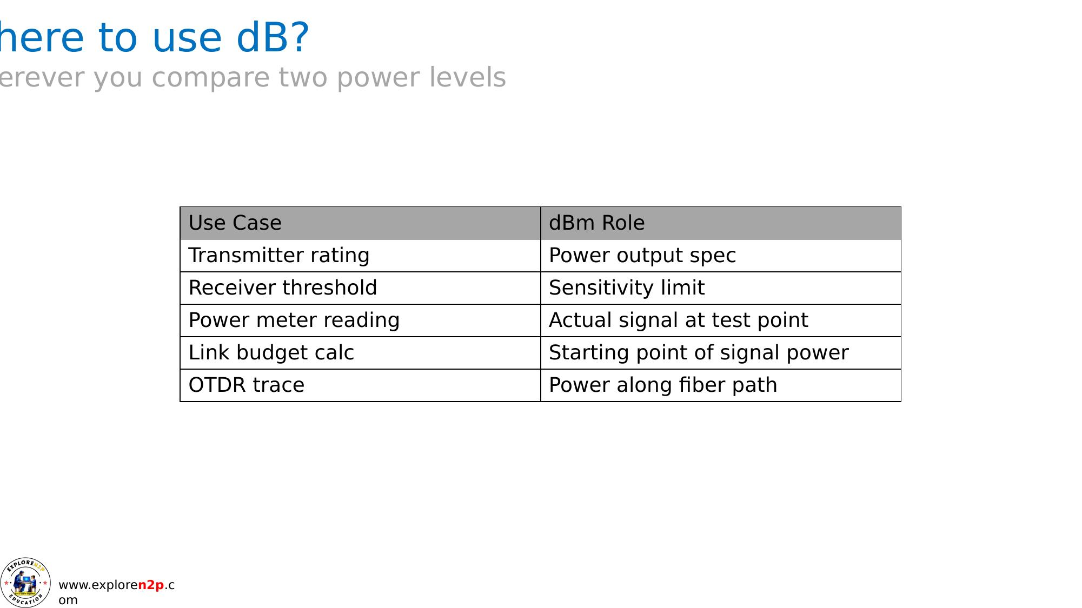
Figure 9 — Contexts where dBm is the correct unit to use
Use Case | dBm Role | Example Value
Transmitter output | Launch power specification | SFP: +3 dBm at 1310 nm
Receiver sensitivity | Minimum acceptable signal at Rx input | GPON ONT: −27 dBm min
Power meter reading | Actual signal level at any test point | −14.5 dBm after splice
Link budget start | Anchor from which all losses are subtracted | +3 dBm Tx → −11 dBm Rx
OTDR launch level | Reference for power vs. distance trace | OTDR: +6 dBm launch
NMS alarm threshold | Trigger for low-power network alarms | Alert at < −25 dBm

7. Quick Decision Guide — dB or dBm?
One question resolves the choice every time:

If you are… | Use
Measuring power at a specific point in a system | dBm
Describing a gain, loss, or ratio between two points | dB

✅ Quick Examples
- dBm: "The OLT output is +3 dBm." ← absolute level at one point
- dBm: "Power meter reads −14.7 dBm at the 8 km mark." ← absolute level at one point
- dB: "The 10 km fibre span has 3.5 dB of loss." ← relative change between two points
- dB: "The EDFA provides +20 dB of gain." ← relative change
- dB: "OSNR is 22 dB." ← ratio of signal to noise at the same point

8. Summary — dB vs. dBm at a Glance
Property | dB (Decibel) | dBm (Decibel-Milliwatt)
Type | Relative ratio | Absolute power level
Reference | Another power level (P_in) | Fixed: 1 milliwatt (1 mW)
0 value means | No change — P_out = P_in exactly | Power is exactly 1 mW
Positive value | Gain (output > input) | Power above 1 mW
Negative value | Loss (output < input) | Power below 1 mW
Analogy | Height difference between mountains | Height above sea level
Typical use | Loss specs, gain, SNR, ORL, margin | Tx power, Rx sensitivity, meter readings
Standalone? | No — needs two reference points | Yes — self-contained

9. Glossary of Key Terms
Term | Definition
dB (Decibel) | Logarithmic ratio of two power levels. Formula: 10 × log₁₀(P_out / P_in). Dimensionless.
dBm | Decibels relative to 1 milliwatt. Absolute power. Formula: 10 × log₁₀(P / 1 mW).
Attenuation | Reduction in signal power through a medium. Expressed in dB or dB/km.
Gain | Increase in signal power from an amplifier. Expressed in positive dB.
Insertion Loss | Power loss from inserting a passive component (connector, splitter, MUX) into a path.
Return Loss (ORL) | Reflected power vs. launched power. Negative dB; larger magnitude = better.
SNR / OSNR | Signal-to-Noise / Optical Signal-to-Noise Ratio. Signal power vs. noise, in dB.
Receiver Sensitivity | Minimum dBm at which a receiver correctly decodes data.
Power Budget | Tx power minus total losses. Must exceed receiver sensitivity plus margin.
EDFA | Erbium-Doped Fibre Amplifier. All-optical C-band amplifier; +15 to +25 dB gain.
OTDR | Optical Time-Domain Reflectometer. Locates splices, connectors, and breaks.
GPON | Gigabit Passive Optical Network (ITU-T G.984). PON standard for FTTH.
SFP / XFP | Hot-swappable optical transceivers. Tx power and Rx sensitivity rated in dBm.
Nanowatt (nW) | 10⁻⁹ W = 10⁻⁶ mW = −60 dBm. One billionth of a watt.
Picowatt (pW) | 10⁻¹² W = 10⁻⁹ mW = −90 dBm. One trillionth of a watt.

10. References
- ITU-T G.984 Series. (2008–2016). Gigabit-capable passive optical networks (GPON). International Telecommunication Union.
- ITU-T G.652. (2016). Characteristics of a single-mode optical fibre and cable. International Telecommunication Union.
- Lammle, T. (2020). CCNA Cisco Certified Network Associate study guide (Exam 200-301). Sybex / Wiley.
- Hecht, J. (2015). Understanding fiber optics (5th ed.). Laser Light Press.
- Keiser, G. (2021). Optical fiber communications (5th ed.). McGraw-Hill Education.
- NodalWire Academy. (2024). dB and dBm explained for telecom engineers [YouTube video]. https://www.youtube.com/@NodalWire

11. Student Q&A — Common Questions Answered
The following questions were raised during the tutorial session and YouTube discussion. Each answer is a standalone explanation that reinforces the concepts covered above.

Q1 What is the output power of a 5G base station antenna?
5G base station output power varies significantly depending on the type of deployment:

Base Station Type | Use Case | Tx Power | In dBm
Macro cell (gNB) | Wide outdoor coverage, highways, cities | 20 W – 160 W | +43 to +52 dBm
Micro cell | Dense urban streets | 2 W – 10 W | +33 to +40 dBm
Small cell / Pico | Indoors — malls, offices, stadiums | 100 mW – 2 W | +20 to +33 dBm
Femtocell / Home node | Home and office CPE | 10 mW – 100 mW | +10 to +20 dBm
Massive MIMO element | Per antenna element (64–128 total) | ~200 mW per element | ~+23 dBm each

⚠️ Important Correction to the Introduction
Incorrect statement: "A 5G base station transmits at 1 milliwatt." This was used as an illustration but is technically wrong.
Correct statement: A 5G macro base station transmits at 20–160 W (+43 to +52 dBm). The value 1 mW (0 dBm) is the dBm reference point, not a real base station power level.

Q2 What is the typical received power at a mobile phone?
The received power at a mobile phone (User Equipment, UE) depends on distance from the tower, obstacles, and frequency band. Here are the typical ranges:

Signal Condition | Received Power (dBm) | What It Means Practically
Excellent — next to tower | −30 to −40 dBm | 4 bars; streaming in HD with no issues
Good — suburban, clear LOS | −40 to −60 dBm | 3–4 bars; normal calls and data
Normal — typical urban use | −60 to −75 dBm | 2–3 bars; acceptable performance
Weak — indoors, far from tower | −75 to −90 dBm | 1–2 bars; slow data, dropped calls
4G LTE minimum sensitivity | −102 dBm | Technical floor; signal barely usable
5G NR minimum sensitivity | −106 dBm | 5G can work at slightly lower levels
Dead zone | Below −110 dBm | No service; signal lost

The complete dB journey from base station to phone:
Tx Power: +46 dBm (40 W macro base station)
Path loss (2 km): −115 dB (free space + building losses)
Antenna gain: +18 dB (base station + UE combined)
─────────────────────────────────────────────
Received at phone: −51 dBm (good signal ✓)

📱 Practical Tip for Students
Check your own phone’s signal strength right now in exact dBm:
- Android: Settings → About Phone → Status → Signal Strength
- iPhone: Dial *3001#12345#* → tap Call → Field Test mode
You will see a real dBm value — probably between −55 and −90 dBm depending on where you are. This immediately makes the concept real and personal.

Q3 Why do we always refer to 1 mW in the dBm formula? Why specifically 1 mW?
This question gets to the heart of why dBm was invented. The answer is historical and practical.

The Historical Reason
In the 1930s, Bell Labs engineers needed a standard reference power level to compare telephone equipment across manufacturers. They needed a value that satisfied four requirements simultaneously:

Requirement | Why It Matters | How 1 mW Satisfies It
Small enough | Telecom signals are weak; watts are too large | 1 mW = 0.001 W; sits in the mW–μW range of real signals
Large enough | Must be measurable with 1930s instruments | 1 mW was easily measurable with available equipment
Central | Values above and below should be modest numbers | 1 mW sits near the middle of the practical range
Round number | Easy to calculate with | 1 mW is a clean power-of-10 value

The Practical Reason: Symmetry
Because 1 mW was chosen, the dBm scale lines up naturally with real equipment:
+46 dBm = 40 W ← 5G macro base station Tx
+20 dBm = 100 mW ← optical booster amplifier
+3 dBm = 2 mW ← typical SFP laser output
0 dBm = 1 mW ← reference — right in the middle
-3 dBm = 0.5 mW ← after a 1×2 splitter
-30 dBm = 0.001 mW ← weak optical signal
-90 dBm = 0.000000001 mW ← mobile phone receive level

🌊 The Sea Level Analogy
Geographers chose sea level as altitude zero because most human activity happens close to it — some things are a bit above, some a bit below, and the numbers stay small. Telecom engineers chose 1 mW for exactly the same reason. It is the sea level of power measurement.

Q4 Do I need to memorise the dB reference table? Is there a logic to it?
No, you do not need to memorise it. Once you understand the pattern, every value in the table becomes obvious from two anchor points:

Two Rules to Remember
+3 dB = power doubles (because log₁₀(2) = 0.301, and 10 × 0.301 ≈ 3)
+10 dB = power multiplies by 10 (because log₁₀(10) = 1, and 10 × 1 = 10)

Building the Full Table From Two Rules
Target dB | How to Derive It | Ratio
0 dB | No change — log(1) = 0 | ×1
+3 dB | One doubling | ×2
+6 dB | +3 dB twice: 2 × 2 | ×4
+9 dB | +3 dB three times: 2 × 2 × 2 | ×8
+10 dB | Jump: log(10) = 1 | ×10
+13 dB | +10 dB then +3 dB: 10 × 2 | ×20
+20 dB | +10 dB twice: 10 × 10 | ×100
−3 dB | Mirror of +3 dB (half) | ×0.5
−10 dB | Mirror of +10 dB (one tenth) | ×0.1
−20 dB | Mirror of +20 dB (one hundredth) | ×0.01

🏛️ Building Floors Analogy
Think of dB like floors in a building. Ground floor = 0 dB. Going up 3 floors doubles your power. Going up 10 floors multiplies it by 10. Going down 3 floors halves it. You never memorise each floor — you just know the step size and count from there.

Q5 When do we get 0 dB? Give an example with real numbers.
You get 0 dB whenever P_out equals P_in exactly — regardless of the actual power level. The absolute value does not matter; only the ratio matters.

Proof: Three Different Power Levels, Same Result
P_in | P_out | Ratio | Calculation | Result
10 mW | 10 mW | 10/10 = 1 | 10 × log(1) = 10 × 0 | 0 dB
1 mW | 1 mW | 1/1 = 1 | 10 × log(1) = 10 × 0 | 0 dB
0.001 mW | 0.001 mW | 0.001/0.001 = 1 | 10 × log(1) = 10 × 0 | 0 dB

Three Real Situations That Produce 0 dB
Situation | Example | Why 0 dB
Ideal patch cable | Signal enters at +3 dBm, exits at +3 dBm | No resistance; P_out = P_in exactly
Test measurement | Same power meter reading at two adjacent points | No component between them
Loss cancelled by gain | −3 dB splitter then +3 dB amplifier | −3 + 3 = 0 dB net change

Key Insight
0 dB never means ‘no signal’. It means ‘signal unchanged’. A 10 W signal passing through an ideal component with 0 dB loss is still 10 W at the output.

Q6 When do we get +3 dB and −3 dB? Give examples with numbers.
The trigger for ±3 dB is always the same: the power ratio is exactly 2:1.

+3 dB — Power Doubles
log₁₀(2) = 0.301, so 10 × 0.301 = 3.01 ≈ +3 dB. Any doubling, at any power level, produces +3 dB:
P_in | P_out | Ratio | Calculation | Result
1 mW | 2 mW | 2/1 = 2 | 10 × log(2) = 10 × 0.301 | +3 dB
5 mW | 10 mW | 10/5 = 2 | 10 × log(2) = 10 × 0.301 | +3 dB
20 mW | 40 mW | 40/20 = 2 | 10 × log(2) = 10 × 0.301 | +3 dB

−3 dB — Power Halves
log₁₀(0.5) = −0.301, so 10 × (−0.301) = −3.01 ≈ −3 dB. The 1×2 splitter is the most common −3 dB component in fibre networks:
P_in | P_out (each port) | Ratio | Calculation | Result
10 mW | 5 mW | 5/10 = 0.5 | 10 × log(0.5) = 10 × (−0.301) | −3 dB
4 mW | 2 mW | 2/4 = 0.5 | 10 × log(0.5) = 10 × (−0.301) | −3 dB
1 mW | 0.5 mW | 0.5/1 = 0.5 | 10 × log(0.5) = 10 × (−0.301) | −3 dB

Practical Splitter Chain
Cascading splitters adds 3 dB of loss each time:
- 1×2 splitter: −3 dB (half power)
- 1×4 splitter: −6 dB (quarter power) = two halvings
- 1×8 splitter: −9 dB (one-eighth power) = three halvings
- 1×16 splitter: −12 dB (one-sixteenth) = four halvings
The extra 0.5 dB in a real 1×2 splitter (rated 3.5 dB, not 3 dB) accounts for insertion loss of the physical glass and connectors inside the component.

Q7 How does 0.000000001 W equal −60 dBm — and what power is actually −90 dBm?
This is one of the most common calculation errors, so let us work through it very carefully step by step.

Step-by-Step: Converting 0.000000001 W to dBm
Step | Action | Result
1 | Count the zeros: 0.000000001 W → 9 decimal places = 10⁻⁹ W | 10⁻⁹ W = 1 nanowatt (nW)
2 | Convert W to mW: multiply by 1000 (= 10³) | 10⁻⁹ × 10³ = 10⁻⁶ mW
3 | Write the formula: dBm = 10 × log(10⁻⁶ / 1) | = 10 × log(10⁻⁶)
4 | Apply log rule: log(10⁻⁶) = −6 | = 10 × (−6)
5 | Multiply | = −60 dBm

⚠️ Result: 0.000000001 W = −60 dBm (NOT −90 dBm)
The original tutorial stated this value was −90 dBm. That was incorrect. 0.000000001 W = 1 nanowatt = −60 dBm.

The Correct Mapping: What is −90 dBm?
Power in Watts | Scientific Notation | Power in mW | dBm Value | Name
0.001 W | 10⁻³ W | 1 mW | 0 dBm | 1 milliwatt
0.000001 W | 10⁻⁶ W | 0.001 mW | −30 dBm | 1 microwatt
0.000000001 W | 10⁻⁹ W | 0.000001 mW | −60 dBm | 1 nanowatt
0.000000000001 W | 10⁻¹² W | 0.000000001 mW | −90 dBm | 1 picowatt
0.000000000000001 W | 10⁻¹⁵ W | 0.000000000001 mW | −120 dBm | 1 femtowatt (GPS level)

💡 The Pattern: Every 3 More Zeros = −30 dBm
Start from 0 dBm = 0.001 W. Every time you add 3 more zeros to the watt value, the dBm drops by 30:
0.001 W = 0 dBm (3 zeros)
0.000001 W = −30 dBm (6 zeros)
0.000000001 W = −60 dBm (9 zeros)
0.000000000001 W = −90 dBm (12 zeros)
Count the zeros from the decimal point. Divide by 3. Multiply by −30.

About NodalWire Academy
NodalWire Academy delivers structured telecom training from beginner to professional level across Fiber Optics, GIS for Telecom, Networking, and related disciplines. Sessions are conducted live via Zoom and supported by detailed written tutorials published at www.nodalwireacademy.com.
YouTube: https://www.youtube.com/@NodalWire | Email: contact@nodalwire.com

