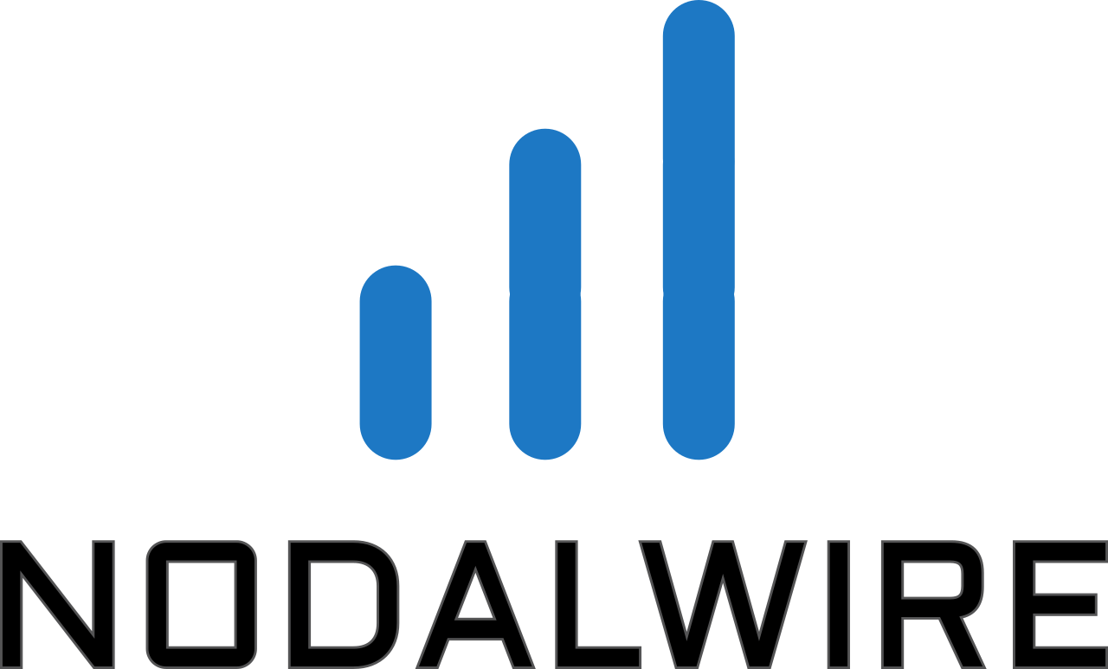

Hospital Modernization
Student Project Build Guide
MVP Prototype | 5 Students | 6 Weeks
Project Platform: www.exploreN2P.com

Purpose
Give the student team enough functional and technical information to begin development immediately and deliver one complete working patient journey.

Project Boundary
Use only dummy/synthetic patient data. This is a prototype, not a production clinical system. Real hospital integrations, real patient data, AI diagnosis, scan analysis, and clinical recommendations are outside this student phase.

Source workflow: Hospital Modernization concept diagram supplied by the project team.

1. What You Are Building
The student team will build one connected web prototype. The goal is not to create every hospital feature. The goal is to prove the core patient workflow from registration through consultation and ordering.
Figure 1 - MVP patient journey

Five Development Steps
Step 1 - Patient Signup + Queue: Create a patient using dummy data, assign a visit, and show the patient in a queue.
Step 2 - Nurse Intake + Patient Record: Enter vitals and basic details, then upload sample reports into the visit record.
Step 3 - Doctor Consultation + Voice AI: Doctor reviews the visit, dictates notes, receives text, reviews the AI rewrite, edits it, and approves the final version.
Step 4 - Prescription + Lab Order: Doctor creates a simulated prescription or laboratory/test order and stores its status.
Step 5 - Integration + Final Demo: Connect all screens and data into one reliable end-to-end demonstration.
Definition of Done
A new dummy patient can move through the entire workflow without manual database changes or disconnected screens.

2. Users and Screens
Use simple role-based access. A single login page may be used for the prototype. Each user sees only the screens needed for the role.
Figure 2 - Required screen navigation
Role | Required Screens | Main Actions
Front Desk / Patient | Patient Signup, Queue | Create patient, start visit, view queue status
Nurse | Queue, Nurse Intake, Patient Record | Open queued patient, enter vitals, upload report
Doctor | Patient Record, Consultation, Voice Note, Orders | Review record, dictate/edit/approve note, create order
Admin / Demo | Dashboard | View demo data and basic system status

3. Functional Requirements

Patient Signup + Queue
- Create patient: name, DOB, sex, phone, optional email, dummy insurance ID.
- Create a visit when the patient checks in.
- Assign a queue number and status: Waiting, In Intake, Ready for Doctor, With Doctor, Completed.
- Show a queue list that refreshes after a status change.

Nurse Intake
- Open a patient visit from the queue.
- Enter blood pressure, temperature, pulse, oxygen saturation, weight, and short intake note.
- Upload one or more sample PDF/image reports.
- Mark the visit Ready for Doctor.

Doctor Consultation
- Display patient demographics, current visit, vitals, uploaded documents, and previous prototype notes if available.
- Provide a Record / Stop control for voice dictation.
- Show raw speech-to-text output before AI rewriting.
- Generate an AI-organized note without adding new clinical facts.
- Allow doctor edits before approval.
- After approval, lock the final note from normal editing and save approval date/time.

Prescription / Lab Order
- Choose Prescription or Lab Order.
- Prescription: medicine, dose/instructions, duration, optional pharmacy name.
- Lab: test name, notes, optional lab name.
- Status for prototype: Draft, Sent, Received/Completed (simulated).

Patient Record
- Keep the current visit data linked under one patient ID.
- Show vitals, documents, doctor note versions, prescription/lab orders, and timestamps.
- Keep the original audio file linked to the doctor note when technically feasible.

4. Voice-to-Text and AI Note Workflow
Figure 3 - Doctor voice documentation flow
Important AI Rule
The AI may improve grammar, organization, headings, and readability. It must not invent symptoms, diagnoses, medication, test results, or other clinical facts that were not dictated or already present in the input.

Versions to Store
Version | Stored? | Editable? | Purpose
Original audio | Yes | No | Backup/reference
Raw transcript | Yes | No after creation | Exact STT result
AI draft / doctor-edited note | Yes | Yes until approval | Working version
Final approved note | Yes | No after approval | Official prototype note

5. Recommended Technical Architecture
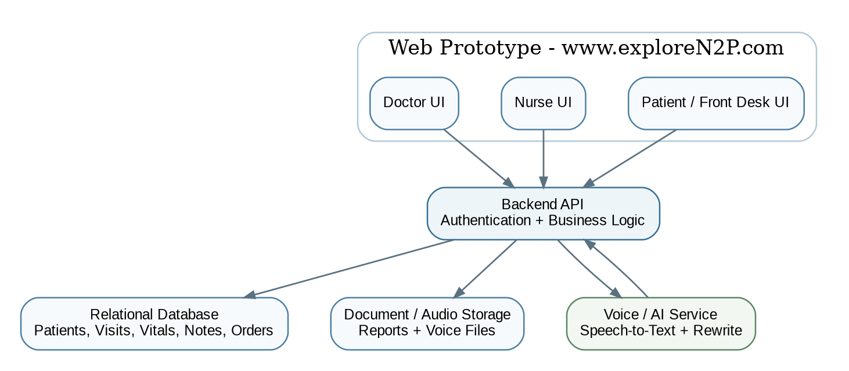
Figure 4 - Recommended MVP architecture
Recommended reference stack: React or Next.js for the web UI, a simple REST backend (FastAPI, Node/Express, or the team's approved equivalent), PostgreSQL for structured data, object/file storage for reports and audio, and an API-based speech-to-text + LLM service for the voice workflow. Keep all external services behind backend endpoints so they can be replaced later.
Do Not Overbuild
One web application, one backend, one database, and one shared repository are enough. Avoid microservices, complex cloud automation, mobile apps, RFID, barcode hardware, real pharmacy interfaces, and real lab interfaces in this phase.

6. Minimum Data Model
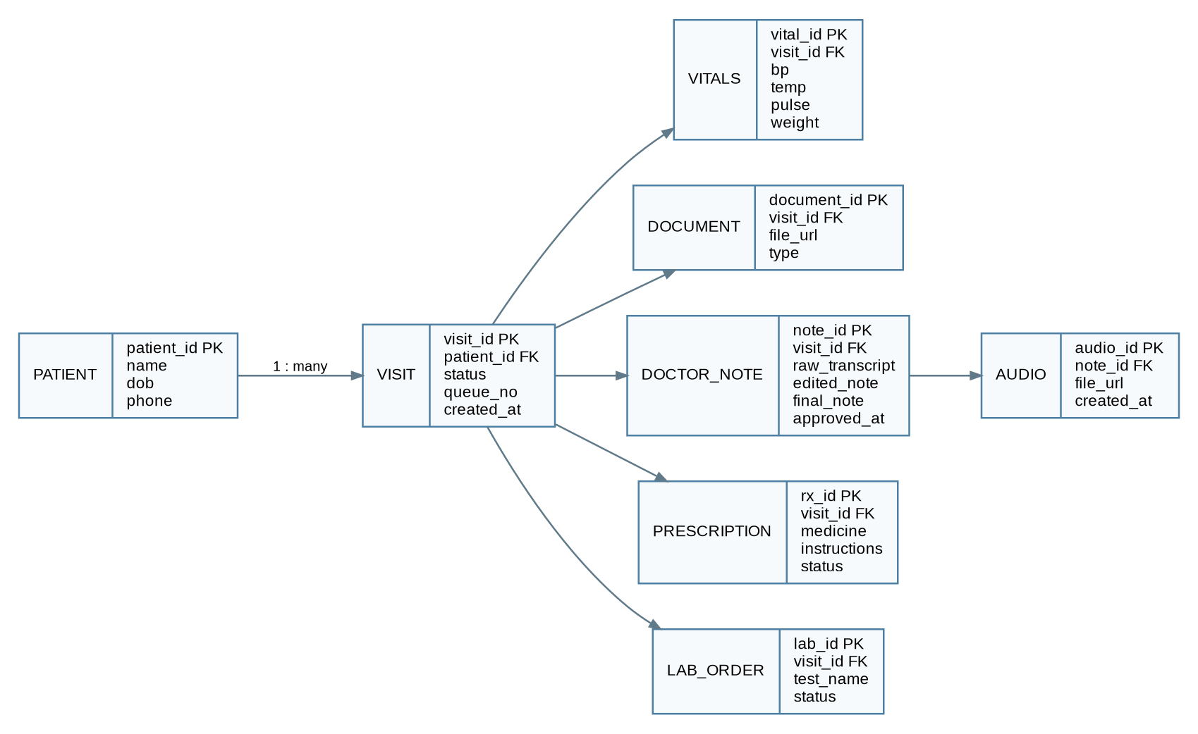
Figure 5 - Minimum database entities and relationships

Minimum Tables / Objects
Object | Must Contain | Notes
Patient | ID, name, DOB, phone, demographics | One patient can have many visits
Visit | ID, patient ID, queue number, status, timestamps | Central unit for the MVP workflow
Vitals | Visit ID, BP, temp, pulse, SpO2, weight | Entered by nurse
Document | Visit ID, filename, type, file URL | Sample reports only
Doctor Note | Visit ID, raw transcript, edited note, final note, approval timestamp | Core voice-AI record
Audio | Note ID, audio file URL, timestamp | Keep original dictation
Prescription | Visit ID, medicine/instructions/status | Simulated sending
Lab Order | Visit ID, test/notes/status | Simulated sending
User | ID, name, role, login identifier | Prototype role access

7. Minimum API Contract
The exact URL naming can change, but the application should provide equivalent operations. Students should agree on the contract before coding frontend and backend independently.
Method | Endpoint Example | Purpose | Used By
POST | /api/patients | Create patient | Front desk
POST | /api/visits | Create/check-in visit | Front desk
GET | /api/queue | List active queue | All clinical roles
PATCH | /api/visits/{id}/status | Change queue/visit status | Nurse/Doctor
POST | /api/visits/{id}/vitals | Save vitals | Nurse
POST | /api/visits/{id}/documents | Upload report | Nurse
GET | /api/visits/{id} | Load complete visit record | Doctor
POST | /api/visits/{id}/audio | Save dictation audio | Doctor
POST | /api/visits/{id}/transcribe | Generate raw transcript | Doctor
POST | /api/visits/{id}/rewrite-note | Create AI-organized draft | Doctor
POST | /api/notes/{id}/approve | Approve final note | Doctor
POST | /api/visits/{id}/prescriptions | Create prescription | Doctor
POST | /api/visits/{id}/lab-orders | Create lab order | Doctor

8. Team Assignment and 6-Week Plan
Student | Primary Ownership | Integration Responsibility
1 | Patient signup + queue | Connect patient/visit IDs to nurse workflow
2 | Nurse intake + uploads | Ensure data appears correctly for doctor
3 | Doctor dashboard + record view | Integrate consultation and orders
4 | Voice-to-text + AI note | Implement version storage and approval flow
5 | Orders + backend integration + testing | Help merge modules and own end-to-end test
All students: use one shared repository, review each other's code, and integrate every week. No student module is considered complete until it works in the shared application.
Week | Focus | Required Checkpoint | Output
1 | Introduction + design | Architecture, data model, API contract agreed | Repository + basic app skeleton
2 | Build 1 | Patient signup -> queue -> nurse intake works | First integrated demo
3 | Build 2 | Doctor can open complete visit record | Second integrated demo
4 | Build 3 | Voice -> transcript -> AI draft -> edit works | Voice workflow demo
5 | Build 4 | Approval + prescription/lab order + end-to-end flow | Feature complete MVP
6 | Test + document | Acceptance tests pass | Final demo + handover

9. Acceptance Test - Final Demonstration
The final demo should be performed as one continuous scenario. Use one prepared dummy patient and do not edit database records manually during the demonstration.
- Create the dummy patient and start a visit.
- Patient appears in the queue with a queue number.
- Nurse opens the visit, enters vitals, uploads a sample report, and marks Ready for Doctor.
- Doctor opens the same visit and sees patient details, vitals, and uploaded report.
- Doctor records a short consultation note.
- System saves audio and generates the raw transcript.
- AI creates an organized note without adding new facts.
- Doctor changes at least one sentence and approves the note.
- System shows the stored raw transcript, edited note, final approved note, and timestamps.
- Doctor creates either a prescription or lab order and marks it Sent.
- Visit record shows the completed workflow and all linked information.
MVP Pass Condition
If the team can complete the scenario above reliably from the web interface, the student project is successful.

10. Required Handover
- Complete source code in the agreed project repository.
- README with setup/start instructions and required environment variables.
- Database schema or migration files and dummy seed data.
- List of API endpoints.
- Short test report showing which acceptance tests passed.
- Known limitations and recommended next steps.
- Final presentation/demo material stored in the ExploreN2P project document repository.

Out of Scope for This Student MVP
The original modernization concept also includes broader registration channels, mobile access, external pharmacy/laboratory connections, cloud/local redundancy, and richer patient access. Those ideas remain part of the larger hospital modernization vision, but they are intentionally deferred so this six-week student project stays achievable.
Start Here on Day 1
Create the shared repository and app skeleton, agree on the data model and API contract in this guide, load dummy data, and make the first vertical slice work: Patient Signup -> Queue -> Nurse Intake. Do not wait for every screen to be designed before integration begins.

