Developing Soft and Parallel Programming Skills Using Project-Based Learning

# Fall-2018

# Team Nine30

# Noah-Raine De Joya, Angelica Amis, Frankie Sanchez, Sai Pavan Nuthalapati, Phillip King

**Planning and Scheduling:**

|  |  |  |  |  |  |  |
| --- | --- | --- | --- | --- | --- | --- |
| **Assignee Name** | **Email** | **Task** | **Duration (Hours)** | **Dependency** | **Due Date** | **Notes** |
| Frankie Sanchez | fsanchez4@student.gsu.edu | In charge of the programming portion of Task 3 Part B: Parallel Programming Basics | 4 hours | Raspberry PI hardware & the tutorials contained in the assignment | 10/26/18 | Created detailed  lab report to  describe  observations of  parallel  programming |
| Phillip King  (Coordinator) | pking17@student.gsu.edu | Assist with programming Task 3 – Part B: Parallel Programming Basics; Task 3 – Record and upload YouTube video to Team Nine30 channel | hours | Raspberry PI hardware; YouTube; Team member involvement for the video recording session | 10/26/18 | Recorded videos on 10/24/18 after class |
| Angelica Amis | aamis1@student.gsu.edu | Task 5 – Report all tasks done by group members through written communication | 1 hours | Information needed for report append | 10/26/18 | Touched up by answering missing questions and finishing chart |
| Sai Pavan Nuthalapati | snuthalapati@student.gsu.edu | Create & maintain GitHub as outlined in Task 2: Collaboration;  Answer Task 3 questions Part A: Foundation | 2 hours | GitHub | 10/26/18 (GitHub); 10/26/18 (Report) | Periodically maintain & update the work progress on GitHub |
| Noah De Joya | ndejoya1@student.gsu.edu | Work Breakdown Rubric of Task 1 – Planning and Scheduling; Assist team with Task 3 – Foundation Questions | 2 hours | None | 10/26/18 | Created detailed chart breaking down the duties of each group member |

**Parallel Architecture and Programming Skills**

**Foundation:**

1. Define the following: Task, Pipelining, Shared Memory, Communications, Synchronization.

* Task: A task is typically a program or program-like set of instructions that is executed by a processor.
* Pipelining: Breaking a task into steps performed by different processor units, with inputs streaming through.
* Shared Memory: A computer architecture where all processors have direct (usually bus based) access to common physical memory.
* Communications: The event of data exchange through a shared memory bus or over a network, to name a few, for parallel tasks.
* Synchronization: The coordination of parallel tasks in real time, very often associated with communications.

1. Classify parallel computers based on Flynn's taxonomy. Briefly describe every one of them

* Single Instruction, Single Data (SISD): A serial computer which only has single instruction stream and single data stream during any one clock cycle.
* Single Instruction, Multiple Data (SIMD): one of parallel computer which execute the same instruction at any given clock cycle and processing unit is capable of operating on a different data element.
* Multiple Instruction, Single Data (MISD): Each processing unit operates on the data independently via separate instruction streams, a single data stream is fed into multiple processing units.
* Multiple Instruction, Multiple Data: Every processor may be executing a different instruction stream, every processor may be working with a different data stream

1. What are the Parallel Programming Models?

Ans: Shared memory (without threads), threads, distributed memory/ message passing,

data parallel, hybrid, Single Program Multiple Data (SPMD), Multiple Program

Multiple Data (MPMD)

1. List and briefly describe the types of Parallel Computer Memory Architectures. What type is used by OpenMP and why?

* Uniform Memory Access (UMA): Identical processors with equal access and access times to memory. All the processors are aware of any updates made to any one processor.
* Non-Uniform Memory Access (NUMA): One Symmetric Multiprocessor (SMP) can directly access memory of another SMP and not all processors have equal access time to all memories.

1. Compare Shared Memory Model with Threads Model?

Ans: In shared memory, processes and tasks have an equal access to the memory for

reading and writing. In a thread model a single process can have multiple threads

running at the same time.

1. What is Parallel Programming?

Ans: Parallel programming increase the available computation power for faster application processing or task resolution. It is the execution of multiple processes or threads simultaneously through either a single or multiple processor.

1. What is system on chip(SoC)? Does Raspberry PI use system on SoC

* A system on chip(SoC) is a microchip which is capable to handle all the tasks run on a CPU without any other external chips supporting it. It contains GPU, memory, USB controller, power management circuits, and wireless radios.
* Raspberry PI uses system on chip (SoC)

1. Explain what the advantages are of having a System on a Chip rather than separate CPU, GPU and RAM components.

* The size of CPU is a bit smaller than SOC but SOC accommodates all the required components without any additional chips.
* Due to its very high level of integration and much shorter wiring, an SoC also uses considerably less power.
* In today’s world and in future we expect electronics to be sleeker, lightweight, small, and with long lasting battery power. SoCs takes less space while providing good computing power and provides more space for batteries.
* In today’s market we have many manufactures making phones, tablets and other electronics with pricing ranging from really cheap to expensive. SoCs requires only one chip which costs less than manufacturing multiple chips this makes product manufacture cheap in return making products cheaper.

**Parallel Programming Basics:**

**Program 1: parallelLoopEqualChunks.c**

$ nano parallelLoopEqualChunks.c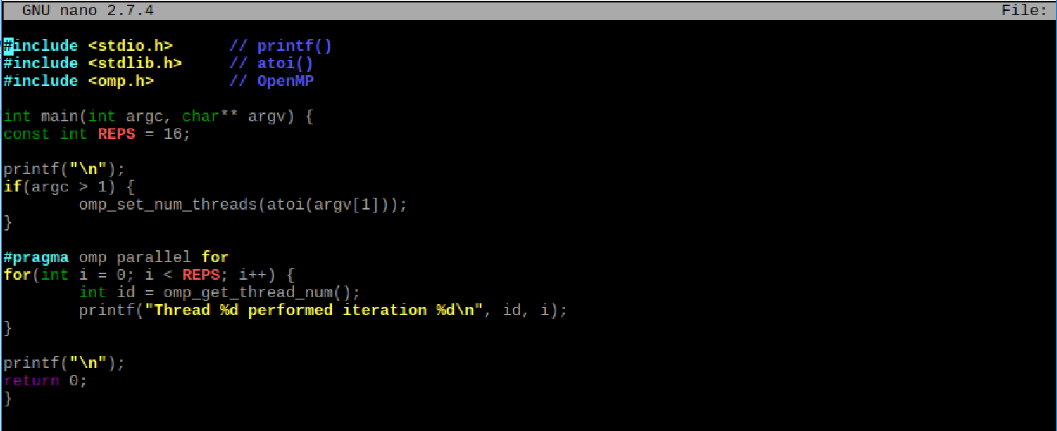

Here we typed out the C file in the terminal window using nano. To compile the program and rename it *pLoop*, we performed the following:

$ gcc parallelLoopEqualChunks.c -o pLoop -fopenmp

To make sure our file was created, we utilized the ‘ls’ utility. Then, we ran the program with 4 threads by using 4 as the argument. Since the Raspberry Pi has 4 cores, it was natural to try 4 threads.

$ ./pLoop 4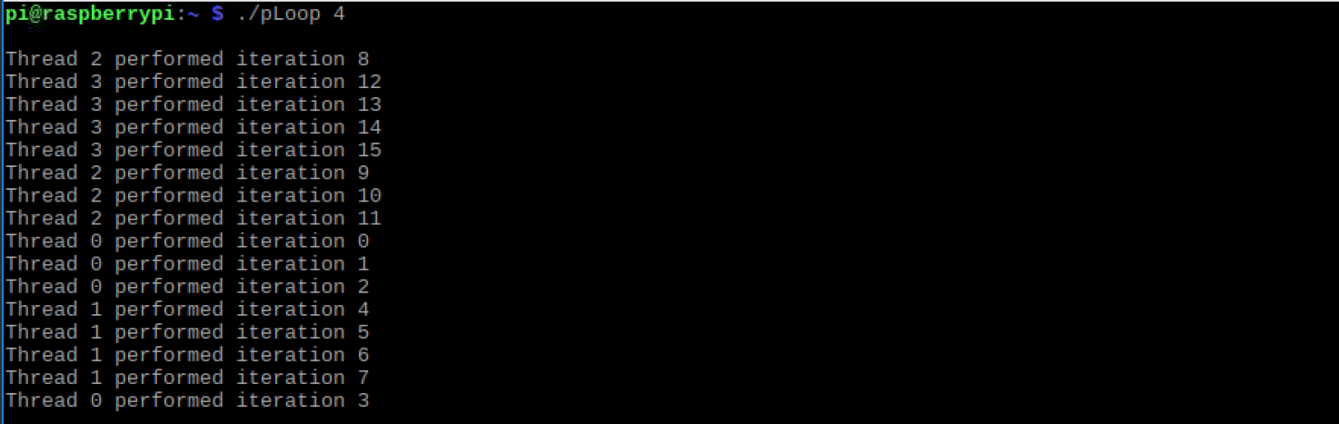

It is interesting to note that the order of the iterations as displayed on the terminal follows no specific pattern, with the exception of threads undertaking consecutive iterations. One would think that the iterations would move in order, or the order of when the thread executes, but this is not the case. The more important take away is that thread 0 manages the first 4 iterations (0-3), thread 1 manages the second 4 iterations (4-7), thread 2 manages the third 4 iterations (8-11), and thread 3 manages the last 4 iterations (12-15). Below we will run the same program using arguments 3, 2, 1 and no argument.

$ ./pLoop 3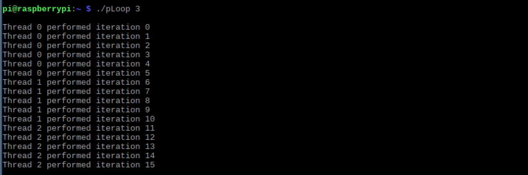

With 3 as the argument, thread 0 performed 6 iterations (0-5), thread 1 performed 5 iterations (6-10), and thread 2 performed 5 iterations (11-15). The interesting takeaway is that thread 0 had one additional iteration in comparison to the threads 1 and 2.

$ ./pLoop2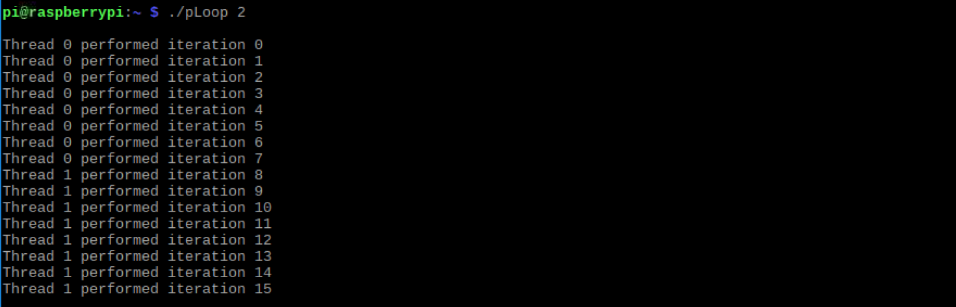

With 2 as the argument, thread 0 performed 8 iterations (0-7)and thread 1 performed 8 iterations (8-15). The total number of iterations was evenly divided among the 2 threads.

$ ./pLoop 1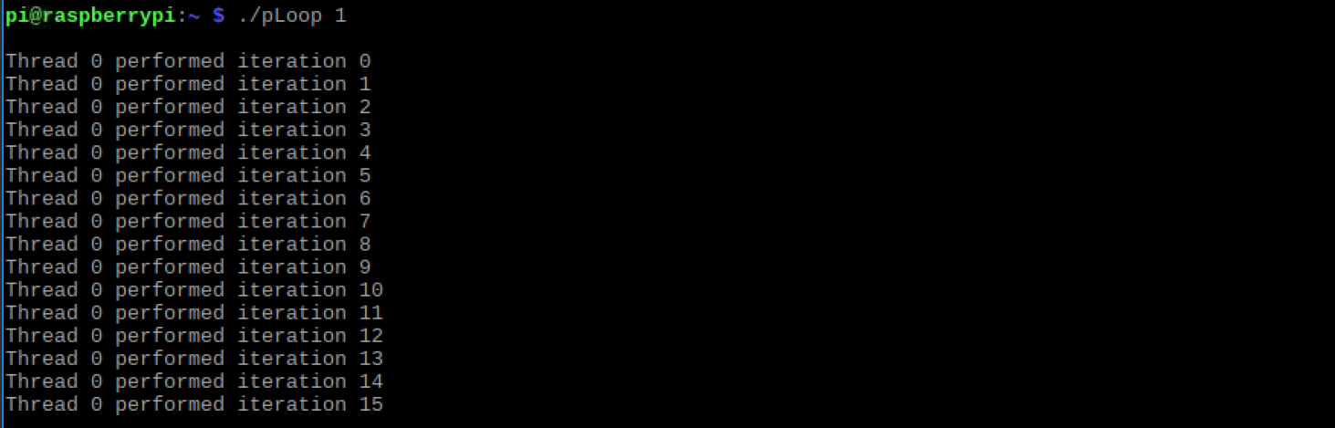

With 1 as the argument, thread 0 performed all iterations. This is not surprising.

$ ./pLoop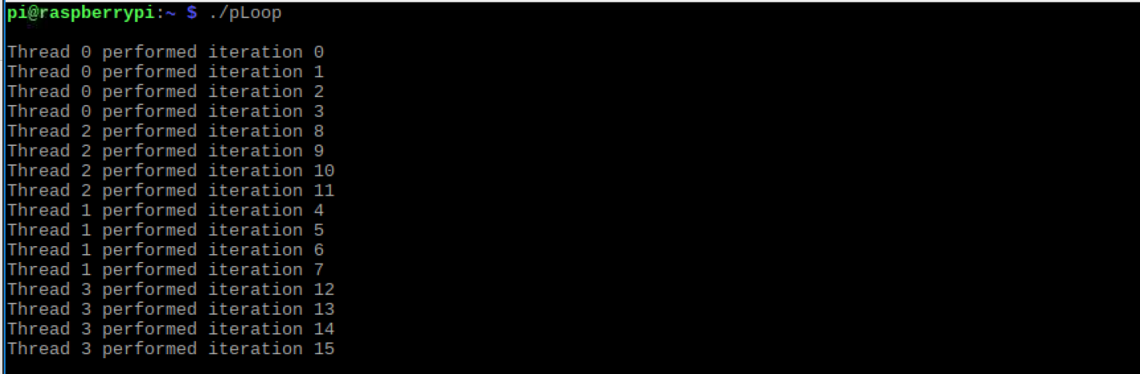

With no argument, it’s surprising to see that the threads were set according to the number of available cores (4 cores = 4 threads). Again, the output is like that of the output with 4 as the argument.

It appears that a modulo operator is used to calculate the remainder when the number of iterations is not evenly divisible by the number of threads. One iteration is added on to each lower thread until the remaining value (remainder = remaining iterations) is depleted. For example, in the *pLoop* program with 3 as the argument, thread 0 took on the additional iteration. We know we have 16 iterations, and we have 3 as the argument. 16 mod 3 = 1. With 1 as the remainder, this was added onto the lowest thread, thread 0, giving it 6 iterations; while the other threads undertook 5 iterations.

**Program 2: parallelLoopChucksof1.c**

$ nano parallelLoopChunksof1.c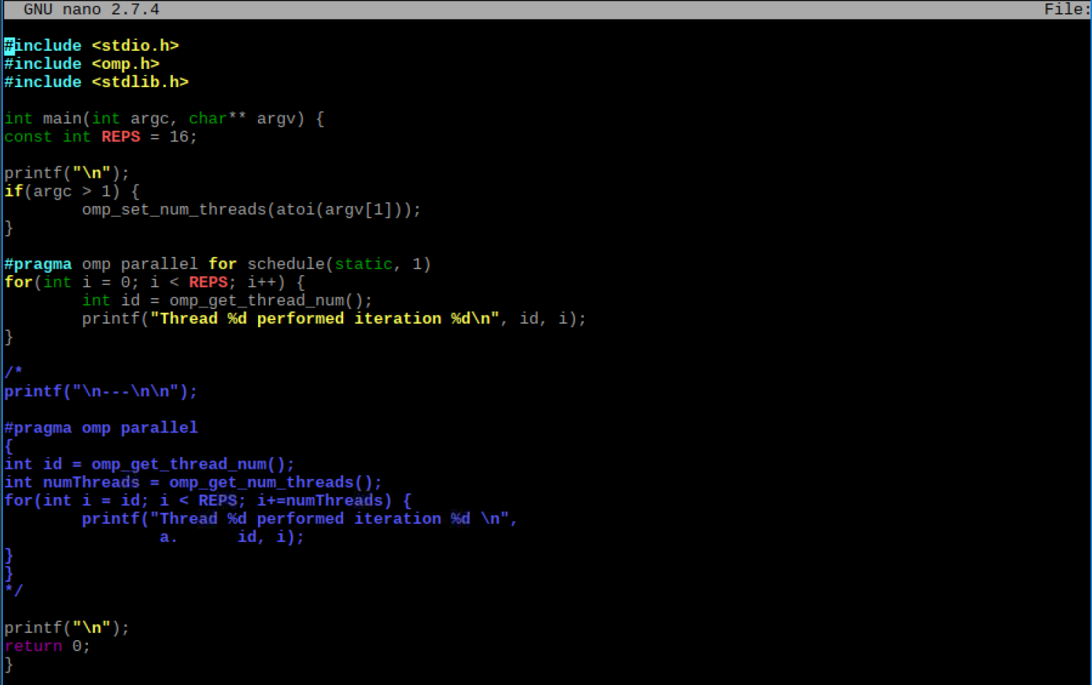

Here we typed out the C file in the terminal window using nano. To compile the program and rename it *pLoop2*, we performed the following:

$ gcc parallelLoopChunksOf1.c -o pLoop2 -fopenmp

To make sure our file was created, we utilized the ‘ls’ utility. Then, we ran the program with 4 threads by using 4 as the argument. Since the Raspberry Pi has 4 cores, it was natural to try 4 threads.

$ ./pLoop2 4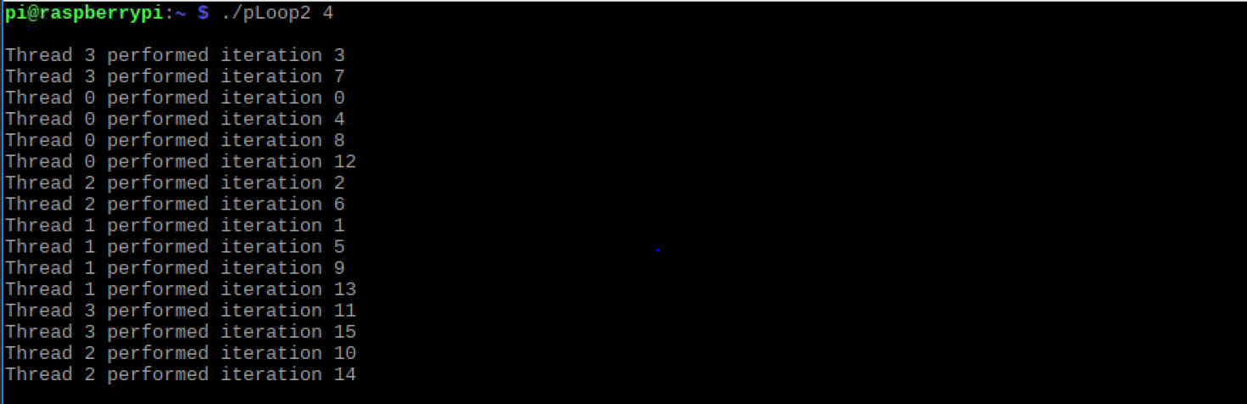

After running the program with an argument of 4, we can see that each thread computes an equal amount of work, just not consecutive iterations. In this case, each thread completes 1 (chunk size) iteration and moves on to the next thread/iteration combination (i.e. 0 thread performs iteration 0, 1 thread performs iteration 1, thread 2 performs iteration 2, and so on until the 4 threads complete the first 4 iterations; then repeats until all iterations are complete). This is surprising in the sense that declaring a static assignment can dictate the amount of work and order by which threads can compute work. Below we will replace 4 with other values for the number of threads.

./pLoop2 3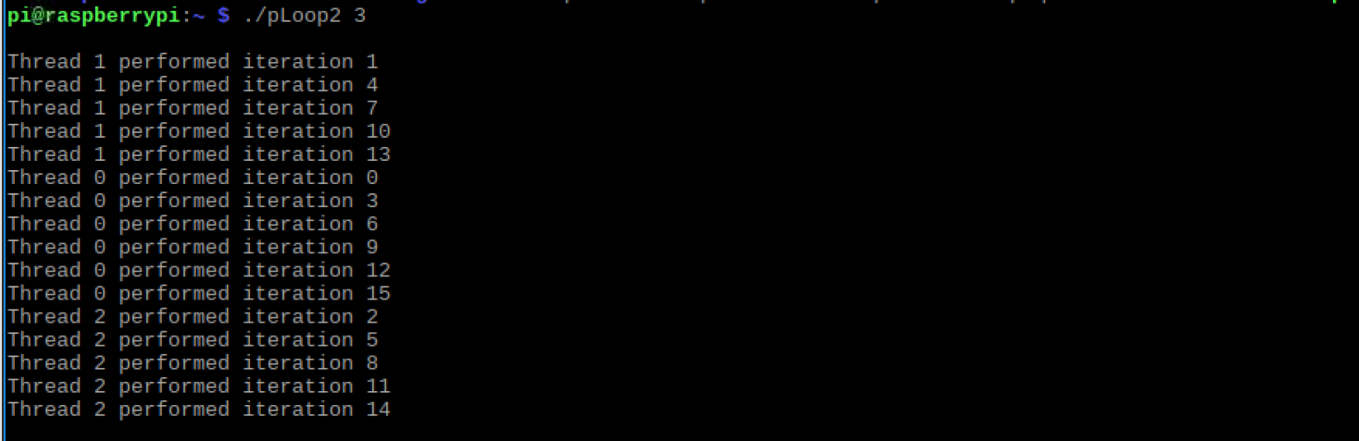

With 3 as the argument, we can see the number of threads is set to 3 threads (threads 0-2). With static being set and assigned a value of 1 (chunk size), we schedule each thread to do one iteration of the loop in a regular pattern. Also, we notice that the remainder principle still applies. Thread 0 has 6 iterations (0, 3, 9, 12, and 15), thread 1 has 5 iterations (1, 4, 7, 10, and 13), and thread 2 has 5 iterations (2, 5, 8, 11, and 14). Since 16 % 3 = 1, the remaining value 1 was added to thread 0—the lowest thread—giving it an extra iteration.

./pLoop2 2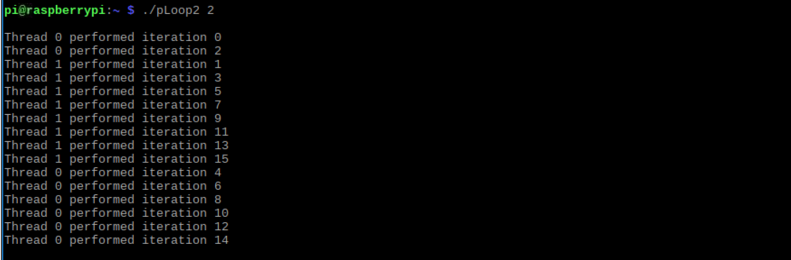

With 2 as the argument, we see the same process with an equal number of iterations between the two threads 0 and 1.

./pLoop2 1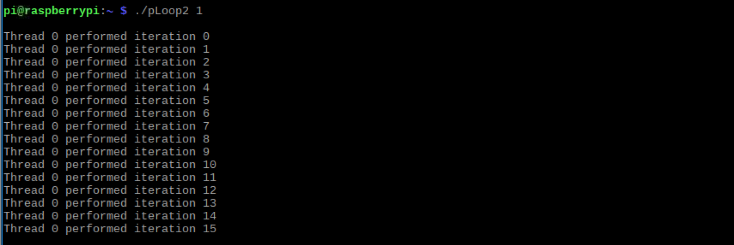

Thread 0 handles all the iterations. Although static and chunk size are set, there is only 1 thread which doesn’t meet the argument size requirement for the *if-statement*.

./pLoop2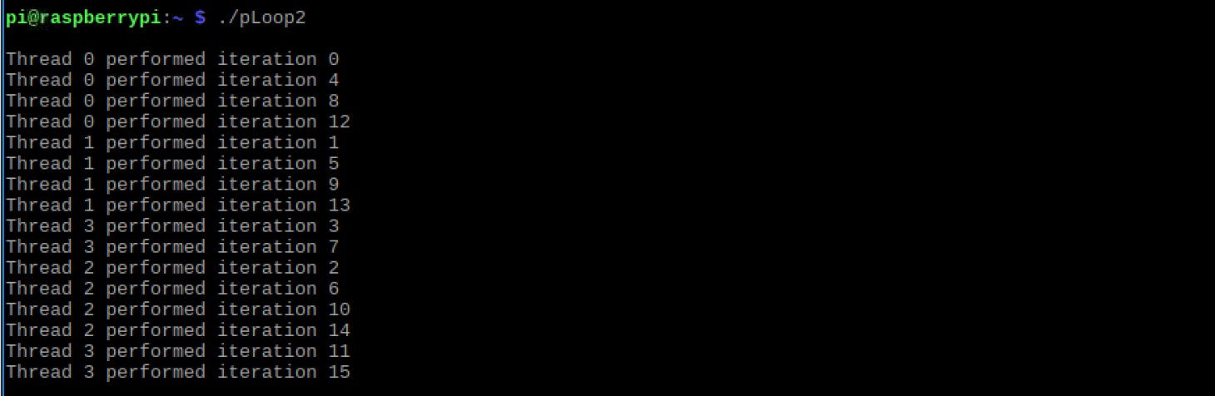

The output of the *pLoop2* program without arguments is similar to the output when the argument is set to 4 (4 cores = 4 threads). This result is expected.

We can also assign the threads dynamically by changing *static* to *dynamic*. Under this assignment, when a thread completes it gets the next iteration or chuck still needed to be completed. For example:

#pragma omp parallel for schedule (**dynamic**, 1)

**Program 3: reduction.c**

$ nano reduction.c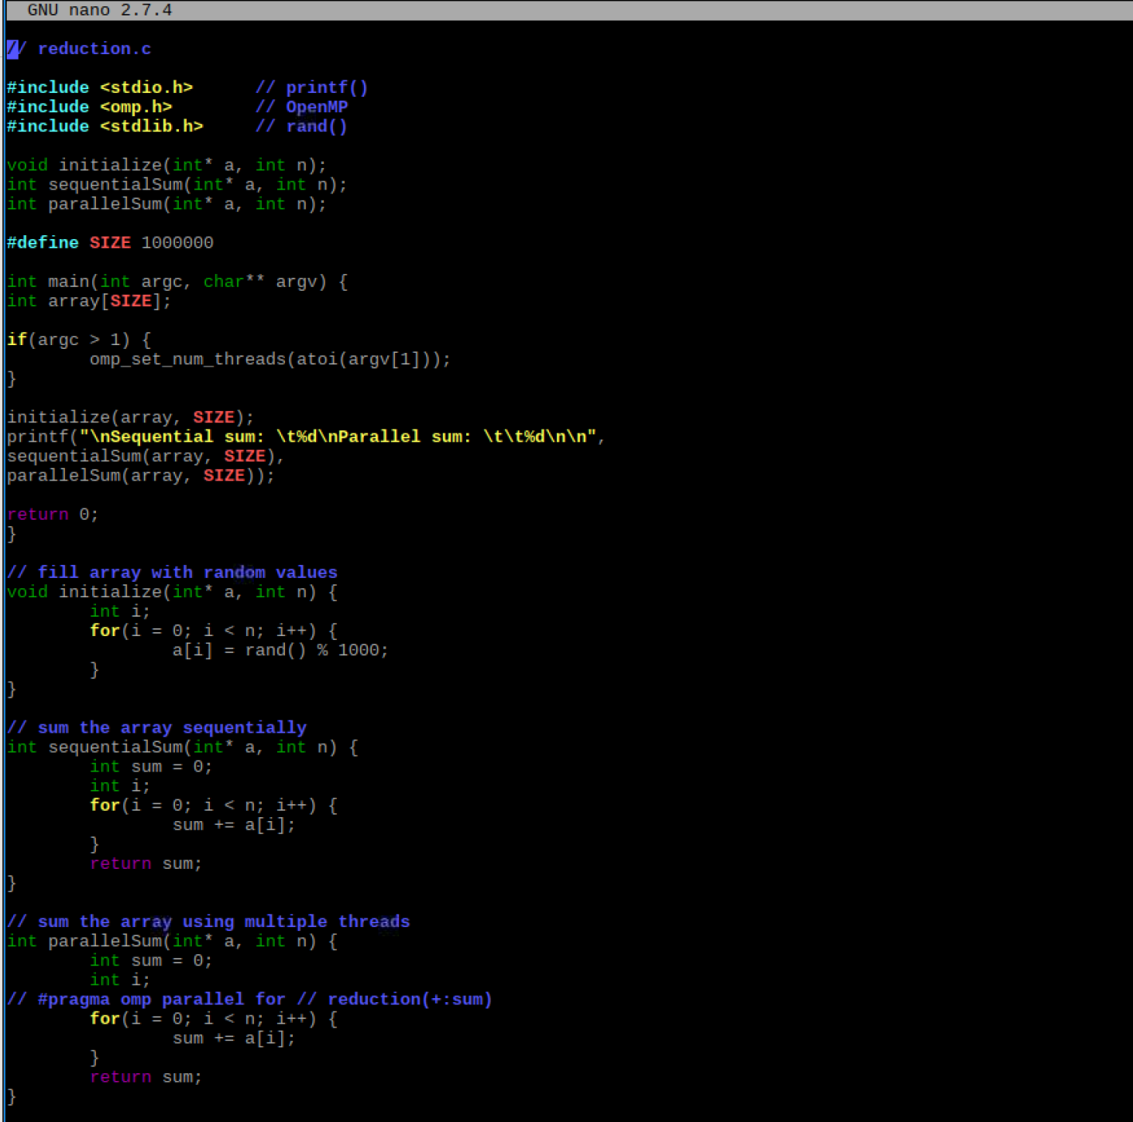

Here we typed out the C file in the terminal window using nano. To compile the program and rename it *reduction*, we performed the following:

$ gcc reduction.c -o reduction -fopenmp

After compiling we ran the program with arguments 4, 3, and no arguments. This is shown below.

./reduction 4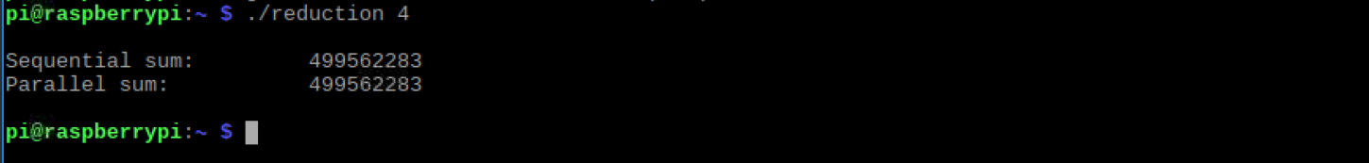

/.reduction 3

/.reduction

In this program, an array of randomly assigned integers is a set of data shared between both sequentialSum() and parallelSum() functions. The functions are identical while the #pragma line is commented out. Thus, we can expect the for loops to sum up all the values in the array. This results in the same output for each function. The correct output is produced by both sequentialSum() and parallelSum() in this example.

Now we will remove the // in front of #pragma in line 39, re-compile, and re-run the program. This will uncomment the first part of the #pragma line allowing the program to run in parallel. The output after running the program with arguments 4, 3, 2, 1, and no arguments are below:

$ ./reduction *n* ;(where n = 4, 3, 2, 1, and “ “)











Here we immediately notice the sequentialSum() function’s results do not match the parallelSum() function’s results, apart from when the argument is set to 1. This makes sense because to set the number of threads, the argument must be a value greater than 1. Here parallelSum() does not produce the correct output. This is interesting as we are allowing parallel computation; however, without the reduction clause the threads cannot implicitly communicate to keep the overall sum updated as each work on a portion of the array.

Next we removed the second // in line 39, re-compiled and re-ran the program using arguments of 4, 3, 2, 1, and no argument. The output is shown below.

$ ./reduction *n* (where n = 4, 3, 2, 1, “ “)

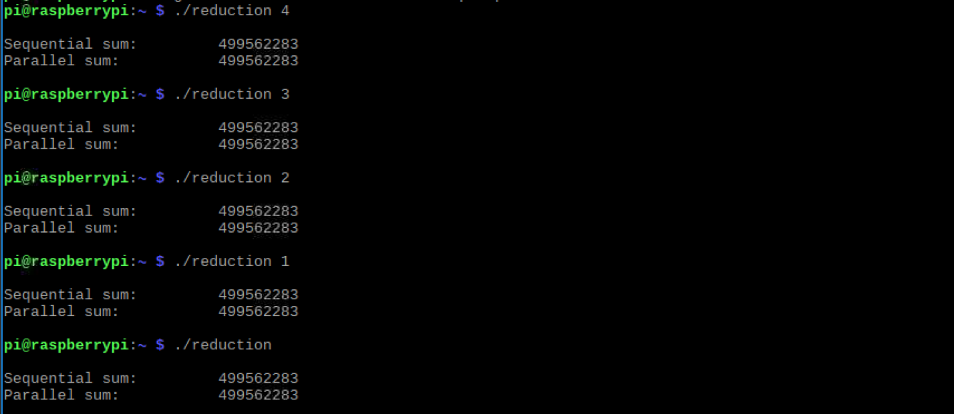

The resulting sum of both functions now equals the correct output. This is what should happen as the reduction clause is now available to be read and executed. The reduction clause, reduction(+:sum), allows all the values to be summed together by using the OpenMP parallel for pragma. The plus sign in the pragma reduction clause signals the variable sum is being computed by added values together in the loop. The threads are now communicating to keep the overall sum updated as each of them works on the portion of the array.

We believe the parallel for pragma did not produce the correct result without the reduction clause because the threads have no way of communicating to track the sums of each iteration. This communication is paramount to return a sum of all computations performed by each thread. The accumulator sum needs to be private as each thread completes its work. Then, when each thread is finished, the final sum of their individual sums is computed. The variable sum is dependent on what the other threads are doing.

A full snapshot of program 3 is below.

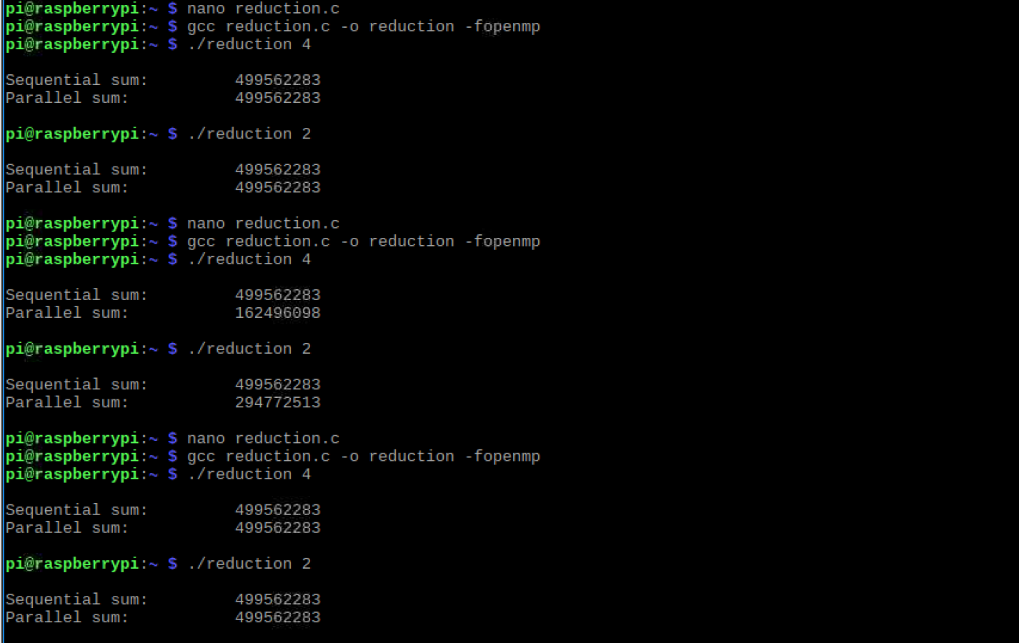

Appendix:

Links –

Slack: https://csc3210.slack.com/messages/CCLREFSHG/

GitHub: https://github.com/TeamNine30

YouTube Channel Link: https://www.youtube.com/channel/UCtZwypH0nkXfciumbrXb8HQ

Screen Shots –

Slack:



GitHub: 

