I tried to use as little AI as possible for this task. I asked it to generate clues or hints as to what I must do and most of my answers were from google searches and visiting a bunch of sites just to figure out what to do. I did use its help to generate the controller files and launch files and when I got stuck I asked for help.
Initially gazebo opened but there was nothing there.
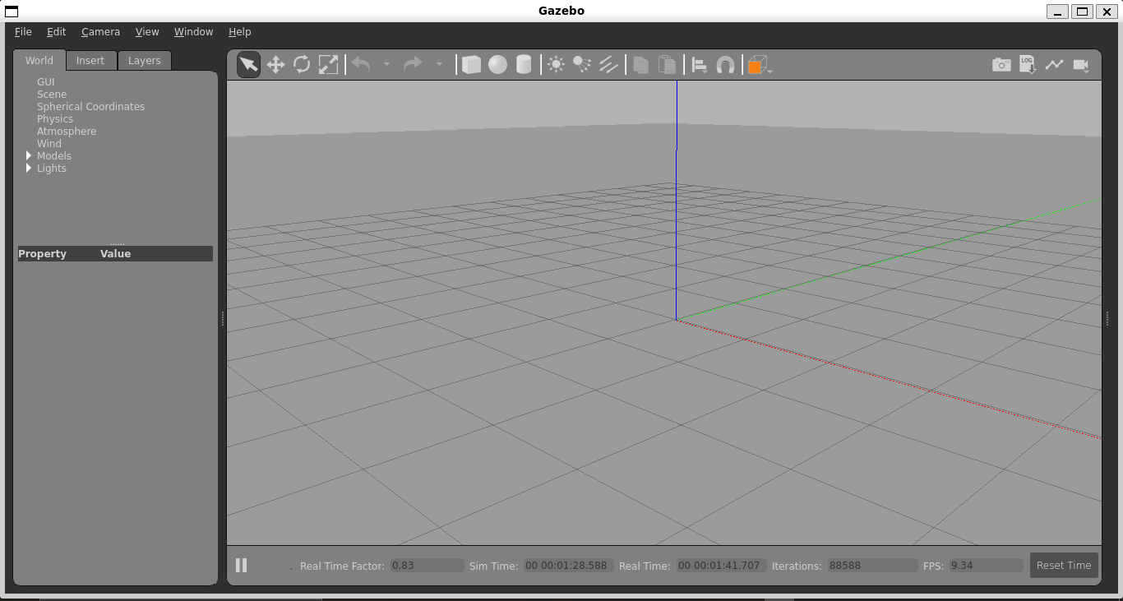
Eventually, I was able to spawn the rover. Not sure if it is correct but it was there and the main body was moving (I have no idea why it happened or even if it should have happened or not, the video is attached)
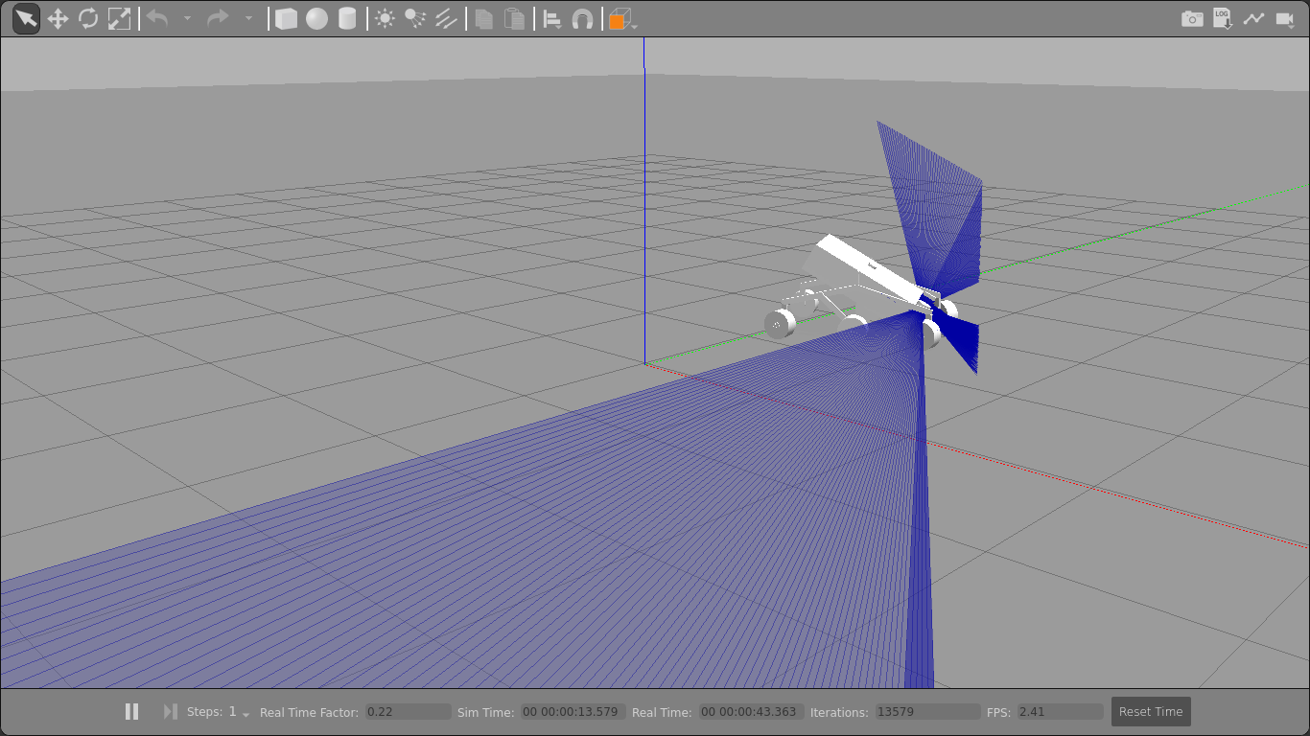
The rover was spawned but every time I tried to run a command including ros2_control it just kept showing the same error with spawner (it was waiting for control manager to become available) I asked chatgpt to fix the error and it told me to make some changes in the launch file and when I did the rover was sideways.
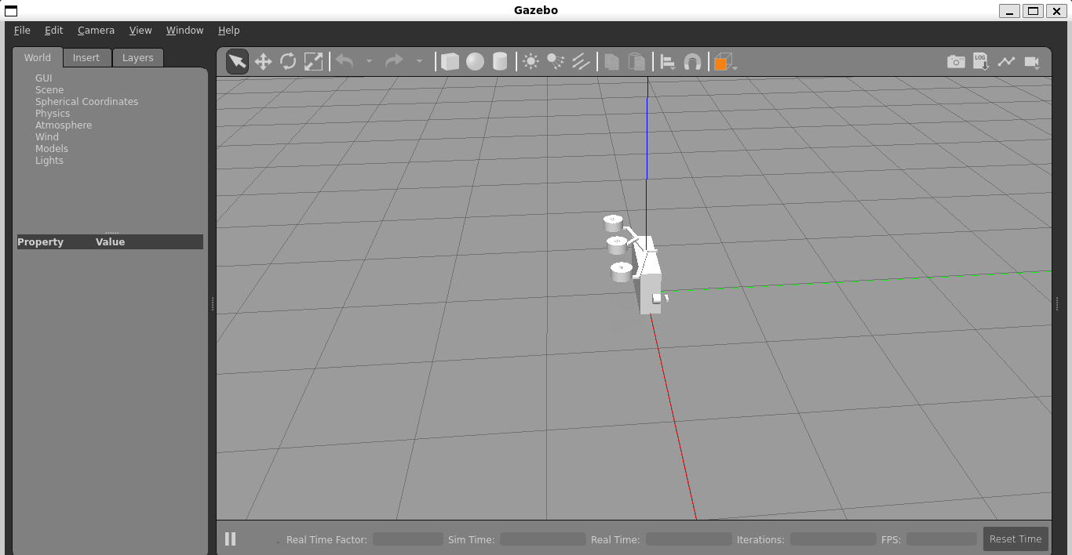
It was really late and I am already 5 days behind schedule so I have submitted my file where I have only done the first core task.

