Southern Luzon State University
Lucban, Quezon
College of Engineering
CPE Department

Class Schedule Monitoring System

Dalmacion, Jenny Lou F.
Obmasca, Bryan Bernard I.
Pornobi, Mark Anxernee M.
Rait, Fraulen Kaye J.
Salvania, Djanico I.
Vasquez, Carlos Nicholas J.

Engr, Jeru Shalom A. Barlos
CPEE1-Elective Instructor

- Introduction
- Purpose
The purpose of the Class Schedule Monitoring System is to monitor the different classes assigned to each classroom in the College of Engineering together with additional information such as the time span, instructor, class section and the subject.
- Scope
The System comprises of the schedule assigned to each classroom of the College of Engineering together with additional information such as the time span, instructor, class section and the subject.
There are three levels of authorization as to what privileges corresponds to each user level. The lowest level is the student level; second, at the middle level is the instructor level; and lastly, the highest level is the administrator level. The student level have the search function. When logged in, the student can search the classroom and the table in the system will display the schedule corresponding the room that was chosen. The instructor level have the search and add function. The instructor can add whatever schedule he/she was assigned. The administrator have all the privileges namely, add, delete, update, and search. The administrator will manage all the data that will be inputted in the system. He/she can add, delete, and update the data as to manage the system.
An export to pdf function is also available to convert the searched data into a downloadable format.
- System Overview
Class Schedule Monitoring System provides the tools to manage the data inputted in the system. It contains the following features:
- A log-in system
- Three user levels
- A normalized database
- An export to PDF function
- Technical Definitions
Normalized database is minimizes data redundancy through the process of organizing columns and tables of a relational database.
Export to PDF is a function that converts searched data into PDF.

- System Architectural Representation
- Flow Chart
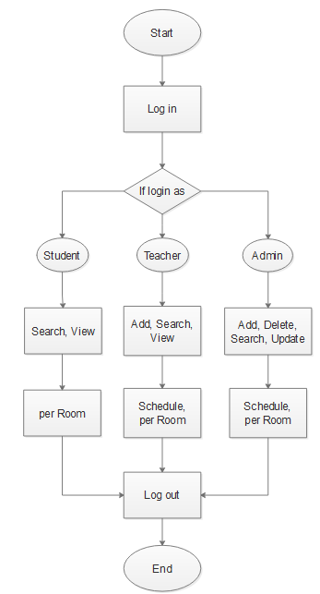

- Document-Object Model

- Case Diagram
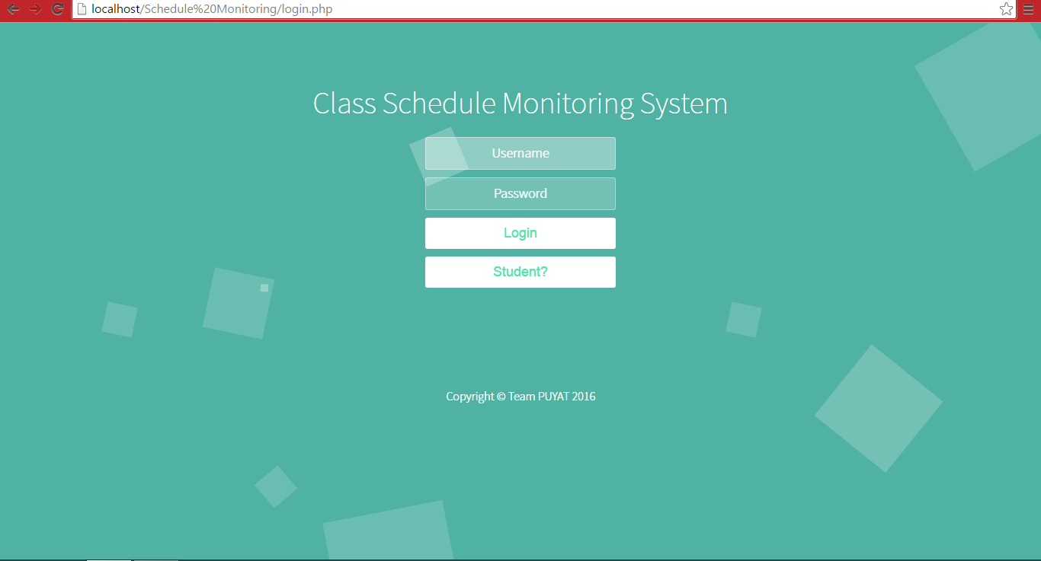
Log-in system of the project.

Administrator Level interface.
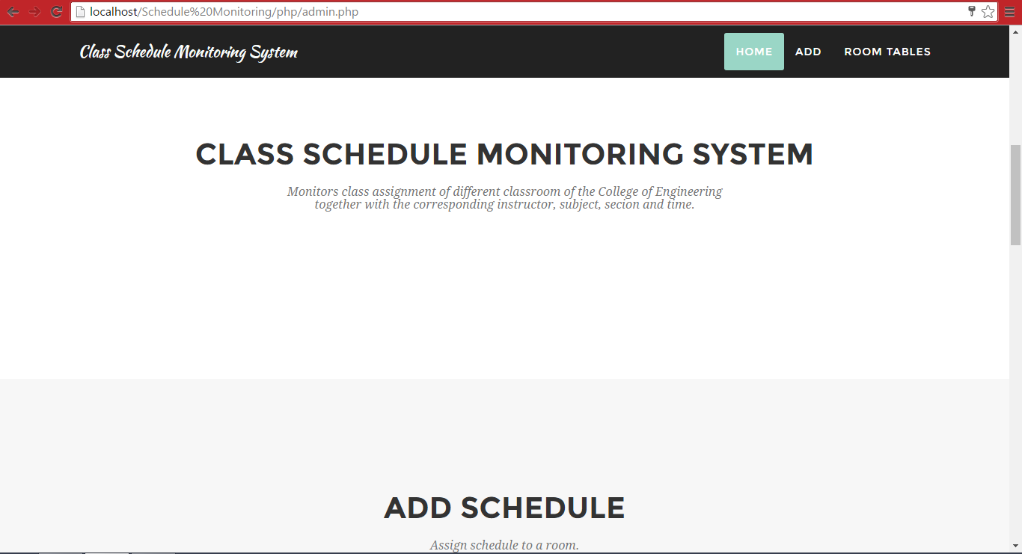
Home page
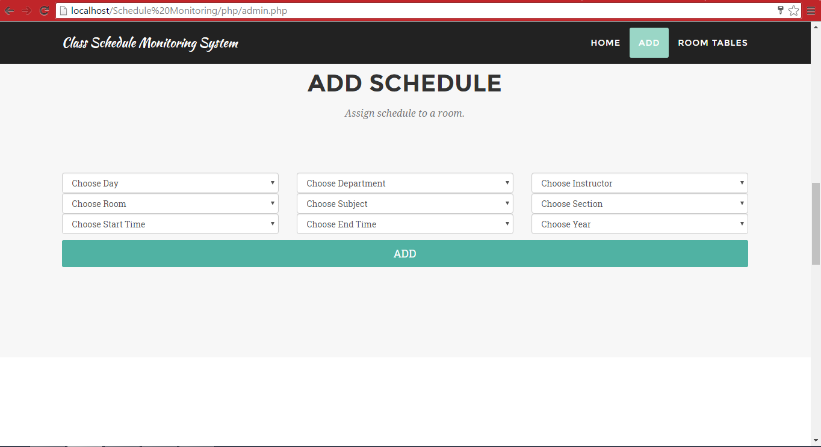
Interface for assigning a schedule to a room.
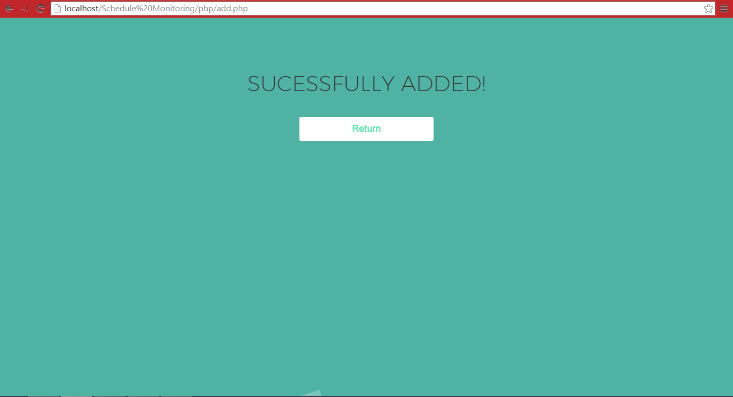
Automatically prompts user if the schedule assignment is successful.
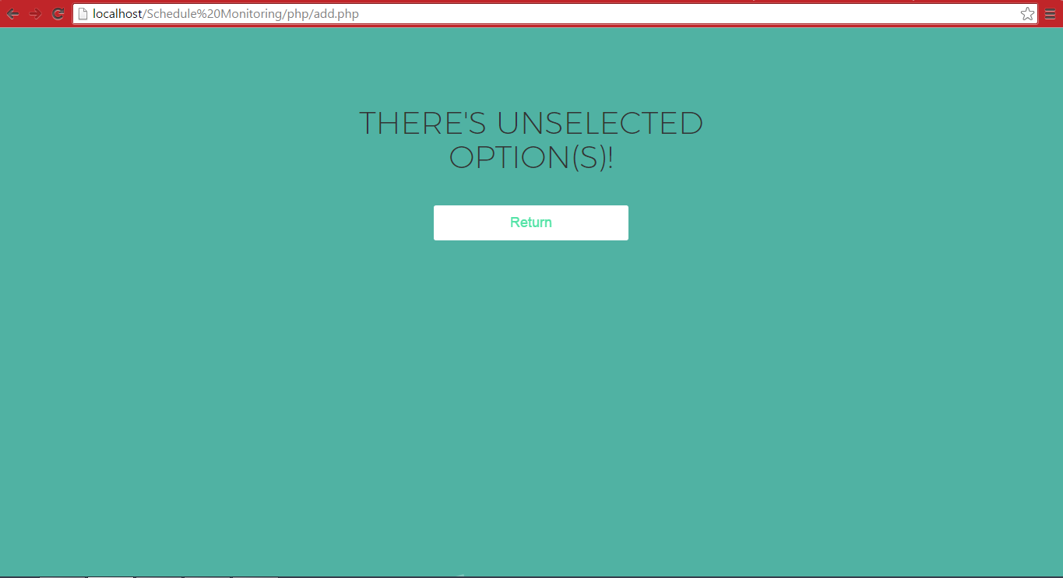
Redirects to an error page when a field is empty.
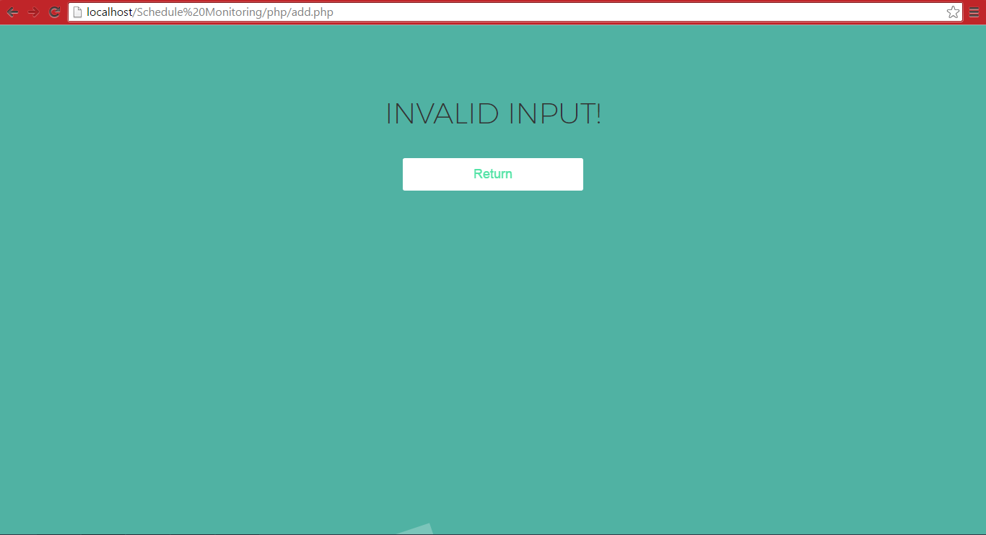
Redirects to an error page when there is a conflict of schedule assignment.
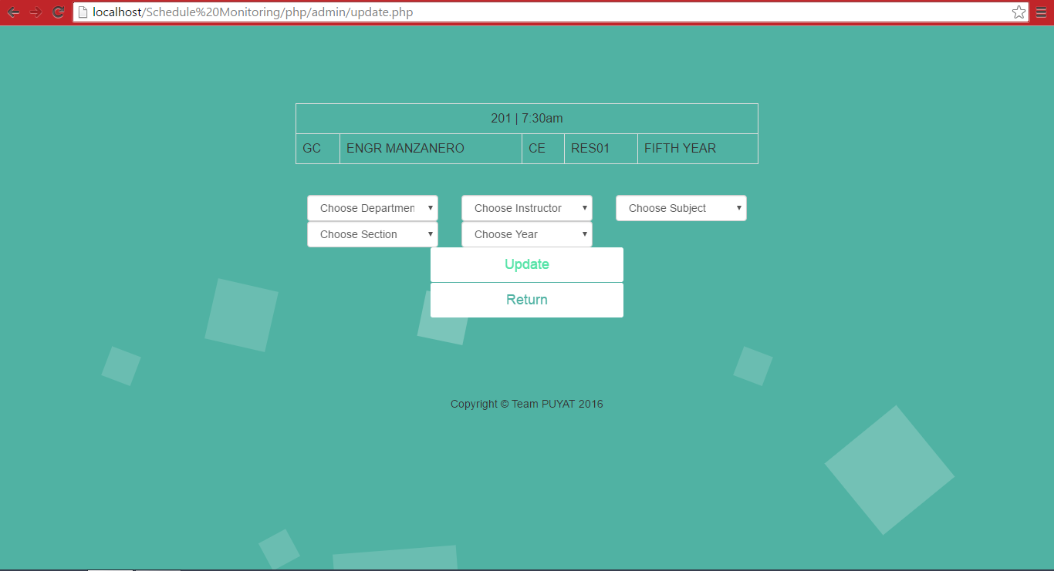
Update function of the Admin level.
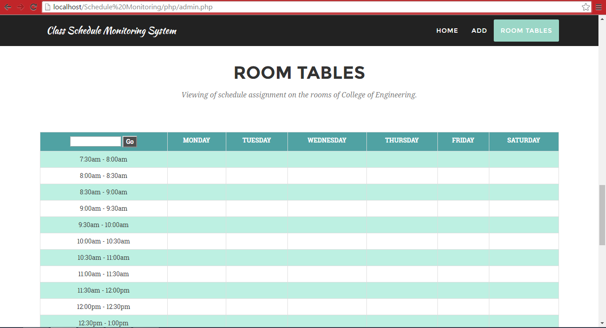
Interface for searching and viewing of schedule assignments.

Export to PDF function
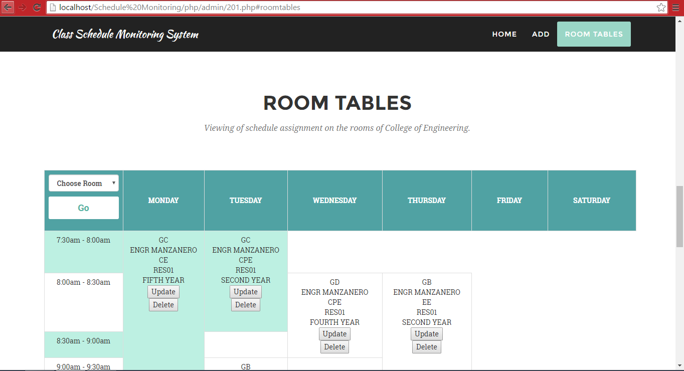
When a user utilizes the search function.

Interface for the Instructor level.
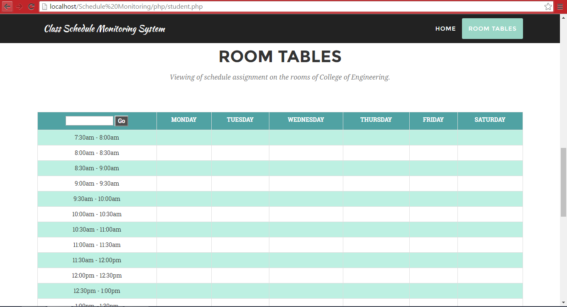
Interface for the Student level.
- Source Codes
- Software Tools
XAMPP is an open-source web server package that works on various platforms. It was used to create and configure the database written in MySQL.
Sublime Text is a cross-platform source code editor with a Python application programming interface (API). It natively supports many programming languages and markup languages, and its functionality can be extended by users with plugins, typically community-built and maintained under free-software licenses.
Bootstrap is a free and open-source front-end for creating websites and web applications. It was used to design the system.
jQuery is a cross-platform JavaScript library designed to simplify the client-side scripting of HTML. jQuery's syntax is designed to make it easier to navigate a document, select DOM elements, create animations, handle events, and develop Ajax applications.

- Project Management
- Gantt Chart
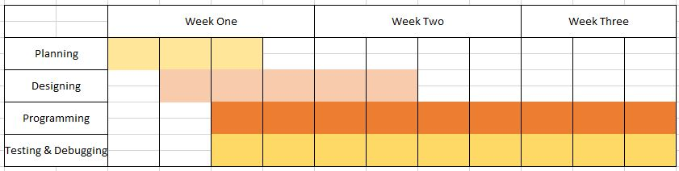
- Project Members Job Specification

Vasquez, Carlos Nicholas J.
Content Strategist
Contribution:
- Created and normalized the tables in the database, documented the progress and helped in the conceptualization and programming of the system.

Salvania, Djanico I.
Content Service Representative
Contribution:
- Assisted in debugging the system.


Pornobi, Mark Anxernee M.
UI Designer/Content Service Representative
Contribution:
- Analyzed some of the bugs and errors that we encountered.
- Assisted creating/planning of the Back-End.


Obmasca, Bryan Bernard I.
Team Leader/Full Stack Developer
Contribution:
- Head of the system.
- Managed the team.
- Modified the downloadable bootstrap (Front-End).
- Head of the Back-End.


Dalmacion, Jenny Lou F.
Front-End Developer
Contribution:
- Front-end support
- Table developer (front-end)


Rait, Fraulen Kaye J.
Debugger
Contribution:
- Front-end support
- Back-end support

