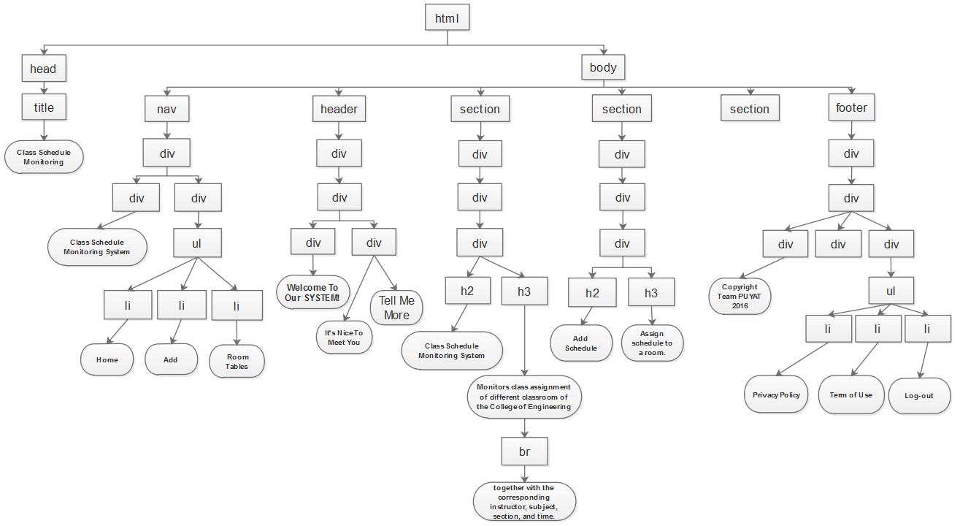***DOCUMENT OBJECT MODEL***

***DOCUMENT OBJECT MODEL***

***(for the third section)***

