ZAHORÍ 2.5

© Panel Sistemas Informáticos

INDEX
INDEX 2
1. SETUP 3
2. Creating a zahorí project from scratch 4
3. Description of the structure and files within a Zahorí project 5
3.1.1. PARENT MODULE 6
3.1.2. TESTS MODULE: aat 7
3.1.3. APPLICATION MODULE: app 10
4. Test execution 11
4.1. From Eclipse 11
4.2. From command line 13
4.3. From Jenkins 13
5. Test reports 13
5.1. Log files 14
5.2. Screenshots 14
5.3. Word document 15
5.4. Video 16
5.5. ALM 16

SETUP

To start developing with Zahorí, the following software must be installed in your machine:

- Java JDK 1.7 (or later)
Download and inatallation instructions can be found in Oracle official website: http://www.oracle.com/technetwork/es/java/javase/overview/index.html

- Maven 3 (or later)
Download and inatallation instructions can be found in Maven official website: https://maven.apache.org/install.html

- An IDE supporting Java:
  - Eclipse: https://eclipse.org
  - Netbeans: https://netbeans.org
  - IntelliJ IDEA: https://www.jetbrains.com/idea
  - …

- Source code repository (preferably GIT):
  - GIT: https://git-scm.com/
  - Subversion: https://subversion.apache.org/
  - CVS: http://www.nongnu.org/cvs/

- Zahorí framework
Zahorí framework consists in a .jar file, usually provided by a Nexus server previously configured or provided.
To start using it, you will only need to include the Zahorí maven dependency in your project within the pom.xml file:
<dependency>
<groupId>es.panel.cest</groupId>
<artifactId>zahori</artifactId>
<version>2.5 </version>
</dependency>

This will be explained more in detail in next sections.

- Zahorí maven archetype
In order to start developing tests as fast as possible, you can use the zahorí archetype to generate the basic project structure needed to start using Zahorí.
Zahorí archetype is also provided through the Nexus repository.
How to use this archetype will be explained in next sections.

- Webdriver (for web tests)
To be able to execute web tests you will need the specific webdriver for the target browsers.
You can download them here: http://www.seleniumhq.org/download/#thirdPartyDrivers
These are the most common:
  - Internet explorer:
http://selenium-release.storage.googleapis.com/2.53/IEDriverServer_Win32_2.53.1.zip
  - Microsft Edge:
https://developer.microsoft.com/en-us/microsoft-edge/tools/webdriver/
  - Firefox: https://github.com/mozilla/geckodriver/releases
  - Chrome: https://sites.google.com/a/chromium.org/chromedriver/
  - Safari: https://webkit.org/blog/6900/webdriver-support-in-safari-10/

Download drivers that you need in this folder: D:/ENVIRONMENT/selenium
This is the default folder in which Zahorí will look for the drivers, but you can choose one of your choice and specified it in zahori.propertes file.

- H3270 (for mainframe/host tests)
To be able to execute mainframe/host tests you will need the host emulator H3270
It can be downloaded here: http://h3270.sourceforge.net/
There you can also find the installation and running instructions.

Creating a zahorí project from scratch
To create a new Zahorí project just follow these steps:

- Open a new command line window and change to the directory where you want the new project to be located.

- Execute the following command to generate the project.
Before executing it, replace these variables with desired values:
<PACKAGE>: for example: com.santander
<PROJECT_NAME>: for example: TestZahori

mvn archetype:generate -DarchetypeGroupId=es.panel.cest -DarchetypeArtifactId=zahori-maven-archetype -DarchetypeVersion=2.5-SNAPSHOT -DgroupId=<PACKAGE> -DartifactId=<PROJECT_NAME> -Dpackage=<PACKAGE>.<PROJECT_NAME> -Dversion=1.0-SNAPSHOT -DzahoriVersion=2.5-SNAPSHOT

Example:
mvn archetype:generate -DarchetypeGroupId=es.panel.cest -DarchetypeArtifactId=zahori-maven-archetype -DarchetypeVersion=2.5-SNAPSHOT -DgroupId=com.santander -DartifactId=TestZahori -Dpackage=com.santander.testZahori -Dversion=1.0-SNAPSHOT -DzahoriVersion=2.5-SNAPSHOT

This command will generate a folder with the same name as <PROJECT_NAME>: “TestZahori”

- Import the generated project from Eclipse (or your favorite IDE):
File > Import > Maven: Existing Maven Projects > select folder named “TestZahori”

This action will load the project into the IDE.
In the next section the structure and files within the project are described.

Description of the structure and files within a Zahorí project

Zahorí projects have the following basic structure and files:

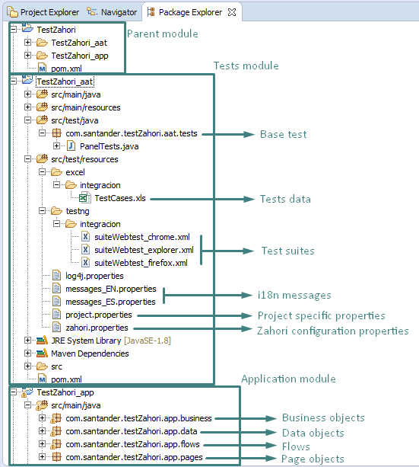

PARENT MODULE
This module is just a maven container for aat and app modules. The aim of it is to wrap both modules into a single project.

It contains the parent pom.xml file in which the following main parameters are defined:

- Project identification properties
<groupId>com.santander</groupId>
<artifactId>TestZahori</artifactId>
<version>1.0-SNAPSHOT</version>
<name>TestZahori</name>

- Java version and encoding
<properties>
<project.build.sourceEncoding>UTF-8</project.build.sourceEncoding>
<build.compiler>1.8</build.compiler>
...
</properties>

- Modules: aat and app
<modules>
<module>TestZahori_app</module>
<module>TestZahori_aat</module>
</modules>

- Project dependencies:
<dependencies>
<dependency>
<groupId>es.panel.cest</groupId>
<artifactId>zahori</artifactId>
<version>2.5-SNAPSHOT</version>
</dependency>
...
</dependencies>

- Artifacts repository: Nexus
<distributionManagement>
<repository>
<id>${nexus.id.release}</id>
<name>Releases</name>
<url>${nexus.home.release}</url>
</repository>
<snapshotRepository>
<id>${nexus.id.snapshot}</id>
<name>Snapshots</name>
<url>${nexus.home.snapshots}</url>
</snapshotRepository>
</distributionManagement>

TESTS MODULE: aat
This is the tests module. It contains all information related with tests: the base test, test data, test suites and configuration files:

- Base test: in the example above this is the file PanelTests.java. It is responsible to initialize the test, create the test context, retrieve test case data, execute the test invoking the corresponding flow, and finalize the execution generating test reports.

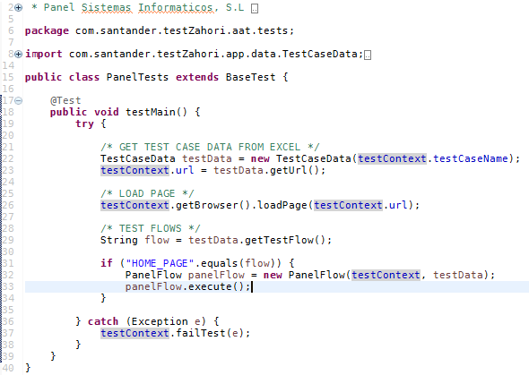

- Test data: TestCases.xls in the example. This is the file where the data for each test case is parameterized. Excel files are the default for this purpose, but test data could be retrieved from any other data sources (xml, csv, databases,…).

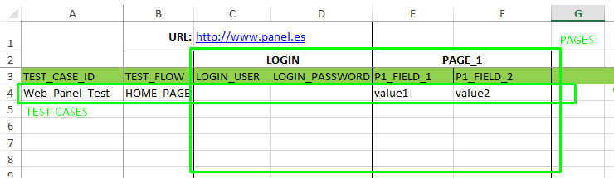

- Test suites: in the example above suiteWebtest_chrome.xml, suiteWebtest_explorer.xml and suiteWebtest_firefox.xml. They represent test suites, grouping test cases by functionalities or by execution capabilities (OS, browser,…). These files are the initiators of test executions, invoking the corresponding base test.

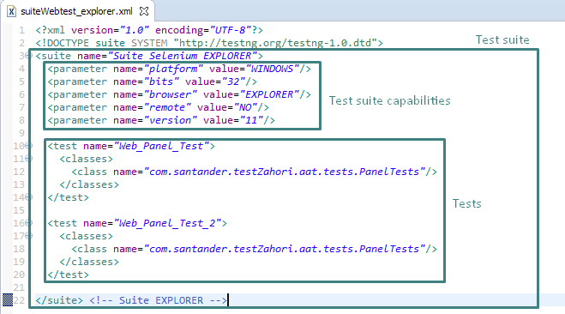

- I18n messages: properties files (messages_EN.properties, messages_ES.properties …) where internationalized messages are defined, in order to display reports in several languages.

- Project specific properties: project.properties. A properties file where project variables can be defined like this:
com.santander.example.variable=1200

Then, along the automation project, the value of this property can be retrieved using the testContext like this:
testContext.getProjectProperty(“com.santander.example.variable”);

- Zahorí configuration properties: zahori.properties. This file contains all configurable parameters of Zahorí framework.
Main parameters are the following:

  - WebDrivers:

# Name of the webDriver for Internet Explorer
webdriver.ie.driver.name=/IEDriverServer.exe

# Path where the Internet Explorer webDriver is located
webdriver.ie.driver.path=D:/ENVIRONMENT/selenium/iedriver/

# Path where the Chrome webDriver is located
webdriver.chrome.driver=D:/ENVIRONMENT/selenium/chromedriver/chromedriver.exe

  - Test execution timeout:

# Timeout for finding an element
zahori.test.execution.timeout.findElement=20

  - Test reports:

# Path where reports (evidences) will be generated
zahori.test.results.dir=target/test-results/

# Flag to generate or not a log file containing low level execution details zahori.test.results.evidence.generateLogFile=1

# Flags to generate video of the execution when test is passed or failed
zahori.test.results.evidence.generateVideo.passed=1
zahori.test.results.evidence.generateVideo.failed=1

# Flag to generate word document containing high level execution details and screenshots
zahori.test.results.evidence.generateDoc=1

# Flag to generate screenshots
zahori.test.results.evidence.generateScreenshots=1

  - Options for Test Management Systems: ALM, TestLink

# Flag to update results in selected TMS
zahori.test.results.tms.enabled=1

# TMS where test results will be updated. Supported: ALM and TestLink
zahori.test.results.tms=ALM
zahori.test.results.tms.updateTestResult=1

# TMS Report Options: flags to select what evidences to upload
zahori.test.results.tms.uploadEvidence.logFile.passed=1
zahori.test.results.tms.uploadEvidence.logFile.failed=1
zahori.test.results.tms.uploadEvidence.video.passed=1
zahori.test.results.tms.uploadEvidence.video.failed=1
zahori.test.results.tms.uploadEvidence.doc.passed=1
zahori.test.results.tms.uploadEvidence.doc.failed=1

# TestLink: url and credentials
zahori.test.results.tms.testLink.url=http://10.65.32.115/testlink/lib/api/xmlrpc/v1/xmlrpc.php
zahori.test.results.tms.testLink.apiKey=09d3cd7f595e430aaf5b982460

# TestLink: project and test plan information
zahori.test.results.tms.testLink.projectName=CGAE - SIGA - AUTOMATIZACIÓN
zahori.test.results.tms.testLink.planName=Informe de Justificación - AUTOMATIZACIÓN

# ALM: url and credentials
zahori.test.results.tms.alm.url=http://alm1.prod.gs.corp/qcbin/
zahori.test.results.tms.alm.username=XI324621
zahori.test.results.tms.alm.password=9b755e430aaf5b==

# ALM: project and test plan information
zahori.test.results.tms.alm.domain=SW_COMPONENTS
zahori.test.results.tms.alm.project=QTP_DESARROLLO
zahori.test.results.tms.alm.testSet=Root\\Prueba Concepto Zahorí\\Ejecución_entorno_CERT

APPLICATION MODULE: app
This module contains the following components:

- Data Objects: Java beans containing the specific data needed to execute the test case. These objects encapsulate and group related data.

- Page Objects: represent and encapsulate the elements contained in a user interface page. Page objects are composed of page elements: input fields, buttons, links, …

- Business Objects: Java classes that group (one or many) successive page objects in business modules in order to create reusable components.

- Flows: Java classes that group (one or many) successive business objects to create reusable components in a higher level of abstraction than business objects.

The relation between all these components can be seen in the next figure:
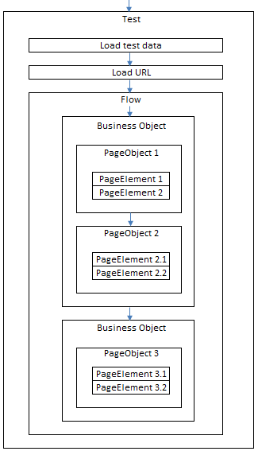

Test execution

From Eclipse
To run a test suite from Eclipse:
- Option 1: Right click on the test suite > Run as > TestNG Suite

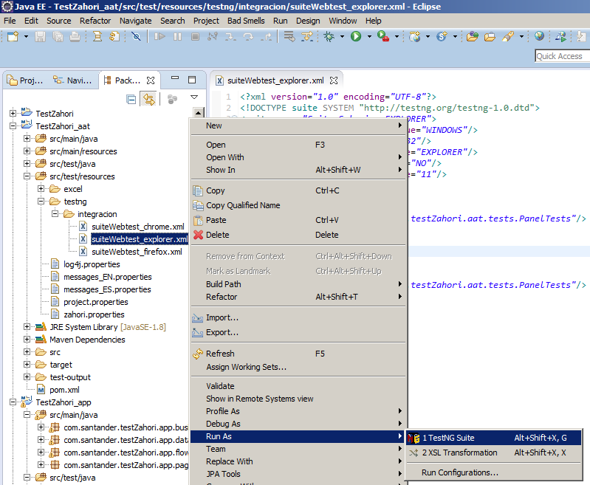

- Option 2: once you have run a test suite using option 1, then you can run a test suite just by cliking eclipse run button as follows:

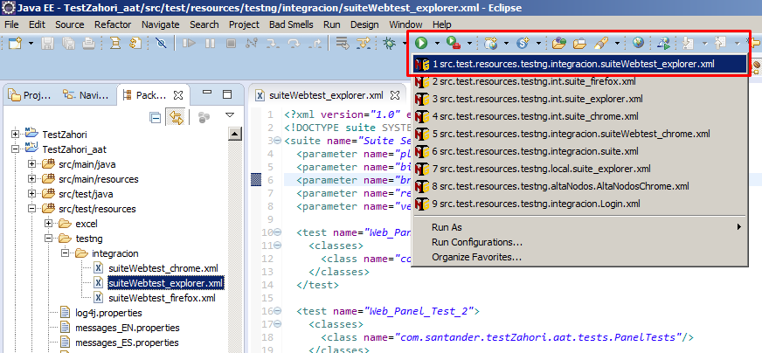

From command line
To run a test suite from the command line follow this steps:
- Open a command line terminal and change the directory where the project is located
In the example used along this document: go to directory “TestZahori”.

- Run the test suite:
mvn verify -U -Dentorno=<ENVIRONMENT> -DsuiteFile=<TEST_SUITE_NAME>

In the example used along this document:
mvn verify -U -Dentorno=integracion -DsuiteFile=suiteWebtest_explorer

From Jenkins

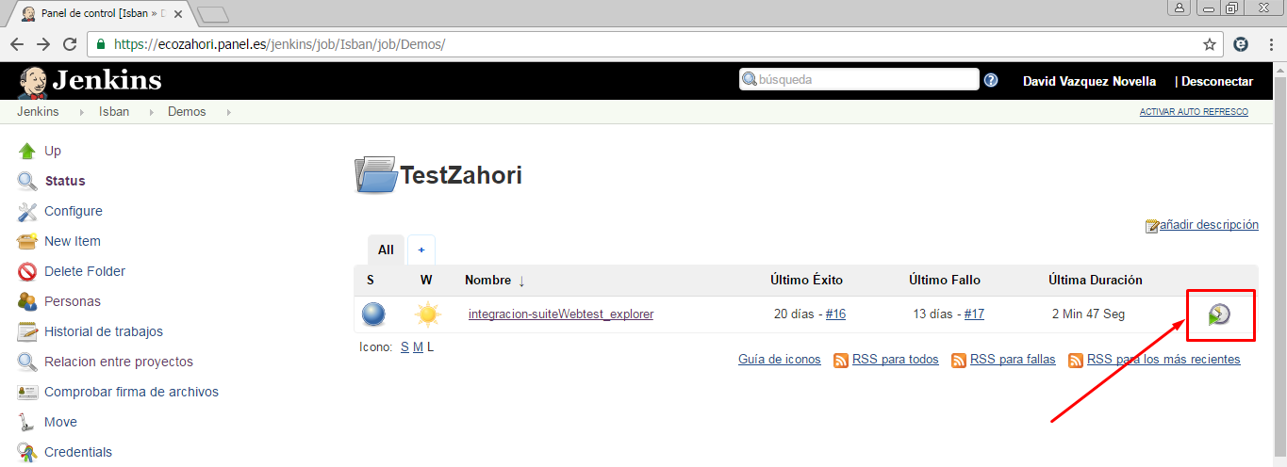

Test reports

Test reports are generated by default in the following project folder (can be changed in zahori.properties):
<Project_name>\<Project_name>_aat\target\test-results\<TestCaseName>\<Browser>\<Timestamp>

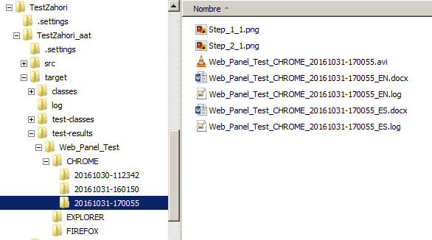

Reports generated include: log files, screenshots, word document and video. You can enable or disable any of them in zahori.porperties file.

Log files
These are low level reports. They contain all the actions executed during the test, useful to investigate what happened in case an unexpected error occurred.

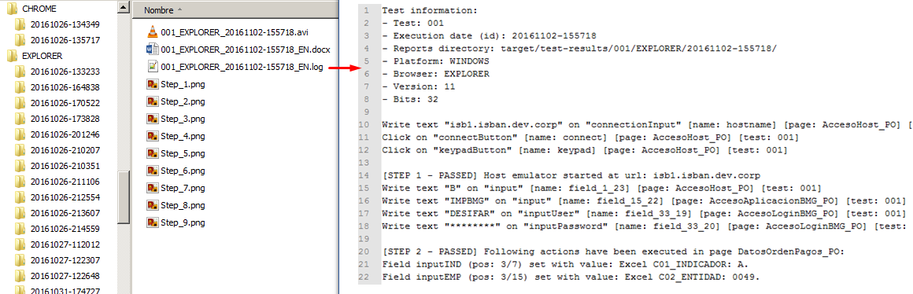

To write in log files use this java method:
testContext.logInfo(text, textArgs);

Screenshots
Screenshots can be taken using the following java methods:
testContext.logStepPassedWithScreenshot(stepDescription, args);
testContext.logStepFailedWithScreenshot(stepDescription, args);
testContext.logPartialStepWithScreenshot(partialStepDescription, args);

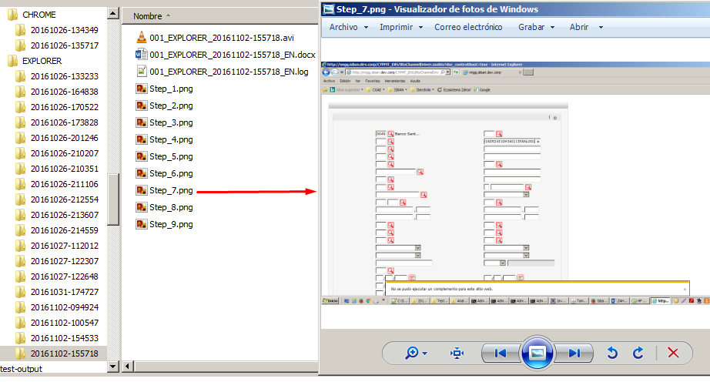

Word document
This document contains high level information about the execution of a paticular test case: test case information, test steps executed, screenshots and test result.

To write steps and screenshots in this document use the following java methods:
testContext.logPartialStep(partialStepDescription, args);
testContext.logPartialStepWithScreenshot(partialStepDescription, args);
testContext.logStepPassed(stepDescription, args);
testContext.logStepPassedWithScreenshot(stepDescription, args);
testContext.logStepFailed(stepDescription, args);
testContext.logStepFailedWithScreenshot(stepDescription, args);

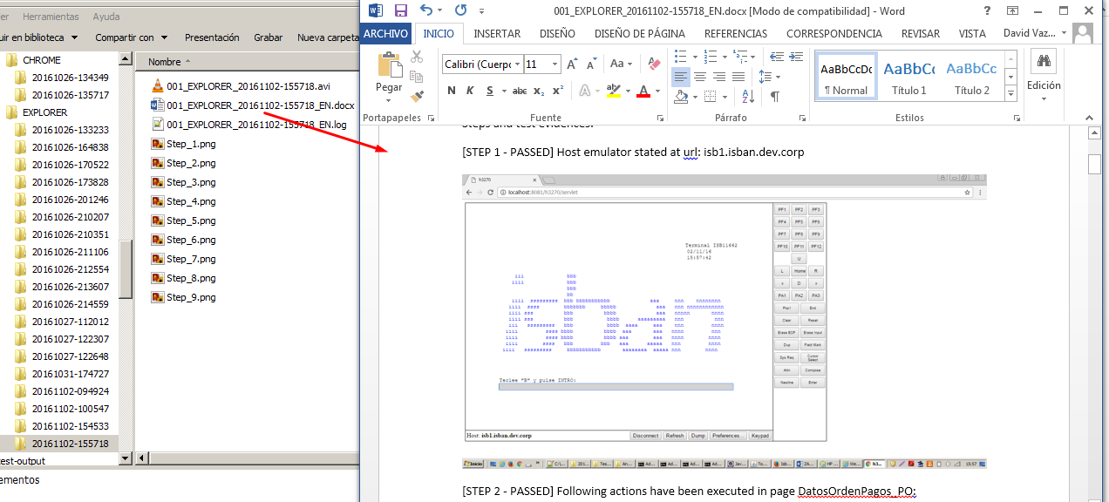

Video
A video file is created for each test case execution. Video generation is enabled by default, but it can be disabled in zahori.properties file.

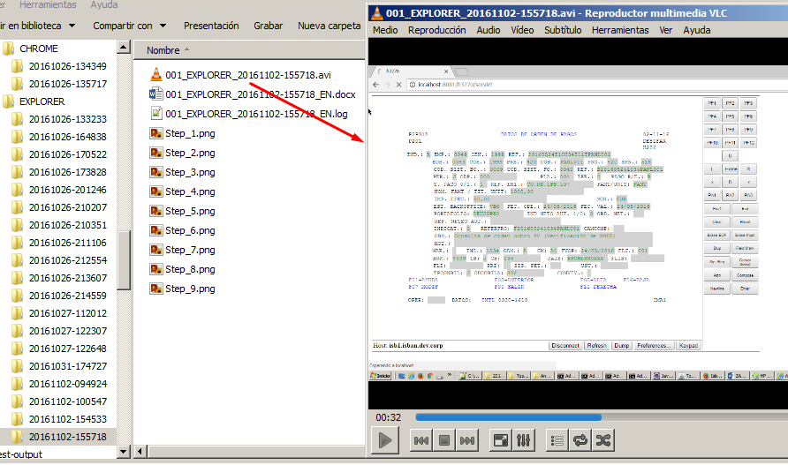

ALM
Test status and reports can be uploaded to ALM in order to track the project status. In zahori.properties file you can choose what reports will be uploaded to ALM. Also you will have to define in this file the ALM credentials and the project parameters (see section Description of the structure and files within a Zahorí project for more information about ALM configuration).

In every test case execution the following information is updated in ALM:
- At test case level:
  - Test case estatus: Passed or Failed
  - Test case execution date
  - Test case execution hour

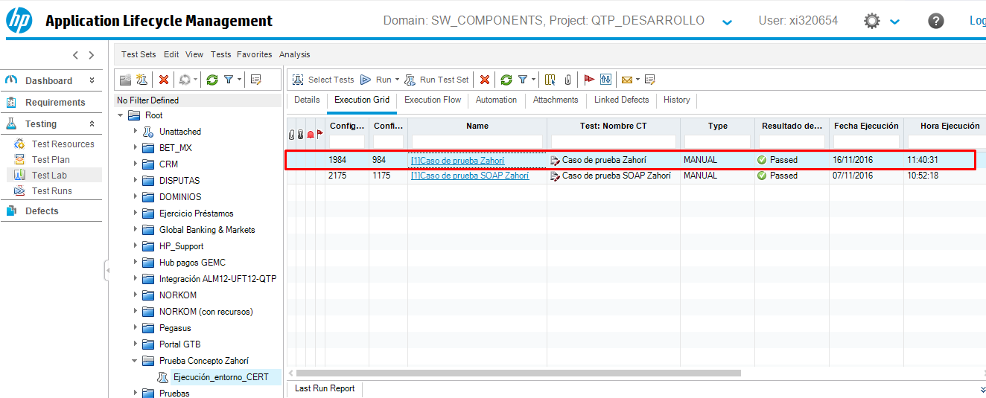

- At Test Run level. A new run is created with this information:
  - Test run status: Passed or Failed
  - Test run duration (in seconds)
  - Test run execution date
  - Test run execution hour
  - Test run steps, with: step name, status, date, hour, description, expected and actual result.
  - Test run attachments: reports regenerated by Zahorí (logs, documents, videos, …)

