Course **JavaScript UI & DOM**

Teamwork assignment

Team Simba

Project name: **Flapper**

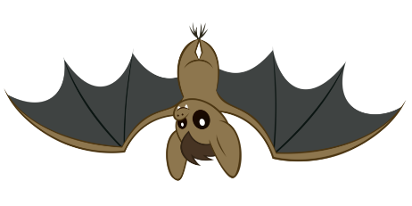

Team members:

[Nailses ( Илиана Йорданова )](http://telerikacademy.com/Users/Nailses)

[kskondov ( Константин Кондов )](http://telerikacademy.com/Users/kskondov)

[kolchagov ( Иван Колчагов )](http://telerikacademy.com/Users/kolchagov)

[marin.stoyanov ( Марин Стоянов )](http://telerikacademy.com/Users/marin.stoyanov)

**Team** **name**: Simba

**Team** **on** **Git**: <https://github.com/TeamSimba>

**Project** **name**: Flapper

**Project** **on** **Git**: <https://github.com/TeamSimba/Flapper>

**List of Contributors**:

* [Nailses ( Илиана Йорданова )](http://telerikacademy.com/Users/Nailses)
* [kskondov ( Константин Кондов )](http://telerikacademy.com/Users/kskondov)
* [kolchagov ( Иван Колчагов )](http://telerikacademy.com/Users/kolchagov)
* [marin.stoyanov ( Марин Стоянов )](http://telerikacademy.com/Users/marin.stoyanov)

**Project** **purpose**: gaming

**How** **to** **play**:

1. Press ENTER button from keyboard or “Start game” on game screen
2. Press UP ARROW to fly
3. Beware of stalactites, crash will kill you

**Add-ons**:

In addition there is second version of the game with main character “Birdy”

**Used languages**:

1. HTML 5
2. CSS 3
3. JavaScript + Kinetic JS library

**Assets**:

* JavaScript client application
* Use HTML5 canvas and canvas framework KineticJS
* Use animations for the canvas
* The application works in the latest versions of the browsers: Google Chrome, Mozilla Firefox, Internet Explorer 10/11, Opera and Apple Safari
* The application follows the best practices for producing high-quality code
* Use GIT as a source control system (GitHub preferable)