**Game Pitch Document:  
Vessoul**  
**by Team Spinning Chairs  
GAM 200 and GAM 205, Fall 2014  
  
  
  
  
  
  
Team Spinning Chairs:  
Esteban Maldonado** -Producer  
-Graphics Programming and Gamestate Manager **Henry Morgan**-Tech Director   
-Editor and Editor UI **Judy Cheng**-Physics Programmer  
-Sound Programmer **Steven Gallwas**-Gameplay programmer  
-Game Design, Gameplay Programming **Ian Aemmer**-Lead Game Designer  
-Prototyping, Playtesting, Design

**Table Of Contents**

Introduction - Page - 3

Target Audience - Page - 4

Selling Points - Page - 5

Competitive Titles - Page - 6

Technology - Page - 7

Art Examples - Page - 8 & 9

S.W.O.T Chart - Page - 10

**Introduction**

Vessoul is a short 2D platformer focused on a singular Enemy which chases the player throughout the game. “The Wall Enemy” eats away at the level behind the player, dynamically altering the gameplay and path the player takes through the game.

The Wall Engages and Scares the player, driving them towards the end of each level as well as providing all of the unique mechanics for gameplay. Some paths of the level will only open up as the wall tears at the level’s integrity, while others won’t open unless the player performs several tasks as the game levels move along.  
  
 The Wall itself scales in difficulty depending on the skill of the player, so that it always maintains at least a minimal threat level to all player skill levels.

**Target Audience**

Vessoul is targeted towards people who enjoy short independent games and quick platforming. The Target audience is not for people who are good at platforming games, but for people who perhaps have little experience with the genre. The leaps are easy to make and the focus of the game is less on the difficulty and more about the experience of being scared and chased by a dangerous foe.   
  
The game rating is E10+, for mild cartoon violence (breaking cartoonish robots apart and cartoonish missile explosions)

**Selling Points**

* Playable with both Keyboard and Controller
* Easy and engaging for players of all skill levels
* Enemy Difficulty scales with the skill of player
* Dynamic Level Destruction alters levels each playthrough

**Competitive Titles**

The biggest game we face competition from is Flipping Good time. Flipping Good Time boasts incredibly easy platforming specially designed for players not very good at platforming games, and in many cases without any way to fail a level, and also a heavy collection theme with emphasis on picking up thousands of lights, appealing to a large group of people who are collect-a-thon enthusiasts, regardless of a preference or lack of preference for platforming.

Vessoul trumps Flipping Good Time in regards to ease of play very solidly, because it scales in difficulty depending on how well the player is doing. This means players who are much better at platformers are just as engaged as those who are not. We also engage Flipping Good Time’s collect-a-thon nature by approaching the attitude of gamers who enjoy that sort of thing in a similar, but different, fashion. In Flipping Good Time, players actively collect glowing orbs. In Vessoul, there are objects that can be picked up… just not by you. Vessoul’s primary antagonist eats the level after you. The WHOLE level. Players receive engagement from watching the enemy “collect” the platforms and tiles the game is built out of one by one. In this way we match Flipping Good Time, as well as get a little more engagement out of the act by creating a “threatening” enemy force to provide scares to the player, even if it is programmed in a way that scales back its difficulty for less skilled players.

Another solid platforming title that we will face competition is Return to the sky. Return to the Sky is very similar to Vessoul, as a running game where a player is chased by a wall of death. Return to the Sky is a simple game with Running and Jumping as it’s only mechanics, and an emphasis on art style.

Vessoul trumps Return to the Sky despite similar mechanics, because our wall of death enemy is simply more engaging. Return to the Sky’s enemy is a simple animated sprite that slowly moves right. In Vessoul, the Enemy has actions and performs feats that alter the level in direct response to player actions and is more than just a scary looking animation.

**Technology**

The engine for the game is component based, and being written in C++. C++ is the preferred language for game development because it provides (relative to most modern programming languages) very low-level access to hardware, which is necessary to gain maximum performance at runtime (the time during which the game is running).

A component-based engine is based around adding small segments of code called Components to individual objects in the game (I.E. adding a “Create Light Source” component to an object representing a street lamp). This is significantly more scalable than other architectural alternatives, and is the modern standard for game development engines.

The engine development team is using Microsoft Visual Studio for engine development. Visual Studio provides integrated development environment including debugging tools.

Mercurial and SVN are used as source control for both engine developers, designers, and content developers.

The art developers and designers are using Photoshop and Paint.net for content creation and editing.

The designers on the team are using Tiled to create tile maps for the in game levels.

The audio developers are using FMOD Studio for audio settings.

**Art Examples**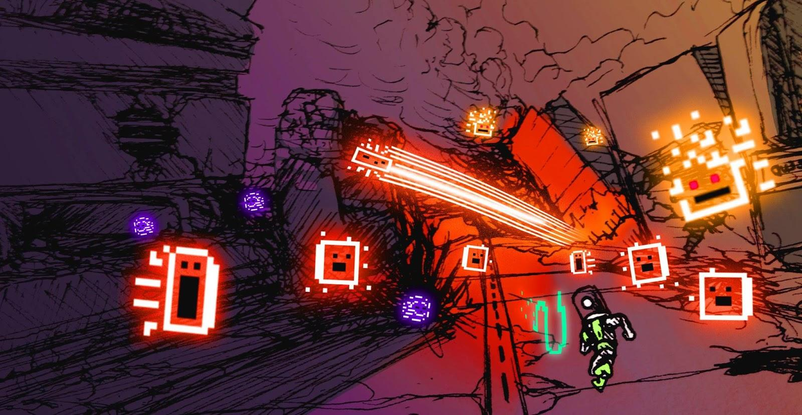

Vessoul’s theme is that of a futuristic, but ruined landscape. The art uses bright and vivid colors for “Still Working” aspects of the environment: things the player can interact with or use. Machines that still pose a threat, or anything at all that still happens to work after all this time. Ruined or otherwise broken things that form background, platforms, and walls will have muddled grays, browns, and purples.

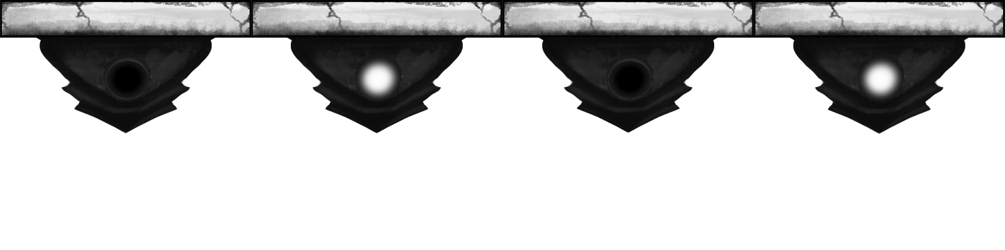

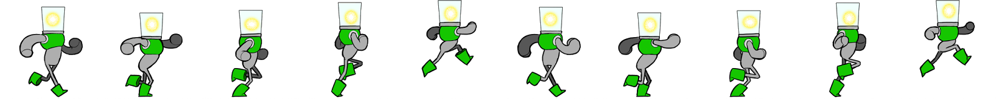  
  
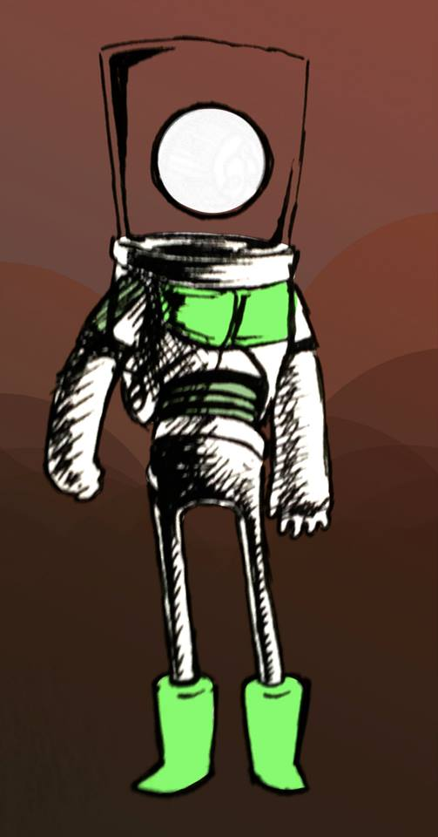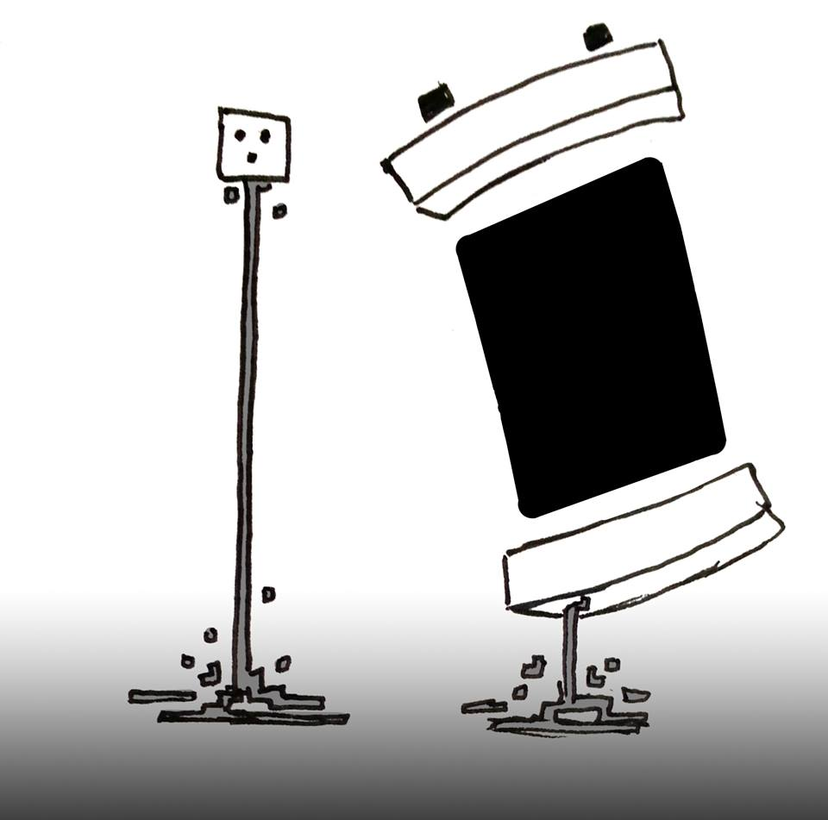

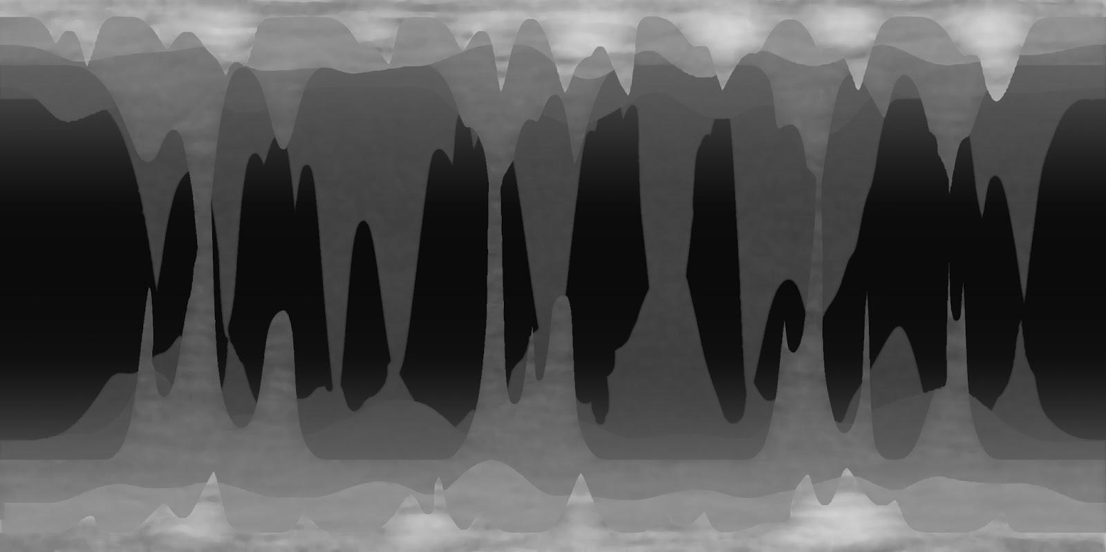

**S.W.O.T Chart**

|  |  |  |
| --- | --- | --- |
|  | **Helpful** | **Harmful** |
| **Internal Origin** | **STRENGTHS** Characteristics of the Business or project that give it an advantage over others.   * Team Enthusiasm * Idea is a Unique twist on a stale genre * Platformers are a particularly easy genre to generate content for * We all speak a Common Language * Small Compact Team Size means communication happens frequently | **WEAKNESSES** Characteristics that place the business or project at a disadvantage relative to others.   * Team has never worked with each other before * First time programming Graphics * First time programming an editor * First time using an engine editor built from scratch |
| **External Origin** | **OPPORTUNITIES** Elements in the environment that the project could exploit to its advantage.   * GAM 200 club has frequent lectures were game teams help other game teams. * There are students all around DigiPen who have passed GAM 200/205 before, and can be asked for help * The GAM staff are at DigiPen almost every day and respond to Emails and Questions about the Projects. | **THREATS** Elements in the environment that could cause trouble for the business or project.   * Other Classes with assignments * Personal Lives * Some Team Members have Jobs * Source Control is bad in general * Excessively noisy Edison Lab with neighbors who use their team workspace to play Multiplayer games. |