DiabetesCare

# User Manual

Version 1.0

01/01/2023

**Table of Contents**

1. Introduction 1

1.1 Overview 1

2. Getting Started 2

2.1 Set-up Considerations 4

2.2 Accessing the System 4

2.3 System Organization & Navigation 4

2.3.1 Mental Health Section 6

2.3.2 Physical Activity 7

2.3.3 Nutrition/Diet 8

2.4 Exiting the System 9

3. Using the System 10

3.1 Mental Health Recommender System 10

3.1.1 Journal 10

3.1.2 Discover 10

3.2 Physical Activity Recommender System 10

3.2.1 Log workout 10

3.3 Nutrition/Diet Recommender System 10

3.3.1 Log Meal (Breakfast – Lunch – Dinner) 10

4. Troubleshooting & Support 11

4.1 Error Messages 11

Appendix A: Record of Changes 12

List of Tables

Table 1 - Record of Changes 12

## Introduction

This User Manual (UM) provides the information necessary for users to effectively use the DiabetesCare, it will explain all the functionalities and how the app works in order to make sure the user understand it fully.

### Overview

The system was created in order to assist in management of diabetes and controlling it. It includes all the same features that an diabetes management app would have such as inputting blood glucose levels and blood pressure, but it also adds 2 new main features that we believe will make the experience much better for the user.

The first main feature is social media analysis of dietary habits, physical activity habits, and mental health trends, which will give the user an indication as a chart (shown below) to help them understand how they are doing.

The second main feature is a recommender system for mental health activities, physical activities, and nutritional recommendations to help the user keep their stress under control, their physical health as a priority and make sure they are eating only their required foods.

The application requires a public twitter account to create an account, and consent for us the access the user’s twitter data and analyze it.

## Getting Started

The first page the user will find is a log in page.

If no account was created, then the user can sign up and give us the information being asked of them.

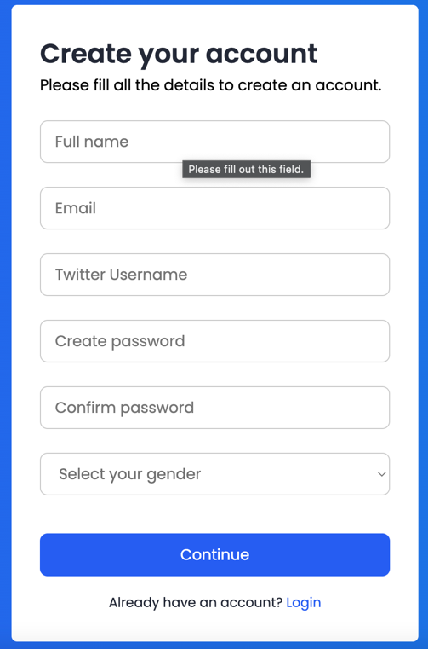

We then ask for the user’s consent to access their twitter data and analyze it.

Once confirmed the user is taken to the self-assessment form to give us the information required to be able to recommend appropriate calories and workouts

Once this is finished the user will be taken back to the sign in page and they can log in.

### Set-up Considerations

* User must enter a **valid** email and **public** twitter username open signing up or they will be unable to complete the process.
* User must have WIFI connection in order to be capable of using the application

### Accessing the System

* The user needs to have an account on our database, and use the twitter username and password set up during the sign up to log in
* Upon losing/forgetting their password, an email can be sent with instructions on how to reset the password

### System Organization & Navigation

Once the user has logged in, they will be taken to the home page which consists of three main sections

1. Their twitter analysis results

1. Blood Pressure, glucose level entry and weight updates

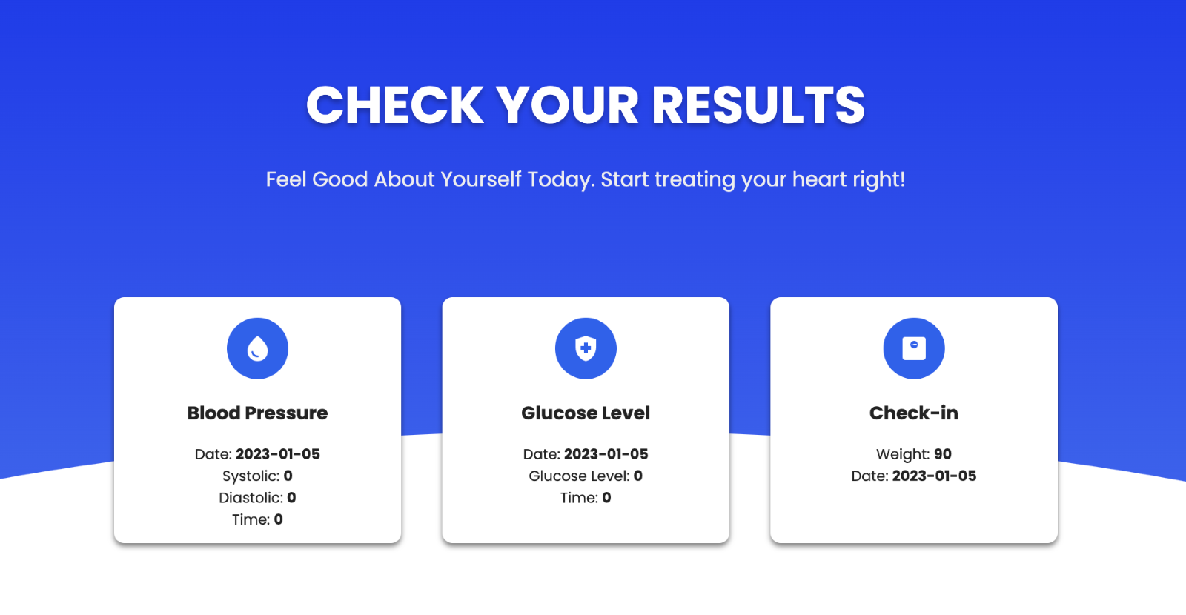

1. Your progress in terms of recommended activities/diet

From the home page the user will be able to access the 3 recommender systems (section 3) , input their glucose levels and blood pressure (section 2), and check their twitter analysis results daily.

#### Mental Health Section

##### Journal Page

##### Discover Page

##### Completed Activities

#### Physical Activity

##### Workouts for you

##### Workout Description

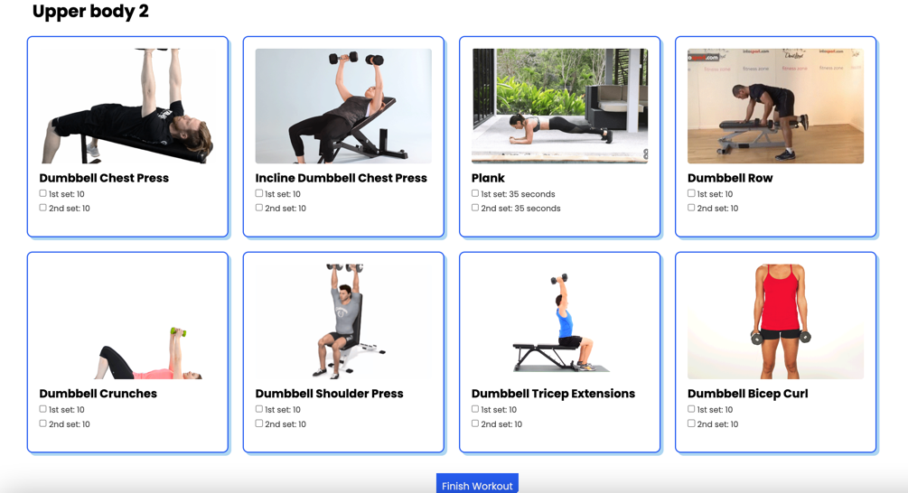

##### Completed Workouts

#### Nutrition/Diet

##### Food options (different for each meal i.e: breakfast-lunch-dinner)

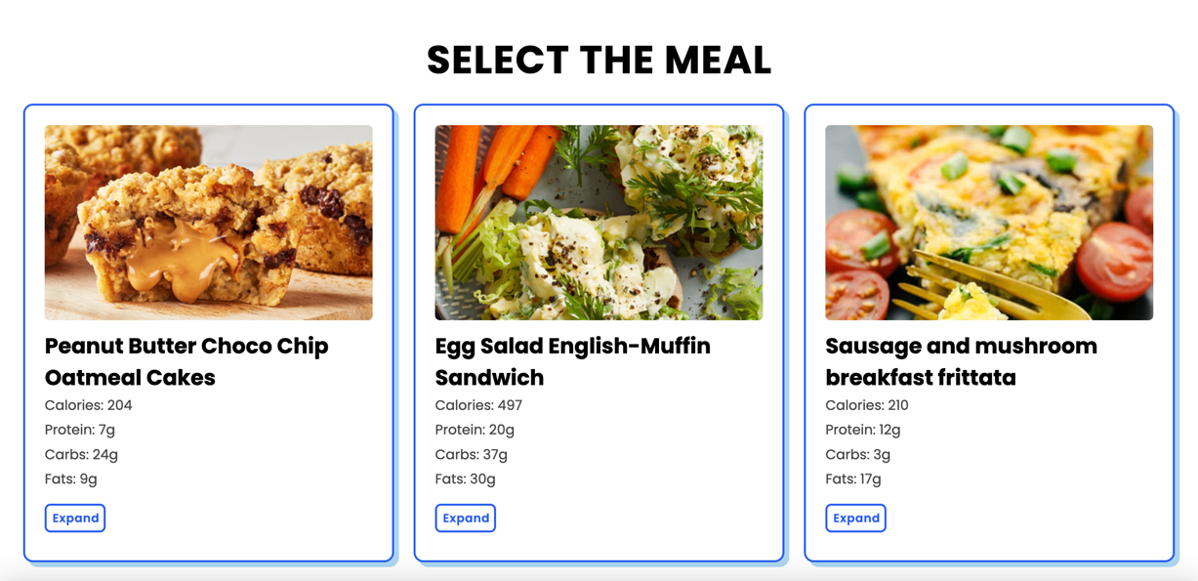

##### Log Meal

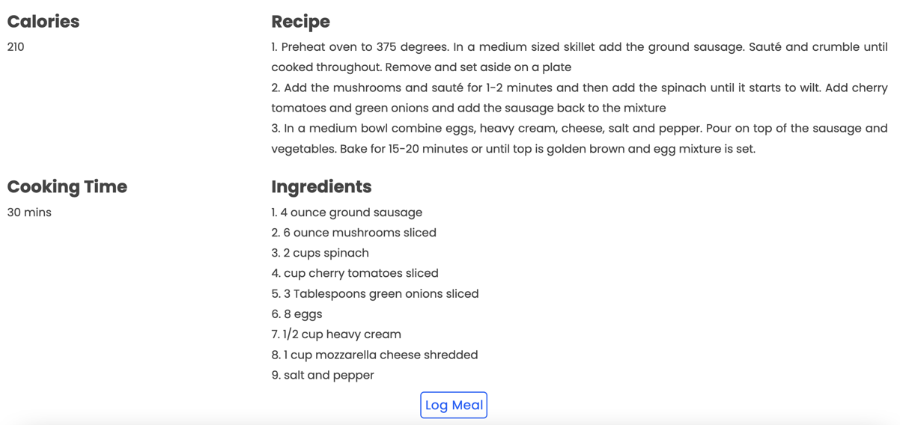

##### Food Diary of the Day

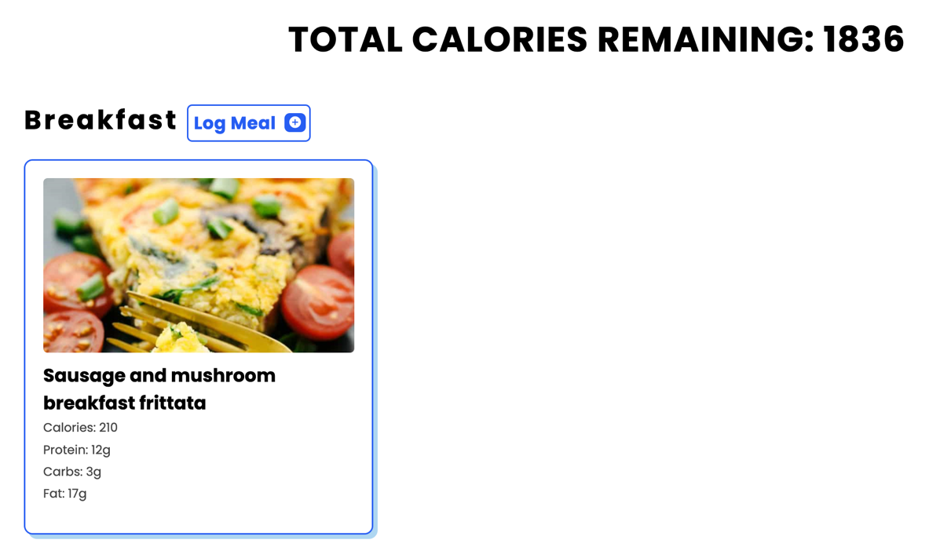

#### Blood Glucose and Blood Pressure

#### Check in (weight update)

### Exiting the System

* User simply to close the website, that will automatically sign them out.

## Using the System

The following sub-sections provide detailed, step-by-step instructions on how to use the various functions or features of the DiabetesCare

### Mental Health Recommender System

User is given a journal to enter their thoughts and feelings, which allows the app the give them recommendation based on the emotion detected from the text.

#### Journal

* As shown in section 2.3.1.1 the user simple must enter text into the text box, and press add entry, which will confirm an entry into their daily journal.
* The journal is essential in order to use the discover functionality since the recommendations depend on what the user has inputted

#### Discover

* After user has entered at least one journal entry, they should be shown a list of different activities where they will be able to select an activity, read it’s description, and if it is something they wish to do they can go ahead and log it after they finish.

### Physical Activity Recommender System

User is given workouts based on their self-assessment result/information given

#### Log workout

* User is shown a list of workouts both aerobic and strength based. The user can check what any of the workout includes, if the user has found one to be convenient for them at the time, they can complete it and log it.

### Nutrition/Diet Recommender System

User is given workouts based on their self-assessment result/information given

#### Log Meal (Breakfast – Lunch – Dinner)

* User will click on “Log Meal” and depending on which meal type they pressed it for they will be shown different recommendations, so the breakfast log meal button will show breakfast options, while the lunch log meal button will show lunch options, and the same goes for dinner.
* The user can check the meal’s ingredients and recipe before choosing to log it, once satisfied with their choice they can log the meal.

## Troubleshooting & Support

Instructions: Describe all recovery and error correction procedures, including error conditions that may be generated and corrective actions that may need to be taken. Organize the information in sub-sections as appropriate. The following are common sub-sections that may be included as appropriate.

### Error Messages

* Invalid email address
* Invalid Twitter Username
* Inputting weight in decimals

Appendix A: Record of Changes

Instructions: Provide information on how the development and distribution of the User Manual will be controlled and tracked. Use the table below to provide the version number, the date of the version, the author/owner of the version, and a brief description of the reason for creating the revised version.

Table 1 - Record of Changes

| Version Number | Date | Author/Owner | Description of Change |
| --- | --- | --- | --- |
| 1.1 | 01/01/2023 | DiabetesCare | First Creation of UMI |