Coral Reef Digital Twin
Model Documentation - Architecture, Results & Comparison

Project: Prototype digital twin for coral reef monitoring around Sri Lanka
Goal: Simulate seabed sensors · Forecast SST · Score coral bleaching risk

1. Executive Summary

This report documents the complete development of a coral reef digital twin, a prototype AI system designed to simulate seabed temperature sensors, reconstruct spatial temperature fields, forecast short-term temperature changes, and assess coral bleaching risk. The project uses satellite Sea Surface Temperature (SST) and Degree Heating Weeks (DHW) data from NOAA Coral Reef Watch as stand-ins for real seabed loggers, with small noise added to simulate the difference between surface and underwater readings.
The system evolved through eight major model stages from a simple persistence baseline to a Physics-Informed Neural Network (PINN) for spatial mapping, through sequence-based LSTM models for forecasting, ending with a deployable ANN–LSTM model that beats the persistence baseline at 3-7 day horizons.

Key Findings at a Glance
Finding | Result
Best spatial model | PINN (MAE 0.73–0.93°C on hold-outs)
Best 1-day forecast | ANN–LSTM: 0.154°C MAE (persistence: 0.156)
Best 3-day forecast | ANN–LSTM: 0.228°C MAE (persistence: 0.240) ↑
Best 7-day forecast | ANN–LSTM: 0.294°C MAE (persistence: 0.320) ↑
Optimal history length | 60 days (ablation: 7, 14, 30, 60, 90 tested)
Bleaching risk method | DHW-aware, NOAA-style (≥4 watch, ≥8 alert)
Prototype sensor method | 3 triangle sensors + ±0.2°C noise on SST

2. The Problem and Prototype Concept
Coral reefs are highly sensitive to water temperature. Elevated temperatures cause coral bleaching, the expulsion of symbiotic algae, which can lead to coral death if sustained. Early warning systems that predict temperature stress a few days in advance allow reef managers to take protective action.
The ideal system would use physical seabed temperature loggers placed around a reef. However, deploying real underwater sensors is expensive and time-consuming. This project creates a prototype that can be tested and validated now, designed so that real sensor streams can replace the simulation later.

Prototype Sensor Simulation
Since real seabed sensors are not yet available, we simulate them using satellite SST data:
- Take satellite SST at a reef location (freely available from NOAA CRW).
- Place 3 virtual sensors in a triangle around the reef site.
- Add small random noise (±0.2°C) to each sensor to mimic: (a) the difference between sea surface and seabed temperature, (b) individual sensor measurement error.
- This gives us 3 slightly different time series that a real deployment would produce.
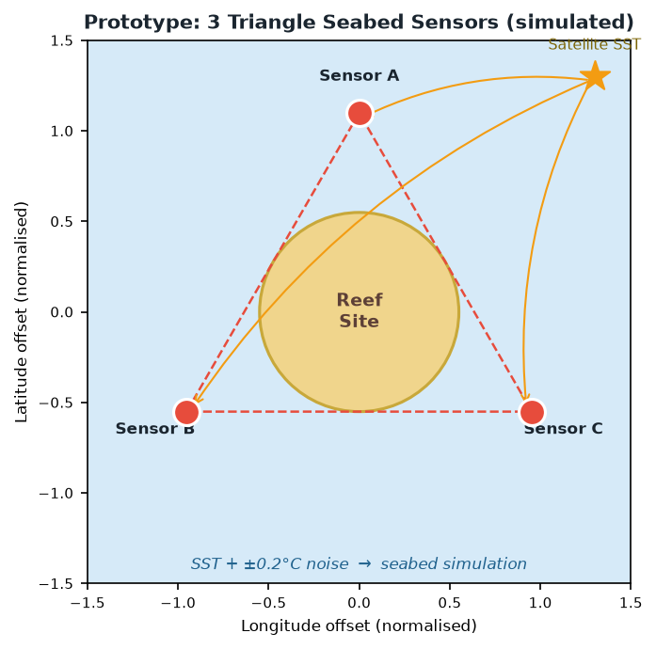
This approach is scientifically valid as a prototype - SST and seabed temperature are correlated, and the noise magnitude is realistic for shallow tropical reefs.

Figure 1. Prototype seabed sensor layout — 3 triangle points around a reef, simulated with satellite SST + ±0.2°C noise.

Overall System Pipeline
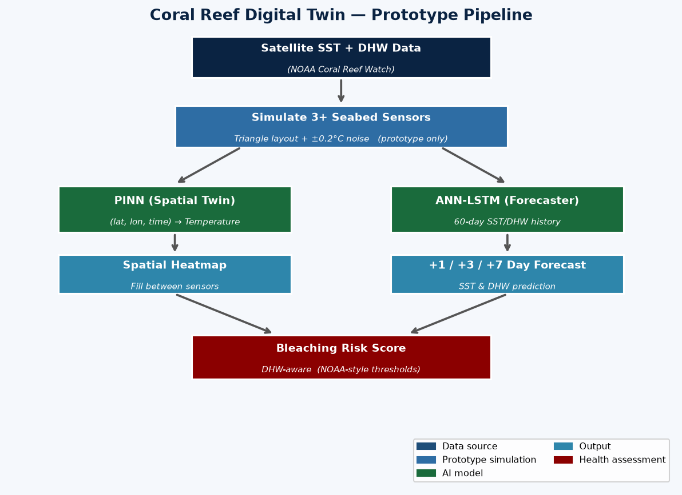
Figure 2. Complete prototype pipeline from satellite data to bleaching risk alert.

The pipeline has three main roles filled by different models:
Role | Model | Why This Choice
Spatial mapping  (fill between sensors) | PINN | Continuous spatial field in space–time using physics
Short-term forecast  (+1/+3/+7 days) | ANN–LSTM  (60-day history) | Best skill in experiments; learns seasonal patterns
Health alert | DHW-aware Risk Scorer | NOAA-style stress thresholds; interpretable

3. Model Evolution Overview

The system evolved through 8 stages. Each stage addressed a specific weakness discovered in evaluation. The timeline below shows this progression:

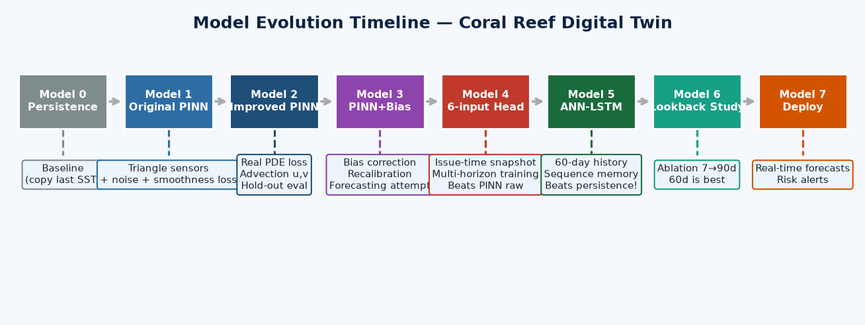
Figure 3. Model evolution from simple baseline to deployable forecaster.

# | Model | Main Idea | Status
0 | Persistence | Tomorrow = today (copy last SST) | Strong baseline - every model must beat this
1 | Original PINN  (triangle + noise) | First spatial prototype with simulated sensors | Conceptual ancestor - sensor simulation still valid
2 | Improved PINN  (real PDE + advection) | Physics-based loss, real multi-site data, hold-outs | Keep for spatial maps
3 | PINN + Bias/Recalibration | Correct warm drift in forecasts | Intermediate - helps but still loses to persistence
4 | 6-input Forecast Head | Issue-time snapshot → future values | Beaten by LSTM
5 | ANN–LSTM / CNN–ANN–LSTM | 60-day history + sequence memory | ANN–LSTM wins - current best forecaster
6 | Lookback Ablation | Test history lengths 7 → 90 days | 60 days is the sweet spot
7 | Deploy ANN–LSTM | Operational forecast + risk notebook | Current deployment path

4. Model-by-Model Description

4.0 Model 0 - Persistence Baseline
The persistence model is the simplest possible forecast: predict that tomorrow's temperature will be the same as today's. Despite its simplicity, it is a strong baseline for short-term forecasting because ocean SST changes slowly.
Rule: SST(t + h) = SST(t) for all horizons h
Any machine learning model that cannot beat persistence at 3–7 days is not useful for operational forecasting. All learned models are compared against this benchmark.
Horizon | Persistence MAE (°C)
1 day | 0.156
3 days | 0.240
7 days | 0.320

4.1 Model 1 - Original PINN (First Prototype)
The first model was a Physics-Informed Neural Network trained on three simulated seabed sensors arranged in a triangle around a single reef site. Satellite SST was used as the underlying signal, with ±0.2°C noise added to each of the three points.

Architecture
Input (3): [lat_norm, lon_norm, time_norm]
Hidden: Dense(128, tanh) + BatchNorm
Dense(128, tanh) + BatchNorm
Dense(64, tanh) + BatchNorm
Dense(64, tanh) + BatchNorm
Dense(32, tanh) + BatchNorm
Output (1): Dense(1, sigmoid) → normalised SST
Parameters: ~33,217

Physics Loss (Weak — First Version)
The first version used a simplified smoothness constraint rather than a real PDE:
Loss = MSE(data) + λ × mean( (ŷ[i+1] − ŷ[i])² )
This penalises abrupt changes between consecutive batch predictions but is not a true physical law. It was replaced in Model 2 with a proper heat equation residual.

What This Model Proved
- Triangle + noise is a valid prototype approach for seabed sensor simulation.
- PINN can learn a smooth spatial-temporal field from sparse noisy inputs.
- Weaknesses: smoothness loss is not real physics; data was not independently held out.

4.2 Model 2 - Improved PINN (Spatial Digital Twin)
The PINN was significantly improved in three areas: physics, data, and evaluation.

Improvements Made
- PHYSICS: Replaced the smoothness penalty with the true heat advection–diffusion PDE residual, computed via TensorFlow's GradientTape during training.
- DATA: Training on 5 real satellite locations around Sri Lanka — Hikkaduwa, Kalpitiya, Passikudah, South East, Trincomalee - instead of a single noisy series.
- EVALUATION: Proper time and location hold-outs (newest 20% of dates for test; Trincomalee held out as unseen location).
- ADVECTION: u and v ocean current components estimated from multi-site SST gradients by least-squares regression, stored in advection.pkl.

Physics Loss — Heat Advection-Diffusion PDE
The physics residual R is computed at collocation points using automatic differentiation:
R = ∂T/∂t + u × ∂T/∂lon + v × ∂T/∂lat − α × ∇²T
Total Loss = MSE(data) + λ × mean(|R|²)
where:
T = predicted normalised temperature
u, v = advection velocities (estimated from SST gradients)
α = diffusion coefficient
λ = physics weight (tuned by sweep, typically 0.001–0.01)
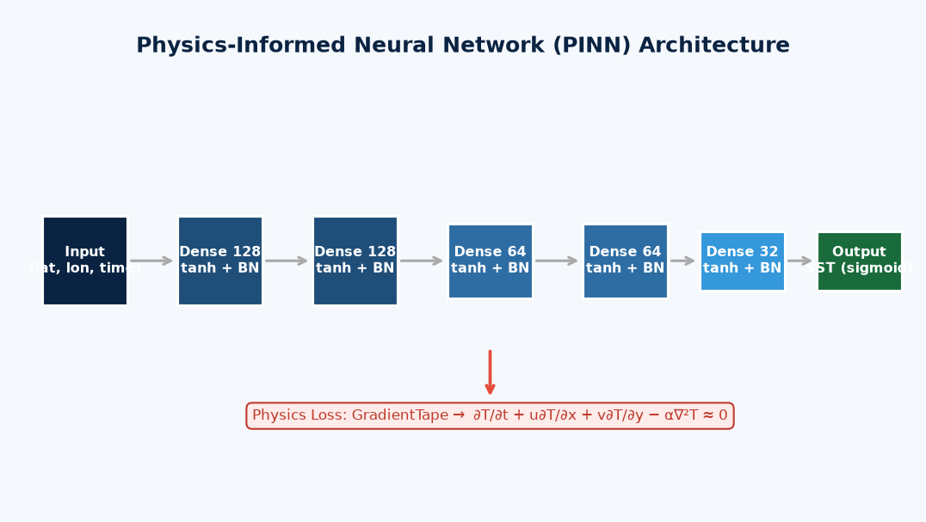
Figure 4. PINN architecture with MLP backbone and PDE-based physics loss via GradientTape.

Interpolation Performance
Split | MAE (°C) | RMSE (°C) | Notes
Validation (time) | 0.73 | 0.93 | In-period reconstruction
Test (newest years) | 0.93 | 1.17 | Warm bias ~+0.55°C
Location hold-out  (Trincomalee) | 0.75 | 0.96 | Good spatial transfer
The PINN is a good spatial interpolator - it can reconstruct temperatures between sensor locations. However, when used as a short-term forecaster, it performs poorly against the persistence baseline. This motivated the development of dedicated forecasting models.

4.3 Model 3 - PINN + Bias Correction / Recalibration
Rather than discarding the PINN for forecasting, we attempted to rescue it using post-processing corrections.

Bias Correction
bias = mean(actual − PINN_prediction) over recent days at issue time
corrected_forecast = PINN_forecast + bias

Recalibration
Additional offsets computed from validation set residuals, stored in recalibration.pkl, are applied on top of bias correction.

Results After Bias Correction
Horizon | PINN Raw (°C) | PINN + Bias (°C) | Persistence (°C)
1 day | 0.87 | 0.22 | 0.154
3 days | 0.87 | 0.28 | 0.240
7 days | 0.87 | 0.37 | 0.320
Bias correction is essential - it reduces PINN forecast error from 0.87°C to 0.22–0.37°C. However, it still loses to the persistence baseline at all horizons. The PINN lacks the temporal pattern memory needed for short-term forecasting.

4.4 Model 4 - Six-Input Forecast Head
A dedicated supervised forecast head was trained on issue-time snapshot features — the location, target time, forecast horizon, and current SST/DHW values.

Architecture
Input (6): [lat_norm, lon_norm, time_target_norm, horizon_norm,
SST_issue_norm, DHW_issue_norm]
Hidden: Dense(128, tanh) + BN → Dense(128) → Dense(64) → Dense(64) → Dense(32)
Output (2): [SST_norm, DHW_norm] (sigmoid)
Loss: MSE (no PDE - snapshot inputs can't support spatial PDE)
Parameters: ~33k

Results
Horizon | Forecast Head MAE (°C) | Persistence MAE (°C)
1 day | 0.202 | 0.154
3 days | 0.286 | 0.240
7 days | 0.371 | 0.320
Much better than raw PINN as a forecaster, but still behind persistence. The fundamental problem is that a single snapshot does not contain enough historical context. The model cannot see recent trends, seasonal cycles, or anomaly patterns.

4.5 Model 5 - ANN–LSTM (Winning Forecaster)
The key insight from Models 3 and 4 was that a snapshot of current conditions is insufficient. Short-term forecasting requires history - the model needs to see recent trends, oscillations, and anomaly patterns to predict the next few days accurately.
The ANN–LSTM uses the last 60 days of SST and DHW observations as input, processes them with a feature-mixing Dense layer (applied to each day independently), then passes the sequence through an LSTM to capture temporal dependencies.
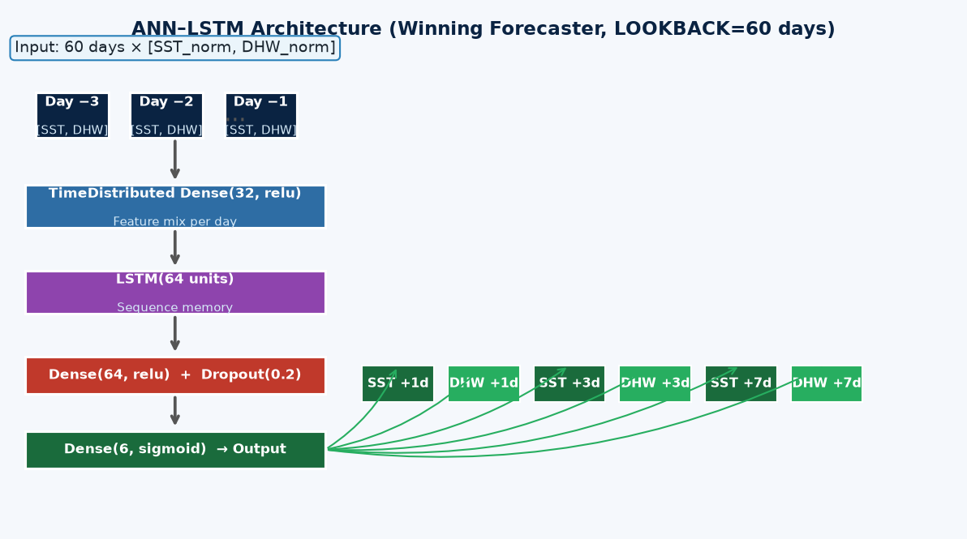
Figure 5. ANN–LSTM architecture - the winning forecaster. Input: 60 days × 2 features. Output: SST and DHW at +1, +3, +7 day horizons.

Architecture Details
Layer | Type | Output Shape | Purpose
Input | - | (batch, 60, 2) | 60 days of [SST_norm, DHW_norm]
TimeDistributed Dense | Dense(32, relu) | (batch, 60, 32) | Feature mix per day
LSTM | LSTM(64 units) | (batch, 64) | Sequence memory & temporal patterns
Dense + Dropout | Dense(64, relu), Dropout(0.2) | (batch, 64) | Non-linear transform + regularisation
Output | Dense(6, sigmoid) | (batch, 6) | SST+DHW at +1d, +3d, +7d
Total parameters: ~29,500 (LOOKBACK=60). Training: Adam optimiser, MSE loss, EarlyStopping on val_loss with patience=10, ReduceLROnPlateau.

Why LSTM?
- LSTM cells maintain a 'cell state' that can carry information across many time steps.
- Gating mechanisms (input, forget, output gates) let the model decide what to remember and what to discard from the 60-day history.
- This is ideal for SST which has seasonal trends, slow drift, and occasional anomalies.

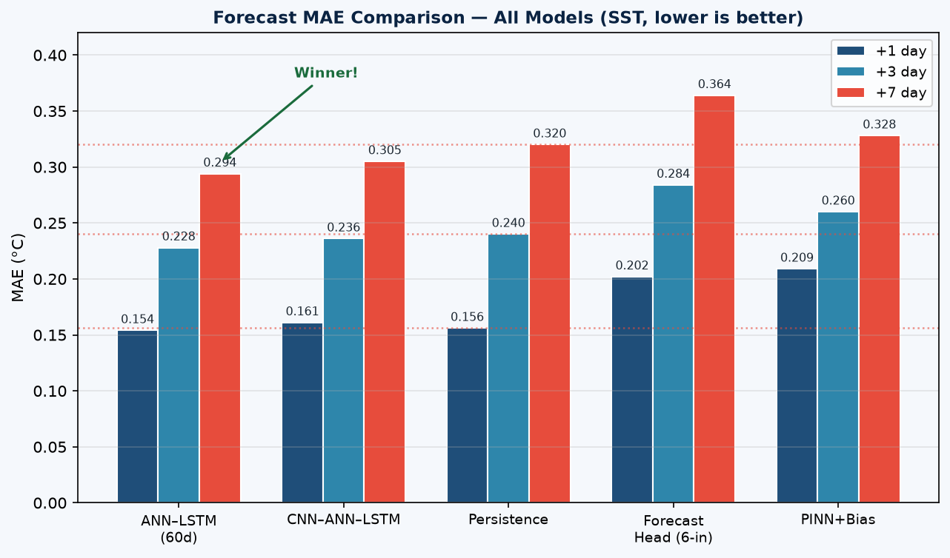
Results
Model | +1 day MAE | +3 day MAE | +7 day MAE | Beats Persistence?
ANN–LSTM (60d) ★ | 0.154 | 0.228 | 0.294 | Yes (3d, 7d)
CNN–ANN–LSTM | 0.161 | 0.236 | 0.305 | Yes (3d, 7d)
Persistence | 0.156 | 0.240 | 0.320 | Baseline
Forecast Head (6-in) | 0.202 | 0.284 | 0.364 | No
PINN + Bias | 0.209 | 0.260 | 0.328 | No

Figure 6. Forecast MAE comparison across all models and horizons. Dotted lines mark persistence benchmark. ANN–LSTM wins at 3 and 7 days.

4.6 Model 6 - CNN–ANN–LSTM
The CNN–ANN–LSTM adds 1D convolutional layers before the LSTM to extract local temporal patterns (e.g., short-term oscillations) before the sequence modelling stage.
Input (batch, 60, 2)
→ Conv1D(32, kernel=5, relu) ← 5-day local patterns
→ Conv1D(32, kernel=3, relu) ← 3-day refinement
→ TimeDistributed Dense(32)
→ LSTM(64)
→ Dense(64, relu) + Dropout(0.2)
→ Dense(6, sigmoid) ← same 6-output as ANN-LSTM
Parameters: ~33,900
Result: Close second to ANN–LSTM, but convolutions did not help significantly on daily SST data (which is slow and smooth). The simpler ANN–LSTM is preferred.

4.7 Model 7 - Lookback Ablation (History Length Study)
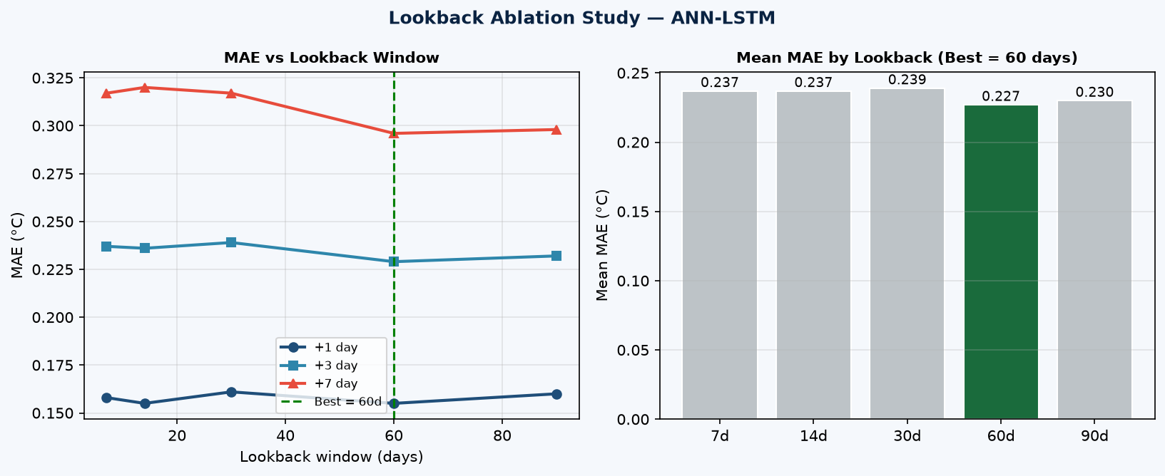
To justify using 60 days of history, a systematic ablation study was conducted: the same ANN–LSTM was trained five times with different lookback windows.
Experiment | Lookback | MAE +1d | MAE +3d | MAE +7d | Mean MAE
A | 7 days | 0.158 | 0.237 | 0.317 | 0.237
B | 14 days | 0.155 | 0.236 | 0.320 | 0.237
C | 30 days | 0.161 | 0.239 | 0.317 | 0.239
D ★ BEST | 60 days | 0.155 | 0.229 | 0.296 | 0.227
E | 90 days | 0.160 | 0.232 | 0.298 | 0.230

Figure 7. Lookback ablation results. Left: MAE per horizon vs lookback window. Right: Mean MAE (60 days is the best, green bar).

Key Findings from Ablation
- 7–30 days: Short history underperforms at 7-day lead - not enough context.
- 60 days: Best overall. Captures 2× the seasonal signal of shorter windows.
- 90 days: Marginally worse than 60, extra history adds noise / computation cost.
- Conclusion: 60 days is the evidence-based choice for deployment.

4.8 Model 8 - Deployed ANN–LSTM Forecaster
The final deployment notebook (11_deploy_ann_lstm_forecaster.ipynb) loads the best ANN–LSTM model and demonstrates operational use:
- Loads ann_lstm_L60_best.h5 and associated scalers.
- Takes last 60 days of historical SST+DHW for a reef site.
- Produces +1/+3/+7 day SST and DHW forecasts with uncertainty context.
- Computes persistence comparison at each horizon.
- Calculates DHW-aware bleaching risk for each forecast step.
- Saves forecast plots and CSV outputs to lstm_deploy/.

5. Bleaching Risk Assessment Layer
The bleaching risk scorer is not a neural network - it is an interpretable rule-based system built on NOAA Coral Reef Watch methodology, applied on top of model outputs.

How It Works
Four signals are combined into a final risk score (0 to 1):
Signal | Weight | Description
DHW (primary) | High | Degree Heating Weeks: accumulated heat stress over 12 weeks
Temperature anomaly | Medium | Predicted SST minus monthly climatological baseline
Duration of warm stress | Medium | How many consecutive days above baseline
Warming rate | Low | Rate of temperature increase (°C/day)

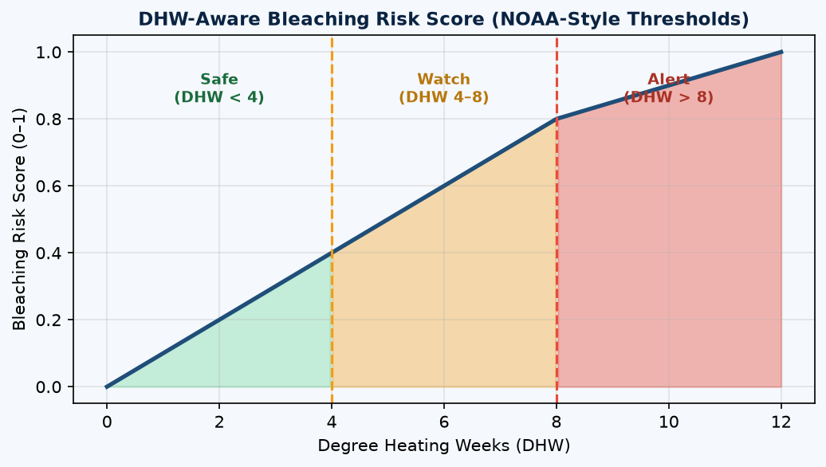
NOAA-Style DHW Thresholds
DHW Value | Risk Level | Meaning
< 4 °C-weeks | Safe (Level 0) | No significant stress
4–8 °C-weeks | Watch (Level 1) | Possible bleaching
> 8 °C-weeks | Alert (Level 2) | Likely/severe bleaching

Figure 8. DHW-to-risk mapping. Risk score increases from Safe (green) through Watch (amber) to Alert (red) as accumulated heat stress rises.
DHW is particularly important because a single warm day is less harmful than sustained warmth over weeks. A reef can recover from a brief temperature spike but not from weeks of elevated heat, this is exactly what DHW captures.

6. Full Model Comparison

6.1 Forecasting Performance (SST MAE °C)
All models evaluated on the same test set (n=1,680 samples, 5 locations, held-out time period). Lower MAE = better.
Rank | Model | +1 day | +3 days | +7 days | Beats Persistence  (3–7d)?
1 ★ | ANN–LSTM (60d) | 0.154 | 0.228 | 0.294 | Yes
2 | CNN–ANN–LSTM | 0.161 | 0.236 | 0.305 | Yes
3 | Persistence | 0.156 | 0.240 | 0.320 | Baseline
4 | Forecast Head (6-in) | 0.202 | 0.284 | 0.364 | No
5 | PINN + Bias | 0.209 | 0.260 | 0.328 | No

6.2 Spatial Interpolation Performance (PINN)
The PINN is evaluated separately as a spatial model — its role is to fill temperature values between sensor locations, not to forecast future values.
Split | MAE (°C) | RMSE (°C) | Notes
Validation (time hold-out) | 0.73 | 0.93 | In-period reconstruction
Test (newest years) | 0.93 | 1.17 | Warm bias ~+0.55°C
Location hold-out  (Trincomalee) | 0.75 | 0.96 | Good spatial generalisation

6.3 Architecture Cheat-Sheet
Model | Input | Core | Output | ~Params
PINN | (lat, lon, t) | MLP 128×2–64×2–32  + PDE loss | SST (1d) | 33k
Forecast Head | 6 snapshot features | Same MLP, MSE loss | SST + DHW (2d) | ~33k
ANN–LSTM | (60, 2) SST/DHW | TD-Dense→LSTM→Dense | 6 (3 horizons × 2) | 29k
CNN–ANN–LSTM | (60, 2) SST/DHW | Conv1D×2→TD-Dense  →LSTM→Dense | 6 (3 horizons × 2) | 34k
Persistence | Last SST | Rule-based copy | Same SST | 0
Risk Scorer | T, DHW, baseline | Weighted rules | Score 0–1, Level 0–2 | 0

7. Key Notebooks and Scripts

Notebook / Script | Purpose
01_data_preparation.ipynb | Simulate triangle sensor data from SST with noise
02_pinn_model.ipynb | Train the PINN spatial model
03_visualization.ipynb | Generate spatial heatmaps and risk maps
04_real_spatial_data.ipynb | Load real multi-site satellite data with hold-outs
05_estimate_advection.ipynb | Estimate ocean current u, v from SST gradients
06_evaluation.ipynb | Full hold-out and forecast skill evaluation
07_improve_forecasts.ipynb | Bias correction, recalibration, 6-input head
08_tune_physics.ipynb | Sweep physics weight λ to find optimal value
09_lstm_sequence_forecast.ipynb | Train ANN–LSTM and CNN–ANN–LSTM; compare all models
10_lookback_ablation.ipynb | History length ablation: 7, 14, 30, 60, 90 days
11_deploy_ann_lstm_forecaster.ipynb | Operational deployment: load model, forecast, risk alert
pinn_physics.py | PINN model class, PDE residual, GradientTape training step
prepare_data.py | Data loading, scaling, time+location split, .npy export
estimate_advection.py | Least-squares u,v estimation from multi-site SST
validate_forecast.py | Forecast skill evaluation vs persistence/climatology baselines
recalibrate.py | Rolling recalibration offsets from validation residuals
forecaster.py | PINNForecaster class with bias correction and risk output
utils.py | DHW-aware bleaching risk calculation helper

8. Key Findings and Lessons Learned
Finding 1: Triangle + SST noise is a valid prototype
Until real seabed loggers exist, simulating 3 sensors with ±0.2°C noise on satellite SST is scientifically defensible. The design is ready to accept real sensor streams.

Finding 2: PINN is the right tool for spatial mapping, not for forecasting
The physics-informed network excels at interpolating temperature between sensor locations (0.73–0.93°C MAE). As a raw short-term forecaster, it is outperformed even by the trivial persistence model. Use PINN for maps; use LSTM for predictions.

Finding 3: Real physics loss matters for honest evaluation
Replacing the batch-smoothness penalty with a true heat advection–diffusion PDE residual via GradientTape made the physics constraint meaningful — but did not magically improve 1–7 day forecasts. Physics helps the map task; it does not substitute for temporal history.

Finding 4: Bias correction is essential for PINN forecasts (but not enough)
The PINN has a systematic warm bias of ~0.55°C on test data. Adding bias correction reduces forecast error from 0.87°C to 0.22–0.37°C — a dramatic improvement — but still behind persistence at all horizons.

Finding 5: Snapshot features are insufficient for forecasting
The 6-input forecast head (current location, time, horizon, SST, DHW) performed better than the raw PINN but still could not beat persistence. A single snapshot of current conditions cannot encode recent trends or seasonal context.

Finding 6: 60 days of history + LSTM is the first approach to beat persistence
The ANN–LSTM with a 60-day lookback window beats persistence at 3 and 7 days. This proves that temporal memory is the key ingredient for short-term reef forecasting.

Finding 7: 60 days > 90 days for lookback
The ablation study shows that more history is not always better. 90 days adds noise and slightly worse performance. 60 days is the evidence-based optimum for this dataset.

Finding 8: Split roles across models
The best architecture is: PINN = spatial map, ANN–LSTM = time forecast, DHW risk scorer = health alert. No single model does all three tasks best.

9. One-Sentence Summary
We started with a triangle-sensor PINN prototype on noisy SST to mimic seabed loggers, improved physics and evaluation for a spatial digital twin, then showed that short-term coral-temperature forecasting needs sequence memory — culminating in an ANN–LSTM with 60 days of SST/DHW history as the best forecast model, while the PINN remains the spatial map engine.

