**Software Requirements Specification**

**Product – BLOG PLATFORM**

# Introduction

## Purpose

This document provides a functional overview of a web based Blog platform that has to support the development and test planning processes of this project. Its goal is to present the scope, the basic content and the main functionalities that are supposed to be developed.

## Scope

The scope of this project is the creation of a blog platform with its main sections and sub sections, content, functionalities and design.

## Out of scope

On this phase of development we will not aim the integration of our product with other external systems as affiliation systems, commercials, payment gateways, etc. The categorization of the blog posts in separate topics, the restriction requirements and user agreements, detailed user profile attributes are also not in this scope.

## Overview

The rest of this document contains the overall description of the blog platform and the specific requirements for the system.

# Overall Description

## Product Perspective

The blog platform will provide the possibility to all internet users to share their thoughts, knowledge, feelings and concerns. It will be absolutely free platform with no restrictions upon age, gender, race, country or religion. It should be user friendly and easy to use.  
The economical purpose of this product is to gain popularity, big number of commercials and wide network of affiliate collaboration.

## Product functions

### Offers personal blogging profile:

Every registered user is able to create personal blogging profile with user name, password and personal details.

### Offers personal blogging space:

Every registered user is able to create a blog topic and content and share them to the world.

### Offers the possibility to comment publications:

Every user can add a comment to any publication.

## Constraints

**The following are the constraints:**

* The project must be completed within the budget
* The project must be completed within a specified period of time.
* The system should be up 24/7.
* The system should enforce user authentication security and guarantee reliability.

# Specific Requirements

## Blog platform architecture and content:

### Authentication screen:

* Background – picture, slide etc. - MODAL FOR ALL PAGES
* Login section – pop-up:
  + Username
  + Password
  + LOGIN button
* Registration section – pop-up
  + Username
  + Password
  + Confirm password
  + Email
  + Full name
  + Profile picture
* Support contacts and development team details – MODAL FOR ALL PAGES

### Main navigation screen

#### PROFILE section

##### Edit profile pop-up

* + Old password
  + New password
  + Confirm new password
  + New email
  + New profile picture
  + New full name
  + SAVE CHANGES BUTTON

##### Log out – navigates back to the authentication page

##### User’s picture field

#### HOME section

#### ADD POST section

* Title field
* Description field
* Content
* Tags
* ADD POST button

#### ALL POSTS

* 4 windows with the first 4 posts in short are shown – title (clickable – shows the , short content, author (clickable) and READ MORE button
  + - READ MORE button opens the whole post and one new window:
      * LEAVE A COMMENT
        + Name
        + Email
        + Comment
        + ADD COMMENT button
* Pages number counter – shows 4 posts per page. Clickable

## Product Functions

## Functional Requirements

We describe the functional requirements by giving various use cases.

*Use cases related to System Authentication:*

*Use Case №1:* Login  
*Primary Actor*: User  
*Pre Condition*: Installed browser and active internet connection   
*Main scenario*:

1. User initiates browser
2. User specifies web address for accessing the CRM
3. User gives the login and password ( refer to next chapters section “User Screens” )
4. System does authentication
5. Activity Stream is displayed

*Alternate scenario:*  
 4.1 Authorization fails – wrong username/password  
 4.1.1 Prompt the user that he typed the username/password wrong  
 4.1.2 Allow him to re-enter the username/password  
 4.2 Authorization fails – forgotten username/password  
 4.2.1 Prompt the user to enter his registered email  
 4.2.2 User receives an email with instructions about his login credentials

*Use Case №2*: Change password  
*Primary Actor*: User  
*Pre Condition*: User logged in   
*Main scenario*:

1. User goes to Bitrix24.Network Page from the profile menu located at the top pane ( refer to next chapters section “User Screens” )
2. User goes to Edit Profile
3. User initiates “Change Password” functionality
4. User provides current password, new password and confirm new password
5. System displays message for successful change

*Alternate scenario:*  
 4.1 Authorization fails – wrong password  
 4.1.1 Prompt the user that he typed the password wrong  
 4.1.2 Allow him to re-enter the password  
 4.2 Authorization fails – new password and confirm new password do not match  
 4.2.1 Prompt the user that new password and confirm new password do not match  
 4.2.2 Allow him to re-enter the attributes.  
 4.3 Authorization fails – new password and confirm password are less than 6 chars  
 4.3.1 Prompt the user that password must be at least 6 characters  
 4.3.2 Allow him to re-enter new and confirm password

## User Screens

1. Authentication screen:

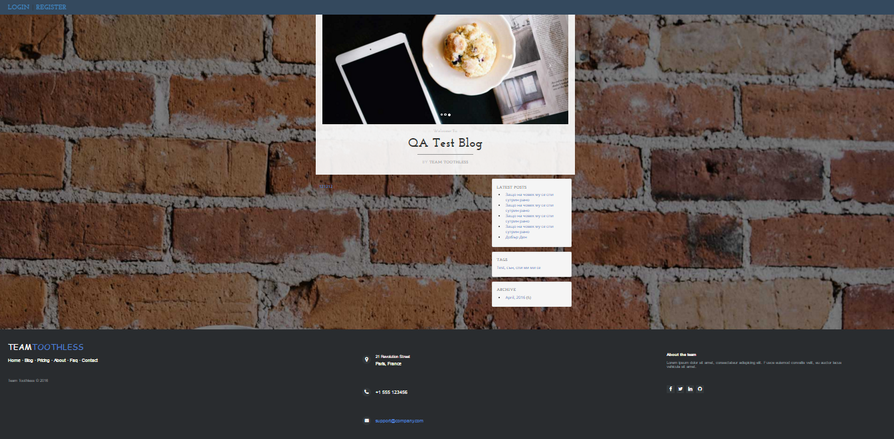

## Reliability

Reliability is an important factor to make CRM trustable. Some issues should be considered as following:

### Availability:

CRM should be available 24 hours per day, 7 days per week. Maintenance access period is a month. Database is backed up.

### Mean Time Between Failures (MTBF):

3 month.

### Mean Time to Repair (MTTR):

2 hours

### Maximum Bugs or Defect Rate:

Less than 1minor bug per 1000 lines of code.

### Bugs or Defect Rate:

No critical bug that causes data loss or system crash is allowed.

## Performance

### The information retrieval should be as fast as possible for customer satisfaction.

To ensure this, the consumer should be able to download a page in 5 seconds with a 33.6 Kbps modem. The form submission should not take a long time to be processed, especially in the CRM module case, in which form applications play a major role.

### The server should be able to serve 25 percent of registered customers

The server should be able to serve 25 percent of registered customers simultaneously, which may be about several thousand for a medium scaled electronic enterprise.

### Separation of connection handling and data processing

Separation of connection handling and data processing would definitely improve the overall system performance as well as cost incurred.

### Software runs on an online platform

Slow data retrieval because of poor programming must be absolutely discarded since the software runs on an online platform.

### Minimize the data transfer time

The size of data sent to the user can be limited to an upper bound, especially for the multimedia files, to minimize the data transfer time.

### Size of the secondary storage

The larger the primary memory, the faster the applications would run. Moreover the size of the secondary storage should be sufficient for data swapping, recovery and backup procedures.

## Supportability

### Compatible with Operating Systems

* Windows
* Linux
* Sun Solaris

### Compatible with Browsers

* Microsoft Internet Explorer
* Mozilla Firefox
* Google Chrome
* Opera
* Safari

## On-line User Documentation and Help System Requirements

### User Manual

User manuals: will be self-explanatory guide to installation and troubleshooting of CRM. It will allow users to install system using 3 major installation options, namely:

Minimal-Meeting the need of users with limited resources or resource constraint product installation requirements.

Typical: For standard installations

Custom: For expert installations

CD-ROM: Includes the CRM product setup files, with help files and configuration files and Read me.

### Online Help

Online help is available to all registered users. Internet downloadable, online instructions guide is available on web. Online guide also provide complete system description and technologies.

## Licensing Requirements

CRM will be sold with fewer than two licenses policies. Evaluation Use License, which will give a fully functional trial copy for 30 days after which to use the product, it has to be upgraded to a Production Use License. Each copy sold is for installation with one application server. The number of users that can connect to CRM is unlimited. Purchase of an Annual Maintenance and Support contract after the first year of installation is needed to continue getting services such as

* Software upgrades and product enhancements upon their commercial release, and appropriate documentation, and
* Technical assistance with respect to the Software, including
  + Clarification of functions and features;
  + Clarification of documentation;
  + Technical support and guidance in the operation of the Software; and
  + Software error analysis and correction.