**Kathmandu University**

**Department of Computer Science and Engineering**

**Dhulikhel, Kavre**



**A Project Report**

**on**

**“Team Finder”**

**[Code No:ENGG 102]**

**(For partial fulfillment of First Year/ Second Semester in Computer Science/Engineering)**

**Submitted by**

**Ashitom Budhathoki(Roll No.11)**

**Anmol Dahal(Roll No.12)**

**Pratham Paudel(Roll No.37)**

**Ajursha Dahal (Roll No.64)**

**Submitted to**

**Mr. Nabin Ghimire**

**Department of Computer Science and Engineering**

**Submission Date : 1st January 2024**

**Bona fide Certificate**

This project work on

“TeamFinder”

is the bona fide work of

“Ashitom Budhathoki (11) , Anmol Dahal (12) , Ajursha Dahal (64) ,

Pratham Raj Poudel (37)”

who carried out the project work under my supervision.

**Project Supervisor**

**________________________**

**Dr. Sushil Shrestha**  
Assistant Professor  
Department of Computer Science And Engineering

# Abstract

Teamfinder addresses the need for streamlined player recruitment in online gaming. With the growing popularity of online games, building proficient teams is crucial for success. Current methods lack efficiency due to the absence of a centralized platform, leading to inefficiencies. The project aims to develop a user-friendly application using technologies like C++, Qt, and MySQL. The purpose is to introduce an innovative solution for efficiently identifying and selecting suitable players. The application allows players to showcase skills, enabling recruiters to find players based on requirements. Leveraging player profiles, the app suggests compatible players, facilitating seamless communication and team formation. The expected result is a faster player recruitment, connecting teams with skilled players, enhancing team dynamics, and improving the gaming experience. As a suggestion for ongoing improvement, we propose integrating a feedback system for enhanced matching accuracy and user satisfaction. In conclusion, this project introduces a vital solution to meet the growing demands of the online gaming community, offering a robust platform for player-team matchmaking.

**Keywords**: Player Recruitment, C++ , Qt , MySQL, Player Profile.

**Table of Contents**

Abstract ii

List Of Figures iv

Abbreviations v

Chapter 1 : Introduction vi

1.1 Background vi

1.2 Objectives vii

1.3 Motivation and Significance vii

Chapter 2 : Related Works viii

2.1 GamerLink viii

2.2 Teamfind ix

Chapter 3 : Design and Implementation x

3.1 Build Phases x

3.1.1 Login Phase x

3.1.2 Dashboard Phase xi

3.1.3 Invitation Phase xii

3.2 System Requirement Specifications xiii

3.2.1 Software Requirement Specifications xiii

3.2.2 Hardware Requirement Specifications xiv

Chapter 4 : Discussions on Achievements xv

4.1 Features xvi

Chapter 5 : Conclusion And Recommendation xxii

5.1 Limitations xxii

5.2 Future Enhancements xxiii

References xxiv

Appendix xxv

# List Of Figures

Figure 2. 1.1 GamerLink vii

Figure 2. 2 .1 Teamfind viii

Figure 3. 1.1 Login Flow Chart ix

Figure 3. 2.1 UI Flow Diagram x

Figure 3. 3.1 Flowchart of Invitation System xi

Figure 4.1. 1 Login And Registration xv

Figure 4.1. 2 User Dashboard xvi

Figure 4.1. 3 User Profile xvii

Figure 4.1. 4 Player Profile xviii

Figure 4.1. 5 Invitation System xix

Figure 4.1. 6 History Screen xx

Figure i Gantt Chart xxiv

# Abbreviations

MySQL: My Structured Query Language

GPL: General Public License

LGPL: Lesser General Public License

CPU: Central Processing Unit

Ghz: Gigahertz

GB: Gigabytes

MB: Megabytes

VRAM: Video Random Access Memory

YAML: YAML Ain’t Markup Language

API: Application Programming Interface

# Chapter 1 : Introduction

Teamfinder introduces an innovative app addressing the need for efficient player recruitment in online gaming. Designed to be user-friendly, the application allows players to showcase skills, streamlining the process for recruiters to find suitable players for their team. By leveraging player profiles, Teamfinder facilitates seamless communication and swift team formation, enhancing the overall gaming experience.

## Background

In the dynamic landscape of online gaming, recent trends underscore the critical importance of proficient teams for an enhanced gaming experience. With the surge in popularity, there is a growing demand for streamlined recruitment processes, prompting technological innovations. Emerging trends emphasize the development of user-centric applications, empowering players to showcase their skills, while providing recruiters with an efficient platform for team selection.

However, existing works in online gaming recruitment suffer from a significant drawback—the lack of a centralized platform, leading to inefficiencies and mismatches. This limitation not only hampers team success but also significantly impacts the overall enjoyment of the gaming community. Furthermore, the absence of comprehensive applications in the market further accentuates the need for an innovative solution that bridges these gaps.

In response to these challenges, our project, Teamfinder, endeavors to introduce a user-friendly application. By addressing existing drawbacks and filling the market gap, Teamfinder aims to contribute to the ongoing evolution of online gaming recruitment. Through its innovative approach, it aspires to enhance the efficiency of team formation, creating a seamless connection between skilled players and teams, thereby enriching the gaming experience for all.

## Objectives

* Develop a user-friendly application for streamlined player recruitment in online gaming.
* Implement a centralized platform that efficiently identifies and selects suitable players based on skills and preferences.
* Facilitate seamless communication between players and team recruiters for swift and effective team formation.
* Enhance the overall gaming experience by accelerating the player recruitment process, connecting teams with skilled players aligned with their goals.

## Motivation and Significance

The motivation behind choosing the topic of streamlined player recruitment in online gaming is rooted in the growing necessity for efficient team building to enhance the competitive success of online gaming teams. The existing systems often lack a centralized platform, resulting in inefficiencies and mismatches during the player recruitment process. This project, driven by the desire to address these drawbacks, focuses on the development of an innovative application called Teamfinder. This application seeks to revolutionize player recruitment by offering a user-friendly interface and a centralized platform for efficient player identification and selection. By filling the existing gaps in online gaming recruitment systems, Teamfinder aims to contribute significantly to the gaming community's overall experience.

Teamfinder introduces a streamlined approach to online gaming recruitment with key features such as an intuitive **Dashboard System** for informed decision-making, a player-empowering **View Profile** feature, and an efficient **Invitation System** for personalized team invitations. These elements collectively redefine player recruitment, ensuring efficiency and enhancing the overall gaming experience

# Chapter 2 : Related Works

Exploring prior projects and systems in player recruitment for online gaming offers valuable insights into the current landscape. By examining existing works, studies, and applications within this domain, we gain an understanding of the strengths and weaknesses present. This overview sets the stage for recognizing unique features and gaps in the current methodologies, providing context for the innovative contributions of our project.

## 2.1 GamerLink

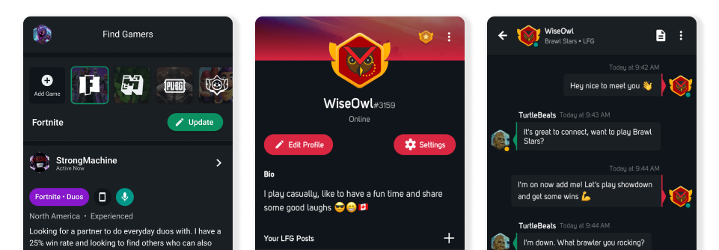GamerLink is a mobile application designed to seamlessly connect gamers based on their preferences, playstyles, and gaming interests. Offering a user-friendly interface, GamerLink allows players to find compatible teammates for specific games or genres. The app facilitates direct communication between players, enabling them to coordinate gaming sessions and build teams efficiently. With features such as profile customization and detailed gaming preferences, GamerLink enhances the matchmaking experience, fostering a sense of community among gamers seeking collaborative and enjoyable gaming experiences.

Figure 2. 1.1 GamerLink

## 2.2 Teamfind

Teamfind is a dedicated platform designed to simplify the process of team-building within the gaming community. With a user-friendly interface, Teamfind allows players to connect with like-minded individuals or teams, creating a space where gamers can find suitable teammates for various games. The platform often features searchable databases, detailed player profiles, and team listings, enhancing the overall experience of forming cohesive gaming teams. Teamfind serves as a valuable resource for players seeking collaborative and competitive gaming experiences, contributing to the sense of community within the diverse landscape of online gaming.

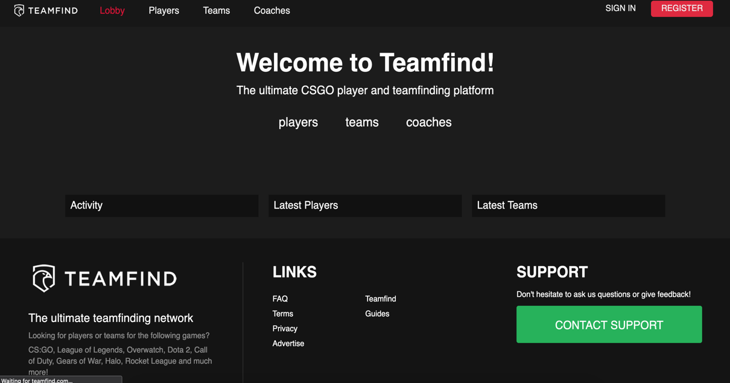

Figure 2. 2 .1 Teamfind

# Chapter 3 : Design and Implementation

Teamfinder evolved through three key phases: securing user access, creating an intuitive exploration hub, and implementing an efficient invitation system for team formation. Each phase followed a systematic flow, ensuring a user-friendly and efficient approach to online gaming recruitment. Collectively, these efforts enhance the player experience in the dynamic world of online gaming.

## 3.1 Build Phases

### 3.1.1 Login Phase

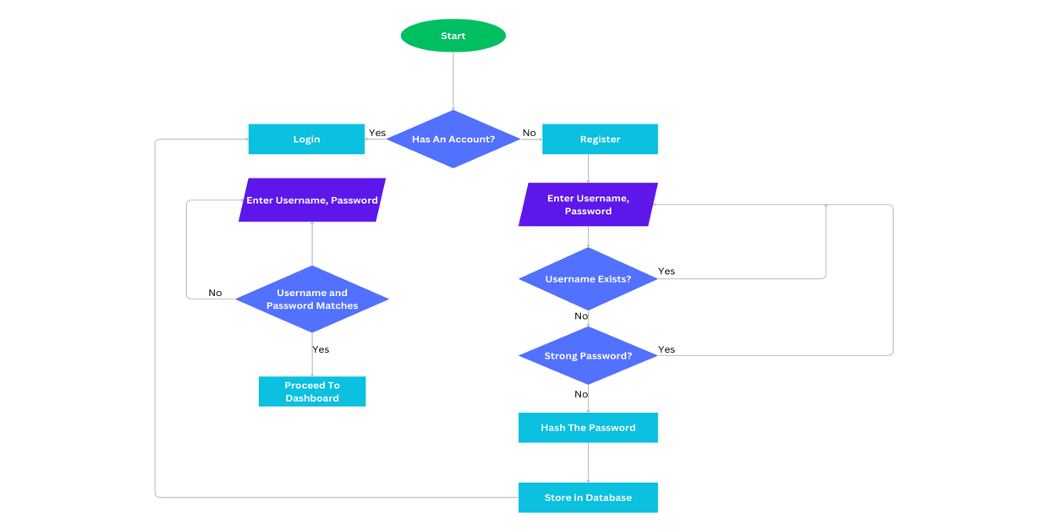The login and registration process was designed to ensure a seamless onboarding experience for players. The flowchart for this phase depicted the sequential steps, including user input validation, password hashing, and database interaction. The login and registration system set the foundation for user interaction within Teamfinder, providing a secure gateway for players to access the application.

**Figure 3. 1.1 Login Flow Chart**

### 3.1.2 Dashboard Phase

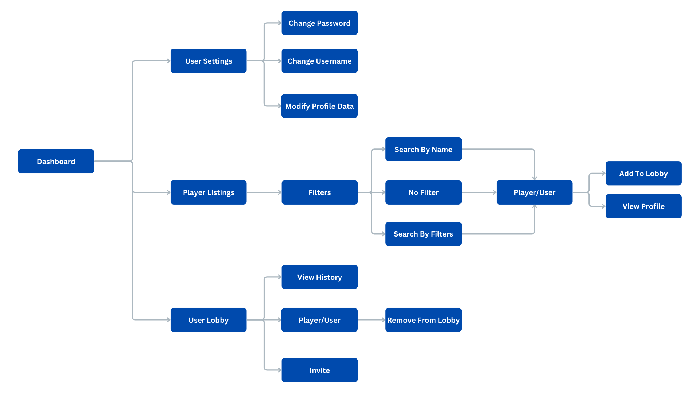The second phase concentrated on the development of the dashboard, which serves as the central hub for user interactions. The design prioritized clarity and ease of navigation, allowing players to view available opportunities, search for teams or players, and manage their profiles. UI - diagrams were instrumental in outlining various interactions such as lobby creation, profile updates, and search functionalities. The implementation of the dashboard aimed to create an intuitive and informative interface for users to explore and engage with Teamfinder's features.

**Figure 3. 2.1 UI Flow Diagram**

### 3.1.3 Invitation Phase

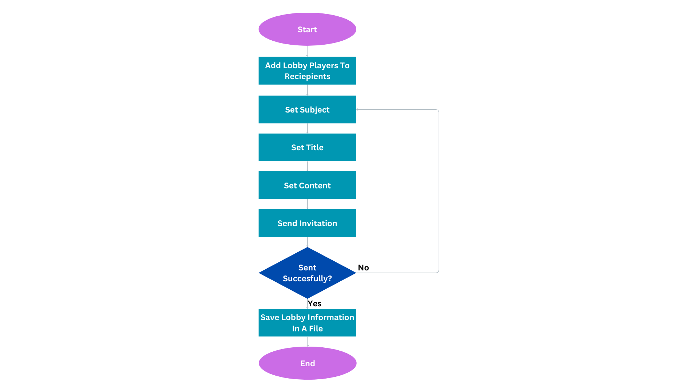In the third development phase, Teamfinder introduced a player-initiated Customizable Invitation Mail System. Now, when a player believes they have a cohesive lobby, they can initiate the invitation process. This action opens a mail window where the user can seamlessly customize the content of the invitation text. This player-centric approach empowers users to personalize their invitations, tailoring the messaging to align with their communication preferences. The system not only simplifies the invitation process but also allows players to take the lead in building their ideal gaming teams, fostering a more engaging and collaborative experience within Teamfinder.

**Figure 3. 3.1 Flowchart of Invitation System**

## 3.2 System Requirement Specifications

### 3.2.1 Software Requirement Specifications

#### **3.2.1.1 Front End Tools**

**Qt**

According to (About Qt - Qt Wiki, n.d.), Qt (pronounced ‘cute’) is a free and open-source widget toolkit for creating graphical user interfaces as well as cross platform applications that run on various software and hardware platforms. Qt is currently being developed by The Qt Company. Qt is available under both commercial licenses and open-source GPL 2.0, GPL3.0, and LGPL 3.0 licenses.

Teamfinder uses Qt to have a clean minimalistic look which provides a very user-friendly interaction. Libraries like QtMySQL has been used for database connection.

#### **3.2.1.2 Back End Tools**

**MySQL**

MySQL is an open-source relational database management system (RDBMS) that is widely used for managing and organizing data. Known for its speed, reliability, and scalability. Teamfinder uses MySQL to efficiently store and manage data, ensuring reliable and seamless access for users. The robust relational database capabilities of MySQL enhance the application's performance and scalability.

**External Libraries**

**YAML-CPP** is a C++ library for parsing and emitting YAML data. It provides a user-friendly interface for working with YAML documents, allowing developers to easily convert C++ data structures to and from YAML format. Teamfinder uses this library for parsing configuration file and data exchange.

**OpenSSL** is a robust open-source library that provides a set of cryptographic functions and protocols in C. It offers support for secure communication over networks and the implementation of various cryptographic algorithms. Teamfinder uses this library for hashing sensitive information.

**POCO** C++ Libraries, short for "POrtable COmponents," provide a collection of open-source C++ class libraries that simplify and accelerate the development of network-centric, portable applications. POCO encompasses modules for network communication, data structures, file systems, and more, offering a comprehensive and lightweight framework for C++ developers.Teamfinder uses this library for creating a mail based invitation system.

### 3.2.2 Hardware Requirement Specifications

* Operating System : Microsoft Windows , Mac OS X.
* CPU Requirements :
  + Processor : Intel x86-compatible CPU
  + Architecture : 64-bit
  + Minimum Clock Speed : 1.6 Ghz
  + Dual-core or higher recommended for optimal performance
* Memory : 4 GB or Higher
* Storage : Minimum Free Disk Space 20 GB
* Graphics : Integrated or Dedicated GPU with at least 128 MB VRAM
* Network : Ethernet or Wi-Fi connectivity for internet access

# Chapter 4 : Discussions on Achievements

After the completion of this project, we observed that the final project has met our objectives. We are certain that Teamfinder is able to solve the problem of absence of a centralized platform , leading to inefficiencies. It emerges as a versatile solution tailored for gamers, catering to both small-scale enthusiasts and extensive gaming communities. It can be used to invite players based on one’s interests and requirements which is the primary reason for using this application. Through the development process, the project became a platform for learning various technologies and concepts such as Qt and MySQL. These acquired skills not only enhance the functionality of Teamfinder but also empower the development team with valuable insights for future advancements.

The Challenges we faced during the development of this project were as follows :-

1. Coordinating seamless integration of player profiles and invitation system.
2. Designing and intuitive and visually appealing interface for diverse gaming preferences.
3. Ensuring robust security for user accounts.
4. Navigating the learning curve with new technologies like SQL , QT.

The difference / improvements seen in the actual project that were different or unplanned in proposed project were as follows :-

1. The application wasn’t supposed to have a invitation feature. However, we have added a invitation feature.
2. The proposed project was supposed to implement merge sort to sort the records. However , we later used ‘SORT’ clause of SQL to sort the data as it would be easier and effective.

## Features

There are many remarkable and extremely significant features developed in our project , ”TeamFinder” , which are listed below :-

1. **Registration and Login**

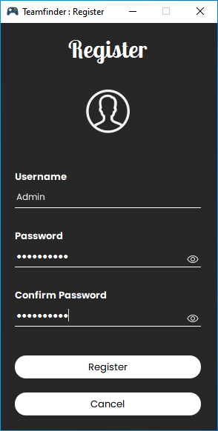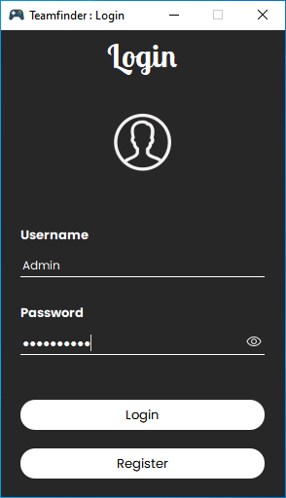The program can be used by multiple users by creating their separate accounts. Once they create the account, they can login into the program to view the dashboard.

**Figure 4.1. 1 Login And Registration**

1. **Password Security**

Our app goes beyond by incorporating SHA-256, an unyielding cryptographic standard, coupled with salting, to fortify user passwords with unbeatable protection. Your credentials undergo a dual-layer transformation into irreversible hashes, augmented by unique salts, ensuring resilience against even the most advanced cyber threats.

1. **User Dashboard**

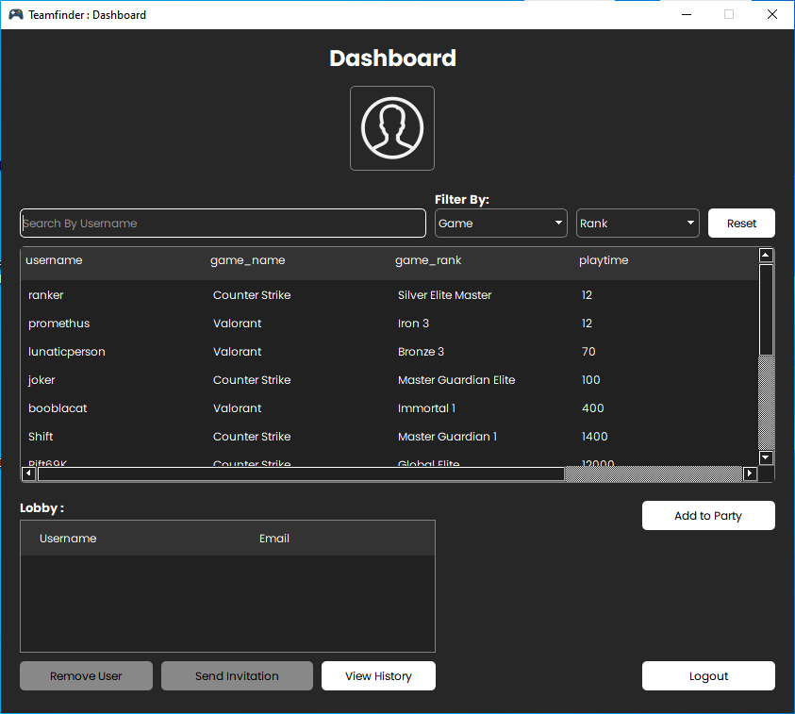The User Dashboard in Teamfinder offers a centralized hub for players to manage their profiles, preferences, and team activities. With an intuitive interface, users can effortlessly navigate, view team invitations, and customize their gaming preferences, fostering a seamless and personalized gaming experience.

**Figure 4.1. 2 User Dashboard**

1. **User Profile**

Teamfinder's User Profile feature empowers players to showcase their gaming skills and preferences. From highlighting achievements to specifying preferred game genres, the User Profile serves as a comprehensive snapshot. This customizable space enables effective team matchmaking by providing recruiters with valuable insights into a player's gaming expertise and interests.

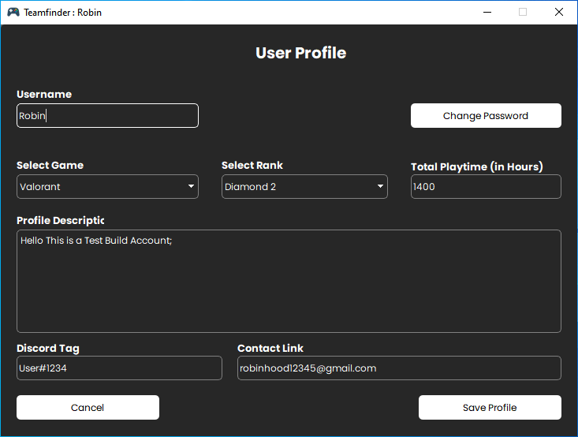

**Figure 4.1. 3 User Profile**

1. **View Player Profile**

The "View Player Profile" feature in Teamfinder allows users to explore detailed insights into a teammate's gaming skills, ranks , and preferences. This streamlined view enhances team coordination by providing a quick overview of a player's gaming expertise, fostering effective collaboration within the gaming community.

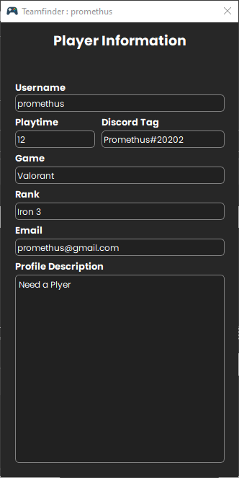

**Figure 4.1. 4 Player Profile**

1. **Send Invitation**

Teamfinder simplifies team formation with the "Send Invitation" feature. Users can seamlessly invite players to join them, initiating the process with a personalized message. This efficient tool fosters effective communication and collaboration, enhancing the overall experience of building dynamic gaming teams.

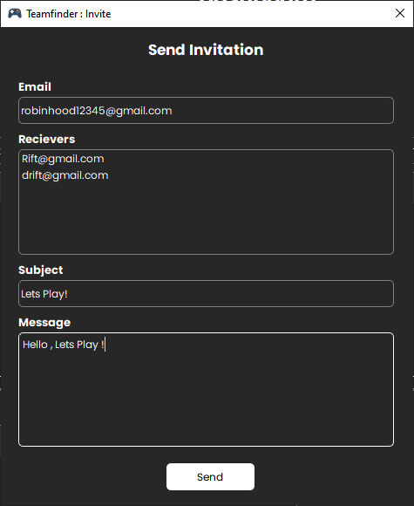

**Figure 4.1. 5 Invitation System**

1. **View History**

Teamfinder's "View Lobby History" feature allows users to revisit past team interactions conveniently stored in a file. Once an invite is sent, this historical record provides a valuable reference point, enabling users to track team formation, invitations, and overall gaming progress with ease.

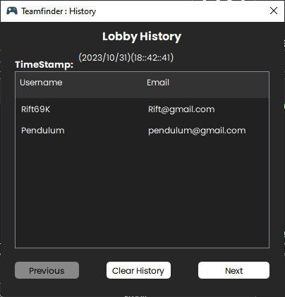

**Figure 4.1. 6 History Screen**

# Chapter 5 : Conclusion And Recommendation

In summary, Teamfinder has successfully achieved its primary goals, including the implementation of a player-initiated, customizable invitation system and the integration of a user-friendly dashboard. The application effectively streamlines team formation, enhances user engagement, and provides valuable insights into players' gaming profiles. However, challenges such as user interface complexities and technological learning curves were encountered, impacting the development process. Despite these challenges, the achieved goals align seamlessly with the project's objectives, contributing to an efficient and personalized online gaming recruitment experience. The ongoing commitment to user feedback and continuous improvement remains a key aspect of Teamfinder's development, ensuring its sustained alignment with the project's overarching objectives.

## 5.1 Limitations

While Teamfinder presents a robust solution for online gaming team recruitment, certain limitations should be acknowledged. These include:

1. The incorporation of new technologies and features may pose a learning curve for users unfamiliar with concepts such as MySQL and Qt, impacting the onboarding experience.
2. While efforts have been made to ensure the security of user accounts, unforeseen security vulnerabilities may exist, requiring continuous vigilance and updates.
3. While efforts have been made to optimize scalability, unforeseen challenges in accommodating a rapidly growing user base may be encountered.
4. The app's effectiveness depends on users supplying accurate data, limiting functionality with incomplete or outdated information.

## 5.2 Future Enhancements

To further elevate the capabilities of Teamfinder, potential areas for enhancement include:

1. Explore the integration of artificial intelligence algorithms to optimize team matchmaking, taking into account player skill levels, preferences, and historical gaming performance.
2. Introduce real-time collaboration features within the lobby, enabling users to communicate and strategize seamlessly during gameplay for an enhanced gaming experience.
3. Continuously fortify the application's security protocols, incorporating advanced measures to safeguard user accounts and sensitive data against evolving cybersecurity threats.
4. Explore opportunities to enhance compatibility by integrating with a broader range of gaming platforms, expanding the application's reach and user base.
5. Explore partnerships with popular gaming platforms to integrate with their APIs, offering users seamless access to gaming statistics, achievements, and in-game activities.

# References

"GamerLink - Universal Looking For Group (LFG) App." <https://gamerlinkapp.com/>.

"Teamfind - Team and Player Finding for CS:GO, LoL, Overwatch, RL, CoD ...." <https://teamfind.com/>.

"MySQL :: MySQL 8.0 Reference Manual :: 1.2.1 What is MySQL?." <https://dev.mysql.com/doc/refman/8.0/en/what-is-mysql.html>.

"Getting Started with Qt | Qt 6.6." <https://doc.qt.io/qt-6/gettingstarted.html>.

"A Guided Tour Of The POCO C++ Libraries." <https://docs.pocoproject.org/current/00100-GuidedTour.html>.

"OpenSSL Quick Reference Guide | DigiCert.com." <https://www.digicert.com/kb/ssl-support/openssl-quick-reference-guide.htm>.

"Yaml-cpp | A YAML parser and emitter in C++." <https://jbeder.github.io/yaml-cpp/>.

# Appendix

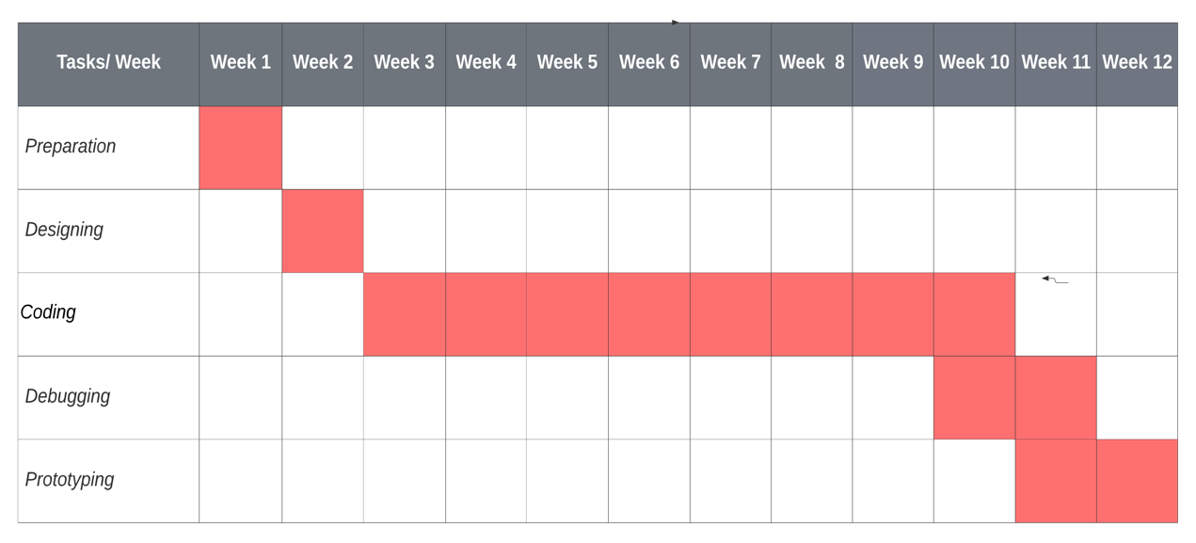

**Figure i Gantt Chart**

Source code of the project and its binary release can be found in the following link:

<https://github.com/TeamUp-Bummers/TeamFinder>