**Kathmandu University**

**Department of Computer Science and Engineering**

**Dhulikhel, Kavre**



**A Project Proposal**

**on**

**“Team Finder”**

**[Code No: ENGG-102]**

**(For partial fulfillment of First Year/Second Semester in Computer Science)**

**Submitted by**

**Ashitom Budhathoki (Roll No. 10)**

**Ajursha Dahal (Roll No.11)**

**Anmol Dahal (Roll No. 12)**

**Pratham Raj Poudel (Roll No.33)**

**Submitted to**

**Mr. Nabin Ghimire**

**Department of Computer Science and Engineering**

**Submission Date: 28th August 2023**

# **Abstract**

This project introduces an innovative application designed to streamline the player recruitment process for online gaming teams. With the increasing popularity of online games, assembling proficient teams is pivotal for competitive success. Our application addresses this challenge by efficiently identifying and selecting suitable players for various online games. The surge in online gaming necessitates a robust solution to connect teams with skilled players. Existing methods often lack a centralized platform for player recruitment, leading to inefficiencies and mismatches. This project aims to develop an application that facilitates the seamless discovery of players for online game teams. By providing a user-friendly interface, players can showcase their skills and preferences, while team recruiters can specify their requirements. Our application will incorporate user profiles highlighting players' skills. Team managers can list their requirements, and the app will then suggest suitable players based on skills, facilitating easy communication and team formation. We expect our app to speed up player recruitment, connecting teams with skilled players who align with their goals. This enhances team dynamics and the gaming experience. We recommend the incorporation of a feedback system for players and teams to continuously enhance the application's matching accuracy and user satisfaction

**Keywords:** (Player Recruitment, Team Formation, Player Profiles , Database system)

Table of Contents

Abstract i

List of Figures iii

Abbreviation iv

Chapter 1: Introduction 1

1.1 Background 1

1.2 Objectives 2

1.3 Motivation and Significance 2

1.4 Expected Outcome 3

Chapter 2: Related Works 4

3.1 Planning 5

3.2 Designing 5

3.3 Coding 5

3.3 Debugging 5

3.5 Prototyping 6

3.6 Workflow Diagram 6

Chapter 4: System Requirement Specifications 7

4.1 Software Specifications 7

4.1.1 Front End Tools 8

4.1.2 Back End Tools 8

4.2 Hardware Specifications 8

Chapter 5: Project Planning and Scheduling 9

References 10

# **List of Figures**

Figure 3.6.1 Workflow Diagram 6

Figure 5.1 Gantt Chart 9

# **Abbreviation**

MySQL: My Structured Query Language

OS: Operating System

API: Application Programming Interface

Ghz: Gigahertz

RAM: Random Access Memory

GB: Giga Bytes

MB: Mega Bytes

# **Chapter 1: Introduction**

## **1.1 Background**

Within the realm of online gaming, a notable shift has transformed multiplayer experiences from solitary pursuits into collaborative and competitive journeys spanning global virtual landscapes. This evolution has highlighted the growing requirement for streamlined tools that facilitate seamless player collaboration and interaction. In response to this evolving landscape, the present project envisions the creation of an innovative team finder application tailored exclusively for online games. The central objective of this endeavor is to simplify and enhance the team formation process, catering to the diverse needs and preferences of players.

Recent trends in the online gaming sphere have been notably influenced by the surge of esports, thrusting competitive gaming into the mainstream spotlight. This trend not only underscores the importance of teamwork and coordination but also emphasizes the demand for platforms that enable players to effortlessly locate and connect with compatible teammates. Concurrently, the integration of social elements within games, such as in-game chat systems and guilds, underscores the value of fostering a sense of community and shared experiences among players. However, existing methods of team formation often fall short in addressing the intricate nuances of player compatibility and synergy. These approaches, ranging from manual searches on forums to in-game matchmaking systems, lack the sophistication required to establish well-balanced teams, resulting in suboptimal gameplay experiences.

The need for a specialized team finder app is highlighted by the limitations of current approaches. This app would harness new technologies to analyze data and match players with compatible skills, communication preferences, and gaming styles. By overcoming current drawbacks, the project aims to enhance online gaming, promote better team synergy, and nurture gaming communities.

## **1.2 Objectives**

### 

The primary objectives of this project are to gain firsthand insight into the world of software development while focusing on the creation of a team finder application for online games. The project aims to offer an intuitive and user-friendly platform that simplifies the often-intricate process of team assembly in online games. Our specific objective includes:

* To Enhance player collaboration
* To Prioritize User-Centric Design
* To Cultivate Community Engagement

## **1.3 Motivation and Significance**

Our journey into this project is deeply rooted in our shared experiences as avid gamers. The frustrations stemming from the scarcity of suitable teammates in the vast landscape of online gaming are a narrative we intimately understand. Countless times, we've found ourselves grappling with the challenge of assembling compatible teams. It's precisely this firsthand understanding that has ignited our collective motivation to embark on this ambitious endeavor.

The significance of our project reverberates through the heart of the gaming community. The existing systems often fall short in addressing the intricate dynamics of team formation. By concentrating on players' unique preferences and compatibility factors, our team finder application intends to bridge the gap. It serves as a spotlight, showcasing individuals who are well-matched for potential team composition. This endeavor, we believe, holds the potential to ease the frustrations of players grappling with mismatched teams. Ultimately, this translates into gaming experiences that are not just enjoyable, but also truly fulfilling.

However, what truly sets our project apart is its unwavering dedication to fostering genuine unity and effective teamwork. Unlike conventional systems that often overlook the nuances of player interactions, our application is designed to forge connections among individuals who share common gaming interests and playstyles. By simplifying the process of discovering like-minded teammates, our project aspires to enrich the cooperative facet of online gaming. Through this, we aim to cultivate a sense of cohesion within the gaming community—a space where players don't just collaborate, but also build lasting relationships. As we journey forward, our vision encompasses offering players a dependable platform to connect, collaborate, and elevate their gaming ventures.

## **1.4 Expected Outcome**

The expected outcome of this project is a user-centric platform enabling seamless player selection for online gaming teams. By factoring in availability, skills, and preferences, the system aims to refine team dynamics. This streamlined approach is poised to enhance gameplay experiences, fostering better coordination and cooperation. Additionally, the platform's anticipated outcome includes stronger player interactions and community engagement, as users collaborate to assemble teams aligned with their goals. Overall, the project's success lies in offering a tailored team selection experience that elevates online gaming interactions and builds a more cohesive and connected gaming community.

# **Chapter 2: Related Works**

The realm of online gaming currently lacks comprehensive platforms that offer real-time availability of players for various games. Existing projects and applications in this domain are notably scarce. Here are a few applications that somewhat match the scope of our project, but they are limited in their functionality and game coverage. This scarcity underscores the need for a novel solution that consolidates and provides readily accessible information regarding player availability across a diverse range of online games.

**2.1 GamerLink: GamerLink** offers a user-friendly platform designed to connect gamers based on their preferences and gaming interests. While it primarily emphasizes finding teammates, it does offer a rudimentary indicator of player availability for specific games. However, its drawback lies in the limited depth of player availability information it provides, often lacking comprehensive coverage of games and lacking real-time updates.

**2.2 PlayPal:** PlayPal, focuses on skill-based matchmaking and considers player preferences as well. This application's strengths include providing insights into player availability while emphasizing matchmaking. However, it falls short in terms of game coverage, often centering around skill levels and not necessarily boasting a substantial user base for all games.

# **Chapter 3: Procedure and Methods**

Embarking on a methodical journey, this project follows a structured approach with distinct stages, each contributing to the development of a robust platform for selecting players in online gaming teams. The journey unfolds through the following sections:

## **3.1 Planning**

At the outset, tasks are thoughtfully distributed among team members, bolstered by comprehensive web research to gather insights from existing solutions. This informs the creation of a comprehensive development plan, charting the project's scope, milestones, and timelines, providing a clear roadmap for the tasks ahead.

## **3.2 Designing**

The design phase shifts concepts into visual realities. Here, emphasis is placed on crafting an intuitive user interface, realized through wireframing and prototyping techniques. In parallel, the coding process commences, translating design elements into functional components of the platform

## **3.3 Coding**

The coding phase is the heart of the project, where the envisioned platform truly takes form. Development encompasses creating a user-friendly interface, constructing a robust profile system, implementing efficient data storage and input mechanisms, and integrating advanced algorithms to intelligently list players according to specific requirements.

## **3.3 Debugging**

The debugging phase entails rigorous testing to identify and resolve issues, ensuring a seamless user experience by addressing bugs and inconsistencies. This step fortifies the platform's foundation before moving to the prototyping phase, enhancing its overall quality and readiness for refinement and optimization.

## **3.5** **Prototyping**

As development progresses, the prototyping phase refines the platform using real-world usage and feedback. It includes controlled beta testing for user interaction insights, optimization efforts, thorough documentation, and culminates in the official platform release after validation.

## **3.6 Workflow Diagram**

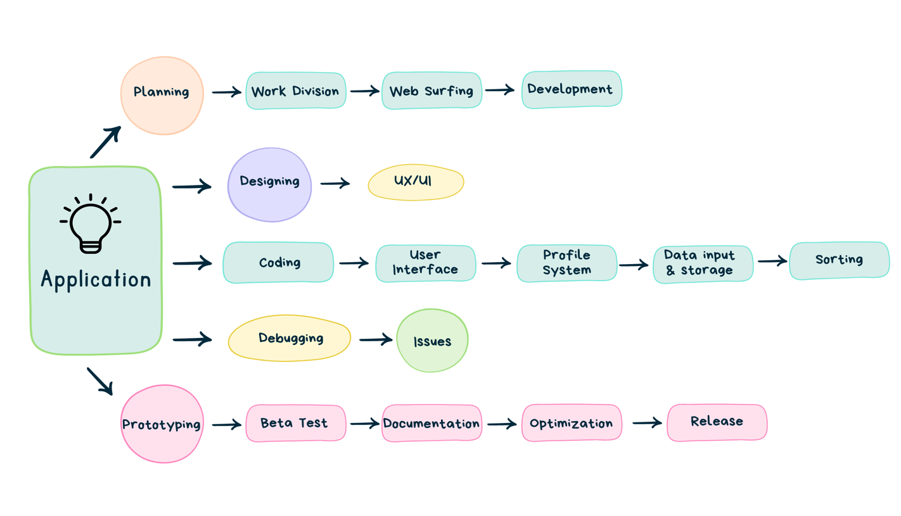The mind map-driven workflow diagram encapsulates the project's journey. It unfolds with meticulous planning, progressing into designing an intuitive user interface. Coding stages encompass robust profile systems, data efficiency, and intelligent listing of players. Debugging, prototyping, optimization, and documentation refine the platform, culminating in its official release. This visual overview succinctly underscores each phase's role in realizing the project's goal.

Figure 3.6.1 Workflow Diagram

# **Chapter 4: System Requirement Specifications**

## **4.1 Software Specifications**

This section provides an in-depth view of the application's design and functionality, covering both its functional and non-functional requirements, as well as the tools to be utilized.

The **functional requirements** of the online application encompass specific features aimed at enhancing user experience. These include a sophisticated player selection and team assembly mechanism to facilitate seamless team creation. Real-time data synchronization ensures that users receive up-to-date information. The application will incorporate communication and collaboration features, allowing users to interact and coordinate effectively. Furthermore, an integrated notification and alerts system will provide users with timely updates about relevant information.

Regarding **non-functional requirements**, attributes enhancing the application's performance, usability and scalability are considered. Performance goals encompass swift loading times, minimal latency, and high responsiveness. The application's scalability aims to accommodate increased user activity and data load without compromising performance. Compatibility across devices and operating systems ensures broad accessibility for users.

### **4.1.1 Front End Tools**

The **front-end tools** selected for the software system play a pivotal role in shaping its user interface and interactions. These tools encompass:

* OS: Mac OS & Windows
* Programming Platform: C++
* APIs or Libraries: qt5

### **4.1.2 Back End Tools**

In back-end domain, the software will rely on following tools for efficient data management:

* MySQL: MySQL, an open-source relational database management system which powers applications with its efficient data storage and retrieval.

## **4.2 Hardware Specifications**

The software system is designed to operate efficiently across a range of hardware configurations. For optimal performance, a minimum hardware setup of a dual-core processor with a clock speed of 1.8 GHz, 4 GB RAM, and 100 MB of available hard disk space is recommended. Stable high-speed internet connectivity is advised for real-time data interaction. The software system ensures compatibility with various desktop and laptop computers.

# **Chapter 5: Project Planning and Scheduling**

The project's timeline is depicted in the Gantt chart below, showcasing the planned start and end dates for each phase, major milestones, and the overall project duration.

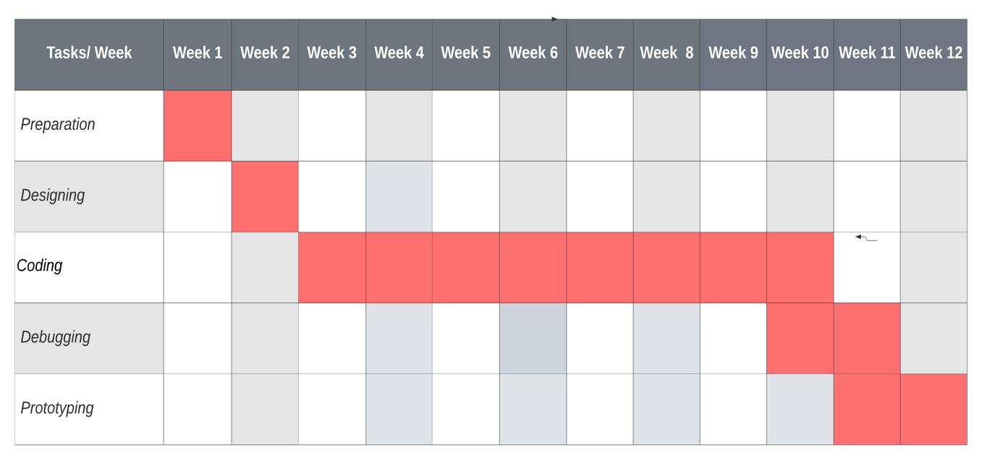

Figure 5.1 Gantt Chart

The Gantt chart serves as a visual representation of the project's progress, allowing for efficient tracking of tasks, dependencies, and potential delays. Through meticulous planning and adherence to the schedule, the project aims to achieve its goals within the designated timeframes, ensuring a successful software release.

# **References**

"Find Your Team - TEAMS.gg." *(Publication Date: February 16, 2023)*. <https://teams.gg/>

"The Importance of Team Dynamics in Esports: A Look at Successful Strategies and Failures." *(Publication Date: April 11, 2023)*. *GameInfoHub*. <https://gameinfohub.com/the-importance-of-team-dynamics-in-esports-a-look-at-successful-strategies-and-failures/>

"CSGO Teamfinder: What Is It and How Does It Work?" *(Publication Date: June 28, 2021)*. *GlobalCSGO*. <https://globalcsgo.com/guides/csgo-teamfinder-services/>

"MySQL - Wikipedia." Retrieved from <https://en.wikipedia.org/wiki/MySQL>

**"Qt (software) - Wikipedia." Retrieved from** <https://en.wikipedia.org/wiki/Qt_(software)>

"GamerLink - Universal Looking For Group (LFG) App." <https://gamerlinkapp.com/>.