Software Requirements Specification

April, 2016

Product – www.snimka.bg

**Team Vermatrix Goldenhide**

1. **Introduction**
   1. **Purpose**

The purpose of this document is to provide an overview of the web application www.snimka.bg from a functional perspective. Also part of that work is to illustrate the purpose and complete declaration for the development of system. We will give highlights to some technical considerations relating to the application, and also highlights for some technical and organizational implementation issues. This document is primarily intended to be proposed to a customer for its approval and a reference for developing the first version of the system for the development team.

* 1. **Scope**

The scope of the project is to create document with software requirements specification for the website www.snimka.bg. In order to do this “Team Vermatrix Goldenhide” will analyze information for managing this web application and information provided on the site.

“Snimka.bg” is a web application which helps people to upload, store and share their pictures. Capacity of the storage is 6 GB per user and there is limit of the size of single picture which is 6 MB. Users can also look at other pictures and albums by random suggestions on the start page of the application or by searching with the name of the album or the author.

The application is free to use and the only requirement is for user to have connection to the internet. Owner of the album can provide information and description of the pictures which will act as the bases for the search results displayed to the other users. An administrator also uses the web-portal in order to administer the system and keep the information accurate. The administrator can, for instance, verify users, manage their information and check pictures for inappropriate content. All system information is maintained in a database, which is located on a web-server.

* 1. **Overview**

This document contains the overall description of the website www.snimka.bg and the specific requirements for the system. It also provides an overview of the system functionality and system interaction with other systems.

1. **Overall Description**
   1. **Product Perspective**

This project is free web application, so customers do not need to buy the product and customize it to reflect their needs. The system is already operational and some of the features can be used even without registration. End users only need any conventional web browser to use the system. The interface is intuitive and requires minimal training. [www.snimka.bg](http://www.snimka.bg) runs on dedicated webserver available 24/7 hosted by the software provider. Since this is a data-centric product it needs to store data somewhere. For that purpose system should use database. Thereby the end user is able to get or set different data - in this case this means to look at pictures and albums, to add and modify pictures and albums, to rate pictures or to write comments. All of the database communication is going over the Internet. To avoid problems with overloading the operating system the application is only allowed to use 6 gigabytes of memory and the maximum size of single picture is 6 megabytes.

* 1. **Product functions**

With this web application, the users are able to search for pictures and albums, to upload and organize them in albums and share them. The search result is based on the criteria the user inputs. There are several search criteria and it will be possible for the administrator of the system to manage the options for those criteria that have that. The web portal provides functionality to manage the system and the album information. Users can also rate and comment on other albums and pictures and add favorite authors or albums to profile.

* 1. **User characteristics**

There are three types of users that interact with the system: unregistered users, registered users and administrators. Each of these three types of users has different use of the system so each of them has their own requirements.

The unregistered users can only use the application to look at pictures and albums. This means that the user have to be able to search for picture, choose an album from that search and then navigate to it. In order for the users to get a relevant search result there are multiple criteria that the users can specify. Unregistered users can also make comments of pictures.

The registered users have all options of unregistered users plus some other features. They can upload pictures and albums and manage the information about them. Registered users can also rate pictures and interact with other users by sharing their pictures and making favorites.

The administrators are managing the overall system so there is no incorrect information within it. The administrator can manage the information for each picture as well as the options for both the albums and the user information.

* 1. **Constraints**
* Internet connection - since the application fetches data from the database over the Internet, it is crucial that there is an Internet connection for the application to function.

* Capacity - application will be constrained by the capacity of the database. Since the database is shared between all users it may be forced to queue incoming requests and therefor increase the time it takes to fetch data.
* Nonstop - the application should be always accessible by the users.
* Security - the system should enforce user authentication security and guarantee reliability.
  1. **Assumptions and dependencies**

One dependency of the product is that it must always be used with supported type of pictures. This means that to perform upload of photos the system requires valid picture format.

1. **Flow chart**



1. **Specific requirements**
   1. **Product function**

|  |  |  |  |
| --- | --- | --- | --- |
| CLASS OF USE CASES | № | USE CASES | DESCRIPTION OF USE CASES |
| Related to System Authentication | 1 | **Account creating** | *Create a working account* |
| Related to System Authentication | 2 | **Login** | *Login into snimka.bg with the created account details* |
| Related to Albums | 3 | **Create Album** | *Creates a new album* |
| 4 | **Edit Album** | *Allows album editing* |
| 5 | **Delete Album** | *Deletes the album* |
| Related to Pics | 6 | **Upload Pic** | *Uploads a new pic* |
| 7 | **Comment Pic** | *Allows pic comment* |
| 8 | **Rotate pic to the left** | *Rotates pic to the left* |
| 9 | **Rotate pic to the right** | *Rotates pic to the right* |
| 10 | **Delete Pic** | *Deletes the pic* |
| Related to Settings | 11 | **Change profile info** | *Changes the name, state, city. etc* |
| 12 | **Change profile photo** | *Changes the avatar of the user with new pic* |
| 13 | **Password change** | *Changes the password of the user* |
| 14 | **Email change** | *Changes the email of the user* |

* 1. **Functional Requirements**

We describe the functional requirements by giving various use cases.

*Use cases related to System Authentication:*

*Use Case №1:* Creating account  
*Primary Actor*: Prospect User  
*Pre Condition*: Installed browser and active internet connection

*Main scenario*:

1. User initiates browser
2. User writes snimka.bg URL in address bar
3. User gives username, password and fills all * fields
4. System does authentication
5. Start homepage is displayed

*Alternate scenario:*  
 1 Authorization fails – existing username/password  
 1.1 Prompt the user to type an unique username/ password 1.2 Allow him to re-enter the username/password  
 2 Authorization fails – missed info in * fields   
 2.1 Prompt the user to enter needed info  
 2.2 Successful login

3 Authorization fails – Условия за ползване box not checked   
 2.1 Prompt the user check it  
 2.2 Successful login

*Use Case №2*: Login  
*Primary Actor*: Authorized User  
*Pre Condition*: Installed browser, active internet connection, valid snimka.bg account

*Main scenario*:

1. User initiates browser
2. User writes snimka.bg URL in address bar
3. User gives username and password
4. System does authentication
5. User is logged in snimka.bg

*Alternate scenario:*

*Alternate scenario:*  
 1Authorization fails – wrong username/password  
 1.1 Prompt the user that he typed the username/password wrong  
 1.2 Allow him to re-enter the username/password  
 2 Authorization fails – forgotten username/password  
 2.1 Prompt the user to enter his registered email  
 2.2 User receives an email with instructions about his login credentials

*Use cases related to Albums:*

*Use Case №3:* Creating album  
*Primary Actor*: Valid user  
*Pre Condition*: Installed browser, active internet connection, logged to snimka.bg valid user

*Main scenario*:

1. User initiates browser
2. User writes snimka.bg URL in address bar
3. User gives username and password
4. System does authentication
5. User is logged in snimka.bg
6. User pushes the Upload pic button
7. User chooses album’s title, its category and presses Create a new album button

*Alternate scenario:* 1 New album creation fails – info in * fields not provided

1.1 Prompt the user that fills the needed info  
 1.2 Allow him to create a new album

*Use Case №4:* Edit album  
*Primary Actor*: Valid user  
*Pre Condition*: Installed browser, active internet connection, logged to snimka.bg valid user, created album

*Main scenario*:

1. User initiates browser
2. User writes snimka.bg URL in address bar
3. User gives username and password
4. System does authentication
5. User is logged in snimka.bg
6. Existing album chosen
7. User edits albums title or its category

*Use Case №5:* Delete album  
*Primary Actor*: Valid user  
*Pre Condition*: Installed browser, active internet connection, logged to snimka.bg valid user, chosen existing album

*Main scenario*:

1. User initiates browser
2. User writes snimka.bg URL in address bar
3. User gives username and password
4. System does authentication
5. User is logged in snimka.bg
6. Existing album chosen
7. User presses button Delete album

*Use Case №6:* Upload a pic  
*Primary Actor*: Valid user  
*Pre Condition*: Installed browser, active internet connection, logged to snimka.bg valid user, created album

*Main scenario*:

1. User initiates browser
2. User writes snimka.bg URL in address bar
3. User gives username and password
4. System does authentication
5. User is logged in snimka.bg
6. User pushes the Upload pic button
7. User chooses created album title

*Alternate scenario:* 1 New pic upload fails – no existing album is chosen

1.1 Prompt the user to create an album  
 1.2 Allow him to upload a pic in a chosen album

*Use Case №7:* Comment a pic  
*Primary Actor*: Valid user  
*Pre Condition*: Installed browser, active internet connection, logged to snimka.bg valid user

*Main scenario*:

1. User initiates browser
2. User writes snimka.bg URL in address bar
3. User gives username and password
4. System does authentication
5. User is logged in snimka.bg
6. User chooses any pic on the resource
7. User writes down the text in the comment box
8. User presses the Add button

*Alternate scenario:* 1 New comment on chosen pic fails – the Add button is not pressed.

1.1 Prompt the user to press the add button 1.2 Allow him to upload a pic in a chosen album

*Use Case №8:* Rotate a pic to the left  
*Primary Actor*: Valid user  
*Pre Condition*: Installed browser, active internet connection, logged to snimka.bg valid user, chosen album

*Main scenario*:

1. User initiates browser
2. User writes snimka.bg URL in address bar
3. User gives username and password
4. System does authentication
5. User is logged in snimka.bg
6. User chooses album in which the pic to be rotated is located
7. User presses the turn left button

*Use Case №9:* Rotate a pic to the right  
*Primary Actor*: Valid user  
*Pre Condition*: Installed browser, active internet connection, logged to snimka.bg valid user, chosen album

*Main scenario*:

1. User initiates browser
2. User writes snimka.bg URL in address bar
3. User gives username and password
4. System does authentication
5. User is logged in snimka.bg
6. User chooses album in which the pic to be rotated is located
7. User presses the turn right button

*Use Case №10:* Delete a pic  
*Primary Actor*: Valid user  
*Pre Condition*: Installed browser, active internet connection, logged to snimka.bg valid user, chosen album

*Main scenario*:

1. User initiates browser
2. User writes snimka.bg URL in address bar
3. User gives username and password
4. System does authentication
5. User is logged in snimka.bg
6. User chooses album in which the pic to be deleted is located
7. User chooses the pic to be deleted
8. User presses the turn delete button

*Use Case №11:* Change profile info  
*Primary Actor*: Valid user  
*Pre Condition*: Installed browser, active internet connection, logged to snimka.bg valid user, settings button pressed

*Main scenario*:

1. User initiates browser
2. User writes snimka.bg URL in address bar
3. User gives username and password
4. System does authentication
5. User is logged in snimka.bg
6. User types down new info for name, state, city, DOB, etc
7. User presses the Save changes button

*Use Case №12:* Change profile photo  
*Primary Actor*: Valid user  
*Pre Condition*: Installed browser, active internet connection, logged to snimka.bg valid user, settings button pressed

*Main scenario*:

1. User initiates browser
2. User writes snimka.bg URL in address bar
3. User gives username and password
4. System does authentication
5. User is logged in snimka.bg
6. User chooses a photo
7. User presses the Save changes button

*Use Case №13:* Change password  
*Primary Actor*: Valid user  
*Pre Condition*: Installed browser, active internet connection, logged to snimka.bg valid user, settings button pressed

*Main scenario*:

1. User initiates browser
2. User writes snimka.bg URL in address bar
3. User gives username and password
4. System does authentication
5. User is logged in snimka.bg
6. User types the new password
7. User retypes the new password
8. User presses the Save changes button

*Alternate scenario:*

1 Password change fails- new password is retyped incorrectly

1.1 Prompt the user to retype the new password correctly 1.2 Allow him to save the new password

*Use Case №14:* Email Change  
*Primary Actor*: Valid user  
*Pre Condition*: Installed browser, active internet connection, logged to snimka.bg valid user, settings button pressed

*Main scenario*:

1. User initiates browser
2. User writes snimka.bg URL in address bar
3. User gives username and password
4. System does authentication
5. User is logged in snimka.bg
6. User types the email
7. User presses the Save changes button

*Alternate scenario:*

1 Email change fails- new email is the same as old one

1.1 Prompt the user to enter a new valid email

1.2 Allow him to save a new email

* 1. **User screens**

**4.3.1 Login форма**

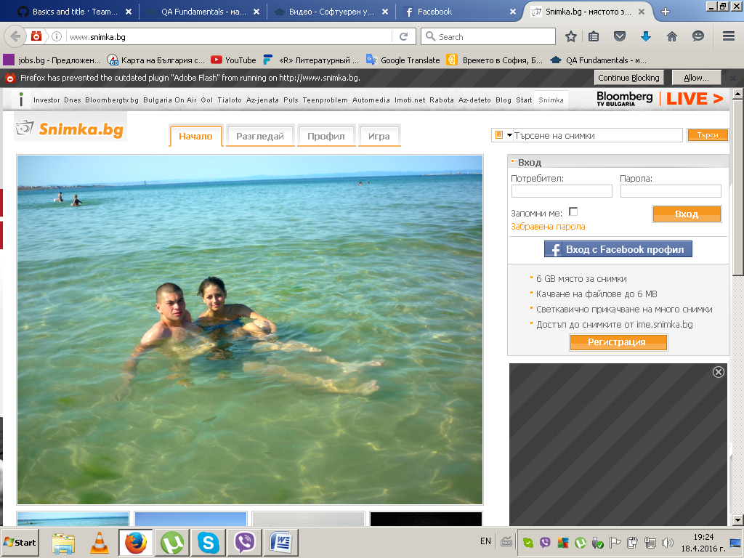

**4.3.2 Съобщения**

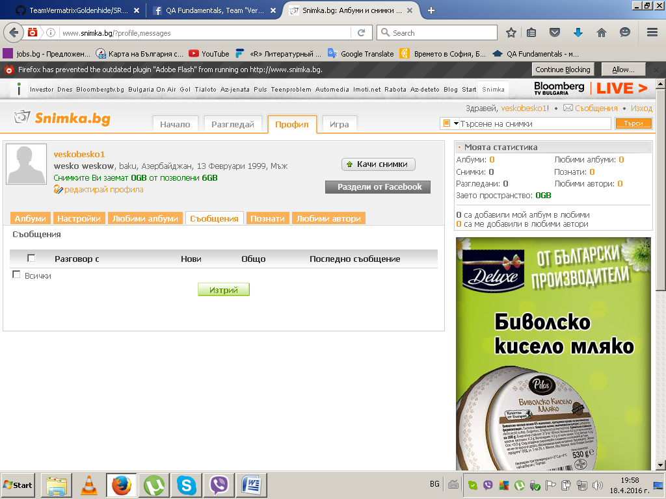

**4.3.3 Албуми**

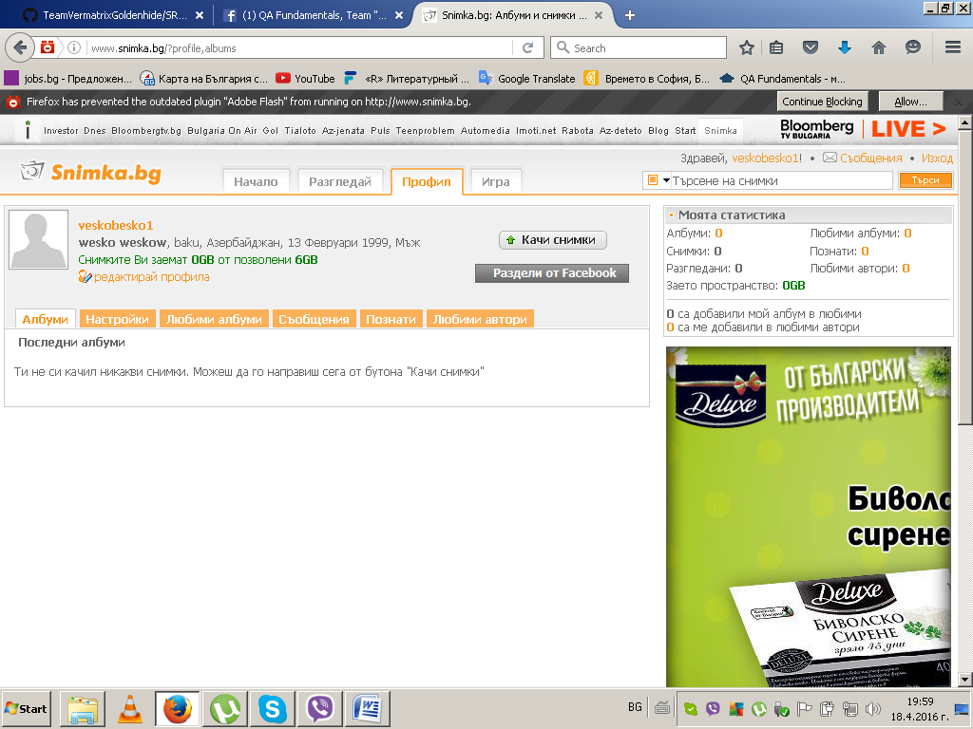

**4.3.4 Настройки**

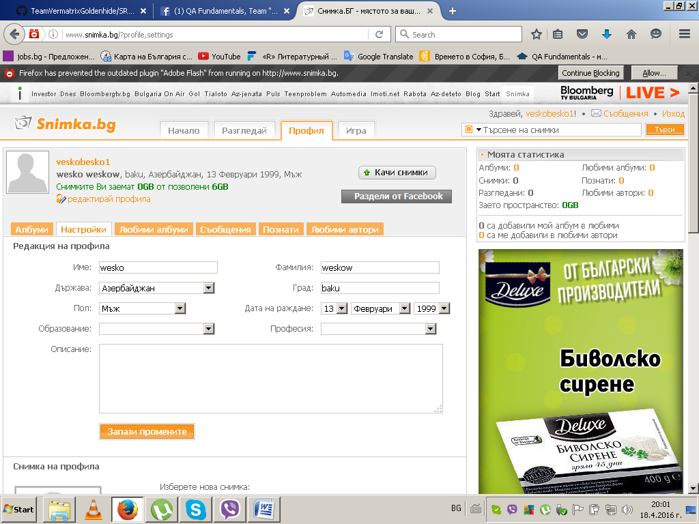

**4.3.5 Любими албуми**

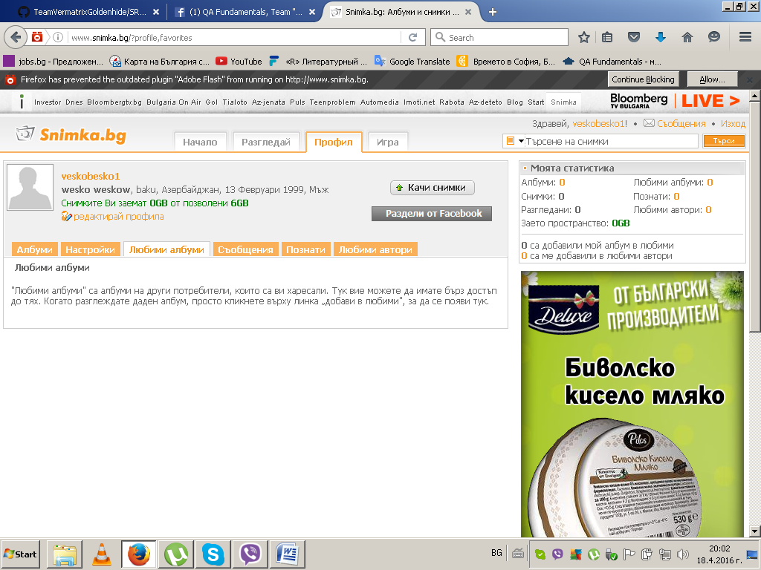

**4.3.6 Познати**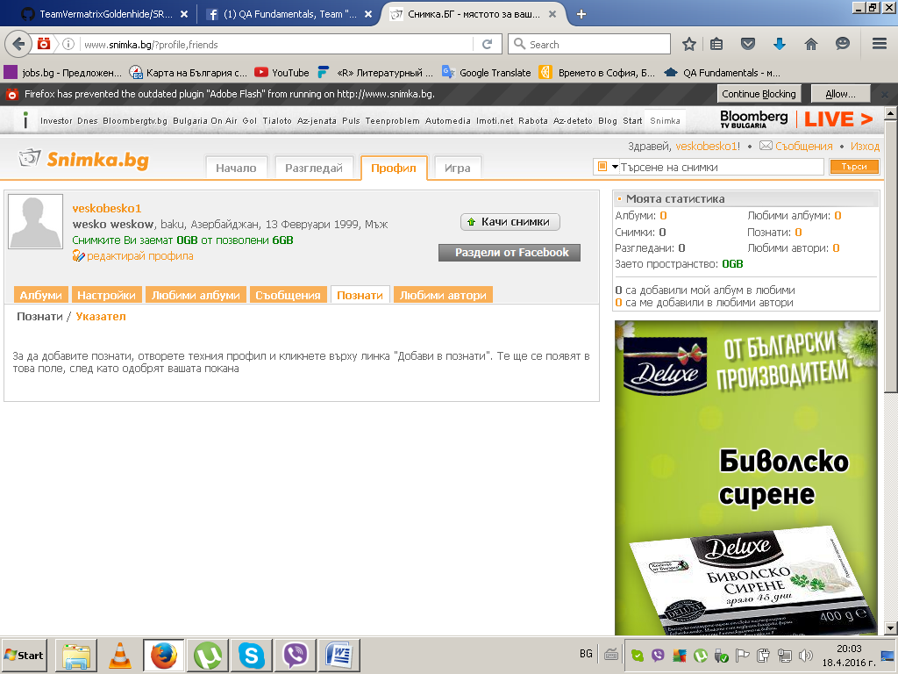

**4.3.7 Любими автори**

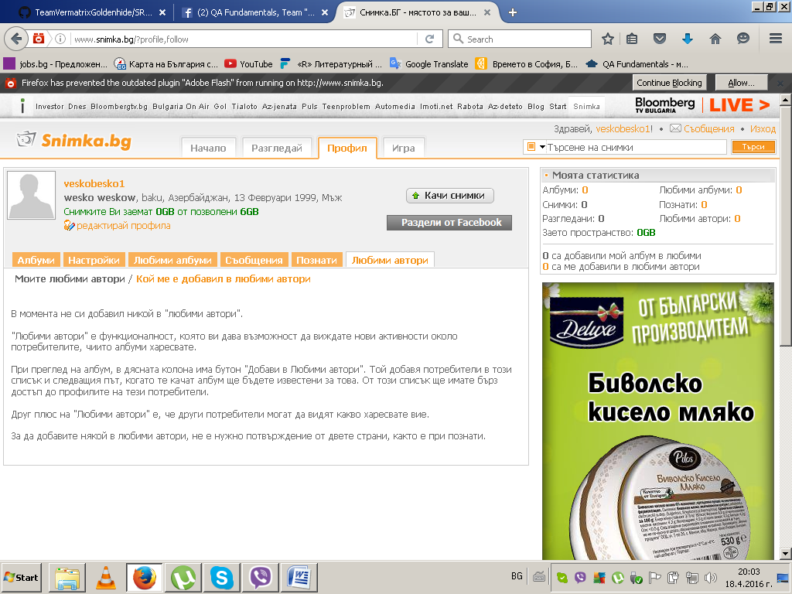

**4.3.8 Messages**

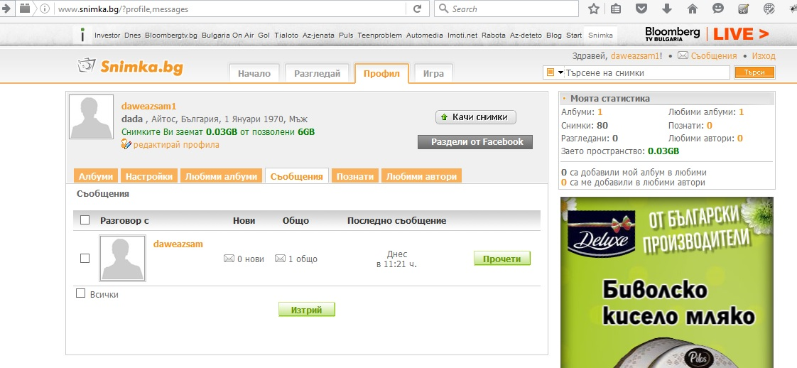

**4.3.9 Добави хора в указател**

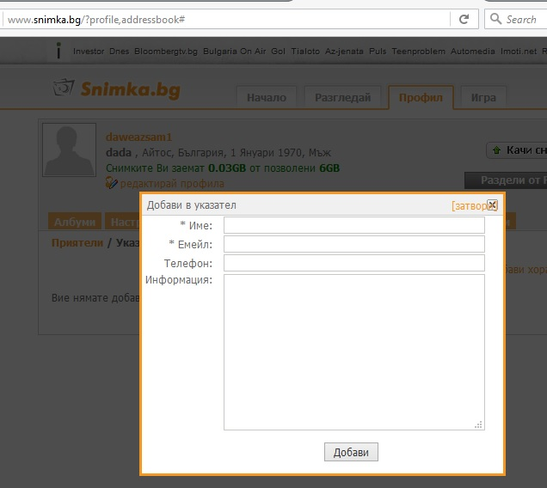

## 4.3.10 Качване на снимки/албуми

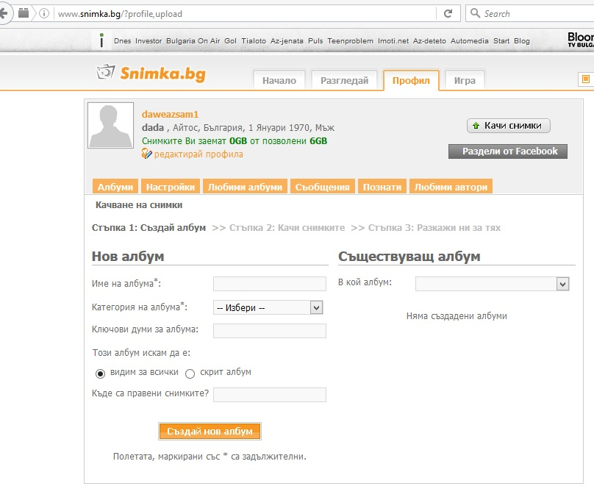

## Reliability

Reliability is an important factor to make [www.snimka.bg](http://www.snimka.bg) trustable.

* 1. **Availability:**

Snimka.bg should be available 24 hours per day, 7 days per week. Maintenance access period is a two month. Database is backed up.

Mean Time Between Failures (MTBF): 3 month.

Time to repair the system : 8-24 hours

* 1. **Performance**
     1. The information retrieval should be as fast as possible for customer satisfaction. To ensure this, the consumer should be able to download a page in 10 seconds with a V.34/28.8 kbit/s modem.
     2. The server should be able to serve 30 percent of registered customers .The server should be able to serve 30 percent of registered customers simultaneously, which may be about several thousand for a medium scaled electronic enterprise.

* 1. **Supportability**
     1. **Compatible with Operating Systems**
* Windows XP, 7/8/8.1/10
* Linux
  + 1. **Compatible with web browsers**
* Microsoft Internet Explorer
* Mozilla Firefox
* Google Chrome
* Opera