Vladimir Georgiev and Boris Zhelev, 2018

User’s Manual

NG Puppies

Version 1.0

Contents

Description 2

1. Data structure 2

2. Login page 3

3. Password-reset page 3

4. Client’s home page (private part) 4

5. Administrator’s home page (administrative part) 7

6. Access-denied page 12

7. Logout button 13

8. Update and create forms 13

NG PUPPIES

# Description

NG Puppies is an application intended for automatic utilities service payments. It provides a connection between a client (e.g., bank or other financial institution) and a telecom company. The telecom company administers the application and provides data to the bank about bills of the bank’s subscribers. The bank can see the bills related to its subscribers and pay them as single transactions or as bulk payments. It can also view history of made payments and statistics about its subscribers (e.g., top ten subscribers with largest bill payments, mean and total amount of paid bills for a given subscriber).

Authentication to the application is provided from the backend (server) of the application via JWT token after providing correct username and password at login time. After successful login the token is saved in the local storage of the page. The token contains information about the username, role, and whether this is the user’s first login into the system or not. Each token is valid for 15 minutes.

1. Data structure



1. Login page

The login page is the public part of the application. It provides access to private part or administrative part depending on user’s credentials, or redirects to password-reset page for first time administrative users.

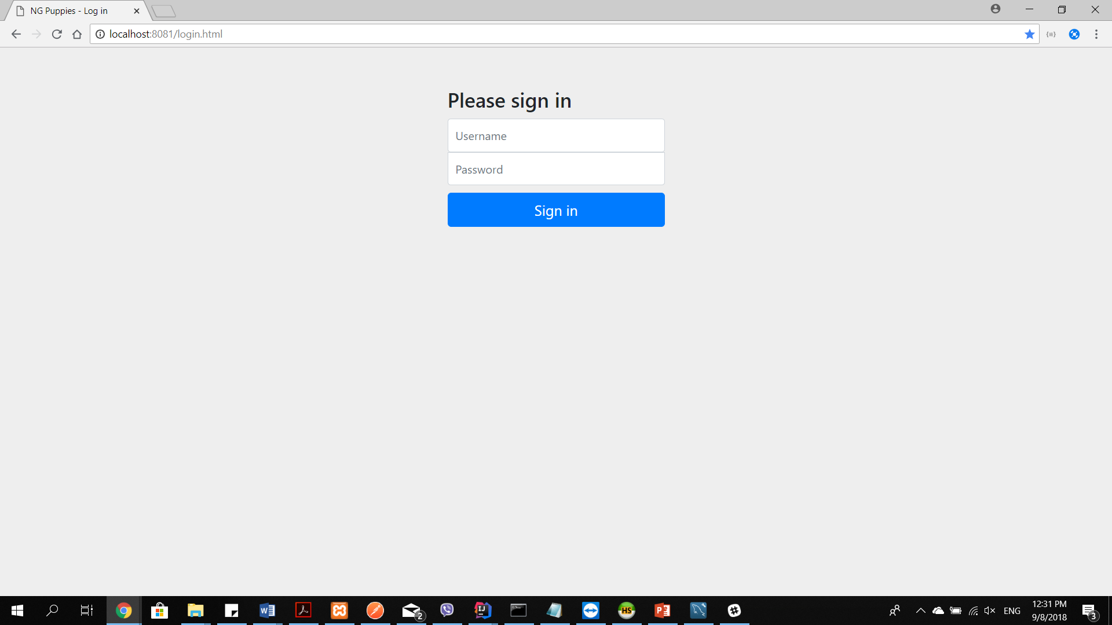

1. Password-reset page

If the user is with administrative credentials but logs in the application for the first time, the user is redirected to a password-reset page before being able to log into the administrative part. On successful password reset, the user is logged out and needs to log in again to proceed to the administrative home page.

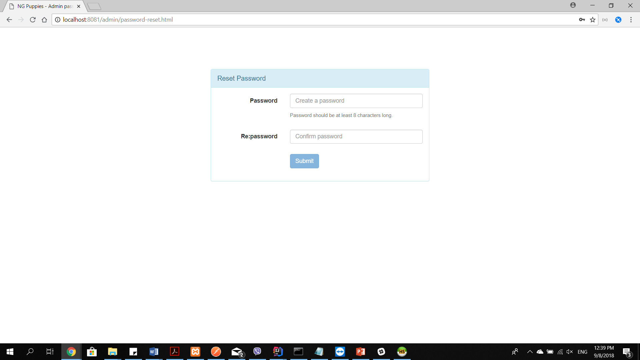

1. Client’s home page (private part)

After a client (e.g., bank) logs into the application it is redirected to the private part of the application, where each client can see several buttons. These buttons provide different functionalities:

* Subscribers
* Unpaid bills
* Top 10 subscribers
* Paid bills

In the footer of the page, the logged in client can find basic information about his/ her username and the credentials he/ she has for the application.

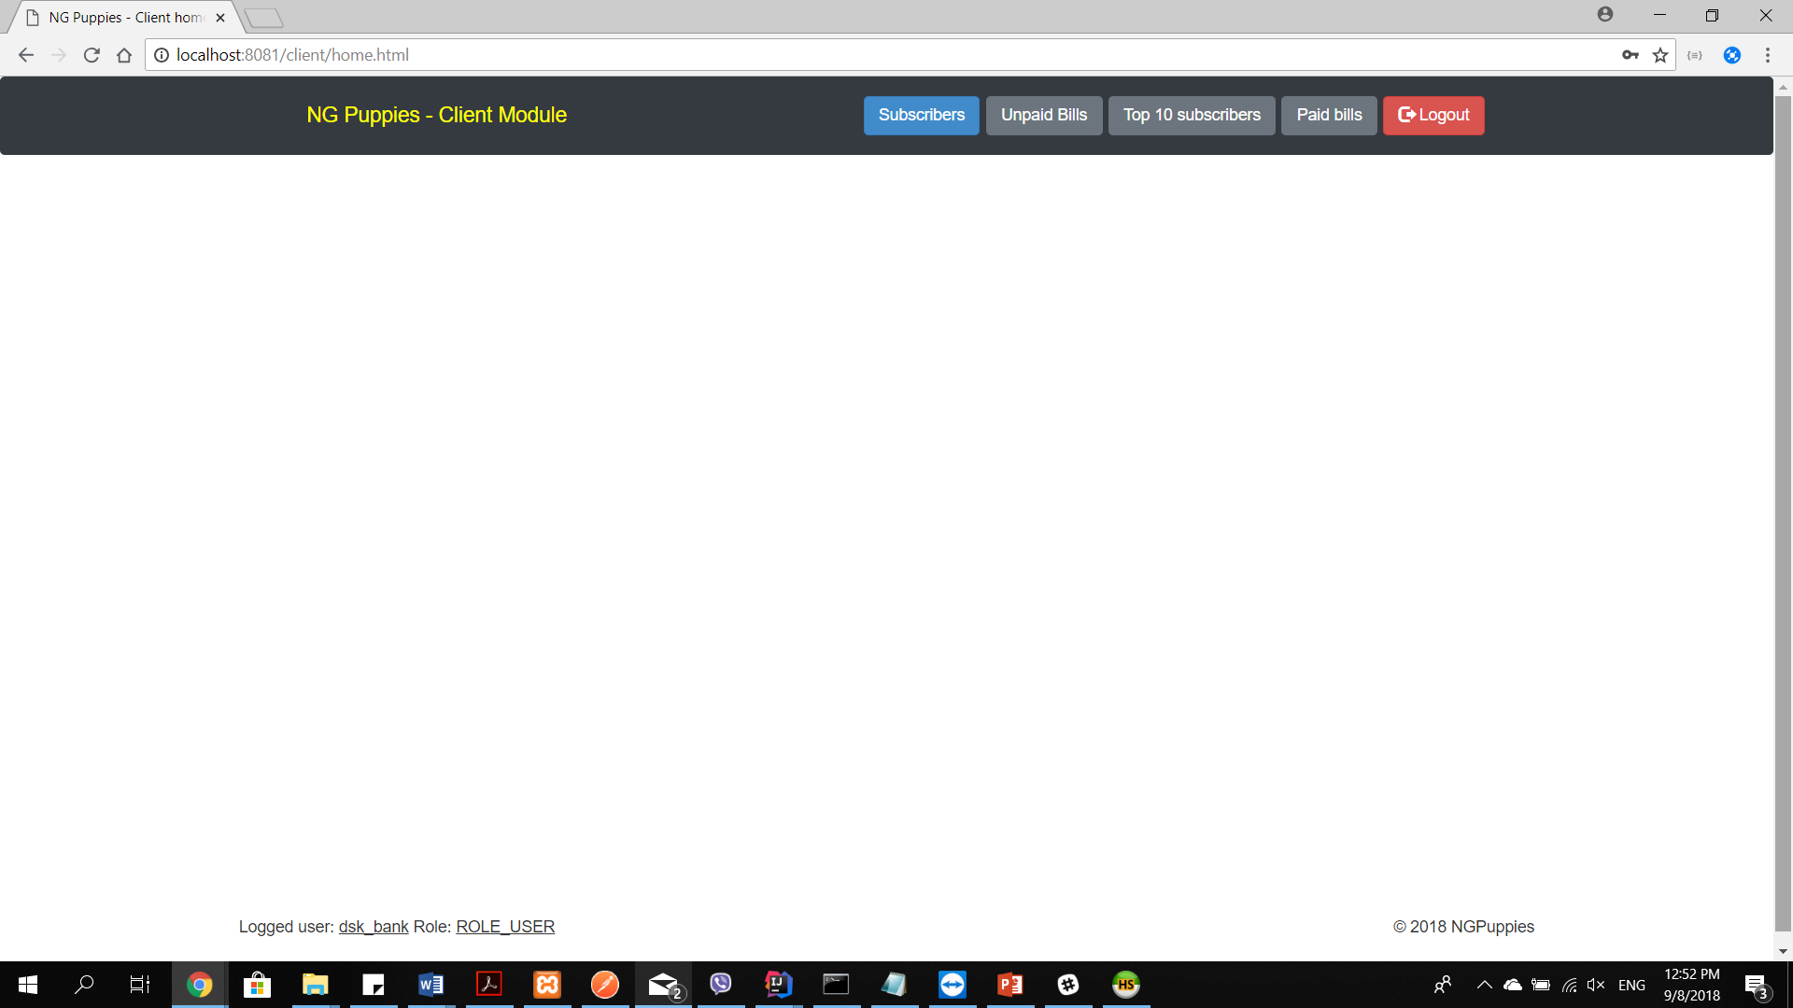

1. Subscribers button – provide access to the bank’s subscribers

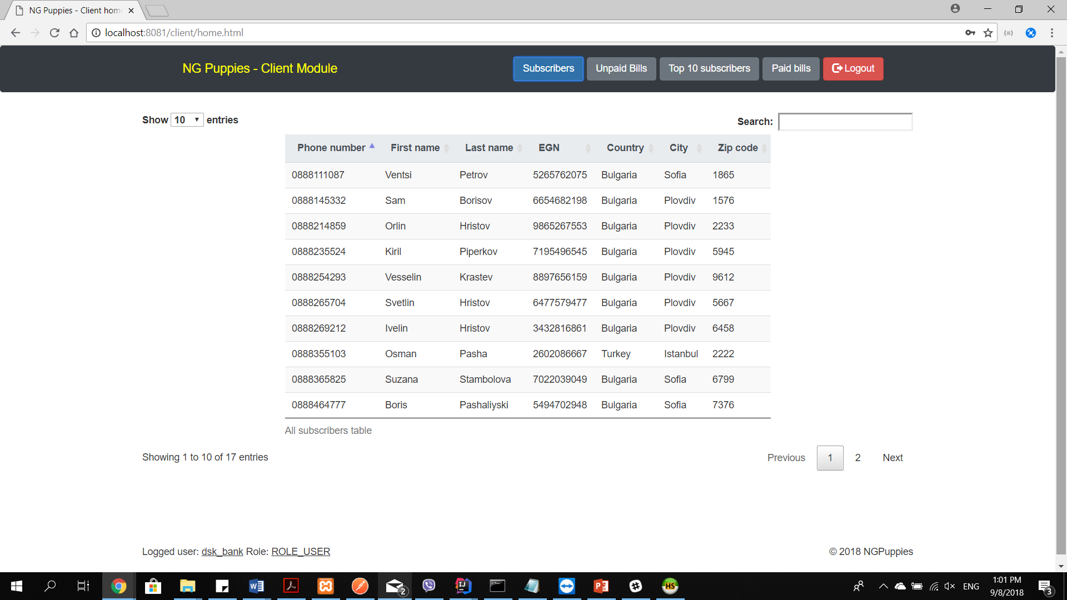

1. Unpaid bills button – provide access to the unpaid bills of the bank’s subscribers

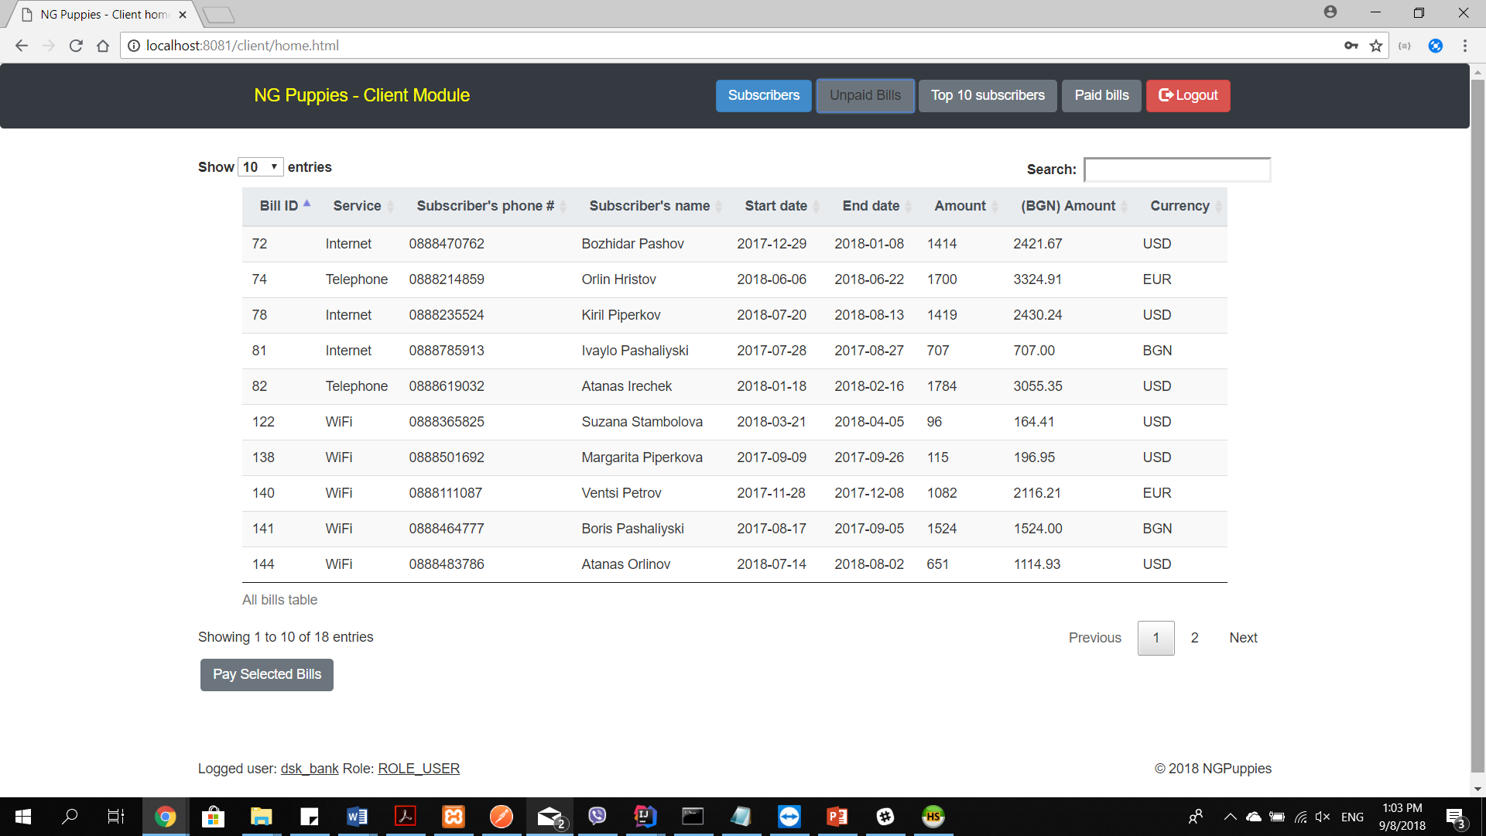

1. Top 10 subscribers button – provide access to ten subscribers of the bank (i.e., those subscribers with highest sum of paid bills

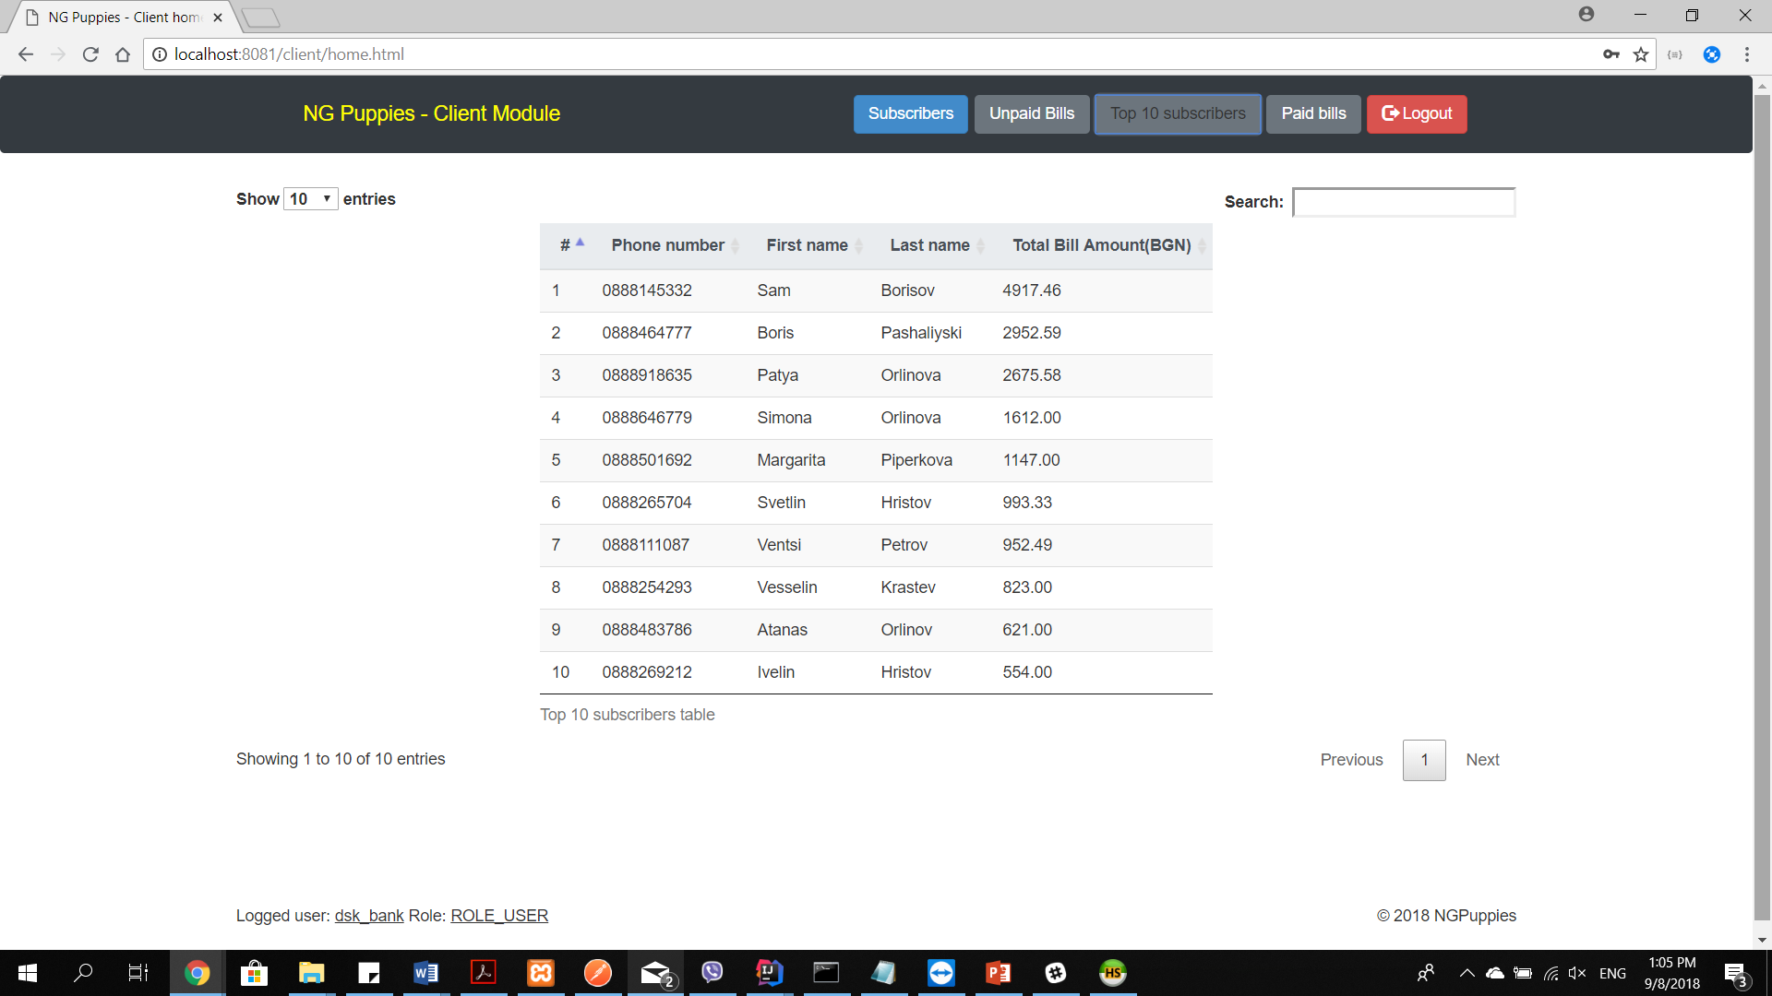

1. Paid bills button – shows all paid bills of the bank’s subscribers

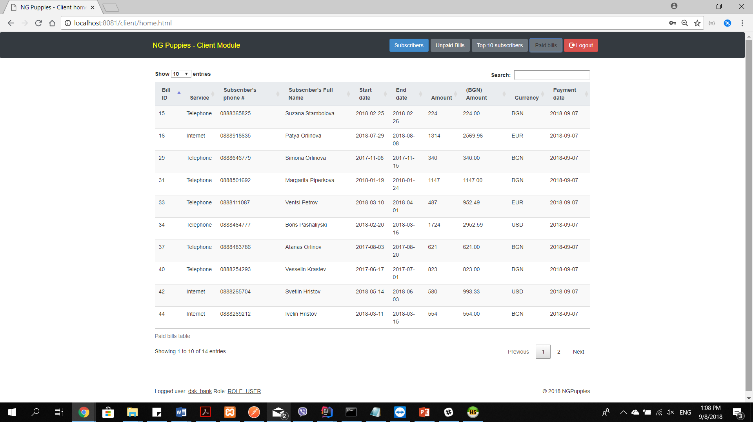

1. Administrator’s home page (administrative part)

After an admin (e.g., telecom company’s employee) logs into the application he/she is redirected to the administrative part of the application, where each admin can see several buttons. These buttons provide different functionalities:

* Personal Details
* Clients
* Admins
* All Users
* Subscribers
* Bills
* Services

In the footer of the page, the logged in user can find basic information about his/ her username and the credentials he/ she has for the application.

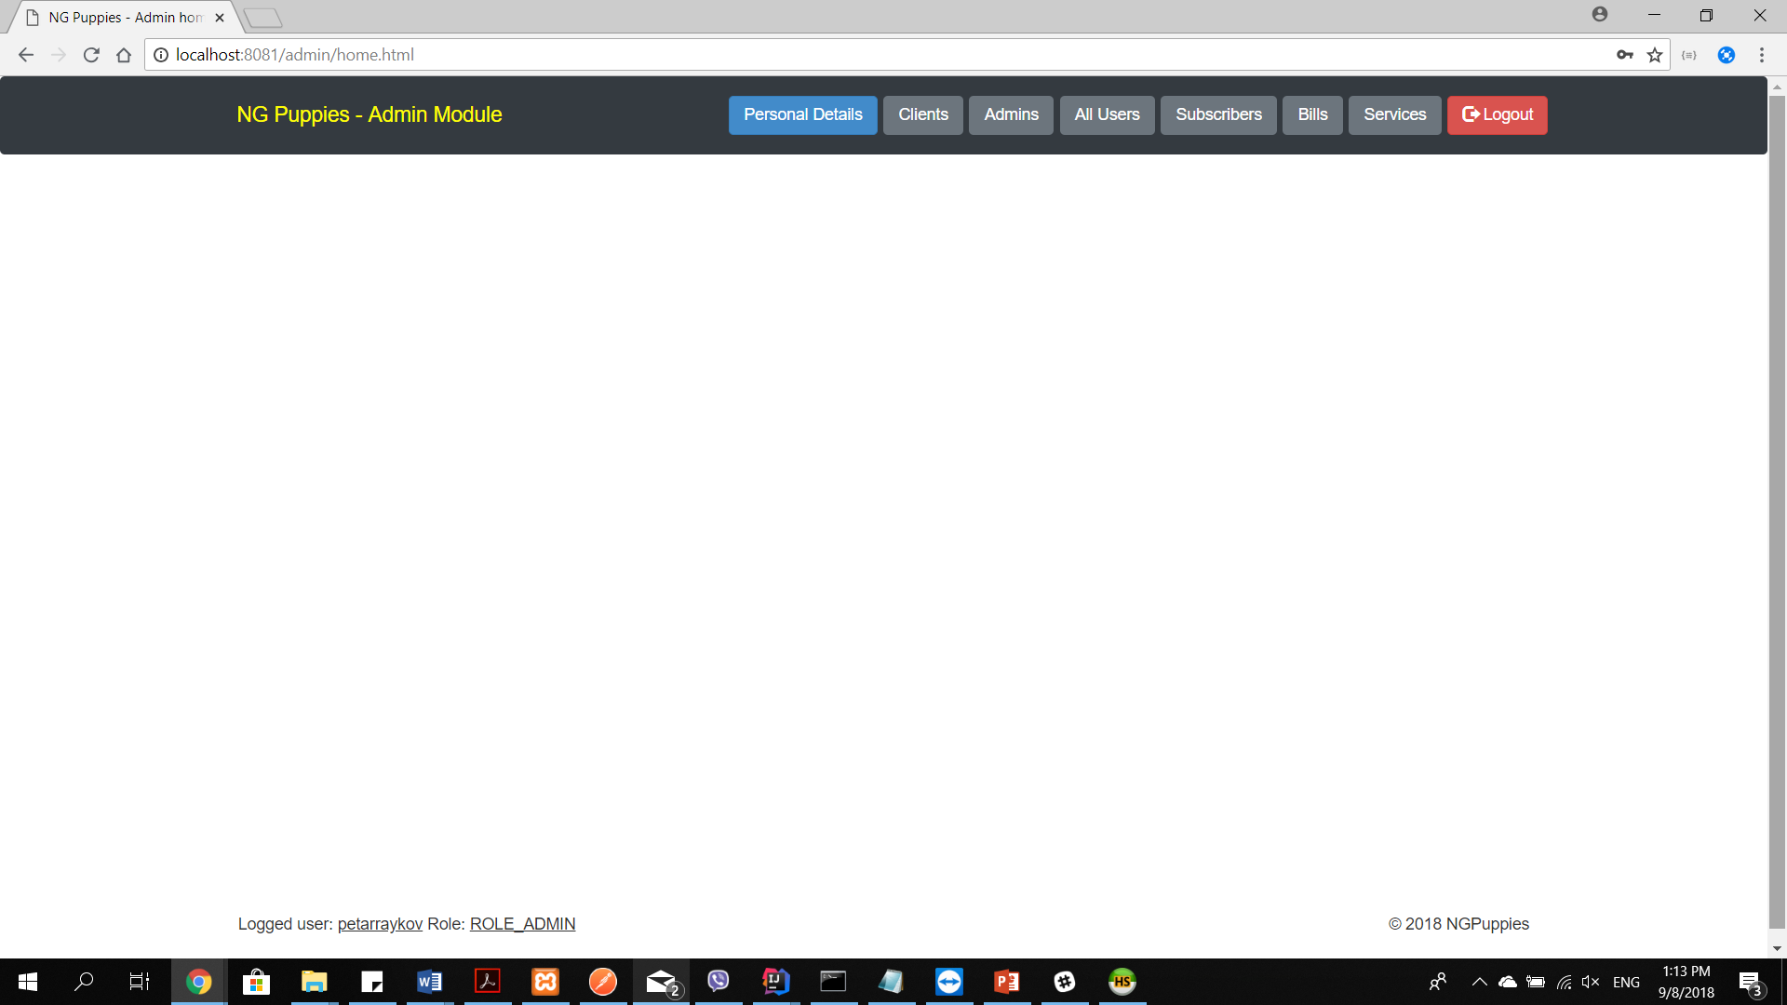

1. Personal Details button – shows information about the logged in user and lets him/ her change his username, password, and/ or email address. On submit the client is redirected to login page due to change of his profile.

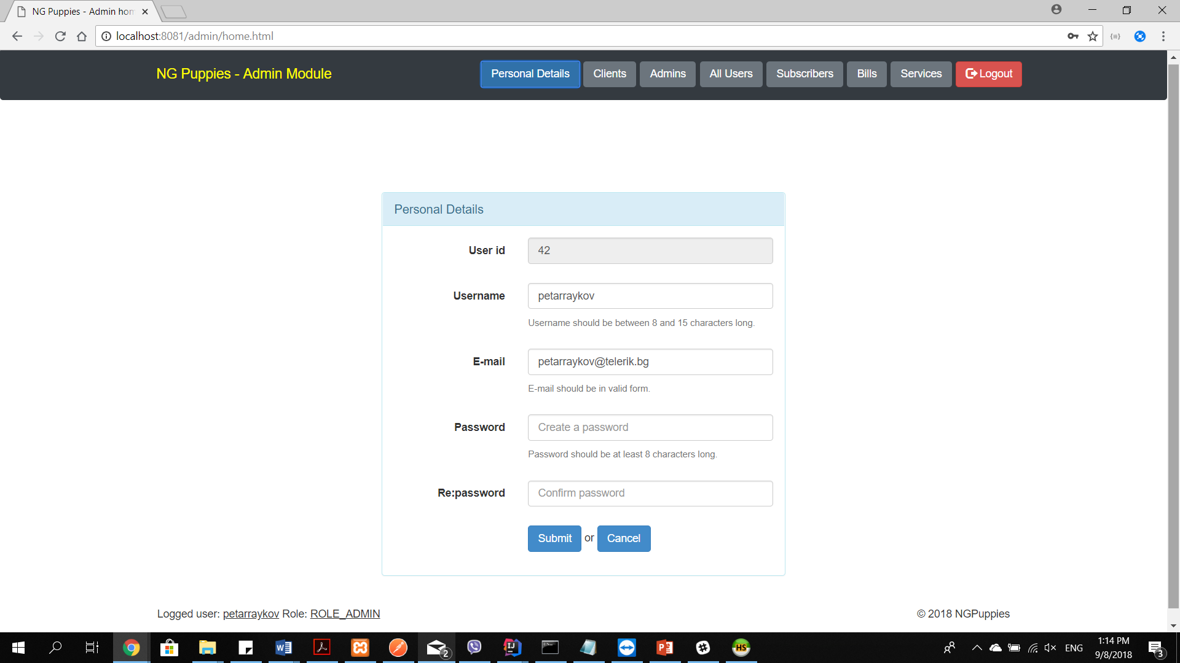

1. Clients button – shows information about all clients (e.g., banks) registered in the application. The admin can delete or update existing clients, or create new ones via the provided buttons at the left bottom of the table.

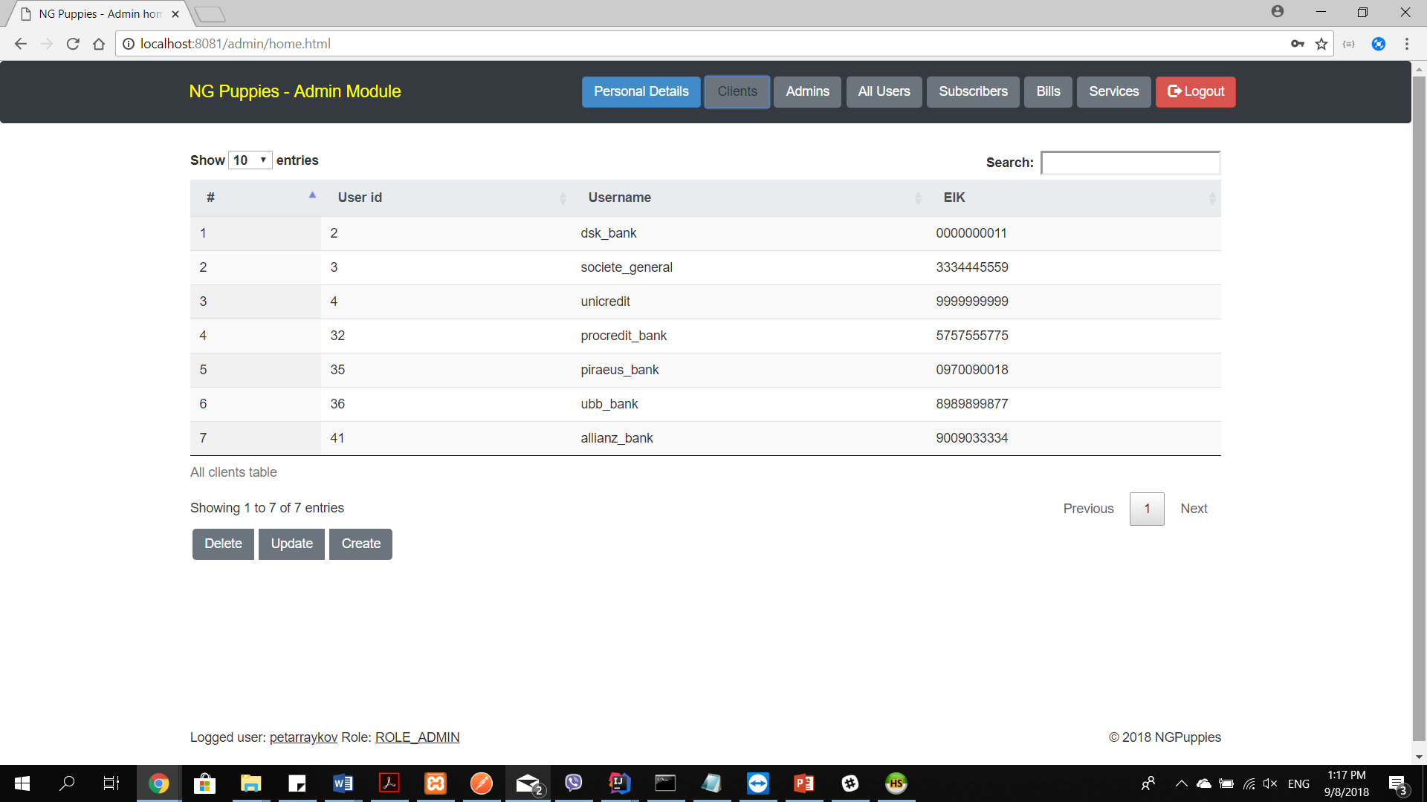

1. Admins button – shows information about all admins (e.g., telecom employees) registered in the application. The admin can delete or update existing admins, or create new ones via the provided buttons at the left bottom of the table.

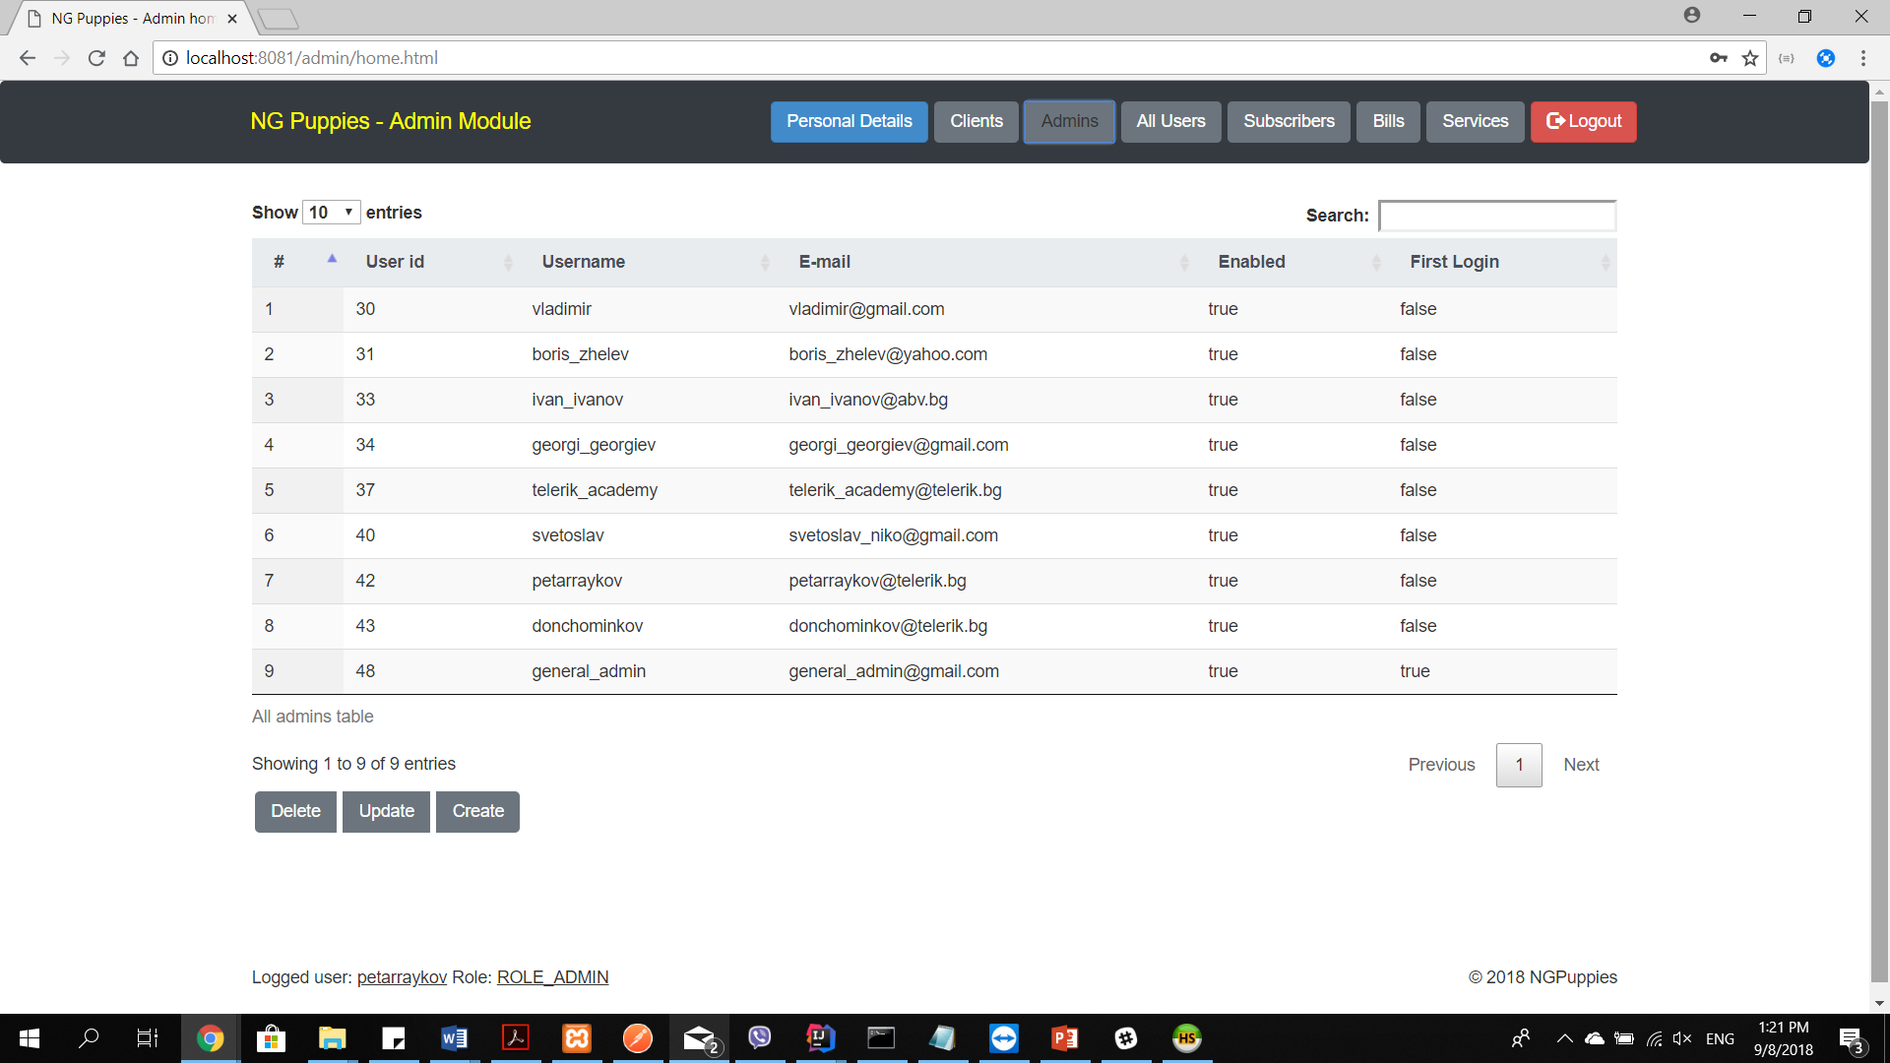

1. All Users button – shows information about all users (e.g., banks and telecom employees) registered in the application. The admin can delete existing users.

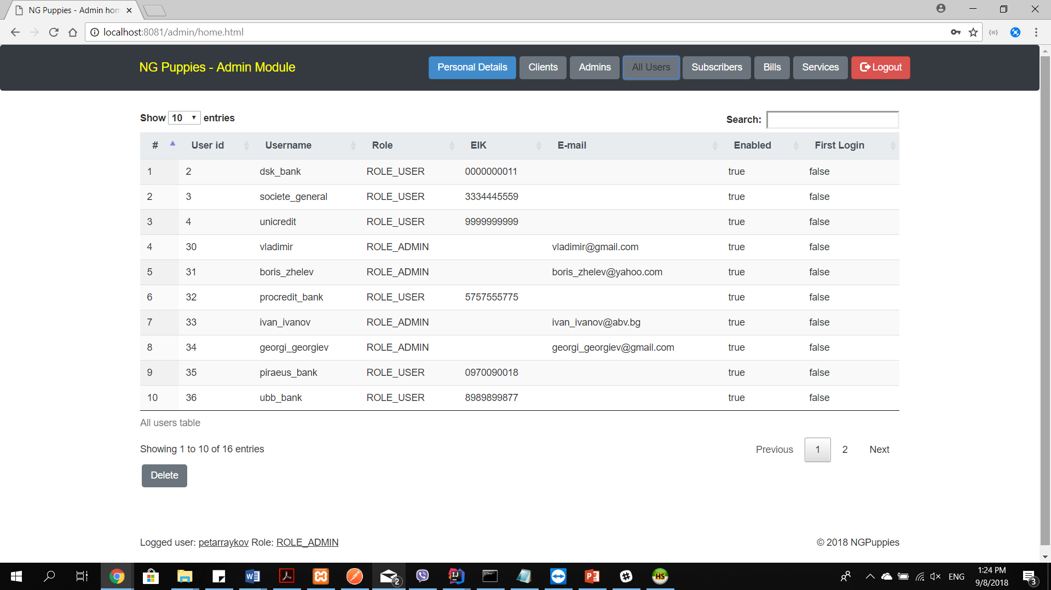

1. Subscribers button – shows information about all subscribers registered in the application. The admin can delete or update existing subscribers, or create new ones via the provided buttons at the left bottom of the table.

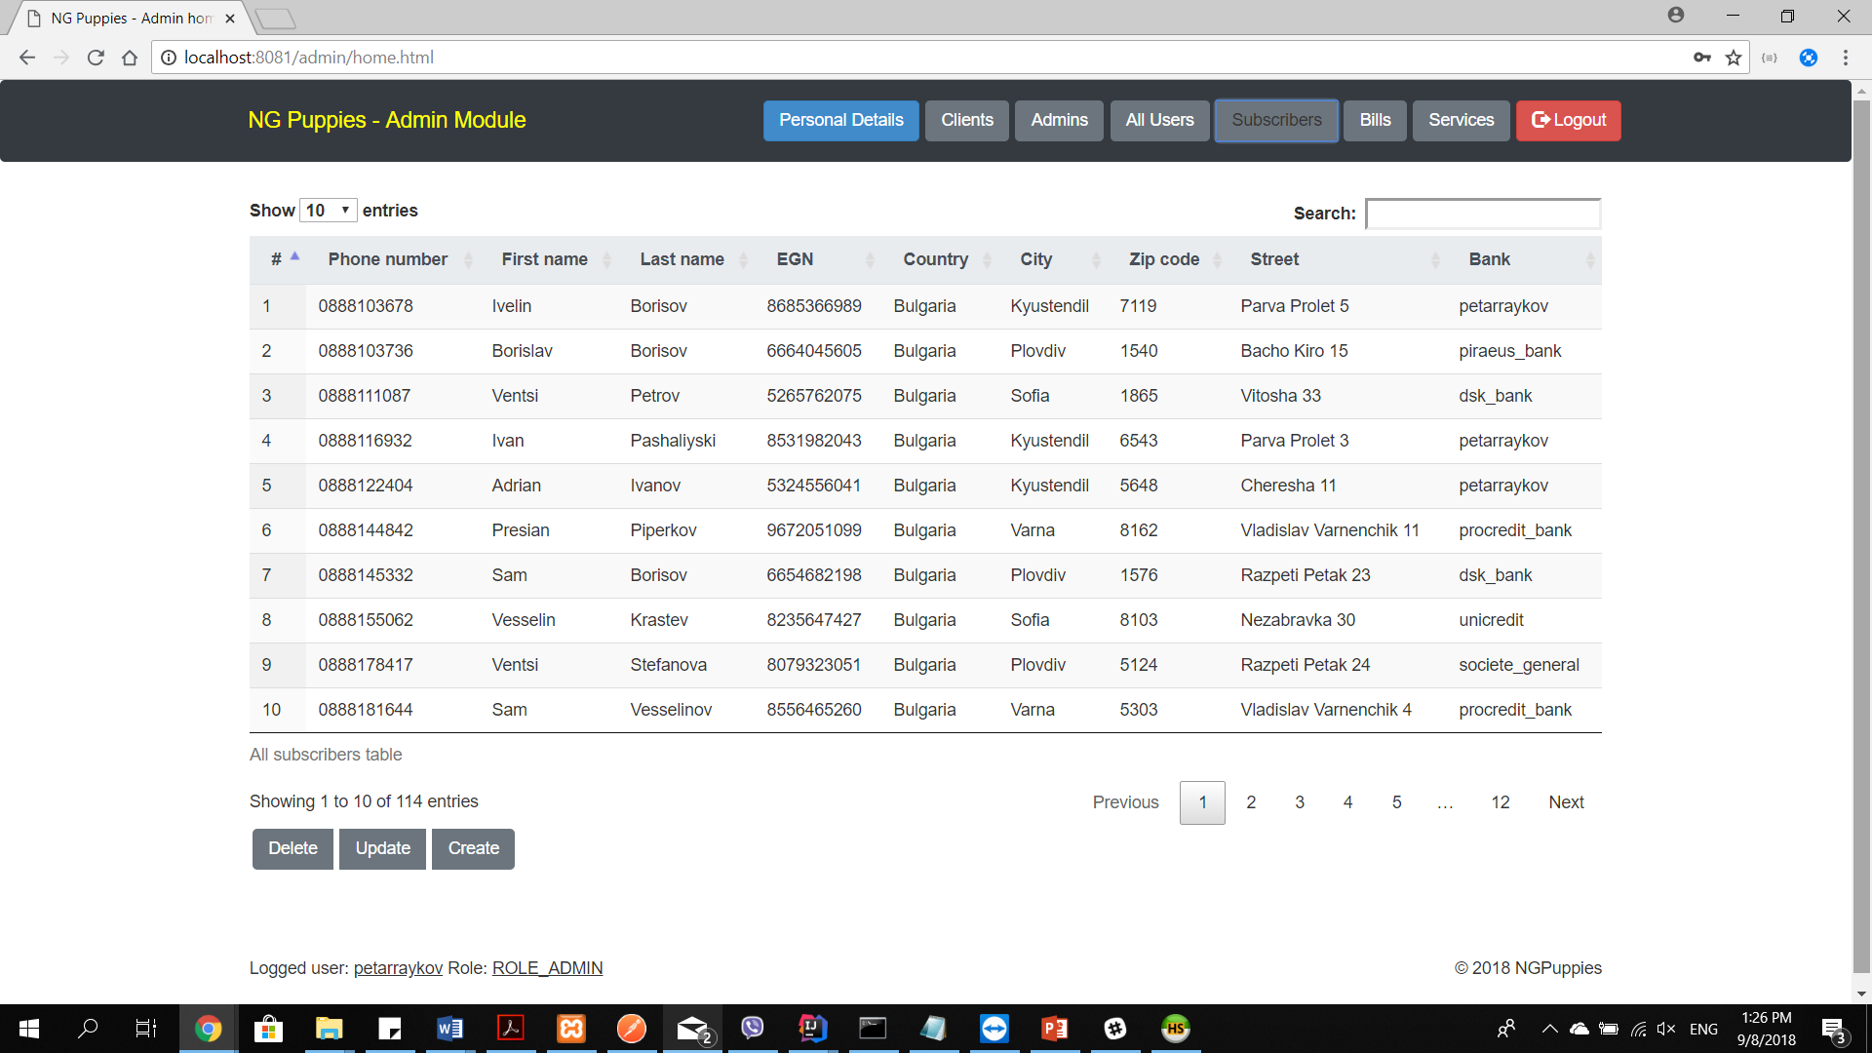

1. Bills button – shows information about all bills registered in the application. The admin can create new bills via the provided button at the left bottom of the table.

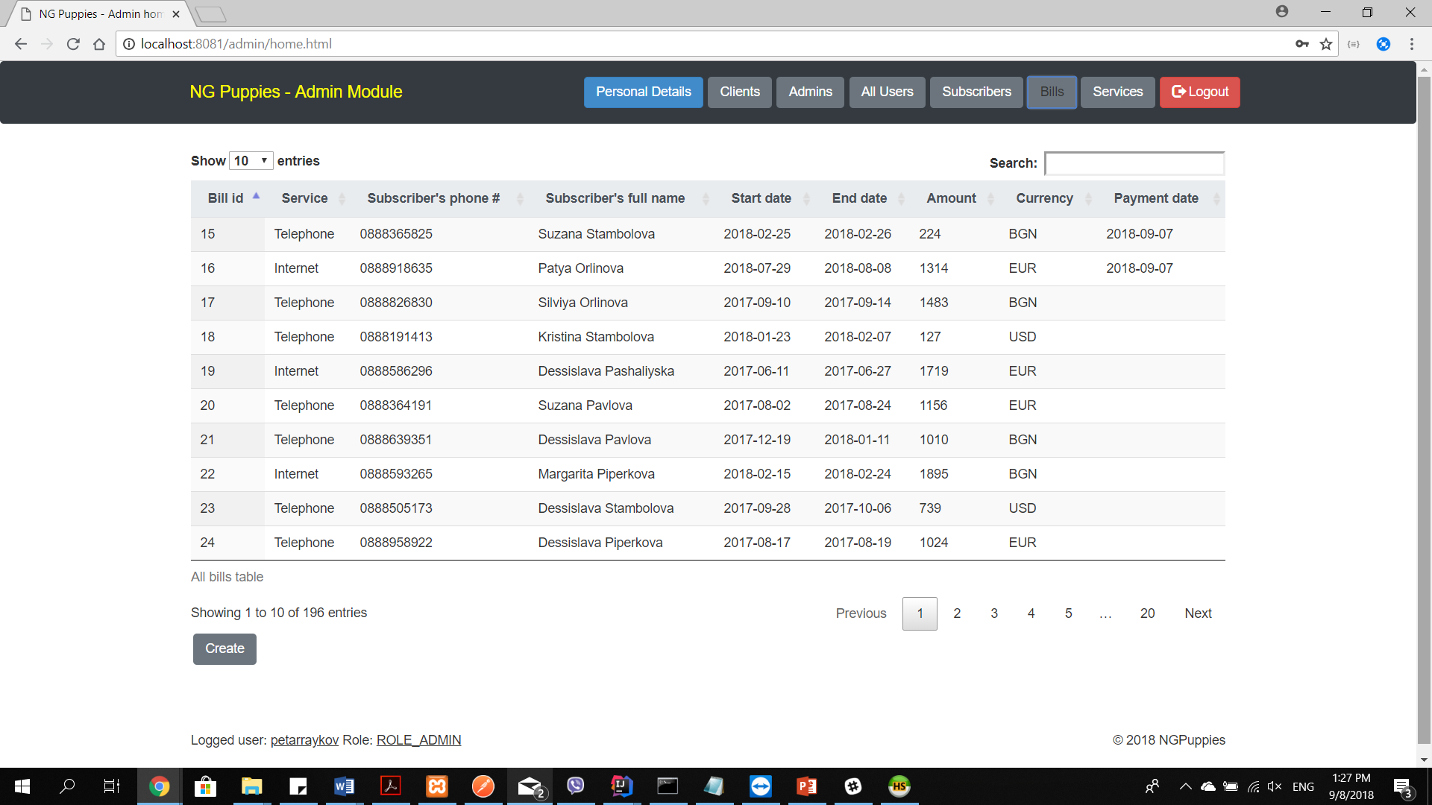

1. Services button – shows information about all services registered in the application. The admin can delete or update existing services, or create new ones via the provided button at the left bottom of the table.

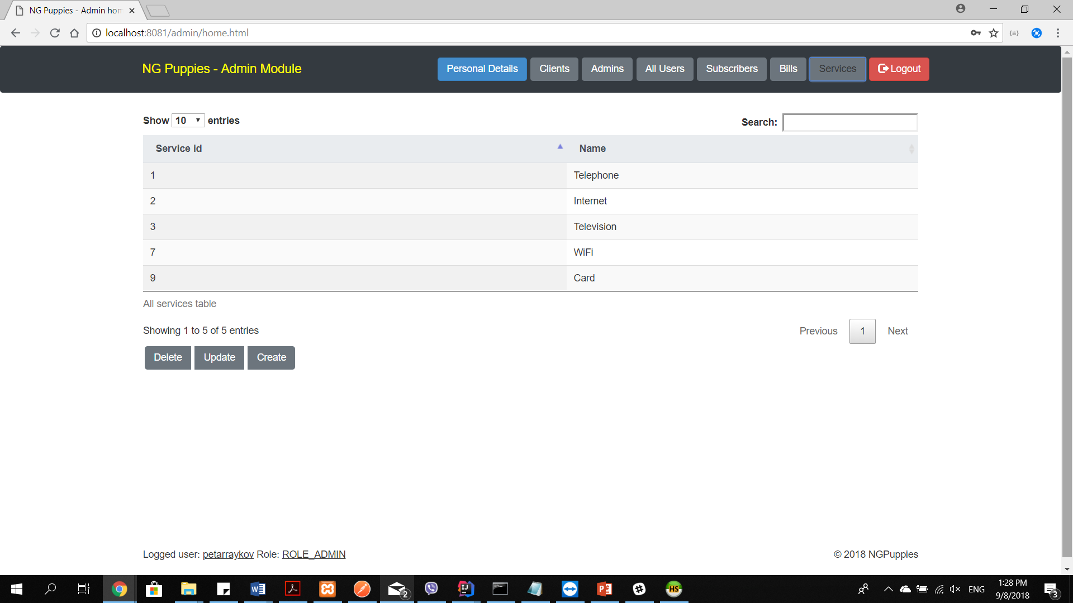

1. Access-denied page

In case a user decides to access a given page by manually typing the url without having the rights to access the page or without being logged in, he/ she is redirected to the access-denied page and is prompted to go back.

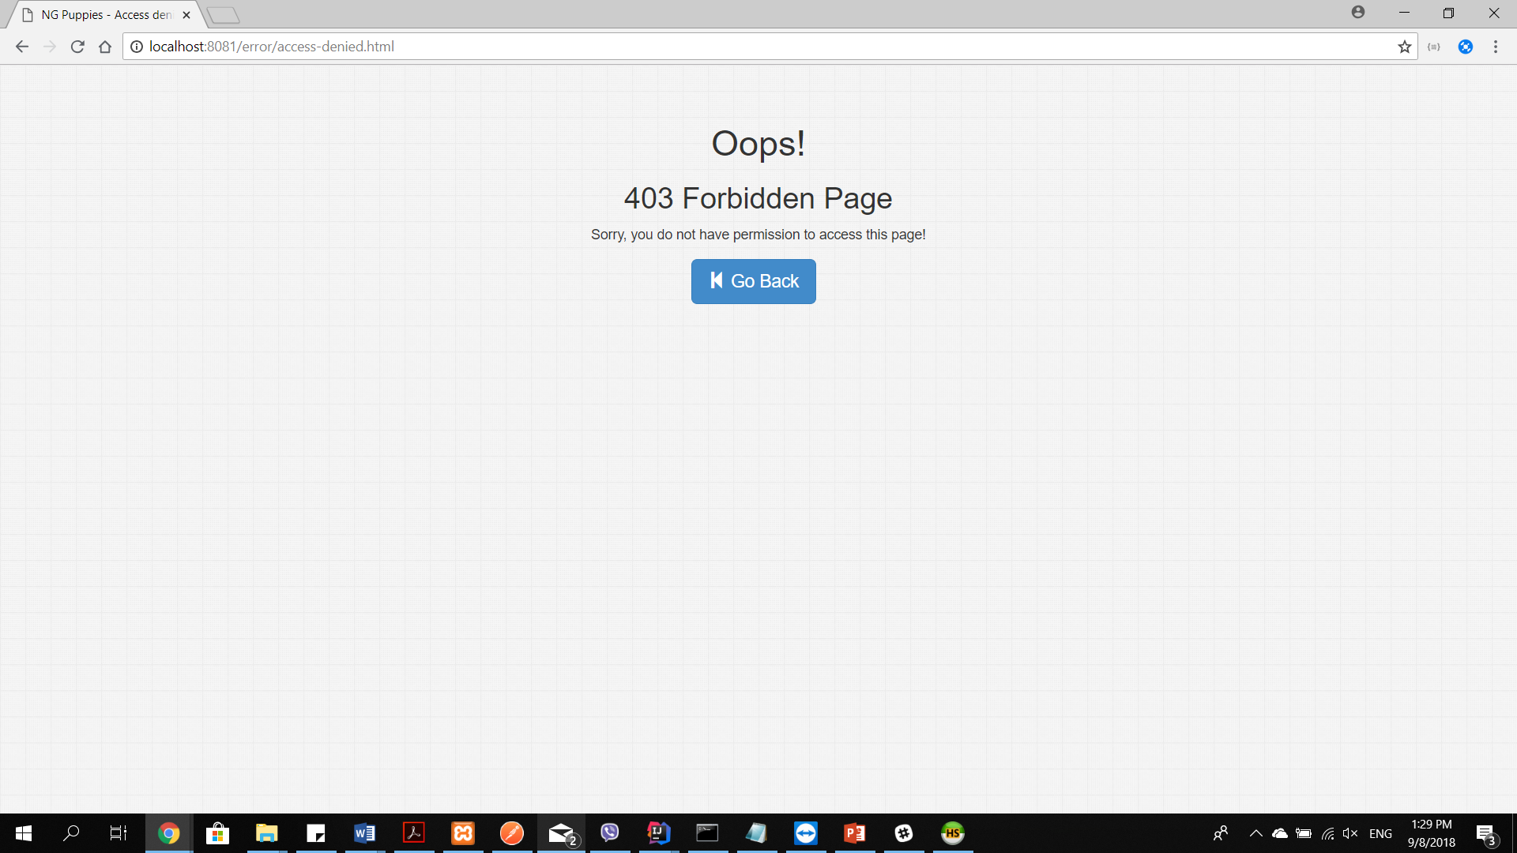

1. Logout button

The logout button clears the local storage of the page and redirects to the login page.

1. Update and create forms

The update and create forms provide the ability to enter property values for the given updated or created objects. They include pattern and min-max length controls for data validation. The submit button activates if and only if a form is properly filled.