**Management**

**Gantt Chart**

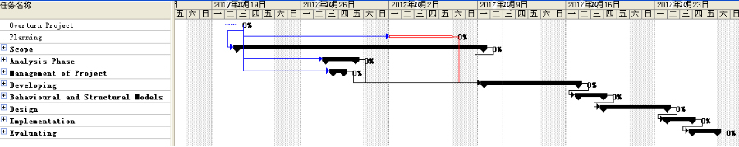

Planning

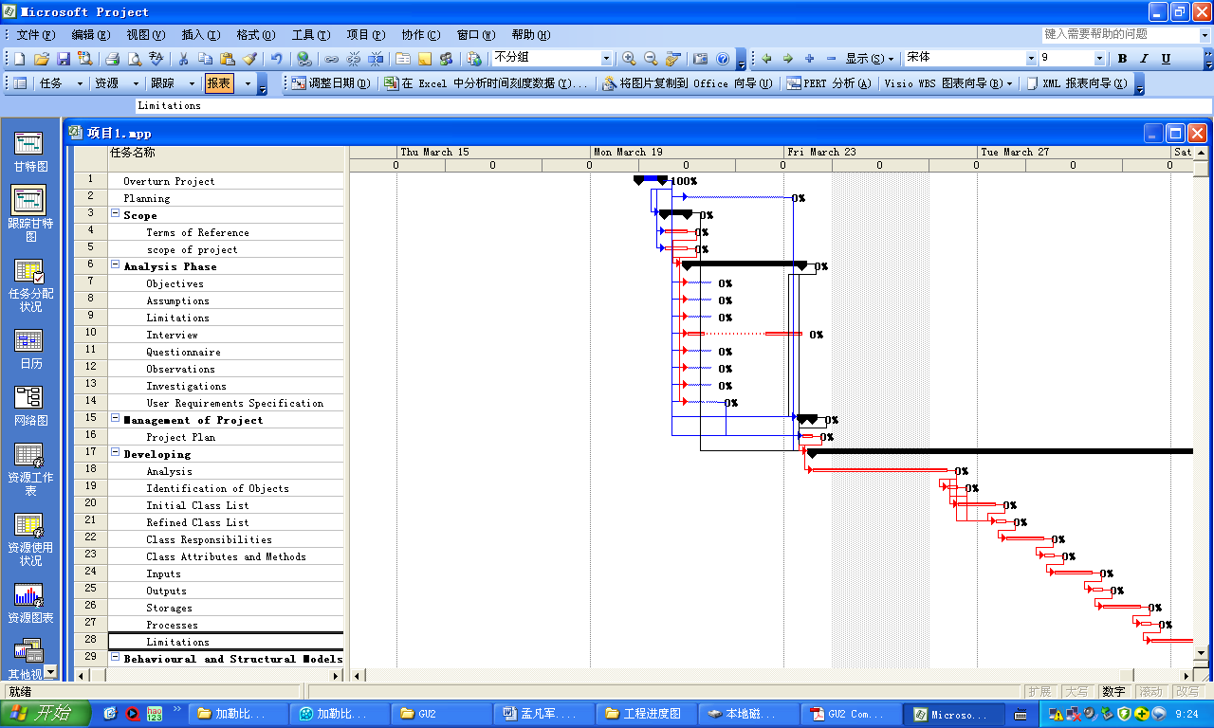

Developmet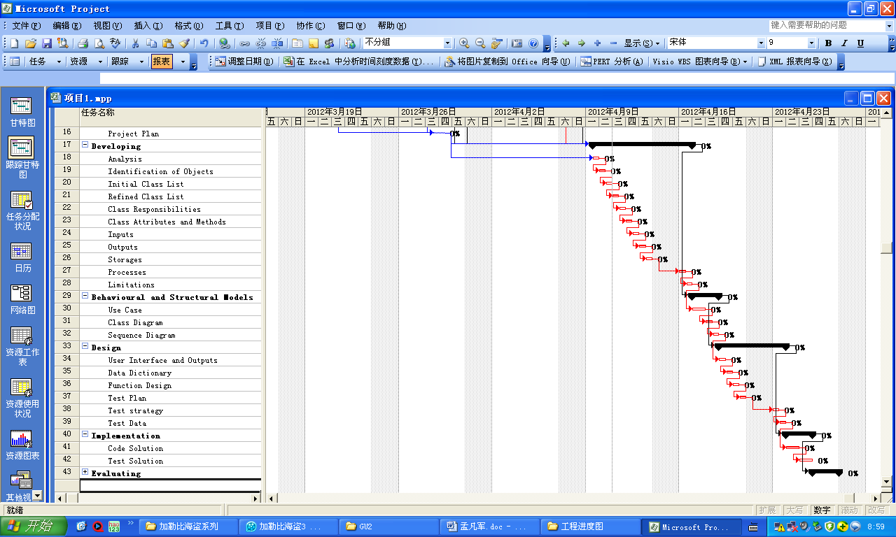

Estimate

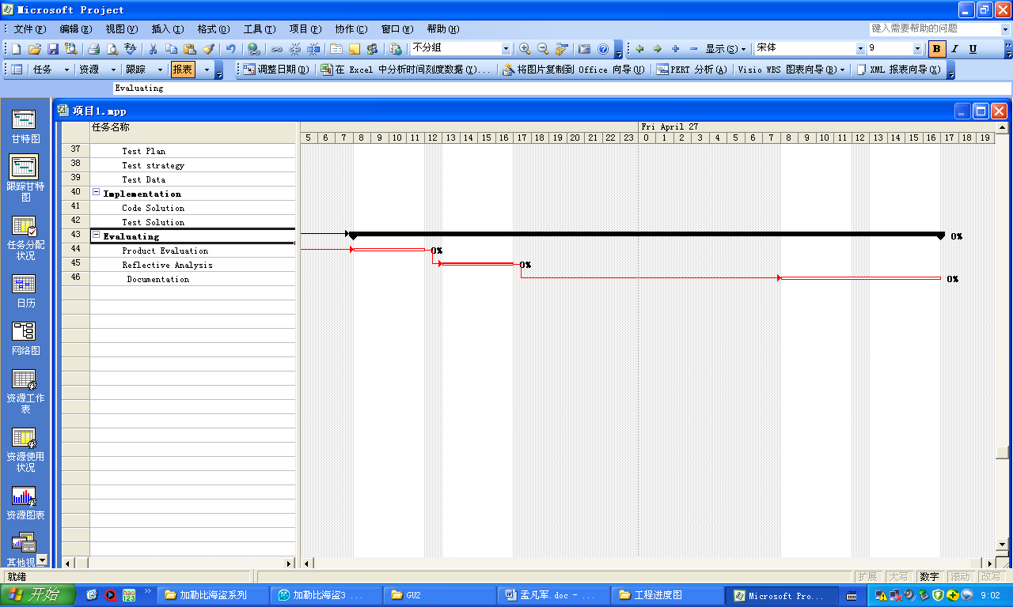

**Risk Assigment**

The great development and promotion of ATM has become the consensus of Chinese Banks.

To reduce the artificial reception counter work intensity, alleviate the pressure of the counter business, as well as ATM intensive management specialization, streamline, efficiency of ATM's centralized management is the inevitable path of icbc.

The management of the bank requires a higher intensification, and centralized management can control many branches.

However, centralized management of large amounts of ATM has broken the original equipment management mode, and the related business processes and handling methods have also undergone fundamental changes.

The automatic teller machine operation mode is a new kind of thing, which brings an innovative business development mode and also brings new security issues.

The automatic teller machine is a window of icbc's external service, which relates to the image of icbc in the customer.With the development of automatic teller, the risk response of icbc to automatic teller machine is still in a state of disordered management.After the occurrence of the risk event, often the response is not timely, the effect of the treatment can not achieve the desired effect.At present, the management level of icbc automatic teller machine cannot stay at the original level. It must set up a management system that meets the system of icbc and is suitable for business development.

**Software Development Lifecycle**

Software life cycle is also known as software life cycle or the system development life cycle, is the software life cycle until the scrap, cycle, problem definition, feasibility analysis, overall description, system design, coding, debugging and testing and acceptance with phase, such as operation, maintenance, upgrading to scrap the points according to time schedule way of thinking is a thinking in software engineering principles, namely, step-by-step, step-by-step, is defined at each stage, work, review, form document for communication, or for future reference, in order to improve the quality of the software.

The seven phases of the software life cycle

1. Definition and planning of the problem

This stage is a joint discussion between the software developer and the demand side, which mainly determines the development goal and feasibility of the software.

2. Demand analysis

In order to determine the feasibility of software development, the software needs to be implemented in detail.

The requirements analysis phase is an important phase, which is well done and will lay a good foundation for the success of the entire software development project.

The only constant is the change itself."

, as well as demand is constantly changing throughout the software development process and in-depth, so we must develop a plan of requirements change to cope with this change, to protect the smooth progress of the project.

Demand analysis of software life cycle

3. Software design

In this stage, the whole software system is designed according to the result of demand analysis, such as system frame design, database design, etc.

Software design is generally divided into general design and detailed design.

Good software design will lay a good foundation for software programming.

Software life cycle software design

4. Program coding

This stage is to convert the result of software design into the program code that the computer can run.

In programming code, it is necessary to establish uniform and standard coding.

To ensure the readability, maintainability of the program, improve the operation efficiency of the program.

5. Software testing

After the software design is completed, rigorous testing is needed to find out the problems that exist in the whole design process and correct them.

The whole testing process is divided into three stages: unit test, assembly test and system test.

The test method is mainly white box and black box testing.

During the testing process, a detailed test plan is established and tested in strict accordance with the test plan to reduce the randomness of the test.

Software life cycle software testing

6. System transformation

The new system is converted from the old system, which is the method of running the system. The conversion method has parallel, batch, distribution, immediate and test five conversion methods.

7. Operation maintenance

Software maintenance is the longest period of the software life cycle.

After the software development is completed and put into use, the software cannot continue to adapt to the user's requirements for many reasons.

To continue the service life of software, software must be maintained.

Maintenance of software includes corrective maintenance and improved maintenance.