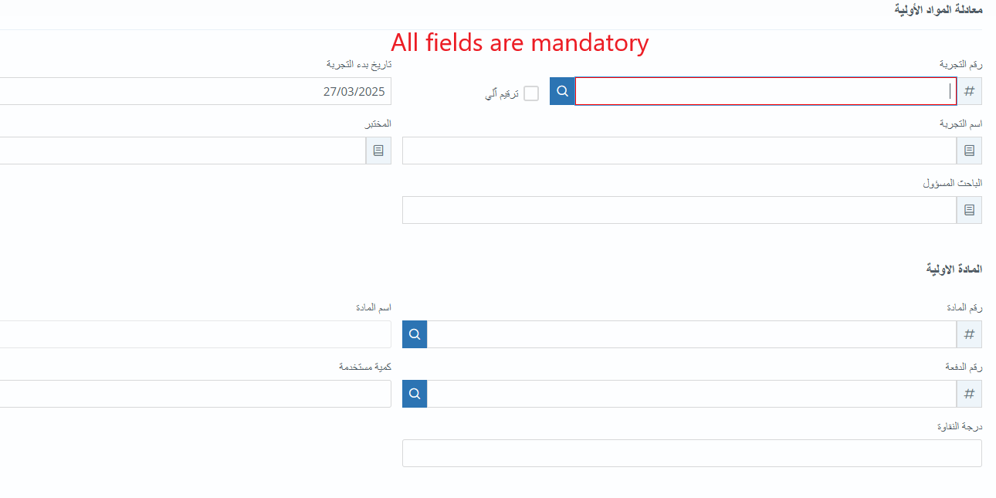Research and development

1. Raw materials equation:

**It will be replaced to a signatures.**

**It will be modified to a search button.**

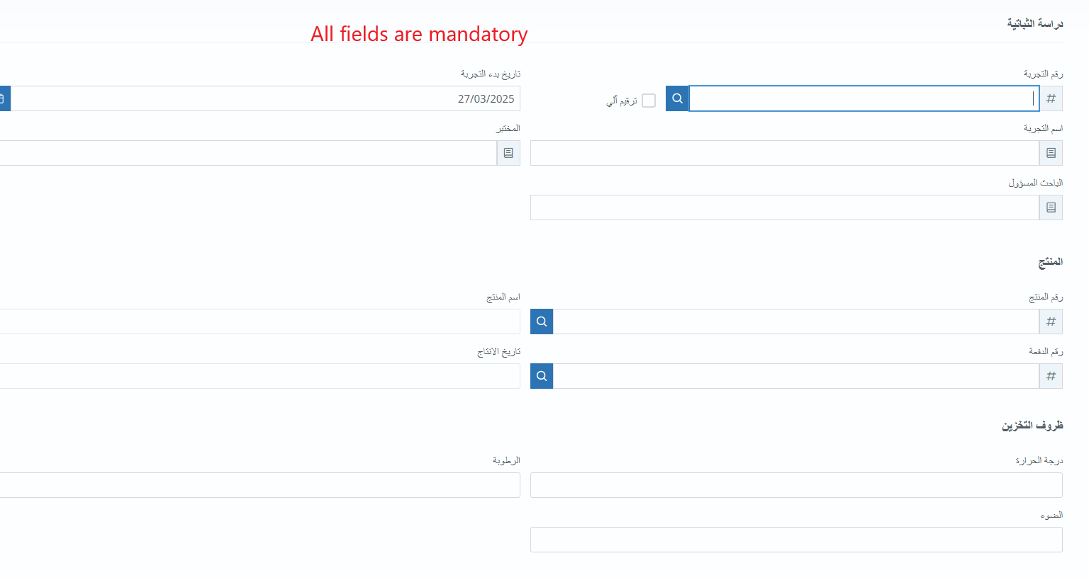2. Stability Study

**It will be replaced to a signatures.**

**It will be modified to a search button.**

3. Internal Purchase Order

**It will be replaced to be filled directly by the logged in user.**

