Assignment 2: Design Tests

* Input space partition
* Each choice coverage

|  |  |  |  |
| --- | --- | --- | --- |
| Characteristic | <0 | =0 | >0 |
| Side1 | a1 | a2 | a3 |
| Side2 | b1 | b2 | b3 |
| Side3 | c1 | c2 | c3 |

|  |  |  |  |
| --- | --- | --- | --- |
| Test case: | Side1 | Side2 | Side3 |
| T1 | a1 | b1 | c1 |
| T2 | a2 | b2 | c2 |
| T3 | a3 | b3 | c3 |

* pair-wise coverage

|  |  |  |  |
| --- | --- | --- | --- |
| Characteristic | <0 | =0 | >0 |
| Side1 | a1 | a2 | a3 |
| Side2 | b1 | b2 | b3 |
| Side3 | c1 | c2 | c3 |

|  |  |  |  |
| --- | --- | --- | --- |
| Test case: | Side1 | Side2 | Side3 |
| T1 | a1 | b1 | c1 |
| T2 | a1 | b2 | c2 |
| T3 | a1 | b3 | c3 |
| T4 | a2 | b1 | c1 |
| T5 | a2 | b2 | c2 |
| T6 | a2 | b3 | c3 |
| T7 | a3 | b1 | c1 |
| T8 | a3 | b2 | c2 |
| T9 | a3 | b3 | c3 |

* Graph coverage

根据triout来划分node

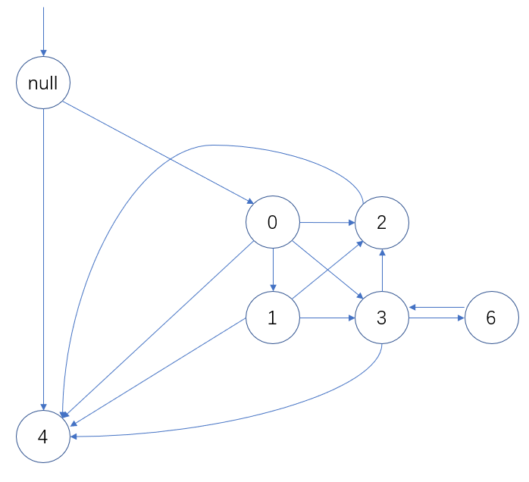

* Node coverage

|  |  |  |  |
| --- | --- | --- | --- |
| triout | Side1 | Side2 | Side3 |
| 0 | 1 | 1 | 1 |
| 1 | 1 | 1 | 2 |
| 2 | 1 | 2 | 1 |
| 3 | 2 | 1 | 1 |
| 4 | -1 | 1 | 1 |
| 6 | 1 | 1 | 1 |

* edge coverage

|  |  |  |  |
| --- | --- | --- | --- |
| testpath | Side1 | Side2 | Side3 |
| 0,1,2 | 2 | 2 | 1 |
| 0,4 | 1 | 1 | 3 |
| 4 | -1 | 1 | 1 |
| 0,3,2 | 1 | 2 | 2 |
| 0,1,4 | 1 | 1 | 3 |
| 0,3,4 | 3 | 1 | 1 |
| 0,2 | 2 | 1 | 2 |
| 0,1,3,6,3 | 2 | 2 | 2 |
| 0,2,4 | 1 | 3 | 1 |

* prime path coverage

|  |  |  |  |
| --- | --- | --- | --- |
| testpath | Side1 | Side2 | Side3 |
| 4 | -1 | 1 | 1 |
| 0,4 | 1 | 1 | 3 |
| 0,1,4 | 1 | 1 | 3 |
| 0,2,4 | 1 | 3 | 1 |
| 0,1,3,6,3 | 2 | 2 | 2 |

* all-use coverage

|  |  |  |  |
| --- | --- | --- | --- |
| All-user path | Side1 | Side2 | Side3 |
| 0,1 | 1 | 1 | 2 |
| 0,2 | 1 | 2 | 1 |
| 0,3 | 2 | 1 | 3 |
| 0,4 | 1 | 3 | 2 |

* Logic coverage
* Predicate coverage

|  |  |  |  |  |
| --- | --- | --- | --- | --- |
| Logic expression | t/f | Side1 | Side2 | Side3 |
| (triOut == 1 && Side1+Side2 > Side3) | Ture | 2 | 2 | 3 |
| False | 1 | 1 | 3 |

* clause coverage

|  |  |  |  |  |
| --- | --- | --- | --- | --- |
| Logic expression | t/f | Side1 | Side2 | Side3 |
| triOut == 1 | Ture | 3 | 3 | 2 |
| False | 3 | 2 | 3 |
| Side1+Side2 > Side3 | Ture | 3 | 3 | 2 |
| False | 3 | 2 | 6 |

* Correlated Active Clause Coverage

|  |  |  |  |  |
| --- | --- | --- | --- | --- |
| triOut == 1 | Side1+Side2 > Side3 | Side1 | Side2 | Side3 |
| T | T | 2 | 2 | 2 |
| T | F | 2 | 2 | 5 |
| F | T | 1 | 3 | 3 |
| F | F | 1 | 3 | 5 |

