Asian Theological Seminary (ATS)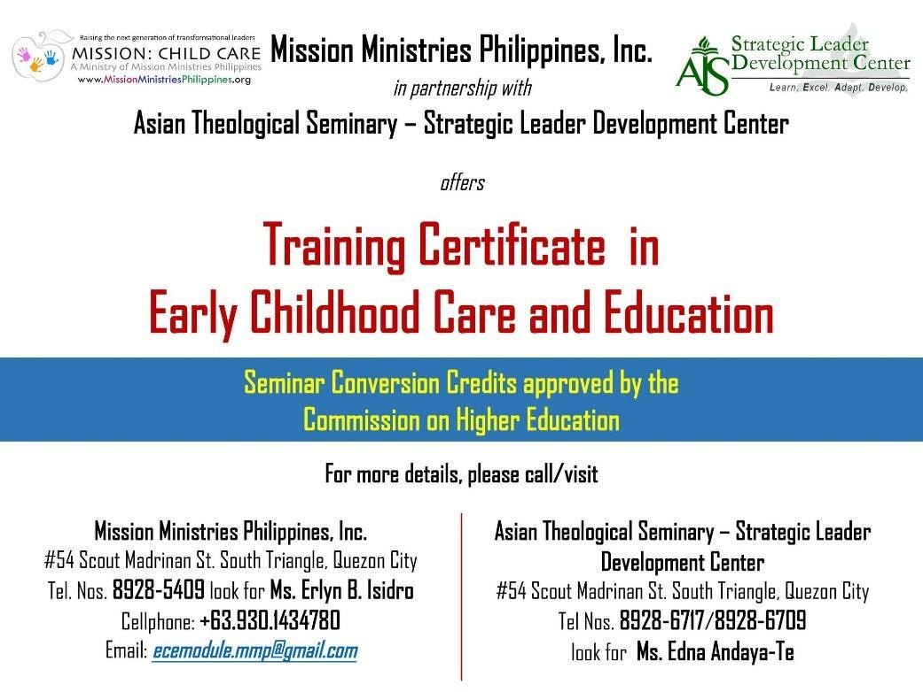

Strategic Leader Development Center

&

Mission Ministries Philippines, Inc.

Training Certificate in ECE

SY {{school_year}}

REGISTRATION

|  |  |  |  |  |  |  |
| --- | --- | --- | --- | --- | --- | --- |
| NAME: {{first_name}} {{middle_name}} {{last_name}} | | | | | | |
| ADDRESS: {{address}} | | | | | | |
| MOBILE NO: {{mobile_number}} | | LANDLINE: {{landline}} | | | EMAIL: {{email}} | |
| DATE OF BIRTH: {{birthdate}} | | | NATIONALITY: {{nationality}} | | | |
| PLACE OF BIRTH: {{birthplace}} | | | | | | |
| GENDER: {{gender}} | | CIVIL STATUS: {{civil_status}} | | | NO. OF CHILDREN: {{no_of_children}} | |
| SCHOOL: {{school}} | | | ADMIN: {{admin}} | | | |
| OCCUPATION: {{occupation}} | | | | | | |
| CHURCH: {{church}} | | | PASTOR: {{pastor}} | | | |
| IS YOUR SCHOOL A PARTNER OF MMP? (YES / NO) | | | | | {{is_partner_school}} | |
| EDUCATIONAL  ATTAINMENT: | GRADE SCHOOL  {{gradeschool}} | HIGH SCHOOL  {{highschool}} | | COLLEGE  {{college}}  ({{college_course}}) | | GRADUATE  {{graduate}}  ({{graduate_course}}) |
|
| OTHERS  {{others}} | | | | | |

**II. Why am I enrolling with the Training Certificate in ECE Module?**

{{essay}}

Print Name and sign:

Requirements:

Photocopy of Form 138 / Transcript of Record for college graduate:

2x2 ID picture

________________________________

|  |
| --- |
| **IN CASE OF EMERGENCY, CONTACT:**  NAME: {{emergency_name}}  ADDRESS: {{emergency_address}}  MOBILE NO. : {{emergency_mobile_number}} |