Terence Bush Jr

CSC 4710: Database System

Project Report

My name is Terence Bush, and I am the sole member of the Bus Boys. This name came along as I was thinking of a database to create and my mother who worked for Greyhound came home. As I looked at her, I decided at that moment to do a database about bus stations.

The scope of this project was the create a nice size database of a network of bus stations. This would include multiple bus companies, bus stations, their locations, employees, customers, and tickets. This would show When a customer brought their ticket, where they were leaving from and going to, what bus company their were riding with, the employee of that company that was driving them and any necessary information about that employee or the customer.

The implementation of this database would be if an overseer of multiple bus stations needed to see any information about his bus stations.

The ER diagram:

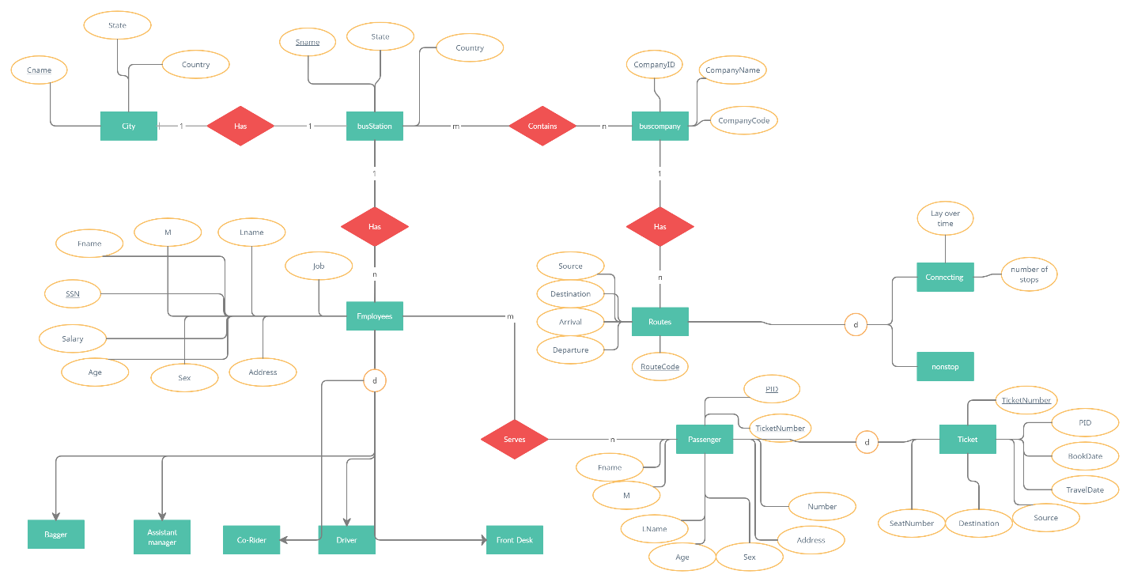 Use Cases: 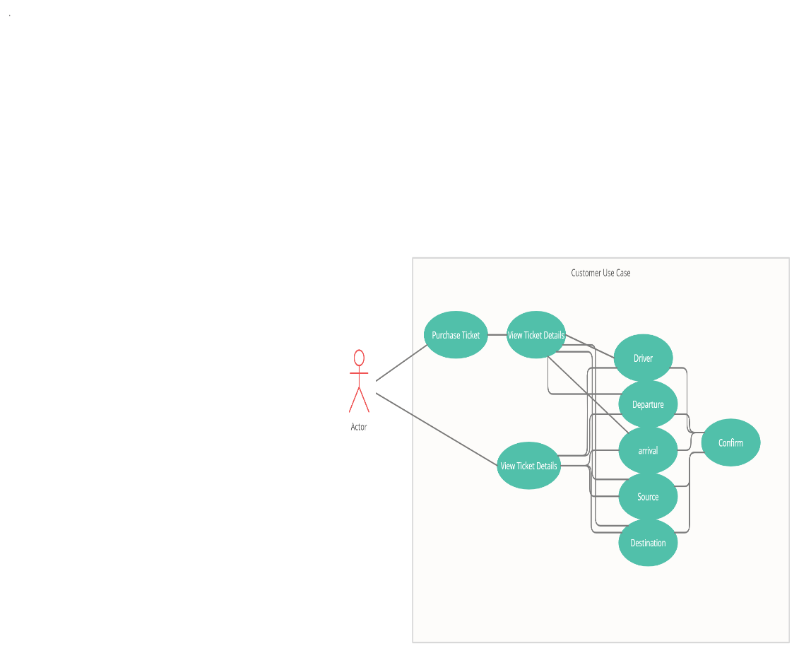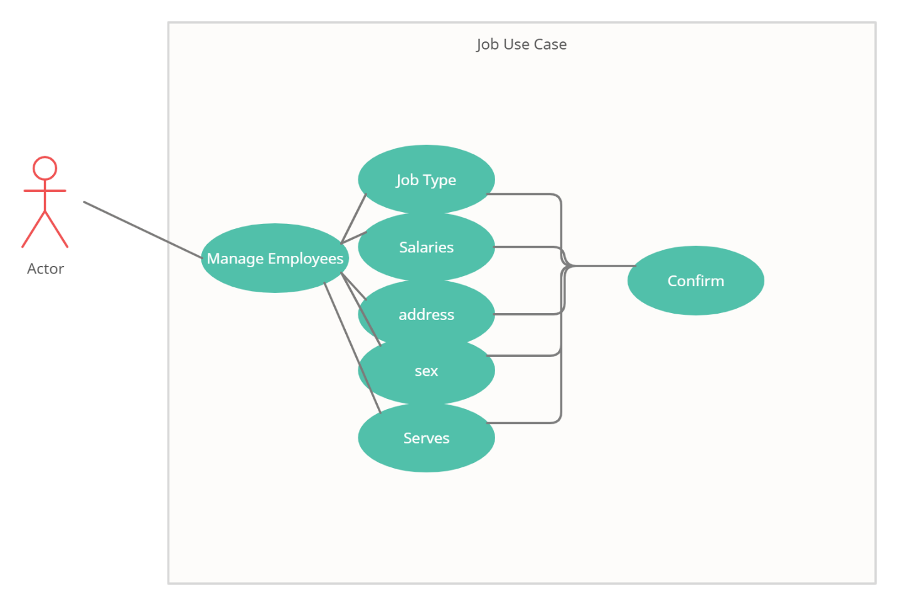

All diagrams will have the .png file on github

The conclusion to this project is that there will be a system that will allow a customer to input details and find a bus route that will take them from point A to point B. It will show them the destination, source, departure, and arrival so they may link a route to their schedule.

This database will show an employee their salary, information about themself, where they are to serve. Such as an employee such as a front desk attendant will always have the same serve for a bus station however a driver may have to serve another bus station if they have a connecting route.

The database will show an overseer everything of the two. They can see all information regarding the customer and the employee. The overseer will be able to see sensitive information regarding both groups that will not be available to either group. This included information such as addresses and Social security numbers for safety reasons.

References:

<https://www.youtube.com/watch?v=Y4w-jcmBZKk> EER Diagram

<https://www.comparabus.com/en-us/bus-companies> Bus companies

<https://www.greyhound.com/en-us/bus-stations-in-georgia> station locations