Show Me Your ID!

(2026)
Game Design Document
Version 2.6

Twin Studio

Jessie Mariel De Mesa
Elijah Japeth Ramos
Clarence Manalo
Daniel Steven Solitaria
Diosdado Fabelico II
John Perilla
Daniella Garing

Planned release: November 2026, PC / Steam

Table of Contents
Part 1. Research: the industry game design document
1.1 Definition and purpose
1.2 Characteristics of a good GDD
1.3 Standard contents
1.4 Writing guidance
1.5 Common pitfalls
1.6 The three supplied sample documents
1.7 Structure of the merged GDD

Part 2. Game design document: Show Me Your ID!
Scope and provenance note
2.1 Document control
2.2 Game overview
2.3 Purpose, key features and design guidelines
2.4 Competitive and market analysis
2.5 Game flow summary
2.6 Gameplay and mechanics
2.7 Player definition
2.8 Rules, challenges, strategies and balance
2.9 Progression and difficulty
2.10 Story, setting and characters
2.11 World and level design
2.12 Art direction
2.13 Audio design
2.14 Interface and user interaction
2.15 Technical design
2.16 Production plan
2.17 Release and marketing
2.18 Risks and constraints
2.19 Implementation status
2.20 Systems the game does not have
2.21 Glossary
2.22 References

Part 1. Research: the industry game design document

1.1 Definition and purpose
A game design document (GDD) is a blueprint for a video game. It records the game's concept, mechanics, story, characters, levels, interface, audio, technical needs, and plan so that a whole team builds the same game. Published outlines stress that the document must carry every detail the team needs, either in the document itself or in linked support documents, because anything left out tends to be left out of the game.
A GDD typically serves to:
- Give designers, artists, programmers, audio staff, producers, and QA a single shared reference.
- Control scope by stating what is and is not in the game.
- Preserve design intent and the reasons behind key decisions.
- Communicate the plan to stakeholders such as publishers, platform holders and new team members.

1.2 Characteristics of a good GDD
- A living document. It changes throughout development, so it carries a design history (change log) that briefly describes each major version.
- A reference, not a narrative. It is organised so people can find answers quickly: full table of contents, numbered headings, hyperlinks where practical, and a glossary.
- Scaled to the project. A small mobile game needs far less than a large open-world title. Large documents are split into a core document plus support documents (for example, a level document, a script, an art bible, or a technical design document).
- Distinct from a pitch document. A pitch is short, persuasive, and sells the idea. A GDD is detailed and explains how the game works and why.
- Clear and testable. Rules are stated precisely, terms are used consistently, and key questions (such as "what is the main gameplay loop?") are answered explicitly.

1.3 Standard contents
Published outlines vary by author and school, but they converge on the same core. The list below consolidates the widely circulated generic outline (game overview, game flow, gameplay, world, interface, and so on), the academic structure used in university game design courses, and commercial GDD guides.
1. Title page, table of contents, and document control: title, version, authors, date, a table of contents covering all subsections, and a design history of changes.
2. Game overview High concept; genre; target platform(s); target audience; number of players and modes; unique selling points and design pillars; predecessors and comparable games; project scope.
3. Game flow and progression How the player moves through the game, both through the framing interface (menus, screens) and the game itself; objectives; mission, challenge and puzzle structure; difficulty progression; economy (resources, currency, rewards); game options.
4. Gameplay and mechanics Core gameplay loop; rules (setup, play, scoring, win and lose conditions); control scheme; player abilities and states; items and power-ups; enemies and hazards; balance.
5. Story, setting and characters Backstory, plot, character descriptions and the relevance of the story to gameplay.
6. World and level design World layout; list of levels or areas with their objectives; level types; the teaching and pacing strategy; representative level walkthroughs.
7. Interface and user interaction Heads-up display (HUD), menus, screen flow, feedback to the player, accessibility and options.
8. Art direction Visual style, characters, environments, animation, and references or mock-ups.
9. Audio and music Music style and cues, sound effects, and how audio supports gameplay.
10. Technical design Target hardware, engine or tools, memory and performance constraints, delivery system, minimum requirements, program structure, physics and rendering as relevant.
11. Production plan Team and roles, schedule, milestones, dependencies, risks and implementation order.
12. Release, marketing and business (optional) Market positioning, release plan, monetisation, and promotion.
13. Appendices Glossary, research, references, and any support documents. Academic variants also add an artist statement (why the game exists), predecessors, and projected cultural impact.

1.4 Writing guidance
- Start with the concept and the player's experience, then move to detail.
- State rules in concrete, checkable terms rather than vague descriptions.
- Use diagrams, flowcharts, mock-ups and tables wherever they communicate faster than prose.
- Assign an owner and date to each section, and update the design history on every revision.
- Keep the document proportionate: enough detail to build from, not so much that nobody reads it.

1.5 Common pitfalls
- A document so long and unstructured that it is never read.
- Content that is out of date because nobody maintains it.
- Vague statements ("fun combat") instead of defined mechanics.
- No stated scope, leading to feature creep.
- Mixing pitch material (persuasion) with specification (instructions).

1.6 The three supplied sample documents
Three sample GDDs were reviewed and merged into this document. They agree on the core (concept, gameplay, story, interface, audio, plan) and differ in scale and in the genre-specific systems they add.
Sample | Type and scope | Distinctive sections | What was adopted
Unity, Game Design Document (GDD) Template | Short fill-in template | Game elements, technical details, gameplay, key features, design guidelines, game flow, player information and user interface. | The basic GDD structure and section guides, used in sections 2.2, 2.3, 2.5, 2.7, 2.8, 2.14 and 2.15.
World Walker GDD (Ireland, Pirintr, Bajracharya, Phillips) | About 15 pages; single-player sci-fi action RPG | Game overview, features, story, characters, rules, challenges, strategies, balance, interface and audio. | Detailed game descriptions, market analysis, rules, challenges, balance and audio design, used in sections 2.2 to 2.14.
Project Vanishing GDD ("The Vanishing") | About 27 pages; first-person fantasy RPG for PC | Story, objectives, controls, world design, art, interface, sound, mechanics and production planning. | Mechanics, controls, implementation details and production planning, used in sections 2.5, 2.6, 2.14, 2.15, 2.16 and 2.22.
Both RPG samples include systems that Show Me Your ID! does not have (dialogue, skill trees, merchants, customization). Section 2.20 lists each of these and states why it is excluded rather than leaving it silently out.

1.7 Structure of the merged GDD
Part 2 follows one consolidated order. The table shows which source each section draws on.
Part 2 section | Drawn from
2.1 Document control | Industry outline and Project Vanishing (document versions and references).
2.2 Game overview | Unity (game details); World Walker (description and target audience); Project Vanishing (game brief).
2.3 Purpose, key features and design guidelines | Unity (game features and guidelines); World Walker (purpose and game features).
2.4 Competitive and market analysis | World Walker (competitive analysis, audience and market)
2.5 Game flow summary | Unity (gameplay flow); World Walker (game flow and menus).
2.6 Gameplay and mechanics | Industry outline and Project Vanishing (gameplay systems and mechanics).
2.7 Player definition | Unity (player details); Project Vanishing (character states and conditions).
2.8 Rules, challenges, strategies and balance | World Walker (rules, challenges and balance); Unity (gameplay rules).
2.9 Progression and difficulty | World Walker (difficulty); Project Vanishing (level and challenge progression).
2.10 Story, setting and characters | World Walker and Project Vanishing (story and characters).
2.11 World and level design | World Walker (game world); Project Vanishing (environments and level design).
2.12 to 2.13 Art direction and audio design | World Walker (style, audio); Vanishing (art style, sounds)
2.14 Interface and user interaction | Unity (UI); World Walker (controller map, menus, HUD, manual); Vanishing (controls, GUI)
2.15 Technical design | Unity (technical specs); Vanishing (implementation notes)
2.16 Production plan | Vanishing (project plan, Gantt, Scrum)
2.17 to 2.19 Release, marketing, risks, and implementation status | Industry outline and Project Vanishing (release plans, project goals, limitations, risks, development tracking, and documentation accuracy).
2.20 Excluded sections; 2.21 Glossary | All samples; industry outline
2.22 References | Industry outline and Project Vanishing (sources and references).

Part 2. Game Design Document: Show Me Your ID!

Scope and provenance note

Show Me Your ID! was designed and developed by Twin Studio as the team's game production project. This document is based on the team's concept paper and the playable build. The rules, numbers, and controls describe the game's design. If a design has changed but the build has not yet been checked, or if a feature is still unfinished, this is stated in Section 2.19.

2.1 Document control

Title: Show Me Your ID!

Version: 2.6 (November 3, 2026)

Covers: The planned November 2026 PC / Steam release.

Authors: Twin Studio (team roles are listed in Section 2.16).

Version history
Version | Date | Change
1.0 | October 20, 2026 | First edition, written using the concept paper and the structure of the sample GDDs.
2.0 | October 31, 2026 | Reworked the document based on the playable build. Added the four-question system with a limit of two, administrator hunt, comfort room, painted hallway and rooms, seven illustrated students, sanity rules per night, and an implementation status table. Removed text accidentally carried over from an unrelated sample document.
2.1 | October 31, 2026 | Redesigned Night 5 based on the Nightmare Fredbear night in FNaF 4. The administrator became the main threat, and the player must survive until dawn. Added an interrogation without student questions. The comfort room became a peek-only area, the lit hallway was removed, tokens were moved to the main menu, and the night opening sequence and How to Play card were added.
2.2 | October 31, 2026 | Rebuilt the school map using the desk map. It now includes Security, Room 101, Room 202, CR-1, the sealed server room, and CR-2. Changed the peek system to use a black cover with a visible opening. During patrol, the mouse only aims the flashlight, while doors and items are selected based on the guard's position. Removed the TRACK meter. The hunt still has no audio, so captions provide the cues. The administrator also says he will be back and leaves after being declined.
2.3 | November 1, 2026 | Changed the window system so it stays open until every student has been processed. Added one required patrol cycle through Room 101, Room 202, and one comfort room. Added anomalies at the window, in the hallway, and in peek rooms. Night 5 was changed to include the administrator hunt, with light as the only defense. Nights 1 to 4 lead straight to the next night, while Night 5 ends with results followed by the ending. Classroom 2 and CR-2 were mirrored.
2.4 | November 2, 2026 | Roaming anomalies were limited to the hallway. Standing anomalies were added to peek rooms. They stay still, appear in some rooms each night, and at least one is always present. The hallway now has only a weak light around the guard, making the flashlight necessary for seeing ahead, including the ceiling and floor.
2.5 | November 3, 2026 | Changed visitor counts to 4, 5, 6, and 7 on Nights 1 to 4. Night 5 now has seven students followed by the administrator, making eight visitors. It follows the same window and mistake rules as the earlier nights. Night 5 has no separate patrol, roaming anomalies, or hooded figures. Both ACCEPT and DECLINE start the hunt, and neither stamp causes an immediate loss. The number of window anomalies is randomized each night, with at least one appearing. Lockdown was changed into a students-only mode with no patrol, a 35-second inspection per visitor, four questions, and a three-mistake limit.
2.6 | November 3, 2026 | Corrected the document to match the current build. Visitors per night are 4, 6, 7 and 8 on Nights 1 to 4, then eight students and the administrator on Night 5 (34 in total), with a fixed number of window anomalies (2, 3, 4, 5 and 5). Thirteen students with three-digit ID numbers. On Night 5, DECLINE closes the window and the Patrol button starts the hunt, and ACCEPT loses at once. Mistakes are counted over the whole game, a breach fails Nights 1 to 4, and the nights run straight on without the main menu. Corrected the patrol (it opens after the last visitor), the hallway and peek anomalies, the sanity values, the hunt timings, the clue order rule, Night 6, Lockdown and its unlock, and the flowchart. Removed the design decisions table.

Section ownership and last update

Each section has an assigned owner who is responsible for keeping its information accurate. Whenever a section changes, the owner updates its date and the design history.
Section | Owner | Last Updated
2.1 Document control | Jessie Mariel De Mesa | November 3, 2026 (v2.6)
2.2 Game overview | Jessie Mariel De Mesa | November 3, 2026 (v2.6)
2.3 Purpose, key features and design guidelines | Jessie Mariel De Mesa | November 3, 2026 (v2.6)
2.4 Competitive and market analysis | Jessie Mariel De Mesa | November 2, 2026 (v2.4)
2.5 Game flow summary | Jessie Mariel De Mesa | November 3, 2026 (v2.6)
2.6 Gameplay and mechanics | Elijah Japeth Ramos, John Perilla | November 3, 2026 (v2.6)
2.7 Player definition | Elijah Japeth Ramos, John Perilla | November 3, 2026 (v2.6)
2.8 Rules, challenges, strategies and balance | Elijah Japeth Ramos, John Perilla | November 3, 2026 (v2.6)
2.9 Progression and difficulty | Elijah Japeth Ramos, John Perilla | November 3, 2026 (v2.6)
2.10 Story, setting and characters | Jessie Mariel De Mesa | November 3, 2026 (v2.6)
2.11 World and level design | Diosdado Fabelico II, Daniella Garing | November 3, 2026 (v2.6)
2.12 Art direction | Daniel Steven Solitaria, Diosdado Fabelico II, Daniella Garing | November 3, 2026 (v2.6)
2.13 Audio design | Clarence Manalo | November 3, 2026 (v2.6)
2.14 Interface and user interaction | Jessie Mariel De Mesa | November 3, 2026 (v2.6)
2.15 Technical design | Elijah Japeth Ramos, John Perilla | November 3, 2026 (v2.6)
2.16 Production plan | Jessie Mariel De Mesa | November 3, 2026 (v2.6)
2.17 Release and marketing | Twin Studio | November 2, 2026 (v2.4)
2.18 Risks and constraints | Elijah Japeth Ramos, John Perilla | November 3, 2026 (v2.6)
2.19 Implementation status | Elijah Japeth Ramos, John Perilla | November 3, 2026 (v2.6)
2.20 Systems the game does not have | Elijah Japeth Ramos, John Perilla | November 2, 2026 (v2.4)
2.21 Glossary | Elijah Japeth Ramos | November 3, 2026 (v2.6)
2.22 References | Elijah Japeth Ramos | November 3, 2026 (v2.6)

2.2 Game overview

Title: Show Me Your ID!

Genre: 2D psychological horror, deduction, and exploration.

Platform: PC (Windows), planned for Steam.

Controls: Mouse and keyboard.

Players: One.

Modes: Normal (five nights), Night 6 (Challenge), and Lockdown.

Developer and publisher: Twin Studio.

Tagline: "Everyone has an ID. Not everyone is a student."

High concept. The player works as a night custodian at Hollowbrook College, a school that announced its closure in the middle of the school year without explaining why. The school remains open at night so its students can finish the term. The player's job is to check IDs, decide who can enter, and patrol the dark hallways. However, some of the people who arrive at the window are not actually students.

Design pillars

Evidence-based decisions: Players use IDs, student files, answers, and faces to decide whether someone is a real student.

Horror through small inconsistencies: Strange details can appear in people, documents, and places.

Different gameplay areas: The fixed security desk provides a calm checkpoint, while the dark hallway creates a more dangerous environment to explore.

Permanent decisions: Every stamp has a consequence.

Rewarding exploration: Finding clues helps reveal the reason behind Hollowbrook's closure.

Target audience. Players aged 13 and above who enjoy horror, mystery, investigation, and anomaly-spotting games.

Influences. Papers, Please (2013) influenced the document inspection and stamping system. Five Nights at Freddy's (2014) influenced the night shift setting, limited visibility, and five-night structure. I'm on Observation Duty (2018) influenced the anomaly spotting and observation-based horror.

Scope. Nights 1 to 4 have 25 visitors in total, with 4, 6, 7, and 8 visitors per night. Night 5 has eight students followed by the district administrator, making nine visitors. This gives the game 34 visitors across the five nights: 33 students and one administrator.

The game takes place in the security room, hallway, two classrooms (Room 101 and Room 202), and two comfort rooms (CR-1 and CR-2). There is also a sealed server door at the end of the hallway. Players can find ten clues that lead to the Secret ending. The game has three endings (Win, Lose, and Secret) and two additional modes (Night 6 and Lockdown).

2.3 Purpose, key features and design guidelines

Purpose. The player takes the role of Hollowbrook College's night custodian. Their job is to check the people entering the school and decide who actually belongs there. While doing this, the player also investigates the reason behind the school's mysterious closure.

Game elements (what the player does)

Read the student ID and paper slip, then flip the ID to check its back.

Ask up to two questions out of four and compare the answers with the ID and student file.

Open the registry cabinet and check the folders for Room 101 and Room 202.

Stamp ACCEPT or DECLINE, then return the ID through the window.

Complete one patrol cycle on Nights 1 to 4. This includes walking through the hallway, peeking into Room 101, Room 202, and one comfort room using the lamp, and looking for clues.

Keep sanity above zero, avoid letting anomalies in, and stay below three breaches and three false rejections over the whole game.

Key features

A document-checking system where the player verifies the ID number, photo, expiry date, year level, course, and student status (regular or transferee).

Four questions are available, but only two can be asked per student. Two questions remain locked until the player flips the ID or opens the student file.

Some anomalies give incorrect answers about their classroom, course, year level, or status. Others have mismatched faces or invalid documents.

Five nights with increasing difficulty. Night 5 follows the same student inspection process as the earlier nights, with eight students followed by the district administrator. There is no patrol cycle on this night. Declining the administrator lets the player start the hunt from the Patrol button, and the player must survive until dawn. Accepting him loses the game at once.

A painted hallway with limited lighting. The guard has a weak light around him and uses a flashlight to see farther ahead. The two classrooms and two comfort rooms can only be inspected by peeking through their doorways with a cursor-controlled lamp.

Ten clues that must be found in the correct order to unlock the Secret ending. Clue 7 is the pocket watch in Room 101. It is also the game's only token and has no other use.

Two additional modes, Night 6 (the Challenge) and Lockdown. Night 6 becomes available on the main menu after completing the story with either the Win or Secret ending. Lockdown becomes available after Night 6 has been beaten.

Design guidelines

Use a high-contrast black, white, and grey visual style.

Keep rooms simple and easy to understand.

Keep the security desk fixed while allowing the player to explore the hallway.

Reuse the thirteen illustrated students throughout the nights.

Make player decisions permanent.

Give hunt encounters time limits and accessible ways for the player to respond.

Keep the game suitable for players aged 13 and above.

Game design definitions

The following terms are used throughout this document to keep the rules consistent.

Breach: Allowing an anomaly or a student with an expired ID inside.

False rejection: Rejecting a student whose papers are valid.

Mistake: Either a breach or a false rejection. Mistakes are counted over the whole game. The administrator's stamp is not a mistake: DECLINE leads to the hunt, and ACCEPT loses the game at once.

Failed night (Nights 1 to 4): Ending the shift with an anomaly let in, or reaching zero sanity. After a breach the game moves on and the next night starts with less sanity. After a blackout the night is played again.

Win: Complete Nights 1 to 5, decline the administrator, survive the hunt until dawn, and finish with fewer than three breaches and fewer than three false rejections.

Lose: On Night 5: accepting the administrator, getting caught three times during the hunt, reaching zero sanity, or reaching three breaches or three false rejections over the whole game.

Secret ending: Complete the Win ending while having found all ten clues in the correct order.

Technical summary
Field | Value
Technical form | 2D, sprite-based graphics with a code-built uGUI interface.
View | Fixed point-and-click desk in the security room, 2D side-scrolling hallway, and peek view with a lamp cursor for classrooms and comfort rooms.
Platform / device | Windows PC with mouse and keyboard.
Engine / language | Unity 6.3 (project stamped 6000.3.0f1), C#, Built-in Render Pipeline.
Reference resolution | 1920 x 1080 (16:9). The desk layout is designed using a 1280 x 720 reference frame.
Players | 1

2.4 Competitive and market analysis

Show Me Your ID! combines document inspection and anomaly spotting in a school horror setting. These ideas can also be seen in other games, but our project uses them in its own way.
Title | Developer and year | Relevance
Papers, Please | Lucas Pope, 2013 | Inspired the document-checking system, where players compare papers with the rules before stamping them. Our game places this checkpoint in a school and adds horror and exploration.
Five Nights at Freddy's | Scott Cawthon, 2014 | Influenced the night shift setting, limited visibility, and five-night structure. It also shows how horror can be created through tension and limited information instead of relying on gore.
I'm on Observation Duty | Notovia, 2018 | Inspired the idea of looking for unusual details and spotting anomalies during a night shift.
The Exit 8 | Kotake Create, 2023 | Shows how anomaly-spotting games can build tension through observation and small changes  in familiar places.

Position in the market. Anomaly-spotting horror is already an established niche on PC. What makes Show Me Your ID! different is that players do more than look for strange things in the environment. They also need to decide who is allowed inside the school. They use IDs, student files, and spoken answers as evidence before making a decision. Since each stamp is permanent, every choice can have a consequence.

2.5 Game flow summary

Title screen: The player can choose New Game, Continue, Settings, Credits, or Exit. Night 6 appears after completing the story with either the Win or Secret ending, and Lockdown appears after Night 6 has been beaten (see Section 2.3).

Night opening: Starting a new game begins with a black screen. The night title appears and fades, followed by the dialogue box. The screen then reveals the closed security booth. A sticky note is placed on the desk. During Night 1, this note serves as the How to Play card.

Visitor arrival: Visitors arrive one at a time based on the arrival clock. The time gaps between visitors are listed in Section 2.9.

Inspection: When a visitor arrives, the shutter opens. The player checks the ID and paper slip, asks up to two questions, opens the student file if needed, stamps the slip, and returns the ID.

Patrol: On Nights 1 to 4, the window closes after the last visitor and the patrol opens. Each of these nights requires one complete patrol cycle before END SHIFT becomes available (see Section 2.6). On Night 5 the Patrol button stays closed until the administrator has been declined, and then it starts the hunt.

Visitor count: Nights 1 to 5 have 4, 6, 7, 8, and 9 visitors, respectively. The first eight visitors on Night 5 are students, and the ninth and final visitor is the district administrator. Declining him leads to the hunt, and accepting him loses the game.

End of shift: On Nights 1 to 4, END SHIFT becomes available after all visitors have been processed and the required patrol cycle is complete. On Night 5, the player must survive the hunt until dawn instead. There is no END SHIFT button for this night.

Night results: When a night on Nights 1 to 4 ends, the next night starts straight away, with no return to the main menu. A night failed by a breach still moves on, and the next night starts with less sanity. A night lost to zero sanity is played again. The player can pause and quit at any time, and Continue resumes from the saved night. Night 5 ends with a results screen followed by the ending. If Night 5 is lost, the ending screen offers to retry it, and Continue starts Night 5 again from the beginning.

Gameplay outline

Opening: The player starts at the main menu and proceeds to the night introduction.

Options: The Settings menu contains master, music, and effects volume controls. A pause menu also provides access to the controls screen.

Modes: Normal includes five nights. A guided tutorial for Night 1 is built but switched off for now. Night 6 (the Challenge) becomes available after completing the story with the Win or Secret ending, and Lockdown after Night 6 has been beaten.

Levels: The game includes five nights and the locations listed in Section 2.11.

Winning and losing: The conditions for each ending are explained in Section 2.3.

Ending: The ending screen displays the title, a description, and a summary of the player's decisions.

Why it is fun: Each visitor gives the player a small puzzle to solve using the available evidence. The anomalies become harder to notice as the nights progress, and every stamp matters because it can lead to a consequence.
Game flowchart
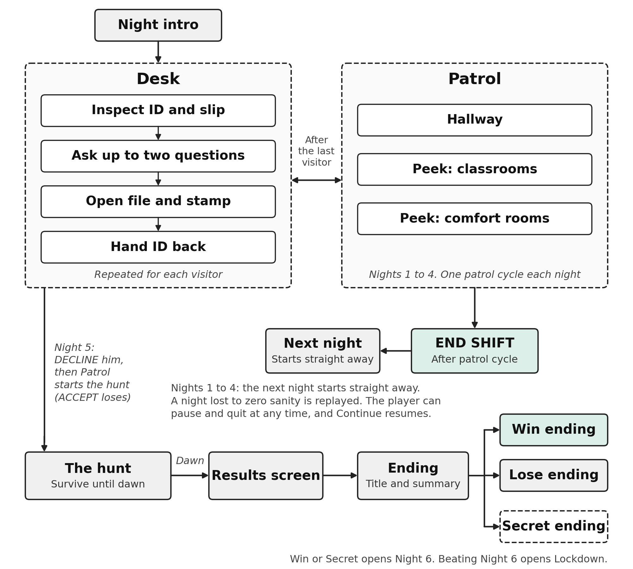

2.6 Gameplay and mechanics
Core loop. Inspect, ask, check, decide, then explore and survive.
Camera and perspective. A fixed point-and-click desk; a side-scrolling hallway with A and D movement; and a cursor lamp view when peeking into a classroom or a comfort room.

The window and the papers
- Student ID: Name, ID number (HB-YYYY-NNN), photo, course, year, regular or transferee, and expiry date. The back of the ID can be read by flipping it (click the black spine, or F).
- Paper slip: A second paper with the name, ID number and reason for coming. It must agree with the ID.
- Student file: The registry cabinet holds a folder per room (Room 101 and Room 202). Each file lists the true course, year, status and first class.
- Faces: The ID photo always shows the real student. The face should match the ID photo unless there is a photo defect. Comparing them is done by eye.
- Rules note and tonight’s log: The night’s rule, and a list of everyone already stamped with their ID numbers.

The four questions
The questions panel has four buttons. The player may ask only two per student (the panel shows 2/2), so the choice matters.
Question | Unlocks when | What a lie looks like
Your course? | Always available | The course differs from the card or file.
Your year? | After the ID has been flipped | Year differs from the card or file.
Regular or transferee? | After the student’s file has been opened | Status differs from the card or file.
First classroom? | Always available | The other room, a room the school does not have, or the wrong class.

Locked and used up questions are greyed out. Hearing an answer again is free, and each answer stays on its button. The visitor's dialogue style (hesitant, flat, overly smooth or echoing) can warn the player that something is wrong before the second question is spent.

Stamping and handing back
The player drags an ACCEPT or DECLINE stamp onto the slip. The slip glows while a stamp is held, the mark lands where it was dropped, and stamping again replaces the mark. Then the ID is dragged back to the window. The decision counts at that moment and is permanent.

Anomalies and how they show
Defect | Where the player sees it
Photo mismatch (clear or one feature off) | The face at the window against the ID photo
Expired ID | Expiry date earlier than tonight’s date
Invalid ID format | ID number does not follow HB-YYYY-NNN
Year, course or status mismatch | ID against the student file
Name mismatch | Name on the ID against the file
Not in the registry (ghost student) | No file exists for the ID number
Duplicate ID (night 3 and later) | The same number was already stamped tonight (see tonight’s log)
Slip mismatch | The paper slip disagrees with the ID
Classroom lie | The answer to the first class question disagrees with the file
Spoken lie | The answer about course, year or status disagrees with the card

Some anomalies look completely normal on paper and give themselves away only by a spoken answer. A missing student: when an anomaly joins the line, it may make one real student disappear before reaching the window, at most once per night. That night then has one visitor fewer, and the radio displays an on-screen notification about the roll call discrepancy.

Patrol
The player leaves the desk through the Patrol button, which opens after the last visitor of the night. In the hallway the custodian walks (A and D, Shift to run) and interacts with E. Every room is dark at first. One patrol cycle is required each night on nights 1 to 4: peek into Room 101, Room 202 and one comfort room (CR-1 or CR-2, either one) before END SHIFT. Night 5 has no separate patrol cycle, because the hunt is the patrol.
- Flashlight: F toggles a wide sweep beam, Q switches to a tight focus beam, L turns it off. It points at the cursor. While lit it turns the guard to face it; while off he faces the way he walks. The cursor selects nothing on patrol: doors and items go by where the guard stands. The beam runs on a battery that is full at the start of every patrol and drains while a beam is lit, faster in focus mode. During the Night 5 hunt, the battery is refilled when the hunt starts and whenever he comes up behind the player, so it never leaves the player without light.
- Hallway light: The guard carries a weak light that shows only a small pool around him, so what lies ahead is black. The flashlight does the looking, and the mouse aims it up at the ceiling and down at the floor too.
- Roaming anomalies: They walk the hallway only, on nights 1 to 4. One is already waiting when each patrol starts, and at least two come on every patrol. There are three kinds: a small four-legged crawler that runs along the floor or the ceiling, a crouched one that slides along the floor, and one that hangs from the top of the hallway above the doors. The wide sweep slows any of them to half speed; holding the focus beam on one repels it. Being caught costs sanity (section 2.7).
- Standing figures: On nights 1 to 4, the peek rooms hold a standing figure (the hooded figure, the crouched one or the one that hangs from the ceiling), in some rooms each night and always at least one. Hold the lit lamp on its body for about 3 seconds (the Focus lamp is 1.3 times faster). It stays perfectly still the whole time and never attacks. Then the lamp goes black and a slow fade brings the room back with it gone.
- Peeking: Room 101, Room 202 and both comfort rooms are not entered. From the doorway the player moves a lamp cursor (F toggles it, Q switches wide or tight) that cuts a real hole in a black cover and shows the room behind it. E selects only what the lit lamp is on. S or the bottom edge steps back.
- Comfort rooms: CR-1 and CR-2 stand either side of the sealed server door at the east end, and are peeked into like the classrooms.
- Things to inspect: Besides the clues: the patrol clipboard and two lockers in the hallway, and the mirror, sinks and stalls in the comfort rooms.
- Token: The pocket watch in Room 101 is clue 7 and the game’s only token. It can be inspected once and has no other purpose.
- Clues: Ten clues in three areas (section 2.11). Inspecting one shows a close up picture beside its text.

Night 5: eight students, then the administrator and the hunt
Night 5 starts like every other night. The player checks 8 students at the window with the same papers, questions and stamps as nights 1 to 4. The ninth and last visitor is the district administrator, who arrives with a staff badge and a roster memo that do not match. The four student questions do not apply to him. Instead the player talks to him (T) about his badge name, badge number, face, first stop and any evidence found. Evidence means clues the player found on nights 1 to 4. The questions are unlimited, and he speaks only through the dialogue box. Each answer has a follow-up that can catch him in a lie. Each lie exposed shortens the base hunt duration of 210 seconds by 15 seconds, up to six lies. The hunt duration cannot go below 120 seconds.
The player then stamps ACCEPT or DECLINE:
- ACCEPT: the administrator is let inside and the game is lost at once.
- DECLINE: the administrator says he will be back and leaves the window. The window closes, and the hunt starts when the player clicks Patrol.
The Patrol button stays closed on night 5 until he has been declined. There are no roaming anomalies or standing figures on night 5, and the hunt is the night's patrol.
During the hunt, it plays like the Nightmare Fredbear night of Five Nights at Freddy's 4. He is the only threat in the building, and the player survives until dawn (210 seconds at base, shortened by 15 seconds for each lie exposed, down to 120 seconds ). There is no audio yet, so captions say when he is walking and where he stops. He stops in one of two kinds of places, and only light stops him. Each success gives sanity back (section 2.7):
Where he stops | FNaF 4 equivalent | Counter
In Room 101, Room 202, CR-1 or CR-2 | The closet | Peek in and keep the lamp on his head for 1.8 seconds, within 9 seconds
Right behind you in the hallway | The bed | Aim at him and flash his face within 2.8 seconds
Too slow and he catches the player: sanity drops and they are thrown back. Three catches and he reaches the server door, which is the Lose ending. Dawn is the Win or Secret ending. He stops more often as dawn nears.
The hunt can never get stuck: the dawn clock always runs, every phase has a time limit, the security door is locked, and leaving a peek is always possible. Quit and Continue restarts the hunt.

Items and documents
- Student ID, paper slip, student files, rules note, tonight’s log.
- School map (the floor plan, opened with M).
- ACCEPT and DECLINE stamps.
- Flashlight and lamp (the peek light).
- The pocket watch (clue 7, the only token).

Enemies and hazards
- Impostor students (anomalies) at the window.
- Document and answer inconsistencies.
- Roaming anomalies in the hallway.
- The standing figures in the peek rooms (a sighting, never an attack).
- The district administrator.
- Sanity loss from time at the window, scares and time spent in the dark.

2.7 Player definition
The player is the newest temporary night custodian of Hollowbrook College. At the desk the custodian sits and inspects; in the hallway the custodian walks and can be frightened by roaming anomalies.
Property | Rule | Feedback
Sanity | Starts at 100% each night, lower after a failed night. Falls with a visitor at the window, scares and long stretches in the dark (values below). | Sanity bar, warnings, screen distortion
False rejections | A student with valid papers turned away. Counted over the whole game: three by night 5 is the Lose ending. | Result at hand back, night results, ending summary
Breaches | An anomaly, or an expired ID, accepted. Ending a shift with one fails that night (nights 1 to 4). Three over the whole game is the Lose ending on night 5. | Result at hand back, night results, ending summary
Night progress | Night 1 to 5 with a fixed number of visitors | Top bar: night, date and clock 22:00 to 02:00
Battery | Powers the flashlight beam; full at the start of each patrol | HUD battery meter
Clues found | Ten clues that open the secret ending | Notification when a clue is logged

Sanity values. These are starting targets for playtesting. They live in GameConfig with the other tunable numbers (section 2.15).
Event | Sanity change
A visitor standing at the window | -0.25% per second
A correct decision | +8%, paid back gradually
Caught by a roaming anomaly in the hallway | -15%
Each 10 seconds walking the dark hallway or peeking into a room | -3%
Caught by the administrator during the hunt | -15%
Each successful counter during the hunt | +8% (up to 100%)
Start of every night | Reset to 100% (less after a failed night)

Stage | Sanity | Effect
Stable | 100% to 70% | No effect
Uneasy | 69% to 40% | Warning indicator and faint audio change
Shaken | 39% to 15% | Screen-edge vignette and louder audio
Breaking | 14% to 1% | Strong vignette and warning on the HUD

Audio effects are planned effects as the player's sanity decreases but are not yet finalized. Full-screen distortion is reserved for anomalies and is never used for sanity.
When sanity reaches zero. On nights 1 to 4 the custodian blacks out and the night is a failed night that is played again (section 2.3). On night 5 a blackout is the Lose ending. In Night 6 it is a failure of the Challenge (section 2.8).
Rewards. A correct decision keeps the night safe. Clues give progress toward the secret ending.

2.8 Rules, challenges, strategies and balance
Rules
- Every visitor must be inspected at the window before the player stamps.
- An expired ID must never be accepted. Accepting one is a breach.
- The stamp is permanent once the ID is handed back.
- A false rejection and a breach are both mistakes, counted over the whole game. Ending a shift with a breach fails that night (nights 1 to 4), and three of either is the Lose ending on night 5.
- Each night has a fixed number of visitors: 4, 6, 7 and 8 on nights 1 to 4, and 8 students plus the administrator (9) on night 5.
- The player can ask only two questions per student. The administrator gets his own interrogation instead.
- END SHIFT needs every visitor dealt with and one complete patrol cycle on nights 1 to 4. On night 5 the night ends at dawn.
- Winning, losing and the Secret ending are defined in section 2.3.
Representative challenges
- Night 1: learn the window, the stamps, the files and the questions on routine cases.
- A subtle mismatch: one feature of the face, or one letter of the name, is off.
- A clean looking student whose answer disagrees with the file.
- Choosing which two of four questions to spend, when two are locked until the ID is flipped or the file is opened.
- The dark classroom: clues are only seen under the lamp.
- Night 5: finish a normal night of eight students, then decide whether to trust the official or the evidence. Declining him brings the hunt, and the player must hold him off with the light until dawn.
- Night 6: the administrator returns with a new set of interrogation questions and a harder hunt.
Strategies
- Check the papers in the same order every time.
- Use a question to test the ID rather than repeat it.
- Flip the ID and open the file before spending the locked questions.
- Use tonight’s log to catch duplicate ID numbers.
- Remember that declining everyone avoids breaches but causes false rejections.
Balance
- Two-sided risk: Breaches and false rejections both count toward the Lose ending, so neither "accept all" nor "decline all" can work.
- Limited information: Two questions out of four force a choice and make a locked question a real cost.
- Escalation: More visitors, more anomalies, faster arrivals and subtler defects each night (section 2.9).
- Cheap to retry, costly at the end: A failed night costs sanity at the start of the next night, or a replay after a blackout, so nights 1 to 4 teach through failure. The Lose ending is decided on night 5, so the final result always carries weight.
- Playtesting needed: The limit of three mistakes, the arrival gaps, the sanity values, the battery rate, the hunt timers (3 catches, 210 seconds to dawn) and the Lockdown timer are design values. Tunable numbers live in one settings asset (GameConfig).
Higher pressure modes
- Night 6 (the Challenge): Unlocked after completing the story with the Win or Secret ending. The administrator returns, says he does not give up, and asks for the right decision. He has a new set of interrogation questions. Stamping DECLINE starts the pursuit, and ACCEPT fails the Challenge. It is harder than Night 5, with shorter stalks and a limit of two catches. Sanity starts at 100%, and the clock and sanity rules work as they do in Night 5. Reaching two catches or zero sanity fails the Challenge; the ending screen offers to retry it, and the story ending does not change.
- Night 1 tutorial: It is built but switched off for now, so Night 1 currently plays like any other night. When it is switched on, a new story opens with a guided night. The player first inspects a real student, followed by a student with an expired ID. The patrol then opens early, introducing the flashlight, a slow hallway anomaly, and the peek mechanic through Room 101 and Room 202. After completing the guided patrol, the player returns to the desk to finish the remaining inspections. SKIP TUTORIAL is always available.
- Lockdown: Unlocked after Night 6 has been beaten. Lockdown is a students-only mode with no patrol and no sanity drain. All 13 students are at the gate in one night, six of them anomalies, and every one of them frightened. They reach the window 8 to 11 seconds apart, and the player has 35 seconds, counted from the moment a face reaches the window, to inspect each one and decide. The four questions apply, with a limit of two per student. Accepting an anomaly, turning away a real student, or letting the 35 seconds run out (the student is taken) is a mistake. Three mistakes lose. Clearing the line wins, ranked FLAWLESS, STEADY or BARELY HELD.
- Saves: Night 6 and Lockdown never change the story save. Quitting either ends it.

2.9 Progression and difficulty
The game runs five nights of rising difficulty. Nights 1 to 5 have 34 visitors in total: 33 students and the administrator. Night 6 and Lockdown are separate modes (section 2.8).
Night | Title | Visitors | Window anomalies | Arrival gap (s) | What changes
1 | Introduction | 4 | 2 | 25 to 30 | Learn the desk and the first walk. Two anomalies with one defect each, no spoken lies.
2 | Initial Inconsistencies | 6 | 3 | 20 to 24 | First spoken lies. One defect each.
3 | Increasing Anomalies | 7 | 4 | 16 to 19 | Subtle photo differences and duplicate ID numbers. Up to two defects each.
4 | Investigation | 8 | 5 | 13 to 15 | Patrol becomes important; the hallway and classrooms hold the clues.
5 | Final Shift | 8 students + Administrator (9) | 5 among the eight students, plus the administrator as the final anomaly | 10 to 12 | Same window rules as nights 1 to 4, with no patrol cycle. Interrogate him, decline him, and survive the hunt until dawn.
The arrival gap is multiplied by 0.8 each night, starting at 25 to 30 seconds on Night 1. Each night has a fixed number of window anomalies (2, 3, 4, 5 and 5 on nights 1 to 5), set in the night table in GameConfig. These anomalies are included in the total visitor count for that night.
Roaming anomalies appear in the hallways on Nights 1 to 4, with one already waiting when each patrol starts. The peek rooms also always contain at least one standing figure during these nights. Neither roaming anomalies nor standing figures appear on Night 5. Exploration becomes more important as the player progresses through the later nights.

2.10 Story, setting and characters
Setting. Hollowbrook College, a school whose closure was announced mid-year after a confidential identification project created false identities that began to appear in person. The school stays open at night so its students can finish the term.
Premise. A temporary night custodian is hired to verify students who are finishing the term. Night by night the records stop adding up, and anomalies walk in disguised as students. The player inspects documents, investigates the building and finds out what the identification project was.
Characters
- The custodian (player): Drawn as a guard in a cap. Walks the hallway and sits at the desk.
- Students: Thirteen illustrated students reused across the nights. Their names and ID numbers are in the table below.
- Anomalies: Entities that imitate students and give themselves away in papers, answers or faces. Roaming anomalies and the standing figures are the same kind of entity, met in the hallway and the peek rooms.
- The district administrator: Arrives on night 5 as the last visitor, after the eight students, with a staff badge. He is the final anomaly.
Student | ID number | Note
Mark Angelo Mendoza | HB-2024-101 | Illustrated bust
Nathaniel Aquino | HB-2026-153 | Illustrated bust
Maria Clara Santos | HB-2023-183 | Illustrated bust
Liza May Ramos | HB-2024-341 | Illustrated bust
Raffy Isedru | HB-2001-129 | Illustrated bust (faculty)
Ranielle Waterbonia | HB-2023-667 | Illustrated bust
Rhevster Estrellita | HB-2025-053 | Illustrated bust
Paolo Garcia | HB-2024-134 | Illustrated bust
Angelica Cruz | HB-2023-190 | Illustrated bust
Mark Anthony Villanueva | HB-2026-167 | Illustrated bust
Bea Dela Cruz | HB-2026-158 | Illustrated bust
Giones Acirfa | HB-2025-143 | Illustrated bust
Kristine Joy Bautista | HB-2024-342 | Illustrated bust

The student list and ID numbers are working data and may change before release.

2.11 World and level design
Method. A fixed security room for inspection, a side-scrolling hallway for patrol, and four peek-only rooms: two classrooms (Room 101, also called Classroom 1, and Room 202, also called Classroom 2) and two comfort rooms (CR-1 and CR-2). The hallway and both maps are built from one table.
Area | How it is played | What is there
Security room (desk) | Point and click | Window, cabinet, questions, stamps, papers, map, patrol and end shift buttons
Hallway | Walk, run, interact, flashlight | In order from the west: the security door, Room 101, Room 202, CR-1, the sealed server door and CR-2. Along it: a flickering ceiling light, a notice board, a flyer, a framed school photo, a wall clock, the patrol clipboard and two lockers.
Room 101 (Classroom 1) | Peek with a lamp from the doorway | Chalkboard, front desk, lost and found shelf with the pocket watch
Room 202 (Classroom 2) | Peek with a lamp from the doorway | Window, filing cabinet
CR-1 and CR-2 | Peek with a lamp from the doorway | A dim bathroom: mirror, sinks and stalls to inspect

The ten clues. The secret ending needs them in this order. Clues are kept between nights. A clue inspected out of order is still logged, but it breaks the order, and the Secret ending is then out of reach for that game. The notification shows how many clues have been found, and each clue text points toward the next place.
Order | Clue | Area | Where
1 | Flickering Light | Hallway | Ceiling light
2 | Chalkboard | Room 101 | Chalkboard
3 | Front Desk | Room 101 | Front desk
4 | Sealed Door | Hallway | Server door
5 | Classroom Window | Room 202 | Window
6 | Notice Board | Hallway | Notice board
7 | Pocket Watch (the token) | Room 101 | Lost and found shelf
8 | Old School Photo | Hallway | Framed photo
9 | Filing Cabinet | Room 202 | Filing cabinet
10 | Stopped Clock | Hallway | Wall clock

Five clues are in the hallway, three in Room 101 and two in Room 202. The comfort rooms hold no clues.
Case study: night 1. Night 1 has four visitors with plain details so the player can learn the order of checks. Two of them are anomalies with one defect each, and there are no spoken lies. The patrol opens after the last visitor and teaches the flashlight, the peek and the first roaming anomaly, and completing it is required, as on nights 2 to 4.

2.12 Art direction
- Visual style: A hand painted, high-contrast black, white and grey look, with rough torn edge frames on the interface and chalk-like letters. Distortion is reserved for anomalies.
- Characters: Illustrated busts of the thirteen students with altered versions for photo defects, the administrator (with a glitch version), and the guard (idle pose and two walking poses).
- Anomalies in the building: The roaming anomalies are a small four-legged crawler, a crouched one that slides along the floor, and one that hangs from the top of the hallway. The standing figures in the peek rooms are still and faceless. All of them must stay readable in the narrow flashlight beam and the peek light.
- Environments: A painted desk, a 30-unit-wide painted hallway, painted classroom and comfort room backdrops, and close up pictures of the clues.
- Files and naming: Final art lives in Resources/Art in Characters, UI (SecurityDesk, MainMenu) and Environment folders with snake_case names. Source files stay in the Art folder.
- Type: Bahnschrift (including Bold Condensed) for the interface and Chiller for display titles.
The game is currently in its Alpha stage, with art assets still undergoing development and refinement. The figures below will be updated as the project progresses toward its final version.
Stage | Content | Figure
1. Concept art | Initial sketches and the concept desk | 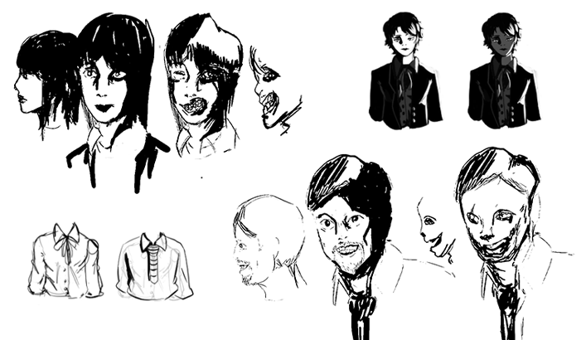
2. Style development | Refined designs that set the look | 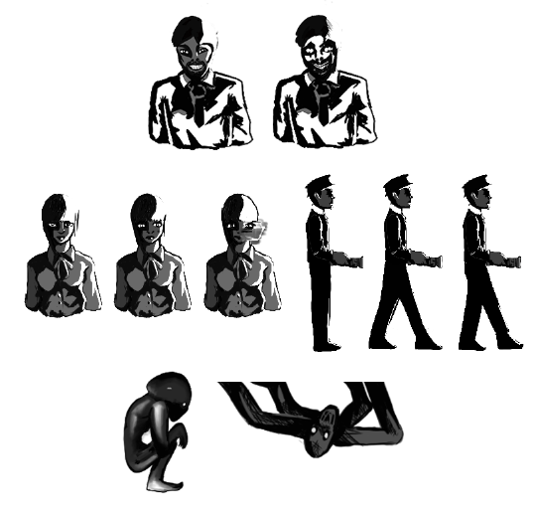
3. Asset creation | Ongoing creation of characters, props and environments | 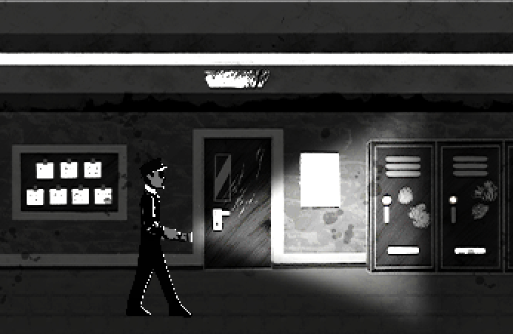
4. In-game | A Unity screenshot of the desk and the hallway | 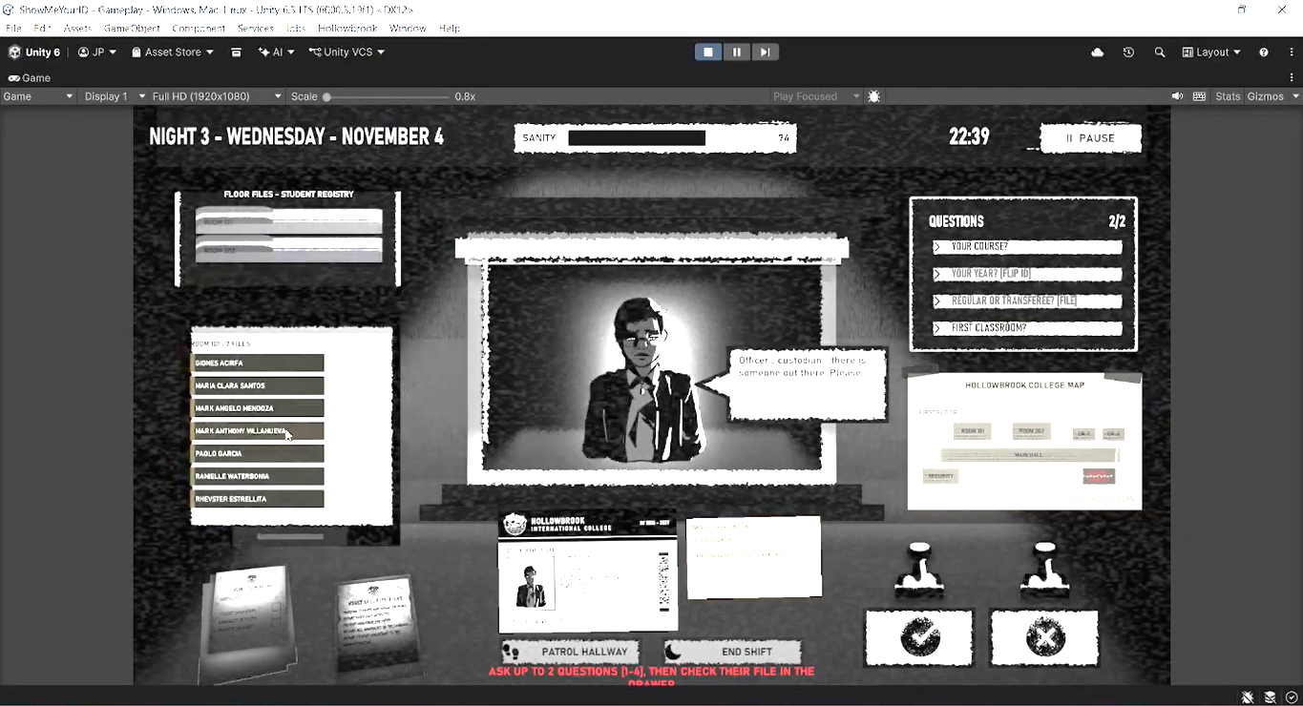  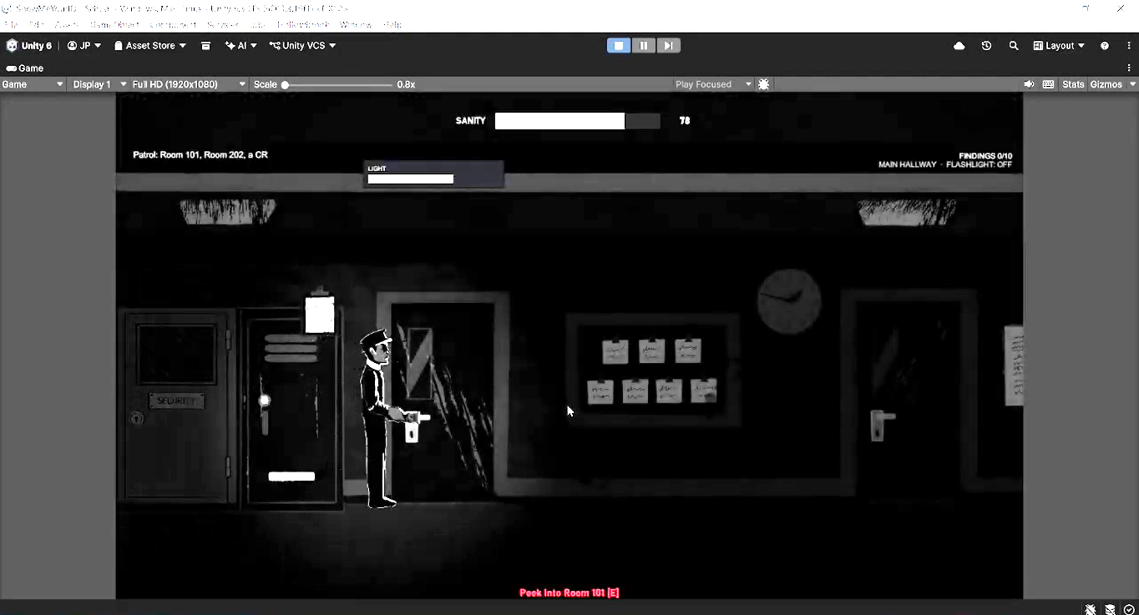

2.13 Audio design
- Composer and sound designer: Clarence Manalo.
- Goals: Build a tense atmosphere during inspection and exploration.
- Integration: Music and effects for the desk, hallway, classrooms, comfort rooms and anomaly encounters, plus interface sounds for stamps, papers and drawers. Volume has master, music and effects sliders.
- Current state: No audio files are in the build yet, so the game is silent. The night 5 hunt uses captions instead of sound. Final recorded audio is added by dropping files with the agreed names into Resources/Audio; a missing file stays silent.

2.14 Interface and user interaction
Action | Control
Inspect papers, ask questions, stamp, open the file drawer | Mouse
Ask questions 1 to 4 | Buttons, or keys 1 to 4
Flip the ID | Click the black spine, or F
File drawer | Click the cabinet, or Tab
Talk to the administrator | T
Close a sheet (rules or log) | X, Esc, or click outside
Map | M
Walk left and right / run | A and D or arrows / hold Shift
Interact (doors, clues, inspectable things, peek entry) | E
Flashlight sweep / focus / off | F / Q / L
Peek: lamp on or off / wide or tight | F / Q
Peek: select what the lamp is on / step back | E / S or the bottom edge
Advance dialogue | Click, Space, Enter or E
Pause | Esc
Erase save data (main menu) | F2 three times, then confirm

The same key can mean different things on the desk, in the hallway and in a peek (F flips the ID, toggles the flashlight, or toggles the lamp). The prompt line and the bottom bar always name the keys that apply.
HUD
- At the desk: night number, date, game clock (22:00 to 02:00), sanity bar, and the prompt line under the desk buttons that names the next step.
- In patrol: flashlight mode, battery and clue notifications. While peeking, a bar at the bottom shows the controls. During the hunt: progress to dawn and catches so far.
- In Night 6 the clock and sanity work as in night 5. In Lockdown the desk shows a 35 second bar and the mistake count, and sanity does not drain.
Screens
- Title, night intro, desk, patrol, peek, map, pause, settings, credits, night results, ending and game over screens.
- Settings: master, music and effects volume. Display and accessibility options, including reduced motion and photosensitive mode, are planned for implementation.

2.15 Technical design
- Engine: Unity 6.3, Built-in Render Pipeline, uGUI, Input System 1.20.1 (Active Input Handling: Both).
- Language: C#. Rules (rosters, questions, queue, endings, the hunt) are plain C# without Unity types, so they run in automated tests.
- Scenes: MenuScene, DeskScene (desk) and PatrolScene (patrol). A scene router moves between the desk and the patrol and keeps shared systems alive.
- Interface build:The interface is currently generated through code and saved as scene objects that can be inspected and edited in the Unity Hierarchy and Inspector. Reusable editable Unity prefabs for the screens are still planned for a future development stage.
- Assets: Art and audio load from the Resources folders. Missing art falls back to a plain generated placeholder, and a missing audio file is silent.
- Saves: A versioned, checksum-guarded file (save version 4) holds the night, the queue, the clues, and the hunt. Settings are stored separately. Older saves are ignored.
- Tunable numbers: Arrival gaps, mistake limits, sanity values, battery rate, hunt timers, and the Lockdown timer live in one settings asset (GameConfig).
- Testing: About 120,000 automated rule checks, about 1,460 button-level flow checks that play the desk, the patrol and the whole hunt, and a compile against the real Unity assemblies. These cannot judge look, sound, or feel, so playtesting in the editor is still required.
Item | Specification
Platform | Windows PC
Engine | Unity 6.3
Rendering | Built-in Render Pipeline
Interface | Unity UI (uGUI)
Reference resolution | 1920 x 1080, 16:9. The patrol camera is 10 units tall, so the painted hallway and rooms are drawn at 108 pixels per unit and map one to one on a 1080p screen. Large textures are imported with a 4096 limit.

Data the game tracks
- Current night, score, streak and run timer.
- Visitor records, verification results and processed counts.
- False rejections, breaches and anomalies turned away (per night and over the whole game).
- Sanity and the hunt state.
- Clue progress and clue order.
- Queue state, arrival timing, the current visitor and the questions already asked.

2.16 Production plan
Role | Person | Notes
Director and narrative | Jessie Mariel De Mesa | Oversees the project and writes the story
UI designer | Jessie Mariel De Mesa | Designs the interface, menus, and desk layout
Asset artist | Daniel Steven Solitaria | Characters
Asset artist | Diosdado Fabelico II | Environments and props
Asset artist | Daniella Garing | Environments and props
Programmers | Elijah Japeth Ramos, John Perilla | Gameplay, interactions and tools
Composer and sound designer | Clarence Manalo | Music and sound effects

Milestones
When | Milestone
October 2026 | Playable build: five nights, patrol, hunt, three endings, tests passing
Late October 2026 | Illustrated students, painted desk, hallway and rooms in the build; four questions with a limit of two
Early November 2026 | Playtest in the Unity editor; fix feel, balance and layout issues; move screens into editable prefabs
Mid November 2026 (proposed) | Content lock. Final audio dropped in. Steam page and trailer ready.
Late November 2026 | Release candidate and Steam release

Testing and quality assurance. Every change is checked by the automated suite before it is merged. Visual, audio and feel checks are done by playing in the editor, and the issues found are tracked as pull requests.
Version control. Changes are made one phase at a time as stacked pull requests on GitHub.

2.17 Release and marketing
- Platform and date: PC / Steam, planned for November 2026.
- Positioning: A short, evidence-based horror game for fans of Papers, Please and night shift horror. Five nights, about one session of play, with a secret ending that rewards a second run.
- Marketing: A poster and trailer, screenshots of the desk and the hallway, and a Steam page. Marketing is handled by the team.
- Rating: Targeted at ages 13 and above. No formal age rating has been obtained yet.

2.18 Risks and constraints
Risk | Plan
Release in November 2026 with final audio, editable prefabs and the Steam page still open | Lock content in mid November. Final audio is the first item allowed to ship in a later update, with silence as the fallback.
Editor only checks: the look, sound and feel have not been seen outside a headless build | Playtest in Unity before release and fix issues in small pull requests
Interface built in code is hard for artists to adjust | Move screens into editable prefabs, one screen at a time
No audio files yet | Replace with final recorded files; the names are already fixed
Balance of the failure limits, arrival gaps, sanity values, battery and hunt | Playtest the tuning numbers in GameConfig
Large art files in the repository | Keep final art small and keep large source files out of the game build
Student names and numbers are working data | Confirm the final list with the director before release

2.19 Implementation status
This table separates implemented systems from planned features. A feature marked "Built" has been implemented in the current build, but its final behavior may still require testing.
Feature | Status | Notes
Desk: ID, slip, files, stamps, hand back | Built | Concept art layout matched
Four questions with a limit of two and locks | Built | Year needs a flipped ID; status needs the open file
Thirteen illustrated students | Built | Names and numbers are working data
Patrol: hallway and flashlight | Built | Interaction by body, mouse aims the beam; follows the desk map
Roaming anomalies and standing figures | Built | Hallway roamers (three kinds) and standing figures in peek rooms; needs balance playtest
Peek lamp with a hole in the dark | Built | Black cover with a real hole; needs confirming in the editor
CR-1 and CR-2 | Built | Peek only, with three things to inspect
Night opening sequence and how to play card | Built | Black, title, dialogue, closed booth, open booth
Administrator interrogation | Built | No student questions; lies exposed shorten the hunt
Night 5 queue: 8 students, then the administrator | Built | Check the queue order, the mistake limits on the student part, and the switch to the interrogation and hunt
Endings: Win, Lose, Secret | Built | Plus Night 6 (the Challenge) and Lockdown
Night 5 hunt after DECLINE | Built | Only DECLINE starts the hunt, from the Patrol button. ACCEPT loses at once.
Night 6 and Lockdown on the main menu | Built | Night 6 opens after the story's Win or Secret ending, and Lockdown after Night 6 is beaten. Lockdown is students only (section 2.8).
Credits screen | Built | Names and roles come from one list
Walk in and glide animation for visitors | Dropped | The art is not layered, so it cannot be animated
Final audio | Planned | No sound files in the build yet; the game is silent
Editable Unity prefabs for screens | Planned | Screens are built in code today
Steam page and trailer | Planned | Marketing work

2.20 Systems the game does not have
These systems appear in other genres and sample documents. They are left out on purpose.
System | Why it is not in the game
Branching dialogue and quests | Story is told through papers, answers and clues. The administrator talk is a short list, not a tree.
Skill trees, experience and inventory management | Progress comes from nights and clues, not from character growth.
Shops and currency | The pocket watch/token is a collectible clue with no currency or purchasing function.
Combat and weapons | The flashlight and lamp reveal and repel; nothing is fought.
Character creation | The custodian is a fixed character.
Multiplayer and online services | Single player, offline.
Voice acting and localization | Text only, in English.
Scanner and camera panel | Cut: verification is by papers, files and questions.

2.21 Glossary
- Anomaly: A visitor or presence that is not what it claims to be.
- Breach: An anomaly that was allowed in, or an expired ID that was accepted.
- False rejection: A student with valid papers who was turned away.
- Mistake: A breach or a false rejection.
- Failed night: A night on Nights 1 to 4 that ends with an anomaly let in, or with zero sanity. After a breach the game moves on and the next night starts with less sanity; after a blackout the night is played again.
- Clue: One of ten findings that open the secret ending. The pocket watch is clue 7.
- Peek: Looking into a room from the doorway with the lamp cursor.
- Patrol cycle: Peeking into Room 101, Room 202 and one comfort room in a single night. Required on nights 1 to 4. Night 5 has no patrol cycle.
- Tonight’s log: The list of everyone already stamped tonight, with their ID numbers.
- Catch: The administrator reaching the player during the hunt. Three catches end the Night 5 run, while two catches end the Night 6 Challenge.
- Lie exposed: A follow-up that catches the administrator out. Each one shortens the hunt.
- Lockdown: The extra students-only mode with no patrol. Frightened faces reach the window, and the player has 35 seconds to inspect each one using the four questions (limit of two). Three mistakes lose.
- HUD: Heads-up display; information shown on screen.
- Scene root: The object in each scene that holds its screens. The setup tool fills it and you can edit what it holds.
- Sprite: A 2D image used for characters, props and interface.

2.22 References
- Papers, Please. Lucas Pope, 2013.
- Five Nights at Freddy’s. Scott Cawthon, 2014.
- I’m on Observation Duty. Notovia, 2018.
- The Exit 8. Kotake Create, 2023.
- Game Design Document structure, Rensselaer Polytechnic Institute: https://homepages.hass.rpi.edu/ruiz/EGD/gamedesigndocument.htm
- Pingle Studio, "What is a Game Design Document?": https://pinglestudio.com/knowledge-base/for-beginners/what-is-a-game-design-document
- PickFu, "How to create the perfect game design document": https://www.pickfu.com/blog/game-design-document/
- Unity, "Game Design Document (GDD) Template" (structure only).
- Nightmare Fredbear, FNaF Wiki (reference for the night 5 design): https://fivenightsatfreddys.fandom.com/wiki/Nightmare_Fredbear
- FNAF 4 Complete Guide, Steam Community (reference for the night 5 design): https://steamcommunity.com/sharedfiles/filedetails/?id=2806989911

