https://nextjs.org/learn/dashboard-app/mutating-dataChapter
Next Topics:
You can also read more about security with Server Actions for additional learning.
https://nextjs.org/blog/security-nextjs-server-components-actions - middleware
Getting Started
This command uses create-next-app, a Command Line Interface (CLI) tool that sets up a Next.js application for you. In the command above, you're also using the --example flag with the starter example for this course.

- app: Contains all the routes, components, and logic for your application, this is where you'll be mostly working from.
- /app/lib: Contains functions used in your application, such as reusable utility functions and data fetching functions.
- /app/ui: Contains all the UI components for your application, such as cards, tables, and forms. To save time, we've pre-styled these components for you.
- /public: Contains all the static assets for your application, such as images.

Chapter 3

Optimizing Fonts and Images
Why optimize fonts?
Fonts play a significant role in the design of a website, but using custom fonts in your project can affect performance if the font files need to be fetched and loaded.
Cumulative Layout Shift is a metric used by Google to evaluate the performance and user experience of a website. With fonts, layout shift happens when the browser initially renders text in a fallback or system font and then swaps it out for a custom font once it has loaded. This swap can cause the text size, spacing, or layout to change, shifting elements around it.
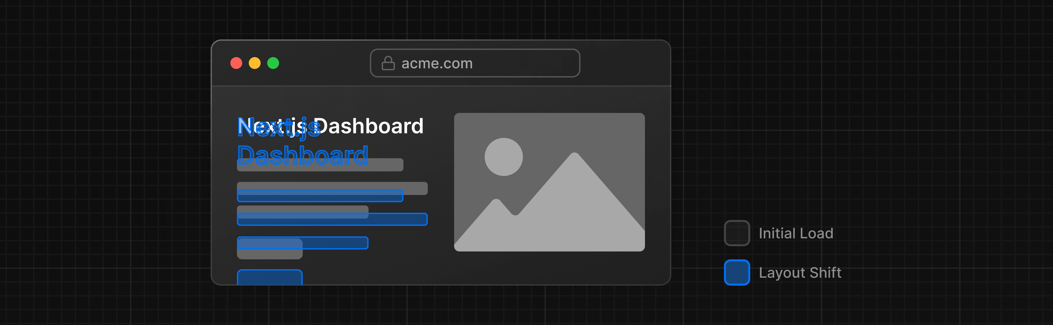
Next.js automatically optimizes fonts in the application when you use the next/font module. It downloads font files at build time and hosts them with your other static assets. This means when a user visits your application, there are no additional network requests for fonts which would impact performance.
Next.js downloads font files at build time and hosts them with your other static assets. This means when a user visits your application, there are no additional network requests for fonts which would impact performance.
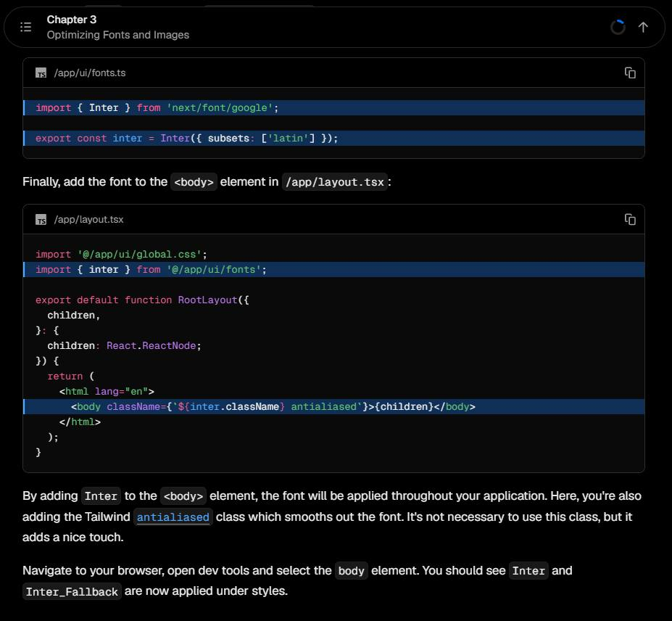
Why optimize images?
Next.js can serve static assets, like images, under the top-level /public folder. Files inside /public can be referenced in your application.
With regular HTML, you would add an image as follows:
<img src="/hero.png" alt="Screenshots of the dashboard project showing desktop version"/>
However, this means you have to manually:
- Ensure your image is responsive on different screen sizes.
- Specify image sizes for different devices.
- Prevent layout shift as the images load.
- Lazy load images that are outside the user's viewport.
Image Optimization is a large topic in web development that could be considered a specialization in itself. Instead of manually implementing these optimizations, you can use the next/image component to automatically optimize your images.
The <Image> component
The <Image> Component is an extension of the HTML <img> tag, and comes with automatic image optimization, such as:
- Preventing layout shift automatically when images are loading.
- Resizing images to avoid shipping large images to devices with a smaller viewport.
- Lazy loading images by default (images load as they enter the viewport).
- Serving images in modern formats, like WebP and AVIF, when the browser supports it.
In your /app/page.tsx file, import the component from next/image. Then, add the image under the comment:
Images without dimensions and web fonts are common causes of layout shift due to the browser having to download additional resources.
Recommended reading
There's a lot more to learn about these topics, including optimizing remote images and using local font files. If you'd like to dive deeper into fonts and images, see:
- Image Optimization Docs
- Font Optimization Docs
- Improving Web Performance with Images (MDN)
- Web Fonts (MDN)
- How Core Web Vitals Affect SEO
- How Google handles JavaScript throughout the indexing process

Chapter 4

Creating Layouts and Pages
Nested routing
Next.js uses file-system routing where folders are used to create nested routes. Each folder represents a route segment that maps to a URL segment.
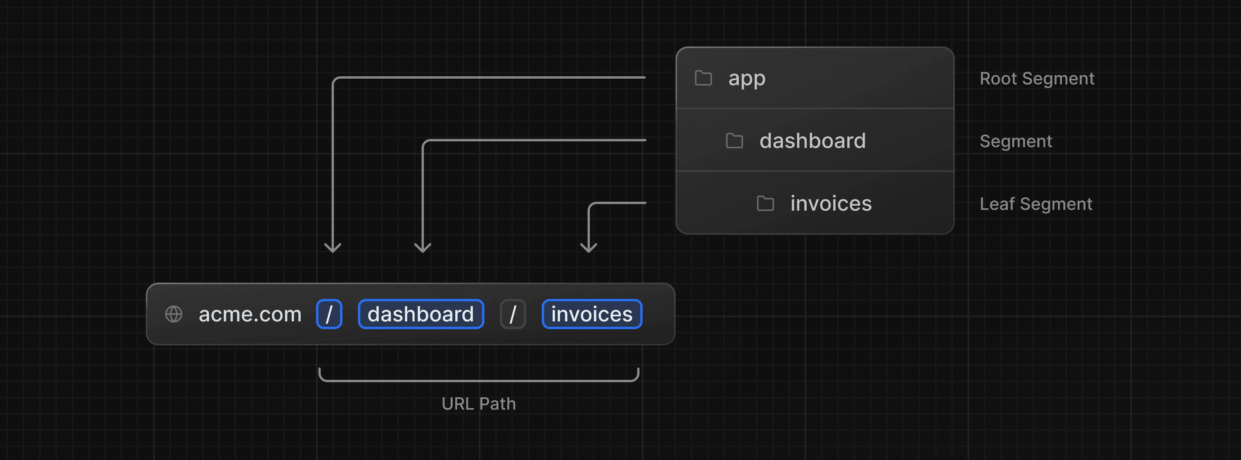
You can create separate UIs for each route using layout.tsx and page.tsx files.
page.tsx is a special Next.js file that exports a React component, and it's required for the route to be accessible.
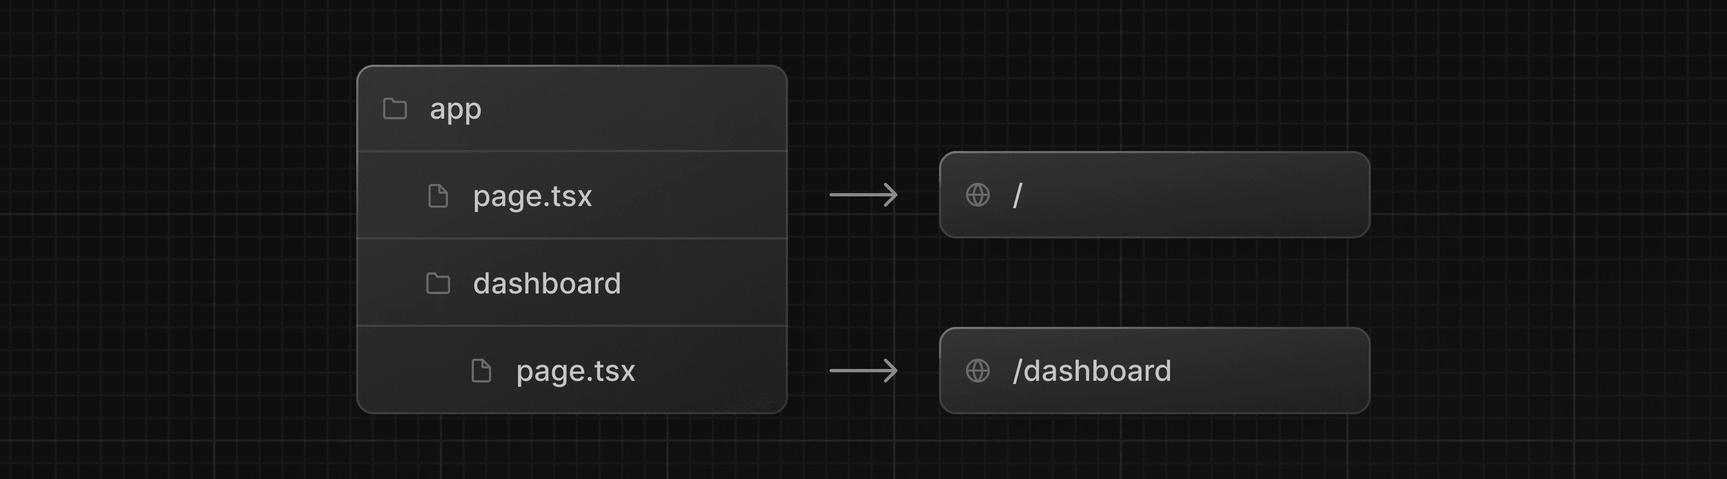
This is how you can create different pages in Next.js: create a new route segment using a folder, and add a page file inside it.
By having a special name for page files, Next.js allows you to colocate UI components, test files, and other related code with your routes. Only the content inside the page file will be publicly accessible. For example, the /ui and /lib folders are colocated inside the /app folder along with your routes.
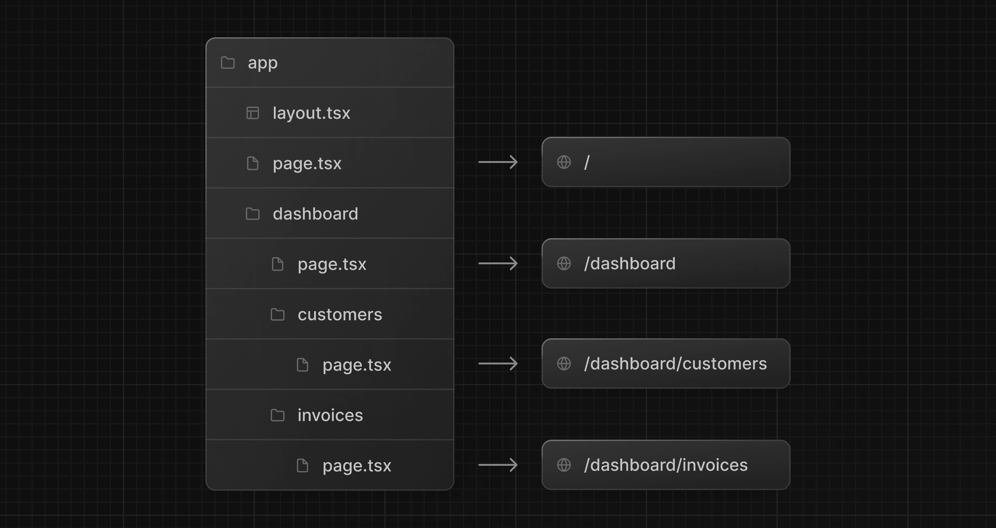
Creating the dashboard layout
Dashboards have some sort of navigation that is shared across multiple pages. In Next.js, you can use a special layout.tsx file to create UI that is shared between multiple pages. Let's create a layout for the dashboard pages!
Inside the /dashboard folder, add a new file called layout.tsx and paste the following code:
/app/dashboard/layout.tsx
A few things are going on in this code, so let's break it down:
First, you're importing the <SideNav /> component into your layout. Any components you import into this file will be part of the layout.
The <Layout /> component receives a children prop. This child can either be a page or another layout. In your case, the pages inside /dashboard will automatically be nested inside a <Layout /> like so:
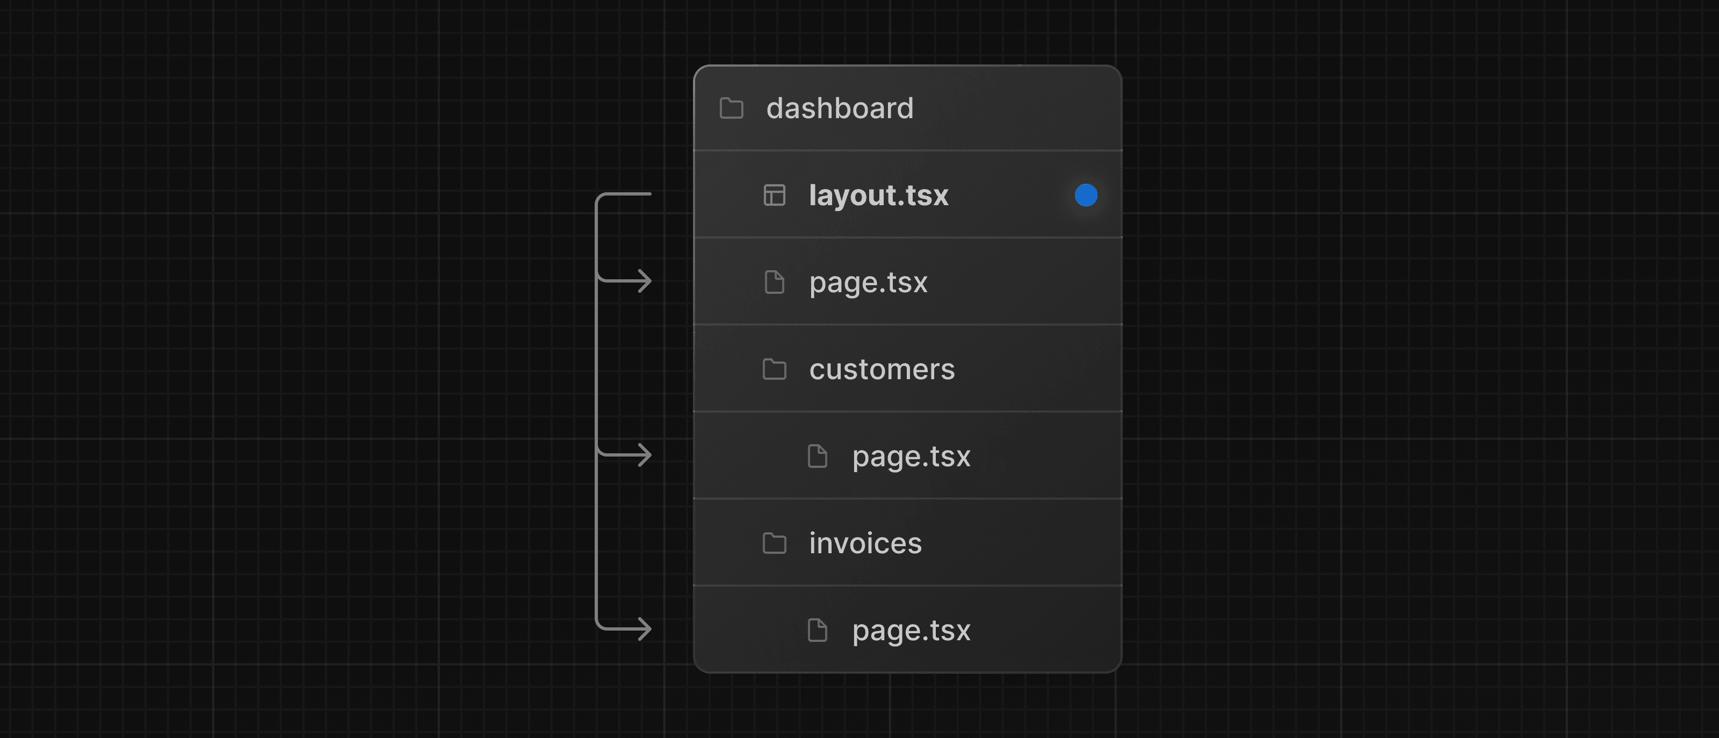
One benefit of using layouts in Next.js is that on navigation, only the page components update while the layout won't re-render. This is called partial rendering which preserves client-side React state in the layout when transitioning between pages.
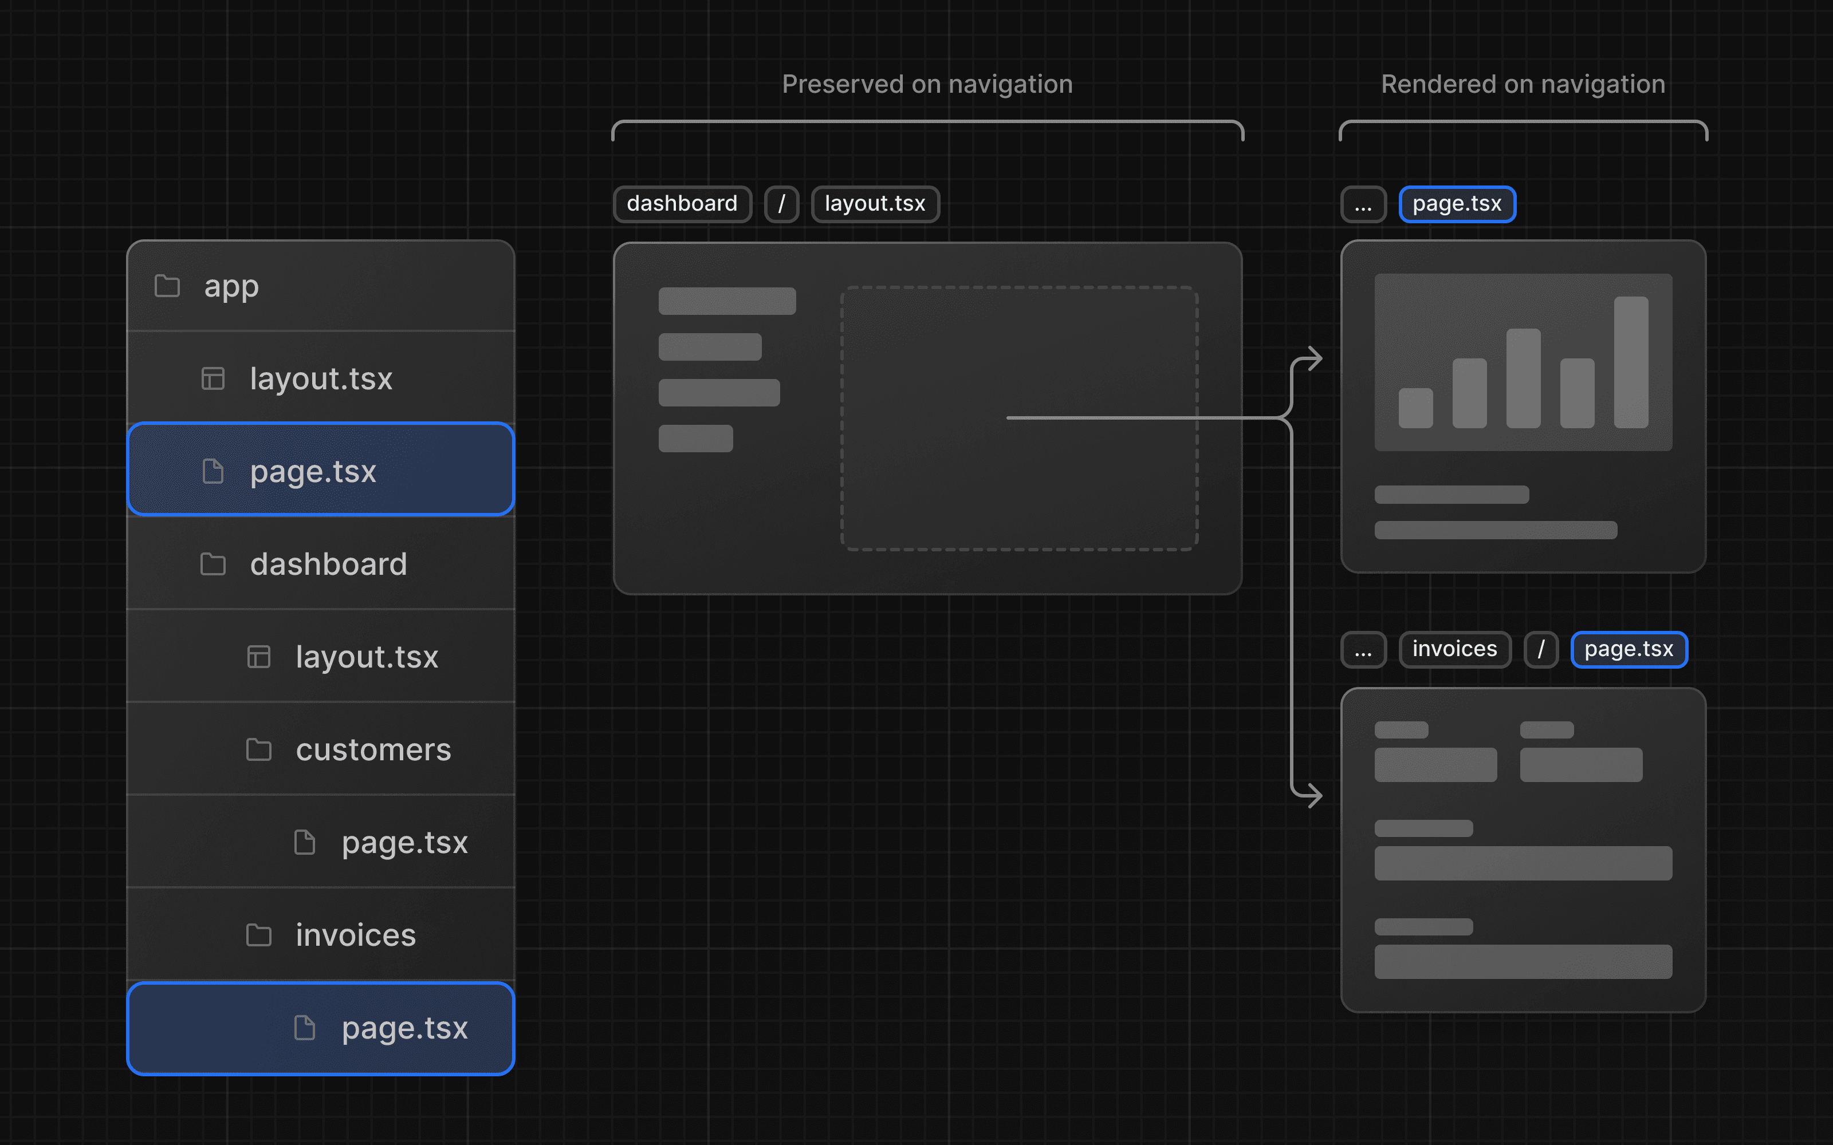
Root Layout
This is called a root layout and is required in every Next.js application. Any UI you add to the root layout will be shared across all pages in your application. You can use the root layout to modify your <html> and <body> tags, and add metadata (you'll learn more about metadata in a later chapter).
Chapter 5

Navigating Between Pages
In the previous chapter, you created the dashboard layout and pages. Now, let's add some links to allow users to navigate between the dashboard routes.

Before we used <a/> tags to navigate but this causes the whole page to refresh, including the layout(context or parent components)
The <Link> component
In Next.js, you can use the <Link /> Component to link between pages in your application. <Link> allows you to do client-side navigation with JavaScript.
Linking and Navigating
Last updated August 25, 2026
In Next.js, routes are rendered on the server by default. This often means the client has to wait for a server response before a new route can be shown. Next.js comes with built-in prefetching, streaming, and client-side transitions ensuring navigation stays fast and responsive.
This guide explains how navigation works in Next.js and how you can optimize it for dynamic routes and slow networks.
Server Rendering
In Next.js, Layouts and Pages are React Server Components by default. On initial and subsequent navigations, the Server Component Payload is generated on the server before being sent to the client.
There are two types of server rendering, based on when it happens:
- Prerendering happens at build time or during revalidation and the result is cached.
- Dynamic Rendering happens at request time in response to a client request.
The trade-off of server rendering is that the client must wait for the server to respond before the new route can be shown. Next.js addresses this delay by prefetching routes the user is likely to visit and performing client-side transitions.
Prefetching
Prefetching is the process of loading a route in the background before the user navigates to it. This makes navigation between routes in your application feel instant, because by the time a user clicks on a link, the data to render the next route is already available client side.
Next.js automatically prefetches routes linked with the <Link> component when they enter the user's viewport.
<nav>
{/* Prefetched when the link is hovered or enters the viewport */}
<Link href="/blog">Blog</Link>
{/* No prefetching */}
<a href="/contact">Contact</a>
</nav>
How much of the route is prefetched depends on whether it's static or dynamic:
- Static Route: the full route is prefetched.
- Dynamic Route: prefetching is skipped, or the route is partially prefetched if loading.tsx is present
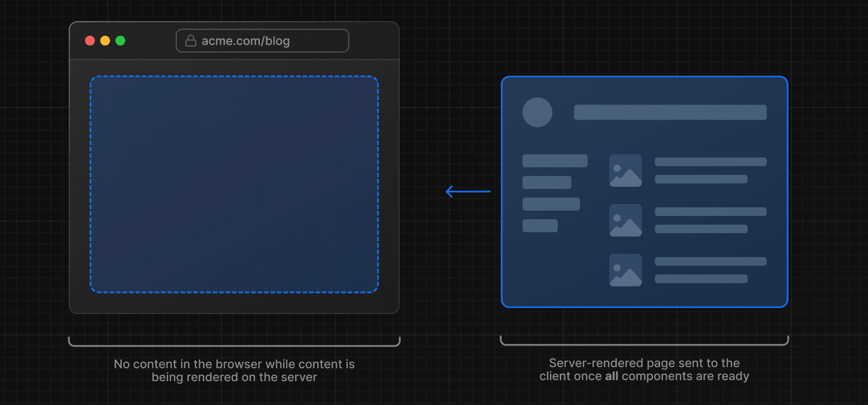
To improve the navigation experience to dynamic routes, you can use streaming.

STREAMING
Streaming allows the server to send parts of a dynamic route to the client as soon as they're ready, rather than waiting for the entire route to be rendered. This means users see something sooner, even if parts of the page are still loading. See the Streaming guide for a deep dive into how streaming works in Next.js.
To use streaming, create a loading.tsx in your route folder:

loading.js special file
export default function Loading() {
// Add fallback UI that will be shown while the route is loading.
return <LoadingSkeleton />
}
Behind the scenes, Next.js will automatically wrap the page.tsx contents in a <Suspense> boundary. The prefetched fallback UI will be shown while the route is loading, and swapped for the actual content once ready.
Good to know: You can also use <Suspense> to create loading UI for nested components.
Benefits of loading.tsx:
- Immediate navigation and visual feedback for the user.
- Shared layouts remain interactive and navigation is interruptible.
- Improved Core Web Vitals: TTFB, FCP, and TTI.
To further improve the navigation experience, Next.js performs a client-side transition with the <Link> component.
Client-side transitions
Traditionally, navigation to a server-rendered page triggers a full page load. This clears state, resets scroll position, and blocks interactivity.
Next.js avoids this with client-side transitions using the <Link> component. Instead of reloading the page, it updates the content dynamically by:
- Keeping any shared layouts and UI.
- Replacing the current page with the prefetched loading state or a new page if available.
Client-side transitions make server-rendered apps feel like client-rendered apps. And when paired with prefetching and streaming, they enable fast transitions, even for dynamic routes.
Next.js also handles scrolling to the top of the page during client-side transitions. If content scrolls behind a sticky or fixed header after navigation, you can fix this with CSS scroll-padding-top.
Good to know: In development mode, you can use the Next.js Devtools to identify if the route is static or dynamic. See devIndicators for more information.
function HoverPrefetchLink({ href, children,}: { href: string children: React.ReactNode}) {
const [active, setActive] = useState(false)
return ( <Link href={href} prefetch={active ? null : false} onMouseEnter={() => setActive(true)} >
{children}
</Link> )}
Hydration not completed
<Link> is a Client Component and must be hydrated before it can prefetch routes. On the initial visit, large JavaScript bundles can delay hydration, preventing prefetching from starting right away.
React mitigates this with Selective Hydration and you can further improve this by:
- Using the @next/bundle-analyzer plugin to identify and reduce bundle size by removing large dependencies.
- Moving logic from the client to the server where possible. See the Server and Client Components docs for guidance.
Native History API
Next.js allows you to use the native window.history.pushState and window.history.replaceState methods to update the browser's history stack without reloading the page.
pushState and replaceState calls integrate into the Next.js Router, allowing you to sync with usePathname and useSearchParams.

window.history.pushState
Use it to add a new entry to the browser's history stack. The user can navigate back to the previous state. For example, to sort a list of products:
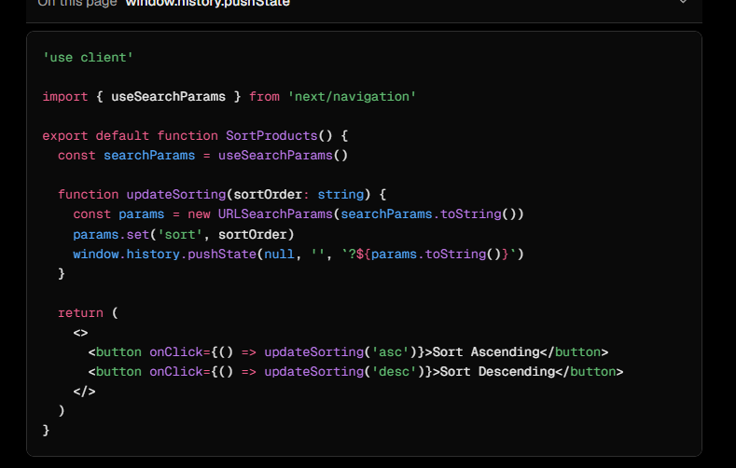
Automatic code-splitting and prefetching
To improve the navigation experience, Next.js automatically code splits your application by route segments. This is different from a traditional React SPA, where the browser loads all your application code on the initial page load.
Splitting code by routes means that pages become isolated. If a certain page throws an error, the rest of the application will still work. This is also less code for the browser to parse, which makes your application faster.
Furthermore, in production, whenever <Link> components appear in the browser's viewport, Next.js automatically prefetches the code for the linked route in the background. By the time the user clicks the link, the code for the destination page will already be loaded in the background, and this is what makes the page transition near-instant!
Pattern: Showing active links
A common UI pattern is to show an active link to indicate to the user what page they are currently on. To do this, you need to get the user's current path from the URL. Next.js provides a hook called usePathname() that you can use to check the path and implement this pattern.
Since usePathname() is a React hook, you'll need to turn nav-links.tsx into a Client Component. Add React's "use client" directive to the top of the file, then import usePathname() from next/navigation😀
Chapter 7

Fetching Data
API layer
APIs are an intermediary layer between your application code and database. There are a few cases where you might use an API:
- If you're using third-party services that provide an API.
- If you're fetching data from the client, you want to have an API layer that runs on the server to avoid exposing your database secrets to the client.
In Next.js, you can create API endpoints using Route Handlers.
Database queries
When you're creating a full-stack application, you'll also need to write logic to interact with your database. For relational databases like Postgres, you can do this with SQL or with an ORM.

There are a few cases where you have to write database queries:

When creating your API endpoints, you need to write logic to interact with your database.
If you are using React Server Components (fetching data on the server), you can skip the API layer, and query your database directly without risking exposing your database secrets to the client.
Using Server Components to fetch data
By default, Next.js applications use React Server Components. Fetching data with Server Components is a relatively new approach and there are a few benefits of using them:
- Server Components support JavaScript Promises, providing a solution for asynchronous tasks like data fetching natively. You can use async/await syntax without needing useEffect, useState or other data fetching libraries.
- Server Components run on the server, so you can keep expensive data fetches and logic on the server, only sending the result to the client.
- Since Server Components run on the server, you can query the database directly without an additional API layer. This saves you from writing and maintaining additional code.
You could fetch all the invoices and sort through them using JavaScript. This isn't a problem as our data is small, but as your application grows, it can significantly increase the amount of data transferred on each request and the JavaScript required to sort through it.
Instead of sorting through the latest invoices in-memory, you can use an SQL query to fetch only the last 5 invoices. For example, this is the SQL query from your data.ts file:

What are request waterfalls?
A "waterfall" refers to a sequence of network requests that depend on the completion of previous requests. In the case of data fetching, each request can only begin once the previous request has returned data.
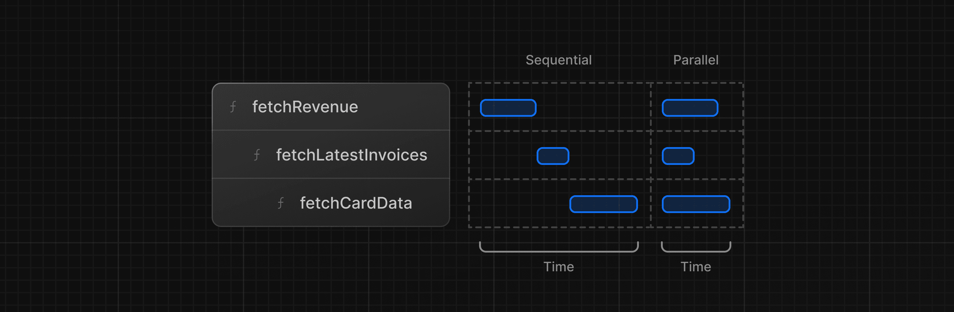
This pattern is not necessarily bad. There may be cases where you want waterfalls because you want a condition to be satisfied before you make the next request. For example, you might want to fetch a user's ID and profile information first. Once you have the ID, you might then proceed to fetch their list of friends. In this case, each request is contingent on the data returned from the previous request.
However, this behavior can also be unintentional and impact performance.

PARALLEL DATA FETCHING
A common way to avoid waterfalls is to initiate all data requests at the same time - in parallel.
In JavaScript, you can use the Promise.all() or Promise.allSettled() functions to initiate all promises at the same time. For example, in data.ts, we're using Promise.all() in the fetchCardData() function:
/app/lib/data.ts
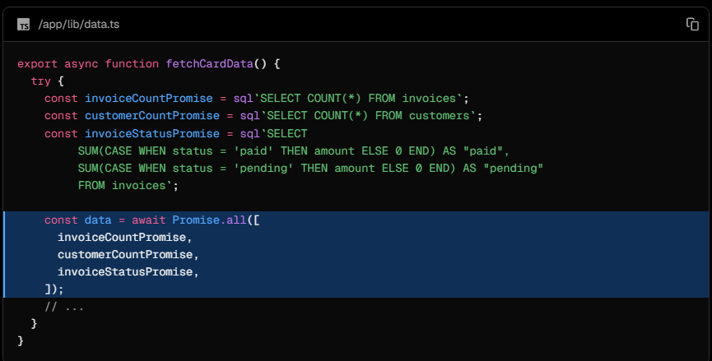
By using this pattern, you can:
- Start executing all data fetches at the same time, which is faster than waiting for each request to complete in a waterfall.
- Use a native JavaScript pattern that can be applied to any library or framework.
However, there is one disadvantage of relying only on this JavaScript pattern: what happens if one data request is slower than all the others? Let's find out more in the next chapter.
Chapter 8
Static and Dynamic Rendering
What is Static Rendering?
With static rendering, data fetching and rendering happen on the server at build time (when you deploy) or when revalidating data.

Whenever a user visits your application, the cached result is served. There are a couple of benefits of static rendering:
- Faster Websites - Prerendered content can be cached and globally distributed when deployed to platforms like Vercel. This ensures that users around the world can access your website's content more quickly and reliably.
- Reduced Server Load - Because the content is cached, your server does not have to dynamically generate content for each user request. This can reduce compute costs.
- SEO - Prerendered content is easier for search engine crawlers to index, as the content is already available when the page loads. This can lead to improved search engine rankings.
- When your data updates, you want to show the latest changes in your dashboard. Static Rendering is not a good fit for this use case.
Static rendering is useful for UI with no data or data that is shared across users, such as a static blog post or a product page. It might not be a good fit for a dashboard that has personalised data which is regularly updated.

The opposite of static rendering is dynamic rendering.
What is Dynamic Rendering?
With dynamic rendering, content is rendered on the server for each user at request time (when the user visits the page). There are a couple of benefits of dynamic rendering:
- Real-Time Data - Dynamic rendering allows your application to display real-time or frequently updated data. This is ideal for applications where data changes often.
- User-Specific Content - It's easier to serve personalized content, such as dashboards or user profiles, and update the data based on user interaction.
- Request Time Information - Dynamic rendering allows you to access information that can only be known at request time, such as cookies or the URL search parameters.

SIMULATING A SLOW DATA FETCH
The dashboard application we're building is dynamic.
However, there is still one problem mentioned in the previous chapter. What happens if one data request is slower than all the others?
Let's simulate a slow data fetch. In app/lib/data.ts, uncomment the console.log and setTimeout inside fetchRevenue():
Now open http://localhost:3000/dashboard/ in a new tab and notice how the page takes longer to load. In your terminal, you should also see the following messages:
With dynamic rendering, your application is only as fast as your slowest data fetch.
They're two separate axes, and mixing them up is the most common Next.js confusion.
Axis 1: Server vs Client components (where the code runs)
- Server Components are the default in the App Router. They run only on the server, never ship JS to the browser, and can be async, so you can await a DB call or fetch directly in the component. They can't use hooks, state, effects, or browser APIs.
- Client Components are marked with 'use client' at the top of the file. This is the React you already know: useState, useEffect, onClick, and so on. Despite the name, they still get pre-rendered to HTML on the server and then hydrate in the browser. 'use client' really means "this component also ships JS and hydrates."
Axis 2: Static vs Dynamic rendering (when the HTML is generated)
This applies per route, not per component.
- Static rendering: the HTML is generated at build time (or on revalidation), cached, and served from a CDN. It's fast and cheap.
- Dynamic rendering: the HTML is generated per request. A route becomes dynamic when it reads request-time data such as cookies(), headers(), searchParams, uncached fetches, or connection().
How they combine
All four combinations are valid:
 | Static route | Dynamic route
Server comp | Blog post rendered at build | Dashboard reading the user's cookie
Client comp | Interactive carousel on a static page | Like button on a personalised feed
Chapter 9

Streaming
Streaming is a data transfer technique that allows you to break down a route into smaller "chunks" and progressively stream them from the server to the client as they become ready.
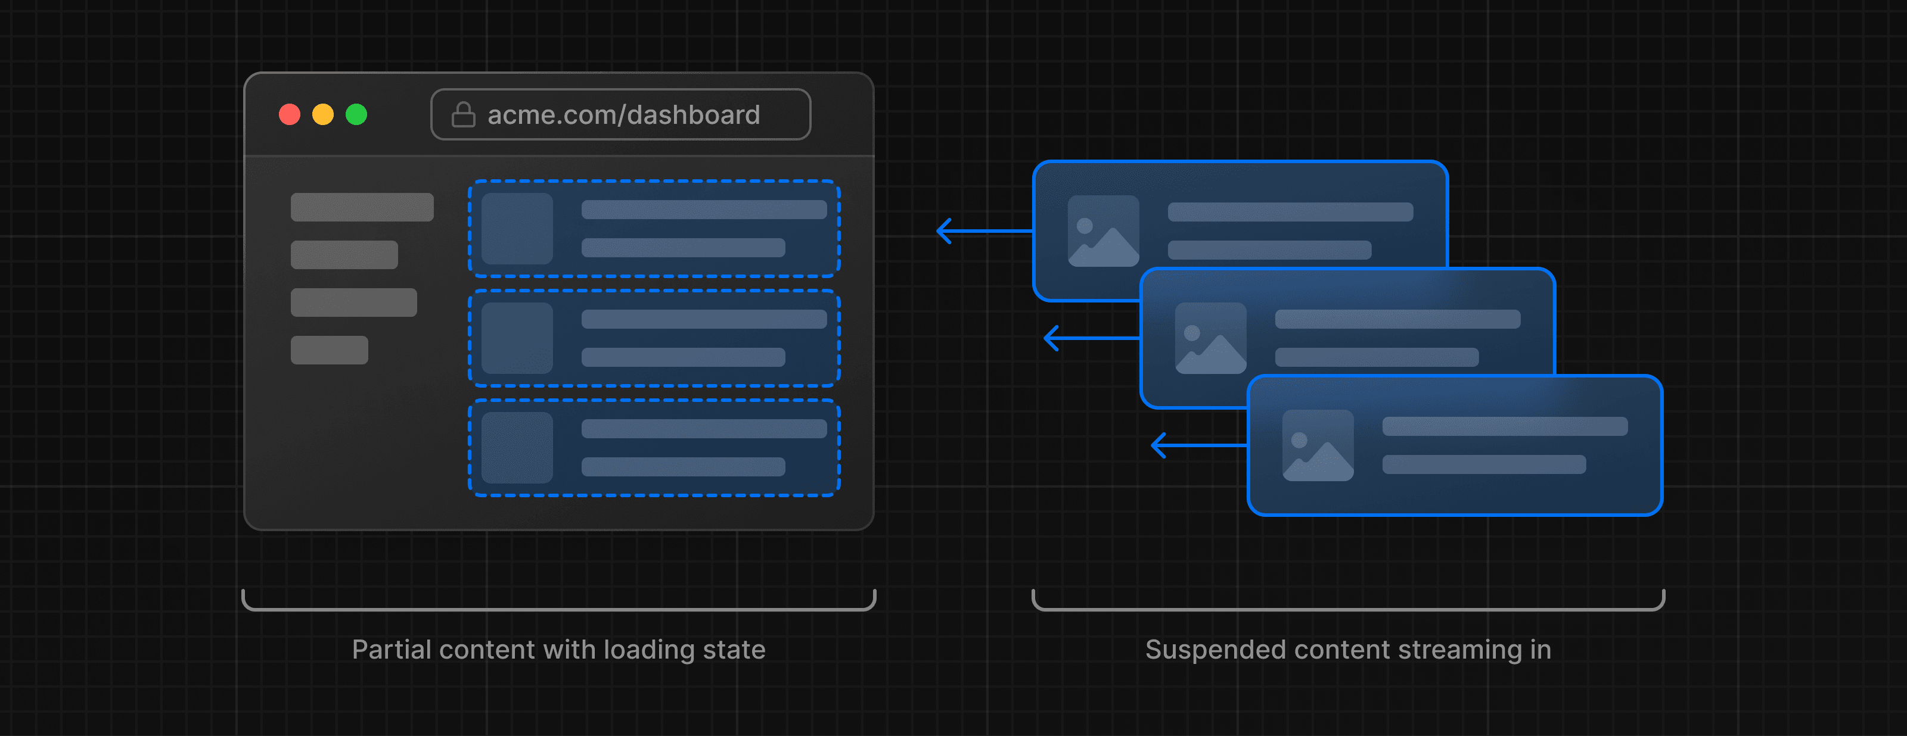
By streaming, you can prevent slow data requests from blocking your whole page. This allows the user to see and interact with parts of the page without waiting for all the data to load before any UI can be shown to the user.
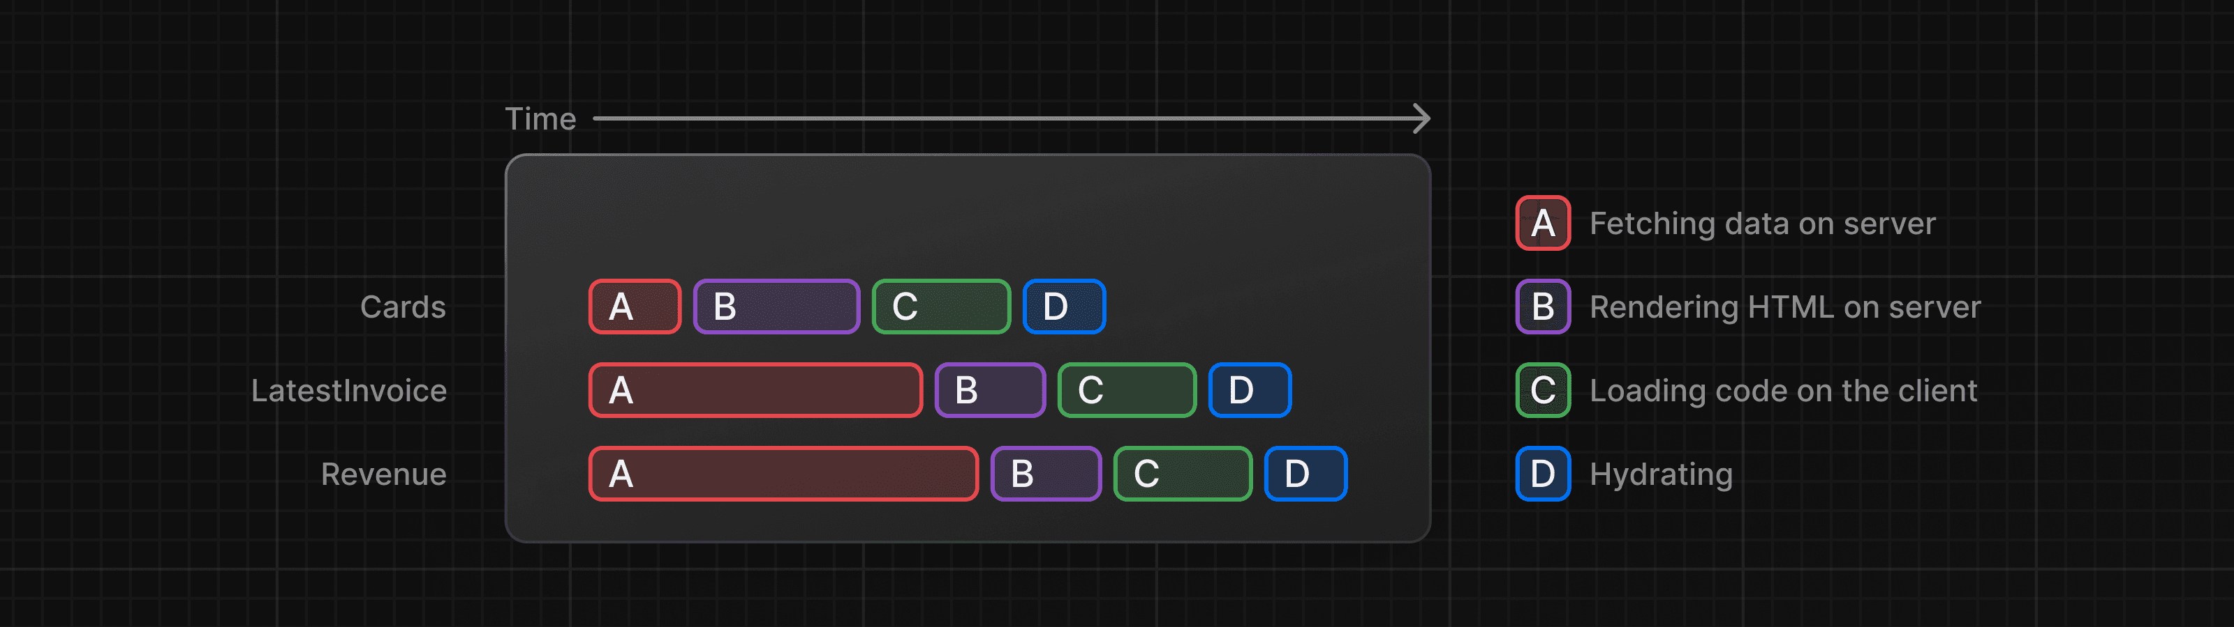
Streaming works well with React's component model, as each component can be considered a chunk.
One advantage of this approach is that you can significantly reduce your page's overall loading time.
There are two ways you implement streaming in Next.js:
At the page level, with loading.tsx
- with the loading.tsx file (which creates <Suspense> for you)
- loading.tsx is a special Next.js file built on top of React Suspense. It allows you to create fallback UI to show as a replacement while page content loads.
- Since <SideNav> is static, it's shown immediately. The user can interact with <SideNav> while the dynamic content is loading.
- The user doesn't have to wait for the page to finish loading before navigating away (this is called interruptable navigation).
Adding loading skeletons
- A loading skeleton is a simplified version of the UI.
- Sent first
- Use them as a placeholder (or fallback) to indicate to users that the content is loading
- Any UI you add in loading.tsx will be embedded as part of the static file,
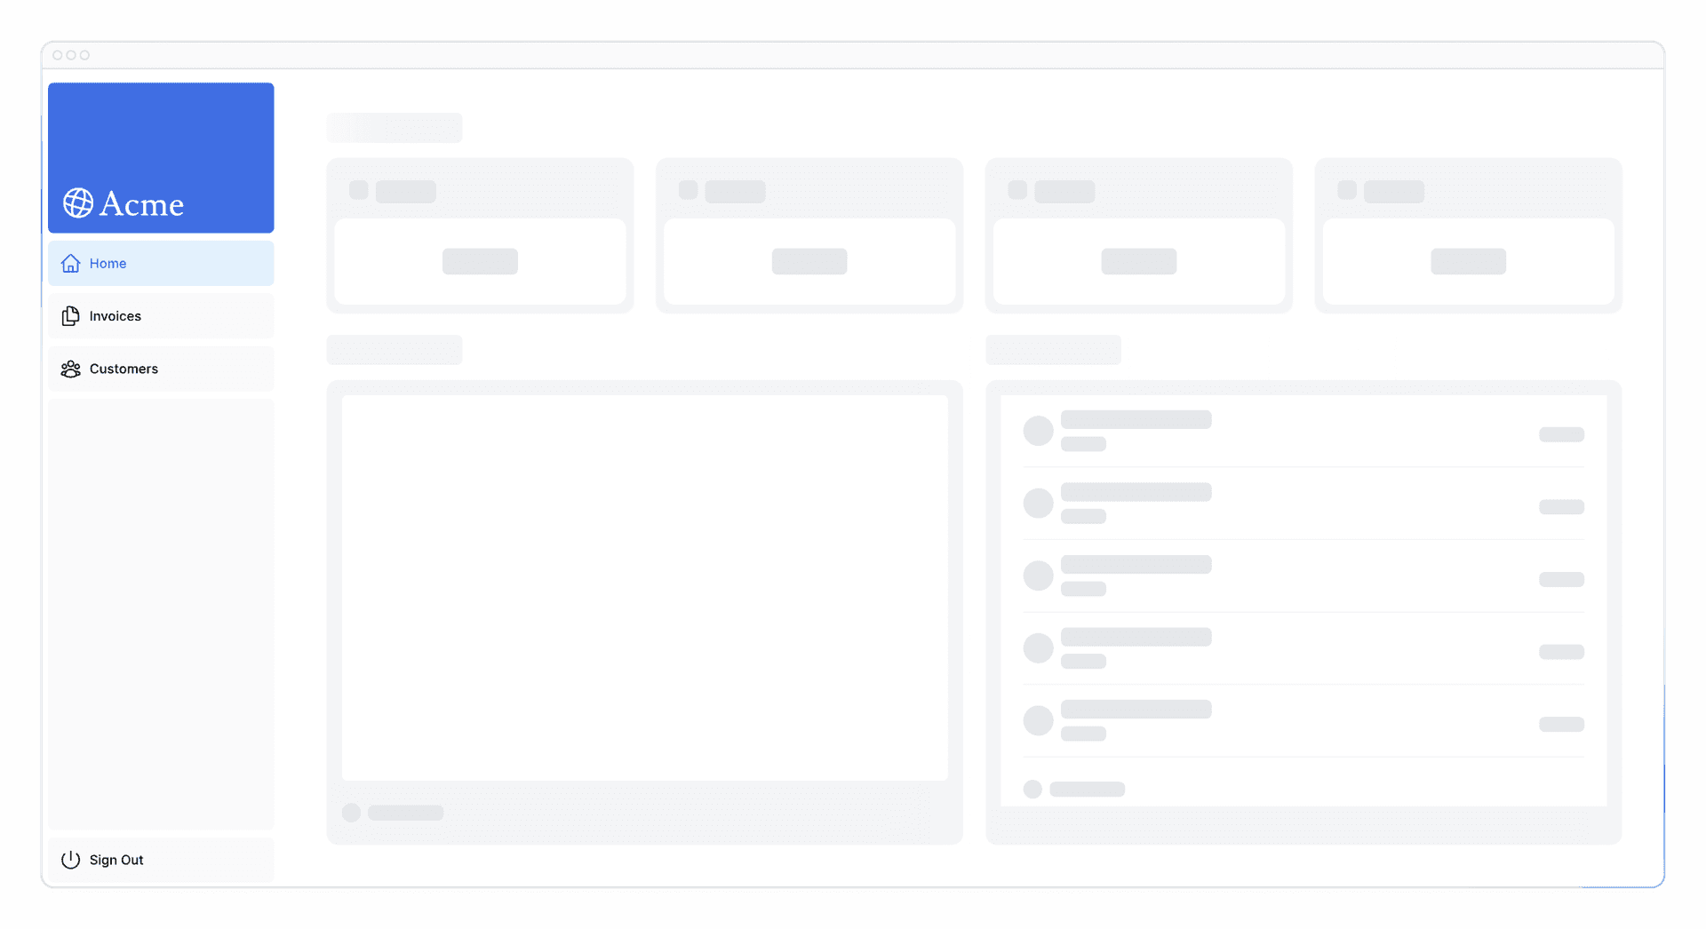
Right now, your loading skeleton will apply to the invoices.
Fix using Routing Groups - Create a new folder called /(overview) inside the dashboard folder. Then, move your loading.tsx and page.tsx files inside the folder:

Route groups allow you to organize files into logical groups without affecting the URL path structure. When you create a new folder using parentheses (), the name won't be included in the URL path. So /dashboard/(overview)/page.tsx becomes /dashboard.
Here, you're using a route group to ensure loading.tsx only applies to your dashboard overview page. However, you can also use route groups to separate your application into sections (e.g. (marketing) routes and (shop) routes) or by teams for larger applications.
At the component level, with <Suspense />
Suspense allows you to defer rendering parts of your application until some condition is met (e.g. data is loaded). You can wrap your dynamic components in Suspense. Then, pass it a fallback component to show while the dynamic component loads.
- Stream specific components using React Suspense

Grouping components
You can fetch data for each individual card, but this could lead to a popping effect as the cards load in, this can be visually jarring for the user.
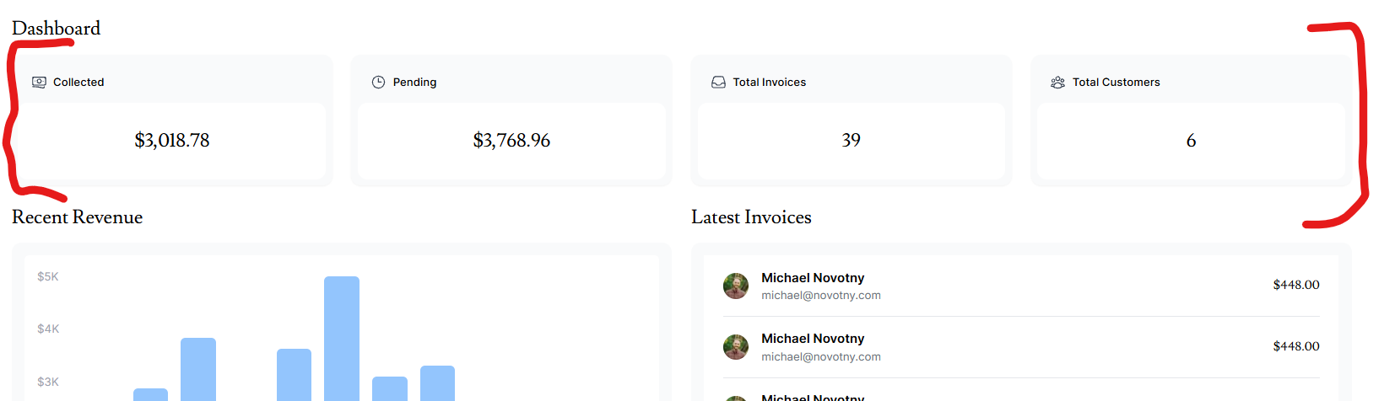
To create more of a staggered effect, you can group the cards using a wrapper component. This means the static <SideNav/> will be shown first, followed by the cards, etc.
Deciding where to place your Suspense boundaries
- How you want the user to experience the page as it streams.
- What content you want to prioritize.
- If the components rely on data fetching.

Where you place your suspense boundaries will vary depending on your application. In general, it's good practice to move your data fetches down to the components that need it, and then wrap those components in Suspense. But there is nothing wrong with streaming the sections or the whole page if that's what your application needs.
Don't be afraid to experiment with Suspense and see what works best, it's a powerful API that can help you create more delightful user experiences.

- You could stream the whole page like we did with loading.tsx... but that may lead to a longer loading time if one of the components has a slow data fetch.
- You could stream every component individually... but that may lead to UI popping into the screen as it becomes ready.
- You could also create a staggered effect by streaming page sections. But you'll need to create wrapper components.

Chapter 10

Adding Search and Pagination
Why use URL search params?
As mentioned above, you'll be using URL search params to manage the search state. This pattern may be new if you're used to doing it with client side state.
There are a couple of benefits of implementing search with URL params:
- Bookmarkable and shareable URLs: Since the search parameters are in the URL, users can bookmark the current state of the application, including their search queries and filters, for future reference or sharing.
- Server-side rendering: URL parameters can be directly consumed on the server to render the initial state, making it easier to handle server rendering.
- Analytics and tracking: Having search queries and filters directly in the URL makes it easier to track user behavior without requiring additional client-side logic.

ADDING THE SEARCH FUNCTIONALITY
These are the Next.js client hooks that you'll use to implement the search functionality:
- useSearchParams- Allows you to access the parameters of the current URL. For example, the search params for this URL /dashboard/invoices?page=1&query=pending would look like this: {page: '1', query: 'pending'}.
- usePathname - Lets you read the current URL's pathname. For example, for the route /dashboard/invoices, usePathname would return '/dashboard/invoices'.
- useRouter - Enables navigation between routes within client components programmatically. There are multiple methods you can use.

defaultValue vs. value / Controlled vs. Uncontrolled
If you're using state to manage the value of an input, you'd use the value attribute to make it a controlled component. This means React would manage the input's state.
However, since you're not using state, you can use defaultValue. This means the native input will manage its own state. This is okay since you're saving the search query to the URL instead of state.
When to use the useSearchParams() hook vs. the searchParams prop?
You might have noticed you used two different ways to extract search params. Whether you use one or the other depends on whether you're working on the client or the server.
- <Search> is a Client Component, so you used the useSearchParams() hook to access the params from the client.
- <Table> is a Server Component that fetches its own data, so you can pass the searchParams prop from the page to the component.
As a general rule, if you want to read the params from the client, use the useSearchParams() hook as this avoids having to go back to the server.

BEST PRACTICE: DEBOUNCING
Then type "Delba" into your search bar and check the console in dev tools. What is happening?
Dev Tools Console
Searching... D
Searching... De
Searching... Del
Searching... Delb
Searching... Delba
You're updating the URL on every keystroke, and therefore querying your database on every keystroke! This isn't a problem as our application is small, but imagine if your application had thousands of users, each sending a new request to your database on each keystroke.
Debouncing is a programming practice that limits the rate at which a function can fire. In our case, you only want to query the database when the user has stopped typing.
How Debouncing Works:
- Trigger Event: When an event that should be debounced (like a keystroke in the search box) occurs, a timer starts.
- Wait: If a new event occurs before the timer expires, the timer is reset.
- Execution: If the timer reaches the end of its countdown, the debounced function is executed.

Chapter 11

Mutating Data
What are Server Actions?
React Server Actions allow you to run asynchronous code directly on the server. They eliminate the need to create API endpoints to mutate your data. Instead, you write asynchronous functions that execute on the server and can be invoked from your Client or Server Components.
Security is a top priority for web applications, as they can be vulnerable to various threats. This is where Server Actions come in. They include features like encrypted closures, strict input checks, error message hashing, host restrictions, and more — all working together to significantly enhance your application security.
Using forms with Server Actions
In React, you can use the action attribute in the <form> element to invoke actions. The action will automatically receive the native FormData object, containing the captured data.
For example:
// Server Componentexport
default function Page() {
// Action
async function create(formData: FormData)
{ 'use server';
// Logic to mutate data...
}
// Invoke the action using the "action" attribute
return <form action={create}>...</form>;
}
Forms that invoke Server Actions from Server Components support progressive enhancement. They can be submitted before JavaScript loads on the client, such as when a network connection is slow.
By adding the 'use server', you mark all the exported functions within the file as Server Actions. These server functions can then be imported and used in Client and Server components. Any functions included in this file that are not used will be automatically removed from the final application bundle.
You can also write Server Actions directly inside Server Components by adding "use server" inside the action. But for this course, we'll keep them all organized in a separate file. We recommend having a separate file for your actions.
Good to know: In HTML, you'd pass a URL to the action attribute. This URL would be the destination where your form data should be submitted (usually an API endpoint).
However, in React, the action attribute is considered a special prop - meaning React builds on top of it to allow actions to be invoked.
Behind the scenes, Server Actions create a POST API endpoint. This is why you don't need to create API endpoints manually when using Server Actions.
Storing values in cents
It's usually good practice to store monetary values in cents in your database to eliminate JavaScript floating-point errors and ensure greater accuracy.
Since you're updating the data displayed in the invoices route, you want to clear this cache and trigger a new request to the server. You can do this with the revalidatePath function from Next.js:
Because of Next.js has a client-side router cache, for prefetching and other route handlers, so rehydrate
Updating an invoice
The updating invoice form is similar to the create an invoice form, except you'll need to pass the invoice id to update the record in your database. Let's see how you can get and pass the invoice id.

Next.js allows you to create Dynamic Route Segments when you don't know the exact segment name and want to create routes based on data. This could be blog post titles, product pages, etc. You can create dynamic route segments by wrapping a folder's name in square brackets. For example, [id], [post] or [slug].

<Link
href={`/dashboard/invoices/${id}/edit`}
className="rounded-md border p-2 hover:bg-gray-100" >
<PencilIcon className="w-5" />
</Link>
In addition to searchParams, page components also accept a prop called params which you can use to access the id. Update your <Page> component to receive the prop:
export default async function Page(props: { params: Promise<{ id: string }> }) {
const params = await props.params; const id = params.id;
....
}
Chapter 12

Handling Errors

Add JavaScript's try/catch statements to your Server Actions to allow you to handle errors gracefully.
redirect is being called outside of the try/catch block. This is because redirect works by throwing an error, which would be caught by the catch block. To avoid this, you can call redirect after try/catch. redirect would only be reachable if try is successful.
Handling all errors with error.tsx
The error.tsx file can be used to define a UI boundary for a route segment. It serves as a catch-all for unexpected errors and allows you to display a fallback UI to your users.
Handling 404 errors with the notFound function
Another way you can handle errors gracefully is by using the notFound function. While error.tsx is useful for catching uncaught exceptions, notFound can be used when you try to fetch a resource that doesn't exist.

That's something to keep in mind, notFound will take precedence over error.tsx, so you can reach out for it when you want to handle more specific errors!
To learn more about error handling in Next.js, check out the following documentation:
- Error Handling
- error.js API Reference
- notFound() API Reference
- not-found.js API Reference
Chapter 13
Improving Accessibility
Using the ESLint accessibility plugin in Next.js
Next.js's ESLint configuration includes the eslint-plugin-jsx-a11y plugin, which helps catch accessibility issues early. For example, this plugin warns if you have images without alt text, use the aria-* and role attributes incorrectly, and more.

IMPROVING FORM ACCESSIBILITY
There are three things we're already doing to improve accessibility in our forms:
- Semantic HTML: Using semantic elements (<input>, <option>, etc) instead of <div>. This allows assistive technologies (AT) to focus on the input elements and provide appropriate contextual information to the user, making the form easier to navigate and understand.
- Labelling: Including <label> and the htmlFor attribute ensures that each form field has a descriptive text label. This improves AT support by providing context and also enhances usability by allowing users to click on the label to focus on the corresponding input field.
- Focus Outline: The fields are properly styled to show an outline when they are in focus. This is critical for accessibility as it visually indicates the active element on the page, helping both keyboard and screen reader users to understand where they are on the form. You can verify this by pressing tab.
These practices lay a good foundation for making your forms more accessible to many users.
Client-Side validation
There are a couple of ways you can validate forms on the client. The simplest would be to rely on the form validation provided by the browser by adding the required attribute to the <input> and <select> elements in your forms. For example:
<input
id="amount"
.....
required
/>
Server-Side validation
By validating forms on the server, you can:
- Ensure your data is in the expected format before sending it to your database.
- Reduce the risk of malicious users bypassing client-side validation.
- Have one source of truth for what is considered valid data.

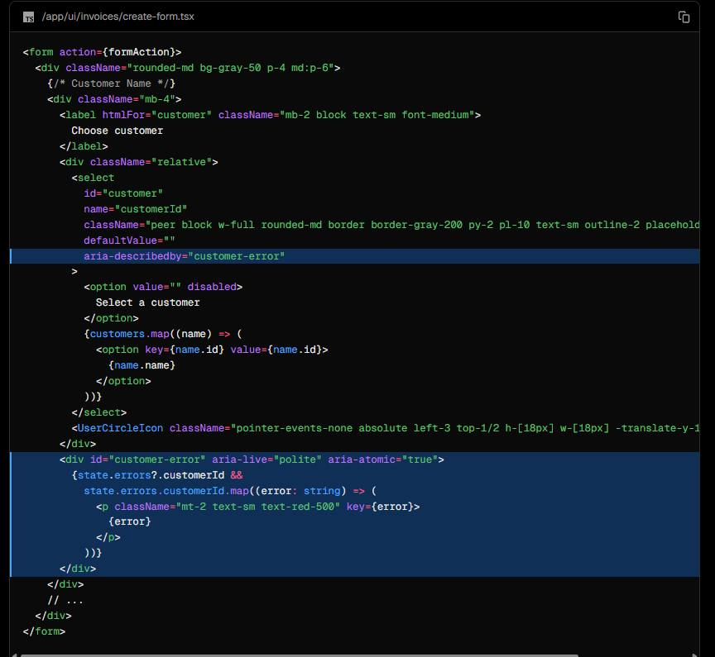
In the code above, you're also adding the following aria labels:
- aria-describedby="customer-error": This establishes a relationship between the select element and the error message container. It indicates that the container with id="customer-error" describes the select element. Screen readers will read this description when the user interacts with the select box to notify them of errors.
- id="customer-error": This id attribute uniquely identifies the HTML element that holds the error message for the select input. This is necessary for aria-describedby to establish the relationship.
- aria-live="polite": The screen reader should politely notify the user when the error inside the div is updated. When the content changes (e.g. when a user corrects an error), the screen reader will announce these changes, but only when the user is idle so as not to interrupt them.

Chapter 14

Adding Authentication

WHAT IS AUTHENTICATION?
Authentication is a key part of many web applications today. It's how a system checks if the user is who they say they are.
A secure website often uses multiple ways to check a user's identity. For instance, after entering your username and password, the site may send a verification code to your device or use an external app like Google Authenticator. This 2-factor authentication (2FA) helps increase security. Even if someone learns your password, they can't access your account without your unique token.
Authentication vs. Authorization
In web development, authentication and authorization serve different roles:
- Authentication is about making sure the user is who they say they are. You're proving your identity with something you have like a username and password.
- Authorization is the next step. Once a user's identity is confirmed, authorization decides what parts of the application they are allowed to use.

So, authentication checks who you are, and authorization determines what you can do or access in the application.
Chapter 15

Adding Metadata
Metadata is crucial for SEO and shareability. In this chapter, we'll discuss how you can add metadata to your Next.js application.
What is metadata?
In web development, metadata provides additional details about a webpage. Metadata is not visible to the users visiting the page. Instead, it works behind the scenes, embedded within the page's HTML, usually within the <head> element. This hidden information is crucial for search engines and other systems that need to understand your webpage's content better.
Why is metadata important?
Metadata plays a significant role in enhancing a webpage's SEO, making it more accessible and understandable for search engines and social media platforms. Proper metadata helps search engines effectively index webpages, improving their ranking in search results. Additionally, metadata like Open Graph improves the appearance of shared links on social media, making the content more appealing and informative for users.
Types of metadata
There are various types of metadata, each serving a unique purpose. Some common types include:
Title Metadata: Responsible for the title of a webpage that is displayed on the browser tab. It's crucial for SEO as it helps search engines understand what the webpage is about.
<title>Page Title</title>
Description Metadata: This metadata provides a brief overview of the webpage content and is often displayed in search engine results.
<meta name="description" content="A brief description of the page content." />
Keyword Metadata: This metadata includes the keywords related to the webpage content, helping search engines index the page.
<meta name="keywords" content="keyword1, keyword2, keyword3" />
Open Graph Metadata: This metadata enhances the way a webpage is represented when shared on social media platforms, providing information such as the title, description, and preview image.
<meta property="og:title" content="Title Here" /><meta property="og:description" content="Description Here" /><meta property="og:image" content="image_url_here" />
Favicon Metadata: This metadata links the favicon (a small icon) to the webpage, displayed in the browser's address bar or tab.
<link rel="icon" href="path/to/favicon.ico" />
Adding metadata
Next.js has a Metadata API that can be used to define your application metadata. There are two ways you can add metadata to your application:
- Config-based: Export a static metadata object or a dynamic generateMetadata function in a layout.js or page.js file.
- File-based: Next.js has a range of special files that are specifically used for metadata purposes:
- favicon.ico, apple-icon.jpg, and icon.jpg: Utilized for favicons and icons
- opengraph-image.jpg and twitter-image.jpg: Employed for social media images
- robots.txt: Provides instructions for search engine crawling
- sitemap.xml: Offers information about the website's structure
You have the flexibility to use these files for static metadata, or you can generate them programmatically within your project.
With both these options, Next.js will automatically generate the relevant <head> elements for your pages.

FAVICON AND OPEN GRAPH IMAGE
In your /public folder, you'll notice you have two images: favicon.ico and opengraph-image.jpg.
Move these images to the root of your /app folder.
After doing this, Next.js will automatically identify and use these files as your favicon and OG image. You can verify this by checking the <head> element of your application in dev tools.
Good to know: You can also create dynamic OG images using the ImageResponse constructor.

PAGE TITLE AND DESCRIPTIONS
You can also include a metadata object from any layout.js or page.js file to add additional page information like title and description. Any metadata in layout.js will be inherited by all pages that use it.
The Next.js Metadata API is powerful and flexible, giving you full control over your application's metadata. Here, we've shown you how to add some basic metadata, but you can add multiple fields, including keywords, robots, canonical, and more. Feel free to explore the documentation, and add any additional metadata you want to your application.

