CUSTOMER REVIEW SENTIMENT ANALYSIS
Power BI Data Analysis & Dashboard Project
Submitted by: Tebogo Rakoto
1. Project Overview
This project analyses customer review data to identify review trends, customer sentiment, product-category performance, purchasing channels and the distribution of reviews across customer cities. The analysis was developed in Microsoft Power BI and presented as an interactive dashboard.
2. Project Objectives
- Analyse the number of customer reviews over time.
- Compare reviews across purchase channels.
- Identify cities with higher and lower numbers of reviews.
- Analyse customer sentiment as Positive, Negative and Neutral.
- Compare average ratings across product categories.
- Analyse sentiment by product category.
- Present the findings in a clear and professional Power BI dashboard.
3. Tools and Technologies Used
- Microsoft Power BI Desktop – data visualisation and dashboard development.
- Power Query – data preparation and transformation.
- DAX / Power BI calculations – analytical calculations where applicable.
- Excel / CSV – customer review dataset.
- Visual Studio Code – source-code/project files where applicable.
- GitHub – hosting and sharing source-code/project files.
4. Dataset
The dataset contains 400 customer review records. Key fields include Customer City, Customer ID, Customer Review, Product, Product Category, Purchase Channel, Rating, Review Date, Review ID and Sentiment.
5. Dashboard Components
Number of Review Over Time: Shows how review volume changes over the review period.
Review by Purchase Channel: Compares Website and Mobile App review volumes.
Reviews by Customer City: Compares review volume across customer cities.
Customer Sentiment Distribution: Shows Positive, Negative and Neutral review proportions.
Average Rating by Product Category: Compares average ratings across product categories.
Product Category Sentiment Analysis: Compares sentiment across product categories.
6. Key Findings
- The dashboard contains 400 customer reviews in total.
- Positive sentiment is dominant, with 291 positive reviews (72.75%).
- Negative sentiment accounts for 79 reviews (19.75%).
- Neutral sentiment accounts for 30 reviews (7.50%).
- Website reviews are higher than Mobile App reviews.
- Pretoria has the highest displayed review volume, while Durban has the lowest.
- Positive sentiment is the largest sentiment category across the displayed product categories.
- The dashboard supports further investigation of customer experience by product, city and purchase channel.

7. Final Power BI Dashboard
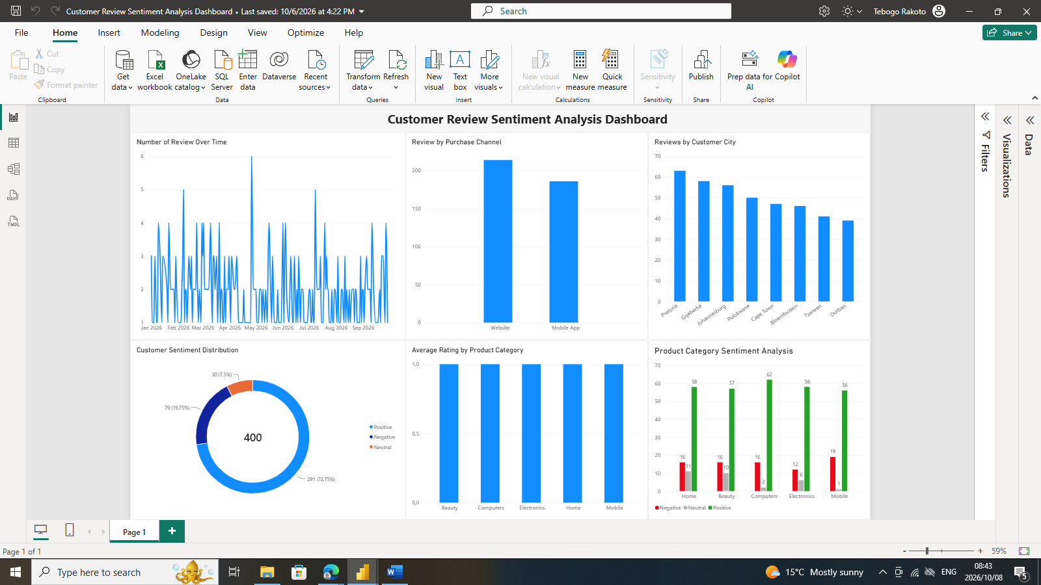
Figure 1: Final Customer Review Sentiment Analysis Dashboard
8. Project and Source-Code Links
The Power BI dashboard was created in Power BI Desktop. Visual Studio Code can be used to edit supporting project files, while GitHub provides a shareable repository link for source code.
GitHub Repository: https://github.com/Tebogo16299/customer-review-sentiment-analysis
Power BI File:ecommerce_customer_review\Customer Review Sentiment Analysis Dashboard.pbix
Visual Studio Code Project: ecommerce_customer_review\sentiment_analysis.py

9. Submission Contents
- Project report/document.
- Power BI Dashboard (.pbix).
- Source dataset, where permitted.
- Source-code/project files, where applicable.
- GitHub repository link.
- Final dashboard screenshot.

10. Conclusion
This project demonstrates practical data-analysis and business-intelligence skills by transforming customer review data into an interactive Power BI dashboard. It demonstrates data preparation, visualisation, sentiment analysis and the communication of business insights.

