

FACULTY
OF
INFORMATION
AND
COMMUNICATION TECHNOLOGY

NATIONAL DIPLOMA: COMPUTER SYSTEMS ENGINEERING

USER MANUAL – VERSION 2.0

SUBJECT NAME: Project Design 376

SUBJECT CODE: PD2316D

PROJECT TITLE: Smart Registration System for Exam Venue Access Based on Face Recognition

LECTURER NAME: Muwanguzi Mark Ntume and Chunling Du

STUDENTS NAME: TC Mance

STUDENTS NUMBER: 222138469

EMAIL ADDRESS: 222138469@tut4life.ac.za

CONTACT NUMBER: 063 392 8361

SUBMISSION DATE: 5 November 2026
TABLE OF CONTENTS
List of Figures and Tables 3
List of Figures 3
List of Tables 4
1. Scope 5
1.1 Identification 5
1.2 System overview 5
1.3 Document overview 6
2. Referenced Documents 7
3. Software Summary 7
3.1 Software application 7
3.2 Software inventory 8
3.3 Software environment 9
3.4 Software organisation and overview of operation 9
3.4.1 Logical components (user's point of view) 9
3.4.2 Performance characteristics 9
3.4.3 Relationship to other systems and people 10
3.4.4 Supervisory and security controls 10
3.5 Contingencies and alternate modes of operation 10
3.6 Security and privacy 11
3.7 Assistance and problem reporting 11
4. Access to the Software 12
4.1 First-time user 12
4.1.1 Access control 12
4.1.2 Installation and setup 12
4.2 Initiating procedure (exam day) 14
4.3 Description of inputs 15
4.3.1 Input conditions 15
4.3.2 Input formats 16
4.3.3 Composition rules 16
4.3.4 Input vocabulary 16
4.3.5 Sample inputs 17
4.4 Description of outputs 17
4.4.1 General description 17
4.4.2 Output formats at the door 17
4.4.3 Sample outputs 18
4.5 Recovery and error correction 19
4.6 Stopping and suspending work 19
5. Processing Reference Guide 20
5.1 Capabilities 20
5.2 Conventions 20
5.3 Processing procedures 20
5.3.1 Sign in and sign out 20
5.3.2 Manage venues (administrator) 21
5.3.3 Manage door units (administrator) 21
5.3.4 Enrol a student 22
5.3.5 Students and modules 24
5.3.6 Book an exam 25
5.3.7 Run the door unit 28
5.3.8 Handle a denied student or a "No seat" flag (manual override) 28
5.3.9 Accounts (administrator) 29
5.3.10 E-mail log 29
5.3.11 Replace a door PC (administrator) 30
5.4 Related processing (background tasks) 30
5.5 Data backup 30
5.6 Recovery from errors, malfunctions and emergencies 31
5.7 Messages 31
5.8 Quick-reference guide 31
6. Query Procedures 32
6.1 Database and data file format 33
6.2 Query capabilities 34
6.3 Query preparation 34
6.4 Control instructions 35
7. Notes 35
7.1 Acronyms and abbreviations 35
7.2 Known limitations 35
7.3 Document history 36
7.4 Summary 36
7.5 Figure sources 36
8. References 36
Appendix A: Hardware Guide 37
A.1 Parts list 37
A.2 Wiring 37
A.3 Power-up and shutdown 38
A.4 Mounting and positioning 38
A.5 Hardware test 38
A.6 Care and maintenance 38
Appendix B: Door Program Settings 38
Appendix C: Database Creation 39

List of Figures and Tables

List of Figures
Figure 1: System context: door unit, backend, database and SRS Console 6
Figure 2: UML use case diagram: who can do what 8
Figure 3: SRS Console sign-in screen 12
Figure 4: UML deployment diagram: where each part runs 13
Figure 5: Exam-day procedure 15
Figure 6: Student enrolment screen 16
Figure 7: UML state machine of the door unit with its LCD messages 17
Figure 8: Dashboard with live statistics, students recognised now and exam bookings 18
Figure 9: Troubleshooting at the door 19
Figure 10: SRS Console menu map 20
Figure 11: Venues and devices 21
Figure 12: Device page with the hidden device key and its enrolled students 22
Figure 13: UML sequence diagram: enrolling a student 23
Figure 14: Student list with search and filters 24
Figure 15: Modules 25
Figure 16: Exam bookings 26
Figure 17: Exam calendar 26
Figure 18: Exam sessions, once-per-session entry and automatic sign-out 27
Figure 19: UML sequence diagram: booking an exam, e-mails and automatic sign-out 27
Figure 20: UML activity diagram: what happens when a student walks up 28
Figure 21: Accounts (administrators only) 29
Figure 22: Email log 30
Figure 23: UML class diagram of the database (11 tables) 33
Figure 24: Door unit wiring 37

List of Tables
Table 1: System identification 5
Table 2: System parts 5
Table 3: Readers of this manual 6
Table 4: Referenced documents 7
Table 5: Software inventory 8
Table 6: Software environment 9
Table 7: Logical components 9
Table 8: Performance characteristics 10
Table 9: Operating modes 10
Table 10: What is stored and where 11
Table 11: Assistance 11
Table 12: Backend settings 14
Table 13: Exam-day steps 15
Table 14: Input conditions 15
Table 15: Enrolment fields 16
Table 16: Status words 16
Table 17: Outputs 17
Table 18: Door results 18
Table 19: Sample dashboard rows (demo data) 18
Table 20: Problems and what to do 19
Table 21: Conventions 20
Table 22: Background tasks 30
Table 23: Messages 31
Table 24: Main tables 34
Table 25: Acronyms and abbreviations 35
Table 26: Document history 36
Table 27: Door unit parts 37
Table 28: Wiring (Arduino Mega) 37
Table 29: config.ini and command-line options 38

1. Scope

1.1 Identification
Table 1: System identification
Item | Detail
System | Smart Registration System for Exam Venue Access Based on Face Recognition
Abbreviation | SRS
Web application name | SRS Console
Version / release | v2.0 / November 2026 (replaces v1.0 of 8 October 2026)
Software this manual covers | (1) PC door program (srs_pc_app.py) and Arduino door unit sketch (srs_door.ino)  (2) Backend server (REST API)  (3) Web application (SRS Console)
Operating platforms | SRS Console: any current desktop or tablet browser · Backend: Node.js 24 on Render · Database: PostgreSQL on Neon · Door program: Windows PC with Python 3 and OpenCV · Door unit: Arduino Mega 2560 (Uno/Nano also work)

1.2 System overview
Purpose. During exams, invigilators normally check attendance registers and student cards by eye. This disturbs students who are writing, and an impersonator can be missed. The SRS replaces the visual check with an automatic face check at the exam venue entrance and keeps a record of every attempt.
How it works in one paragraph. A door unit stands at the venue entrance: a Windows PC with a USB webcam and a small Arduino box with a distance sensor, an LCD screen and a buzzer. When a student stands 25–50 cm from the sensor and holds still for one second, the PC takes the picture and compares the face with the faces enrolled on that PC. A recognised student is let in once per exam session: the LCD shows ACCESS GRANTED and the PC window shows the student's seat number and module, or warns that the student has no seat in this session. An unknown face gets ACCESS DENIED, and the invigilator checks the student card by hand. Every decision appears on the live dashboard of the SRS Console.
Table 2: System parts
Part | What it is | Who uses it
Door unit | Windows PC + USB webcam running the PC door program; Arduino Mega with HC-SR04 distance sensor, 16×2 LCD and buzzer | Students stand in front of it; invigilators set it up and start it
Backend server | Node.js + Express REST API on Render with a PostgreSQL database on Neon | Used automatically by the door unit and the console
SRS Console | Browser-based web app (React) on Vercel | Invigilators and administrators
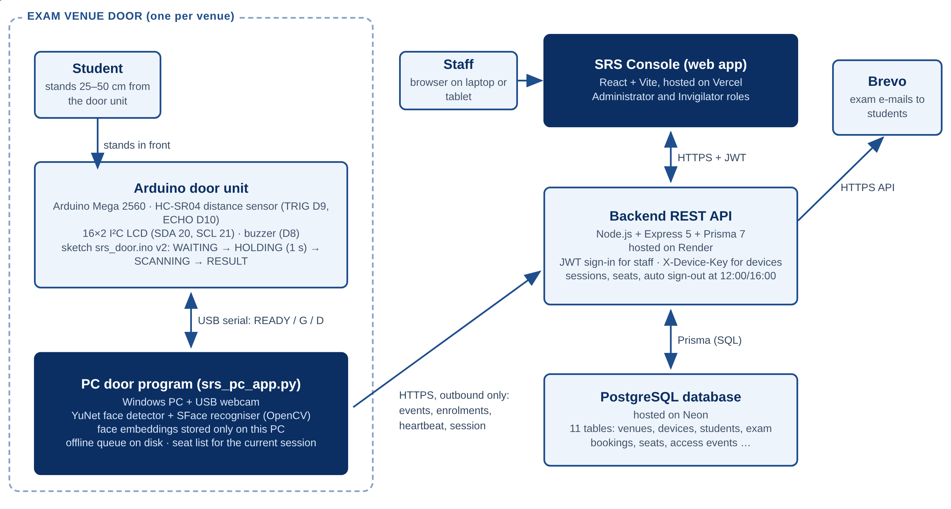
Figure 1: System context: door unit, backend, database and SRS Console
How to read this figure. Boxes are parts of the system; arrows show who talks to whom. The door unit only sends requests out to the backend (it never receives calls), and the SRS Console only talks to the backend, never to the door unit.
Development, sponsor and users. The system was designed and built by the student named on the cover page as the final project of Project Design 376 (PD2316D) at the Tshwane University of Technology (TUT). The intended users are TUT exam invigilators and the administrator who runs the system. The system supports many venues and door units. It does not connect to the university's student information system, so students, modules and exams are entered in the SRS Console.
History. The approved proposal (R1) defined the problem; the design document (R2) fixed a three-part architecture with an ESP32-CAM door device; manual v1.0 described that design. Because of hardware problems with the ESP32-CAM, the door device was rebuilt as a PC + webcam + Arduino door unit. This manual (v2.0) documents that final system.

1.3 Document overview
This manual explains how to set up, operate, monitor and recover the SRS. It is written for two groups of readers.
Table 3: Readers of this manual
Reader | What they do | Read these parts
Invigilator (non-technical) | Signs in, enrols students, starts the door unit, watches the dashboard, handles denied students | Sections 3.1, 4.1, 4.2 to 4.6, 5.3 and the Quick-Start Card in 5.8
Administrator (technical) | Deploys the backend and console, sets up door PCs and Arduinos, manages venues, devices, accounts and backups | Sections 4.1.2 Part B, 3.6, 5.5, 6 and Appendices A to C
Security and privacy of this manual. This manual contains no passwords, device keys or database connection strings. Screenshots use demonstration data only. See Section 3.6 for the privacy rules of the system itself.

2. Referenced Documents
Table 4: Referenced documents
No. | Title | Version / date | Source
R1 | Project Proposal: Smart Registration System for Exam Venue Access | v5, 20 Aug 2026 | Student, via Brightspace
R2 | Design Documentation: Smart Registration System | Sep 2026 | Student, via Brightspace
R3 | User Manual v1.0 | 8 Oct 2026 | Student
R4 | Final Project Report: Smart Registration System | Nov 2026 | Student
R5 | Project Design 376 / Industry Exposure Student Course Guide (PD2316D) | Jul 2025 | Du, C. and Muwanguzi Ntume, M., TUT
R6 | Device API (DEVICE_API.md) and READMEs in the source repository | Current | github.com/TebogoClifford/Smart_Registration_System
R7 | OpenCV Zoo: YuNet face detector and SFace face recogniser | Current | https://github.com/opencv/opencv_zoo
R8 | Arduino Mega 2560 Rev3 documentation | Current | https://docs.arduino.cc/hardware/mega-2560/
R9 | HC-SR04 ultrasonic ranging module datasheet | – | Module vendor (ElecFreaks)
R10 | Protection of Personal Information Act 4 of 2013 (POPIA) | 2013 | Government of South Africa
R11 | Information Regulator Guidance Note on Processing of Special Personal Information | 28 Jun 2021 | https://inforegulator.org.za
R12 | PostgreSQL 16 documentation; Prisma ORM documentation | Current | postgresql.org/docs · prisma.io/docs

3. Software Summary

3.1 Software application
Intended use. To verify, at the entrance of an exam venue, that a person presenting for an exam is an enrolled student, to show their seat for the session, and to keep an auditable record of every attempt.
Capabilities.
- Automatic face check, taken only when the student holds still 25–50 cm from the door unit for one second.
- Each student is let in once per exam session; a second scan shows ALREADY INSIDE.
- Seat number and module shown on the PC window; students with no seat in the session are flagged "No seat" on the dashboard.
- Automatic sign-out of everyone at 12:00 and 16:00, when the morning and afternoon sessions end.
- Live dashboard of all decisions, with an Override button that records manual decisions, and CSV export.
- Enrolment of a student's face from the SRS Console, carried out at the door unit.
- Modules, exam hall bookings with automatic seat allocation within the venue capacity, and an exam calendar.
- E-mails to students when an exam is booked, moved or cancelled, with an e-mail log.
- Staff accounts with two roles (administrator, invigilator) and secure sign-in.
- Keeps working when the internet drops: decisions continue and are uploaded later, never twice.
Expected benefits. Fewer interruptions to students during the exam, less reliance on an invigilator's eyesight, seat information at the door, and a reviewable record of who entered and when.
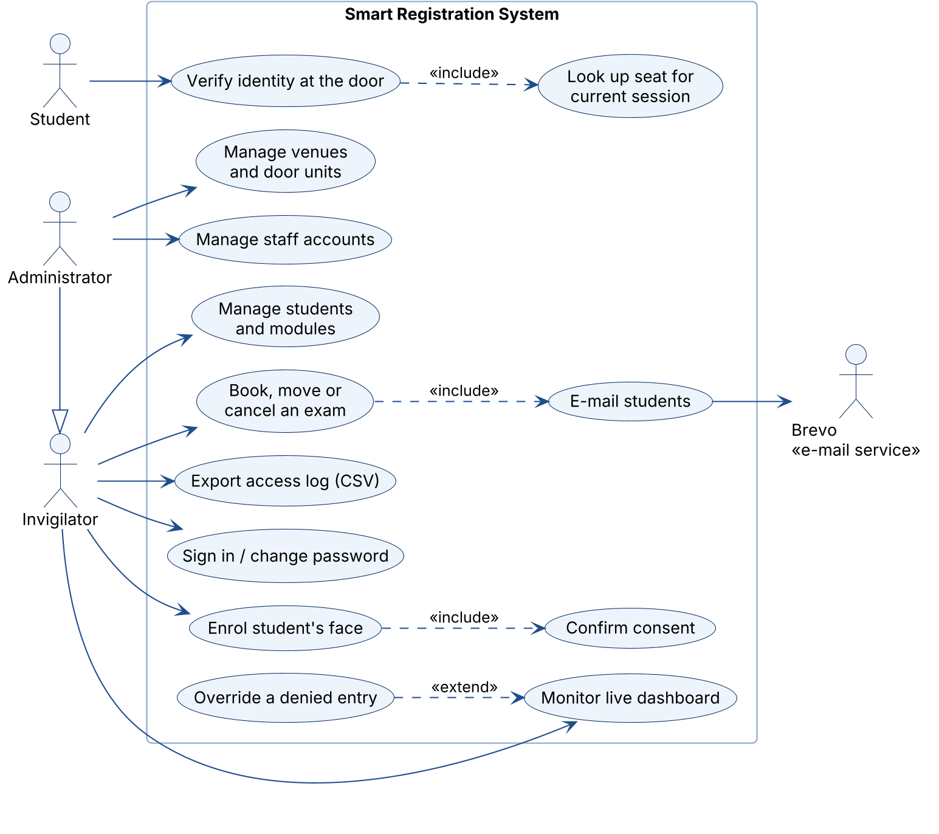`
Figure 2: UML use case diagram: who can do what
How to read this figure. Stick figures are actors (people or outside systems); ellipses inside the box are the things the system lets them do. The hollow-triangle arrow means an Administrator can do everything an Invigilator can. «include» marks a step that always happens as part of another; «extend» marks an optional step.

3.2 Software inventory
Table 5: Software inventory
Item | Where it runs or lives | Sensitive? | Needed to continue in an emergency?
PC door program (Python, OpenCV) | Door PC, folder pc_device | No | Yes: the source and the two model files
Face models (YuNet, SFace, ~39 MB) | Door PC, pc_device/models | No | Yes: re-download with download_models.py
Face embeddings + enrolment photos | Door PC, pc_device/data/embeddings and data/photos | Yes (biometric) | Yes, or re-enrol the students
Offline event queue | Door PC, pc_device/data/event_queue.json | Yes (student IDs) | Uploaded automatically when online
Arduino sketch (srs_door.ino v3) | Arduino flash memory | No | Yes: re-upload from the source
Backend (Node.js, Express, Prisma) | Render web service | No (code); settings are secret | Yes
Database (PostgreSQL) | Neon | Yes (students, e-mails, access log, photos) | Yes: restore from backup (5.5)
SRS Console (React) | Vercel | No | Yes
Secrets | Render settings; config.ini on each door PC | Yes | Yes: keep a secure offline copy
Definitions. An embedding is a list of 128 numbers that represents a face so two faces can be compared. A device key is the secret password a door unit sends with every request so the backend knows it is genuine.
Continuing in an emergency. If any part is unavailable, exam entry continues by manual card checking. No exam depends on the SRS working.

3.3 Software environment
Table 6: Software environment
Requirement | Detail
Invigilator computer | A laptop, desktop or tablet with a current web browser and internet. Nothing to install.
Door PC | Windows 10 or 11 PC or laptop; Python 3 with the packages in pc_device/requirements.txt (opencv-python, numpy, requests, pyserial); free USB ports for the webcam and Arduino.
Webcam | Any USB webcam (720p or better). With camera = auto the highest-numbered camera is used, normally the USB webcam.
Door unit | Arduino Mega 2560 (or Uno/Nano), HC-SR04 sensor, 16×2 LCD with I²C backpack, passive or active buzzer (Appendix A).
Power | Mains power for the PC; the Arduino is powered from the PC's USB port. No batteries.
Network | Internet access from the door PC (outbound HTTPS only, any network). If Wi-Fi drops, events are queued and sent later.
Hosting (administrator) | Render account (backend), Neon account (database), Vercel account (console), optional Brevo account (e-mails).
Manual procedures | Student card check for denied students and students with no seat; student consent before enrolment.

3.4 Software organisation and overview of operation

3.4.1 Logical components (user's point of view)
Table 7: Logical components
Component | What the user sees
Door unit – LCD and buzzer | Instructions (come closer, hold still) and the result with a beep pattern (4.4.2)
Door unit – PC window | Camera view, result banner with name, seat and module, seat list for the session, enrolment in progress, Hardware panel
SRS Console | Dashboard, Venues & Devices, Students (list, enrolment, modules), Exam (bookings, calendar, e-mail log), Accounts, My account
Records | Venues, devices, students, modules, bookings, seats, access events, overrides, e-mails and staff accounts in one database

3.4.2 Performance characteristics
Values come from the program settings and from the benchmark in the final report (R4).
Table 8: Performance characteristics
Characteristic | Value
Capture distance window | 25–50 cm, held still for 1 second
Recognition time (detect + embed + compare) | ≈ 16 ms per 640×480 frame on a 2.1 GHz processor
Frames that must agree before a decision | 3 in a row
Recognition accuracy (public LFW benchmark, threshold 0.40) | 98.6%
False Acceptance Rate (stranger accepted) | 0.03% (1:1); about 1.8% when compared with 100 enrolled faces
False Rejection Rate (enrolled student refused) | 2.8%
Same student logged again at most every | 15 s without the Arduino (60 s when already inside or session ended); with the Arduino every scan is logged
Enrolment | 5 shots averaged; fails after 60 s without a good face
Door program checks for enrolments | every 3 s; session list refreshed every 2 minutes and at 12:00 / 16:00
Dashboard refresh | every 15 s; "Recognised now" panel every 3 s
Device shown Online | if it was heard from in the last 120 s
Offline queue upload | batches of up to 100 events
Factors that reduce accuracy | strong light behind the student, caps, sunglasses or masks, wrong distance, a face enrolled on another door unit
Polling means a program repeatedly asks the server "anything new?" at a fixed interval. It was chosen over pushed updates because it is simple and works through any router or firewall.

3.4.3 Relationship to other systems and people
The SRS is not connected to the university's student information system; students, modules and bookings are entered in the SRS Console. The invigilator remains responsible for the final decision at the door. The SRS supports that decision; it does not replace it.

3.4.4 Supervisory and security controls
- Staff sign in with e-mail and password. Accounts are created only by an administrator.
- New accounts and reset passwords get a temporary password that must be changed at first sign-in (at least 8 characters).
- After 5 failed sign-ins the account is blocked for 15 minutes. A sign-in lasts 12 hours.
- Administrators manage venues, devices, device keys and accounts. Invigilators cannot see device keys or the Accounts page.
- Each door unit sends its secret device key with every request; the backend refuses unknown devices.
- Only the administrator can reach the database and hosting settings.

3.5 Contingencies and alternate modes of operation
Table 9: Operating modes
Mode | When it happens | What still works | What to do
Normal | Door unit, internet and backend available | Everything | Follow Section 5
Offline door unit | Internet drops at the venue | Face checks continue (faces are on the PC); events queued on disk | Keep admitting; the dashboard catches up when online
Backend asleep | First request after a quiet period (free hosting) | The door unit retries; the console may take up to 60 s to load | Wait a minute; refresh
No Arduino | Arduino unplugged or not connected | The PC scans any face that is big enough on camera; no LCD or beeps | Reconnect in the Hardware panel (5.3.7)
Door unit fault | Camera error, PC crash | Nothing automatic | Switch to manual card checks; see 4.5
Emergency evacuation | Fire or alarm | n/a | Leave the venue first; equipment can be replaced

3.6 Security and privacy
The data is biometric. A face photo and the embedding made from it are biometric information, which section 26 of POPIA treats as special personal information. It may only be processed under specific conditions such as the person's consent (R10, R11). The Enrolment screen therefore requires the tick box "The student has been told why their face is captured and agrees to it" before every enrolment. This manual is not legal advice; the institution's Information Officer should confirm the lawful basis and retention period before use on real students.
Table 10: What is stored and where
Data | Location | Notes
Face embedding | Door PC only (data/embeddings) | Never sent to the backend
One enrolment photo per student | Door PC and database | Shown on the console so staff can check who was enrolled
Student number, name, e-mail, course, modules | Database | Entered in the SRS Console
Access events (time, door unit, student, decision) | Database | Student is empty for unrecognised faces
Overrides (who, why) | Database | Recorded when an invigilator lets in a denied student
Video | Nowhere | The door unit never streams or stores video
Rules for users.
- WARNING: Do not share your sign-in details, and do not leave the console open on an unattended computer.
- Do not photograph or copy the dashboard, enrolment photos, CSV exports or database backups except for exam administration.
- Device keys are secrets: never paste them into chats or e-mails.
- Delete exports and backups when the retention period ends (at the end of the year).

3.7 Assistance and problem reporting
Table 11: Assistance
Problem | Contact | Details
Using the console, accounts, door unit faults | System administrator | Admin Test  admin@srs.dev
Academic or project queries | Mr M. Muwanguzi Ntume (Soshanguve South, room 19-207, 012 382 9693); Prof C. Du (Soshanguve South, room 19-219, 012 382 9943, duc@tut.ac.za) | Book consultations at least three days ahead
When reporting a problem, give the date and time, the venue, what you were doing, what you saw on the screen or LCD, and (for the console) a screenshot with student details hidden.

4. Access to the Software

4.1 First-time user

4.1.1 Access control
- Obtaining an account. An administrator creates your account on the Accounts page and gives you a temporary password. Invigilators cannot register themselves.
- Web address. The SRS Console is at https://smart-registration-system-silk.vercel.app/
- First sign-in. You must choose a new password of at least 8 characters before you can continue.
- Changing your password. My account → Change password. Forgotten password: ask an administrator to reset it (Accounts → Reset password).
- Security reminders. Sign out when you leave the computer. Treat every screenshot, export and printout as confidential.

4.1.2 Installation and setup
Part A: Invigilator (nothing to install). Open a current web browser, type the web address from 4.1.1 and sign in (Figure 3). If the page takes up to a minute the first time, wait: hosting that has been idle needs to wake up.
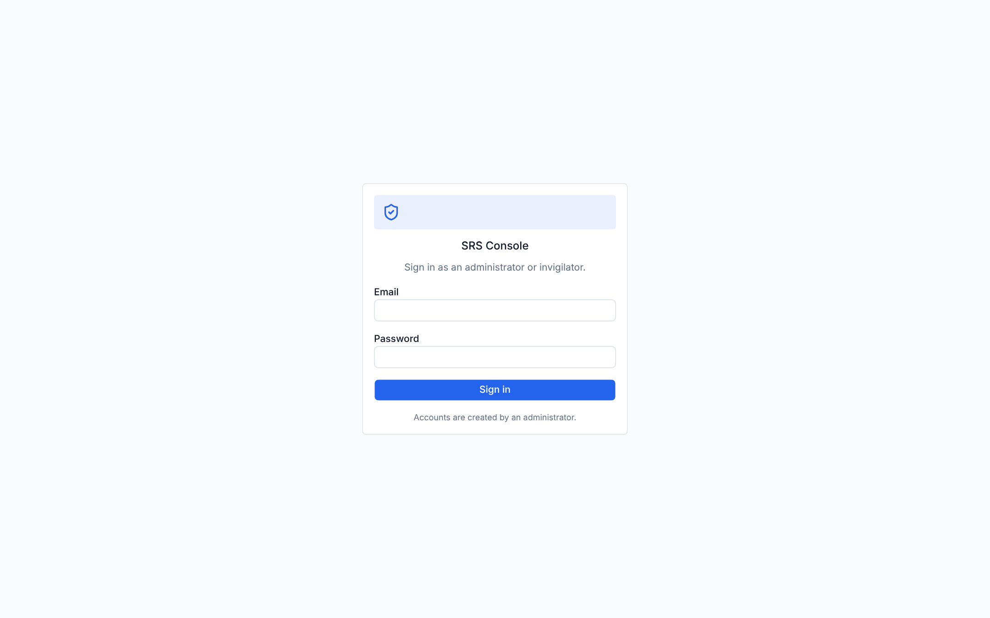
Figure 3: SRS Console sign-in screen
Part B: Administrator (one-time setup). Figure 4 shows where each piece of software is installed. Each step below lists the commands, with what each one does.
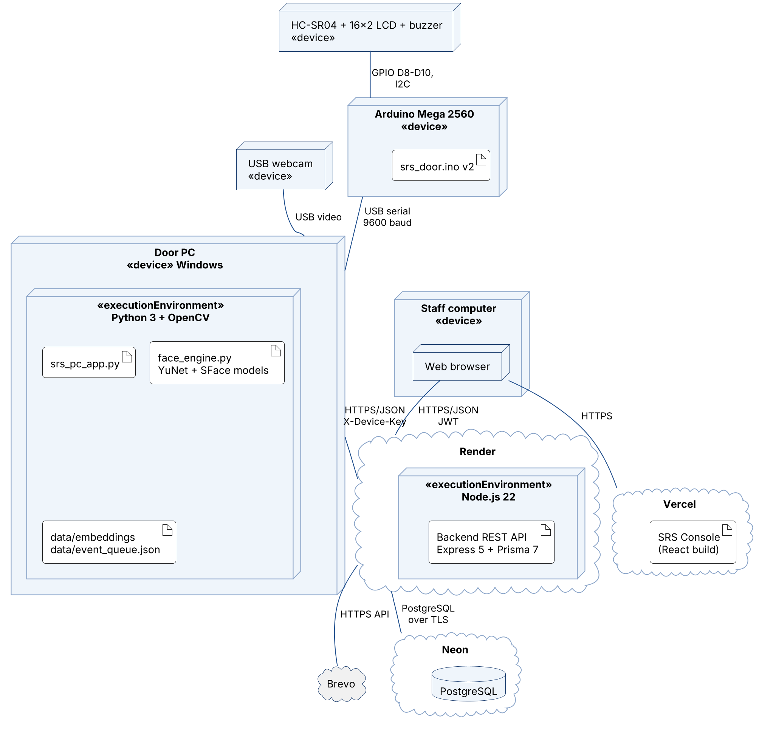
Figure 4: UML deployment diagram: where each part runs
How to read this figure. 3-D boxes are machines or cloud services (nodes); the document shapes inside are the programs and files installed there (artifacts); the lines are the connections, labelled with how they talk (USB, HTTPS, TLS).
B1. Database (Neon). Create a Neon project and copy its connection string (keep it secret). The tables are created automatically by the backend in step B2; no SQL script has to be run.
B2. Backend (Render).
# download the project source code
git clone https://github.com/TebogoClifford/Smart_Registration_System.git
# go into the backend folder
cd Smart_Registration_System/Backend
# install the libraries the backend needs (also generates the Prisma database client)
npm install
# start locally: applies the database migrations (creates the tables), then starts on port 3000
npm start
Settings (environment variables) for the backend, in a .env file locally or in the Render dashboard:
Table 12: Backend settings
Setting | Meaning
DATABASE_URL | Neon connection string (secret)
JWT_SECRET | At least 32 random characters used to sign sign-in tokens (secret)
ADMIN_EMAIL, ADMIN_PASSWORD | The first administrator account, created only when no accounts exist (password 8+ characters)
CORS_ORIGIN | The console's web address, e.g. https://smart-registration-system-silk.vercel.app
BREVO_API_KEY, EMAIL_FROM, EMAIL_MODE | Optional: e-mails to students. Without a key, e-mails are only recorded in the Email log
EXAM_TIMEZONE | Optional, default Africa/Johannesburg
On Render, create a Web Service from the repository with root directory Backend, build command npm install and start command npm start, and add the settings above.
B3. SRS Console (Vercel). Import the repository in Vercel (the root vercel.json builds the web_app folder) and set VITE_API_BASE_URL to the backend address, e.g. https://smart-registration-system.onrender.com.
B4. Door PC (once per door unit).
# go into the door program folder
cd pc_device
# install OpenCV, numpy, requests and pyserial
pip install -r requirements.txt
# download the two face models (~39 MB, checked against known SHA-256 values)
python download_models.py
# make your own settings file, then fill in url, device_id and device_key (Appendix B)
copy config.example.ini config.ini
# test the server address, device key and models without opening the camera
python srs_pc_app.py --check
# open the door window
python srs_pc_app.py
B5. Arduino door unit. Wire the parts as in Appendix A. In the Arduino IDE install the library "LiquidCrystal I2C" (Frank de Brabander), open pc_device/arduino/srs_door/srs_door.ino, choose the board (Arduino Mega or Mega 2560) and port, and upload. Close the IDE's Serial Monitor afterwards (only one program can use the port).
B6. Register the venue and door unit in the console (5.3.2 and 5.3.3), then copy the device id and key into config.ini on the door PC.

4.2 Initiating procedure (exam day)
Figure 5 shows the exam-day procedure; Table 13 gives the steps with the expected result of each.
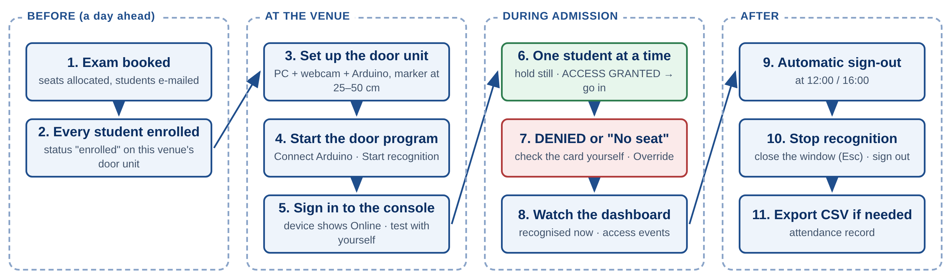
Figure 5: Exam-day procedure
How to read this figure. Read the four groups from left to right (before, at the venue, during admission, after) and the numbered boxes from top to bottom inside each group.
Table 13: Exam-day steps
Step | Action | Expected result
1 | At least a day before: check the exam is booked (Exam → Exam bookings) | Booking listed; e-mails in the Email log (sent once e-mail is set up)
2 | Check every student is enrolled on this venue's door unit (Students → Student list, filter by device) | Status "enrolled"
3 | Set up the door unit: PC on mains, webcam at face height, Arduino connected, floor marker 25–50 cm from the sensor | LCD shows "NOT CONNECTED / Start the PC app" (the door program is not running yet)
4 | Start the door program; in the Hardware panel press Connect; press ▶ Start recognition | LCD: "Smart Register / Step up to scan"; banner: "Stand at the marker and hold still for 1 second"
5 | Sign in to the SRS Console; open Venues & Devices | The door unit shows Online
6 | Test with yourself or a known enrolled student | ACCESS GRANTED on the LCD; a row on the dashboard
7 | Admit students one at a time | One dashboard row per attempt
8 | For ACCESS DENIED or a "No seat" flag, check the student card yourself (5.3.8) | Student admitted or refused by you
9 | When admission closes, stop recognition and close the door program (Esc); sign out of the console | Window closed; sign-in page shown

4.3 Description of inputs

4.3.1 Input conditions
Table 14: Input conditions
Input | Reason | Frequency | Origin | Related inputs
Sign-in details | Prove you are authorised staff | Each session | Staff member | None
Venue name and capacity | Group door units; limit seats | Once per venue | Administrator | None
Device name and venue | Register a door unit | Once per door unit | Administrator | Venue must exist
Student details | Create the student record | Once per student | Invigilator or admin | Venue and device
Module and registrations | Know who writes which exam | Once per module | Staff | Students exist
Exam booking | Book a venue, date and session | Once per exam | Staff | Module, venue capacity
Face capture (enrolment) | Teach the door unit a face | Once per student | Student at the door unit | Student saved first
Face capture (verification) | Decide at the door | Every entry | Student at the door unit | Student enrolled on this unit

4.3.2 Input formats
Enrolment screen (Students → Enrolment, Figure 6):
Table 15: Enrolment fields
Field | What to enter | Limit
Student Number | As printed on the student card | 20 characters
Full Name | As shown on the student card | 100 characters
Email | The student's e-mail; exam bookings, changes and cancellations are e-mailed here | 255 characters
Course (optional) | Choose from the list | n/a
Venue, Device | The venue and the door unit where the student will be checked | n/a
Consent tick box | "The student has been told why their face is captured and agrees to it" | Required
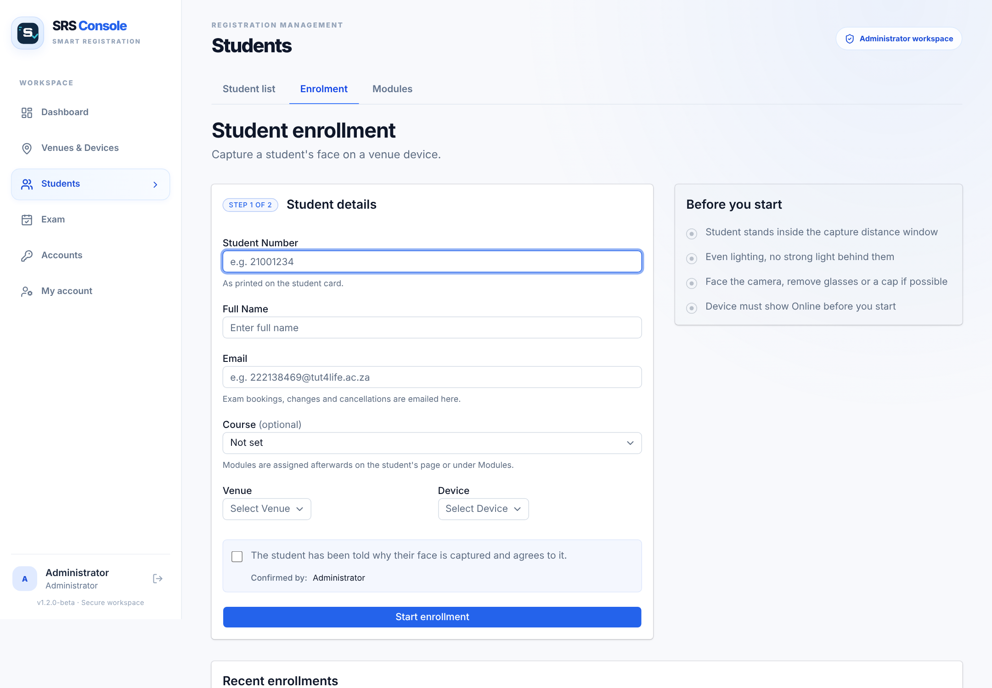
Figure 6: Student enrolment screen

4.3.3 Composition rules
- Student number: letters and digits, no spaces. E-mail: a valid address.
- Capture: one person in front of the camera, face uncovered (no cap peak, mask or sunglasses), looking at the lens, standing at the marker.
- Enrol in lighting similar to the venue entrance, without strong light behind the student.

4.3.4 Input vocabulary
Table 16: Status words
Field | Allowed values | Meaning
Enrolment status | pending, request expired, enrolled, failed | Waiting for the door unit · no door unit collected the request within 10 minutes (press Re-enrol) · face stored · no good capture within 60 s
Device status | Online, Offline | Heard from in the last 120 s, or not
Decision | granted, denied, error, already, ended, signed_out | Let in · unknown face · capture failed · already inside this session · session over · automatic sign-out
Exam session (slot) | 09:00, 13:00 | Morning (ends 12:00) · afternoon (ends 16:00)
Role | admin, invigilator | Administrator · invigilator

4.3.5 Sample inputs
Student Number: 220100037 (sample data only)
Full Name: Lerato Sithole
Email: 220100037@tut4life.ac.za
Venue: Demo Main Hall
Device: Demo Main Hall Camera

4.4 Description of outputs

4.4.1 General description
Table 17: Outputs
Output | Why | Frequency | Where
LCD text + beep | Tell the student the result at once, without waiting for the network | Every scan | Door unit
PC result banner | Name, student number, seat and module for the invigilator | Every scan | Door PC window
Dashboard rows and "Recognised now" | Show every attempt and flag students with no seat | Every scan | SRS Console
Enrolment confirmation | Confirm a student is ready | Once per enrolment | SRS Console
E-mail to student | Exam booked, moved or cancelled | Per booking change | Student's inbox; Email log
CSV export | Attendance record | On demand | Dashboard → Export CSV

4.4.2 Output formats at the door
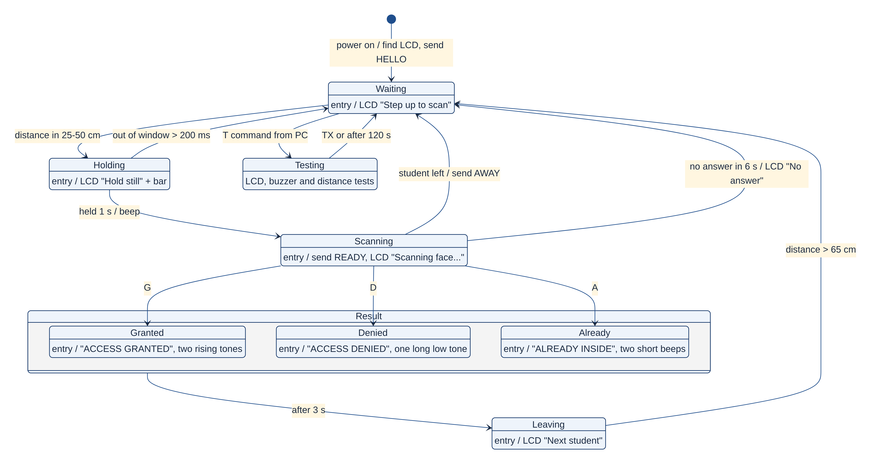
Figure 7: UML state machine of the door unit with its LCD messages
How to read this figure. This is a UML state machine. The black dot is power-on. Each rounded box is a state; "entry /" is what the unit does when it enters that state (the exact LCD text and beep). Each arrow is labelled "event / action": what makes the unit move on, and what it does as it moves. The Result box groups the three possible results.
Table 18: Door results
Result | LCD | Buzzer | PC banner | Meaning
Granted | ACCESS GRANTED / Welcome, go in | Two rising tones | RECOGNISED name · seat N · module (or "no exam seat in this session") | Admit; check the card if there is no seat
Denied | ACCESS DENIED / See invigilator | One long low tone | NOT RECOGNISED – face is not enrolled | Check the student card manually
Already inside | ALREADY INSIDE / Entry recorded | Two short beeps | ALREADY INSIDE name | Was let in earlier this session
Session ended | ACCESS DENIED / See invigilator | One long low tone | SESSION ENDED name · signed out, not let in | Their session is over
No answer | No answer / Please try again | – | – | Student left, or the PC did not answer within 6 s

4.4.3 Sample outputs
Table 19: Sample dashboard rows (demo data)
Time | Device | Student | Decision
08:52:14 | Demo Main Hall Camera | 220100037 Lerato Sithole | Granted
08:52:41 | Demo Main Hall Camera | – | Denied (Override available)
12:00:00 | Demo Main Hall Camera | 220100037 Lerato Sithole | Signed out (session ended)
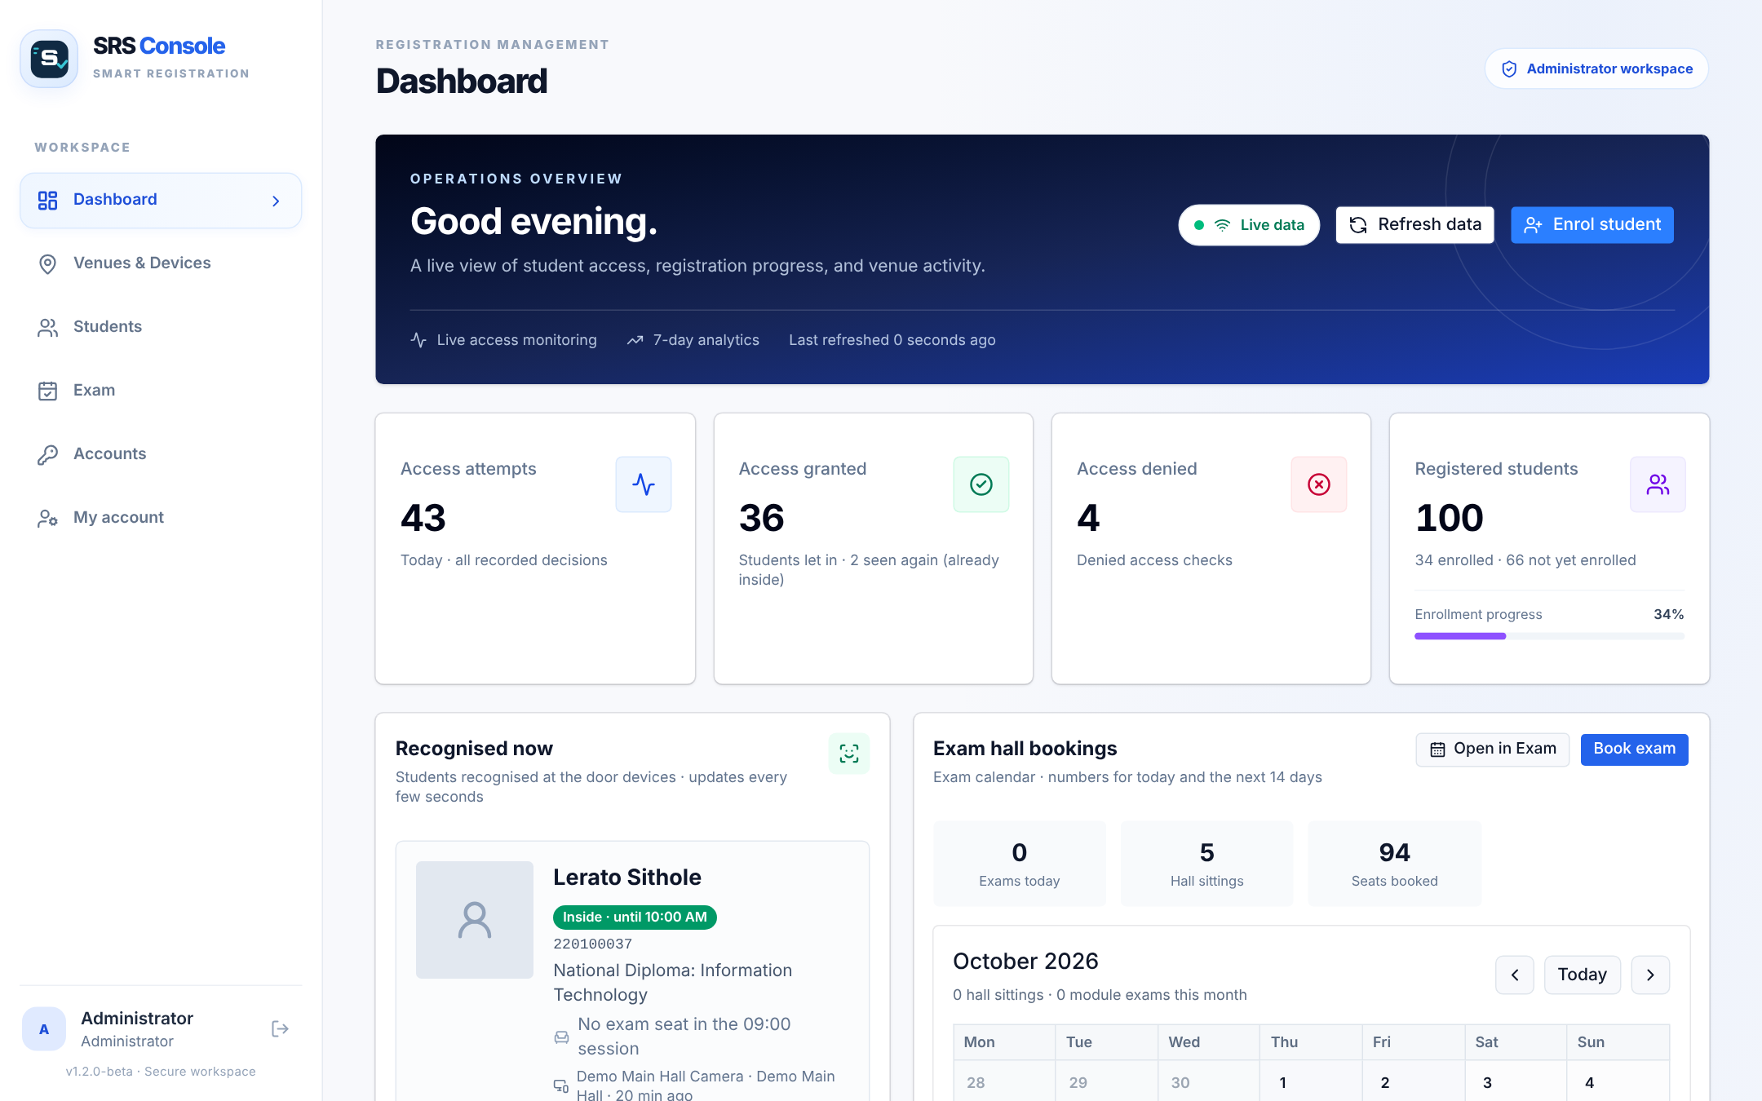
Figure 8: Dashboard with live statistics, students recognised now and exam bookings

4.5 Recovery and error correction
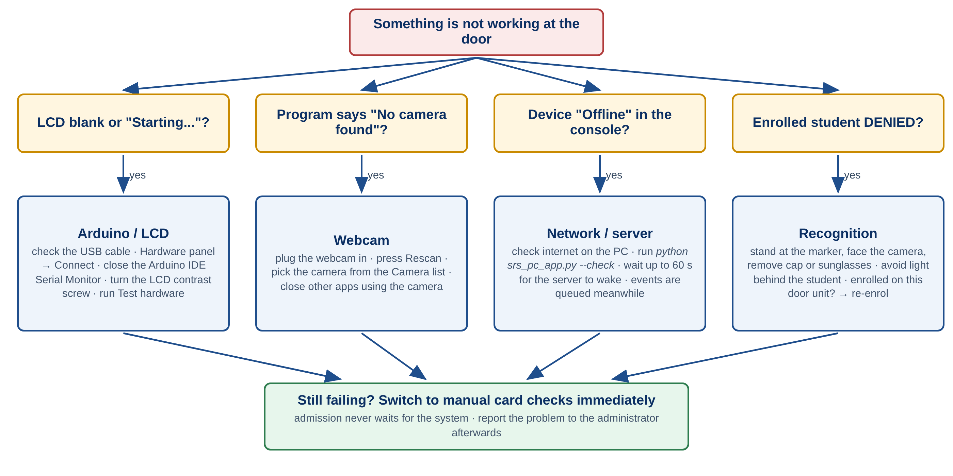
Figure 9: Troubleshooting at the door
How to read this figure. Start at the red box, follow the question that matches what you see, and try the checks in that column. If the problem remains, go to the green box: switch to manual checks.
Table 20: Problems and what to do
Situation | Meaning | What to do
Sign-in fails | Wrong details, or blocked after 5 attempts | Retype; wait 15 minutes; ask an administrator to reset the password
Signed out unexpectedly | The 12-hour sign-in ran out | Sign in again
Door unit shows Offline | Not heard from for 120 s | Check the PC is on, the program is running and the internet works; run --check
LCD shows NOT CONNECTED | The door program is closed or not connected to the Arduino | Start python srs_pc_app.py and press Connect in the Hardware panel
Enrolment stays "Capturing…" | The door unit has not captured yet | Check recognition window is open, the student is at the marker and only one face is in view
Enrolment "Failed" | No good face within 60 s | Improve lighting, remove face coverings, press Try again / Re-enrol
Enrolled student denied | Poor capture, light behind, or enrolled on another door unit | Re-position and try again; re-enrol on this door unit; admit by manual check
"No camera found" | Webcam missing or used by another app | Plug it in, press Rescan, pick it from the Camera list
LCD blank | Contrast, wiring or LCD not found | Turn the contrast screw; run Test hardware (5.3.7)
Event missing from the dashboard | Door unit offline or page not refreshed | Wait 15 s or refresh; queued events appear when the PC is online
Restart and continuity. If anything stops working during admission, switch to manual card checks immediately and fix the SRS later. Entry to the exam must never wait for the system.

4.6 Stopping and suspending work
- Pause admission (e.g. a break): press ■ Stop recognition; the window stays open.
- End of admission: close the door window (or press Esc), then sign out of the console. Events still in the queue are sent the next time the program runs.
- Check it stopped normally: the console returns to the sign-in page; after 120 s the door unit shows Offline.
- Unplug the Arduino and webcam only after the program is closed.

5. Processing Reference Guide

5.1 Capabilities
Figure 10 shows the SRS Console's menu. The first time, work from left to right (venues and devices, students, exams); on exam days use the Dashboard.
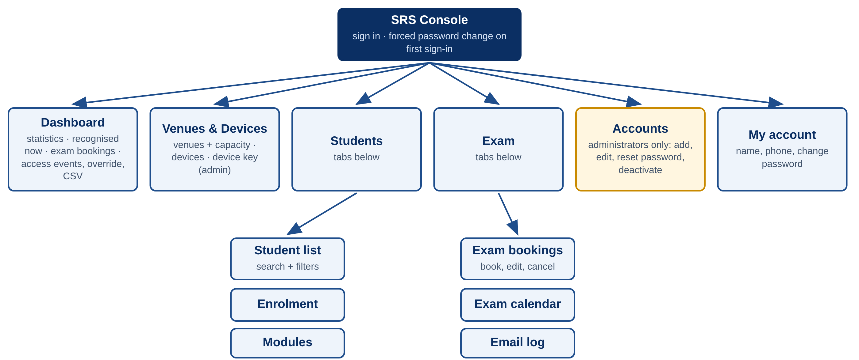
Figure 10: SRS Console menu map
How to read this figure. The top box is the console after sign-in; the second row is the left-hand menu; the bottom boxes are the tabs inside Students and Exam. The yellow Accounts page is visible to administrators only.

5.2 Conventions
Table 21: Conventions
Convention | Meaning
WARNING | Risk of injury, damage or a privacy breach
CAUTION | Risk of losing data or getting a wrong result
monospace | Something you type, or a value stored by the system
Bold menu names | Menu → tab → button, e.g. Students → Enrolment → Start enrolment
Decision colours | Green granted · red denied · orange error · blue already inside · grey signed out

5.3 Processing procedures

5.3.1 Sign in and sign out
1. Open the web address from 4.1.1.
2. Enter your Email and Password and press Sign in.
3. The Dashboard appears.
4. To leave, press the sign-out arrow next to your name at the bottom of the menu; the sign-in page returns.

5.3.2 Manage venues (administrator)
1. Open Venues & Devices.
2. Add a venue with its name (e.g. Exam Hall A) and seat capacity; save.
3. Edit or delete a venue from its page. A venue with door units or exam bookings cannot be deleted.
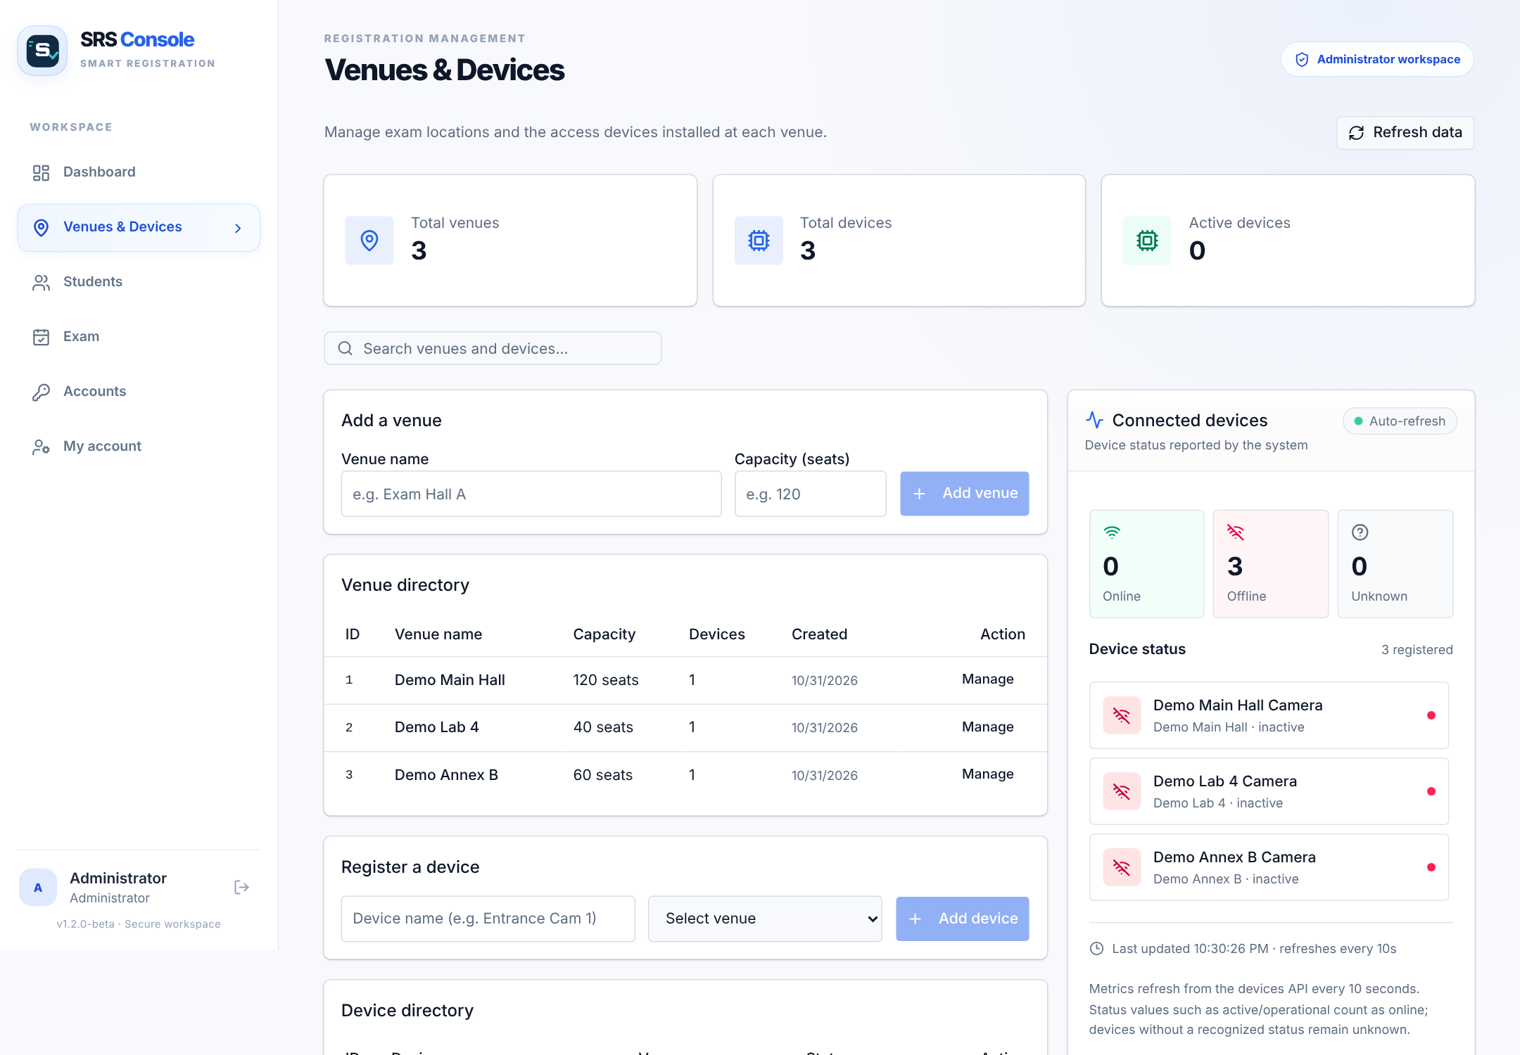
Figure 11: Venues and devices

5.3.3 Manage door units (administrator)
1. In Venues & Devices, add a device with a clear name (e.g. Main Hall Door) and its venue.
2. Open the device (Manage). Press Reveal to see the device key and Copy to copy it into config.ini on the door PC.
3. CAUTION: do not share the key. A device with enrolled students or recorded entries cannot be deleted. If the key may have been seen by someone else, press Replace and copy the new key into config.ini.
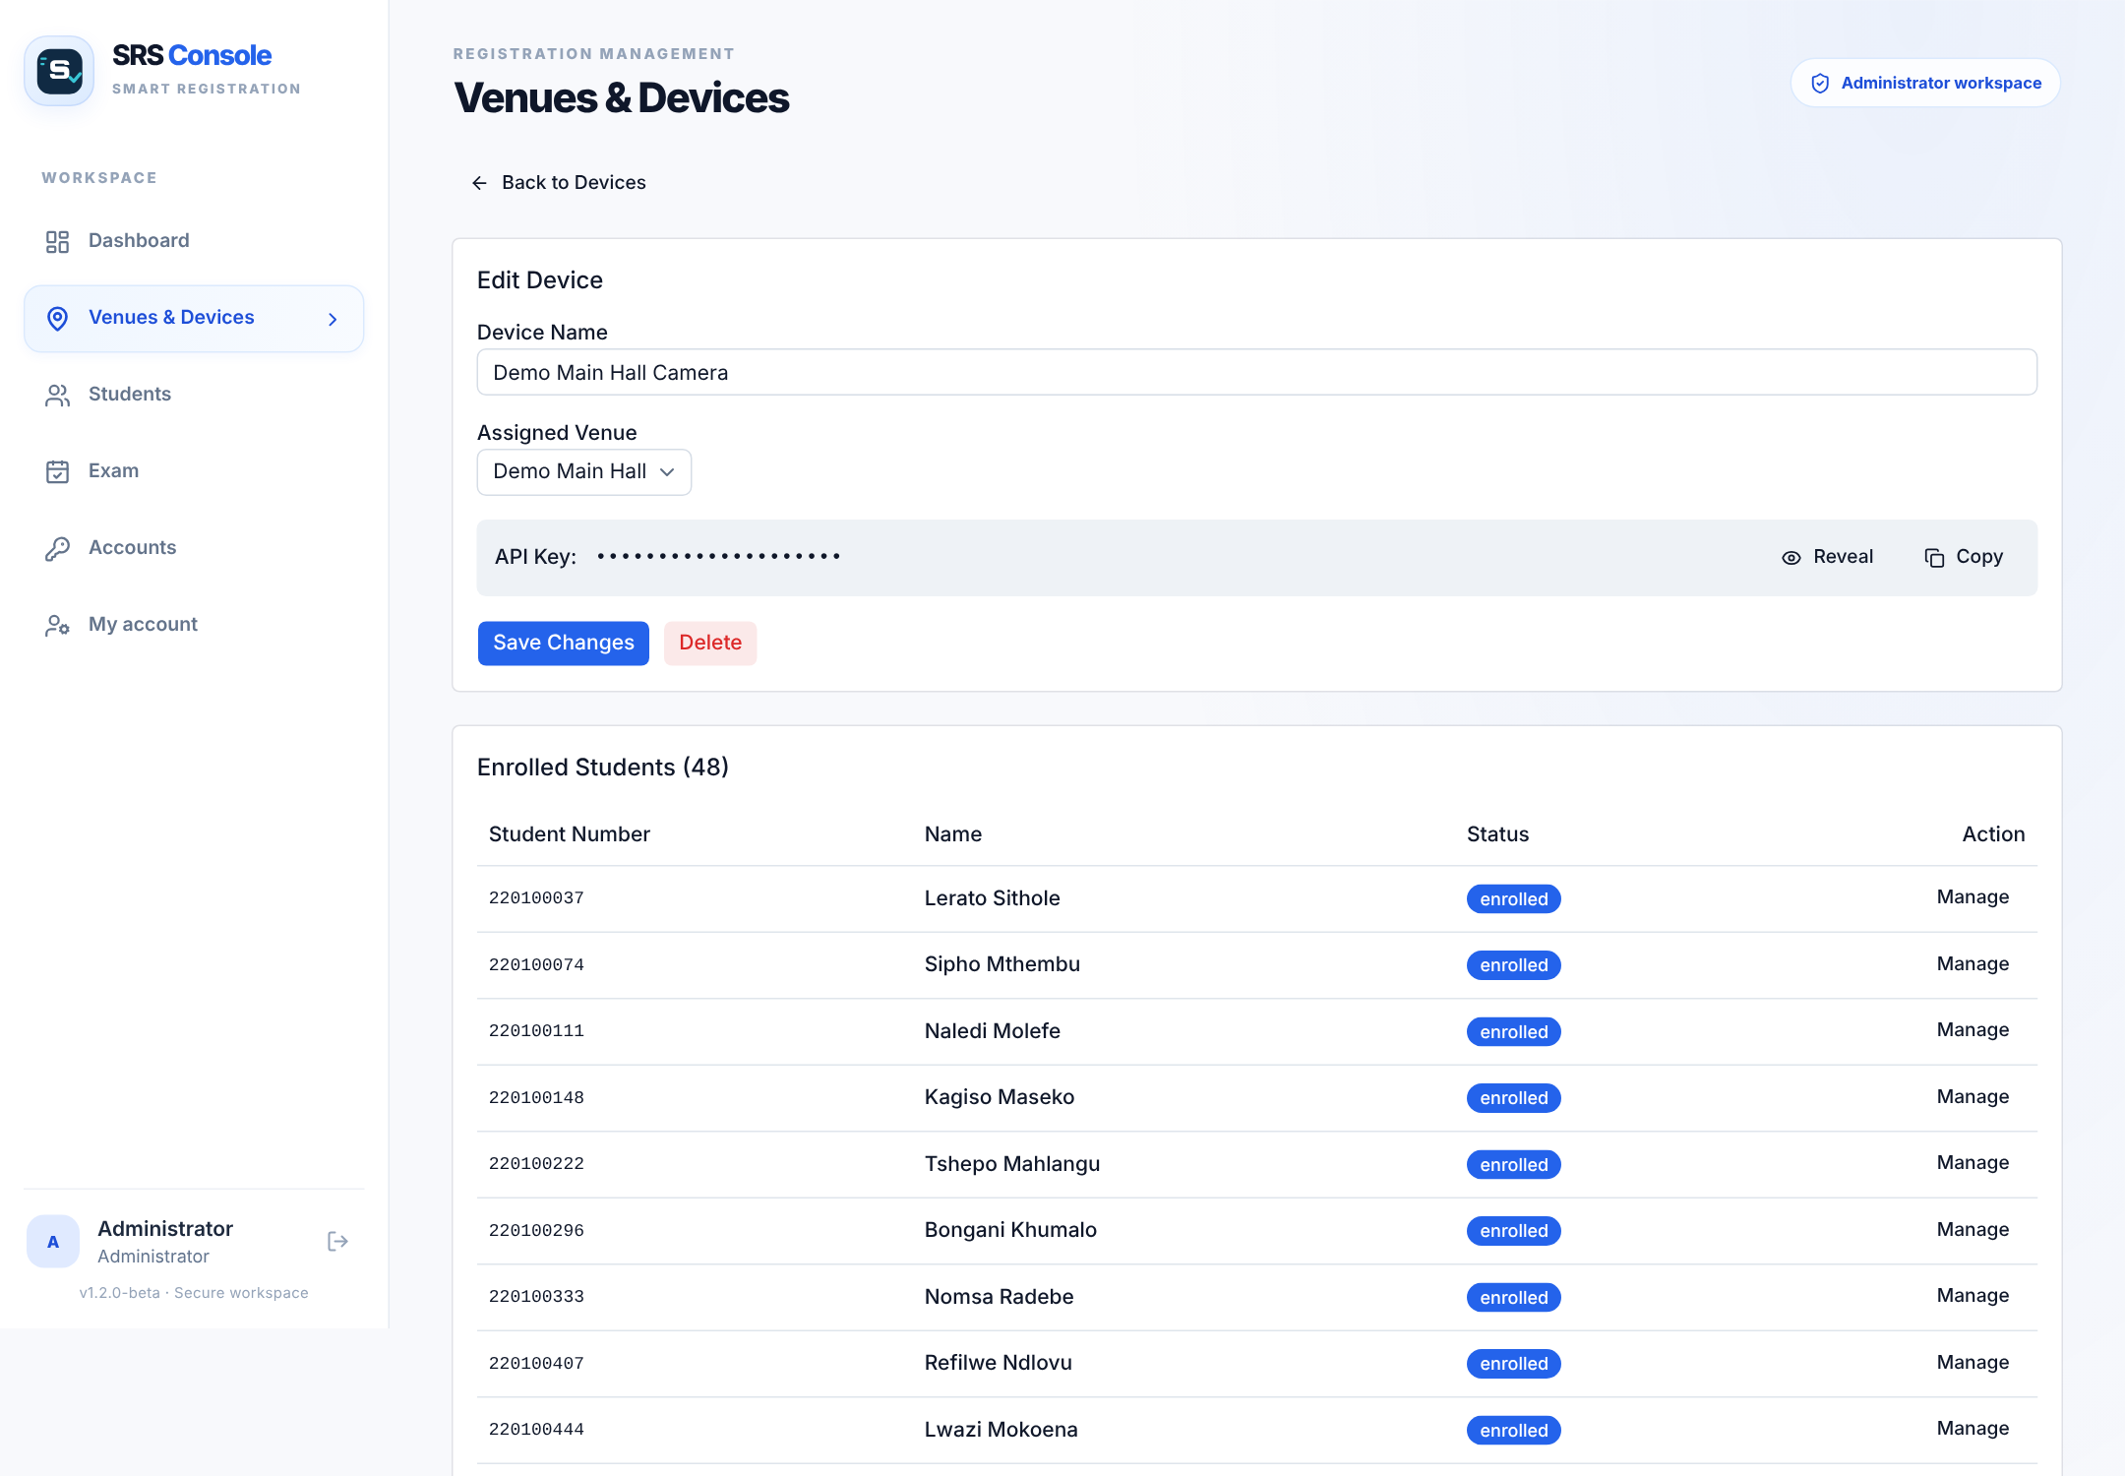
Figure 12: Device page with the hidden device key and its enrolled students

5.3.4 Enrol a student
Enrolment teaches the door unit what a student's face looks like. It is started in the console and carried out at the door unit (Figure 13).
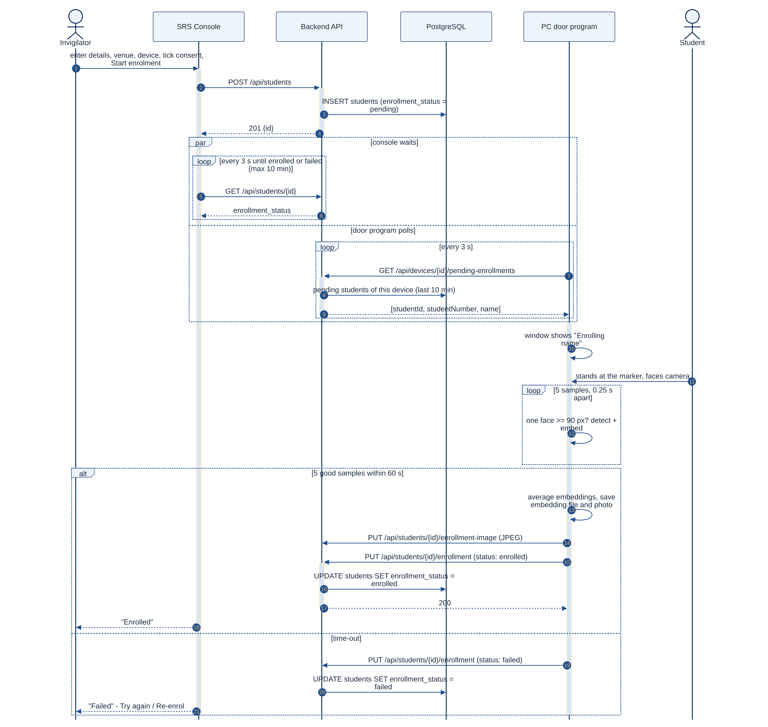
Figure 13: UML sequence diagram: enrolling a student
How to read this figure. This is a UML sequence diagram. Each participant at the top has a dashed lifeline; time runs downwards and the messages are numbered. Solid arrows are requests, dashed arrows are replies, and the thin bars show when a part is busy. Frames group messages: par = happening at the same time, loop = repeated, alt = one of the alternatives (the condition is in square brackets). The face is captured by the door unit, not by your computer.
1. Make sure the door program is running and the device shows Online.
2. Open Students → Enrolment; enter the student details, choose the venue and device, and tick the consent box.
3. Press Start enrolment. The page shows "Capturing…" and the door window shows "Enrolling name".
4. Ask the student to stand at the marker, face the camera and stay still. Five shots are taken automatically.
5. The page changes to Enrolled. If it shows Failed, improve the lighting, remove face coverings and press Try again.
6. An existing student can be enrolled again from their page (Enrol face) or the Recent enrolments list (Re-enrol).
CAUTION: a student is enrolled on one door unit. If the exam uses another door unit, enrol the student there.
CAUTION: one face can belong to one student only. If the face is already enrolled for another student on this door unit, the enrolment is rejected (Failed) and the door PC shows both faces side by side. If the stored face is on the wrong student, re-enrol or delete that student first.

5.3.5 Students and modules
- Students → Student list: search by name, number, e-mail, course or module, and filter by course, module, status or device. Open a student to edit details, modules or enrolment.
- Students → Modules: add a module (code and name) and register students for it. Bookings use these registrations.
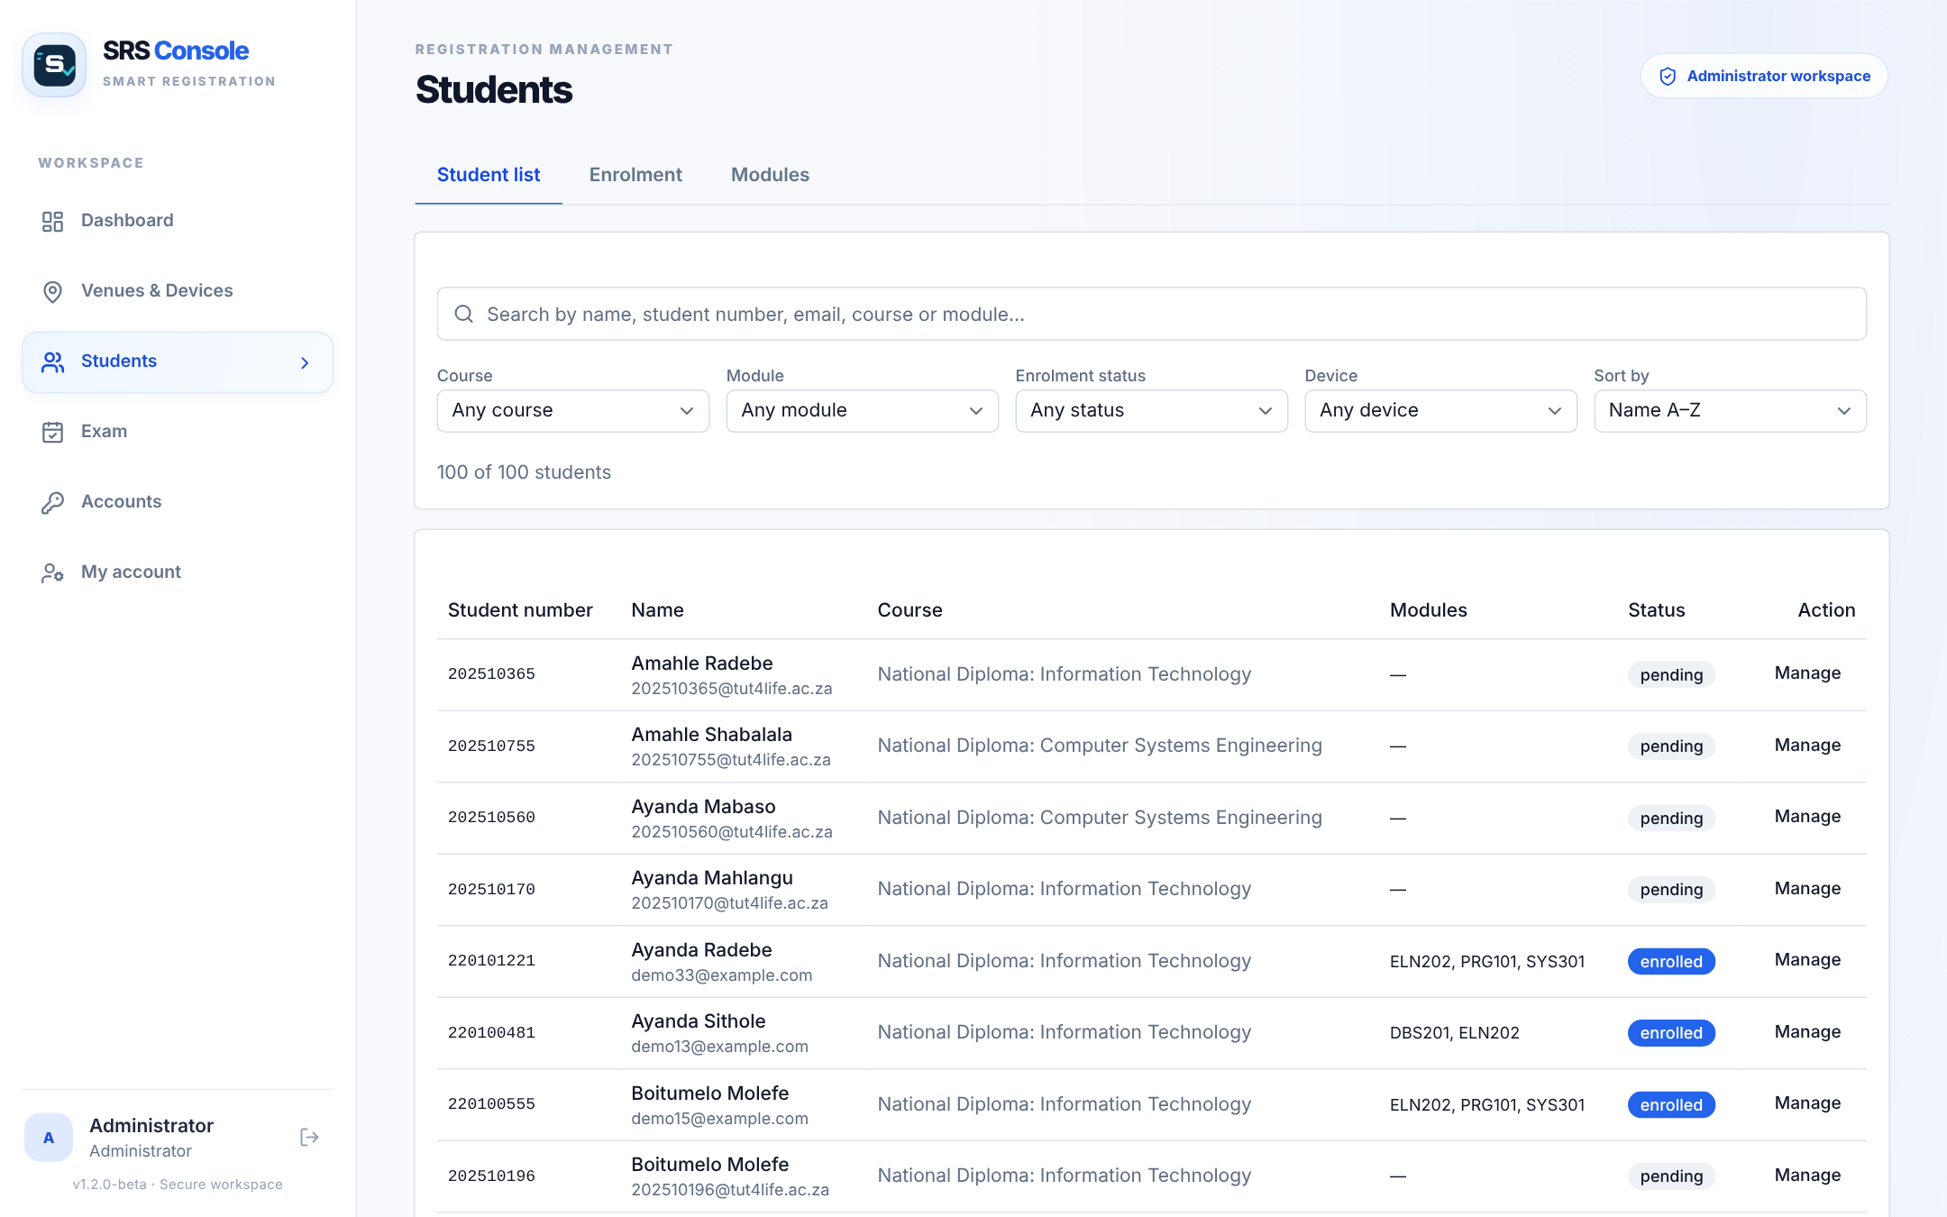
Figure 14: Student list with search and filters
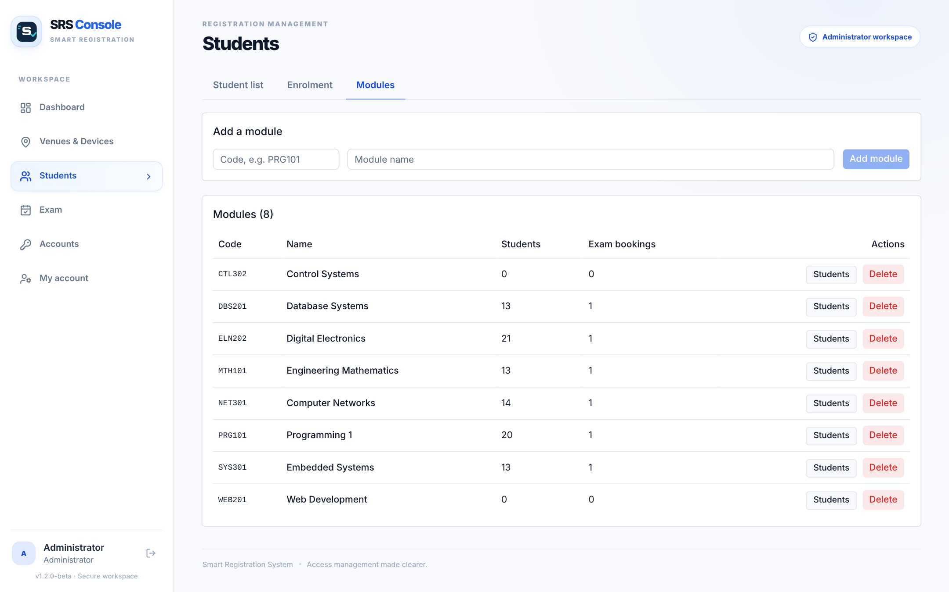
Figure 15: Modules

5.3.6 Book an exam
1. Open Exam → Exam bookings (or click a day in Exam calendar).
2. Choose the module, venue, date and session (09:00 or 13:00). The date picker shows which days still have room.
3. Save. Every student registered for the module gets a seat number in that venue and session, and an e-mail.
4. A booking is refused if the seats would exceed the venue capacity or a student already writes another exam in that session.
5. Edit or cancel a booking from the table or the calendar; the students are e-mailed about the change.
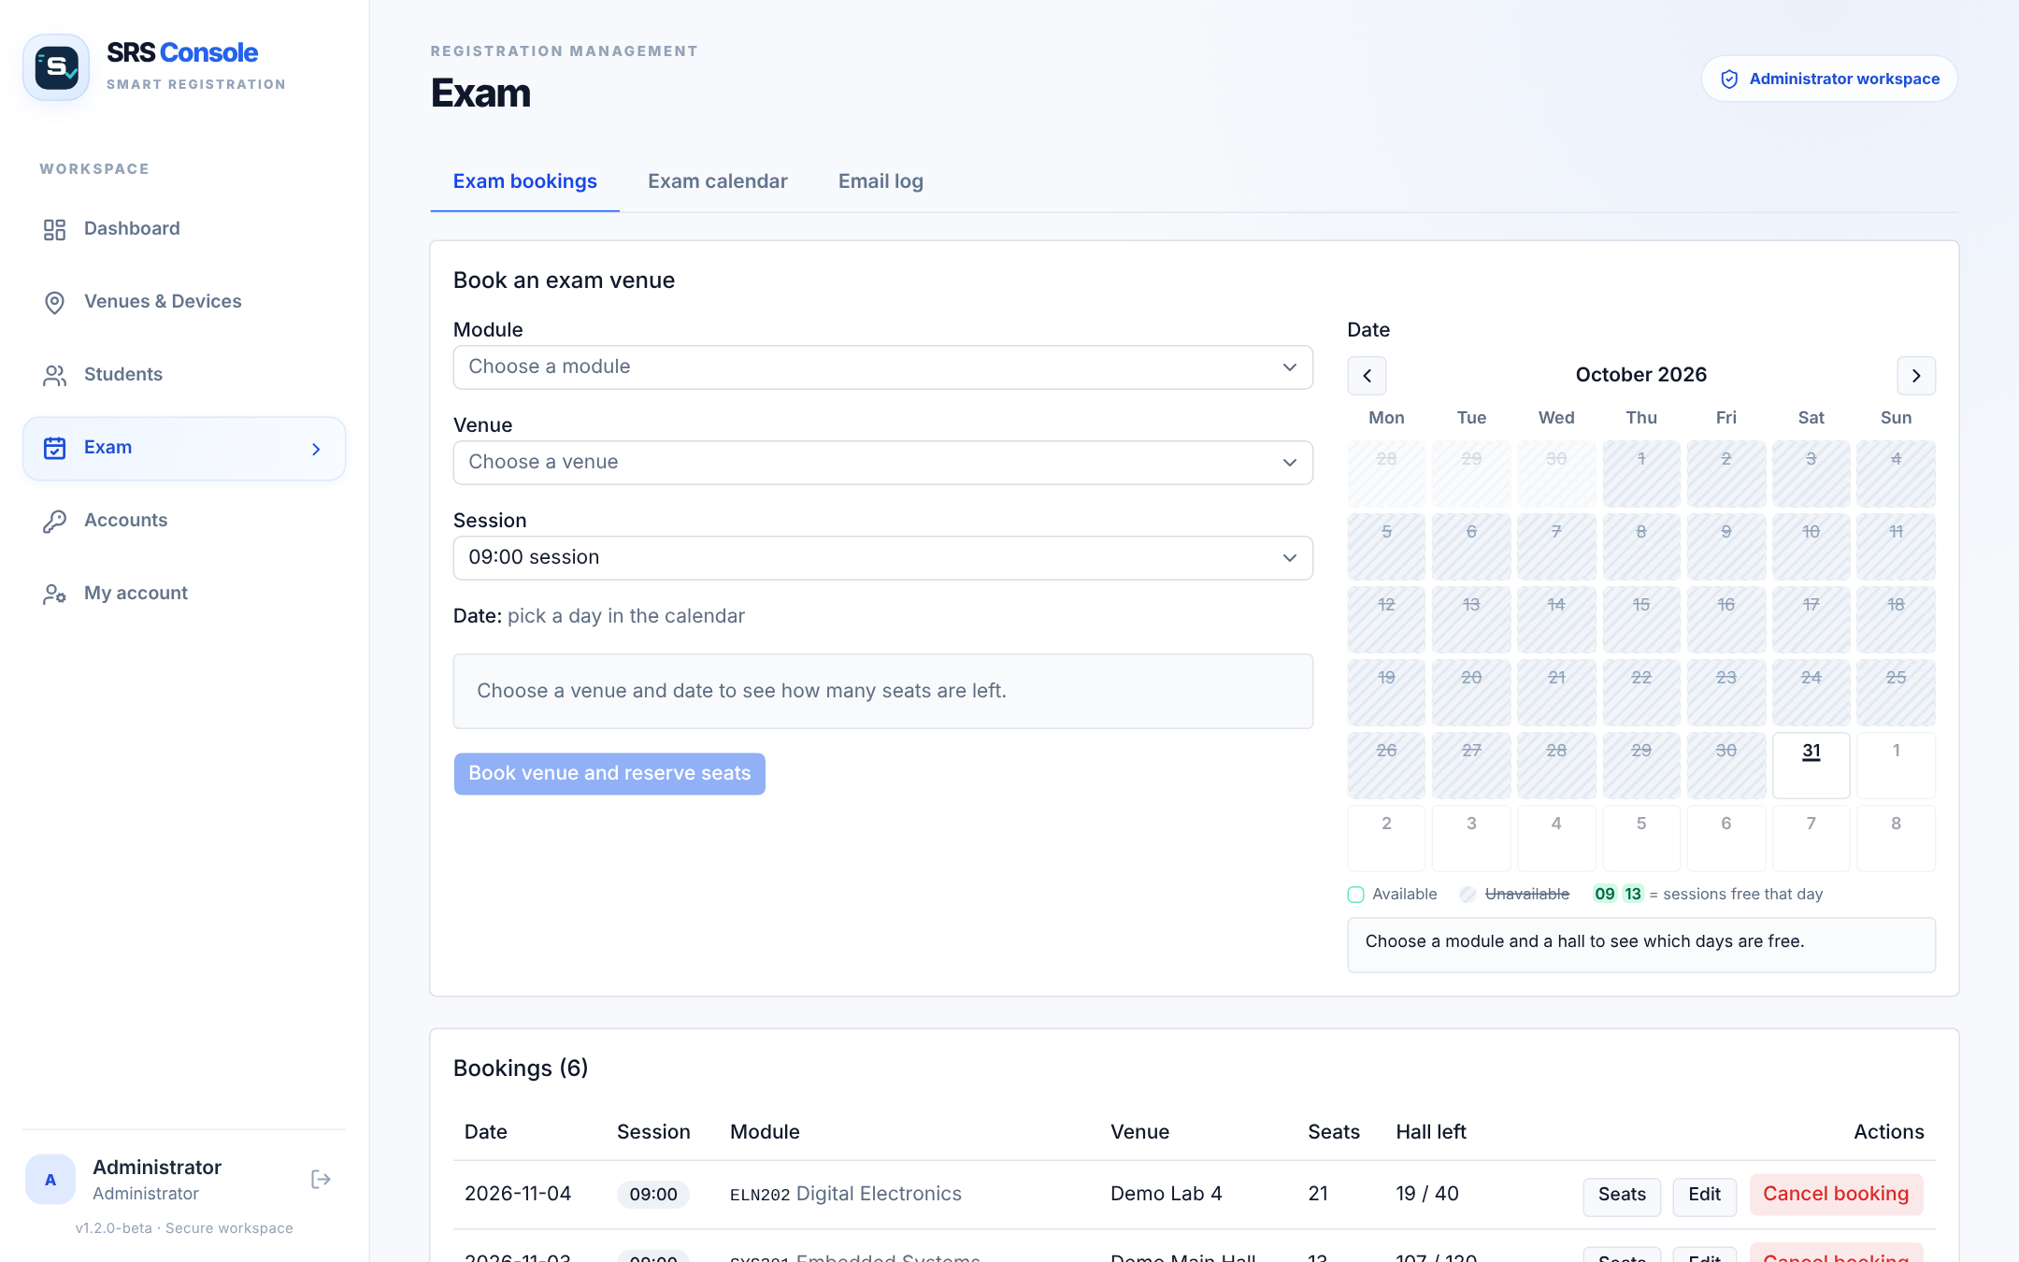
Figure 16: Exam bookings
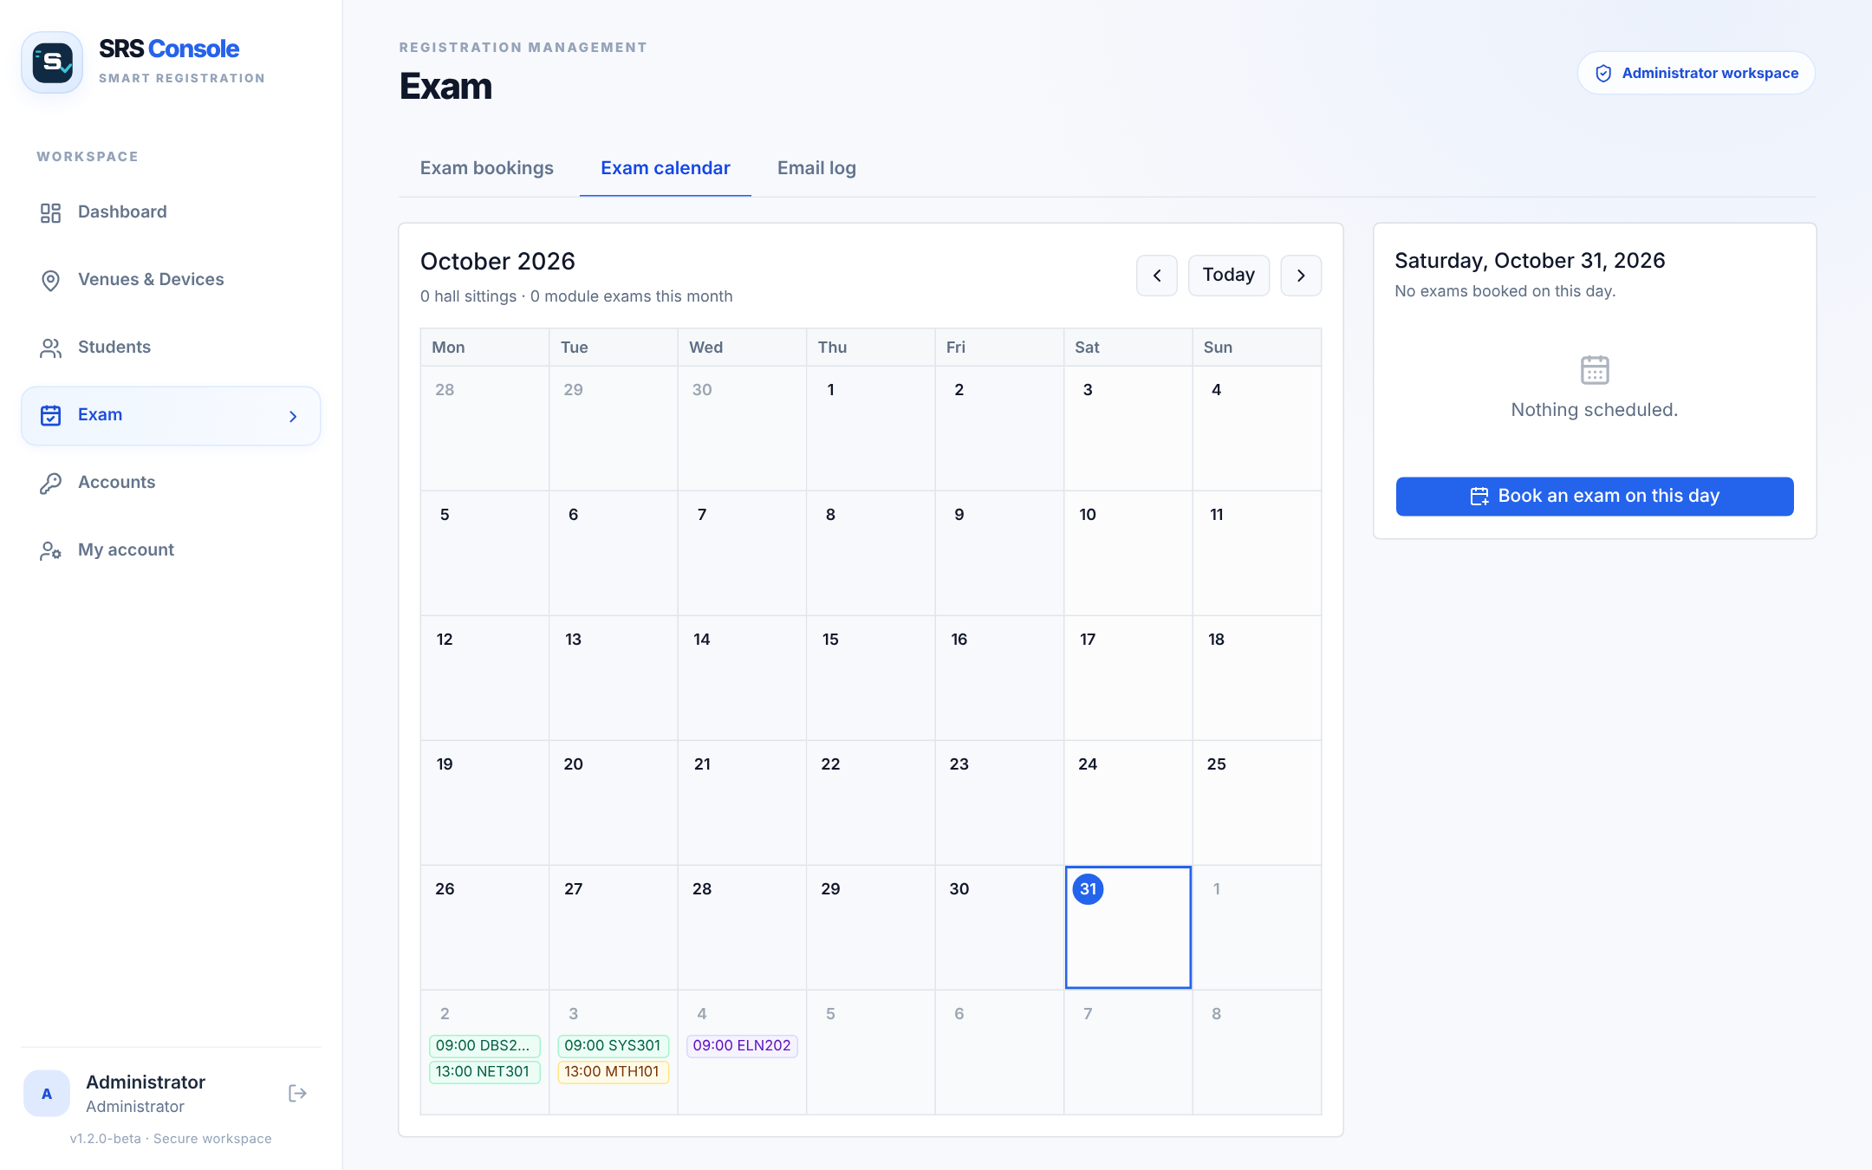
Figure 17: Exam calendar
Figure 18 shows how the two sessions of an exam day work at the door, and Figure 19 what happens inside the system when you book an exam.
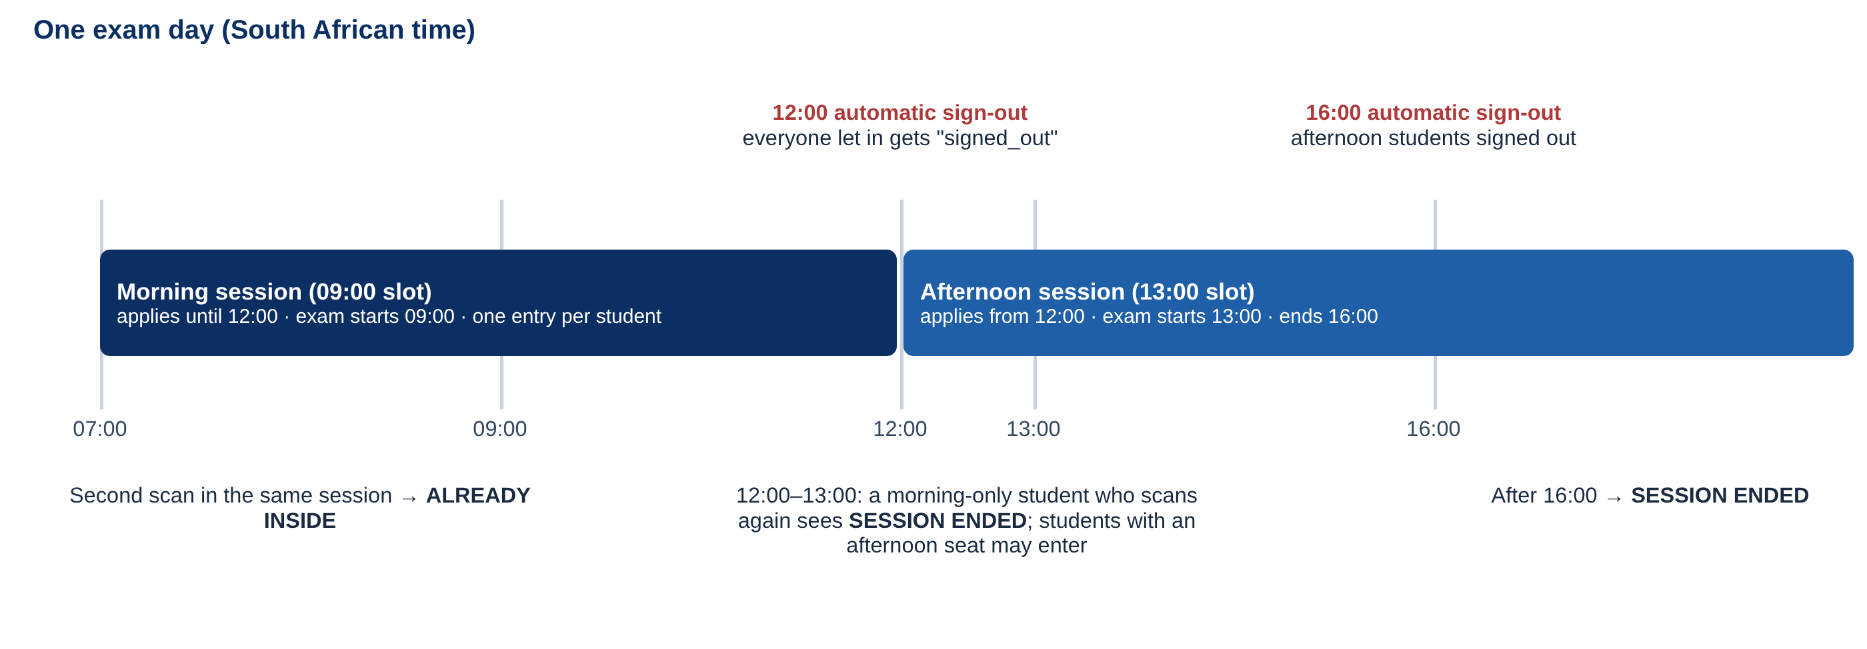
Figure 18: Exam sessions, once-per-session entry and automatic sign-out
How to read this figure. Time runs from left to right. Each coloured bar is a session; the red labels above are the automatic sign-outs; the notes below say what a student who scans again will see.
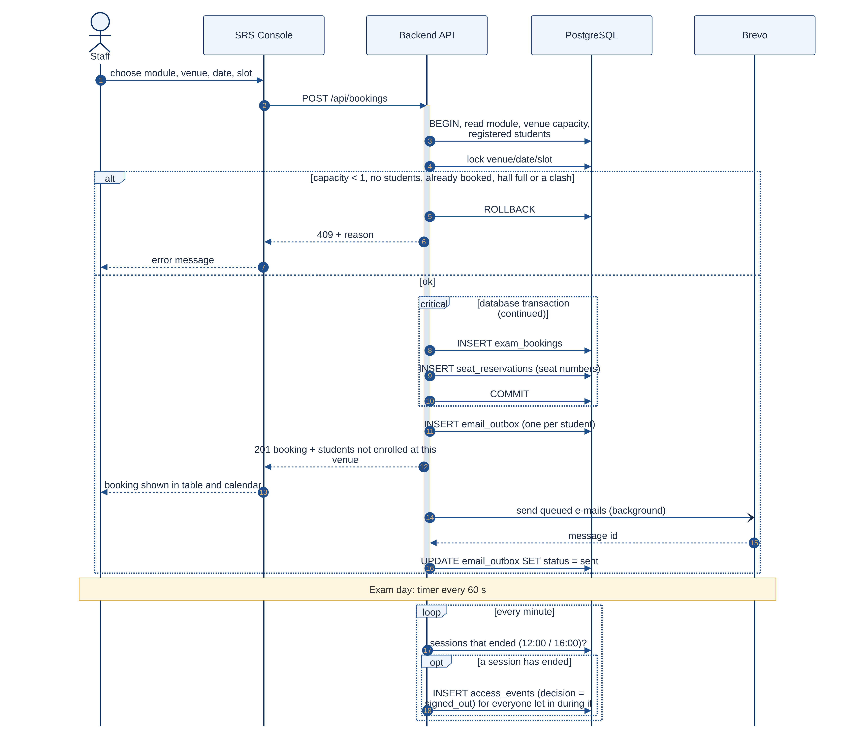
Figure 19: UML sequence diagram: booking an exam, e-mails and automatic sign-out
How to read this figure. Read the numbered messages from top to bottom. The alt frame shows the two outcomes of a booking (refused with a reason, or saved); the loop frame at the bottom is the timer that signs students out at 12:00 and 16:00.

5.3.7 Run the door unit
1. Start python srs_pc_app.py. Pick the webcam from the Camera list (press Rescan after plugging one in).
2. In the Hardware panel choose the Arduino port (e.g. COM20 Arduino Mega 2560) and press Connect. The distance turns green at 25–50 cm.
3. Press Test hardware once to check the Arduino, LCD, buzzer and distance sensor step by step (✔ / ✖ with what to check).
4. Press ▶ Start recognition. The banner says "Stand at the marker and hold still for 1 second".
5. Each result appears in the banner and on the LCD (Table 18 in 4.4.2) and is added to the activity log.
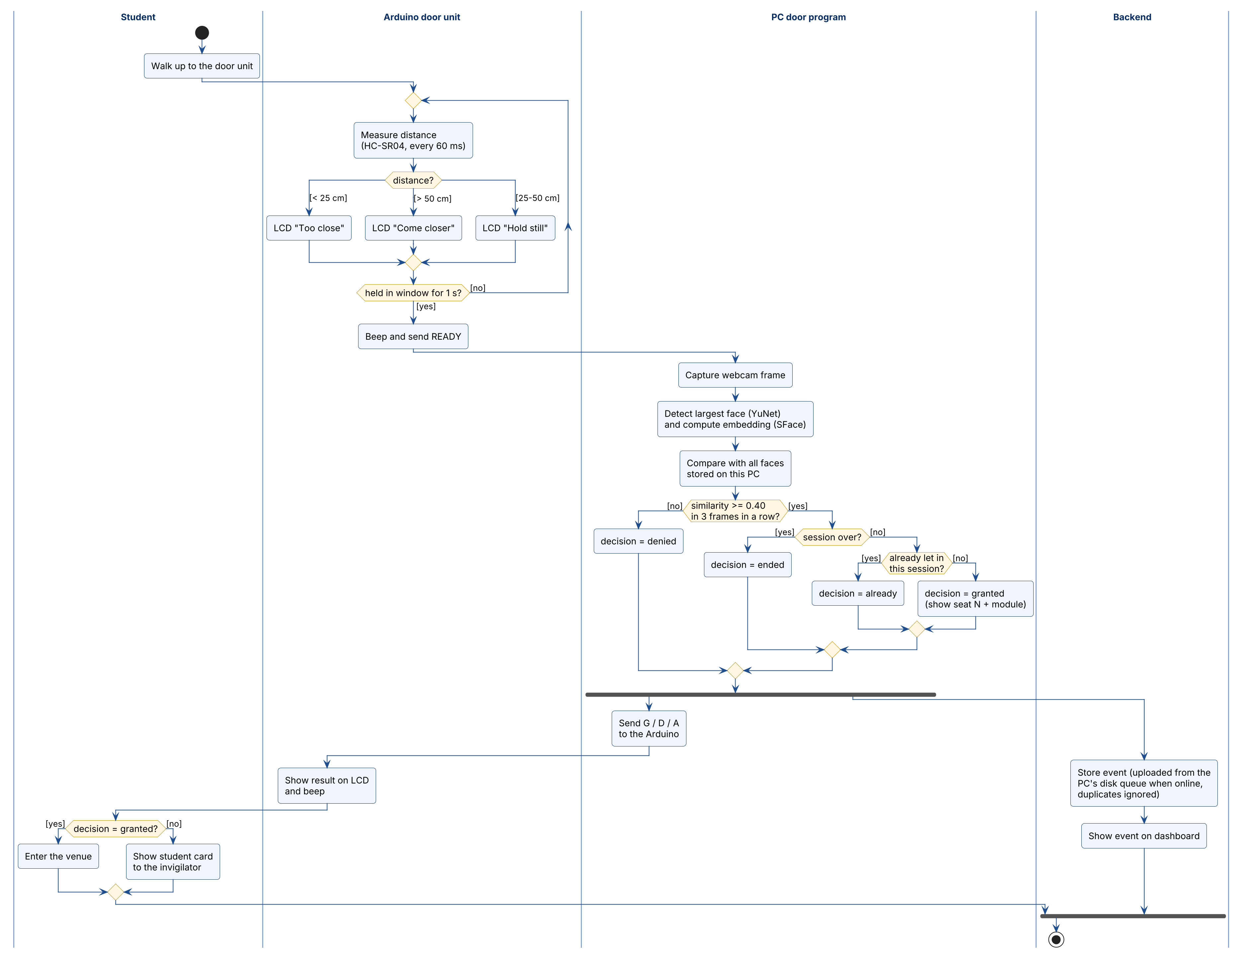
Figure 20: UML activity diagram: what happens when a student walks up
How to read this figure. This is a UML activity diagram with one swimlane (column) per part. Start at the black dot. Rounded boxes are actions; diamonds are decisions, with the condition for each path in square brackets. The thick bar splits the flow into two paths that run at the same time (the LCD result and the upload) and the second bar joins them. The ringed dot is the end.

5.3.8 Handle a denied student or a "No seat" flag (manual override)
The system is a helper. You make the final decision.
1. Ask for the student card and, if required, proof of registration. Compare the photo and details with the student.
2. If the student is genuine, admit them. If not, follow your institution's rules for suspected impersonation.
3. On the Dashboard, find the Denied row and press Override; enter the reason (your sign-in e-mail is recorded automatically). The override is stored with the event.
4. A student flagged "No seat" was recognised but has no seat in this venue and session: check their timetable before admitting them.
5. Report repeated false denials to the administrator so the student can be re-enrolled.
6. Before the exam you can print a paper sign-in sheet as a fallback: Exam → Exam bookings → Seats → Print sign-in sheet.

5.3.9 Accounts (administrator)
- Open Accounts to add a staff member (name, e-mail, role, optional staff number and phone). A temporary password is shown once: hand it over securely.
- Edit the role, deactivate an account, or press Reset password to issue a new temporary password.
- Every user can change their own name, phone and password under My account.
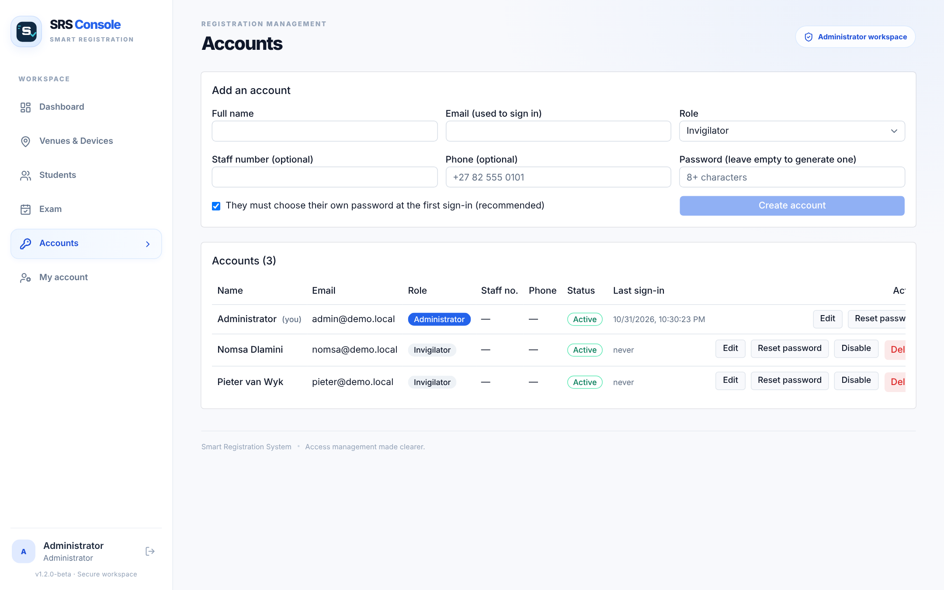
Figure 21: Accounts (administrators only)

5.3.10 E-mail log
Exam → Email log lists every e-mail with its status: sent, queued, failed, logged (no e-mail service set up) or skipped (test mode). Failed e-mails can be retried.
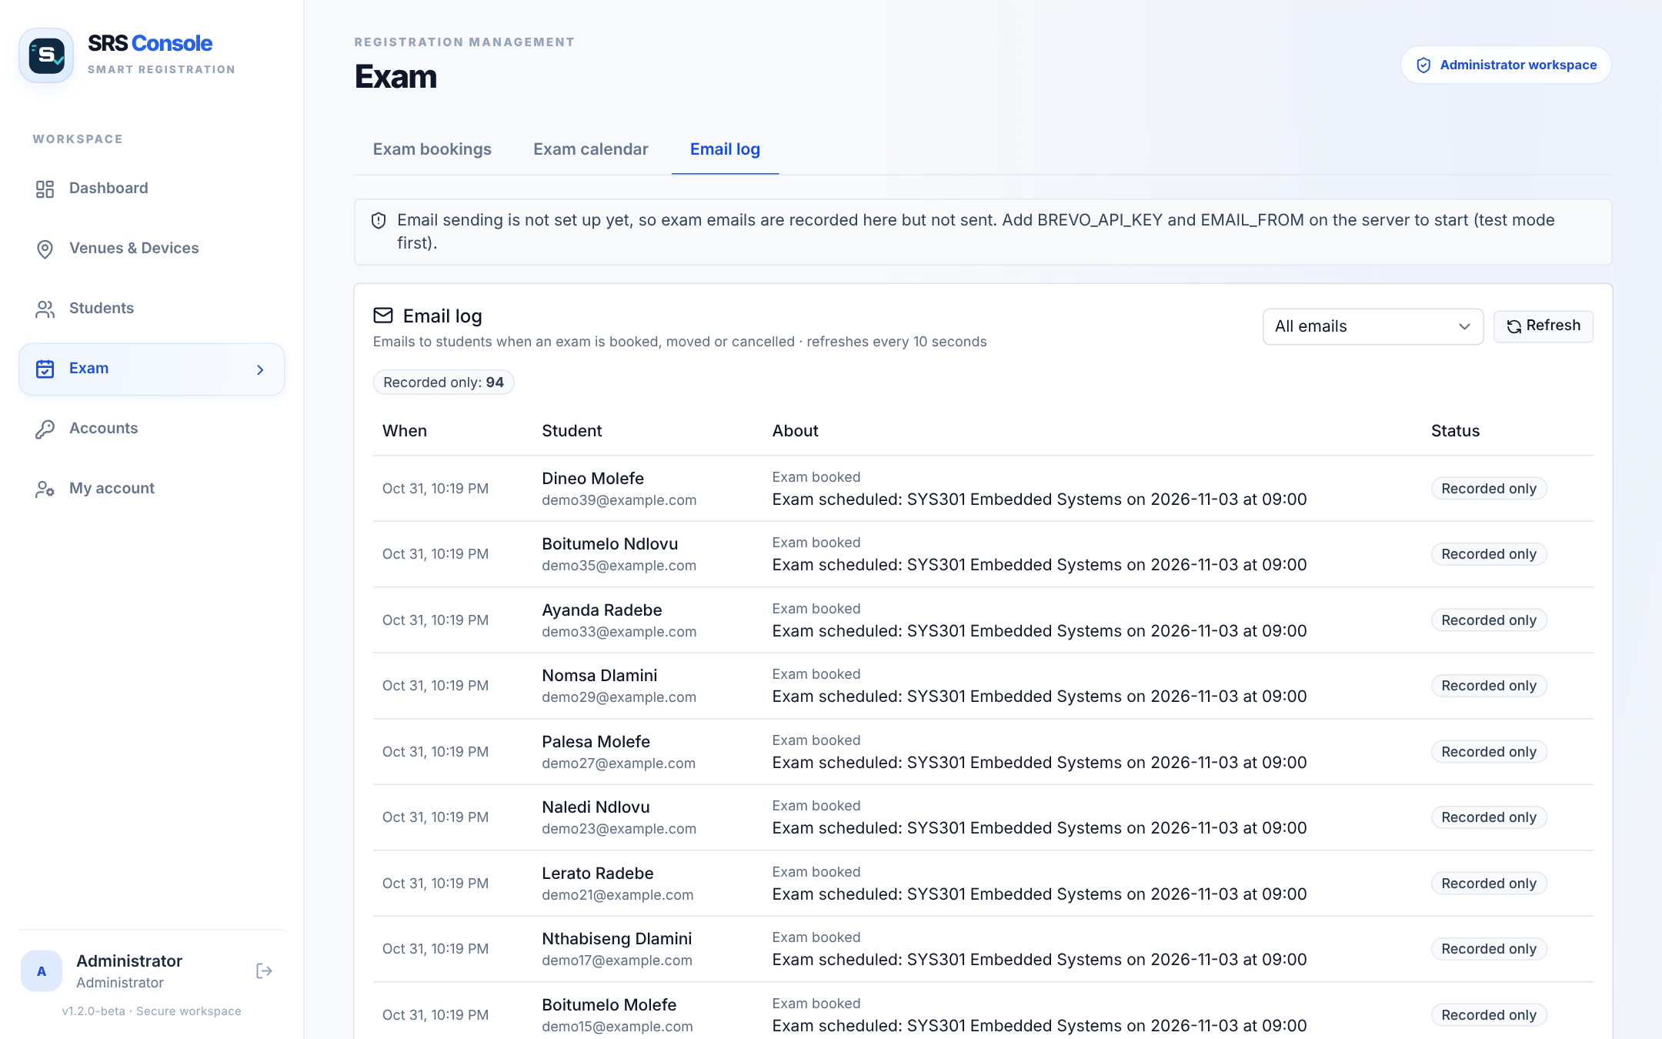
Figure 22: Email log

5.3.11 Replace a door PC (administrator)
1. Copy the folder pc_device/data from the old PC if possible: it holds the embeddings and photos.
2. Otherwise set up the new PC (4.1.2 B4) with the same device id and key (or press Replace on the device page and use the new key), then re-enrol the students (5.3.4).
3. Test with a known student before the exam.

5.4 Related processing (background tasks)
Table 22: Background tasks
Task | What it does | What you must do
Distance gating | The Arduino measures about 16 times a second and only asks for a picture after a 1 s hold | Stand at the marker
Local matching | The PC compares the face with every face stored on it, without the network | Nothing
Session sync | The PC downloads the seat list and who is already inside every 2 minutes and at 12:00 / 16:00 | Keep the PC online
Event queue | Decisions made offline are saved to disk and uploaded in batches, never twice | Avoid closing the program while offline
Roster clean-up | Faces of students no longer enrolled on this door unit are deleted every 5 minutes | Nothing
Heartbeat | The PC tells the backend it is alive, so the console shows Online | Nothing
Automatic sign-out | At 12:00 and 16:00 everyone let in gets a signed_out event | Nothing
E-mail outbox | Booking e-mails are sent in the background; bookings never wait | Check the Email log for failures

5.5 Data backup
Backups protect the records if the database is damaged or deleted. Backup files contain personal data, so store them securely and delete them when the retention period ends.
# create a compressed backup of the whole database (needs the PostgreSQL client tools)
pg_dump "$DATABASE_URL" -Fc -f srs_backup.dump
# restore that backup into an empty database (--clean removes existing objects first)
pg_restore --clean --no-owner -d "$DATABASE_URL" srs_backup.dump
Neon also offers its own restore points, depending on the plan. On each door PC, copy pc_device/data and config.ini to a secure location after enrolment. Keep an offline copy of the Render settings.

5.6 Recovery from errors, malfunctions and emergencies
- Problem during admission: use manual card checks; do not delay students. Fix the SRS afterwards.
- Door program crashed: start it again. Faces and the queue are on disk and are kept.
- Backend or database problem: restore from backup (5.5), then confirm with a test scan.
- Emergency evacuation: leave the venue first; the equipment can be replaced.

5.7 Messages
Table 23: Messages
Source | Message | Type | Meaning / action
Console | incorrect email or password | Error | Retype; after 5 failures wait 15 minutes
Console | new password must be at least 8 characters | Error | Choose a longer password
Console | only an administrator can do that | Error | Ask an administrator
Console | Cannot delete venue: … device(s) still assigned | Error | Move or delete the devices first
Console | Capturing… / Enrolled / Failed | Information | Enrolment progress (5.3.4)
Console | Entry override recorded for event N | Information | Override saved
LCD | Smart Register / Step up to scan | Information | Waiting for a student
LCD | NOT CONNECTED / Start the PC app | Error | The door program is not running: start it and press Connect (5.3.7)
LCD | Too close / Step back · Come closer / Stand at 25-50cm | Instruction | Move to the marker
LCD | Hold still 32cm / ###### | Information | Counting the 1-second hold
LCD | Scanning face... / Look at camera | Information | Picture being taken
LCD | ACCESS GRANTED · ACCESS DENIED · ALREADY INSIDE | Result | See Table 18
LCD | No answer / Please try again | Error | Step up again
LCD | Next student / Step away first | Instruction | The previous student must step back
PC window | No camera found. Plug in the webcam and press Rescan. | Error | Connect the webcam
PC window | Recognition is off – press Start recognition to scan students | Information | Press ▶ Start recognition

5.8 Quick-reference guide
Quick-Start Card (print on one page)
Before the exam: exam booked · every student "enrolled" on this venue's door unit.
At the venue: PC on mains · webcam at face height · Arduino plugged in · marker 25–50 cm from the sensor · start python srs_pc_app.py · Hardware → Connect · ▶ Start recognition · sign in to the console · device Online · test with yourself.
During admission: one student at a time at the marker, hold still 1 s. ACCESS GRANTED → admit (check the card if the dashboard says "No seat"). ACCESS DENIED → check the card yourself, then Override if genuine.
If something breaks: switch to manual checks straight away; LCD blank → Test hardware; "No camera" → Rescan; Offline → check internet, wait a minute.
After the exam: sign-out is automatic at 12:00 / 16:00 · ■ Stop recognition · close the window · sign out · Export CSV if needed.

6. Query Procedures
A query is a request to look up records. Invigilators look up records in the console. Administrators can also query the database directly.

6.1 Database and data file format
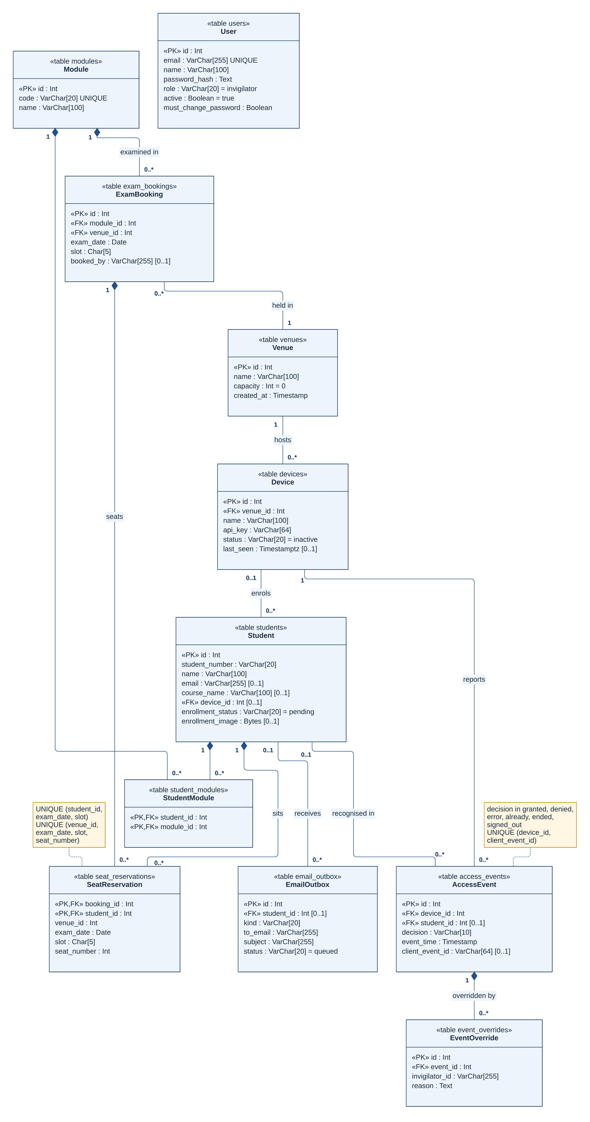
Figure 23: UML class diagram of the database (11 tables)
How to read this figure. This is a UML class diagram: each box is one table (its name on top, its columns and data types below). «PK» marks the unique id and «FK» a column that points to another table. The numbers at each end of a line are multiplicities: 1 = exactly one, 0..1 = none or one, 0..* = any number. A filled diamond means the rows on the other end are deleted together with their owner.
Table 24: Main tables
Table | Holds | Key columns
venues | Exam venues | id, name, capacity
devices | Door units | id, venue_id, name, api_key (secret), status, last_seen
students | Students | id, student_number, name, email, course_name, device_id, enrollment_status, enrollment_image
modules / student_modules | Modules and who is registered | code, name · student_id, module_id
exam_bookings | Booked exams | module_id, venue_id, exam_date, slot (09:00 / 13:00)
seat_reservations | Seats | booking_id, student_id, venue_id, exam_date, slot, seat_number
access_events | Every decision | device_id, student_id (empty = unknown), decision, event_time, client_event_id
event_overrides | Manual decisions | event_id, invigilator_id, reason, created_at
email_outbox | E-mails | kind, to_email, subject, status, sent_at
users | Staff accounts | email, name, role, active, must_change_password, last_login_at

6.2 Query capabilities
- Dashboard → Recent access events: search by student, device or decision; filter by decision and date; Export CSV.
- Students → Student list: search and filter by course, module, enrolment status and device.
- Exam calendar / Exam bookings: bookings by day, venue and session, with seats booked.
- Database (administrators): any query with psql or the Neon SQL editor (6.3).

6.3 Query preparation
# open an interactive session on the database
psql "$DATABASE_URL"
Example 1: every denied attempt today, with the door unit.
-- denied attempts today (times are stored in UTC, so convert them to South African time first)
SELECT e.event_time, d.name AS device
FROM access_events e JOIN devices d ON d.id = e.device_id
WHERE e.decision = 'denied' AND (e.event_time AT TIME ZONE 'UTC' AT TIME ZONE 'Africa/Johannesburg')::date = (now() AT TIME ZONE 'Africa/Johannesburg')::date
ORDER BY e.event_time;
Example 2: attendance for one exam (seated students and their first entry).
-- replace the module code, date and slot with your own
SELECT s.student_number, s.name, r.seat_number, MIN(e.event_time) AS first_entry
FROM seat_reservations r
JOIN exam_bookings b ON b.id = r.booking_id
JOIN modules m ON m.id = b.module_id
JOIN students s ON s.id = r.student_id
LEFT JOIN access_events e ON e.student_id = s.id AND e.decision = 'granted'
AND (e.event_time AT TIME ZONE 'UTC' AT TIME ZONE 'Africa/Johannesburg')::date = DATE '2026-11-02'
WHERE m.code = 'PRG101' AND b.exam_date = DATE '2026-11-02' AND b.slot = '09:00'
GROUP BY s.student_number, s.name, r.seat_number ORDER BY r.seat_number;
Example 3: students per enrolment status and venue.
SELECT v.name AS venue, s.enrollment_status, COUNT(*) AS students
FROM students s
JOIN devices d ON d.id = s.device_id JOIN venues v ON v.id = d.venue_id
GROUP BY v.name, s.enrollment_status ORDER BY v.name, s.enrollment_status;
Example 4: overrides with the reason.
SELECT o.created_at, o.invigilator_id, o.reason, e.device_id
FROM event_overrides o JOIN access_events e ON e.id = o.event_id
ORDER BY o.created_at DESC;

6.4 Control instructions
1. Run queries only from a trusted computer.
2. Use SELECT for reading. Do not run UPDATE or DELETE on live data without a backup (5.5).
3. Close the session with \q.
4. Handle results as confidential personal information.

7. Notes

7.1 Acronyms and abbreviations
Table 25: Acronyms and abbreviations
Term | Meaning
API | Application Programming Interface: the web addresses one program offers to another
Arduino | A small microcontroller board; here it runs the distance sensor, LCD and buzzer
CSV | Comma-Separated Values: a plain spreadsheet file
Embedding | A list of 128 numbers representing a face, used to compare faces
FAR / FRR | False Acceptance Rate (stranger accepted) / False Rejection Rate (enrolled student refused)
HC-SR04 | An ultrasonic sensor that measures distance by timing a sound echo
HTTPS | The secure request/response protocol used between all parts of the system
I²C | A two-wire connection used for the LCD
JWT | JSON Web Token: the signed sign-in token the console sends with every request
LCD | Liquid Crystal Display: the 16×2 character screen on the door unit
OpenCV | Open-source computer vision library that runs the face models
POPIA | Protection of Personal Information Act 4 of 2013
SFace / YuNet | The face recognition model / face detection model
SRS | Smart Registration System
TUT | Tshwane University of Technology

7.2 Known limitations
- Not connected to the university student information system.
- Accuracy depends on lighting, distance and camera quality; always keep manual checks available.
- No liveness check: a good printed photo of an enrolled student could be accepted. The invigilator must watch the door.
- A recognised student without a seat is let in and only flagged; the invigilator decides.
- Free hosting tiers sleep when idle; the first request can take up to a minute.

7.3 Document history
Table 26: Document history
Version | Date | Change
1.0 | 08/10/2026 | First full manual (ESP32-CAM design)
2.0 | 05/11/2026 | Rewritten for the final system: PC + webcam + Arduino door unit, staff accounts, modules, bookings, seats, e-mails, automatic sign-out; measured performance; new figures

7.4 Summary
This manual describes how to set up and use the Smart Registration System at an exam venue. A door unit at the entrance checks a student's face once the student holds still 25–50 cm from it, lets each recognised student in once per session, shows the seat on the PC and the result on an LCD, and reports every decision to the SRS Console. Invigilators enrol students, book exams, watch the live dashboard and make the final decision on any denied student. Administrators deploy the backend and console, set up door units, manage accounts and back up the database. The system handles biometric data, so consent, secure handling and a manual fallback are essential. The most important rule on exam day: admission never waits for the system. If anything fails, check student cards manually.

7.5 Figure sources
All diagrams are the author's own. The UML sequence, class and state machine diagrams were drawn in Mermaid; the UML use case, deployment and activity diagrams in PlantUML (Mermaid has no UML form for these); the other diagrams were drawn as web pages. All screenshots are of the SRS Console running with demonstration data. No figure is taken from another source. The diagram source files are in docs_out/figures/mermaid/src and docs_out/figures/uml/src.

8. References
Du, C. and Muwanguzi Ntume, M. (2025) Project Design 376 / Industry Exposure Student Course Guide (PD2316D). Pretoria: Tshwane University of Technology.
Arduino (n.d.) Arduino Mega 2560 Rev3. Available at: https://docs.arduino.cc/hardware/mega-2560/ (Accessed: 31 October 2026).
Information Regulator (South Africa) (2021) Guidance Note on Processing of Special Personal Information. Available at: https://inforegulator.org.za (Accessed: 31 October 2026).
OpenCV (n.d.) OpenCV Zoo: face_detection_yunet and face_recognition_sface. Available at: https://github.com/opencv/opencv_zoo (Accessed: 31 October 2026).
PostgreSQL Global Development Group (2024) PostgreSQL 16 Documentation. Available at: https://www.postgresql.org/docs/16/ (Accessed: 31 October 2026).
Prisma Data (n.d.) Prisma ORM Documentation. Available at: https://www.prisma.io/docs (Accessed: 31 October 2026).
Republic of South Africa (2013) Protection of Personal Information Act 4 of 2013. Pretoria: Government Printer.
Wu, W., Peng, H. and Yu, S. (2023) 'YuNet: a tiny millisecond-level face detector', Machine Intelligence Research, 20(5), pp. 656–665.
Zhong, Y. et al. (2021) 'SFace: sigmoid-constrained hypersphere loss for robust face recognition', IEEE Transactions on Image Processing, 30, pp. 2587–2598.

Appendix A: Hardware Guide

A.1 Parts list
Table 27: Door unit parts
Part | Purpose
Windows PC or laptop | Runs the door program and face recognition
USB webcam | Takes the pictures
Arduino Mega 2560 (or Uno/Nano) + USB cable | Runs the distance sensor, LCD and buzzer; powered by the PC
HC-SR04 ultrasonic sensor | Measures the distance to the student
16×2 LCD with I²C backpack | Shows instructions and the result
Buzzer (passive or active) | Beeps the result
Breadboard, jumper wires, enclosure / stand | Holds the parts neatly at the entrance

A.2 Wiring
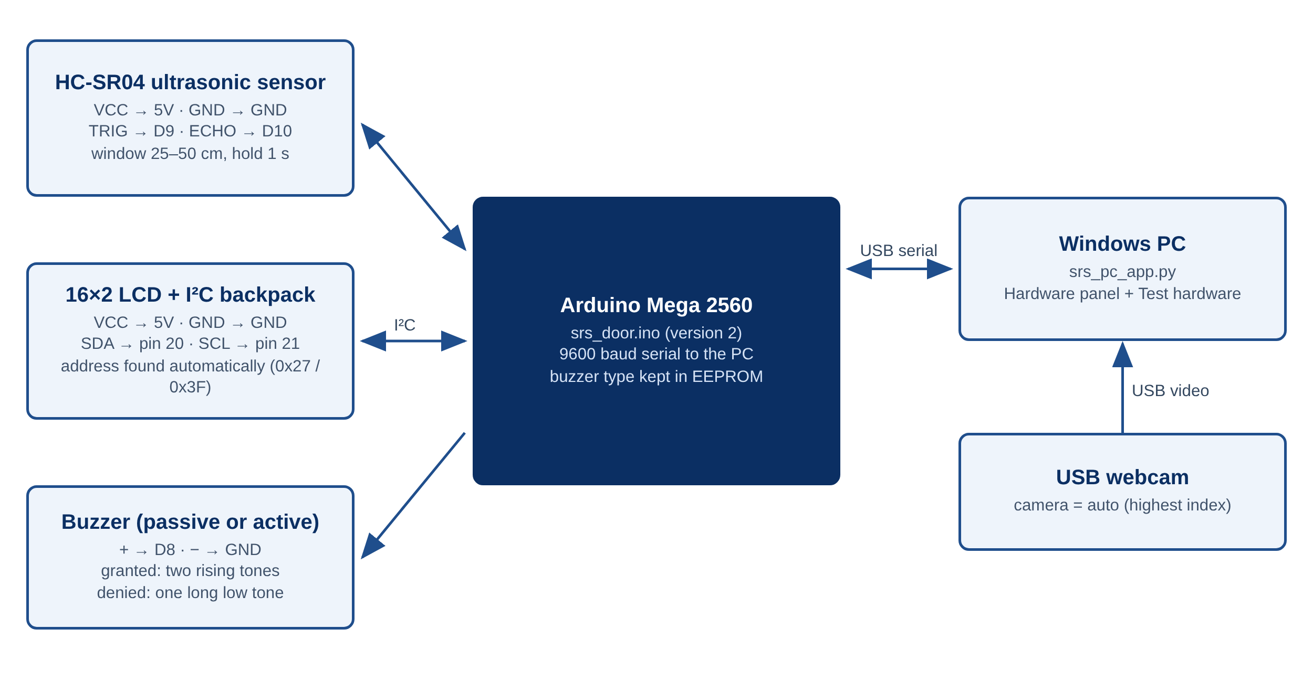
Figure 24: Door unit wiring
How to read this figure. The dark box is the Arduino. Each part is listed with the Arduino pin each of its wires goes to; arrows show the direction of the signal, and double arrows mean data flows both ways.
Table 28: Wiring (Arduino Mega)
Part | Wire | Arduino pin
HC-SR04 | VCC / GND / TRIG / ECHO | 5V / GND / D9 / D10
LCD I²C backpack | VCC / GND / SDA / SCL | 5V / GND / pin 20 / pin 21 (Uno/Nano: A4 / A5)
Buzzer | + / − | D8 / GND
PC | USB | USB port (power and serial, 9600 baud)

A.3 Power-up and shutdown
1. Plug the Arduino into the PC; the LCD shows "Smart Register / Starting..." and then "NOT CONNECTED / Start the PC app" until the door program connects.
2. Start the door program and press Connect in the Hardware panel. The LCD changes to "Smart Register / Step up to scan".
3. Shutdown: close the door program first, then unplug the Arduino.
4. CAUTION: do not move wires while the Arduino is powered.

A.4 Mounting and positioning
- Mount the webcam at face height, facing the place where students will stand, with the HC-SR04 next to it.
- Put a floor marker so the student's face is 25–50 cm from the sensor (about 35 cm works well).
- Keep the space between the sensor and the student clear: the HC-SR04 measures the nearest object in a narrow cone.
- Avoid strong light behind the student (windows, open doors). Even, front-facing light works best.
- Keep cables tidy and out of walkways to avoid trip hazards.

A.5 Hardware test
Test hardware in the door program checks, one by one: (1) Arduino connected over USB, (2) door unit program answers (version 3), (3) LCD found on the I²C bus, (4) LCD shows the test screen (you answer Yes/No), (5) buzzer beeps (if not, it tries the other buzzer type and the Arduino remembers it), (6) distance sensor gives readings, (7) it sees your hand at 25–50 cm. Each step is marked ✔ or ✖ with what to check.

A.6 Care and maintenance
- Wipe the webcam lens with a soft dry cloth.
- Keep the door unit away from water and heat.
- If the LCD is blank, turn the blue contrast screw on its back.

Appendix B: Door Program Settings
Settings live in pc_device/config.ini (kept out of Git because it holds the device key). Each can also be given on the command line.
Table 29: config.ini and command-line options
config.ini | Command line | Meaning | Default
url | --url | Backend address | https://smart-registration-system.onrender.com
device_id | --device-id | The device id shown in the console | –
device_key | --key | The device key (administrators: Reveal on the device page) | –
camera | --camera | Webcam number, or auto (highest number) | auto
serial_port | --serial | Arduino port, e.g. COM3 (empty without an Arduino) | –
min_face_px | --min-face | Faces narrower than this are "too far away" | 90
– | --check | Test the server, key and models, then exit (no camera) | –
Matching uses SFace cosine similarity with threshold 0.40 (MATCH_THRESHOLD in face_engine.py). Raise it if strangers are ever accepted; lower it if enrolled students are often denied.

Appendix C: Database Creation
The database is created and updated automatically: npm start in the Backend folder runs node prisma/deploy.js, which applies every migration in Backend/prisma/migrations before the server starts. The schema is defined in Backend/prisma/schema.prisma (Figure 23). To create demonstration data on a local test database only:
# start the backend against a local test database (applies the migrations)
npm start
# in a second terminal: 3 venues, 3 devices, 6 modules, 40 students, 6 bookings, 27 events
SEED_EMAIL=<admin e-mail> SEED_PASSWORD=<password> npm run seed-demo
# optional: more students and exam bookings for the next two weeks
SEED_EMAIL=<admin e-mail> SEED_PASSWORD=<password> npm run seed-exams
# optional: sample access events for the last 7 days (for the dashboard chart)
SEED_EMAIL=<admin e-mail> SEED_PASSWORD=<password> npm run seed-activity
CAUTION: the seed scripts refuse to run against anything except localhost unless CONFIRM_SEED=yes is set. Never run them against the live database.

