

**Técnicas de Programação 2015/1**

Grupo 06

Style Sheet Java

**Students:**

Gustavo Cavalcante

Maxwell Oliveira

Pedro Sales

Thiago Lima

**Teacher**: Maurício Serrano



23/03/2015

Style Sheet Java.

1. **Files**

* The file name “.java” is the same of the public class that holds it, following the IDE Eclipse's pattern.
* Package, import and class also follow the same pattern.

Ex:

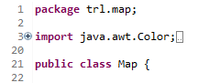

1. **Variables**

* Just one declaration for line.
* All variables must have meaninfull names, without abbreviations.
* Some local variables are flexible to abbreviation.
* Some loop variables can be written with just one letter.
* All variables will be written in english.
* The name of the variables must be written in low case, and variables with more than one word must follow the Java pattern (camel case).
* The constant declarations will be with all letters in upper case and constants names with more than one word will be separated with underscore.

Ex:



1. **Methods**

* All methods names follow the same pattern of the variables, but the name must give an ideia of utility of the method.

Ex:



1. **Commands**

*Condicional Structures:*

* Conditional Structures must have always curly brackets, don't matter the number of the lines.
* An if command must always have an correspondent else, even though it's unnecessary right now.

Ex:

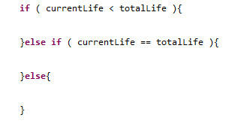

* In the switch block, the commands inside of the cases are separated by blank lines.
* The break command must be always in the last line in each case.

Ex:

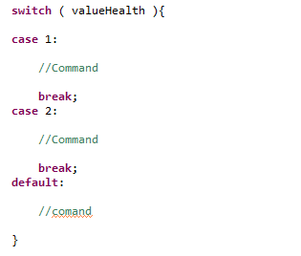

*Exception Handling:*

* The finally command is optional.

*Loops:*

- *For:*

* Always use a local variable inside the loop.
* The only abbraviation of the increment allowed is i++.
* There must be an space after each term in the loop.

Ex:

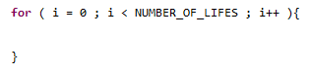

- *While e Do-While:*

* Use the same standard of the for loop.

1. **Indentation**

* The code must have all the curly brackets in the begining right after the closed bracket.
* Will be used the tab as indentation unity.

*Blank lines:*

* All the code blocks must be separated by one blank line, for instance: variables blocks, imports, packages and classes.

*Spaces:*

* Always before the opening bracket in a method.
* All terms insede brackets are separaterd by spaces.

Ex:

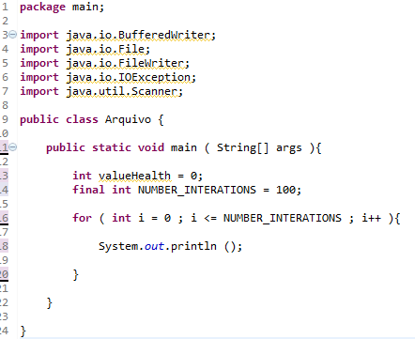

1. **Comments**

* For a single line comment will be used “//” followed by a space and a period in the end of the comment.
* Multiple line comments will be used “/* */” with * in each line, in the Eclipse pattern, and no comments will be written in the line with the “/”.

Ex:

