1. **Compatibility Testing:-**

In this, we have to test the compatibility that the website is opening in the browser or not. So have tested the compatibility in the 3 of the top browsers named Google Chrome, Mozilla Firefox and Microsoft Edge. Name of the video is **Compatibility_Testing.mkv**

**Google Chrome:**

Again after updation I’ve tested the compatibility of the website in this sprint in Google Chrome.  
**Expedted Result** :- This Link should Get opened in the Google Chrome Browser.  
**Actual Result** :- This Link is opening in Google Chrome Browser.

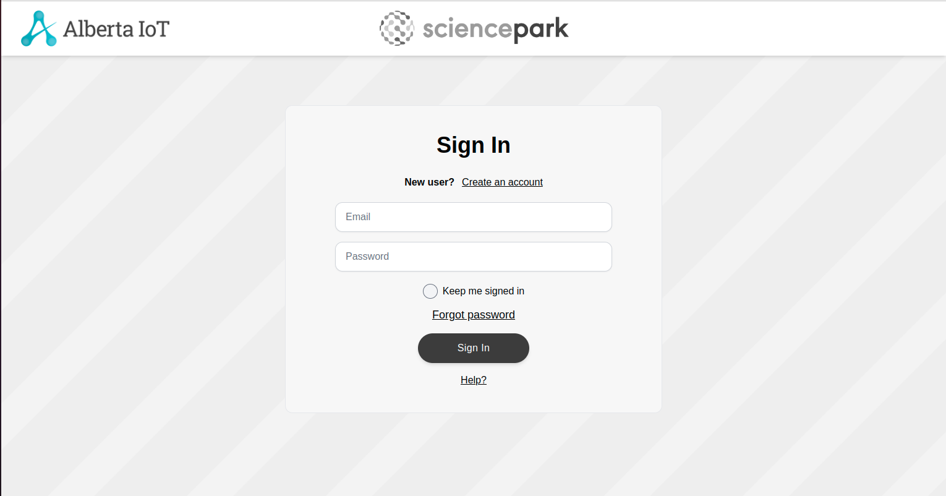

**Mozilla Firefox:**

Again after updation I’ve tested the compatibility of the website in this sprint in Mozilla Firefox  
**Expedted Result** :- This Link should Get opened in the Mozilla Firefox Browser.  
**Actual Result** :- This Link is opening in Mozilla Firefox Browser.

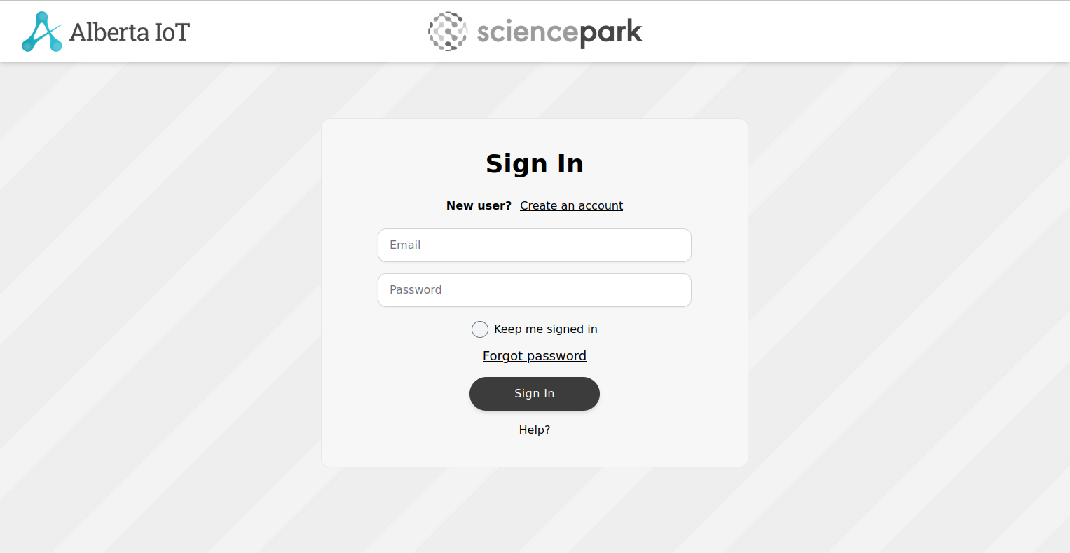

**Microsoft Edge:**

Again after updation I’ve tested the compatibility of the website in this sprint in Microsoft Edge.  
**Expedted Result** :- This Link should Get opened in the Microsoft Edge Browser.  
**Actual Result** :- This Link is opening in Microsoft Edge Browser.

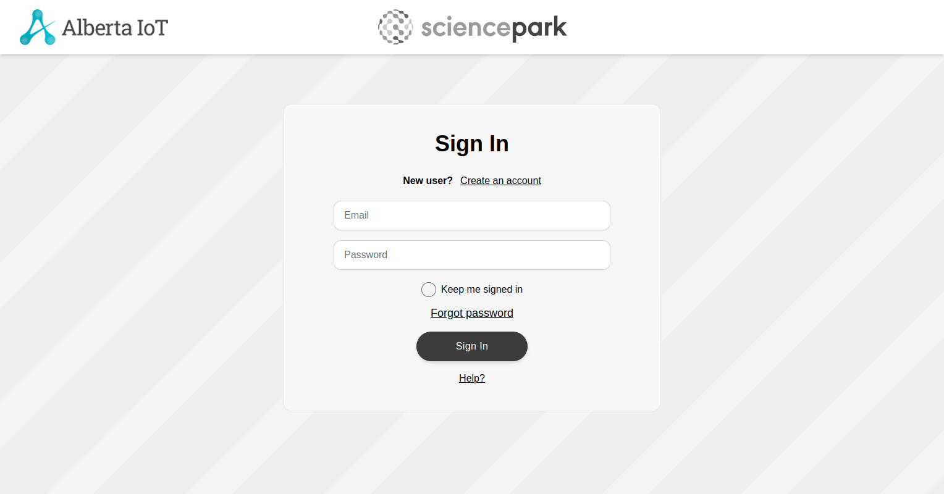

1. **Penetration Testing:-**

In penetration testing, I have scanned the ports in the website from 1 to 50000. In this no any port is open. Name of the video is **penetration_testing_port_scanner.mkv**

Again after updation of the website, I’ve tested the ports but no open ports were detected.  
**Expected Result** :- No Ports should be opened.  
**Actual Result** :- No Ports are opened

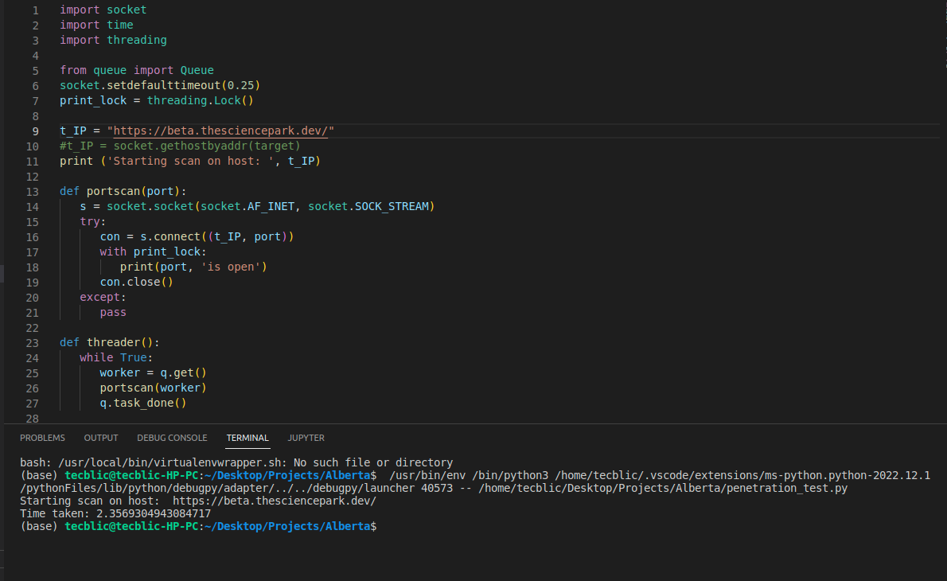

1. **GUI Testing:-**

In this testing, we test the UI of the website. It generally evaluates the textboxes, buttons, links, icons, lists, etc. In this, I have tested Signup Page, Login Page, Create Profile Page, Edit Profile Page, Create Challenge and Business Profile Page. Names of the videos are **signup_page.mkv, Login.mkv, Profile_Create.mkv, Edit_Profile.mkv, Business_Profile.mkv, Create_Challenge.mkv.**

**Signup Page**

Again after updation I’ve tested the Signup Page of the website in this sprint.  
**Expected Result** :- The textboxes should be clickable and user should be able to enter the values.  
**Actual Result** :- The textboxes are clickable and user is able to enter the values.

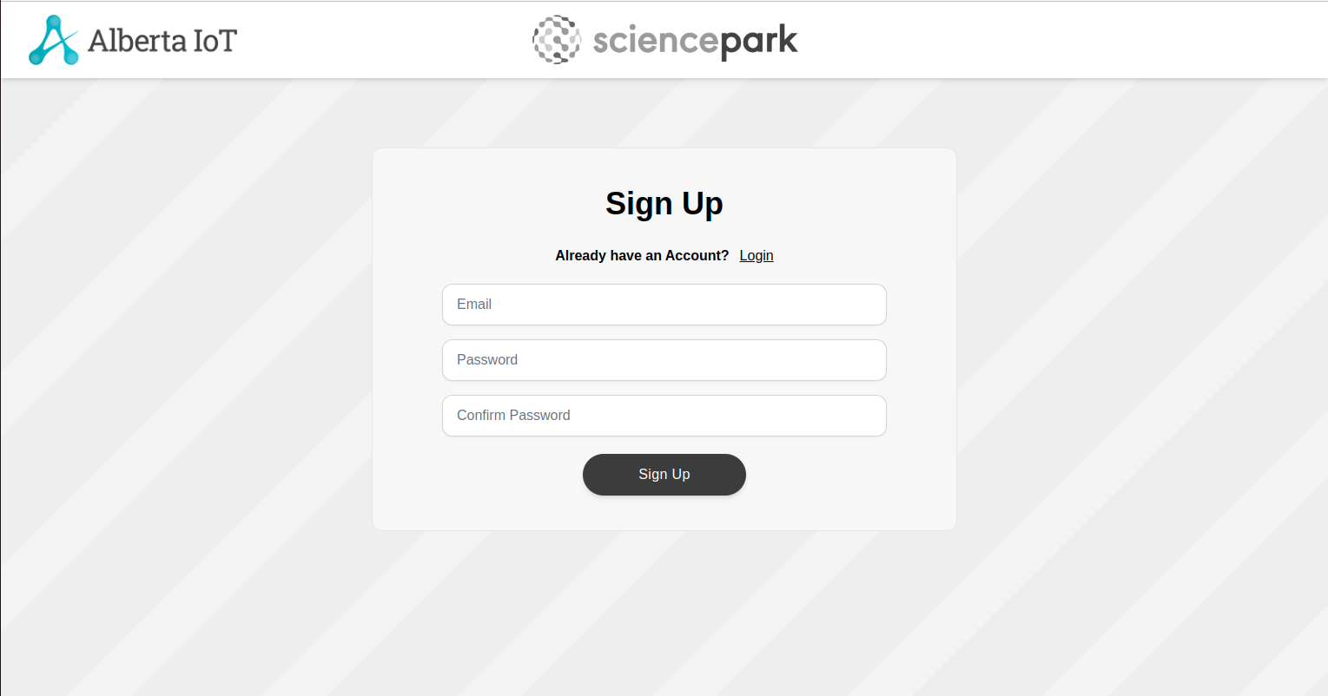

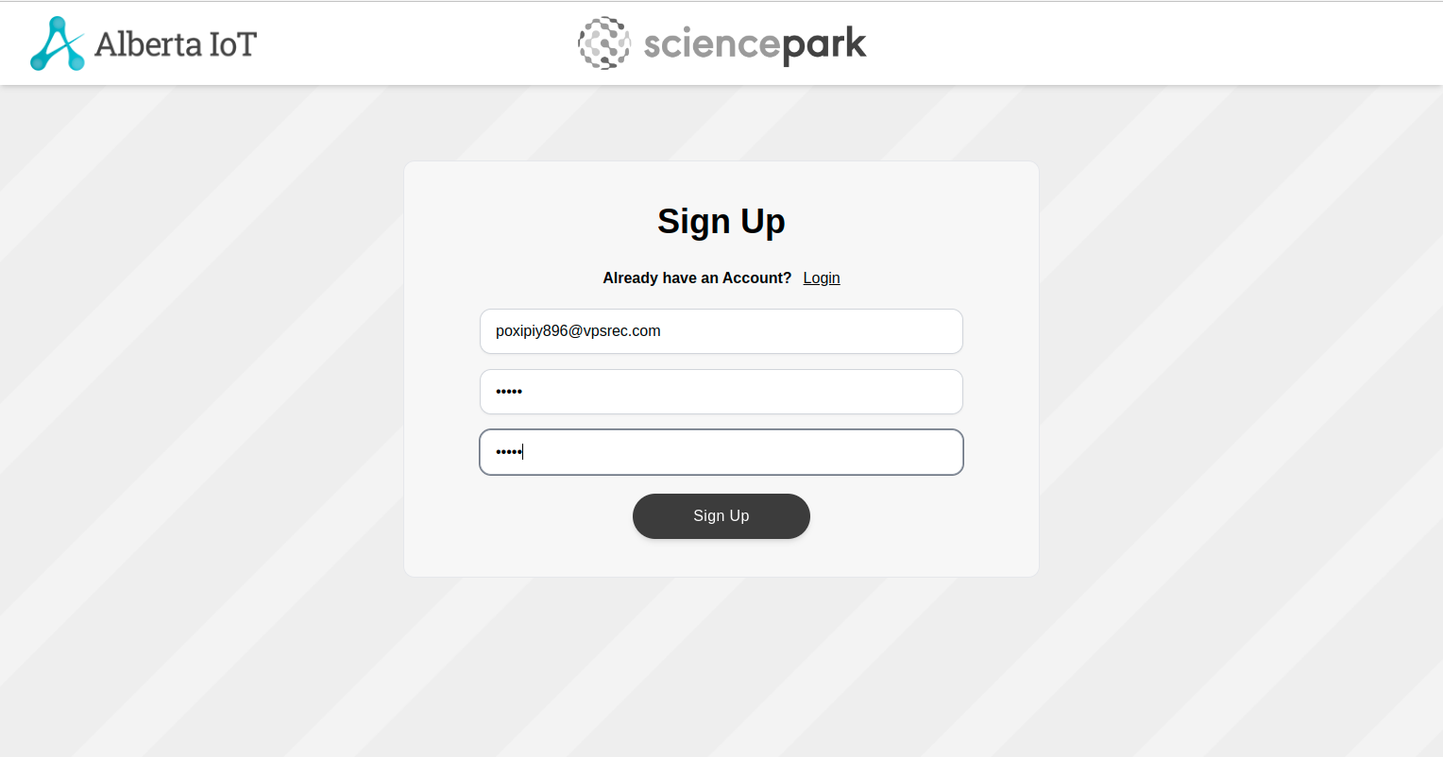

**Login Page**

Again after updation I’ve tested the Login Page of the website in this sprint.  
**Expected Result** :- The textboxes should be clickable and user should be able to enter the values.  
**Actual Result** :- The textboxes are clickable and user is able to enter the values.

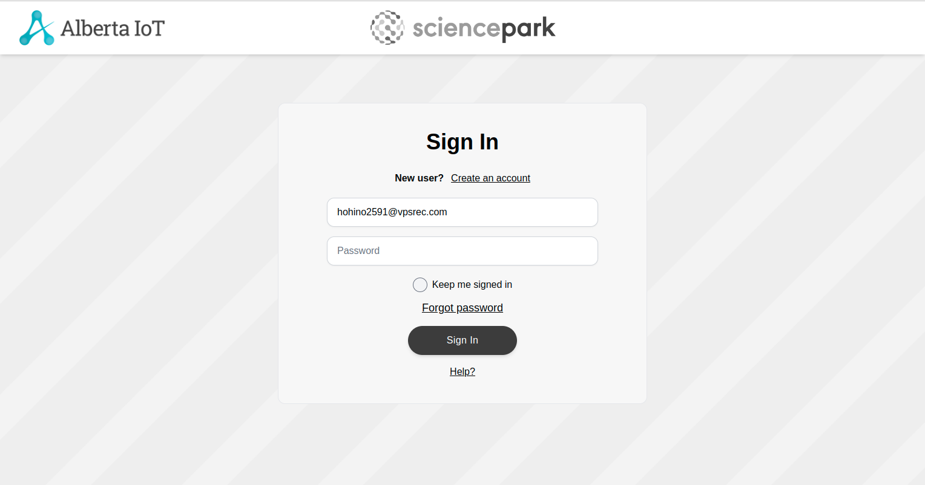

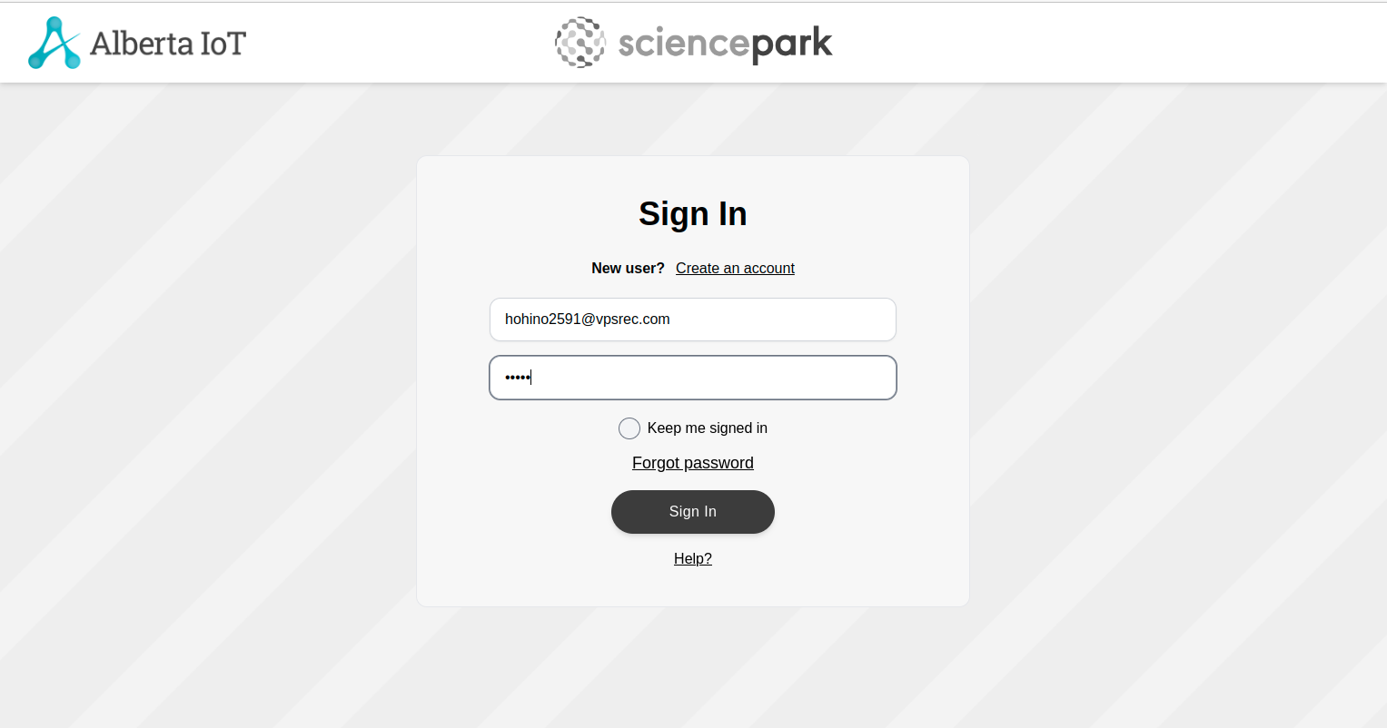

**Profile Create Page:**

Again after updation I’ve tested the Profile Create Page of the website in this sprint.  
**Expected Result** :- The textboxes should be clickable and user should be able to enter the values.  
**Actual Result** :- The textboxes are clickable and user is able to enter the values.

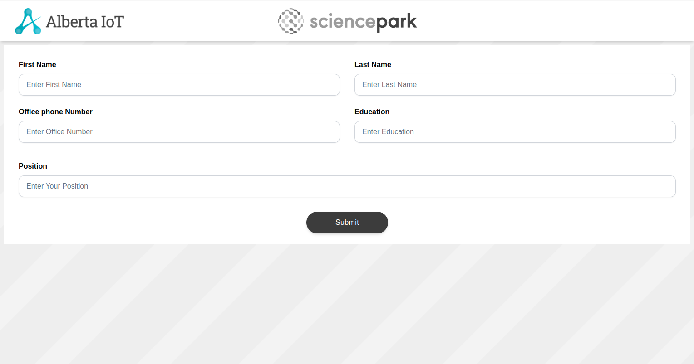

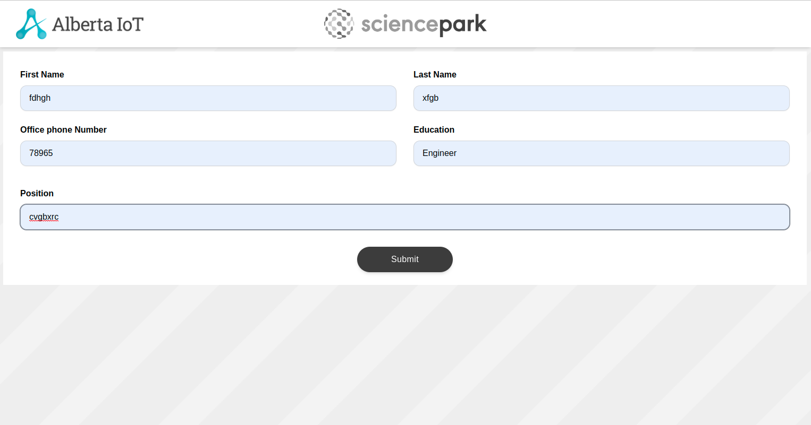

**Edit Profile:**

Have tested the Edit Profile page testboxes and by adding the values.  
**Expected Result** :- The textboxes should be clickable and user should be able to enter the values.  
**Actual Result** :- The textboxes are clickable and user is able to enter the values.

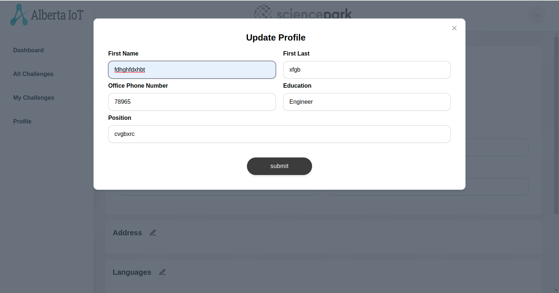

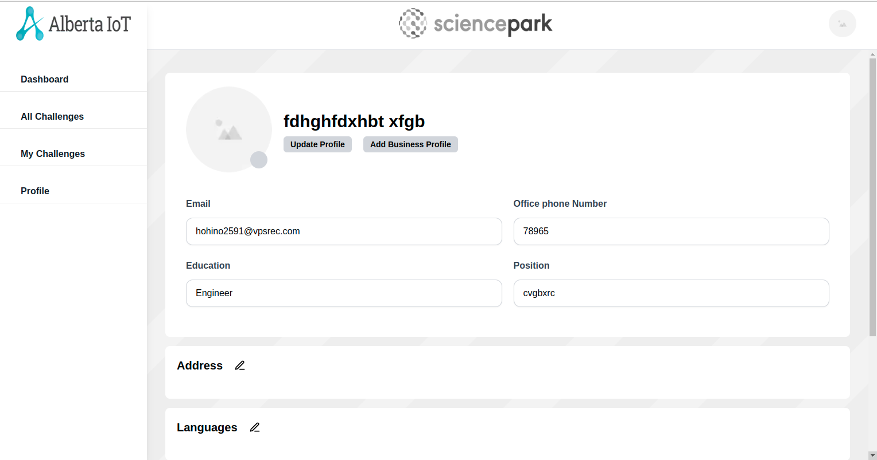

**Business Profile Page**

Have tested the Business Profile page testboxes, Dropdown and by adding the values.  
**Expected Result** :- The textboxes and Dropdown should be clickable and user should be able to enter the values in the textboxes.  
**Actual Result** :- The textboxes and Dropdown are clickable and user is able to enter the values in the textboxes.

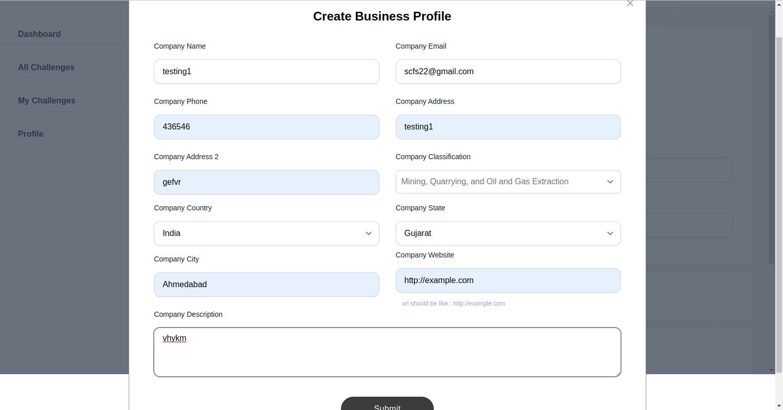

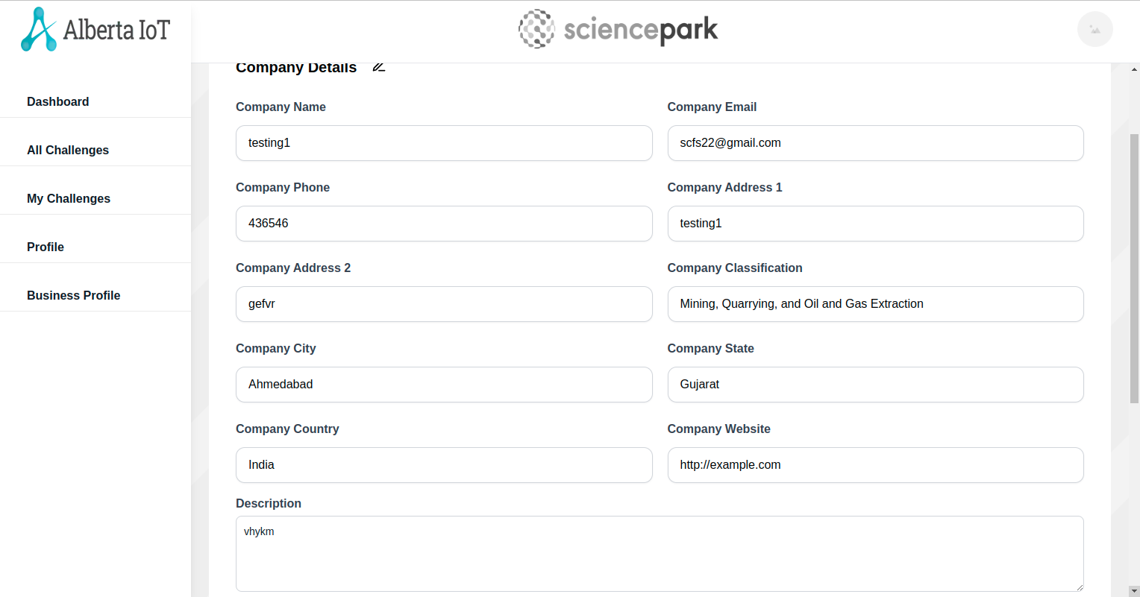

**Update Business Profile**

Have tested the Update business Profile testboxes, Dropdown and by updating the values.  
**Expected Result** :- The textboxes and Dropdown should be clickable and user should be able to update the values in the textboxes.  
**Actual Result** :- The textboxes and Dropdown are clickable and user is able to update the values in the textboxes.

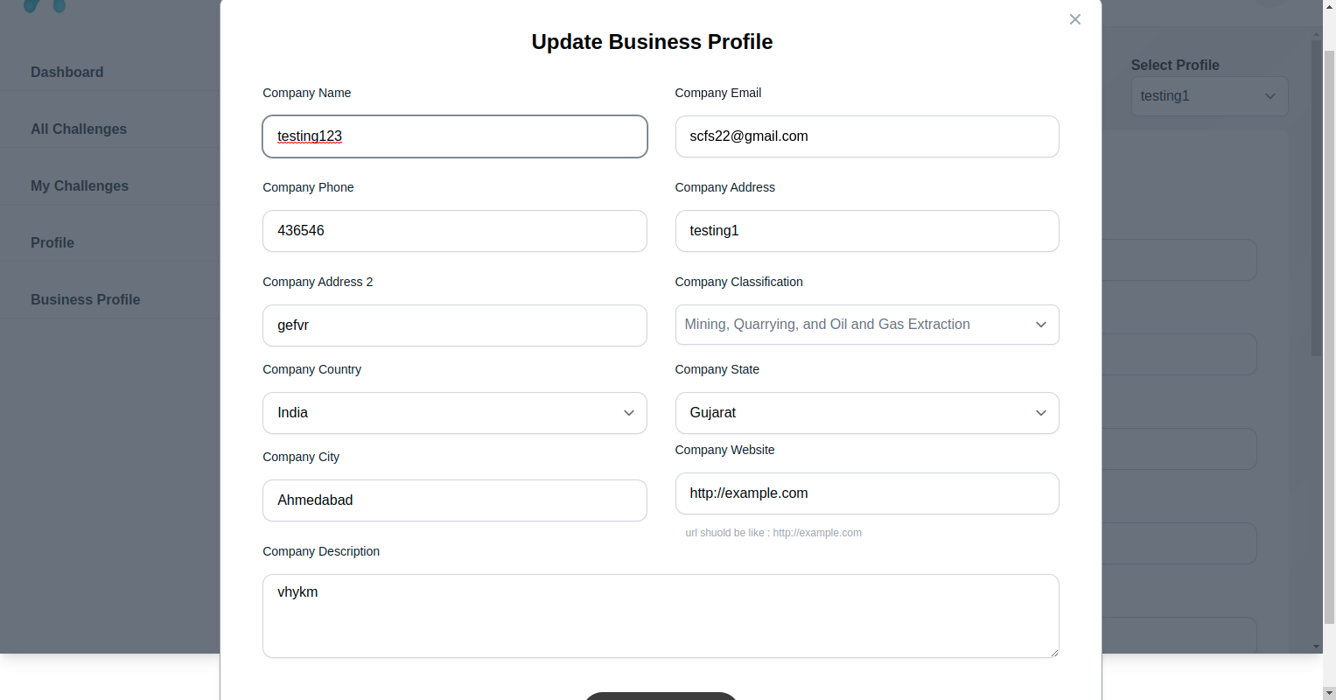

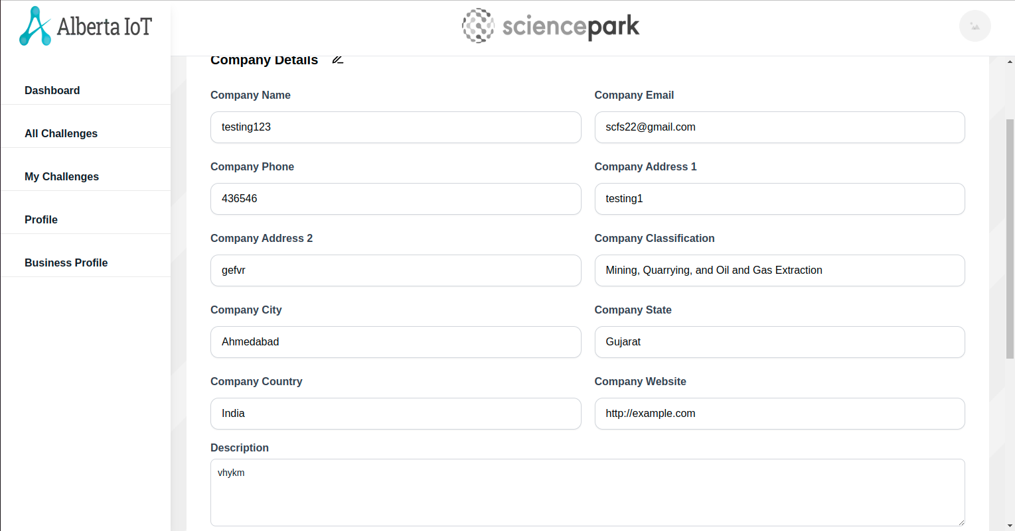

**My Challenge Page:**

Have tested the Create Challenge page testboxes, Dropdown, Checkboxes by adding the values.

**Expected Result** :- The textboxes, Dropdown and Checkboxes should be clickable and user should be able to enter the values in the textboxes.  
**Actual Result** :- The textboxes, Dropdown and Checkboxes are clickable and user is able to enter the values in the textboxes.

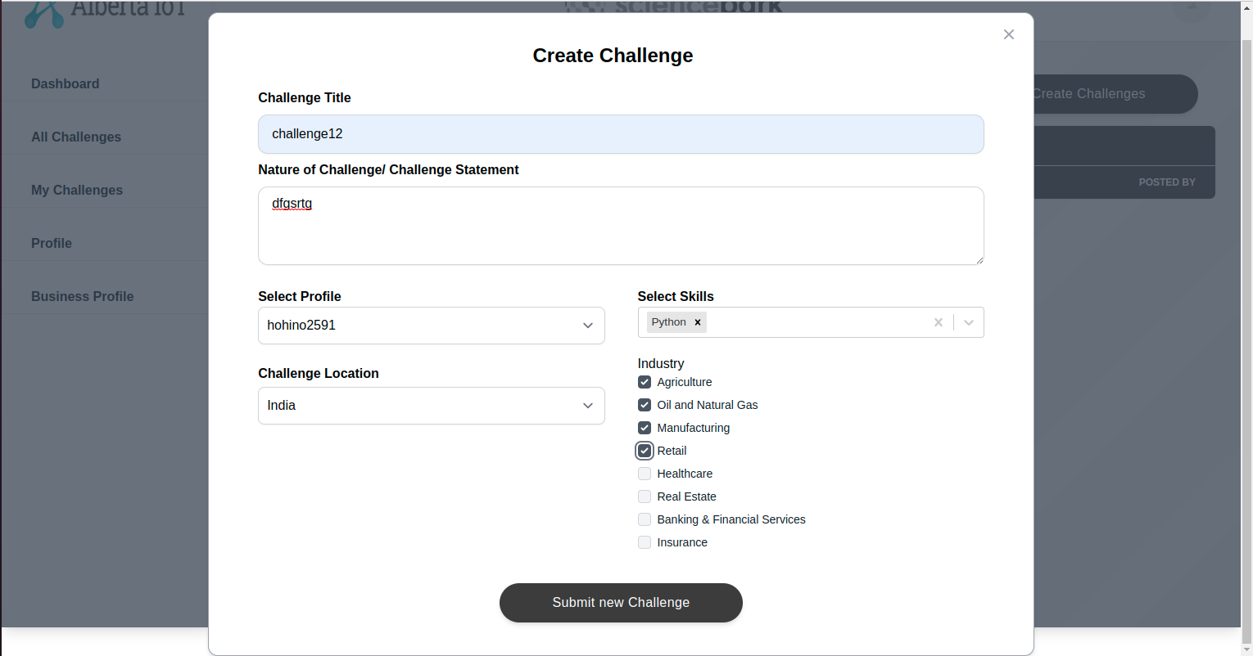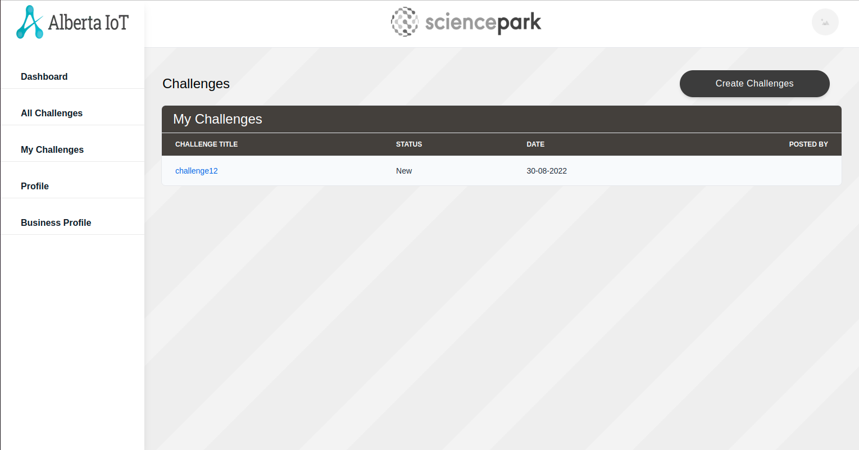

**All Challenges Page:**

*Create challenge is same in both My challenge and All Challenges

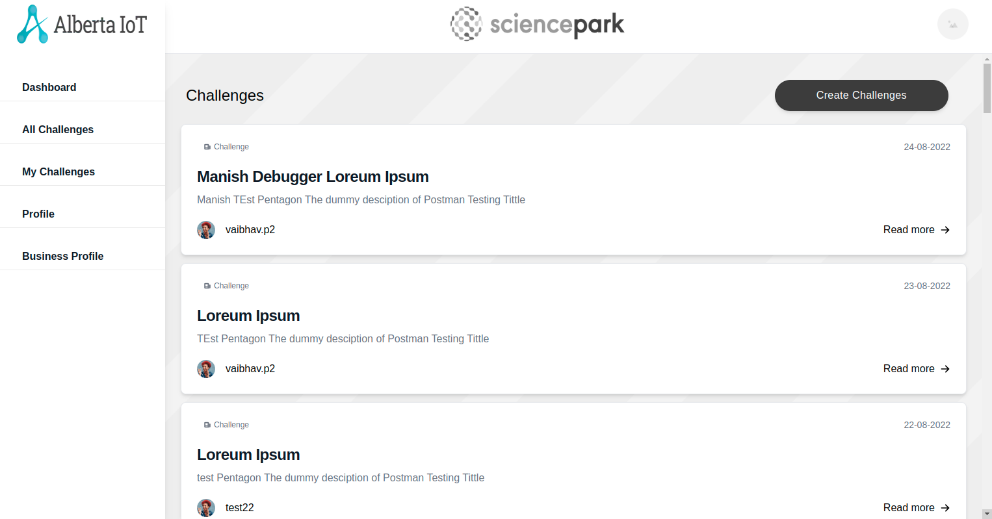

In this, my challenge challenges are not showing.

**Invite Teams:**

Have tested the Create Challenge page testboxes, Checkboxesby adding the values.

**Expected Result** :- The textboxes, Checkboxes should be clickable and user should be able to enter the values in the textboxes.  
**Actual Result** :- The textboxes, Checkboxes are clickable and user is able to enter the values in the textboxes.

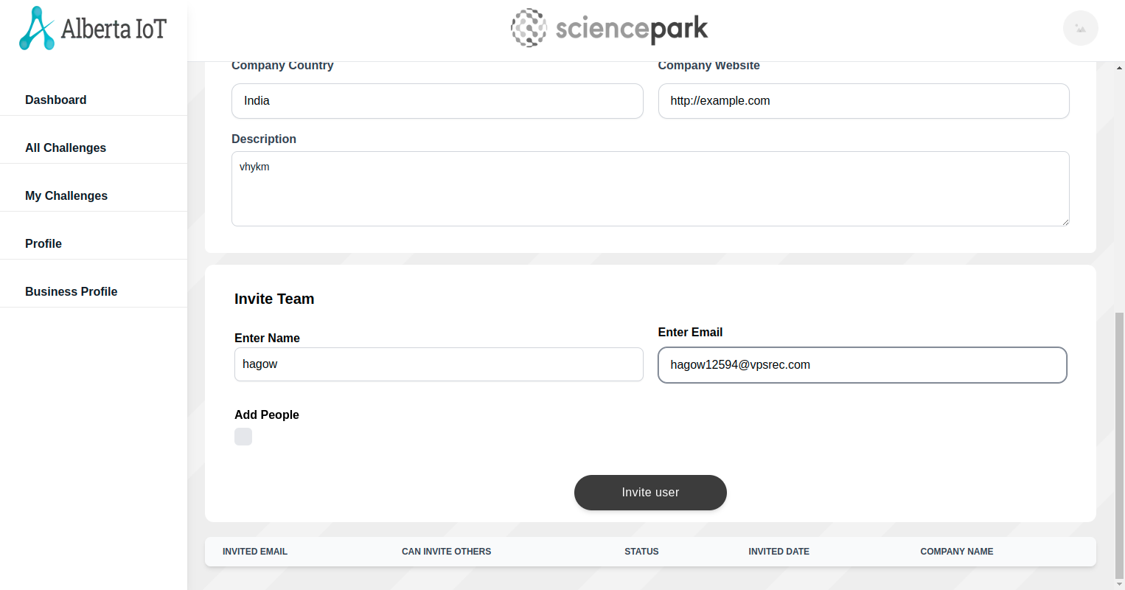

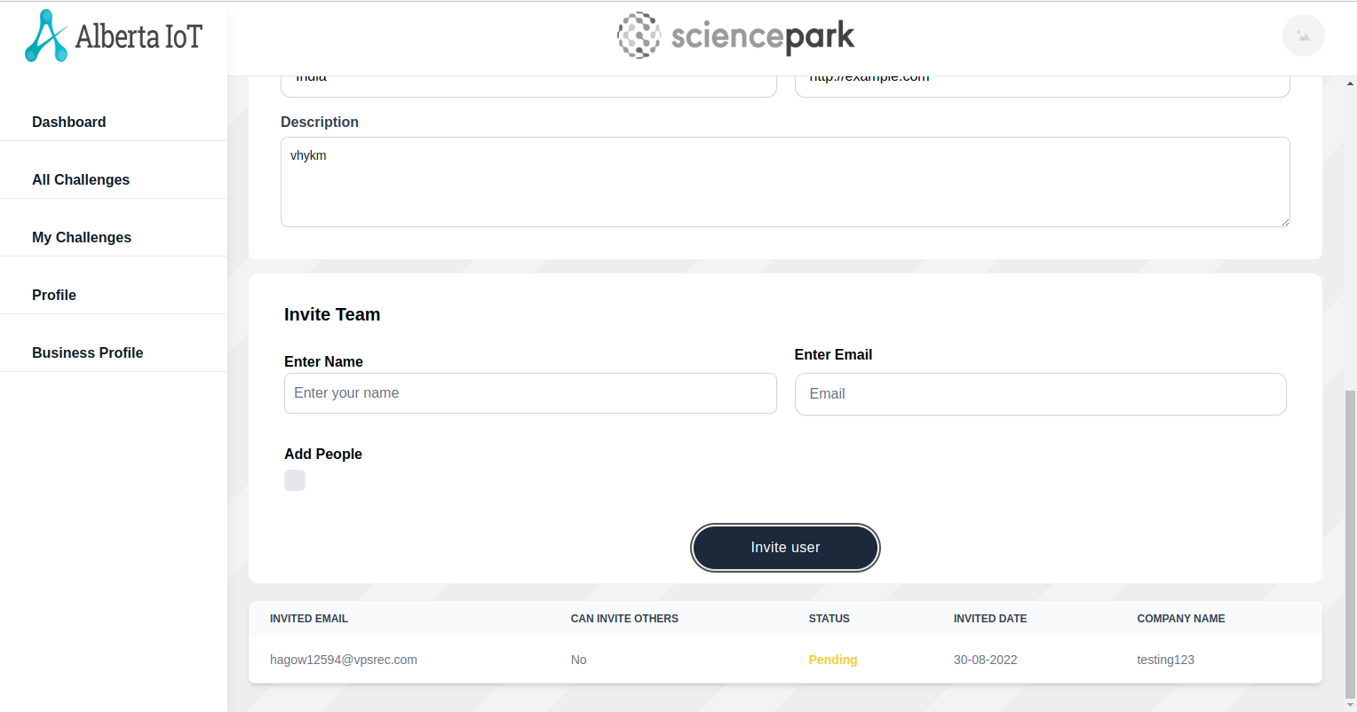*In this, multiple business profiles are showing same users.