**Introduction**

### Purpose:

Our Initial Value Proposition (IVP) is that business, researchers, Post-Secondary Institutions (PSIs), private labs and government groups (funders, labs etc) have no centralized, well-developed method of matching solution providers with solution seekers.

### Scope:

The platform will contain data on resources, (talent, space, equipment, software and hardware solutions / products) which will be matched with well-defined projects needing a solution.

**System Requirements**

## Functional Requirements:

To support the user stories, our application has the following requirements. Others may exist, but we’ve identified and organized as many as possible here. This section summarizes the key components.

## SP.FR.001 Navigation

The application must be able to provide navigation as described in the Application Design section above or in the design specification document created by the designer.

## SP.FR.002 Login

Users must log in to the application using an email address and password. Password requirements should follow as reasonably possible the current best practices the Open Web Application Security Project ([OWASP](https://www.owasp.org/index.php/Authentication_Cheat_Sheet#Implement_Proper_Password_Strength_Controls)) specifies.

## SP.FR.003 Forgot Password Process

Users who forget their passwords can recover it using the [side channel token](https://www.owasp.org/index.php/Forgot_Password_Cheat_Sheet) [methodology](https://www.owasp.org/index.php/Forgot_Password_Cheat_Sheet) (link via email). For the purposes of the MVP we can skip the first step of identity confirmation using security questions as detailed in the specification linked above.

## SP.FR.004 User Profile Editing

Logged-in users will be able to edit the content of their user profiles

* Name
  + First name
  + Last Name
* email address
* Office phone number
  + Field must allow for all different telephone number types to include country codes - for example +011, +1, etc
* Education
  + More than one field as some users may want to add several degrees to their profile
* Position (and any role-relative specifics)
* Languages spoken
* Experience Level (Junior / Senior / Expert)
* Categories of experience (as with profile creation on work-share communities, user will being typing and will be able to select from

proffered choices) - industry classifications to be derived from [Standard](https://en.wikipedia.org/wiki/Standard_Industrial_Classification) [Industrial Classifications](https://en.wikipedia.org/wiki/Standard_Industrial_Classification) <https://en.wikipedia.org/wiki/Standard_Industrial_Classification>

## SP.FR.005 Application Design

Elements of application design will be as shown in the wireframes or the design specification document. We will require a responsive design layout. We intend to support desktop, laptop and tablets.

## SP.FR.006 User Administration Dashboard (Admin)

The technical nature of the platform and its' user match-making process requires some level of admin oversight. This process needs a user administration dashboard to input user details and initiate the invitation process.

## Non Functional Requirements:

**Performance :-** The website’s load time should not be more than one second for users.

**Reliability :-** Applicants can be able to access the website without failure.

**Availability :-** In case of unplanned system downtime, all features will be available after one working day.

**Recoverability :-** If the major incident happens on the website, it must take measures to go back to being fully operational within three days.

**Usability :-** The website’s interface has to be user friendly and easy to use.

## System Requirement GCP(Google Cloud Platform) :-

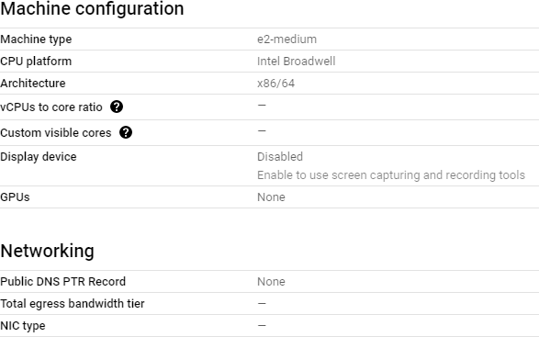

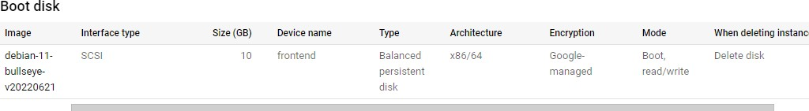

There are 3 VM’s with the same above given configurations :-

1. Dev
2. Alpha
3. Beta

## Cloudflare :-

To use Cloudflare, you need to point the name servers for your domain to Cloudlare's ones.

The traffic is forwarded to the Cloudflare network, where it gets automatically filtered o prevent malicious traffic.

The name servers can be changed where you have registered the domain.

Cloudflare Name Servers:

NS ara.ns.cloudflare.com NS chris.ns.cloudflare.com

DNS Record:

CNAME - www - thesciencepark.dev - Proxied - TTL(Auto)

A - thesciencepark.dev - 68.183.192.104 - Proxied - TTL(Auto) A - alpha - 34.69.195.100 - Proxied - TTL(Auto)

A - beta - 34.172.105.190 - Proxied - TTL(Auto) A - dev - 35.184.8.213 - Proxied - TTL(Auto)

SSL/TLS encryption mode is Flexible (Encrypts traffic between the browser and Cloudflare)

***Alberta Science Park***

**Software Design Document**

Version 1.1

3



# Introduction

#### Document Purpose

The purpose of this document is to outline the technical aspects of the Alberta Science Park Web Application and the technologies used to develop and

implement the application. The goal of this document is to give the reader a better understanding of how the application is being developed and implemented through examples of requirements, constraints, and system architecture.

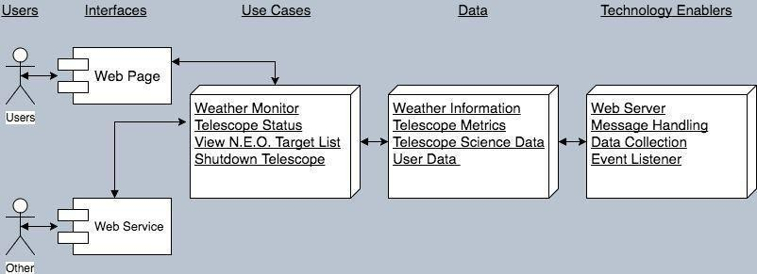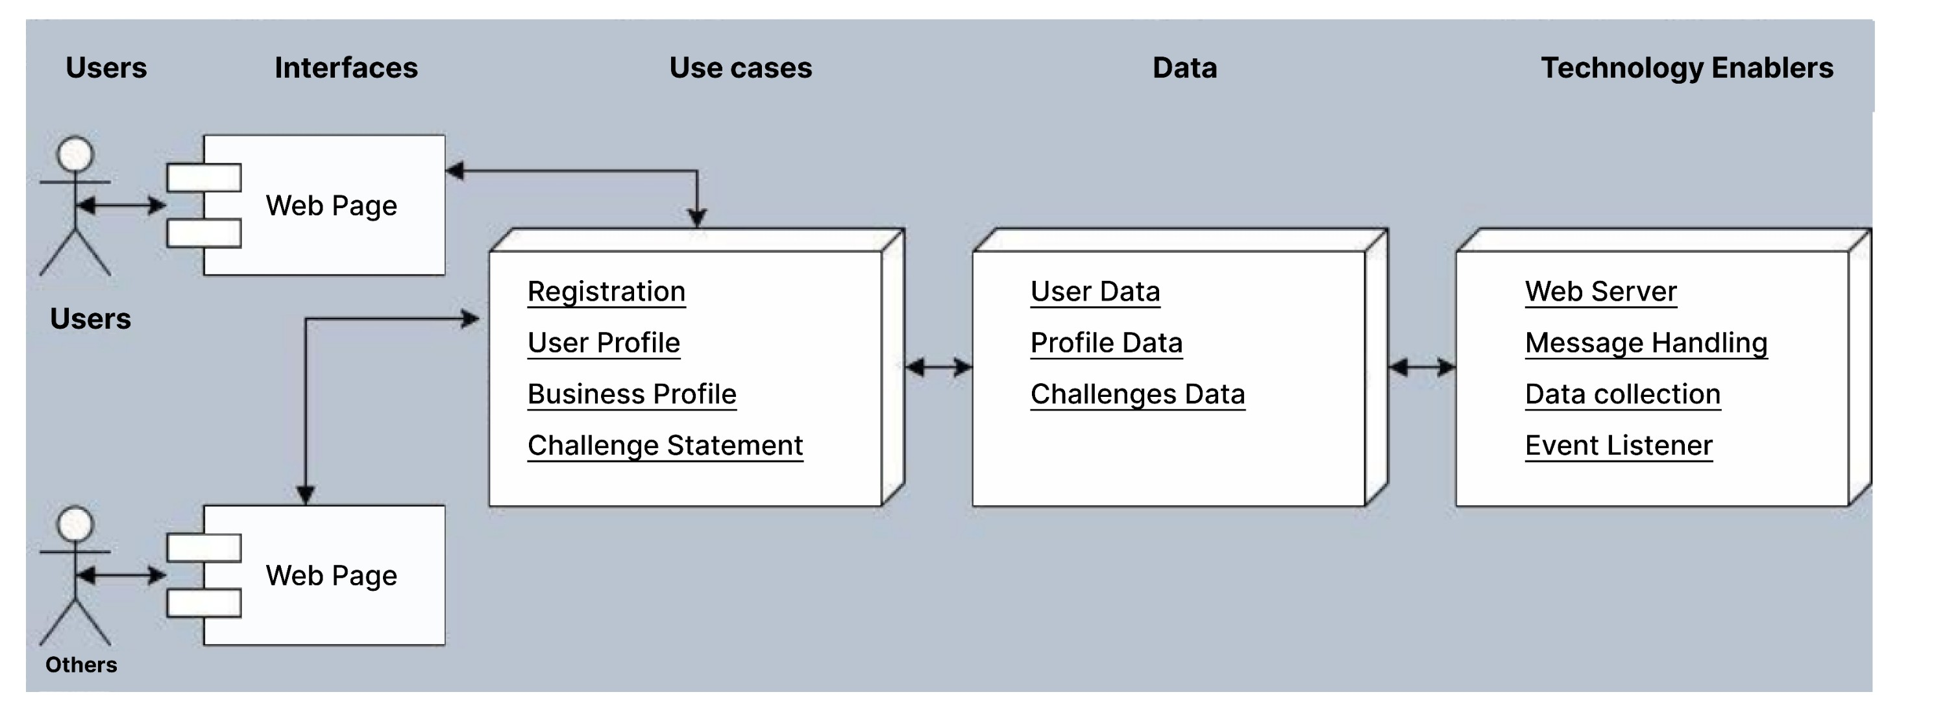



# Architectural Overview

#### Application overview

***Figure 1: Application Overview and Diagram***

#### Core application uses

Figure 1 highlights the use-cases for the Alberta Science Park application. These uses are the expectations of information to be presented to the user.

* Persona One - Geroge
  + His purpose for using the platform is to seek solutions to his particular engineering challenges which affect pipeline operations
* Persona Two - Graham
  + His purpose for using the platform is to ensure utilization of all the

lab's resources, to help secure ongoing funding and attract a steady stream of research applicants to the lab.

* Persona Three - Nancy
  + Her purpose for using the platform is to be more efficient and effective in her sales process, by utilizing the matchmaking process between solution seeker and solution provider, by ensuring that the lab's CV is always up to date in the platform.
* Persona Four - Brenda
  + Her purpose for using the platform, as a platform owner, will be to ensure that the funds were well allocated and spent, and that the utility of the platform is not skewed toward one user group, but offers equally useful functionality to all users and user groups

#### Data

The core information and data constructs required to realize the core application uses are highlighted in Figure 1. The follow data is fundamental to the core use cases.

* Users
  + The current user data will be the current/potential users using the Alberta IoT application. This system will manage the propagation of user data from web services and local hardware.
* Personal Information
  + Personal Information data will be mapped against the particular users collecting their personal data viz. First name, Last name, Education, Position, Languages spoken, Experience Level, Address, Location etc.
* Business Information
  + The Business Information data will be stored as a business profile for each and every user. The data stored will be like Company

Name, Website, Description, Office Phone, Company Classification, Company location etc.

* Challenge Statement
  + The challenge statement data will allow for permission based action between the web application as well as the web service. There will be a user to access the specific challenges he/she has created and also a common list of data to checkout all the challenges going on the platform.

#### Technology Enablers

Figure 1 highlights the key set of components to support implementation of the Alberta Science Park application.

* Web Server
  + The application will reside on a web server. The web server will be required for providing access to the Alberta Science Park IoT application interface and the REST api.
* Data Collection
  + The data collection will be implemented on a gateway machine that will propagate user and challenges data from the portal. This module will also be responsible for sending data to the web database through the REST api.
* Event Listeners
  + This module is the main function of the REST api. It will handle incoming events and request made over http from clients and web service users. It will then hand off the messages to the message handler when

implemented on the portal in near future.

The Alberta Science park IoT application is built predominantly upon the Django framework. The Django framework uses a 3-tier architecture very similar to the popular Model, View, Controller (MVC) architecture. Figure 2 can be seen below and is a diagram of the implemented framework in respect to the web application. In Figure 2 below you can see that a Django project can have multiple applications within itself, and that the Alberta Science park IoT System is using two applications in tandem.

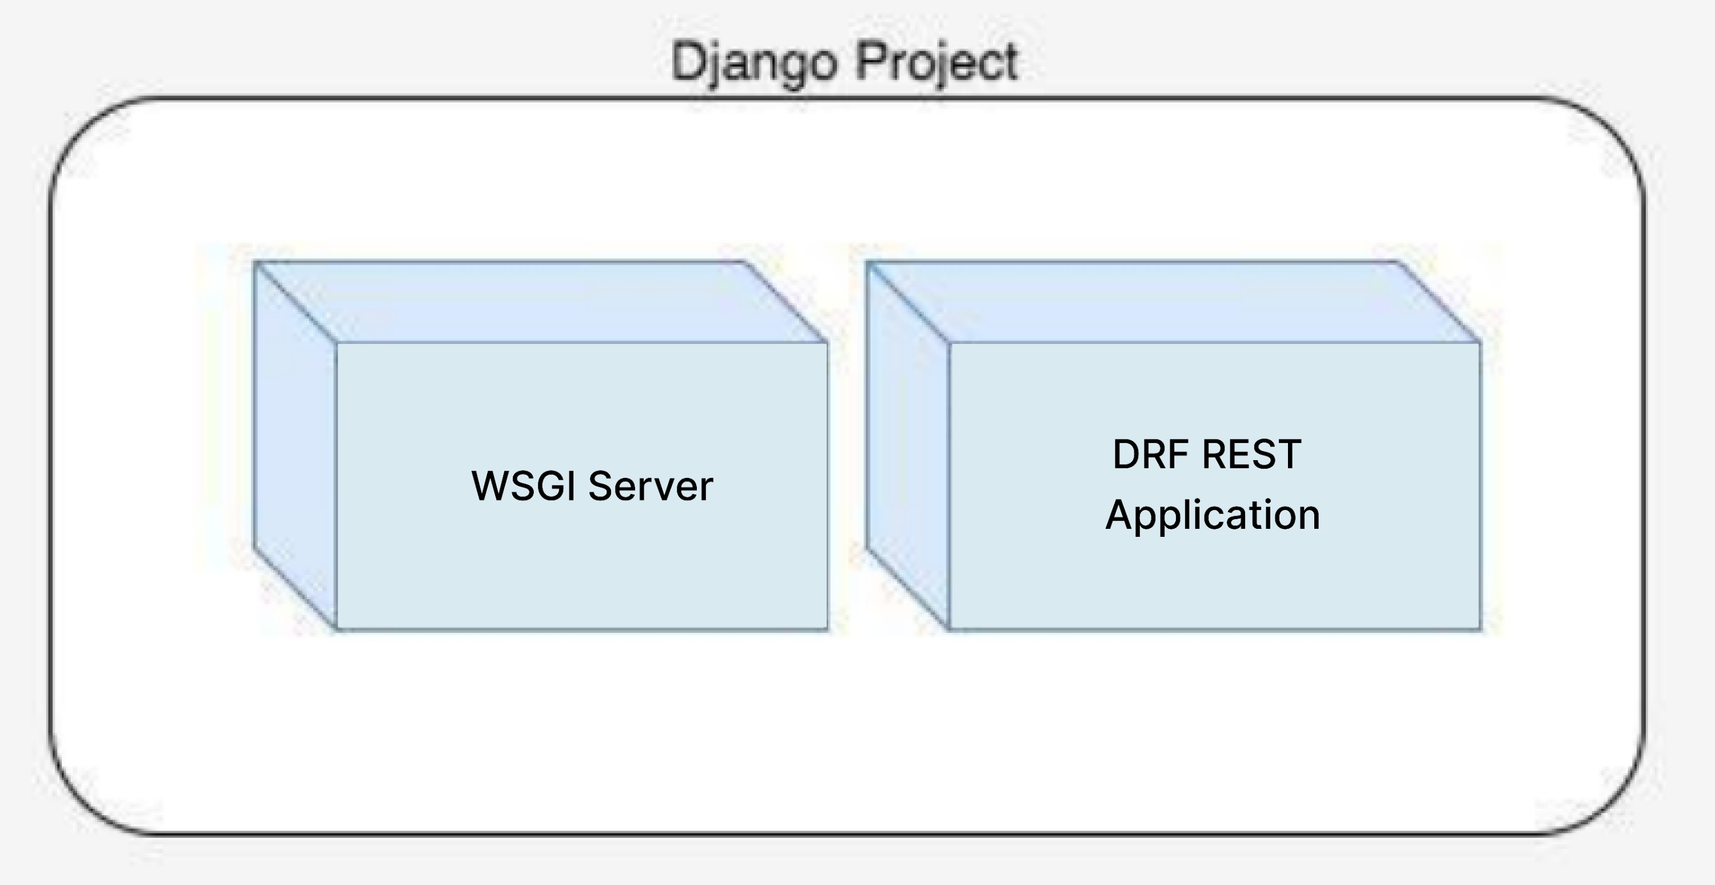

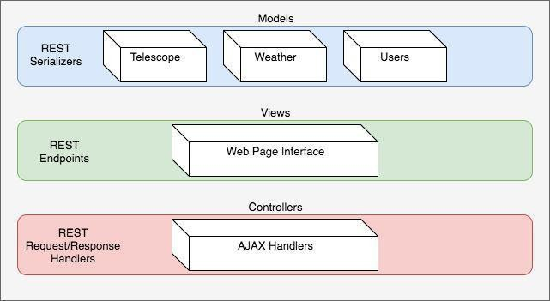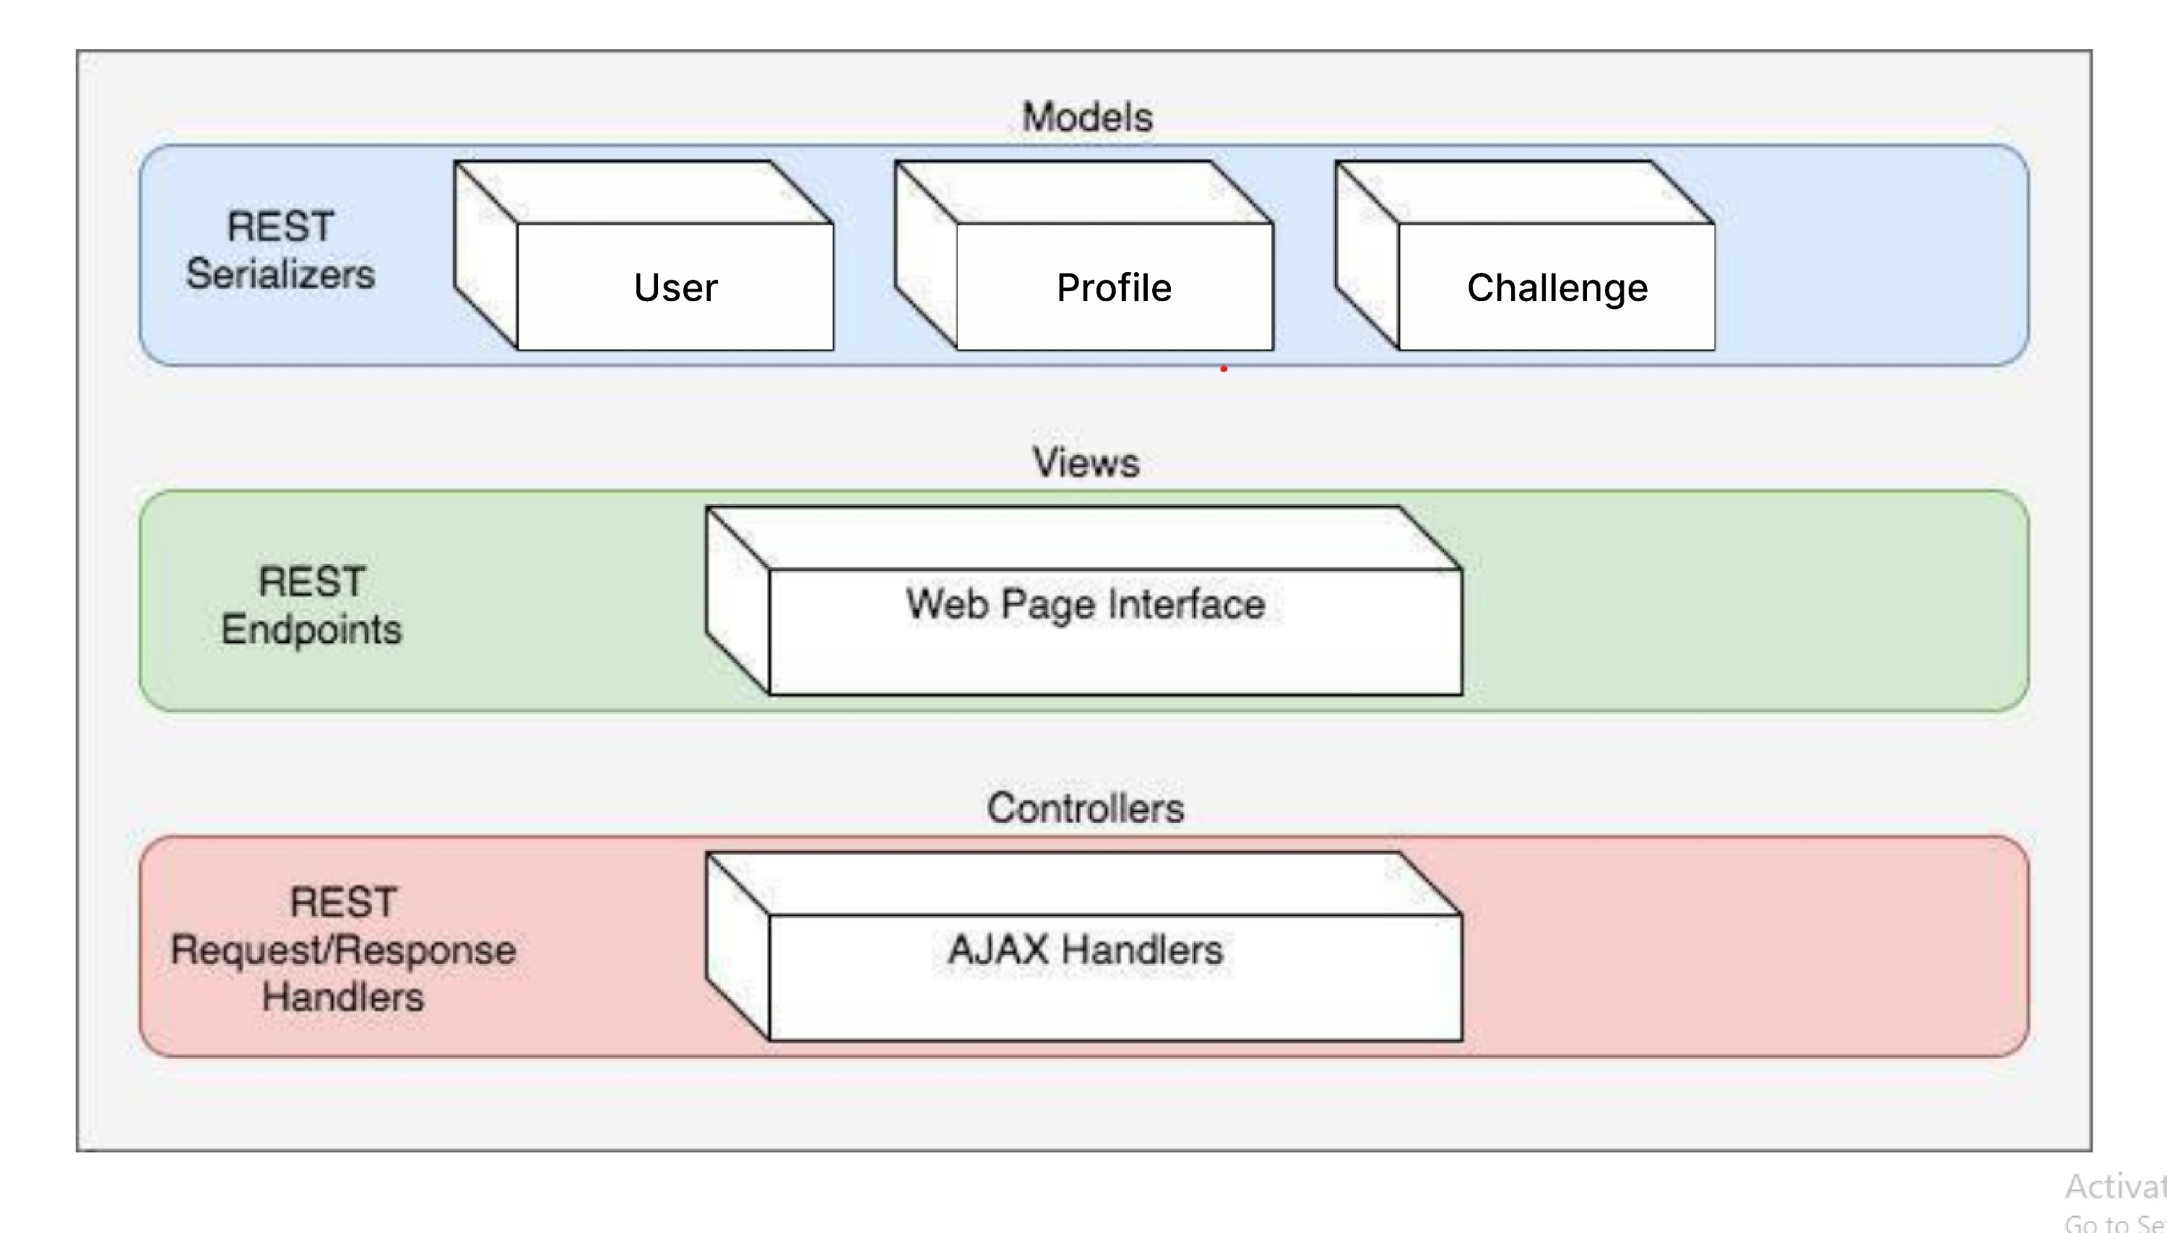

***Figure 2: Web Application Layers Diagram***

In Figure 2 above you see that there are two applications within the single Django Project. These two applications work together to accomplish the goals of the Alberta Science park IoT System. The Alberta Science park IoT Application is the application that is built upon the standard Django framework and is modeled after an MVC architecture.

Figure 3 below is a diagram of the Rest application layers. In the diagram below you can see that there are three main layers: Models, Views, and Controllers. Inside the Models you can see that there are the actual data objects that our application uses to store and display, as well as the REST Serializers that are able to serialize our data into JSON and make it easily consumable by the REST api. The Controller layer handles the GET/POST requests made by users and our application to send and receive data. The View layer is the piece of the application that allows our webpage to be created and displayed with data from the models.

***Figure 3: Layered View of Alberta Science Par****k* ***Architecture***

The Alberta Science park IoT application will use a fusion of two architectures Model, View, Controller architecture, and RESTful architecture. Inside our Django project you may recall that we have created two separate applications. The MVC will be used in the implementation of the web application interface and the RESTful architecture will be used for the backend, which will handle http request to api endpoints including ajax request from the REACT web application and external request from data collecting gateway machines. An overview of how the RESTful architecture works with our standard Django MVC architecture can be seen below in Figure 4.

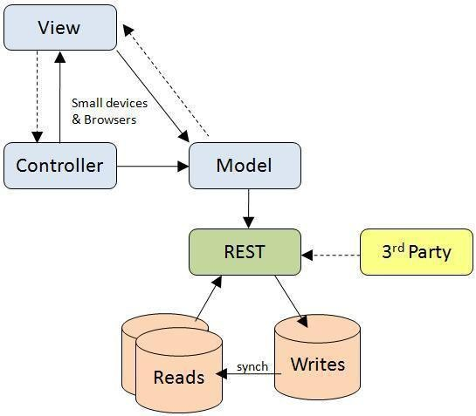

***Figure 4: REST & MVC Architecture Diagram***

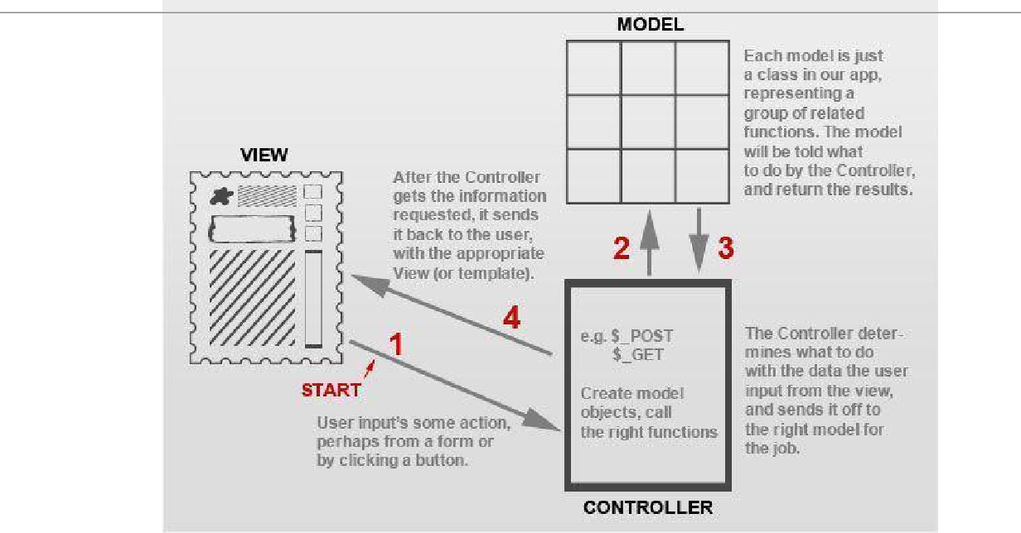

***Figure 5: MVC Diagram***

# Module and Interface Description

#### Django

###### MVC framework vs Django MTV framework.

Our project will be using django at its core. This allows us to set up the website using a commonly used MVC framework. The MVC framework consists of 3 main components; Model, View, and Controller. The model portion of the framework consists of all of the classes that we will need for the project. The View is basically what will appear on the webpage. The controller is what links the Model and the View together.

In Django the underlying MVC architecture is actually slightly different from the classic MVC approach. Models are still Models in Django, but a View is actually called a Template, and a Controller is actually called a View. This means that a Django Template is actually what you see on the webpage, and a View links the classes in a Model together with a React Frontend Technolgy.

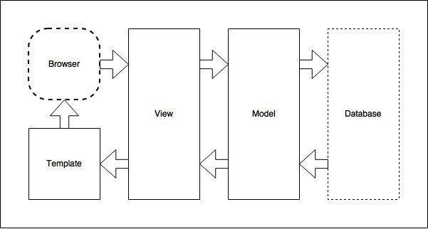

***Figure 6.1: Django MTV Diagram***

###### Flow of data in a Django MTV framework.

Figure 6 shown above showcases a brief overview of the flow of data in a basic Django application, beginning with a request from a browser and resulting in a web page produced back to the browser.

When a request is made to view a webpage provided by a Django application, it is first referenced in a list of url patterns located in a file “url.py”. The url patterns in this file will

link directly to the View portion of the MTV framework by accessing a file called “views.py”

The file “view.py” basically holds all of the functionality for the Django application ( which explains why we reference these as “controllers”), and uses the classes defined in your Model to manipulate the data before sending the data to a template.

The Model keeps all of the models in a file labeled “models.py”. Once a class is defined in this file, any objects created from each class will automatically be added to an SQLite database that is maintained inside the Django app. The requested data from the database will then be returned back to the View, and then returned to template.

Templates are used to dictate how the processed data will look on a webpage after it has been requested. A template consists of all of the basic utilities that can be included in any html document. Each page in a Django project will require its own template.

#### Urls.py

The url patterns in the “urls.py” file include “index”, “register”, “login”, and “create/personal-profile/”. Each url pattern sends a request to the View which calls a function by the same name in the “views.py” file. For example, the url pattern for “index” uses a line of code called “views.index”, and will call the function “index”, from the file “views.py”. This means that “views.py” will only consist of the 4 functions listed above. This “urls.py” file handles the url routing for the django application.

#### Models.py

In Django, database tables are created via python classes. These classes are individually referenced as a “model” and all together we call our database entries the “Models”. In the Alberta Science park IoT System we currently have many models of which let’s consider these three : Challenge Statement Data, Profile(User/Business) Data, and the User Data.

#### Views.py

“Views.py” will consist of 4 functions; “index”, “UserRegistrationView”, “UserLoginView”, and “PersonalProfileCreateView”. These functions return data to specific web pages within our web application. Each of the functions in the View are referenced by the “urls.py” file, and are called after being requested by the corresponding URL address in the Django application.

The View is not responsible for how the data is displayed, but rather what data will be displayed. The View is the section in which all of the functionality for the web application will reside. It is responsible for requesting queries from the database,

and then manipulating and organizing the data before passing it off to a React

-Frontend for displaying to a bowser.



# Implementation Plan

The following section outlines the steps and milestones that need to be completed so that the Alberta Science Park System can be implemented on time. Figure 7.1 below depicts a rough project timeline and includes 10 major implementation milestones.



# Conclusion

As a team, we feel that this project has great potential to very useful to our client. It will enable them to more effectively use their application to match-make possible personas and learn about the interests, and thus making a large impact in their productivity.

###### Compatibility Testing:-

In this, we have to test the compatibility that the website is opening in the browser or not. So have tested the compatibility in the 3 of the top browsers named Google Chrome, Mozilla Firefox and Microsoft Edge. Name of the video is **Compatibility_Testing.mkv**

###### Google Chrome:

Have tested the compatibility in Google Chrome.

**Expedted Result** :- This Link should Get opened in the Google Chrome Browser.

**Actual Result** :- This link is opening in the Google Chrome Browser.

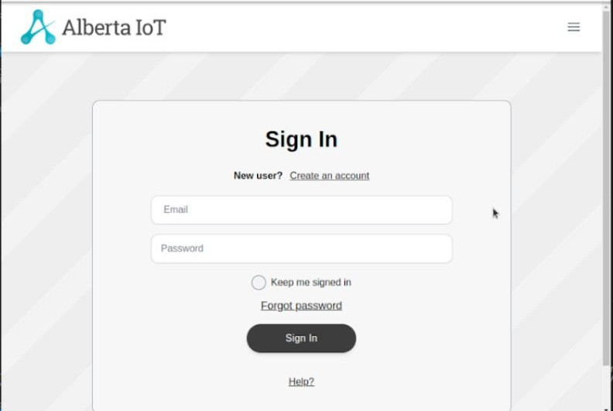

###### Mozilla Firefox:

Have tested the compatibility in Mozilla Firefox.

**Expedted Result** :- This Link should Get opened in the Mozilla Firefox Browser.

**Actual Result** :- This Link is opening in Mozilla Firefox Browser.

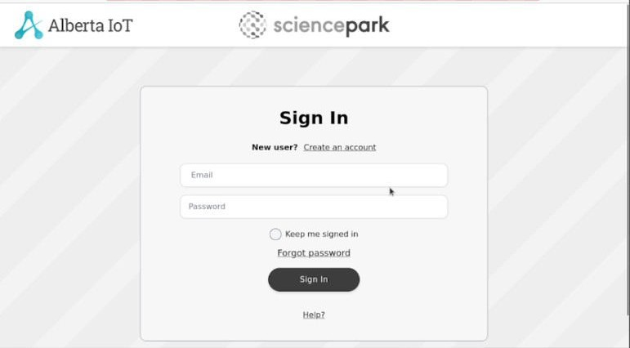

###### Microsoft Edge:

Have tested the compatibility in Microsoft Edge.

**Expedted Result** :- This Link should Get opened in the Microsoft Edge Browser.

**Actual Result** :- This Link is opening in Microsoft Edge Browser.

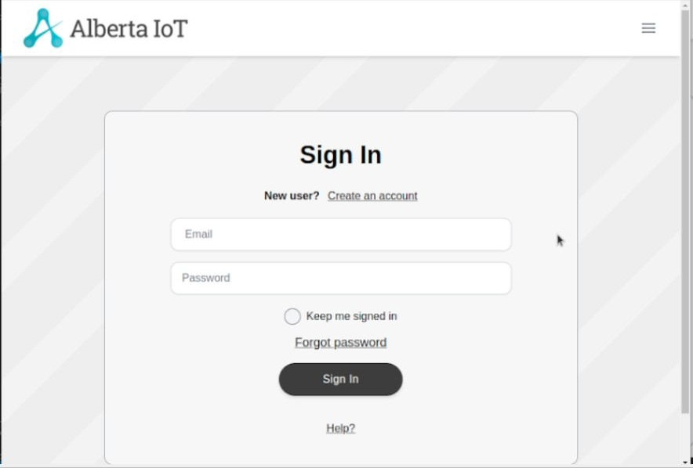

###### Penetration Testing:-

In penetration testing, I have scanned the ports in the website from 1 to 50000. In this no any port is open. Name of the video is **penetration_testing_port_scanner.mkv**

Have scanned to check that which ports are open in the website. No ports are open.

**Expected Result** :- No Ports should be opened.

**Actual Result** :- No Ports are opened

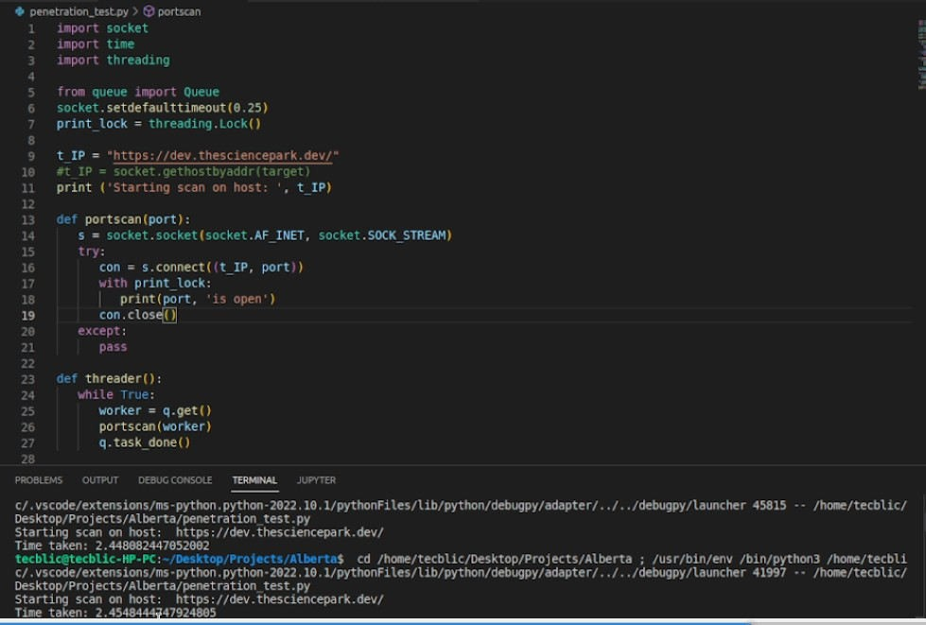

###### GUI Testing:-

In this testing, we test the UI of the website. It generally evaluates the textboxes, buttons, links, icons, lists, etc. In this, I have tested Signup Page, Login Page, Create Profile Page, Edit Profile Page, Create Challenge and Business Profile Page. Names of the videos are **signup_page.mkv, Login.mkv, Profile_Create.mkv.**

###### Signup Page

Have tested the signup page testboxes and by adding the values.

**Expected Result** :- The textboxes should be clickable and user should be able to enter the values.

**Actual Result** :- The textboxes are clickable and user is able to enter the values.

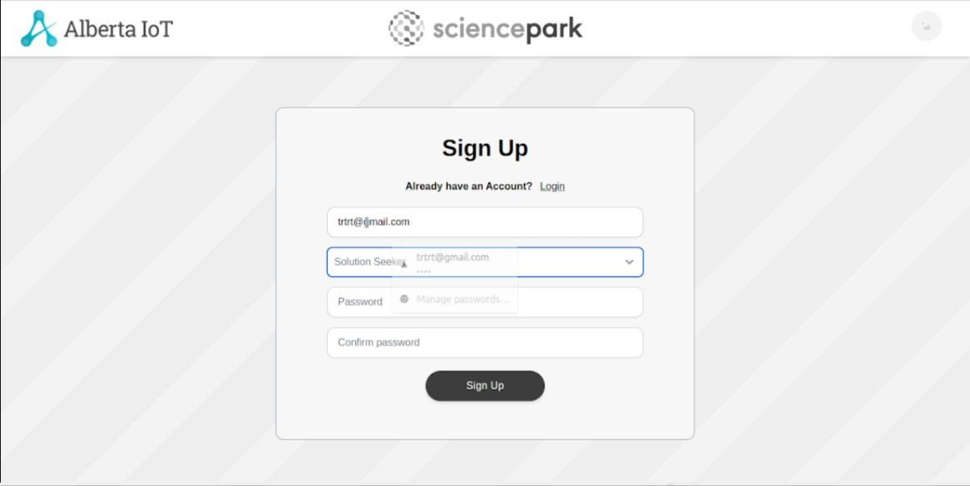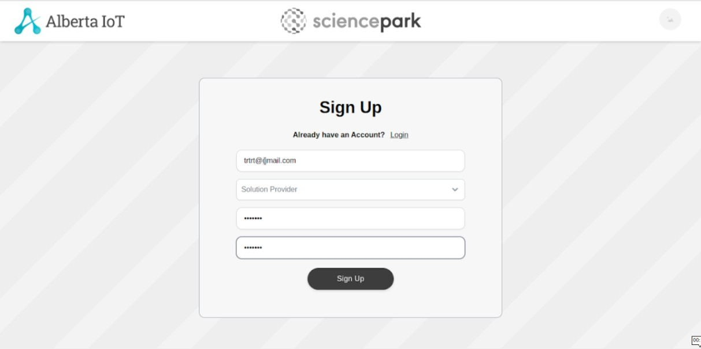

###### Login Page

Have tested the Login page testboxes and by adding the values.

**Expected Result** :- The textboxes should be clickable and user should be able to enter the values.

**Actual Result** :- The textboxes are clickable and user is able to enter the values.

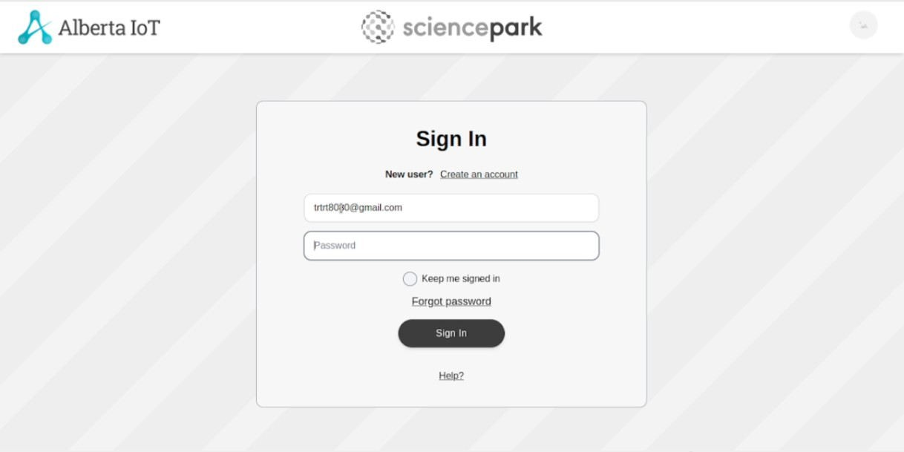

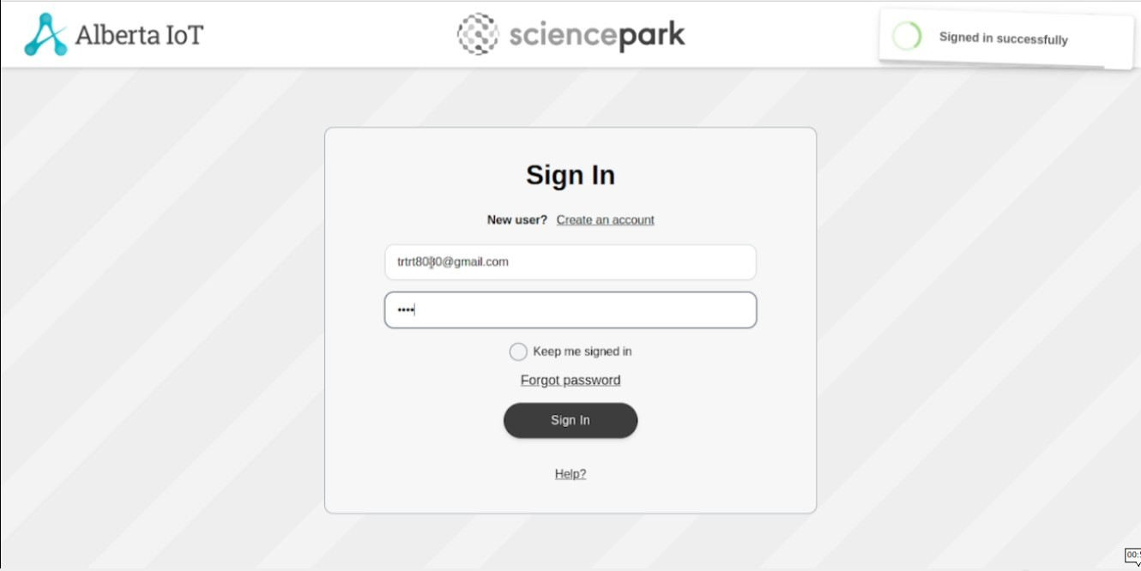

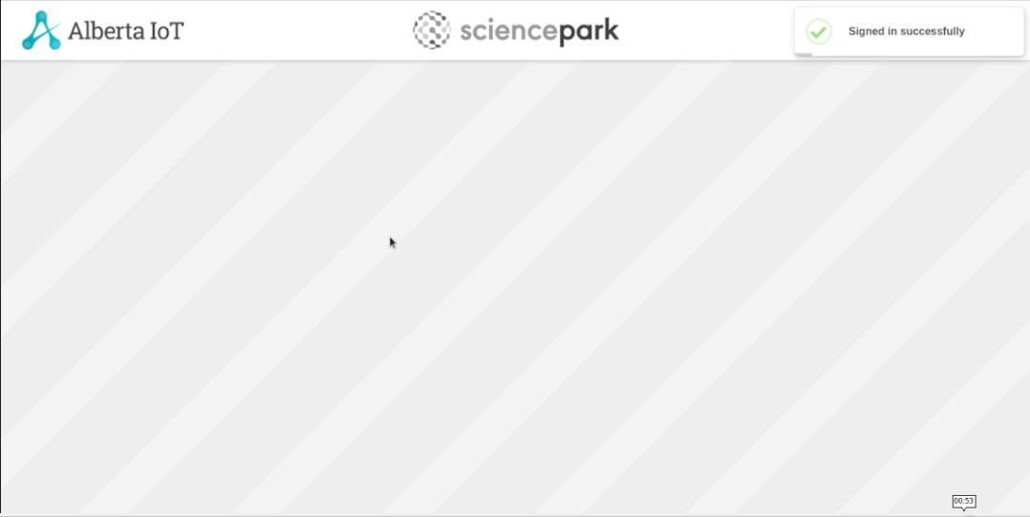

###### Profile Create Page:

Have tested the Profile Create page testboxes and by adding the values.

**Expected Result** :- The textboxes should be clickable and user should be able to enter the values.

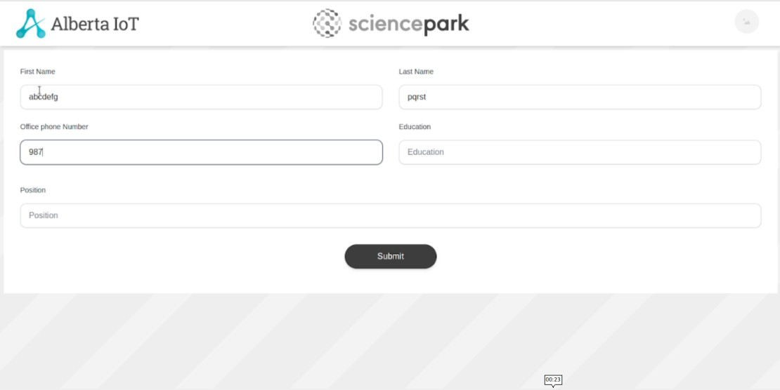**Actual Result** :- The textboxes are clickable and user is able to enter the values.

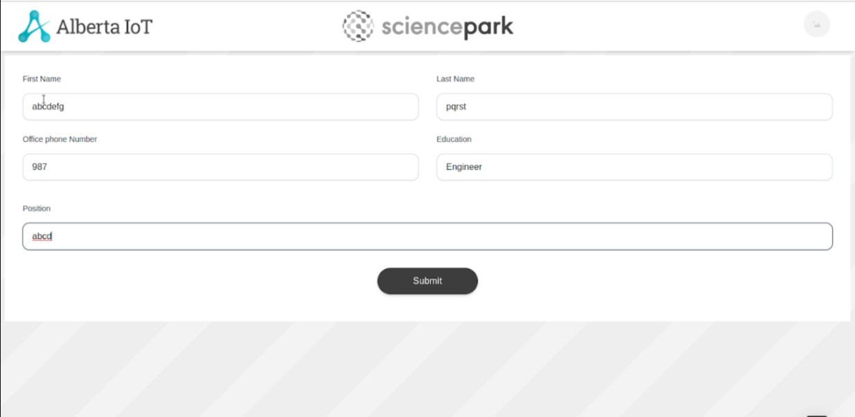

**Manual Testing (Alberta Science Park)**

**Testing Of Urls** — To check whether each URL is correctly mapped to its corresponding view. We discover that all urls function correctly. And following the testing, I used Django coverage to assess the overall accuracy for the urls.py file. Django Coverage is a library that gives us the overall percentage of testing accuracy. Additionally, the overall accuracy is 100%**.**

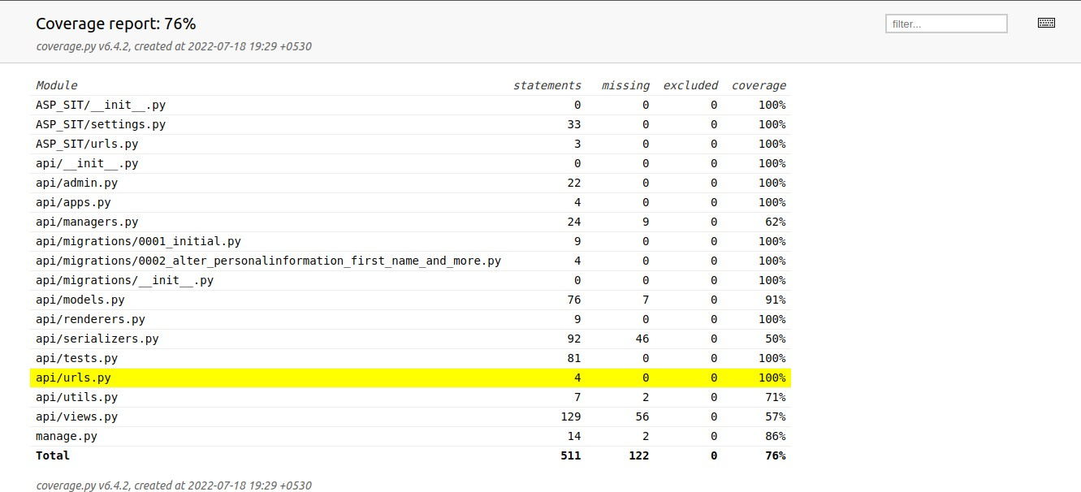

**Testing of Views** – To confirm that each view is functioning properly. Every view stores data in the database and retrieves data from the database. The coverage report for the views.py file is 77%.

###### User Registration View:-

Expected Output Current Output

**HTTP_201_CREATED HTTP_201_CREATED**

###### User Login View:-

Expected Output Current Output

**HTTP_200_OK HTTP_200_OK**

###### User Password Reset View:-

Expected Output Current Output

**HTTP_200_OK HTTP_200_OK**

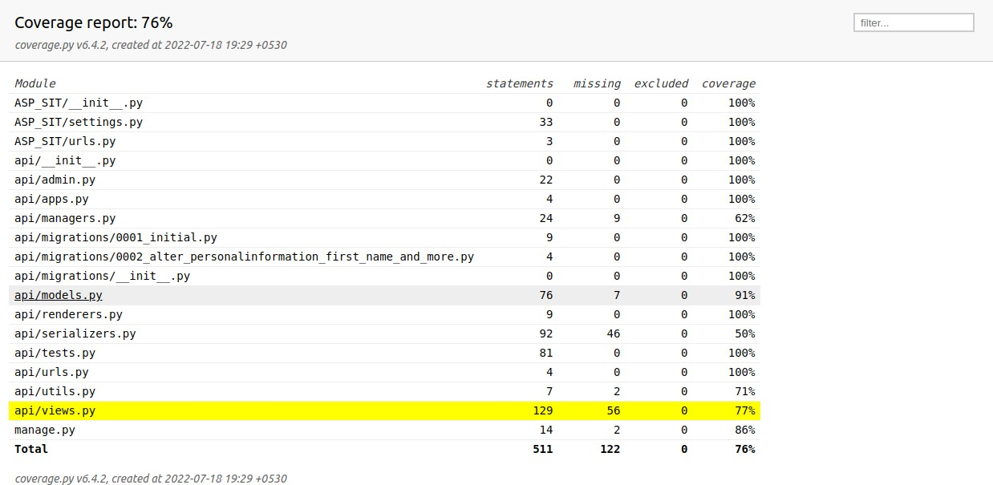

**Testing of Model –** To verify that all models for building databases and tables are functioning properly.coverage report for models.py file is 91%.

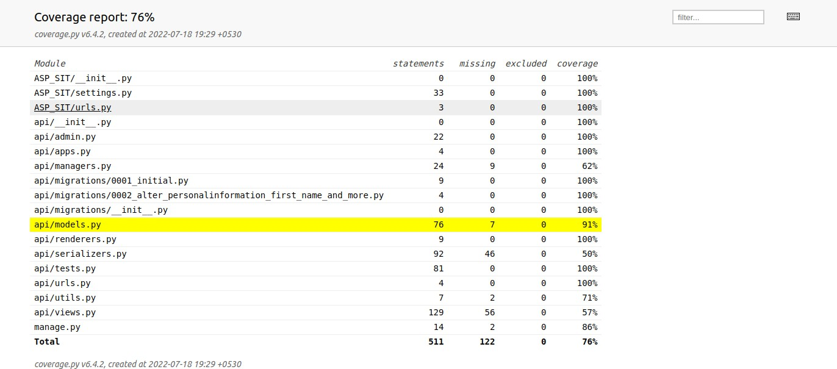

**Overall Report For Sprint 1**

Overall coverage report for sprint 1 is 77%.

### URL’S –

##### 1

Test case is for the user registration url. Test case for this URL passed. Output matches the anticipated outcome.

|  |  |  |
| --- | --- | --- |
| **URL Name** | **Description** | **Status** |
| ‘register/’ | For user registration | Passed |

##### 2

Test case is for the user login url. Test case for this URL passed. Output matches the anticipated outcome.

|  |  |  |
| --- | --- | --- |
| **URL Name** | **Description** | **Status** |
| ‘login/’ | For user login | Passed |

##### 3

Test case is for the user password reset. Test case for this URL passed. Output matches the anticipated outcome.

|  |  |  |
| --- | --- | --- |
| **URL Name** | **Description** | **Status** |
| ‘reset-password/<uid>/<to ken> | For user password reset |  |

##### VIEWS – 1

Test case for the user User Registration. Test case for this VIEW passed. Output matches the anticipated outcome.

|  |  |  |  |  |
| --- | --- | --- | --- | --- |
| **View Name** | **Description** | **Status** | **Expected Result** | **Actual Result** |
| UserRegistrati onView | View for  Register User | Passed | HTTP_201_C REATED | HTTP_201_C REATED |

##### 2

Test case is for the user User Login. Test case for this VIEW passed. Output matches the anticipated outcome.

|  |  |  |  |  |
| --- | --- | --- | --- | --- |
| **View Name** | **Description** | **Status** | **Expected Result** | **Actual Result** |
| UserLoginVie w | View for  User Login | Passed | HTTP_200_O K | HTTP_200_O K |

##### 3

Test case is for the user User Password Reset. Test case for this VIEW passed. Output matches the anticipated outcome.

|  |  |  |  |  |
| --- | --- | --- | --- | --- |
| **View Name** | **Description** | **Status** | **Expected Result** | **Actual Result** |
| UserPassword ResetView | View for Password Reset | Passed | HTTP_200_O K | HTTP_200_O K |

##### MODELS –

**1**

Test case is for the user User Creation. Test case for this MODEL passed. Output matches the anticipated outcome.

|  |  |  |  |  |
| --- | --- | --- | --- | --- |
| **Model Name** | **Description** | **Status** | **Expected Result** | **Actual Result** |
| User | Creating User | Passed | HTTP_201_C REATED | HTTP_201_C REATED |

##### 2

Test case isfor the user Password Reset. Test case for this MODEL passed. Output matches the anticipated outcome.

|  |  |  |  |  |
| --- | --- | --- | --- | --- |
| **Model Name** | **Description** | **Status** | **Expected Result** | **Actual Result** |
| User | Password Reset | Passed | HTTP_200_O K | HTTP_200_O K |

###### Compatibility Testing:-

In this, we have to test the compatibility that the website is opening in the browser or not. So have tested the compatibility in the 3 of the top browsers named Google Chrome, Mozilla Firefox and Microsoft Edge. Name of the video is **Compatibility_Testing.mkv**

###### Google Chrome:

Again after updation I’ve tested the compatibility of the website in this sprint in Google Chrome.

**Expedted Result** :- This Link should Get opened in the Google Chrome Browser.

**Actual Result** :- This Link is opening in Google Chrome Browser.

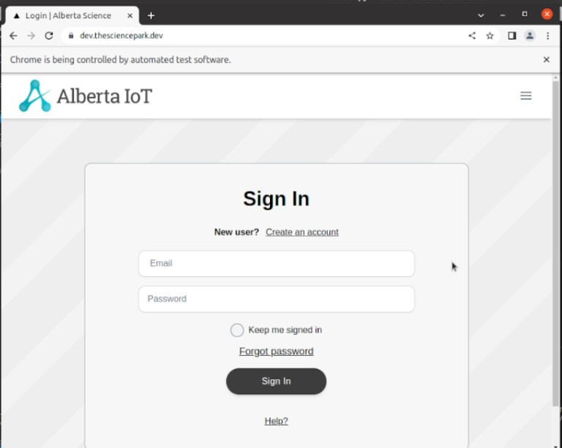

###### Mozilla Firefox:

Again after updation I’ve tested the compatibility of the website in this sprint in Mozilla Firefox

**Expedted Result** :- This Link should Get opened in the Mozilla Firefox Browser.

**Actual Result** :- This Link is opening in Mozilla Firefox Browser.

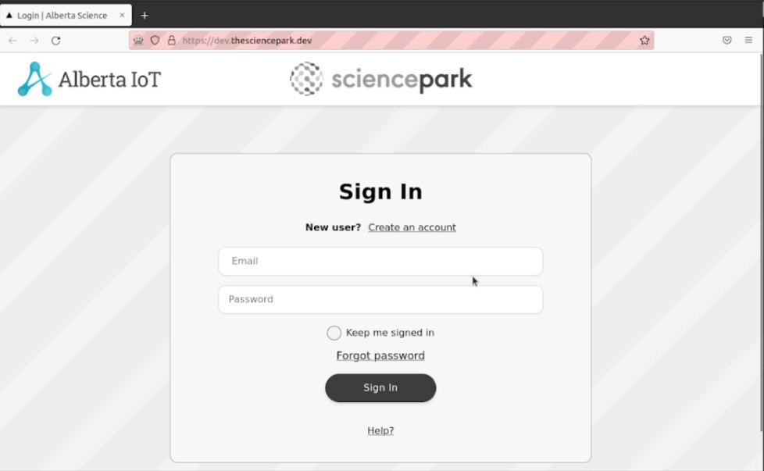

###### Microsoft Edge:

Again after updation I’ve tested the compatibility of the website in this sprint in Microsoft Edge.

**Expedted Result** :- This Link should Get opened in the Microsoft Edge Browser.

**Actual Result** :- This Link is opening in Microsoft Edge Browser.

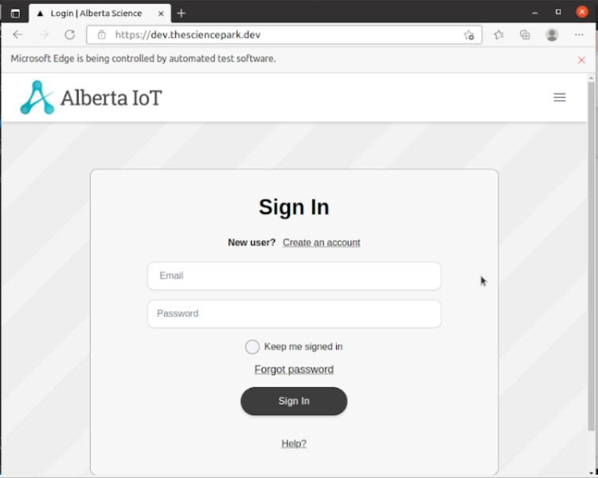

###### Penetration Testing:-

In penetration testing, I have scanned the ports in the website from 1 to 50000. In this no any port is open. Name of the video is **penetration_testing_port_scanner.mkv**

Again after updation of the website, I’ve tested the ports but no open ports were detected.

**Expected Result** :- No Ports should be opened.

**Actual Result** :- No Ports are opened



###### GUI Testing:-

In this testing, we test the UI of the website. It generally evaluates the textboxes, buttons, links, icons, lists, etc. In this, I have tested Signup Page, Login Page, Create Profile Page, Edit Profile Page, Create Challenge and Business Profile Page. Names of the videos are **signup_page.mkv, Login.mkv, Profile_Create.mkv, Edit_Profile.mkv, Business_Profile.mkv, Create_Challenge.mkv.**

###### Signup Page

Again after updation I’ve tested the Signup Page of the website in this sprint.

**Expected Result** :- The textboxes should be clickable and user should be able to enter the values.

**Actual Result** :- The textboxes are clickable and user is able to enter the values.





###### Login Page

Again after updation I’ve tested the Login Page of the website in this sprint.

**Expected Result** :- The textboxes should be clickable and user should be able to enter the values.

**Actual Result** :- The textboxes are clickable and user is able to enter the values.







###### Profile Create Page:

Again after updation I’ve tested the Profile Create Page of the website in this sprint.

**Expected Result** :- The textboxes should be clickable and user should be able to enter the values.

**Actual Result** :- The textboxes are clickable and user is able to enter the values.

###### Edit Profile:

Have tested the Edit Profile page testboxes and by adding the values.

**Expected Result** :- The textboxes should be clickable and user should be able to enter the values.

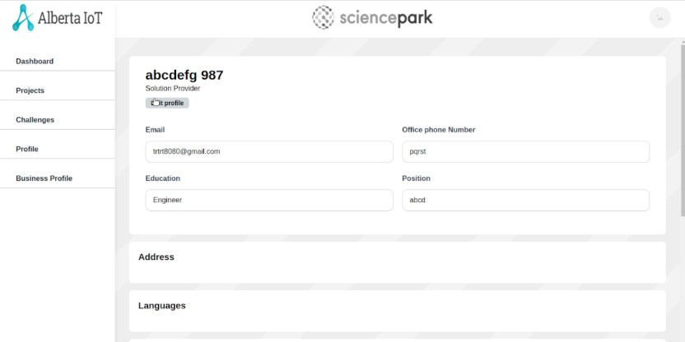**Actual Result** :- The textboxes are clickable and user is able to enter the values.

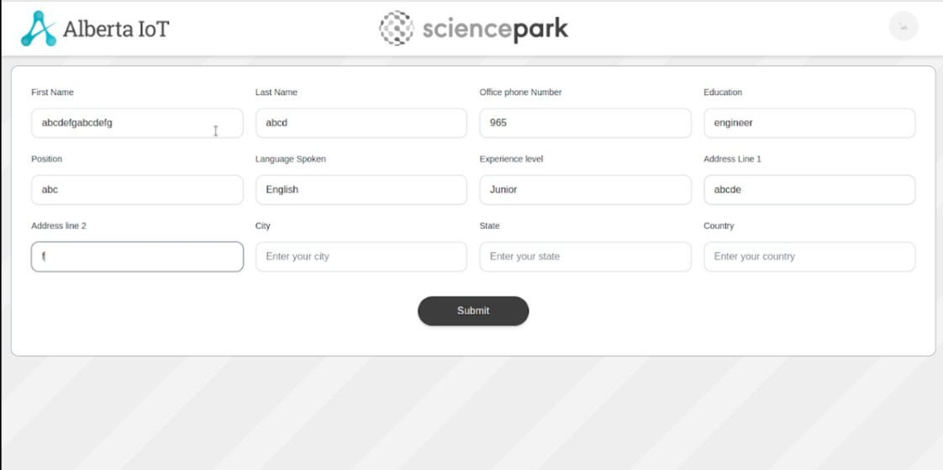

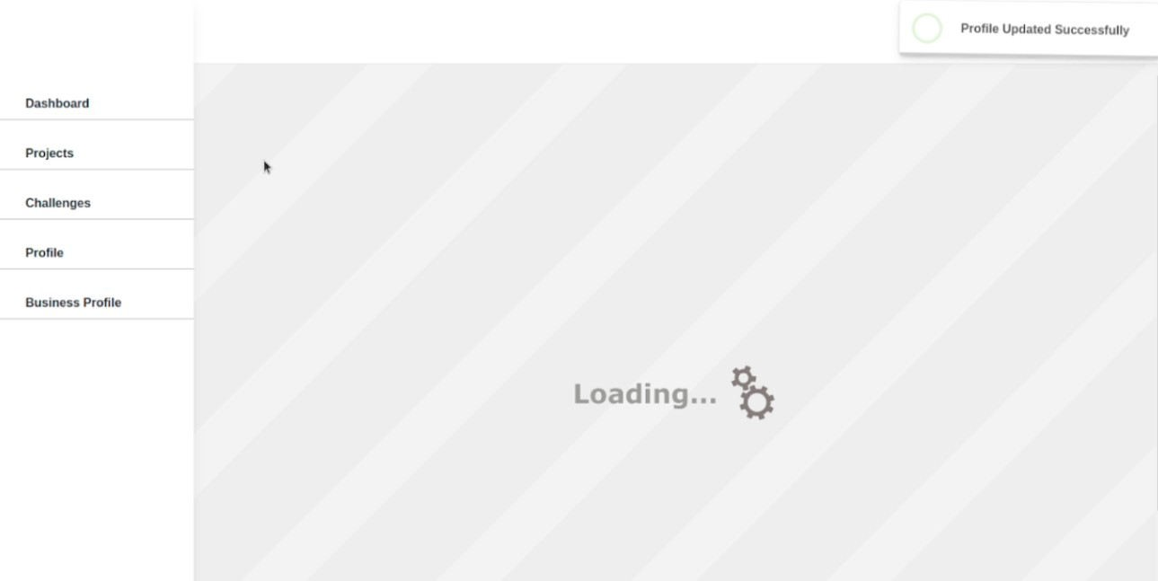

###### Business Profile Page

Have tested the Business Profile page testboxes, Dropdown and by adding the values.

**Expected Result** :- The textboxes and Dropdown should be clickable and user should be able to enter the values in the textboxes.

**Actual Result** :- The textboxes and Dropdown are clickable and user is able to enter the values in the textboxes.

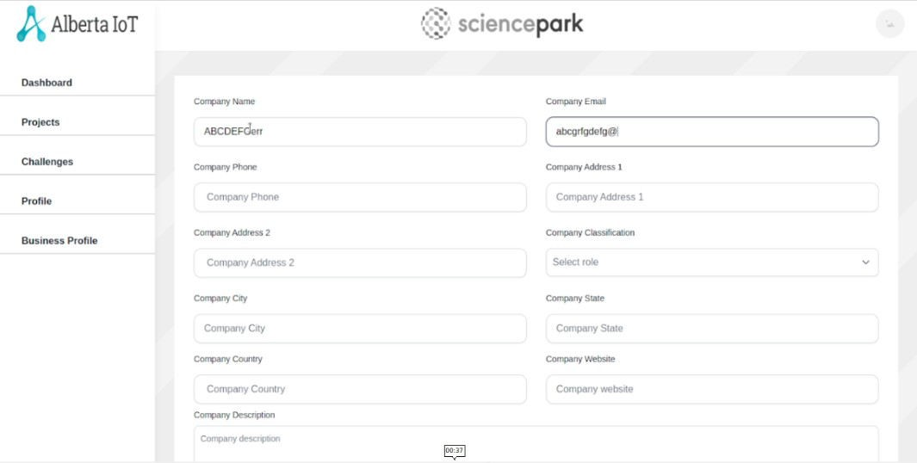

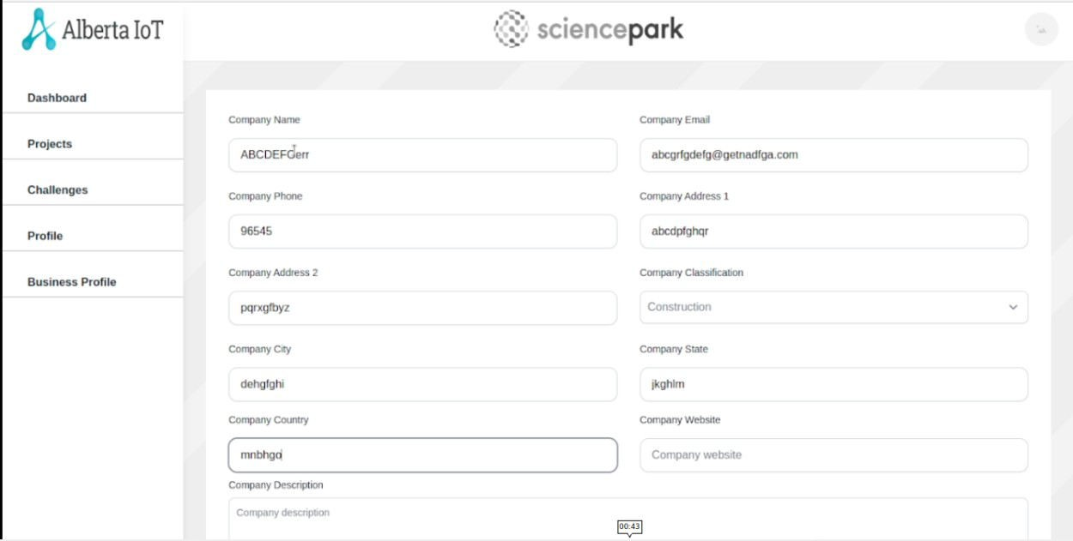

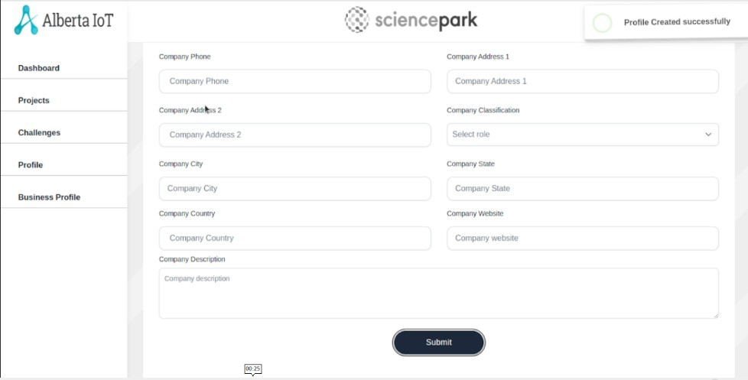

###### Create Challenge Page:

Have tested the Create Challenge page testboxes, Dropdown, Checkboxes and by adding the values. **Expected Result** :- The textboxes, Dropdown and Checkboxes should be clickable and user should be able to enter the values in the textboxes.

**Actual Result** :- The textboxes, Dropdown and Checkboxes are clickable and user is able to enter the values in the textboxes.

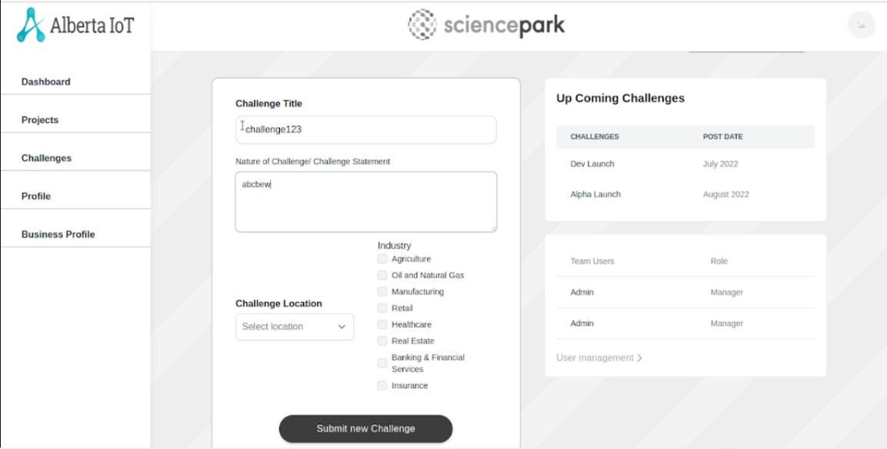

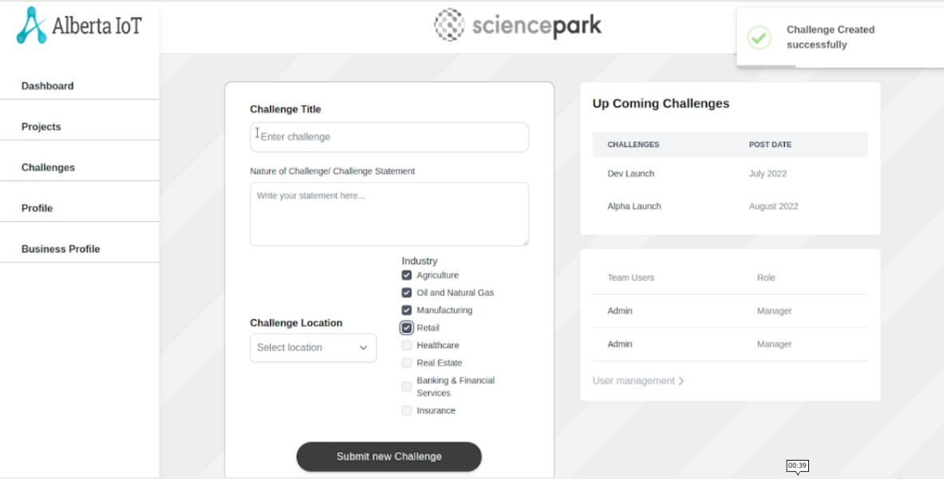

**Manual Testing (Alberta Science Park)**

**Testing Of Urls** — To check whether each URL is correctly mapped to its corresponding view. We discover that all urls function correctly. And following the testing, I used Django coverage to assess the overall accuracy for the urls.py file. Django Coverage is a library that gives us the overall percentage of testing accuracy. Additionally, the overall accuracy is 100%.

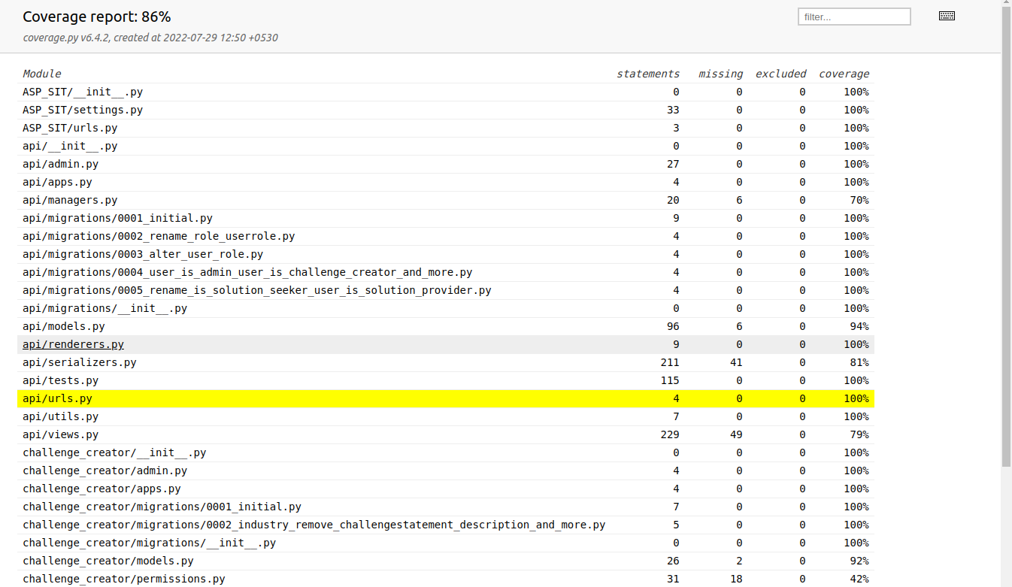

**Testing of Views** – To confirm that each view is functioning properly. Every view stores data in the database and retrieves data from the database. The coverage report for the views.py file is 79%.

##### Personal Profile Create View

Expected Output Current Output

**HTTP_201_CREATED HTTP_201_CREATED**

##### Profile Update View:-

Expected Output Current Output

**HTTP_200_OK HTTP_200_OK**

##### User Change Password View:-

Expected Output Current Output

**HTTP_200_OK HTTP_200_OK**

##### Business Profile Create View:-

Expected Output Current Output

**HTTP_201_CREATED HTTP_201_CREATED**

##### Business Profile Update View:-

Expected Output Current Output

**HTTP_200_OK HTTP_200_OK**

##### Send Password Reset Email View:-

Expected Output Current Output

**HTTP_200_OK HTTP_200_OK**

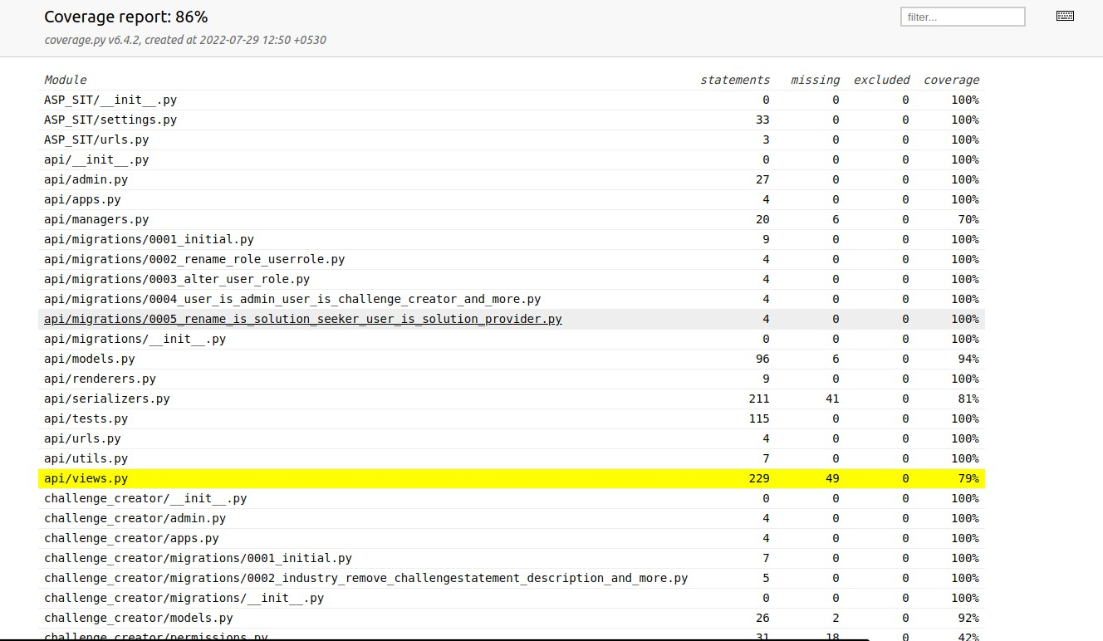

**Testing of Model –** To verify that all models for building databases and tables are functioning properly.coverage report for models.py file is 94%

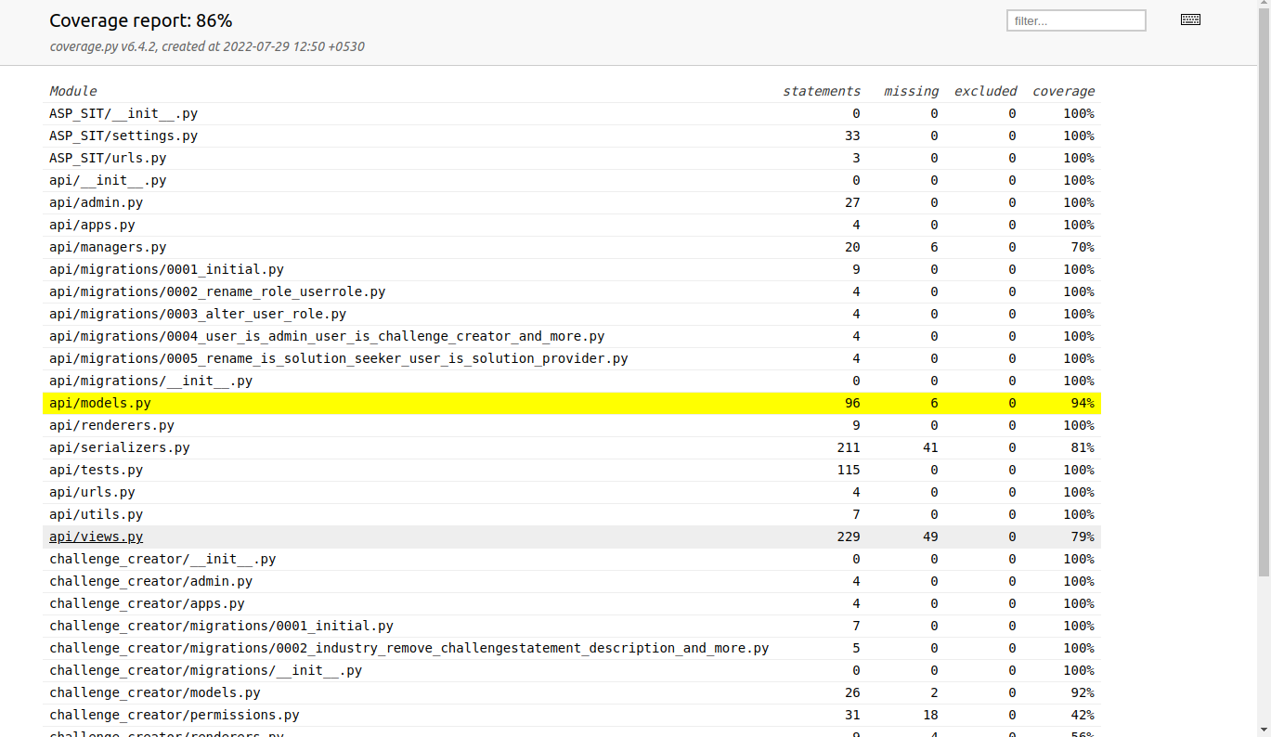

**Final Report For Sprint 2**

Final coverage report for sprint 2 is 86%.

### URL’S –

##### 1

Test case is for the user password reset and send email. Test case for this URL passed. Output matches the anticipated outcome.

|  |  |  |
| --- | --- | --- |
| **URL Name** | **Description** | **Status** |
| ‘send-password-reset-em ail/’ | For user password reset | Passed |

##### 2

Test case is for create personal profile. Test case for this URL passed. Output matches the anticipated outcome.

|  |  |  |
| --- | --- | --- |
| **URL Name** | **Description** | **Status** |
| ‘create/personal-profile/’ | Create personal profile for user | Passed |

##### 3

Test case is for update personal profile. Test case for this URL passed. Output matches the anticipated outcome.

|  |  |  |
| --- | --- | --- |
| **URL Name** | **Description** | **Status** |
| ‘update/personal-profile/<i nt:id>’ | Update personal profile for user | Passed |

##### 4

Test case is for create business profile. Test case for this URL passed. Output matches the anticipated outcome.

|  |  |  |
| --- | --- | --- |
| **URL Name** | **Description** | **Status** |
| ‘create/business-profile/’ | Create business profile for user | Passed |

##### 5

Test case is for update business profile. Test case for this URL passed. Output matches the anticipated outcome.

|  |  |  |
| --- | --- | --- |
| **URL Name** | **Description** | **Status** |
| ‘update/business-profile/< int:id>’ | Update business profile for user | Passed |

##### 6

Test case is for upgrade role. Test case for this URL passed. Output matches the anticipated outcome.

|  |  |  |
| --- | --- | --- |
| **URL Name** | **Description** | **Status** |
| ‘upgrade-role/<int:pk>’ | Upgrade role for user | Passed |

##### VIEW’S

**1**

Test case if for the send reset password email. Test case for this VIEW passed. Output matches the anticipated outcome.

|  |  |  |  |  |
| --- | --- | --- | --- | --- |
| **View Name** | **Description** | **Status** | **Expected Result** | **Actual Result** |
| SendPasswor dResetEmailV iew | View for  Password reset and ends email | Passed | HTTP_200_O K | HTTP_200_O K |

##### 2

Test case is for the create personal profile. Test case for this VIEW passed. Output matches the anticipated outcome.

|  |  |  |  |  |
| --- | --- | --- | --- | --- |
| **View Name** | **Description** | **Status** | **Expected Result** | **Actual Result** |
| PersonalProfil eCreateView | View for  Creating personal profile | Passed | HTTP_201_C REATED | HTTP_201_C REATED |

##### 3

Test case is for the update personal profile. Test case for this VIEW passed. Output matches the anticipated outcome.

|  |  |  |  |  |
| --- | --- | --- | --- | --- |
| **View Name** | **Description** | **Status** | **Expected Result** | **Actual Result** |
| PersonalProfil eUpdateView | View for  Updating personal profile | Passed | HTTP_200_O K | HTTP_200_O K |

##### 4

Test case is for create business profile. Test case for this VIEW passed. Output matches the anticipated outcome.

|  |  |  |  |  |
| --- | --- | --- | --- | --- |
| **View Name** | **Description** | **Status** | **Expected Result** | **Actual Result** |
| BusinesslProfi leCreateView | View for  Creating Business profile | Passed | HTTP_201_C REATED | HTTP_201_C REATED |

##### 5

Test case is for update business profile. Test case for this VIEW passed. Output matches the anticipated outcome.

|  |  |  |  |  |
| --- | --- | --- | --- | --- |
| **View Name** | **Description** | **Status** | **Expected Result** | **Actual Result** |
| BusinesslProfi leUpdateView | View for  Creating Business profile | Passed | HTTP_200_O K | HTTP_200_O K |

##### 6

Test case is for upgrade role. Test case for this VIEW passed. Output matches the anticipated outcome.

|  |  |  |  |  |
| --- | --- | --- | --- | --- |
| **View Name** | **Description** | **Status** | **Expected Result** | **Actual Result** |
| RoleRegitser View | View for upgrade role | Passed | HTTP_200_O K | HTTP_200_O K |

### MODELS –

##### 1

Test case is for the User Creation model. Test case for this MODEL passed. Output matches the anticipated outcome.

|  |  |  |  |  |
| --- | --- | --- | --- | --- |
| **Model Name** | **Description** | **Status** | **Expected Result** | **Actual Result** |
| User | Creating User | Passed | HTTP_201_C REATED | HTTP_201_C REATED |

##### 2

Test case is for the PersonalInformation model. Test case for this MODEL passed. Output matches the anticipated outcome.

|  |  |  |  |  |
| --- | --- | --- | --- | --- |
| **Model Name** | **Description** | **Status** | **Expected Result** | **Actual Result** |
| PersonalInfor mation | Model for creating personal profile | Passed | HTTP_201_C REATED | HTTP_201_C REATED |

##### 3

Test case is for the BusinessInformation model. Test case for this MODEL passed. Output matches the anticipated outcome.

|  |  |  |  |  |
| --- | --- | --- | --- | --- |
| **Model Name** | **Description** | **Status** | **Expected Result** | **Actual Result** |
| BusinessInfor mation | Model for creating Business profile | Passed | HTTP_201_C REATED | HTTP_201_C REATED |

API DOCUMENTATION ---> https://documenter.getpostman.com/view/21689200/VUjPGQUg