- Compatibility Testing:-
In this, we have to test the compatibility that the website is opening in the browser or not. So have tested the compatibility in the 3 of the top browsers named Google Chrome, Mozilla Firefox and Microsoft Edge. Name of the video is Compatibility_Testing.mkv

Google Chrome:
Have tested the compatibility in Google Chrome.
Expedted Result :- This Link should Get opened in the Google Chrome Browser.
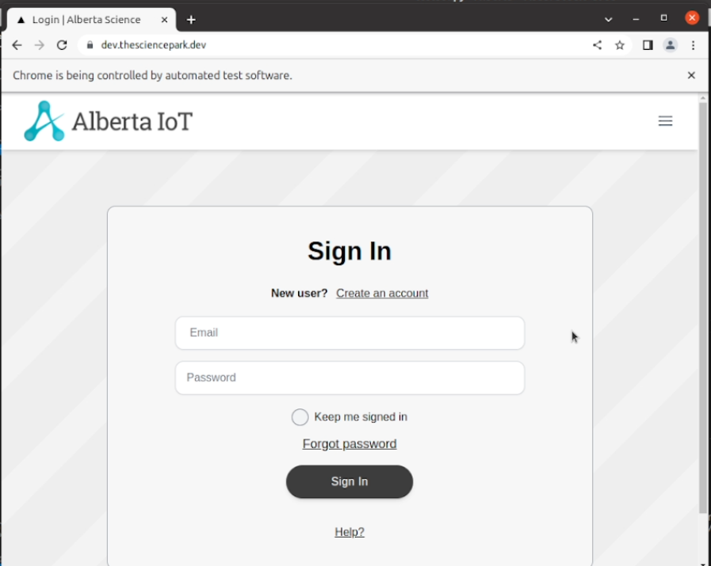
Actual Result :- This link is opening in the Google Chrome Browser.

Mozilla Firefox:
Have tested the compatibility in Mozilla Firefox.
Expedted Result :- This Link should Get opened in the Mozilla Firefox Browser.
Actual Result :- This Link is opening in Mozilla Firefox Browser.
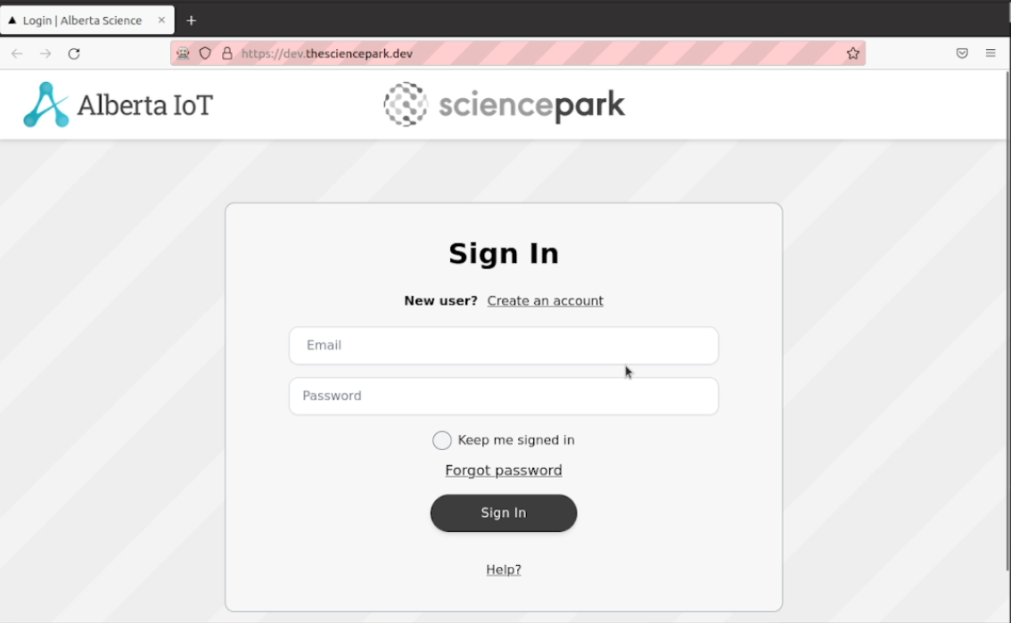

Microsoft Edge:
Have tested the compatibility in Microsoft Edge.
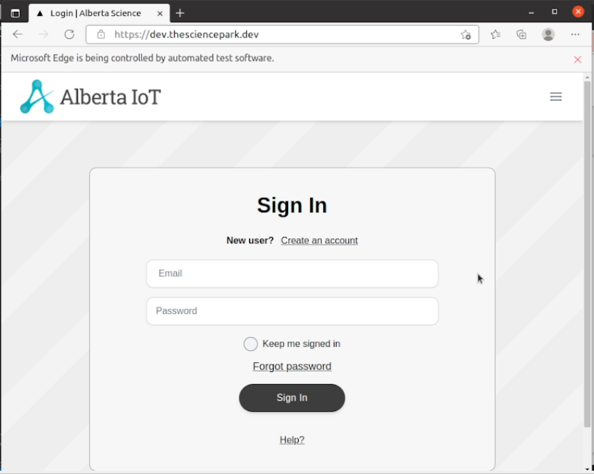
Expedted Result :- This Link should Get opened in the Microsoft Edge Browser.
Actual Result :- This Link is opening in Microsoft Edge Browser.
- Penetration Testing:-
In penetration testing, I have scanned the ports in the website from 1 to 50000. In this no any port is open. Name of the video is penetration_testing_port_scanner.mkv

Have scanned to check that which ports are open in the website. No ports are open.
Expected Result :- No Ports should be opened.
Actual Result :- No Ports are opened
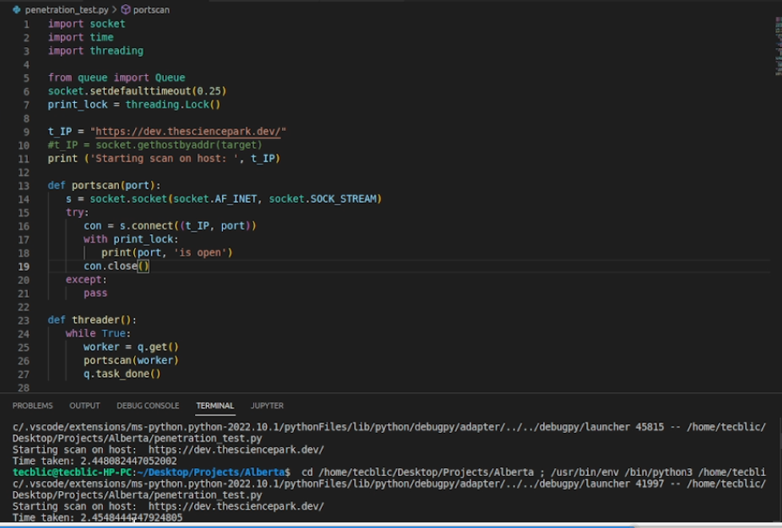

- GUI Testing:-
In this testing, we test the UI of the website. It generally evaluates the textboxes, buttons, links, icons, lists, etc. In this, I have tested Signup Page, Login Page, Create Profile Page, Edit Profile Page, Create Challenge and Business Profile Page. Names of the videos are signup_page.mkv, Login.mkv, Profile_Create.mkv.

Signup Page
Have tested the signup page testboxes and by adding the values.
Expected Result :- The textboxes should be clickable and user should be able to enter the values.
Actual Result :- The textboxes are clickable and user is able to enter the values.
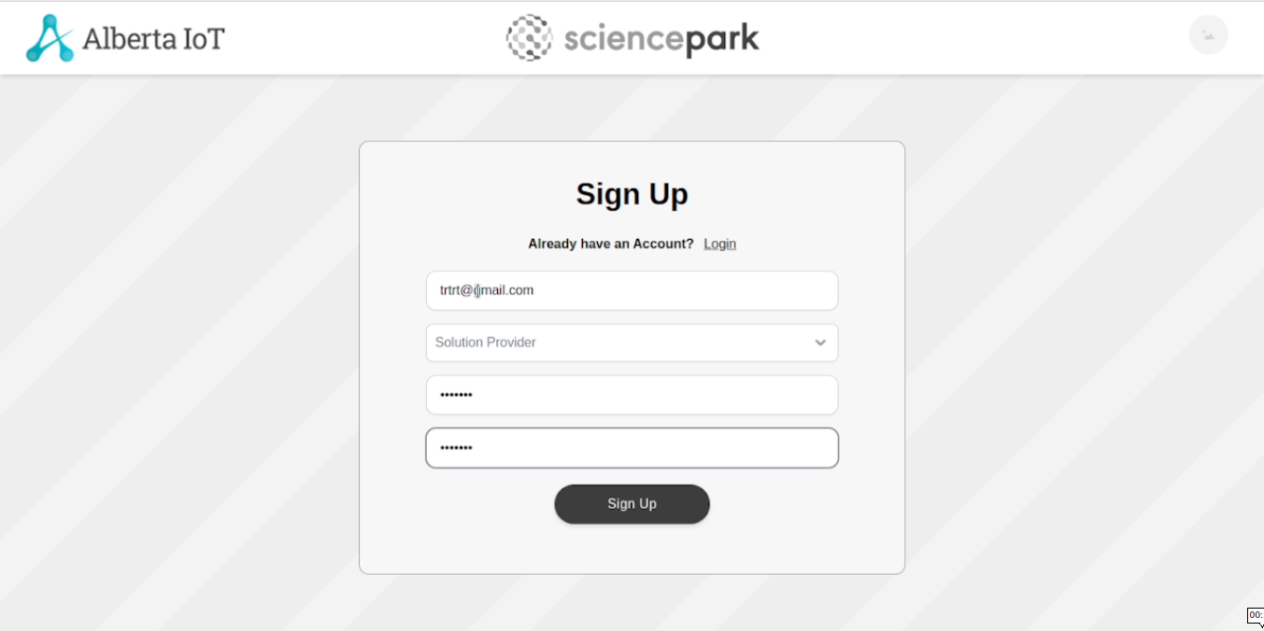
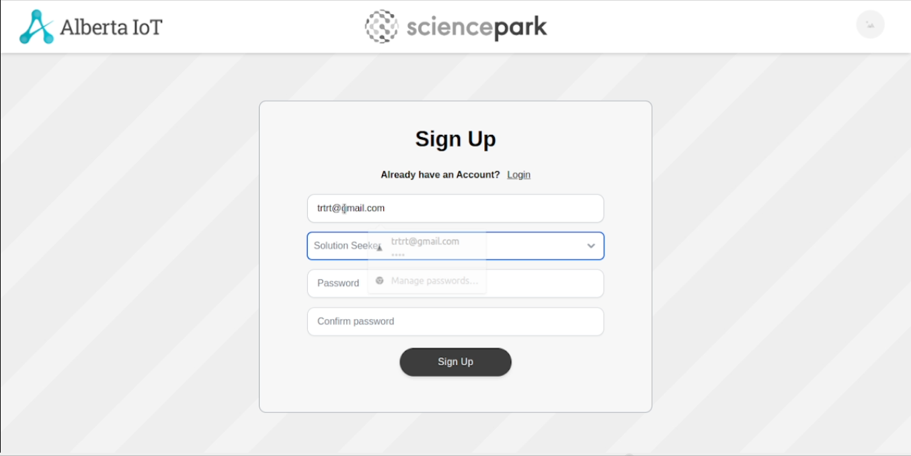

Login Page
Have tested the Login page testboxes and by adding the values.
Expected Result :- The textboxes should be clickable and user should be able to enter the values.
Actual Result :- The textboxes are clickable and user is able to enter the values.
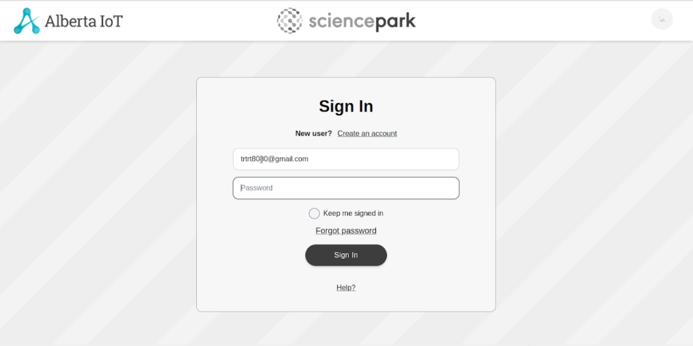
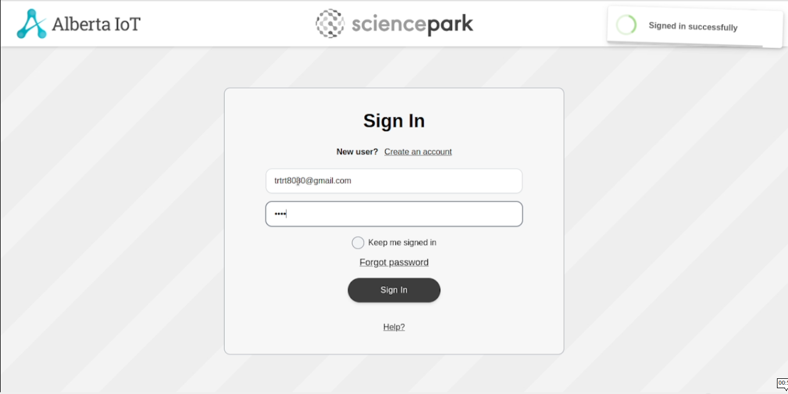
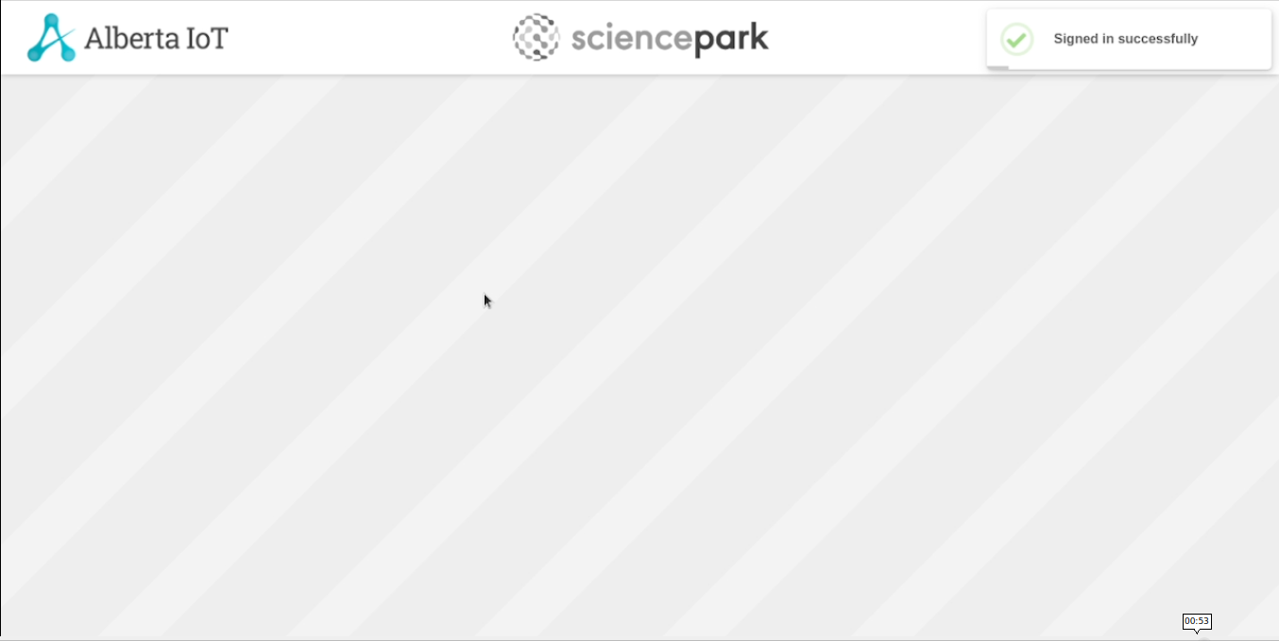

Profile Create Page:
Have tested the Profile Create page testboxes and by adding the values.
Expected Result :- The textboxes should be clickable and user should be able to enter the values.
Actual Result :- The textboxes are clickable and user is able to enter the values.
